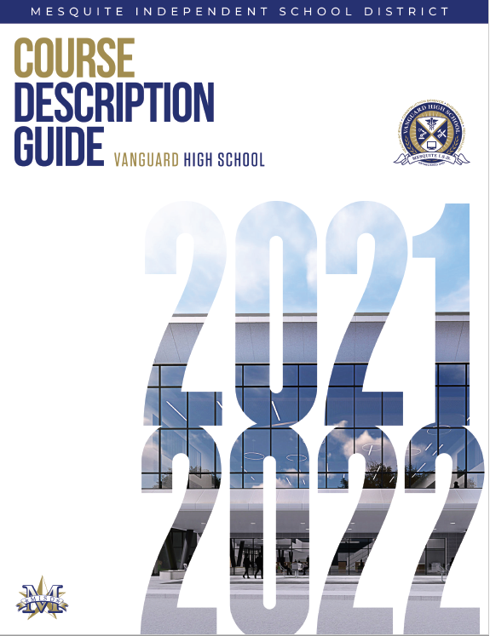

Vanguard High School
Course Description Guide

David Vroonland, Ed.D.
Superintendent of Schools

FOREWORD

Intended for the use of both parents and students, the following pages represent the school administration's continuing eﬀorts to provide pertinent information about your high school and, specifically, a description of the courses oﬀered. The booklet has been assembled by utilizing Texas Education Agency publications as they apply to the local district and by listing the courses that Mesquite ISD high schools generally make available to students. It should be noted, however, that not all of the courses listed are scheduled every year. Since it is not economically feasible to schedule classes in which only a few students enroll, it may be necessary to schedule such classes on an alternate-year basis or to eliminate them. Suﬃcient numbers of student requests for specific courses then become the determining factor as to whether or not a course is scheduled.

Hopefully, this publication will be helpful to students as they enter high school and continue their future to college or career. Students are urged to study this booklet along with the Student Handbook as they plan their graduation programs. All information contained in this publication is the district's interpretation of the State Board of Education adopted amendments to the graduation requirements. If the SBOE and the Texas Education Agency clarify the requirements they will be posted on the Mesquite ISD website at www.mesquiteisd.org. Please check the MISD website often for updates and corrections.

TABLE OF CONTENTS

MISD GRADUATION PROGRAMS AND REQUIREMENTS 6

GENERAL INFORMATION 7
Award of Credit
Classification of Students College Courses
Dual Credit
OnRamps
Texas Virtual School Network
Correspondence/Evening Courses
Credit by Exam for Acceleration
Dropping Courses
Gifted/Talented Program
Ranking Points and Local/State Credit
Technology Applications Credit

COLLEGE ENTRANCE REQUIREMENTS 12
TSI
Advanced Placement Program and Pre-AP Program
NCAA
Top 10%
TEXAS Grant

ACT AND SAT INFORMATION 16

GRADUATION PROGRAMS - ENTERING NINTH GRADERS 17

LIST OF HIGH SCHOOL COURSES 21

DESCRIPTION OF HIGH SCHOOL COURSES 25
ESOL, English, Reading, Speech, Journalism
Languages Other Than English
Mathematics
Science
Social Studies
Health and Physical Education
Fine Arts
Career and Technical Education
Miscellaneous

STATE ASSESSMENT REQUIREMENTS 52

This publication lists the courses that high schools in Mesquite generally make available to students. It should be noted, however, that not all of the courses listed are scheduled every year. Since it is not economically feasible to schedule classes in which only a few students enroll, it may be necessary to schedule such classes on an alternate-year basis or to eliminate them. Suﬃcient numbers of student requests for specific courses then become the determining factor as to whether or not a course is scheduled.
Honors courses are applicable as such only during the regular school year. Grade points are not awarded for any summer school courses nor for courses taken outside the regular school day.

At publication time of this information, the requirements listed are district interpretations of the State Board of Education adopted amendments to the graduation requirements. If the SBOE and the Texas Education Agency change the requirements, those changes will be noted on the district website: www.mesquiteisd.org.
MISD GRADUATION PROGRAMS AND REQUIREMENTS

All students shall meet state and local requirements for graduation. Available graduation programs, credit requirements, and course requirements are based on the year students entered the ninth grade in the fall. Students will be enrolled in courses to complete a graduation program with an endorsement. Students choose an endorsement upon entering 9th grade.
Before a student is permitted to graduate on Foundation plan, the student, the student's parent or guardian, and a school counselor or school administrator must agree that the student would not be able to graduate with an endorsement. This paperwork cannot be done until after the sophomore year.
It is the student's academic achievement record, not the diploma, that is used to diﬀerentiate individual accomplishments, achievement, and graduation program completion. This is a record of performance in high school level courses including courses taken, final grades, credits earned, grade point averages, and standardized test scores. A high school diploma is awarded to all MISD students who have completed one of the district's graduation programs and have passed the exit level state assessment unless the ARD committee has determined the student to be exempt. Students receiving special education services who complete graduation requirements specified in their IEP and who gain the required number of credits will receive a Foundation high school diploma.
Students first enrolled in grade 9 in the 2014-2015 school year or after will be required to take the STAAR EOC assessments as part of their graduation requirement.
Students must pass five end-of-course tests to meet state assessment graduation requirements (Algebra I, Biology, U.S. History, English I (reading and writing) and English II (reading and writing) unless an Individual Graduation Committee or ARD committee has deemed otherwise.

Distinguished Level of Achievement
To be eligible for top 10% automatic admission to a university a student must earn the distinguished level of achievement. The requirements are:
- Successful completion of the Foundation High School Program
- Successful completion of one or more endorsements
- Successful completion of 4 math credits (including Algebra 2)
- Successful completion of 4 science credits
The district expectation is for all our students who complete endorsements to also have the distinguished level of achievement.

Performance Acknowledgements
The last part of the graduation plan is the performance acknowledgments. This is the fourth part of the plan and is not required for graduation but we encourage our students to work toward a performance acknowledgement that will be placed on the transcript. There are several ways to earn a performance acknowledgement.
- Dual credit or an associate degree
- Bilingualism and bi-literacy
- PSAT, SAT, or ACT performance
- Performance of a 3 or better on an AP test
- Business or industry certificate or license

OTHER INFORMATION STUDENTS AND PARENTS SHOULD KNOW
Grade 8 assessment performance is a good indicator of how well students will do on the exit level end-of-course exams. Students who are weak in some areas may need to focus on improving those skills.
Released STAAR tests are available along with the answer keys on the Texas Education Agency's web site: www.tea.texas.gov/student.assessment/. At this website, students and parents can find information about the student assessment program, the testing calendar, the released STAAR tests, statewide results of STAAR, and technical information about the testing program.
For students who receive special education services, the ARD committee determines whether the student will take STAAR EOC or STAAR EOC Alt to measure academic progress. A special education student who successfully completes the minimum curriculum and credit requirements, and completes the requirements of his or her individual education plan (IEP) shall receive a high school diploma.
General Information

This general information has been provided to help clarify questions about your courses. For more detailed information, please read the Student Handbook or check with your school counselors. If the SBOE and the Texas Education Agency clarify the requirements they will be posted on the Mesquite ISD website at www.mesquiteisd.org.

AWARD OF CREDIT
All students who enroll in a two-semester course will continue to earn full credit for the course if both semesters averaged together equal a full year grade of 70 or above for the final grade. The semesters of a full year course must be taken in the correct sequence.

A student may earn a half-credit (.5 credit) in a two-semester course if the student passes only one semester with a grade of 70 and the two semesters averaged together do not equal a final grade of 70.

Students who are awarded a half-credit (.5) for one semester of a two-semester course must retake the failed semester and earn a grade of 70 to gain the other required half-credit. First semester of a two-semester course will not be oﬀered second semester, and second semester of a two-semester course will not be oﬀered first semester. The student must retake the failed semester either in summer school, through campus credit recovery programs, or during the following year to earn the additional half-credit (0.5 credit).

CLASSIFICATION OF STUDENTS
The classification of a student depends upon the number of units of credit earned and not upon the number of years spent in high school. Generally, changes in classification are made at the beginning of the academic year. To be classified as a senior, a student must be scheduled to graduate at the end of the spring semester of the current school year. The minimum number of units required for classification is as follows:

Sophomore | (10th) | 6 units
Junior | (11th) | 12 units
Senior | (12th) | 18 units

COLLEGE COURSES
Before considering enrollment in any college course, students should consult with their counselors for TSI (Texas Success Initiative) requirements. Students must also obtain prior written approval before enrolling in a college course.
Concurrent enrollment for college credit provides the opportunity for students to remain in high school and take courses for college credit in the evenings, on the weekend, or during the summer. Grade points are not awarded for these courses. All fees, tuition, or other costs are the responsibility of the student and his/her parents. These courses generally do not count for high school credit un- less special circumstances exist; however, high school credit may also be earned for academic courses taken concurrently and passed only if these criteria are met:
- The courses are provided by institutions of higher education accredited by SACS (Southern Association of Colleges and Schools Commission on Accreditation) or other recognized regional accrediting associations that are part of the same national organization.
- The course is part of a special program recognized and approved by MISD. The college course should correlate to a Texas state approved course and provide advanced academic instruction beyond or in greater detail than the essential knowledge and skills for the MISD high school course.
- Each course syllabus has been submitted for review and approval by the Assistant Superintendent of Instructional Services prior to student enrollment.
- The student must arrange for an oﬃcial college transcript carrying the final grade to be sent from college to the high school counselor for evaluation before credit can be awarded and before the course can be added to the student's academic achievement record. The transcript will be kept by the school.
Students may receive one credit toward the required courses for high school graduation; additional credits will be counted as elective credits. If MISD teaches the course, then the same amount of credit will be awarded but no grade points will be awarded, unless the course is oﬀered on campus during the school day. Special programs may be added, but those approved at this time are:
- The Junior Statesmen Summer School/University of Texas at Austin, Yale, Stanford, Georgetown, and Northwestern Universities
- TAG Program, College Experience Southern Methodist University
- TIP Program/Duke University
- Texas Academy of Math and Science/University of North Texas

DUAL CREDIT COURSES
Courses are oﬀered to high school students through an oﬃcial agreement between Dallas College and MISD. These specific, pre-approved courses meet both district and college guidelines in order to provide credit for both high school and college when a grade of C or higher is earned. No grade points are awarded for these courses except when taken in MISD during the school day. There are specified enrollment procedures that must be followed.
- Students must be enrolled as full-time students in MISD and must obtain permission from the high school principal or designee prior to college enrollment.
- Students may not leave an assigned course early to take a dual credit course oﬀered at the college.
- Students must provide their own transportation to the college.
- Students are responsible to take TSI assessment and meet other eligibility criteria as required by the college.
- Tuition will be waived from Dallas College for approved, designated dual credit courses. Other expenses for college enrollment, for textbooks, and for course work are the responsibility of the student when the course is taken at the college.
- An approved academic dual credit course may count toward a Performance Acknowledgement when a grade of 3.0 (B) or higher is earned.
- Upon successful completion of the course, a student with a grade of C or higher will receive credit for the college course and may receive credit for the high school course by submitting his/her college transcript or the College Credit Report to his/her counselor. A student is responsible for verifying transferability of course credit to the college/university of choice. Dual credit courses considered for the current school year will be posted on the district website as the courses may vary from year to year. Minimum class size must be met for the class to be taught.

DUAL ENROLLMENT COURSES
OnRamps – University of Texas at Austin
OnRamps works through a dual-enrollment model. Using a hybrid delivery approach, students meet rigorous university-level college readiness standards and have the opportunity to earn UT Austin credit from a UT faculty member and high school credit from their local teacher. OnRamps incorporates an organized data and action analytics approach to support students, teachers, and districts in their pursuit of educational excellence. Credit from the University of Texas at Austin is earned through the University Extension (UEX) within the Texas Extended Campus.
All OnRamps core curriculum courses are guaranteed to transfer to any public institution in Texas. OnRamps courses do not require admission to the university but are aligned with courses taught to UT Austin’s residential students. A TSI qualifying score is not necessary for these courses.
Students taking OnRamps courses will receive two separate grades, one for the college grade and one for the high school grade.
Process for OnRamps Courses:
- Students enroll in a yearlong course taught by their high school teacher for high school credit.
- During the fall semester, OnRamps students must complete a series of required assignments that are designated by an instructor of record at the University of Texas at Austin and earn the minimum grade established by the UT college/department to be eligible to be dually enrolled in the university course offered during the spring semester. (Note that for students enrolled in English and US History Courses, this process will be accelerated.)
- During the spring semester, OnRamps students must complete a series of additional required assignments that are designated by the university’s instructor of record to determine successful completion of the college course.
- The university’s instructor of record will award the appropriate grade based on their performance for the college course. The high school teacher will separately award credit for the grade earned in the high school course, which may differ from that for the college course.
The option of enrollment in OnRamps courses varies at each high school campus. Contact your counselor for the courses available at your high school.

TEXAS VIRTUAL SCHOOL NETWORK
TxVSN provides courses to supplement the instructional programs of public school districts and open enrollment charter schools. Through regular review of student needs, schools may determine that TxVSN courses provide useful instructional options. A student then requests courses and the district-designated TxVSN Site Coordinator reviews and approves course selection. This system of checks and balances allows the public school district or open enrollment charter school to have an active role in the acquisition the TxVSN courses. The district may deny paying for a student to take a course via the TxVSN if 1) The district oﬀers a substantially similar course and 2) A student wants to take more than three year-long courses within a year at his or her own expense.
The Texas Virtual School Network (TxVSN) can provide additional opportunities and options for Texas students through online courses. TxVSN was authorized by the Texas Legislature in 2007 to provide online courses to students in Texas. Please contact your school counselor for more information.

CORRESPONDENCE AND/OR EVENING COURSES
Students are permitted to take correspondence course work with the principal’s prior approval and through either the extension center of the University of Texas or of Texas Tech. (Both are approved by TEA.) Grade points are not awarded for correspondence courses. Generally, two credits may be earned. A counselor can provide other guidelines for correspondence courses. (Seniors enrolled in correspondence courses must complete the course and submit the grade at least 30 days prior to the date of graduation.)
Students may enroll in an accredited evening school only with the approval of the principal. A maximum of two units of credit may be earned in evening school. Grade points are not awarded for evening school work. This includes the MISD PLUS Program.

CREDIT BY EXAM FOR ACCELERATION
Qualifying students may choose to take acceleration exams to gain credit for courses in which they have had no formal prior instruction. The minimum score on the exam must be 80% to gain credit. The student must apply to take these exams during the designated times of the year these exams are oﬀered. School counselors have applications and more detailed information. These tests are oﬀered on designated dates at no cost to the student; however, students who order tests and do not take them will be charged the cost of the test. Students may not retake a test for the same course. Grade points are not awarded for these exams.

DROPPING COURSES
Students must be very careful when considering dropping classes. Students who drop a course while failing may become ineligible under UIL guidelines. Generally, courses will not be dropped after the fourth week of any grading period. At this point, students must complete the six weeks and receive a grade.

GIFTED/TALENTED PROGRAM
To encourage intellectually/academically gifted students to develop to their potential, the Mesquite Independent School District provides a variety of courses to meet the needs of gifted students at the high school level. Students identified as gifted not only have the opportunity to experience in-depth curriculum in gifted/talented classes, but they also have the opportunity to engage in advanced curriculum through Honors and Advanced Placement classes.
The gifted/talented program for high school gifted students is designed to meet the needs of those students who would find an advanced, multidisciplinary curriculum challenging. Students in English and social studies especially will develop the understanding of the interrelationships of various disciplines, how these interrelationships have influenced past and present societies, and how these can influence the future. Students participating in advanced mathematics and science courses will experience greater depth and an accelerated pace in the curriculum. A major goal of the gifted program is to encourage gifted students to become autonomous learners who have a social/ethical responsibility for making valuable contributions to society.
High school students identified as gifted in specific subject areas may select from applicable courses available in that subject area. Program identification is based upon specific subject aptitude and not general intellectual ability. A student must meet the subject criteria in order to be in an English or math or science or social studies gifted class.

English 1 G/T (H), grade 9
English 2 G/T (H), grade 10
English 3 AP G/T (H), grade 11
English 4, AP G/T (H), grade 12
Independent Study, Mentorship H, grade 12 or AP Literature & Composition
Capstone AP (H), grades 10-12
Seminar AP (H), grade 10-12
Research AP (H), grade 11-12

Geometry G/T (H), grade 9
Algebra 2 G/T (H), grade 10
Precalculus G/T (H), grade 11
Calculus AP (H), grade 12

Biology G/T (H), grade 9
Chemistry G/T (H), grade 10
Biology AP (H), grades 10-12
Chemistry AP (H), grades 11-12
Physics AP 1 & 2 (H), grades 11-12

Human Geography AP G/T (H), grade 9
World History AP GT (H), grade 10
United States History AP (H), grades 11-12
United States Government and Politics AP (H), grades 11-12
Macroeconomics Advanced Placement (H), grades 11-12

Note: Additional Advanced and AP courses are available to meet the varying needs of students.

RANKING AND LOCAL/STATE CREDIT
Ranking points are awarded for courses successfully completed beginning in grade nine. Students who receive credit for high school courses taken while in middle school are not awarded rank points for these courses. Rank in class will be determined by accumulated rank points — the total number earned in a student's high school career — in all courses successfully completed by students with grades of 70 or higher. These courses include state approved courses, state approved substitutes and some locally approved courses.
Students will receive grade points only for courses scheduled during the regular school day and during the regular school year (not summer school). Please note on the following chart which courses do not receive ranking points.
Local/State
Course Ranking Points Earned Yes or No Credit
College Prep Yes Local
Correspondence Courses No State
Credit by Exam (Acceleration) No State
Credit Recovery No State
Dual Credit Courses outside school day No State
Individual Study/Applied Music No State
JROTC Yes State
Night/Evening School Courses (Including PLUS Program) No State
Oﬃce/Teacher Aide No Local
Peer Helpers (Year 1 & 2) Yes State
Private/Commercially Sponsored Physical Activity No State
Special Education Content Modified Courses No State
Special Programs/College Concurrent Courses No State
Summer School Courses No State
State Assessment Prep Yes Local
Local credit courses are approved by the Board of Trustees for local credit only and do not count toward state graduation requirements.

TECHNOLOGY EDUCATION – 1 CREDIT LOCAL REQUIREMENT
Students on any of the graduation programs must earn one technology education credit in the same course as part of local graduation requirements. Listed below are various technology related MISD courses oﬀered which count as credit for the technology education requirement. Note that courses may fall under diﬀerent Career and Technical Education career clusters or under Technology Applications in the course description guide. Not all courses are oﬀered on all campuses.
Although the majority of the students will earn the technology education credit through the Business Information Management I foundation course, other options for gaining this credit are included in the list below.

Animation I
Architectural Design I or II
Audio/Video Production I
Business Information Management I or II
Business Information Management MTI I
Computer Science 1 or Computer Science 2 (H)
Digital Media
Engineering Design and Presentation I or II
Foundations of Cyber Security
Graphic Design and Illustration I
Graphic Design and Illustration/Graphic Design and Illustration II Lab
Principles of Applied Engineering
Principles of Architecture
Principles of Arts, Audio/Video Technology, and Communications
Web Design

COLLEGE ENTRANCE REQUIREMENTS
The student who hopes to attend college after high school graduation should begin early to plan a course of study to assure acceptance by the college or university of his/her choice. The high school counselors maintain a collection of college catalogues which list entrance requirements and other vital information for prospective students. The counselors stand ready to share the information and help to interpret it, but it is the responsibility of the student to seek that help. Once the student has made a definite choice of the school he or she plans to attend, it is advisable to keep in contact with that school's admissions oﬃce. By doing so, the student will know well in advance of any entrance requirement changes. It is strongly recommended that the student request his/her own current catalogue from the university or college and study it carefully.

TSI (Texas Success Initiative)
Students planning to attend Texas public colleges and universities must take the TSI assessments or a college designated alternate and receive scores before he/she can register for any college courses. This includes dual credit courses and concurrent enrollment courses taken while in high school. Exemptions may be gained with specified ACT, SAT, or state assessment scores. Students interested in dual credit courses should check with their campus advanced academics specialist or counselor about TSI requirements. Graduating seniors should check with the advising office or testing office at their college of choice for TSI requirements and test registration.

Advanced Placement (AP) Program
The College Board Advanced Placement Program gives students the opportunity to pursue college-level courses while still in high school. This program also challenges students, rewards their achievements, eases the transition to college, and may ease the financial burden of college. The College Board develops the scope and sequence of AP courses and provides training for AP teachers. College credit may be granted by a university based upon Advanced Placement examinations with a score of 3 or higher; therefore, all students enrolled in an AP course are expected to take the AP exam for that course in May. See your counselor or teacher for more information or visit www.apcentral.collegeboard.com for the testing schedule.
According to the College Board, students who complete AP courses are generally:
- better prepared academically
- more likely to complete more college courses in 4 years
- found to perform significantly better than peers who did not take AP courses
- twice as likely to go into advanced study (medicine, law)

Fine Arts | Languages | Science
AP Studio Art - Drawing AP Studio Art-Two  Dimensional Design AP Studio Art - Three  Dimensional Design AP Art History  AP Music Theory | AP Spanish Language AP Spanish Literature AP French Language | AP Biology AP Chemistry AP Physics 1  AP Physics 2  AP Environmental Science
English | Math | Social Studies
AP English Language & Composition  AP English Literature & Composition | AP Calculus AP Statistics | AP Human Geography AP World History  AP Macroeconomics AP Psychology  AP U. S. Government AP U. S. History  AP European History
CTE | AP Capstone
AP Computer Science Principles  AP Computer Science A | AP Seminar  AP Research

Advanced courses prepare students for advanced academics courses, including AP, Dual Credit, and OnRamps, courses and are infused with strategies necessary for success in college level courses. At this level, advanced reading assignments and more in-depth studies are required. Students will be considered on the basis of teacher recommendations, prior grades, achievement test results, and parent approval.
NCAA Student-Athletes — Read the Guide for the College-Bound Student-Athlete each year. It can be found at www.eligibilitycenter.org. All prospective student athletes for Division I and II must register with the NCAA Initial Eligibility Clearinghouse on-line at www.eligibilitycenter.org. Eligible courses for the Clearinghouse must be within four years of high school and within the school day.
Division I
Students who enroll in a Division 1 college and want to participate in athletics or receive an athletic scholarship will need to present 16 core courses in the following academic areas:
- 4 years of English
- 3 years of mathematics (Algebra 1 or higher)
- 2 years of natural/physical science (1 year of lab science)
- 1 additional year of English, mathematics or science
- 2 years of social science
- 4 years of extra core courses (from any listed above, foreign language or nondoctrinal religion/philosophy)
- Graduate from high school
- Earn a minimum required 2.3 grade-point average in your core courses
- Earn a combined SAT or ACT sum score that matches your core-course grade-point average on the sliding scale (e.g., a 2.400 core-course grade-point average requires a minimum 940 combined SAT score or a 71 ACT sum score).
Division II
Division II colleges will require 16 core courses in the following areas:
- 3 years of English
- 2 years of mathematics (Algebra or higher)
- 2 years of natural/physical science (1 year of lab science)
- 3 years of additional English, mathematics or natural/physical science
- 2 years of social science
- 4 years of additional courses (from any area above, foreign language or nondoctrinal religion/philosophy
- Graduate from high school
- Earn a minimum of 2.2 core-course grade-point average or better in your core courses
- Earn a combined SAT sum score of 920 or an ACT sum score of 70. For individuals enrolling at a college or university in Puerto Rico, earn a combined Prueba de Aptitud Academica score of 730.
A Core Course is an academic discipline (as opposed to a vocational or personal service course) that oﬀers fundamental instruction in a specific area of study. Courses taught below a high school's regular academic instructional level (e.g. remedial or compensatory) cannot be considered core courses regardless of the content of the course. At least 75 percent of the instructional content of a course must be in one or more of the required areas and "statistics" must be advanced (algebra-based).
Courses for students with disabilities may be approved even if such courses are taught at a level below the high school's regular academic instructional level (e.g. special education classes) if the high school principal verifies (on the core-course forms) that the courses are substantially comparable, quantitatively and qualitatively, to similar approved core-course oﬀerings in that academic discipline at the high school.
English
Core courses in English include instructional elements in grammar, vocabulary development, com- position literature, analytical/critical reading or oral communication.
Math
Core courses in mathematics include instructional elements in algebra, geometry, trigonometry, statistics and calculus.
Social Science
Core courses in social science contain instructional elements in history, social science, economics, geography, psychology, sociology, government, political science or anthropology.
Natural or Physical Science
Core courses in natural or physical science include instructional elements in biology, chemistry, physics, environmental science, physical science or earth science.
Additional Academic Courses
Core courses in the additional academic area must be from courses in foreign language, philosophy or nondoctrinal religion courses.
SAT or ACT and NCAA Initial Eligibility
The eligibility center will combine the critical reading and mathematics sections of SAT for an overall score. All SAT and ACT scores must be reported directly to the NCAA Initial Eligibility Clearinghouse by the testing agency. When registering for the SAT or ACT, students should use the clearinghouse code of 9999.

SAT/ACT test scores that appear on high school transcripts will not be used for NCAA Initial Eligibility via the Clearinghouse!
For questions that cannot be answered by this guide or for information about sending transcripts or additional information to the eligibility center please use the following address:

NCAA Eligibility Center Certification Processing
P.O. Box 7136 Indianapolis, Indiana 46207-7136
877.262.1492 (customer service 8 a.m. - 6 p.m. Eastern Time, Monday-Friday)
Additional information can be received via www.ncaa.org

Top 10% Program (Excluding University of Texas at Austin)
Top students are eligible for automatic admission to any public university in Texas. Under House Bill 588 passed by the 75th legislature in 1997, students who are in the top ten percent of their graduating class are eligible for automatic admission to any public university in Texas.*
To be eligible for automatic admission, a student must:
- Graduate in the top 10 percent of his/her class at a public or private high school in Texas on the recommended, distinguished achievement program, or distinguished level of achievement.
- Enroll in college no more than two years after graduating from high school; and
- Submit an application to a Texas public university for admission before the institution’s application deadline. Since deadlines vary, please check with the specific university to verify the application deadline. Application deadlines are FIRM deadlines. A student missing a deadline is usually denied admission.
*The law states that class rank shall be based on the end of 11th grade, middle of 12th grade, or at high school graduation, whichever is most recent when the application is completed.

Top 6% to Receive Automatic Admission (University of Texas at Austin ONLY)
Texas law offers eligible applicants automatic admission to public colleges and universities. Automatic admission to UT Austin is available to top 6% freshman applicants from Texas high schools for summer/fall 2021 and spring 2022.
Students and parents wanting more information should visit: http://bealonghorn.utexas.edu/

TEXAS Grant
The state legislature established the TEXAS (Towards Excellence, Access and Success) Grant to make sure that well-prepared high school graduates with financial need could go to college.
Who can apply? Students who...
For an initial award:
- Are Texas residents
- Have not been convicted of a felony or crime involving a controlled substance
- Show financial need
- Estimated EFC (estimated family contribution) less than or equal to $4,000
- Register for Selective Service or are exempt from this requirement
AND
- Be a graduate of an accredited high school in Texas not earlier than the 1998-99 school year
- Complete the Recommended High School Program, Distinguished Achievement Program, the Foundation Plus Endorsement Plan, or the Distinguished Level of Achievement Plan in high school
- Enroll in a non-profit public college or university within 16 months of graduation from a public or accredited private high school in Texas and have accumulated no more than 30 semester credit hours, excluding those earned for dual or concurrent courses awarded for credit by examination (AP®, IB or CLEP)
OR
- Have earned an associate degree from a public technical, state or community college in Texas and
- Enroll in any public university in Texas no more than 12 months after receiving their associate’s degree.
Students entering the program from high school who continue in college and who meet program academic standards can receive awards for up to 150 semester credit hours, until they receive a bachelor’s degree, or for five years if enrolled in a 4-year degree plan or six years if enrolled in a 5-year degree plan, whichever comes first.

How can you apply?

You apply for the TEXAS Grant when you complete and submit the Free Application for Federal Student Aid (FAFSA) or other application as required by your college’s financial aid oﬃce. Funding is limited, so you need to submit your application as soon as possible after January 1 of your senior year. The financial aid oﬃce at each college and university will determine if TEXAS Grant is part of the aid package that is oﬀered to you.

Eligibility for this program is determined by the financial aid oﬃce at the colleges and universities. Contact the college financial aid oﬃce for additional information on eligibility or availability of funds. To read more about this program check out: Texas Education Code, §56.301 and Coordinating Board Rules, Chapter 22 L.

ACT AND SAT INFORMATION
Most of the degree-granting colleges and universities require an admissions examination of some kind. These standardized college admissions tests make it possible for colleges to evaluate students who come from various sections of the country and many diﬀerent kinds of schools. Registration packets are available in the Counseling Center or students may register on-line for the ACT at www.actstudent.org and/or the SAT at www.collegeboard.com. The ACT is a three-hour examination with an optional 30 minute writing test. This exam is similar to an achievement test in English usage, mathematics usage, reading comprehension, and natural science reasoning abilities. Students should check with their college to see if the ACT writing section will be required. The SAT Reasoning Test is a three and a half hour exam of primarily verbal and math reasoning abilities. The writing section of the SAT is not optional.

In order to make the best possible score on a college entrance examination, the following statements may be helpful for making course selections:
- Students who are in the honors program in English and math will usually score high in both areas if they have been successful in the honors program (consistently receiving grades in the 80’s or higher).
- The student who takes science at least through chemistry tends to score significantly higher in math than the student who only goes through biology.
- Students who take more academic courses (English, math, science, social studies, fine arts, and foreign language) tend to score higher on both the ACT and the SAT. Students should try to take a minimum of 18 credits from these courses. The remaining course work should be designed to match the student's intended major and/or college admission’s requirement.
- Preparation for college entrance exams can sometimes be enhanced with a test preparation course. The district oﬀers this opportunity during the spring, outside of school hours, on a tuition basis to correspond with certain SAT and ACT test dates. Some high schools may oﬀer a College Prep course for local credit during the school day. Students can also access test preparation programs free on the internet. See the counselor for details. However, it must be stated that neither these nor any other preparation course will be beneficial without the proper academic preparation.
- Students will be most successful on the SAT and ACT if they follow the counselor’s recommendation, the college preparation timeline, and the suggested academic courses listed in #1, 2, and 3 above.
- Students who are on a college preparation academic program and who have completed at least English 3, Algebra 2, biology and chemistry should take the SAT and/or ACT at the end of their junior year. Students who have not completed these courses are advised against taking the SAT at that time. The ACT would be a better choice at that time for a college entrance examination.
- Students who take the SAT or ACT late in their junior year (May or June) and want to raise their scores by taking the test again as seniors must remember that simply to retake the test with no more preparation will probably result in score decreases. In order to raise scores, students should continue with additional math courses and other academically demanding courses during the senior year. Please check with a counselor before taking or retaking any college entrance test.
- Both tests are normally taken in May/June of the junior year and by seniors before the end of the fall semester of their senior year. A college will always take the best score if a student has tested more than once.
The PSAT/NMSQT is a preliminary test for the SAT, but it is also the test by which 11th grade students enter competition for the National Merit Scholarships. This test is given once on a national test date in October. Information regarding this test is available from the Guidance/Counseling Center.
ACT Test Dates SAT Test Dates
September 11, 2021 October 2, 2021
October 23, 2021 November 6, 2021
December 11, 2021 December 4, 2021
February 5, 2022 March 12, 2022
April 9, 2022 May 7, 2022
June 11, 2022 June 4, 2022
All ACT and SAT test dates are now administered locally at Mesquite High School. More information on the ACT exam can be found at www.act.org. SAT, visit www.collegeboard.org.

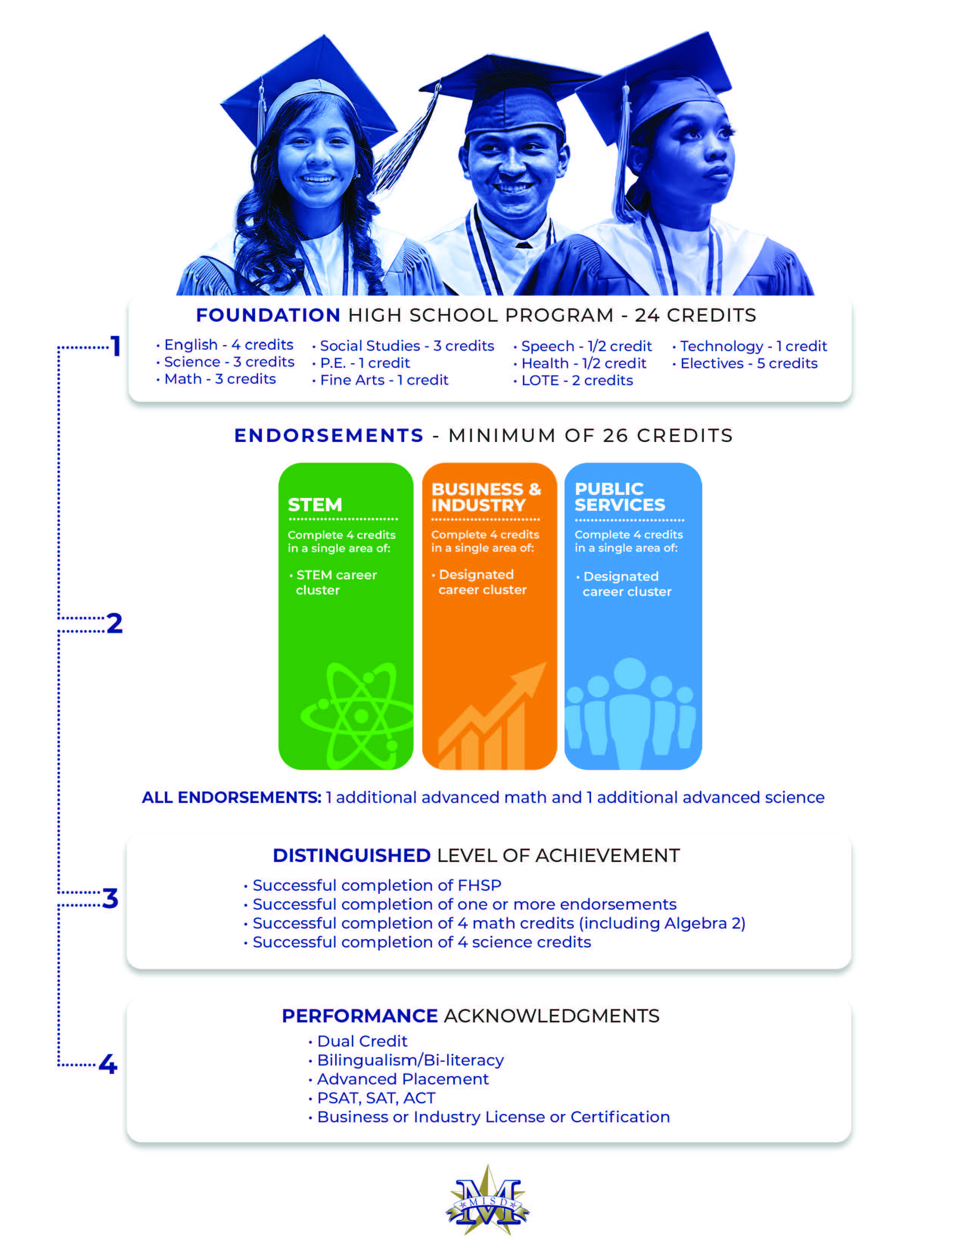

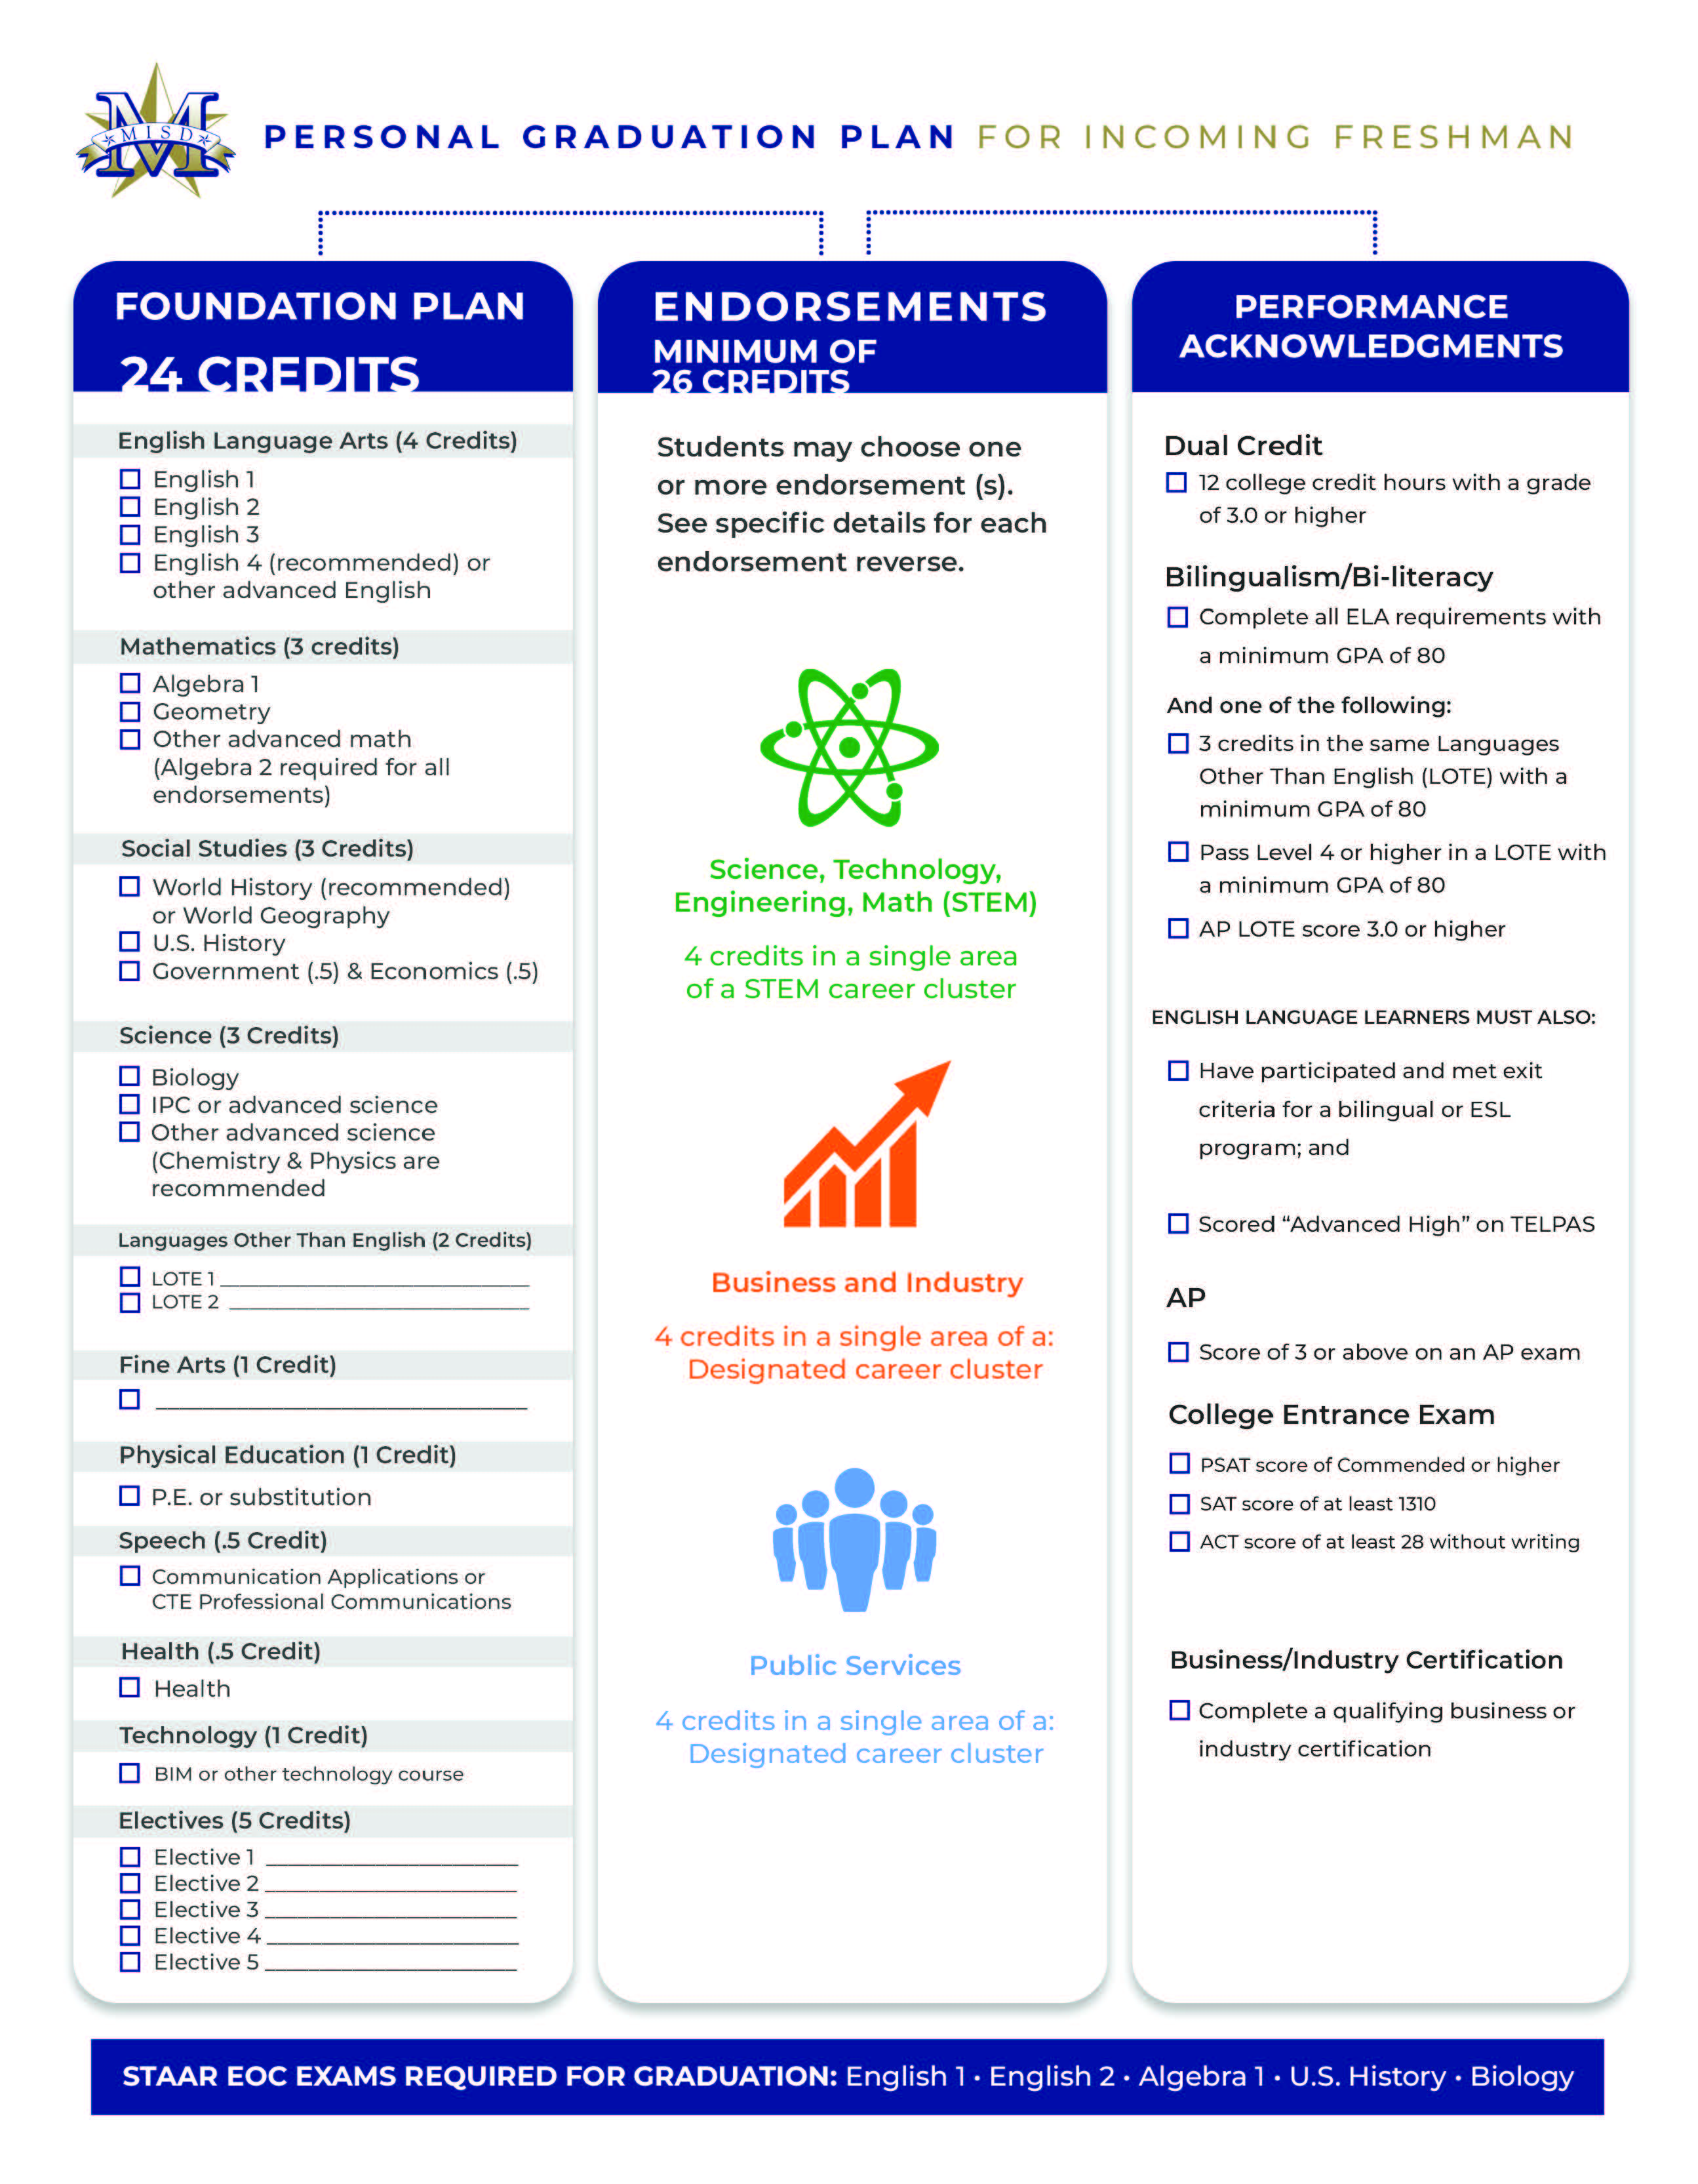

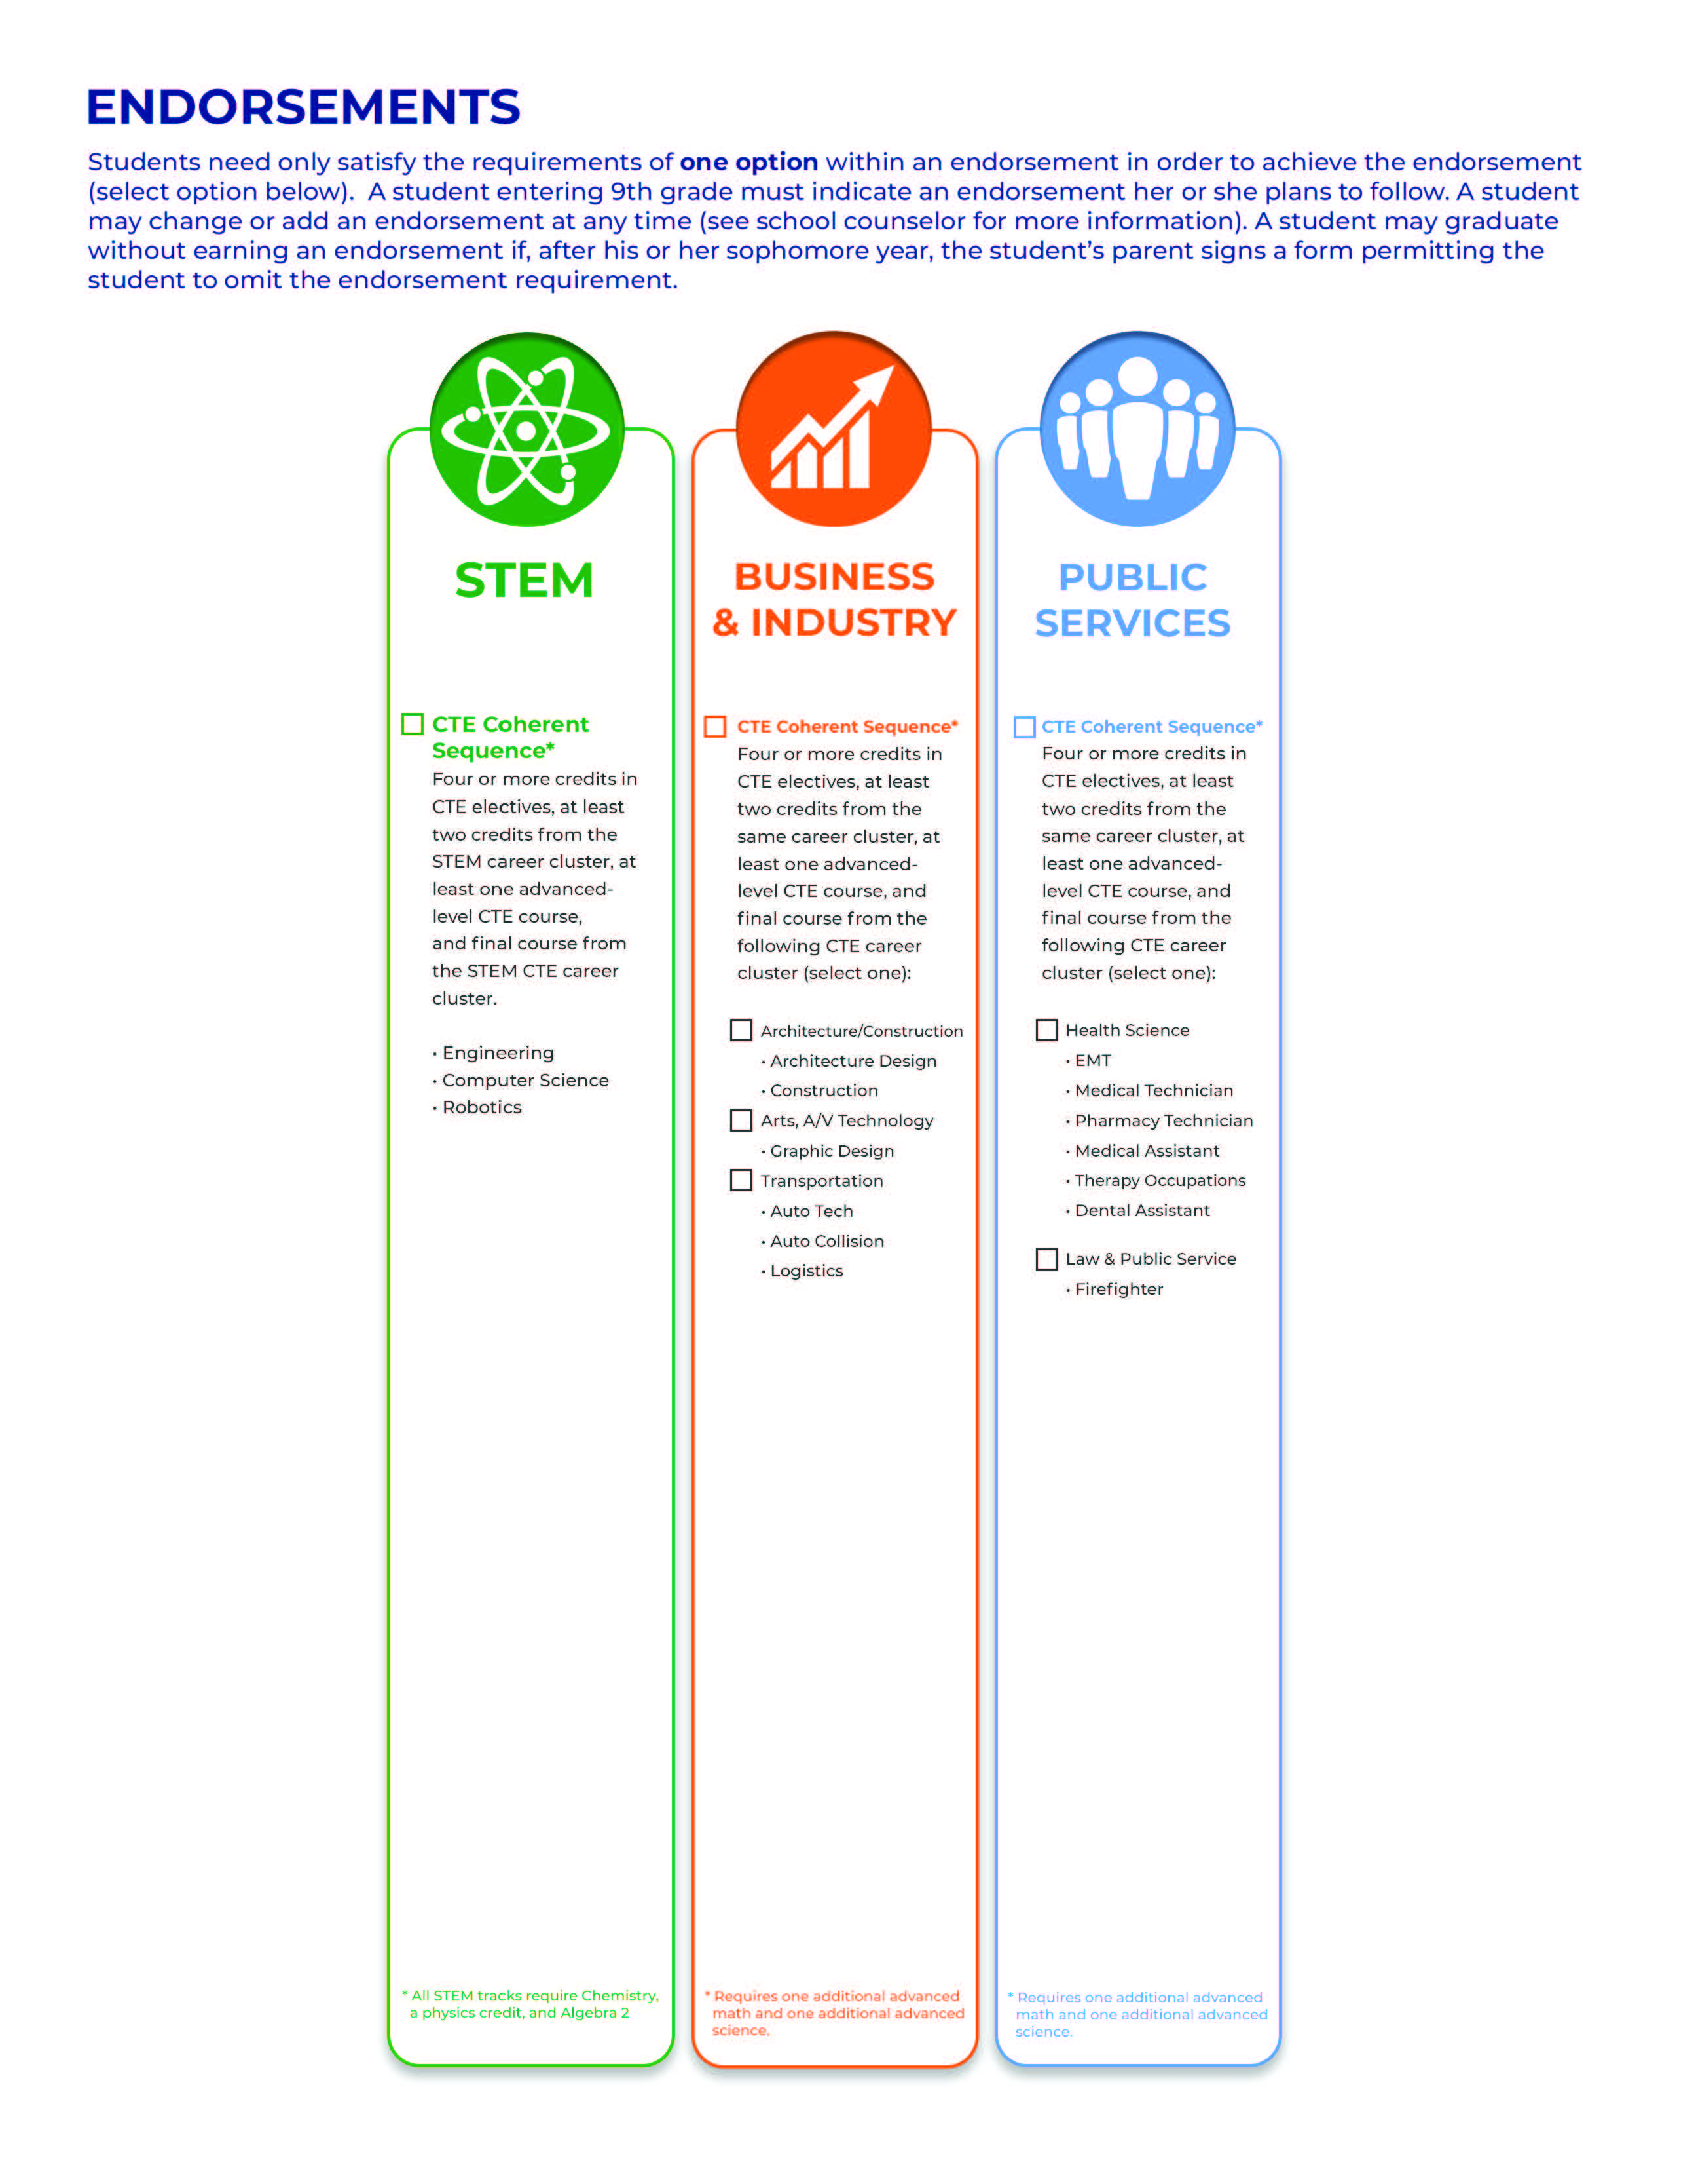

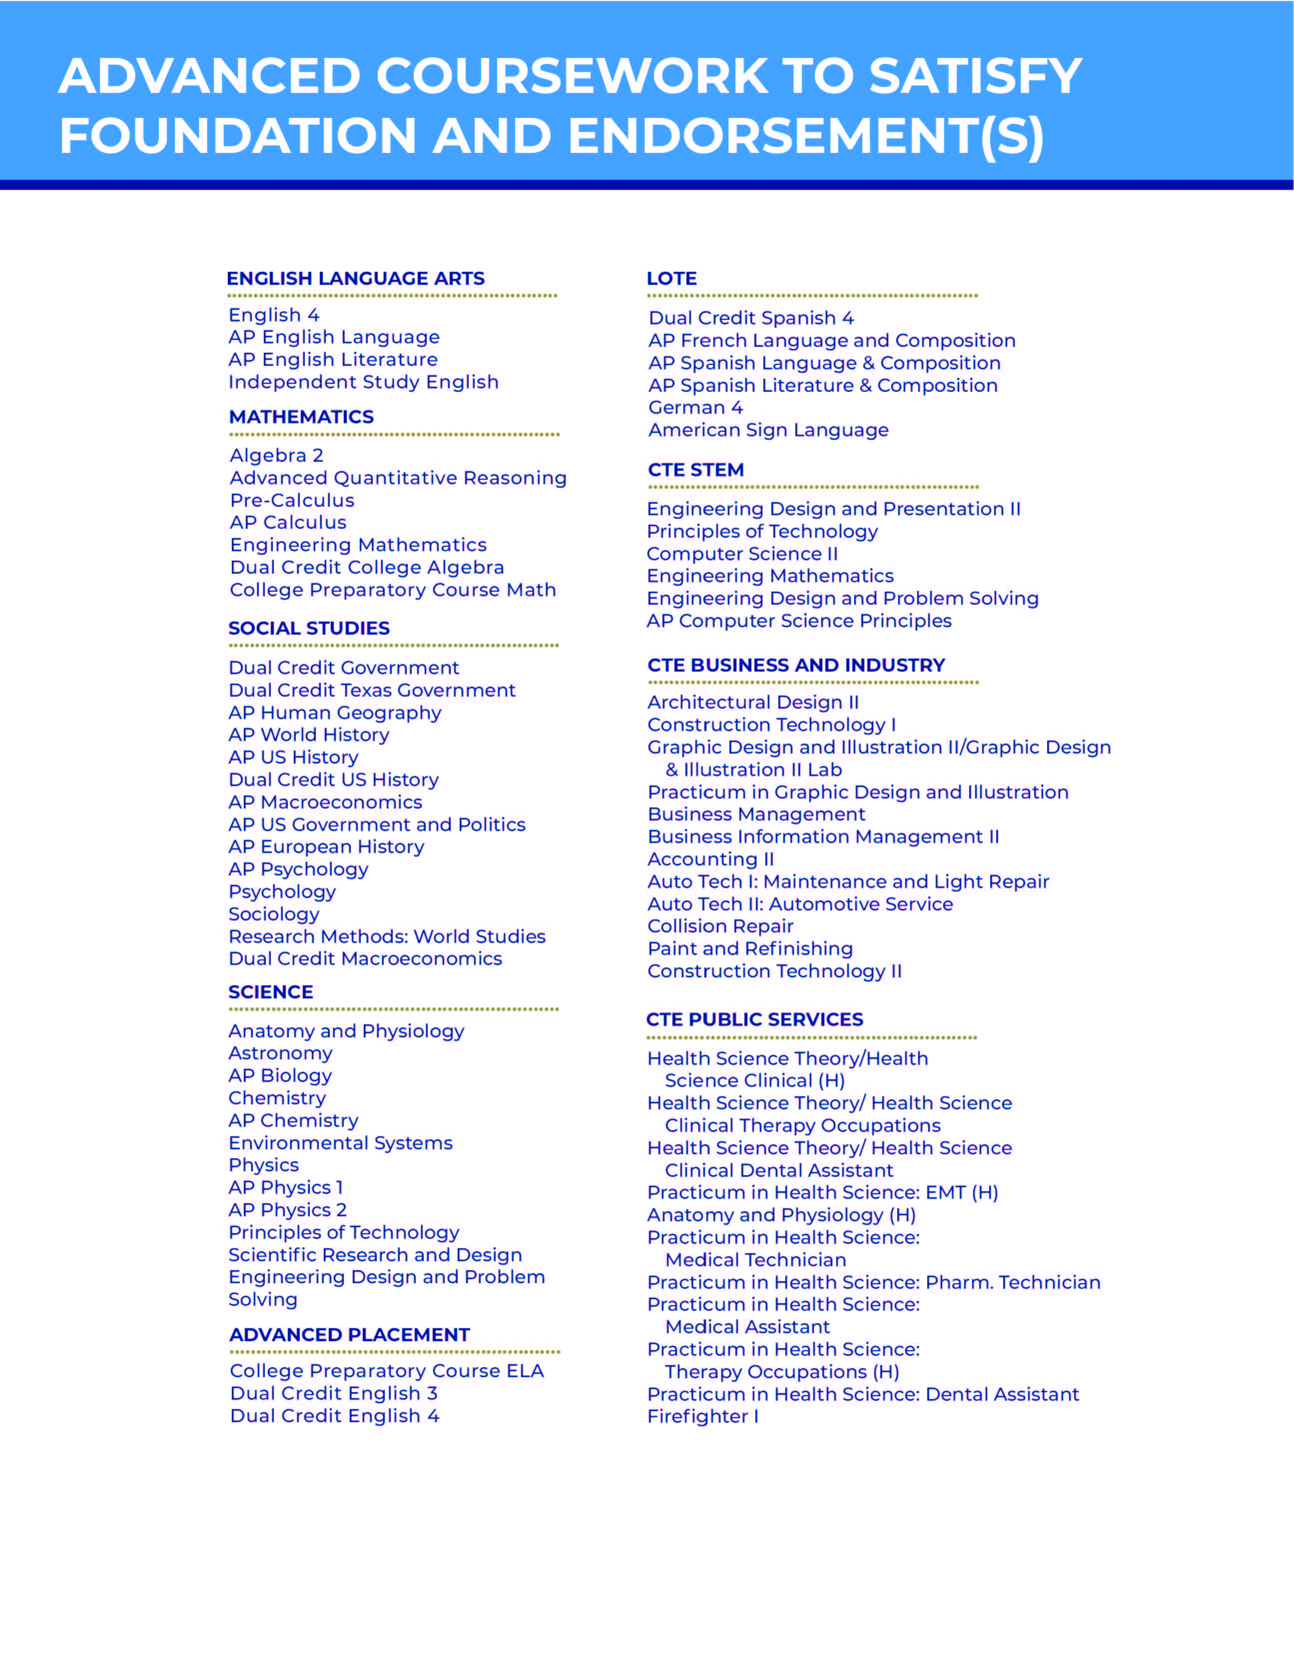
Mesquite Independent School District
High School Courses
2021-2022

ENGLISH | Grade Level | Unit Credit | Page #
English 1 | 9 | 1 | 25
English 1 Advanced (H) | 9 | 1
English 1 G/T (H) | 9 | 1
English 2 | 10 | 1
English 2 Advanced (H) | 9-10 | 1
English 3 G/T (H) | 10-11 | 1
SPEECH |  |  | 26
Professional Communication | 9-12 | 0.5
LANGUAGES OTHER THAN ENGLISH |  |  | 27
Spanish 1 | 9-11 | 1
Spanish for Spanish Speakers 1 | 9-11 | 1
Spanish 2 | 9-12 | 1
Spanish for Spanish Speakers 2 | 9-12 | 1
MATHEMATICS |  |  | 28
Assessment Preparation Mathematics | 9-12 | 0.5
Math Lab – Algebra 1 | 9 | 1
Algebra 1 | 9 | 1
Algebra 1 Advanced (H) | 9 | 1
Geometry | 9-10 | 1
Geometry Advanced (H) | 9-10 | 1
Geometry G/T (H) | 9-10 | 1
Algebra 2 | 10-12 | 1
Algebra 2 Advanced (H) | 10-11 | 1
Algebra 2 G/T (H) | 10-11 | 1
SCIENCE |  |  | 30
Biology | 9-10 | 1
Biology Advanced (H) | 9-10 | 1
Biology G/T (H) | 9-10 | 1
Chemistry | 10-12 | 1
Chemistry Advanced (H) | 10-12 | 1
Chemistry G/T (H) | 10-12 | 1
Chemistry OnRamps (H) | 10-12 | 1
SOCIAL STUDIES |  |  | 32
Human Geography AP G/T (H) | 9 | 1
Human Geography AP (H) | 9-12 | 1
World History Studies | 10-11 | 1
World History Studies Advanced (H) | 10 | 1
Ethnic Studies: African American Studies | 10-12 | 1
Ethnic Studies: Mexican American Studies | 10-12 | 1
HEALTH AND PHYSICAL EDUCATION |  |  | 34
Health | 9-12 | 0.5
Adventure/Outdoor Education | 9-12 | 0.5
Individual Sports | 9-12 | 0.5
FINE ARTS |  |  | 36
Art 1: Basic Design | 9-12 | 1
Drawing 2 | 9-12 | 1
Art Appreciation | 9-12 | 1
CAREER AND TECHNICAL EDUCATION |  |  | 37
School of Technology |  |  | 39
Fundamentals of Computer Science | 9-10 | 1
Computer Science I | 9-12 | 1
Computer Science 2 (H) | 10-12 | 1
Computer Science Principles AP | 9-12 | 1
Principles of Arts, A/V Technology & Communications | 9-10 | 1
Graphic Design & Illustration I | 10-12 | 1
Graphic Design & Illustration II  Graphic Design & Illustration II Lab | 11-12 | 2
Practicum in Graphic Design & Illustration | 12 | 2
School of Engineering |  |  | 41
Automotive Basics | 9 | 1
Automotive Technology I: Maintenance and Light Repair | 11-12 | 2
Automotive Technology II: Automotive Services | 12 | 2
Collision Repair | 11-12 | 2
Paint and Refinishing | 12 | 2
Principles of Applied Engineering | 9-10 | 1
Engineering Design and Presentation I | 10-12 | 1
Engineering Design and Presentation II | 11-12 | 2
Engineering Mathematics | 12 | 1
Engineering Design and Problem Solving | 12 | 1
Robotics I | 10 | 1
Principles of Distribution and Logistics | 9-10 | 1
Management of Transportation Systems | 10-11 | 1
School of Construction Science |  |  | 44
Principles of Architecture | 9-10 | 1
Architectural Design I | 10-12 | 1
Architectural Design II | 11-12 | 2
Principles of Construction | 9-10 | 1
Construction Technology | 9-10 | 1
Construction Technology I | 10-12 | 2
Construction Technology II | 11-12 | 2
School of Health Science |  |  | 45
Principles of Health Science | 9-10 | 1
Medical Terminology | 9-12 | 1
Principles of Law, Public Safety, Correction, and Security Services | 9-10 | 1
Disaster Response | 10 | 1
Firefighter I | 10 | 2
Health Science Theory | 10-11 | 1
Health Science Theory/Health Science Clinical (H) | 11-12 | 2
Health Science Theory/Health Science Clinical Therapy Occupations (H) | 11-12 | 2
Health Science Theory/Health Science Clinical Dental (H) | 11-12 | 2
Practicum in Health Science – EMT (H) | 12 | 2
Practicum in Health Science – Pharmacy Technician (H) | 12 | 2
Practicum in Health Science – Medical Technician (H) | 12 | 2
Practicum in Health Science – Medical Assisting (H) | 12 | 2
Practicum in Health Science – Therapy Occupations (H) | 12 | 2
Practicum in Health Science – Dental Assisting (H) | 12 | 2
Anatomy and Physiology (H) | 11-12 | 1
Business and Finance Courses |  |  | 48
Business Information Management I | 9-12 | 1
Business Information Management II | 10-12 | 1
Principles of Business, Marketing, and Finance | 9-11 | 1
Entrepreneurship | 10-12 | 1
Money Matters | 9-12 | 1
Accounting I | 10-12 | 1
Business Law | 11-12 | 1
Business Management | 11-12 | 1
Dollars and Sense | 9-12 | 0.5
MISCELLANEOUS |  |  | 50
Army JROTC 1,2,3,4 | 9-12 | 1
Army JROTC 4(H) | 12 | 1
College Prep | 11-12 | 0.5 (local credit)
Credit by Examination for Acceleration | 9-12 | Credit determined by state and local guidelines
Student Leadership 1 | 10-12 | 1
Student Leadership 2 | 11-12 | 1 (local credit)
Assessment Prep/Review | 9-12 | 0.5 (local credit)

STATE ASSESSMENT |  |  | 52

This publication lists the courses that high schools in Mesquite generally make available to students. It should be noted, however, that not all of the courses listed are scheduled every year. Since it is not economically feasible to schedule classes in which only a few students enroll, it may be necessary to schedule such classes on an alternate-year basis or to eliminate them. Suﬃcient numbers of student requests for specific courses then become the determining factor as to whether or not a course is scheduled.
Honors courses are applicable as such only during the regular school year. Grade points are not awarded for any summer school courses nor for courses taken outside the regular school day.

English Language Arts
ENGLISH 1 9
Prerequisite – 8th grade English
One Credit; Full year
The English 1 course is a cumulative and sequential program to increase and refine communication skills. Throughout the year a balance is maintained in reading, writing, listening/speaking, and viewing/representing skills. English students read extensively in multiple genres from classic and contemporary literature and informational text to learn the literary forms and terms associated with selections being read. High school students will use the writing process to complete a variety of written compositions on a regular basis.

ENGLISH 1 ADVANCED (H) 9
Prerequisite – 8th grade English
One Credit; Full year
Designed for highly motivated students, this course serves as a continuation of the advanced program developed in the elementary and middle schools. As in English 1, a balance is maintained in reading, literature, composition, grammar, mechanics, and usage. However, the students are given the opportunity to begin their study of language and composition skills at their own advanced level and to develop them to a much greater degree. The writing of a documented research paper is included in this year's work. In literature, the students are encouraged to develop their skills in perception and analysis through a more advanced program involving in-depth analyses, individual study projects, and themes. Emphasis is also placed on the reading, study, and analysis of classical literature in preparation for success in advanced placement classes.
Course will prepare students for the rigor of future Advanced Placement, Dual Credit, and OnRamps classes.

ENGLISH 1 G/T (H) 9
Prerequisite –Admission to the Gifted Program
One Credit; Full year
The humanities-focused course provides appropriately diﬀerentiated learning experiences and an advanced curriculum with emphasis on critical thinking, creative synthesis, and written/oral communication. The class serves as a forum in which the study of literature is a springboard to examine, analyze, explore, argue, evaluate, and to formulate new insights and perspectives. Students will develop an understanding of the interrelationships of various disciplines, how these interrelationships have influenced past and present societies, and how these can influence the future. Through independent and guided research, independent study, cooperative learning, and seminars, the student will ultimately acquire intellectual independence as well as a knowledge of literature and expression.

ENGLISH 2 10
Prerequisite – English 1
One Credit; Full year
The English 2 course is a cumulative and sequential program to increase and refine communication skills. Throughout the year a balance is maintained in reading, writing, listening/speaking, and viewing/representing skills. High school students read in multiple genres from world literature (classic, contemporary and informational texts). Students learn and interpret literary forms and terms associated with selections being read. Students will use the writing process to complete a variety of written compositions on a regular basis.

ENGLISH 3 G/T (H) 10-11
Prerequisite – Admission to the Gifted Program
One Credit; Full year
The humanities-focused course provides appropriately diﬀerentiated learning experiences and an advanced curriculum with emphasis on critical thinking, creative synthesis, and written/oral communication. G/T English 3 represents the third year of a multi-age, cross-grade course oﬀered in a revolving three-year curriculum cycle. The class serves as a forum in which the study of literature is a springboard to examine, analyze, explore, argue, evaluate, and to formulate new insights and perspectives. Students will develop an understanding of the interrelationships of various disciplines, how these interrelationships have influenced past and present societies, and how these can influence the future. Through independent and guided research, independent study, cooperative learning, and seminars, the student will ultimately acquire intellectual independence as well as a knowledge of literature and expression.
Course will prepare students for the rigor of future Advanced Placement, Dual Credit, and OnRamps classes.

Speech

PROFESSIONAL COMMUNICATIONS 9–12
Prerequisite – None
Half credit; Semester
Professional Communications blends written, oral, and graphic communication in a career based environment. Careers in the global economy require individuals to be creative with a strong background in technology, academics and communication. Within this context, students will be expected to develop and expand the ability to write, read, edit, speak and listen. The students will also learn how to apply software applications, manipulate computer graphics, and conduct Internet research.

Languages Other Than English

Students planning to graduate with a Performance Acknowledgement which requires three years of the same foreign language must consider the possibility of the third year course not being available on every campus.

SPANISH 1 9-11
Prerequisite – None
One Credit; Year
The student uses the four fundamental communicative skills of listening, speaking, reading, and writing with emphasis on listening and speaking. Students read and write material containing vocabulary and grammar that is comprehended aurally and reproduced orally. The student studies the way of life, the history, and the customs of Spanish-speaking peoples. With a focus on oral proficiency, extended time is devoted to listening and responding.

SPANISH FOR SPANISH SPEAKERS 1 9-11
Prerequisite – Home Language is Spanish
One Credit; Year
The class is designed to meet the needs of those students who are able to communicate orally in Spanish. Geared for the first-year Spanish student who speaks Spanish at home, this course will focus on improving grammar, reading, and writing skills in Spanish. Please note that this course is conducted solely in Spanish.

SPANISH 2 9-12
Prerequisite – Spanish 1
One Credit; Year
The student continues the development of the four fundamental communicative skills to improve proficiency. Reading comprehension ability as well as cultural understanding is emphasized; however, the focus on oral proficiency is maintained. Laboratory work is continued as in Spanish 1 but is more intensive. Opportunities for media interaction are included.

SPANISH FOR SPANISH SPEAKERS 2 9-12
Prerequisite – Spanish for Spanish Speakers 1
One Credit; Year
Building on the skills taught in the Spanish for Spanish Speakers 1, this course introduces students to more complex language structures and reinforces the writing skills in Spanish. Students also have the opportunity to read and discuss literary texts from the world's Spanish-speaking cultures. Please note that this course is conducted solely in Spanish.

Mathematics
ALGEBRA 1 9
Prerequisite – 8th grade Math
One Credit; Year
Algebra 1 provides the foundation concepts for high school mathematics. It includes the study of foundations for functions, linear functions, and quadratic and other nonlinear functions. The course emphasizes basic algebraic reasoning processes, applications, and problem-solving in real world situations.

ALGEBRA 1 ADVANCED (H) 9
Prerequisite – 8th grade math & academically prepared
One Credit; Year
Advanced Algebra 1 will emphasize problem solving using underlying mathematical processes. Students will use critical thinking, language and communication, research, and high level application skills to make connections within and outside mathematics. Students will expand their knowledge of mathematical theory in regard to algebraic thinking, functional relationships, quadratic and nonlinear functions, and reasoning processes.
Course will prepare students for the rigor of future Advanced Placement, Dual Credit, and OnRamps classes.

GEOMETRY 9–10
Prerequisite – Algebra 1 or may concurrently enroll with Algebra 1 upon attempting full year of Algebra 1
One Credit; Year
Geometry includes the study of spatial reasoning; geometric figures and their properties; the relationship between geometry, other mathematics, and other disciplines; tools for geometric thinking; and underlying mathematical processes such as problem solving, reasoning, multiple representations, applications and modeling, and justification and proof.

GEOMETRY ADVANCED (H) 9–10
Prerequisite – Algebra 1 and academically prepared
One Credit; Year
Students will study the Geometry TEKS in greater depth with additional emphasis on logic, geometric proofs and algebra applications. Advanced Geometry focuses on application through research-based projects, number theory, and mathematical language. Emphasis will be placed on using higher level thinking skills.
Course will prepare students for the rigor of future Advanced Placement, Dual Credit, and OnRamps classes.

GEOMETRY G/T (H) 9 –10
Prerequisite – Algebra 1 and admission to mathematics segment of the gifted program
One Credit; Year
G/T Geometry is designed for mathematically talented students who are intellectually curious and are independent thinkers. It includes an in-depth study of traditional geometric concepts such as the nature of deductive reasoning and geometry of the real world. Logic and proofs, history of geometry, and architectural geometry will be emphasized. Various non-Euclidean geometries will also be investigated.
Course will prepare students for the rigor of future Advanced Placement, Dual Credit, and OnRamps classes.

ALGEBRA 2 10-12
Prerequisite – Algebra 1
One Credit; Year
Algebra 2 continues the study of functions. It includes quadratic and square root functions, rational functions, exponential and logarithmic functions. As in Algebra 1, the relationship between algebra and geometry, problem-solving, applications, and real world situations is emphasized.

ALGEBRA 2 ADVANCED (H) 10–11
Prerequisite – Algebra 1 & academically prepared
One Credit; Year
Students will study the Algebra 2 TEKS with additional emphasis on special functions, operations with radicals, exponential and logarithmic equations, and matrices. Also, topics relating to trigonometry and probability and statistics will be addressed. Advanced Algebra 2 focuses on application and emphasizes higher level thinking skills geared toward Calculus.
Course will prepare students for the rigor of future Advanced Placement, Dual Credit, and OnRamps classes.
ALGEBRA 2 G/T (H) 10–11
Prerequisite – Algebra 1 & Admission into the mathematics segment of the Gifted Program
One Credit; Year
G/T Algebra 2 is designed for mathematically talented students who are intellectually curious and are independent thinkers. It includes an in-depth study of traditional Algebra 2 concepts such as polynomials, rational expressions, matrices, conics, systems of equations and inequalities, linear and quadratic functions, exponential and logarithmic functions, higher degree polynomial functions, sequences and series. Various number systems and their properties will be investigated as students expand their studies into abstract algebra.
Course will prepare students for the rigor of future Advanced Placement, Dual Credit, and OnRamps classes.

Science
BIOLOGY 9–10
Prerequisite – None
One Credit; Year
Biology includes the study of a variety of topics that include: structures and functions of cells and viruses; growth and development of organisms; cells, tissues, and organs; nucleic acids and genetics; biological evolution; taxonomy; metabolism and energy transfers in living organisms; living systems; homeostasis; ecosystems; and plants and the environment.
Students will discover that the living world is made up of systems. All systems have basic properties that can be described in terms of space, time, energy, and matter. Change and constancy occur in systems and can be observed and measured as patterns. Models of objects and events are tools for understanding the natural world and can show how systems work. They have limitations and based on new discoveries are constantly being modified to more closely reflect the natural world.

BIOLOGY ADVANCED (H) 9–10
Prerequisite – Academically Prepared
One Credit; Year
Advanced Biology is an accelerated academic class that covers the same objectives as Biology in more depth and complexity. Students will be expected to complete more self-directed independent projects than in regular Biology class. Students will be expected to participate in the school Science Fair.
Course will prepare students for the rigor of future Advanced Placement, Dual Credit, and OnRamps classes.

BIOLOGY G/T (H) 9–10
Prerequisite – Admission to the Gifted Program
One Credit; Year
The G/T Biology course is designed to provide an appropriately diﬀerentiated learning experience for gifted students. It provides an advanced curriculum with emphasis on critical thinking, creative synthesis, research design, and student initiated investigative procedures. The class serves as a springboard to formulate, examine, analyze, explore, argue, and evaluate new insights and perspectives. Themes are selected to provoke thoughtful exploration of issues, themes, generalizations, independent study and research, writing, presentation (both oral and written, group and individual), critical thinking, and creative production. Students will be expected to participate in the school Science Fair.
Course will prepare students for the rigor of future Advanced Placement, Dual Credit, and OnRamps classes.

CHEMISTRY 10–12
Prerequisite – Algebra 1
One Credit; Year
In Chemistry, students conduct field and laboratory investigations, use scientific methods during investigations, and make informed decisions using critical thinking and scientific problem solving. Students study a variety of topics that include: characteristics of matter; energy transformations during physical and chemical changes; atomic structure; periodic table of elements; behavior of gases; bonding; nuclear fusion and nuclear fission; oxidation-reduction reactions; chemical equations; solutes; properties of solutions; acids and bases; and chemical reactions. Students will investigate how chemistry is an integral part of our daily lives.

CHEMISTRY ADVANCED (H) 10–12
Prerequisite – Biology & Algebra 1; Academically Prepared
One Credit; Year
Advanced Chemistry is an accelerated academic class that covers the core content of Chemistry in more depth and complexity. Students will be expected to complete more self-directed independent projects than in a regular Chemistry class. Students will be expected to participate in the school Science Fair.
Course will prepare students for the rigor of future Advanced Placement, Dual Credit, and OnRamps classes.

CHEMISTRY G/T (H) 10–12
Prerequisite – Biology & Algebra 1; Admission to the Gifted Program
One Credit; Year
The G/T Chemistry course is designed to provide an appropriately diﬀerentiated learning experience for gifted students. It will oﬀer extensive laboratory experiences involving chemical changes in matter. It will also have an emphasis on critical thinking, creative synthesis, research design, and student initiated investigative procedures. G/T Chemistry centers around integrated, thematic units of study. The class serves as a springboard to formulate, examine, analyze, explore, argue, and evaluate new insights and perspectives. Themes are selected to provoke thoughtful exploration of issues, themes, generalizations, independent study and research, writing, presentation (both oral and written, group and individual), critical thinking, and creative production. Students will be expected to participate in the school Science Fair.
Course will prepare students for the rigor of future Advanced Placement, Dual Credit, and OnRamps classes.

CHEMISTRY ONRAMPS (H) 10–12
Prerequisite Algebra 1
One Credit; Year
The Principles of Chemistry I course addresses the nature of matter, energy, chemical reactions, and chemical thermodynamics. The course reviews descriptive chemistry of matter in the natural world as well as compositional and reaction stoichiometry of chemical compounds. Throughout the course, students learn to think like scientists by exploring the underlying theoretical foundations of chemistry, making intuitive arguments for how the world works, and supporting those arguments with quantitative measures. Built with an intention to engage students from a variety of backgrounds, students in the course will learn how to successfully study science by organizing their learning around mastery and ownership of materials. Introduction to Chemical Practices I—the course’s lab component—provides an introduction to the techniques of modern experimental chemistry and is designed to instill basic laboratory and analytical skills. An OnRamps course works through a dual-enrollment model. Using a hybrid delivery approach, students meet rigorous university-level college readiness standards and have the opportunity to earn UT Austin credit from a UT faculty member and high school credit from their local teacher. Credit from the University of Texas at Austin is earned through the University Extension (UEX) within the Texas Extended Campus. OnRamps courses do not require admission to the university but are aligned with courses taught to UT Austin’s residential students. A TSI qualifying score is not necessary for these courses.
Students taking OnRamps courses will receive two separate grades, one for the college grade and one for the high school grade.

Social Studies
HUMAN GEOGRAPHY ADVANCED PLACEMENT G/T (H) 9
Prerequisite – Admission to the Gifted Program
One Credit; Year
The purpose of the Advanced Placement Human Geography course is to introduce students to the systematic study of patterns and processes that have shaped human understanding, use, and alteration of Earth's surface. Students employ spatial concepts and landscape analysis to examine human social organization and its environmental consequences. Students also learn about the methods and tools geographers use in their science and practice. Combined with TEKS for World Geography, this one year course satisfies the state requirement while preparing students for the AP Human Geography exam.
Upon completion of the Advanced Placement Human Geography course, students are expected to take the Advanced Placement Human Geography test.

HUMAN GEOGRAPHY ADVANCED PLACEMENT (H) 9–12
Prerequisite – Admission to the Gifted Program or Academically Prepared
One Credit; Year
The purpose of the Advanced Placement Human Geography course is to introduce students to the systematic study of patterns and processes that have shaped human understanding, use, and alteration of Earth's surface. Students employ spatial concepts and landscape analysis to examine human social organization and its environmental consequences. Students also learn about the methods and tools geographers use in their science and practice. Combined with TEKS for World Geography, this one year course satisfies the state requirement while preparing students for the AP Human Geography exam. A student is not eligible for this course if he/she has received credit for World Geography or Pre-AP World Geography.
Upon completion of the Advanced Placement Human Geography course, students are expected to take the Advanced Placement Human Geography test.

WORLD HISTORY STUDIES 9–10
Prerequisite – None
One Credit; Year
The World History Studies course provides the student with an understanding of the changing world in which he/she lives through an examination of world cultures, their problems and achievements from earliest recorded times. The course covers periods of ancient and medieval history to the development of American civilization and the world today.

WORLD HISTORY STUDIES ADVANCED (H) 9–10
Prerequisite – Academically Prepared
One Credit; Year
This course provides students the opportunity to pursue an accelerated study in world history. The course is designed for students to engage in active, high-level learning to develop skills and concepts needed to succeed at more rigorous academic levels. As students pursue studies throughout the world's historical eras, they will be asked to build significant cause and eﬀect links to explain the world, as they know it. Though the basic content is the same as the regular course, the level of understanding and the opportunities for development are enhanced by the depth and pace of the study.
Course will prepare students for the rigor of future Advanced Placement, Dual Credit, and OnRamps classes.

UNITED STATES HISTORY – STUDIES SINCE RECONSTRUCTION 10–12
Prerequisite – None
One Credit; Year
Content for the study of United States History includes significant individuals, issues, and events after the period of Reconstruction to the present. The course continues the focus from Grade 8 on the history, geography, and political and economic growth of the nation.
Students study the emergence of the United States as a world power. They learn how geography influences historical developments, analyze economic development and growth, understand the nation’s social and cultural developments, and study the political development of the United States from Reconstruction to the present.

UNITED STATES HISTORY ADVANCED PLACEMENT (H) 11–12
Prerequisite – Admission to Gifted or Academically Prepared
One Credit; Year
The Advanced Placement Program in U.S. History is designed to provide students with the analytic skills and factual knowledge necessary to think critically about events in U.S. History. The program prepares students for intermediate and advanced college courses by making demands upon them equivalent to those made by full-year introductory college courses. Students should learn to analyze historical documents their relevance to a given interpretive problem, their reliability, and their importance—and to weigh the evidence and interpretations presented in historical scholarship. The Advanced Placement U.S. History course will help students develop the skills necessary to arrive at conclusions on the basis of an informed judgment and to present reasons and evidence clearly and persuasively in essay format.
AP U.S. History will involve a great deal of reading and independent work. This will include the reading of a comprehensive textbook, a supplementary collection of interpretative articles and/ or primary sources, and one or more book-length studies of a particular era or event. Students will also be involved in analysis/problem solving type activities.
Upon completion of the Advanced Placement U.S. History course, students are expected to take the Advanced Placement U.S. History test. Advanced Placement U. S. History satisfies the one unit credit graduation requirement for U. S. History Studies Since Reconstruction.
ETHNIC STUDIES: AFRICAN AMERICAN STUDIES 10-12
Prerequisite – None
One credit; Year
African American Studies is a conceptually driven course that introduces students the exploration of the rich and diverse history and culture of African Americans. The goal of this course is to broaden the knowledge and understanding of students interested in learning about history, citizenship, culture, economics, science, technology, geography, and the political realities of African Americans. These strands should not be taught in isolation but woven together in an integrated study that helps students understand the world in which we live. This course should provide students with an opportunity to engage with the social, economic, and political activities of African Americans in a way that allows them to make deep connections across the content. The historical content of this course should be taught with relevance to contemporary and current issues in order to ensure a deeper understanding for students.
ETHNIC STUDIES: MEXICAN AMERICAN STUDIES 10-12
Prerequisite – None
One credit; Year
In Ethnic Studies: Mexican American Studies, an elective course, students learn about the history and cultural contributions of Mexican Americans. Students explore history and culture from an interdisciplinary perspective. The course emphasizes events in the 20th and 21st centuries, but students will also engage with events prior to the 20th century.

Physical Education
HEALTH EDUCATION
The local requirement for high school graduation is successful completion of one-half (1/2) credit of health. Either Principles of Health Science or Health Science Theory/Health Science Clinical may substitute for the health requirement (pages 45-46).

HEALTH 9–12
Prerequisite – None
Half credit; Semester
Health is a comprehensive course that leads students to a better understanding about the issues surrounding personal health. This course will include issues concerning personal wellness, mental health, nutrition, interpersonal relationships, the rights and responsibilities of parenting, CPR instruction, and the detrimental eﬀects of substance abuse. This course will also examine the individual and societal cost of sexually transmitted diseases. The goal of this class is to give students suﬃcient information to make good health choices that promote a long and healthy life.

PHYSICAL EDUCATION
Graduation Requirements for students entering ninth grade
Students are required to successfully complete a minimum of 1.0 unit of credit with a maximum of 4 state credits for physical education. Credit can be earned by taking any combination of the following (.5) credit courses; however, credit may not be earned for any physical education course more than once.
- Adventure/Outdoor Education
- Individual Sports
Up to 1 unit of state physical education credit may be earned through participation in JROTC.

ADVENTURE/OUTDOOR EDUCATION 9–12
Prerequisite – None
Half credit; Semester
Adventure/Outdoor Education is designed for students to develop competency in outdoor education activities that provide opportunities for enjoyment and challenge. Emphasis is placed upon student selection of activities that also promote a respect for the environment and that can be enjoyed for a lifetime. Activities may include, but are not limited to: archery, backpacking, boating (canoeing, kayaking, rowing), camping, dutch oven cooking, hiking, wall climbing, ropes course, orienteering, survival skills, water safety instruction, and water sports (fishing, etc.)
Student expectations include:
- demonstration of consistency in execution of the basic skills of adventure/outdoor education activities,
- demonstration of understanding of the rules, skills, and strategies of outdoor education activities and appropriate application,
- analyze and compare health and fitness benefits derived from participation in adventure/ outdoor education activities,
- establish realistic yet challenging health-related fitness goals for adventure/outdoor activities,
- explain and follow safety procedures during adventure/outdoor education activities, and
- list and describe safety equipment used in outdoor activities.
- demonstration of the ability to perform a level of competency in aerobic activities,
- understand and apply safety practices associated with aerobic activities and
- development of positive personal and social skills to work independently and with others in aerobic activities.

INDIVIDUAL SPORTS 9–12
Prerequisite – None
Half credit; Semester
Individual Sports is designed to provide students with the opportunity to develop health-related fitness and an appreciation of a variety of lifetime activities related to developing and maintaining an appropriate level of personal fitness. Students should exhibit a level of competency in two or more sports that may include: archery, badminton, bowling, gymnastics, golf, handball, racquetball, self-defense, tennis, table tennis, track and field, weight training or wrestling. Student expectations include:
- understanding of basic components such as strategies, protocol, and rules of individual sports,
- application of movement concepts and principles to the learning and development of motor skills,
- understanding and application of safety practices associated with individual sports,
- development of positive personal and social skills to work independently and with others in individual sports, and
- exhibits a physically active lifestyle that provides opportunities for enjoyment and challenge through individual sports.

Fine Arts
Electives
A materials fee or additional supplies may be required for the course.

ART 1: BASIC DESIGN 9–12
Prerequisite – None
One credit; Year
This is a foundation course designed to acquaint students with basic design elements, drawing and painting skills, compositional design, various techniques and media, art history, and aesthetics (appreciation of surroundings). Art 1 students use direct observation, imagination and personal experiences as inspiration for artworks. For planning original works, students record visual ideas about their environment and experiences and express these ideas using a variety of media both two and three dimensional media. Learners use concise vocabulary to compare and contrast the use of art elements and design principles in personal works and the works of others.

DRAWING 2 9–12
Prerequisite – Art 1: Basic Design and Teacher Recommendation
One credit; Year
Students will develop and refine drawing skills in contour, gesture, mass cross hatching, stipple, and directional and implied line. Compositional study will include experiences in abstract, nonobjective, and realistic renderings. Students will work in various mediums, such as pencil (both graphite and color), pen and ink, charcoal, and pastels, and will develop an understanding of art history.

ART APPRECIATION 9-12
Prerequisite – None
One credit; Year
Art Appreciation will introduce students to the visual arts and the variety of art mediums and techniques used to create works of art. Students will also study the history of art beginning with the Stone Age to the present. The purpose of this course is to build a context for understanding the arts; structurally, socially, culturally and historically with the intention of making art meaningful to the students’ everyday lives. Students will explore and analyze influential works of art as a way to gain an understanding of the arts as a method of communication and expression. While reflecting upon and assessing the characteristics and quality of art, students will develop, explore and express their personal aesthetics through art projects, presentations, class discussions, writing assignments, and a gallery visit.
This course is not a prerequisite for any advanced art courses.

Career and Technical Education
In association with the CTE State Plan, Mesquite ISD recognizes that there is an immediate need to strengthen not only the current workforce, but also the workforce of tomorrow. Academic concepts must be reinforced and applied through high quality, rigorous technical education. Students are encouraged to seek post secondary educational opportunities. MISD CTE programs seek to close the gaps by preparing students for postsecondary education and the workforce.

Achieve Texas Career Clusters

Achieve Texas is a state initiative to implement the U. S. Department of Education’s 16 career clusters. Career pathways within each cluster will help students plan their educational experience by combining rigorous academics and relevant career education. Mesquite ISD offers classes in 14 of the 16 clusters listed below.

Limited Enrollment Courses*

Mesquite Independent School District oﬀers a number of pre-employment labs. These two
hour labs are designed to provide students with employability skills and are listed below.

- Automotive Technology I & II
- Collision Repair
- Paint and Refinishing
- Engineering Design & Problem Solving and Engineering Mathematics
- Health Science Theory/Health Science Clinical
- Practicum in Health Science

*If more students seek enrollment in a specific program than seats are available, a matrix is used to rank all students on the same criteria. The criteria could include grade level, academic grades, citizenship grades, discipline referrals, attendance, etc.

Nondiscrimination Policy

Equal access to Career and Technical programs and activities is assured students in the Mesquite Independent School District without regard to race, religion, color, sex, national origin, and/or handicapping condition.

SCHOOL OF TECHNOLOGY
FUNDAMENTALS OF COMPUTER SCIENCE 9-10
Prerequisite – None
One credit; Year
Students will foster their creativity and innovation through opportunities to design, implement, and present solutions to real-world problems. Students will collaborate and use computer science concepts to access, analyze, and evaluate information needed to solve problems. Students will learn the problem-solving and reasoning skills that are the foundation of computer science. Students will gain an understanding of the principles of computer science through the study of technology operations and concepts. The six strands include creativity and innovation; communication and collaboration; research and information fluency; critical thinking; problem solving, and decision making; digital citizenship; and technology operations and concepts.

COMPUTER SCIENCE 1 9–12
Prerequisite – Algebra 1
One credit; Year
Computer Science serves both as introductory work for potential computer science majors and as important background experience for students considering study in other fields which significantly involve computing. The primary programming language is Java. The curriculum for this course has four strands: foundations, information acquisition, work in solving problems, and communication. This course does count for the technology education credit requirement.

COMPUTER SCIENCE 2 (H) 10-12
Prerequisite – Computer Science 1
One credit; Year
Computer Science 2 emphasizes advanced computer programming concepts in Java. Computer structure, design, numeration systems, alphanumeric codes, and programming procedures are included. Projects will incorporate the use of the computer for topics in algebra, coordinate geometry, probability and statistics, advanced mathematics, and other content areas. This course does count for the technology education credit requirement.

COMPUTER SCIENCE PRINCIPLES ADVANCED PLACEMENT 9–12
Prerequisite – None
One credit; Year
The AP Computer Science Principles course is designed to be equivalent to a first-semester introductory college computing course. In this course, students will develop computational thinking skills vital for success across all \disciplines, such as using computational tools to analyze and study data and working with large data sets to analyze, visualize, and draw conclusions from trends. The course is unique in its focus on fostering student creativity. Students are encouraged to apply creative processes when developing computational artifacts and to think creatively while using computer software and other technology to explore questions that interest them. They will also develop eﬀective communication and collaboration skills, working individually and collaboratively to solve problems, and discussing and writing about the importance of these problems and the impacts to their community, society, and the world. Students taking this course will take the AP Exam aligned with course content to earn college credits. This course does count for the technology education credit requirement.

PRINCIPLES OF ARTS, AUDIO/VIDEO TECHNOLOGY AND COMMUNICATIONS 9–10
Prerequisite – None
One credit; Year
The goal of this course is for the to student understand arts, audio/video technology, and communications systems. Within this context, students will be expected to develop an understanding of the various and multifaceted career opportunities in this cluster and the knowledge, skills, and educational requirements for those opportunities. This course will focus on base knowledge in designing, producing, exhibiting, performing, writing, and publishing multimedia content including visual and performing arts and design, journalism, and entertainment services. This course does count for the technology education credit requirement.

GRAPHIC DESIGN AND ILLUSTRATION I 10–12
Prerequisite – Principles of Arts, Audio/Video Technology and Communications
One credit; Year
Careers in graphic design and illustration span all aspects of the advertising and visual communications industries. Students will be expected to develop an understanding of the industry with a focus on fundamental elements and principles of visual art and design. This course does count for the technology education credit requirement.

GRAPHIC DESIGN AND ILLUSTRATION II 11–12
GRAPHIC DESIGN AND ILLUSTRATION II LAB
Prerequisite – Graphic Design and Illustration I
Two credits – Blocked for 2 consecutive class periods; Year
This course continues the exploration of careers in graphic design and illustration and spans all aspects of the advertising and visual communications industries. Students will be expected to develop an advanced understanding of the industry with a focus on mastery of content knowledge and skills. This course does count for the technology education credit requirement.

PRACTICUM IN GRAPHIC DESIGN AND ILLUSTRATION 12
Prerequisite – Graphic Design and Illustration II/Lab
Two credits; Year
In addition to developing technical knowledge and skills needed for success in the Arts, Audio/Video Technology, and Communications Career Cluster, students will be expected to develop a technical understanding of the industry with a focus on skill proficiency. Instruction may be delivered through lab-based classroom experiences. Practicum in Graphic Design allows students the opportunity to further explore the graphic industry and the variety of careers available.

SCHOOL OF ENGINEERING
AUTOMOTIVE BASICS 9
Prerequisite – None
One credit; Year
Automotive Basics includes instruction on the basic automotive systems, the theory and principles of the components that make up each system and how to service these systems. Automotive Basics includes applicable safety and environmental rules and regulations. In Automotive Basics, students will gain knowledge and skills in the repair, maintenance, and service of vehicle systems. This study allows students to reinforce, apply, and transfer academic knowledge and skills to a variety of interesting and relevant activities, problems, and settings.
The focus of this course is to teach safety, tool identification, proper tool use, and employability.

AUTOMOTIVE TECHNOLOGY I: MAINTENANCE AND LIGHT REPAIR 10–11
Prerequisite – Introduction to Transportation Technology
Two credits – Blocked for 2 consecutive class periods; Year
In Automotive Technology I: Maintenance and Light Repair, students will gain knowledge and skills in the repair, maintenance, and diagnosis of vehicle systems. This study will allow students to reinforce, apply, and transfer academic knowledge and skills to a variety of interesting and relevant activities, problems, and settings. The focus of this course is to teach safety, tool identification, proper tool use, and employability. Students will have the opportunity to earn ASE entry-level certifications.
Students are expected to purchase an automotive lab shirt at an estimated cost of $25.
***This course is eligible for dual credit through DCCCD for students who meet college entrance requirements.

AUTOMOTIVE TECHNOLOGY II: AUTOMOTIVE SERVICE 11-12
Prerequisite – Automotive Technology I: Maintenance & Light Repair
Two credits – Blocked for 2 consecutive class periods; Year
In Automotive Technology II: Automotive Service, students will gain advanced knowledge of the major automotive systems, the principles of diagnosing and servicing these systems, and applicable safety and environmental rules and regulations. This study will allow students to reinforce, apply, and transfer academic knowledge and skills to a variety of interesting and relevant activities, problems, and settings. The focus of this course is to teach safety, tool identification, proper tool use, and employability. Students will have the opportunity to earn ASE entry-level certifications.

COLLISION REPAIR 10-11
Prerequisite – Introduction to Transportation Technology
Two credits – Blocked for 2 consecutive class periods; Year
Collision Repair includes knowledge of the processes, technologies, and materials used in the reconstruction of vehicles. This course is designed to teach the concepts and theory of systems related to automotive collision repair and refinishing. The focus of this course is to teach safety, tool identification, proper tool use, and employability.
Students are expected to purchase an automotive lab shirt at an estimated cost of $25. Students will have the opportunity to earn ASE entry-level certifications.

PAINT AND REFINISHING 11-12
Prerequisite – Collision Repair
Two credits – Blocked for 2 consecutive class periods; Year
Paint and Refinishing includes advanced knowledge of the processes, technologies, and materials used in the reconstruction of vehicles. This course is designed to teach the concepts and theory of systems related to automotive paint and refinishing. This study will allow students to reinforce, apply, and transfer academic knowledge and skills to a variety of interesting and relevant activities, problems, and settings. The focus of this course is to teach safety, tool identification, proper tool use, and employability. Students will have the opportunity to earn ASE entry-level certifications.

**This course is eligible for dual credit through DCCCD for students who meet college entrance requirements.

PRINCIPLES OF APPLIED ENGINEERING 9–10
Prerequisite – None
One credit; Year
This course provides an overview of the various fields of science, technology, engineering, and mathematics and their interrelationships. Students will use a variety of computer hardware and software applications to complete assignments and projects. Students will work on a design team to develop a product or system. This course does count for the technology education credit requirement.

ENGINEERING DESIGN AND PRESENTATION I 10–12
Prerequisite – Algebra 1 and Principles of Applied Engineering
One credit; Year
Students enrolled in this course will demonstrate knowledge and skills of the process of design as it applies to engineering fields using multiple software applications and tools necessary to produce and present working drawings, solid model renderings, and prototypes. Students will use computer hardware and the Autodesk Design Academy software applications to complete assignments and projects. Through implementation of the design process, students will transfer advanced academic skills to component designs. Additionally, students explore career opportunities in engineering, technology, and drafting and what is required to gain and maintain employment in these areas. This course does count for the technology education credit requirement.

ENGINEERING DESIGN AND PRESENTATION II 11–12
Prerequisite – Engineering Design and Presentation I, and Geometry
Two credits – Blocked for 2 consecutive class periods; Year
This course will provide students the opportunity to master computer software applications in a variety of engineering and technical fields. This course further develops the process of engineering thought and application of the design process. This course does count for the technology education credit requirement.

ENGINEERING MATHEMATICS 12
Prerequisite – Geometry, Algebra 2, Chemistry & Physics or Principles of Technology
One credit – Blocked for 2 consecutive class periods with Engineering Design and Problem Solving; Year
Engineering Mathematics is a course where students solve and model robotic design problems. Students use a variety of mathematical methods and models to represent and analyze problems involving data acquisition, spatial applications, electrical measurement, manufacturing processes, materials engineering, mechanical drives, pneumatics, process control systems, quality control, and robotics with computer programming. This class meets the requirements for the fourth math credit. Students registering for this class need to have met the satisfactory performance level on EOC tests.

ENGINEERING DESIGN AND PROBLEM SOLVING 12
Prerequisite – Geometry, Algebra 2, Chemistry & Physics or Principles of Technology
One credit – Blocked for 2 consecutive class periods with Engineering Mathematics; Year
This course promotes interest in understanding of career opportunities in engineering, intending to promote ingenuity, intellectual talents, and practical skills in devising solutions to engineering design problems. Students use the engineering design process cycle to investigate, design, plan, create, and evaluate solutions. This class meets the requirements for the fourth science credit. Students registering for this class need to have met the satisfactory performance level on EOC tests.

ROBOTICS I 10
Prerequisite: Principles of Applied Engineering
One credit; Year
In Robotics I, students will transfer academic skills to component designs in a project- based environment through implementation of the design process. Students will build prototypes or use simulation software to test their designs. Additionally, students will explore career opportunities, employer expectations, and educational needs in the robotic and automation industry.

PRINCIPLES OF DISTRIBUTION AND LOGISTICS 9-10
Prerequisite – None
One credit; Year
In Principles of Distribution and Logistics, students will gain knowledge and skills in the safe application, design, production, and assessment of products, services, and systems. This knowledge includes the history, laws and regulations, and common practices used in the logistics of warehousing and transportation systems. Students should apply knowledge and skills in the application, design, and production of technology as it relates to distribution and logistics industries. This course allows students to reinforce, apply, and transfer their academic knowledge and skills to a variety of interesting and relevant activities, problems, and settings.

MANAGEMENT OF TRANSPORTATION SYSTEMS 10-11
Prerequisites - Principles of Distribution & Logistics
One credit; Year
In Management of Transportation Systems, students will gain knowledge and skills in material handling and distribution and proper application, design, and production of technology as it relates to the transportation industries. This course includes the safe operation of tractor-trailers, forklifts, and related heavy equipment. This course will allow students to reinforce, apply, and transfer their academic knowledge and skills to management of transportation systems and associated careers.

SCHOOL OF CONSTRUCTION SCIENCE
PRINCIPLES OF ARCHITECTURE 9–10
Prerequisite – None
One credit; Year
Principles of Architecture provides an overview to the various fields of architecture, interior design, and construction management. Students use self-knowledge, education, and career information to set and achieve realistic career and educational goals. Classroom studies include topics such as safety, work ethics, communication, information technology applications, systems, health, environment, leadership, teamwork, ethical and legal responsibility, employability, and career development and include skills such as problem solving, critical thinking, and reading technical drawings. This course does count for the technology education credit requirement.

ARCHITECTURAL DESIGN I 10–12
Prerequisites - Algebra 1, English 1, and Principles of Architecture
One credit; Year
Students gain knowledge and skills specific to those needed to enter a career in architecture and construction or prepare a foundation toward a postsecondary degree in architecture, construction science, drafting, interior design, and landscape architecture. Architectural Design includes the knowledge of the design, design history, techniques, and tools related to the production of drawings, renderings, and scaled models for commercial or residential architectural purposes. This course does count for the technology education credit requirement.

ARCHITECTURAL DESIGN II 11–12
Prerequisites – Architectural I and Geometry
Two credits – Blocked for 2 consecutive class periods; Year
Students gain advanced knowledge and skills specific to those needed to enter a career in architecture and construction or prepare a foundation toward a postsecondary degree in architecture, construction science, drafting, interior design, and landscape architecture. This course includes the advanced knowledge of the design, design history, techniques, and tools related to the production of drawings, renderings, and scaled models for commercial or residential architectural purposes. This course does count for the technology education credit requirement.

PRINCIPLES OF CONSTRUCTION 9–10
Prerequisite – None
One credit; Year
This course is intended to provide an introduction and lay a solid foundation for those students entering the construction or craft skilled areas. The course provides a strong knowledge of construction safety, construction mathematics, and common hand and power tools.

CONSTRUCTION TECHNOLOGY I 10–12
Prerequisite – Principles of Construction
Two credits – Blocked for 2 consecutive class periods; Year
Students gain knowledge and skills related to various careers in the construction trade or prepare for a postsecondary degree in construction management, architecture, or engineering. Students acquire knowledge and skills in safety, measuring, hand tools/power tools, and assembling.
A material fee may be required for this course.

CONSTRUCTION TECHNOLOGY II 11-12
Prerequisites - Construction Technology I
Two credits – Blocked for 2 consecutive class periods; Year
In Construction Technology II, students will gain advanced knowledge and skills needed to enter the workforce as carpenters, building maintenance technicians, or supervisors or to prepare for a postsecondary degree in construction management, architecture or engineering. Students will build on the knowledge base from Construction Technology I and are introduced to exterior and interior finish out skills.

SCHOOL OF HEALTH SCIENCE
PRINCIPLES OF HEALTH SCIENCE 9–10
Prerequisite – None
One credit; Year
This course provides an overview of the therapeutic, diagnostic, health informatics, support services, and biotechnology research and development systems of the health care industry. This course may be substituted for the required .5 credit of health education.

MEDICAL TERMINOLOGY 9–12
Prerequisite – None
One credit; Year
This course is designed to introduce students to the structure of medical terms, including prefixes, suﬃxes, word roots, combining forms, and singular and plural forms, plus medical abbreviations and acronyms. The course allows students to achieve comprehension of medical vocabulary appropriate to medical procedures, human anatomy and physiology, and pathophysiology.
This course is eligible for dual credit through DCCCD for students who meet college entrance requirements.

PRINCIPLES OF LAW, PUBLIC SAFETY, CORRECTION, AND SECURITY SERVICES 9-10
Prerequisite – None
One credit; Year
This course introduces students to professions in law enforcement, protective services, corrections, firefighting, and emergency management services. Students will examine the roles and responsibilities of police, courts, corrections, private security, and protective agencies of fire and emergency services. The course provides students with an overview of the skills necessary for careers in law enforcement, fire service, protective services, and corrections.

DISASTER RESPONSE 10
Prerequisites - None, but required corequisite with Firefighter I
One credit; Year
Disaster Response includes basic training of students in disaster survival and rescue skills that would improve the ability of citizens to survive until responders or other assistance could arrive. Students will receive education, training, and volunteer service to make communities safer, stronger, and better prepared to respond to the threats of terrorism, crime, public health issues and disasters of all kinds.

FIREFIGHTER I 10
Prerequisite - None, but required corequisite is Disaster Response
Two credits – Blocked for 2 consecutive class periods; Year
Firefighter I introduces students to firefighter safety and development. Students will analyze the Texas Commission on Fire Protection rules and regulations, proper incident reporting and records, proper use of personal protective equipment, and the principles of fire safety.

HEALTH SCIENCE THEORY 10-11
Prerequisites - Biology, Principles of Health Science
One credit; Year
The Health Science Theory course is designed to provide for the development of advanced knowledge and skills related to a wide variety of health careers. Students will employ hands-on experiences for continued knowledge and skill development.

HEALTH SCIENCE THEORY/HEALTH SCIENCE CLINICAL (H) 11–12
Prerequisite – Biology, Principles of Health Science
Two credits – Blocked for 2 consecutive class periods; Year
This course is designed to provide for the development of advanced knowledge and skills related to a wide variety of health careers. Students will have hands-on experiences for continued knowledge and skill development. The course is taught in a clinical rotation setting in which students are in a hospital or clinic environment. Instruction is provided for students to develop a basic medical knowledge applicable to the medical field. Instruction includes medical terminology, medical ethics and legal responsibilities, communication skills, and basic medical skills. Professionalism and leadership skills are developed. This course may be substituted for the required .5 credit of health education.
At the end of the school year, students will take the Patient Care Technician (CPCT/A) certification exam.
**Students are required to purchase their hospital attire, personal liability insurance, TB skin test and influenza vaccine, complete a CPR course, and to comply with all requirements of the health care facilities.

HEALTH SCIENCE THEORY/HEALTH SCIENCE CLINICAL-THERAPY OCCUPATIONS (H) 11-12
Prerequisites - Biology, Principles of Health Science
Two credits – Blocked for 2 consecutive class periods; Year
Therapy Occupations is designed for students interested in fields such as physical therapy, medicine, fitness, exercise physiology, kinesiology, nutrition, and athletic injury related fields. This class includes both classroom work as well as hands-on application in order to provide students with an avenue to explore these fields. Through these connections, students will understand the importance that exercise, nutrition, treatment modalities, and rehabilitation play in athletic health. Students will study basic anatomy and the psychological impact of athletic injuries along with assessment and treatment techniques as they apply to athletic injuries. Students are required to purchase their clinical attire, personal liability insurance, TB skin test and influenza vaccine, complete a CPR course, and to comply with all requirements of the health care facilities. Students will begin preparations for the NASM Certified Personal Trainer certification exam.

HEALTH SCIENCE THEORY/HEALTH SCIENCE CLINICAL-DENTAL (H) 11-12
Prerequisites - Biology, Principles of Health Science
Two credits – Blocked for 2 consecutive class periods; Year
This course is designed to provide for the development of advanced knowledge and skills related to careers in Dentistry. Students will have hands-on experiences for continued knowledge and skill development. Students will be able to discuss the history of dentistry; identify dental related career pathways; explain dental legal and ethical responsibilities; recognize professional healthcare behavior and demeanor; and perform basic routine dental office procedures. The purpose of this course is to establish the foundation for future coursework in dental science and prepare secondary students for a future career in dentistry. Professionalism and leadership skills are developed. Students are required to purchase their dental attire, personal liability insurance, TB skin test and influenza vaccine, complete a CPR course, and to comply with all requirements of the health care facilities.

PRACTICUM IN HEALTH SCIENCE EMT (H) 12
Prerequisite – Health Science Theory/Health Science Clinical
Two credits – Blocked for 2 consecutive class periods; Year
This course extends the learning of Health Science Theory/Health Science Clinical by providing extensive training for Emergency Medical Technician (EMT) certification and training to administer electrocardiograms.
Students must be 18 years of age and meet program requirements in order to take the National Registry EMT certification exam.
**Students are required to purchase their hospital attire, personal liability insurance, TB skin test and influenza vaccine, complete a CPR course, and to comply with all requirements of the health care facilities.
This class is taught at HHS and MHS for students from all high school campuses.
This course is eligible for dual credit through DCCCD for students who meet college entrance requirements.

PRACTICUM IN HEALTH SCIENCE PHARMACY TECHNICIAN (H) 12
Prerequisite – Health Science Theory/Health Science Clinical
Two credits – Blocked for 2 consecutive class periods; Year
The course content will emphasize medical terminology specifically to the pharmacy, reading and interpreting prescriptions, dispensing medication and defining prescription and non-prescription drugs by brand versus generic name.
- Students must meet the requirements for obtaining their Registered Technician Trainee Permit. At the end of the school year, students will take the Pharmacy Technician (ExCPT) Certification examination.
- Students are required to purchase their clinical site attire, personal liability insurance, TB skin test and influenza vaccine, complete a CPR course and to comply with all requirements at the health care facilities.
- This class is taught at PHS for students from all high school campuses. Students are required to have their own transportation to clinical sites.

PRACTICUM IN HEALTH SCIENCE MEDICAL TECHNICIAN (H) 12
Prerequisite – Health Science Theory/Health Science Clinical
Two credits – Blocked for 2 consecutive class periods; Year
The course content will emphasize all aspects of blood collection; terminology; anatomy; physiology; blood collection procedures; specimen hands-on practice; and, clinical training in skills and techniques to perform puncture methods. This course also includes important practice and background information on anatomy and physiology of the heart, medical disease processes, the Holter monitor, electrocardiography and echocardiography. This program prepares students for the Phlebotomy Technician and EKG certification exams.
- This class is taught at WMHS for students from all high school campuses
- **Students are required to purchase a lab coat, personal liability insurance, TB skin test and influenza vaccine, and comply with all requirements of the health care facilities.
- Students will take the Phlebotomy Technician (CPT) certification exam and EKG certification exam during the spring semester.

PRACTICUM IN HEALTH SCIENCE MEDICAL ASSISTING (H) 12
Prerequisite – Health Science Theory/Health Science Clinical
Two credits – Blocked for 2 consecutive class periods; Year
The Practicum in Health Science - Medical Assisting course content includes how to assist physicians with exams, take vital signs, practice aseptic technique, interview patients for medical history, provide documentation, perform clinical procedures, use laboratory techniques, understand medical terminology and understand oﬃce procedures. Students will gain valuable knowledge to prepare them to handle both the clinical duties and administrative responsibilities in a variety of healthcare settings. This program prepares students for the Certified Clinical Medical Assistant exam.
- **Students are required to purchase their clinical attire, personal liability insurance, TB skin test and influenza vaccine, complete a CPR course, and to comply with all requirements of the health care facilities.
- Students will take the certified Clinical Medical Assistant (CCMA) certification exam during the spring semester.

PRACTICUM IN HEALTH SCIENCE THERAPY OCCUPATIONS (H) 12
Prerequisite – Health Science Theory/Health Science Clinical
Two credits – Blocked for 2 consecutive class periods; Year
Therapy Occupations provides students with an in-depth study of physical therapy, medicine, fitness, exercise physiology, kinesiology, nutrition, and athletic injury related fields. It includes information about injury prevention, evaluation, treatment, rehabilitation, emergency injury management and administrative functions. Practicum experiences can occur in a variety of locations appropriate to the nature and level of experience. This program prepares students for the Certified Personal Trainer Certification exam. Students are required to purchase their clinical attire, personal liability insurance, TB skin test and influenza vaccine, complete a CPR course, and to comply with all requirements of the health care facilities. Students will take the NASM Certified Personal Trainer certification exam during the spring semester.

PRACTICUM IN HEALTH SCIENCE DENTAL ASSISTING (H) 12
Prerequisites - Biology, Health Science/Health Science Clinical-Dental
Two credits – Blocked for 2 consecutive class periods; Year
The Practicum in Health Science course is designed to give students practical application of previously studied knowledge and skills. Practicum experiences can occur in a variety of locations appropriate to the nature and level of experience. Students will gain in-depth experience, and the opportunity to apply for training and exams such as Registered Dental Assistant. Class will include Introduction to Dental Assisting Profession, Ethics, Communication Skills, Infection Control and Hazard Management, Clinical Procedures, Clerical Functions, Concepts in Radiological and Digital Imaging, cooperating health care facility or training stations. Students are required to purchase their clinical attire, personal liability insurance, TB skin test and influenza vaccine, complete a CPR course, and to comply with all requirements of the health care facilities. Students will have the opportunity to take the Registered Dental Assistant certification exam in the spring semester.

ANATOMY AND PHYSIOLOGY (H) 11–12
Prerequisites – Biology, Chemistry and completion or concurrent enrollment in either Physics or Principles of Technology
One credit; Year
Students conduct laboratory and field investigations, use scientific methods during investigations, and make informed decisions using critical thinking and scientific problem solving. Students study a variety of topics, including the structure and function of the human body and the interaction of body systems for maintaining homeostasis. This course counts as a fourth science credit.
BUSINESS AND FINANCE COURSES
BUSINESS INFORMATION MANAGEMENT I 9-12
Prerequisite – None
One credit; Year
Students implement personal and interpersonal skills to strengthen individual performance in the workplace and in society and make a successful transition to the workforce and postsecondary education. Students will apply technical skills through word-processing, spreadsheet, database, and electronic presentation software. This course does count for the technology education credit requirement.

BUSINESS INFORMATION MANAGEMENT II 10-12
Prerequisite – Business Information Management I
One credit; Year
Students will apply complex technical skills using word-processing and spreadsheet applications and develop electronic presentations using multimedia software. Students in this course will be given the opportunity to take the Microsoft Oﬃce Specialist (MOS) exams. This course does count for the technology education credit requirement.

PRINCIPLES OF BUSINESS, MARKETING, AND FINANCE 9-11
Prerequisite – None
One credit; Year
Students gain foundational knowledge and skills in economies and private enterprise systems, the impact of global business, marketing of goods and services, advertising, and product pricing. Students analyze the sales process and financial management principles. This course allows students to reinforce, apply, and transfer academic knowledge and skills to a variety of interesting and relevant activities, problems and settings in business, marketing, and finance.

ENTREPRENEURSHIP 10-12
Prerequisite – None
One credit; Year
Students will learn the principles necessary to begin and operate a business. The primary focus of the course is to help students understand the process of analyzing a business opportunity, preparing a business plan, determining feasibility of an idea using research, and developing a plan to organize and promote the business and its products and services.

MONEY MATTERS 9–12
Prerequisite – None
One credit; Year
Students will investigate money management from a personal financial perceptive. Students will apply critical-thinking skills to analyze financial options based on current and projected economic factors. Students will examine various methods of achieving short-term and long-term financial goals through various methods such as investing, tax planning, asset allocating, risk management, retirement planning, and estate planning.

ACCOUNTING I 10–12
Prerequisite – BIM I and Money Matters
One credit; Year
Students investigate the field of accounting, including how it is impacted by industry standards as well as economic, financial, technological, international, social, legal, and ethical factors. Students reflect on this knowledge as they engage in the process of recording, classifying, summarizing, analyzing, and communicating accounting information. Students formulate and interpret financial information for use in management decision making.

BUSINESS LAW 11-12
Prerequisite – None
One credit; Year
Students analyze the evolution and development of laws that govern business in our society. Students apply technical skills to address business applications of contemporary legal issues and analyze the social responsibility of business and industry.

BUSINESS MANAGEMENT 11-12
Prerequisite – Principles of Business, Marketing, and Finance, BIM I, and 1 of the following courses: BIM II or Business Law
One credit; Year
Students develop a foundation in the economical, financial, technological, international, social and ethical aspects of business to become competent managers, employees, and entrepreneurs. Students incorporate a broad range of knowledge that includes legal, managerial, marketing, financial, ethical and international dimensions of business to make appropriate management decisions.

DOLLARS AND SENSE 9–12
Prerequisite – None
Half credit; Semester
Dollars and Sense focuses on the management of individual and family resources such as finances, food, clothing, housing, health care, recreation, transportation and time. This course also addresses the management of financial resources to meet the goals of individuals and families across the life span. Eﬀective consumer skills related to housing needs, responsibilities in relation to environmental trends and issues, and the economic system are also analyzed. This course oﬀers a common sense approach to personal financial literacy.

ARMY JROTC 1,2,3,4 9–12
Miscellaneous Courses
Prerequisite – None
One credit per year; Year
Army JROTC is a leadership course using both theory and practical application to develop leadership. The theory provides the student an opportunity to study the character traits of great leaders and principles of leadership and management. Other emphases include college and career readiness skills with a focus on emerging work force requirements in science, technology, math, computer science, and cybersecurity as well as first aid, charter development, financial and logistical management, citizenship in American history and government, service learning, and communication skills. The practical work emphasizes individual and group, participation in unit inspections, and learning to apply the duties and responsibilities of individuals and leaders. Through the corps of cadets, students learn to take and respond to orders, prepare for higher positions of responsibility, and develop self- discipline, pride, and teamwork. Students may participate in such extracurricular activities as robotics, CyberPatriot, color guard, academic, as well as school and community service projects. The course fosters good citizenship, patriotism, self-motivation, and the benefits of leading a healthy, drug-free lifestyle; and gives the student an understanding of basic non-combat military skills. The student does not incur any military obligation. A student may take this course for one to four years as an elective. One physical education credit can be substituted for JROTC 1. JROTC 2, 3, and 4 is a continuation of JROTC 1, and is designed to place the student in higher positions of responsibility. These courses reinforce all previous training and continue to develop the student’s ability to manage, motivate, and lead others.

ARMY JROTC 4 (H) 12
Prerequisite –
- Successful completion of JROTC 2 or 3 and approval by Senior Army Instructor
- Selection to key leadership position - Cadet Brigade, Battalion or Company Commander; Brigade or Battalion Principal Staﬀ Oﬃcer (XO, S1, S2, S3, S4, S5); Brigade or Battalion Command Sergeant Major; Company Executive Oﬃcer or First Sergeant; or Platoon Leader. Other selected positions as approved by the school principal and registrar in coordination with the Senior Army Instructor
One credit per year; Year
This course is designed for students who want to apply advanced leadership and management skills in a practical environment. The leadership and management theory learned during previous JROTC levels is applied daily in an environment in which the cadet, having been selected for and placed in a key leadership position, is required to lead and manage the cadet organization through the preparation and execution of classroom and field training, logistics management, community and school service projects, and major battalion events such as the Military Ball, the Dining Out (awards banquet), the Brigade Review, the Battalion Review and Change of Command, and annual Formal Inspection. The cadet must prepare plans, prepare and issue written and verbal orders and guidance, supervise execution and organize the required support. The cadet will prepare and present numerous projects ranging from after-action reviews and teaching of classroom lessons to the presentation of the entire cadet battalion's program during the annual Formal Inspection. The cadet will directly participate in the management decisions of the battalion by acting as part of the Oﬃcer Review Board, the Senior NCO Promotion Board, or as a member of the Battalion Command and Staﬀ group. The cadet will accept responsibility for the training and preparation of subordinate cadets. Key leadership positions are defined as Brigade, Battalion or Company Commander; Brigade or Battalion Principal Staﬀ Oﬃcer (XO, S1, S2, S3, S4, S5); Brigade or Battalion Command Sergeant Major; Company Executive Oﬃcer or First Sergeant; or Platoon Leader.

COLLEGE PREP 11-12
Prerequisite – None
Half credit; Semester
This local credit course will better prepare our students to take the SAT I: Reasoning Test which is required for admission to many colleges and universities. It is designed to strengthen the verbal and mathematical reasoning skills of our students who are college bound and to also strengthen their test taking skills on the SAT I: Reasoning Test and the SAT II: Subject Tests.

CREDIT BY EXAM FOR ACCELERATION 9-12
Prerequisite – Parent approval
Determined by the course
A student may earn graduation credit by taking exams over a course in which he/she has not received previous instruction. The acceleration procedures require that a student must score at least 90 on a test that assesses the essential knowledge and skills of the course. Students may take the test one time only.
Interested students should consult with their counselor for additional information and an application form. These tests are oﬀered on designated dates at no cost to the student; however, students who order tests and do not take them will be charged the cost of the test. No grade points are awarded for grades earned through acceleration.

STUDENT LEADERSHIP 10-12
Prerequisite – Teacher approval
One credit; Year
This course provides an opportunity to study, practice, and develop group and individual leadership and organizational skills. These skills include but are not limited to decision-making skills, problem-solving techniques, communication skills, leadership roles, human relation skills, and understanding the need for civic responsibility. It is a hands-on lab oriented approach to leadership in which students will engage in projects and areas such as community service, public relations, health and safety-related activities, team building activities, and projects designed to prepare the student for leadership roles and the world of work beyond graduation.

STUDENT LEADERSHIP 2 11-12
Prerequisite – Student Leadership 1
One credit; Year
This course is a continuation of Student Leadership 1. It is for local credit only.

ASSESSMENT PREP 9-12
Prerequisite – Teacher recommendation
Half credit; Semester
This course is designed to provide additional academic support for students preparing to re-take the state assessment in language arts, math, science or social studies.

STATE ASSESSMENT

This information is current at the time of publication. If the State Board of Education or Texas Education Agency revise requirements parents and students will be notified on the Mesquite ISD website: www.mesquiteisd.org.

GRADUATION PROGRAMS and ASSESSMENT REQUIREMENTS

With the implementation of the STAAR EOC program, assessment requirements for graduation have changed. Students who were freshman for the first timein the 2011-12 school year were the first class to be tested with STAAR EOC exams. The following explains how these new tests will aﬀect your child, and what your child needs to do to successfully pass STAAR. Please take some time to carefully read through this information.
If you still have questions about STAAR further information can be found on the Texas Education Agency website at http://tea.texas.gov. EOC questions and answers from the Texas Education Agency are located at http://tea.texas.gov/Student_Testing_and_Accountability/Testing/State_of_Texas_Assess- ments_of_Academic_Readiness_(STAAR)/STAAR_Released_Test_Questions/. Sample EOC questions can be viewed at https://tea.texas.gov/student.assessment/staar/.

Understanding STAAR EOC Exams
High school students will now take a subject-specific and more diﬃcult and intensive end-of- course (EOC) exam at the end of the each these core classes:

English 1 Algebra 1 Biology English II US History

Students will now be tested throughout their high school career, taking a state competency test
for a particular subject upon completing that class. If a student's schedule currently includes any of the courses listed above, the student will take those EOCs in March (for English) and April or May (for all other EOCs).

Additional Information can be found on the Texas Education Agency Website

The website address for the Student Assessment Division a the Texas Education Agency is https:// tea.texas.gov/student.assessment/. Information regarding the student assessment program, the testing calendar, STAAR, EOC, statewide results, and technical information about the testing program can be found at this site.

