Mesquite Independent School District

SOLICITATION NUMBER: RFP No. 2019-017

SOLICITATION NAME:

Data Network Cabling (2019 E-Rate Funding) for Agnew Middle School, Shaw Elementary School and Mesquite High School

BIDS DUE: Tuesday, March 19, 2019
No Later Than: 10:00AM

SUBMIT BIDS TO: Mesquite Independent School District
Attn: Purchasing Department
3819 Towne Crossing Blvd., Suite 203
Mesquite, Texas 75150

Mesquite Independent School District
Darci Hooten, CPPB, CTSBO, Director of Purchasing 3819 Towne Crossing Blvd., Suite 203, Mesquite, Texas 75150
Phone (972) 882-5542 Fax (972) 882-7740

Instructions to Vendors

Solicitation No.: 2019-017
Due Date: Data Network Cabling (2019 E-Rate Funding) for Agnew Middle School, Shaw Elementary School and Mesquite High School
PROPOSALS SUBMITTED WILL BE PUBLICALLY ACKNOWLEDGED

Bids/Proposals are solicited for furnishing the merchandise, supplies, services and/or equipment set forth in this solicitation. One (1) original and one (1) copy of the SEALED bid must be received in the Purchasing Department, 3819 Towne Crossing Blvd., Suite 203, Mesquite, Texas 75150 before 2:00 pm on the above "due date". All envelopes must be clearly marked "Bid/Proposal Enclosed" and the Solicitation number. Late bids will be returned to the vendor unopened. Delivery of bid envelope to other Departments within the MISD is NOT considered as delivery to the Purchasing Department. Faxed or emailed bids/proposals will not be accepted.

Bids/Offers may be withdrawn at any time prior to the official opening. Alterations made before opening time must be initialed by vendor to guarantee authenticity. After the official opening, bids/offers may not be amended, altered, or withdrawn without the recommendation of the Administrative Officer of Purchasing and the approval of the Mesquite Independent School District Board of Trustees.

All addenda will be issued via the district website at www.mesquiteisd.org/depts/ purchasing. All addenda, if required, will be posted on the aforementioned website at least seven (7) days before bid/proposal opening. It is the vendor’s responsibility to check this website for addenda postings prior to submitting responses. Bidders/Offerors finding errors, requests for additional information, omissions, or corrections that need to be made in the specifications shall contact the MISD Director of Purchasing ten (10) days, or as soon as possible before bid is due. You may submit this information via fax to (972) 882-7740 or via email to: dhooten@mesquiteisd.org

The undersigned agrees, if this bid/proposal is accepted, to furnish any and all items upon which prices are offered, at the price(s) and upon the Terms and Conditions contained in the specifications. The period for acceptance of this bid/proposal will be sixty (60) calendar days unless a different period is inserted by vendor.

The Mesquite Independent School District reserves the right to accept or reject in part or in whole any bids/proposals submitted, and to waive any technicalities, and to award bids/proposals in the best interest of the District.

Mesquite Independent School District

General Terms and Conditions Notice to Responsible Vendors

Items below apply to and become a part of terms and conditions of the bid unless superseded by attached terms and supplemental conditions or specifications in which case attached conditions will prevail.

- It is not the policy of Mesquite Independent School District to purchase on the basis of low bids alone, quality and suitability to purpose being the controlling factors; it being understood that the purchaser reserves the right to arrive at such by whatever means he/she may determine.

- The District reserves the right to reject any and/all bids/proposals and to make awards on the individual items as they may appear to be advantageous to theDistrict and to waive all formalities in submitting bids.

- Vendors finding errors, omissions, or corrections that need to be made in the Specifications shall contact the Director of Purchasing ten (10) days, or as soon as possible before bid is due.

- This Request for Proposals and any resulting award(s) shall be interpreted within the laws of the State of Texas and the Uniform Commercial Code (UCC). In case of discrepancies between the laws of the State of Texas and the UCC, the laws of Texas will prevail. Venue for any legal action filed relative to this RFP or any resulting purchase orders shall be in Dallas County Texas.

- In the event that any one or more of the provisions contained in the Invitation For Bid (or resulting purchase order) shall be held by a court of competent jurisdiction to be invalid, illegal or unenforceable, such provision(s) shall not affect any other provision hereof, and this Invitation For Bid (or any resulting purchase order) shall be construed as if the invalid, illegal or unenforceable provision(s) had never been contained herein.

- To the fullest extent permitted by applicable law, the Vendor and its agents, partners, employees, and consultants (collectively “Indemnitors”) shall and do agree to indemnify, protect, defend with counsel approved by the District, and hold harmless the District and its affiliated enterprises, representatives of the District, and their respective officers, directors, members of the board, partners, employees and agents (collectively “Indemnitees”) from and against all claims, damages, losses, liens, causes of action, suits, judgments and expenses, including attorney fees, of any nature, kind, or description (collectively “Liabilities”) of any person or entity whomsoever arising out of, caused by, or resulting from the performance of services, or provision of goods, by Vendor pursuant to this contract, or any part thereof, or anyone for whose acts it may be liable even if it is caused in part by the negligence or omission of any Idemnitee, so long as it is not caused by the sole negligence or willful misconduct of any Indemnitee.

- Non-Appropriation of Funding: No term Contract or Agreement may exceed a period of one (1) year from the approved contract date without specific authorization of the Mesquite Independent School District. Such contract is a commitment of the District's current revenue only. Should funding for the continuance of this Contract be withdrawn by the Board, the District retains the right to terminate the agreement in accordance with the termination provision stated herein and without pecuniary risk or penalty.

- Whenever an article or material is defined by describing a proprietary product or by using the name of a manufacturer or brand name, the term “or equivalent” if not inserted shall be implied. The specified article or material shall be understood as indicating the type, function, minimum standard of design, efficiency and quality desired. It shall not be construed as to exclude other manufactured products of comparable quality, design and efficiency. Specifications received from vendors that are
different from the original requirements must meet or exceed original bid specifications to be considered equivalent. MISD reserves the right to make the final decisions as to comparable items. An article or material, which is shipped and is not equivalent, shall be returned to the supplier transportation charges collect.

- The term “As Specified” or “A/S” will not be accepted. If bidding on a make or model other than specified, bidder is to list make and model of item being bid and must state any deviations from the item specified. The burden of proof of compliance with this specification will be the responsibility of the vendor. Samples of items which are not as specified must be available to the District within 72 hours after our request.

- Prices proposed should be F.O.B. Destination, Freight Prepaid. Seller to pay freight charges, bear freight charges, own freight in transit, and file claims, if any.

- Bids/Proposals received after the time and date specified will not be considered.

- When bid is not returned, the vendor’s name is removed from the vendor’s list.

- All prices will be guaranteed for sixty (60) days from the date of the bid opening.

- PAYMENT BOND (if required). For facilities construction and some services contracts, a payment bond is required for projects/contracts exceeding $25,000. The payment bond must be for 100% of the value of the work to be performed. The bond shall be prepared on a form acceptable to Mesquite ISD and must identify compliance with the provisions of V.T.C.A., Govt Code, Chapter 2253.021 and state that all liabilities of the bond(s) shall be determined in accordance with the provisions of said code. The Surety must be authorized to do business under a Certificate of Authority issued by the State of Texas and hold certificates of authority as an acceptable Surety on the current Department of the Treasury listing as found in the Federal Register. The Surety shall be a US company located in the USA. If a contract is awarded for under $25,000, but subsequent change orders cause the price to exceed $25,000, a payment bond will be required immediately. If the required payment bond is not submitted with the proposal, a bid bond must be submitted and the required payment bond submitted within ten (10) calendar days from the date the offer is accepted by Mesquite ISD.

- PERFORMANCE BOND (if required). For facilities construction and some service contracts, a performance bond is required for projects/contracts exceeding $100,000. The performance bond must be for 100% of the value of the work to be performed. The bond shall be prepared on a form acceptable to Mesquite ISD and must identify compliance with the provisions of V.T.C.A., Govt Code, and Chapter 2253.021 and state that all liabilities of the bond(s) shall be determined in accordance with the provisions of said code. The Surety must be authorized to do business under a Certificate of Authority issued by the State of Texas and hold certificates of authority as an acceptable Surety on the current Department of the Treasury listing as found in the Federal Register. The Surety shall be a

US company located in the USA. If a contract is awarded for under $100,000, but subsequent change orders cause the price to exceed $100,000, a payment bond will be required immediately. If the required performance bond is not submitted with the offer, a bid bond must be submitted and the required performance bond submitted within ten (10) calendar days from the date the offer is accepted by Mesquite ISD.

- BID BOND (if required). If a performance or payment bond is required, bid/proposal must be accompanied by a cashier’s check on any state or national bank in Texas, or an acceptable bid bond, payable unconditionally to Mesquite ISD. The cashier’s check or bid bond shall be in the amount of not less than five percent (5%) of the total amount of the bid/offer. This security is required by Mesquite ISD as evidence of good faith and as a pledge that, if awarded the contract, the offeror will enter into a contract with Mesquite ISD on the terms stated in the CSP and will furnish the required performance and/or payment bond(s) within ten (10) calendar days after the offer is accepted. Should the offeror refuse to enter into such a contract in accordance with his/her offer, or fail to furnish the required bond(s), the amount of the bid security shall be forfeited to Mesquite ISD as liquidated damages, not as a penalty.

- INSURANCE. The successful offeror, at his/her own expense, shall provide and maintain insurance with fiscally sound firms (at least an AM Best rating of A-) authorized to do business in Texas as follows. Successful offeror may be required to provide a copy of insurance coverage to Mesquite ISD. Insurance certificates may contain a provision, or offeror’s signature on this bid/proposal certifies, that coverage afforded under the policies will not be canceled until at least thirty (30) days prior written notice has been given Mesquite ISD. Insurance must remain in effect for the duration of this contract. In some cases, the district may be required to be named as an additional insured on the vendor’s insurance coverage. If the district is to be named as an additional insured on the vendor’s insurance coverage, the certificate indicating this should be provided within ten (10) calendar days from date of award at the vendor’s expense. If the district requires a certificate of insurance, the bid/proposal number and title should be noted in the “Description of Operations/Locations/Vehicles/Special Items” block of the certificate and the “Certificate Holder” block of the certificate should read, “Mesquite ISD, Attn: Purchasing Department, 3819 Towne Crossing Blvd, Suite 203, Mesquite, TX 75150.” Additional insurance requirements may be required for construction and/or services projects and will be identified elsewhere in this document.

  - Workers’ Compensation: Successful offeror must maintain workers’ compensation coverage for employees as required by all applicable Federal and State laws including Employer’s Liability with a limit of at least $1,000,000. If required, all vendors submitting bids or proposals shall include a copy of his/her current insurance certificate indicating coverages of the following lines of coverage in the following minimum amounts.

  - Comprehensive General Liability: $1,000,000 per occurrence; $3,000,000 General Aggregate.

  - Automobile liability Coverage: $1,000,000 Combined Single Limit. Coverage to include “Owned, Non-Owned, and Hired” automobiles.

  - Worker's Compensation indicating “Statutory Limits”. Employer's Liability, $1,000,000 per accident for bodily injury or disease.

  - The insurance requirements, as listed above also apply to any subcontractor(s) in the event that any work is sublet. The contractor is responsible to insure that the sub- contractor(s) meets the minimum insurance requirement limits.

  - Should any of the above describe policies be canceled before the expiration date, the issuing company will mail thirty (30) days written notice to the certificate holder, Mesquite ISD.

  - The contractor shall agree to waive all right of subrogation against the District, its officials, employees and volunteers for losses arising from work performed by contractor for the District.

  - The contractor shall hold the District harmless from and indemnify it against all liability, including attorney's fees, which may arise from and accrue directly from the performance of the work or any obligation of contractor or failure of contractor to perform any work or obligation provided for in this Agreement.

  - The select bidder/offeror will be required to supply an insurance certificate naming Mesquite Independent School District as an additional insured within 10 calendar days of date of award.

  - You are required to submit a certificate of insurance for the above insurance requirements with your bid. NOTE: Items #40.7, #40.8, and #40.9 shall be required of the successful vendor(s).

- WORKERS’ COMPENSATION COVERAGE. A copy of a certificate of insurance, a certificate of authority to self-insure issued by the Texas Department of Insurance-Division Of Workers’ Compensation Commission, or a coverage agreement (TWCC-81, TWCC-82, TWCC-83, or TWCC-84), showing statutory workers' compensation insurance coverage for the person's or entity's employees providing services on a project is required for the duration of the project. Duration of the project includes the time from the beginning of the work on the project until the project has been completed and accepted by the district.

  - Persons providing services on the project ("subcontractor" in Texas Labor Code 406.096) include all persons or entities performing all or part of the services the contractor has undertaken to perform on the project, regardless of whether that person contracted directly with the contractor and regardless of whether that person has employees. This includes, without limitation, independent contractors, subcontractors, leasing companies, motor carriers, owner-operators, employees of any such entity, or employees of any entity that furnishes persons to provide services on the project. Services include, without limitation, providing, hauling, or delivering equipment or materials, or providing labor, transportation, or other service related to a project. Services do not include activities unrelated 11 to the project, such as food/beverage vendors, office supply deliveries, and delivery of portable toilets.

  - The contractor shall provide coverage, based on proper reporting of classification codes and payroll amounts and filing of any coverage agreements, which meets the statutory requirements of Texas Labor Code 401.011 (44) for all employees of the contractor providing services on the project for the duration of the project.

  - The contractor must provide a certificate of coverage to the district prior to being awarded the contract.

  - If the coverage period shown on the contractor's current certificate of coverage ends during the duration of the project, the contractor must, prior to the end of the coverage period, file a new certificate of coverage with the district showing that coverage has been extended.

  - The contractor shall obtain from each person providing services on a project, and provide to the district: (a) A certificate of coverage, prior to that person beginning work on the project, so the governmental entity will have on file certificates of coverage showing coverage for all persons providing services on the project and; (b) No later than seven days after receipt by the contractor, a new certificate of coverage showing extension of coverage, if the coverage period shown on the current certificate of coverage ends during the duration of the project.

  - The contractor shall retain all required certificates of coverage for the duration of the project and for one year thereafter.

  - The contractor shall notify the district in writing by certified mail or personal delivery, within ten (10) days after the contractor knew or should have known, of any change that materially affects the provision of coverage of any person providing services on the project.

  - The contractor shall post on each project site a notice, in the text, form, and manner prescribed by the Texas Workers' Compensation Commission, informing all persons providing services on the project that they are required to be covered, and stating how a person may verify coverage and report lack of coverage.

  - The contractor shall contractually require each person with whom it contracts to provide services on a project to:

    - Provide coverage, based on proper reporting of classification codes and payroll amounts and filing of any coverage agreements, which meets the statutory requirements of Texas Labor Code 401.011 (44) for all of its employees providing services on the project for the duration of the project;

    - Provide to the contractor, prior to that person beginning work on the project, a certificate of coverage showing that coverage is being provided for all employees of the person providing services on the project for the duration of the project;

    - Provide the contractor, prior to the end of the coverage period, a new certificate of coverage showing extension of coverage, if the coverage period shown on the current certificate of coverage ends during the duration of the project.

    - Obtain from each other person with whom it contracts, and provide to the contractor:

      - A certificate of coverage, prior to the other person beginning work on the project; and

      - A new certificate of coverage showing extension of coverage, prior to the end of the coverage period, if the coverage period shown on the current certificate of coverage ends during the duration of the project;

    - Retain all required certificates of coverage on file for the duration of the project and for one year thereafter;

    - Notify the governmental entity in writing by certified mail or personal delivery, within ten days after the person knew or should have known, of any change that materially affects the provision of coverage of any person providing services on the project; and

    - Contractually required each person with whom it contracts to perform as required by items 1-7, with the certificates of coverage to be provided to the person for whom they are providing services.

  - By signing this contract or providing or causing to be provided a certificate of coverage, the contractor is representing to the district that all employees of the contractor who will provide services on the project will be covered by worker's compensation coverage for the duration of the project, that the coverage will be based on proper reporting of classification codes and payroll amounts, and that all coverage 13 agreements will be filed with the appropriate insurance carrier or, in the case of a self-insured, with the commission's Division of Self-Insurance regulation. Providing false or misleading information may subject the contractor to administrative penalties, criminal penalties, civil penalties, or other civil actions.

  - The contractor's failure to comply with any of these provisions is a breach of contract by the contractor that entitled the governmental entity to declare the contract void if the contractor does not remedy the breach within ten days after receipt of notice of breach from the governmental entity.

- It is understood and agreed that MISD reserves the right to increase or decrease quantities or modify condition and specifications by mutual agreement with the selected supplier, both at the time of acceptance of this bid offer as so modified, and subsequent thereto.

- The District is exempt from Federal Excise Tax, State and Local Tax. Do not include tax in your bid totals. If it is determined that tax was included in the bid, it will not be included in the tabulation or any awards. Tax exemption certificate will be furnished upon request.

- Where applicable, samples must be submitted upon request.

- Cash discounts offered may be considered in determining the successful supplier. Cash discount period shall start from the date of receipt of acceptable invoice or from date of receipt of acceptable material, whichever is the later.

- Vendor hereby affirmatively states that it has not participated in any act of collusion, favoritism, gratuity, or inside dealings with any member of the staff of Mesquite Independent School District or it’s Board of Trustees.

- Mesquite Independent School District will receive all merchandise at the L. A. Berry Support Complex at 2133 N. Beltline Road, Mesquite, Texas 75150, unless otherwise stated on purchase order. Non-palletized freight shall be unloaded inside the Warehouse

or School building. Vendor is responsible for providing material handling equipment when delivering to schools or departments. Vendor must advise freight line as to this requirement.

- Pick up and delivery will be made between the hours of 7:00 A.M. and 2:00 P.M. Monday through Friday excluding school holidays. (Unless arrangements are made otherwise with the Administrative Officer of Purchasing or as otherwise specified on the Bid form.)

- Title and Risk of Loss: The title and risk of loss of the goods shall not pass to Mesquite ISD until Mesquite ISD actually receives and takes possession of the goods at the point or points of delivery. Mesquite ISD will not accept responsibility for processing freight damage claims occurring prior to receipt, including concealed damage of goods.

- Vendor will provide detailed information to the District for each item delivered (model number, serial number, product/equipment description).

- Invoices shall be sent directly to the Mesquite Independent School District, Accounts Payable, 3819 Towne Crossing Blvd, Suite 202, Mesquite, TX 75150. Payments are processed after the Business Office has been notified that the items have been received in good condition and no unauthorized substitutions have been made. Invoices must detail the items delivered and reference the Mesquite Independent School District Purchase Order number.

- Vendors are not to unilaterally apply duplicate payments or overpayments against unrelated open invoices without the District’s explicit authorization.

- Upon notification of potential selections for award, the person or entity submitting this bid must give notice to the district if the person or an owner or operator of the business entity has been convicted of a felony. The notice must include a general description of the conduct resulting in this conviction of a felony. (This requirement does not apply to a publicly held corporation.)

- The district shall have the right to cancel for default all or any part of the undelivered portions of this order if the contractor breaches any of the terms hereof including warranties of the contractor or if the contractor becomes insolvent or commits acts of bankruptcy. Such right of cancellation is in addition to and not in lieu of any other remedies which the District may have in law or equity.

- The performance under this order may be terminated in whole or in part by the District in accordance with this provision. Termination hereunder shall be effected by the delivery to the contractor of a “Notice of Termination”: specifying the extent to which performance of work under the order is terminated and the date upon which termination becomes effective. Such right of termination is in addition to and not in lieu of any other rights which the District may have in law or equity.

- The price to be paid by the District shall be that contained in the contractor’s bid which the contractor warrants to be no higher than seller’s current prices on orders by others for products of the kind and specification covered by this contract for similar quantities under similar or like conditions and methods of purchase. In the event contractor breaches this warranty, the price of the items shall be reduced to the contractor’s current prices on

orders by others, or in the alternative, the District may cancel this contract without liability to contractor for breach or contractor’s actual expense.

- The contractor warrants that no person or selling agency has been employed or retained to solicit or secure this contract upon an agreement or understanding for commission, percentage, brokerage, or contingent fee expecting bona fide employees of bona fide established commercial or selling agencies maintained by the contractor for the purpose securing business. For breach or violation of this warranty the District shall have the right in addition to any other right or rights to cancel this contract without liability and to deduct from the contract price, or otherwise recover the full amount of such commission, percentage, brokerage or contingent fee.

- All contracts and agreements between merchants and Mesquite Independent School District shall strictly adhere to the statutes as set forth in the Uniform Commercial Code as last amended in 1990 by the American Law Institute in the National Conference of Commissioners on Uniform State Laws. Reference: Uniform Commercial Code, 1990 official text.

- Questions in regard to this bid must be submitted to the Administrative Officer of Purchasing for clarification.

- No smoking or use of any tobacco products is permitted on school property.

- Purchase Orders will serve as the award instrument(s) against this Invitation for Bid. Orders will be placed as items are approved for purchase and funds become available.

- The Purchase Order number must be clearly identified on each carton label and/or delivery ticket. Otherwise, the shipment is subject to being refused and returned to the vendor at the vendor’s expense.

- If problems with quality or workmanship arise on items received, the supplying vendor is responsible for replacing any/or all items at no cost to the Mesquite Independent School District. The supplying vendor will also be responsible for returning to the designated campus to pick up the items in question. Mesquite ISD will not be responsible for shipping items back to vendors.

- Successful proposer is to remove all packing and packaging material and debris from school property (school dumpster is not to be used) and to properly dispose of all discarded materials.

- Successful Vendor(s) will be required to submit Material Safety Data Sheets for applicable item(s).

- Force Majeure: If by reason of Force Majeure, either party shall be rendered unable wholly or in part to carry out its obligations under this Agreement then such party shall give notice and full particulars of Force Majeure in writing to the other party within a reasonable time after occurrence of the event or cause relied upon, and the obligation of the party giving such notice, so far as it is affected by such Force Majeure, shall be suspended during the continuance of the inability then claimed, except as hereinafter provided, but for no longer period, and such party shall endeavor to remove or overcome such inability with all reasonable dispatch.

- the term “Force Majeure” as employed herein, shall mean acts of God, strikes, lockouts, or other industrial disturbances, act of public enemy, orders of any kind of government of the United States or the State of Texas or any civil or military authority, insurrections, riots, epidemics, landslides, lightning, earthquake, fires, hurricanes, storms, floods, washouts, droughts, arrests, restraint of government and people, civil disturbances, explosions, breakage or accidents to machinery, pipelines or canals, or other causes not reasonably within the control of the party claiming such inability. It is understood and agreed that the settlement of strikes and lockouts shall be entirely within the discretion of the party having the difficulty, and that the above requirement that any Force Majeure shall be remedied with all reasonable dispatch shall not require the settlement of strikes and lockouts by acceding to the demands of the opposing party or parties when such settlement is unfavorable in the judgment of the party having the difficulty.

- EQUAL OPPORTUNITY A. Equal Employment Opportunity: No Offeror, or Offeror’s agent, shall engage in any discriminatory employment practice. No person shall, on the grounds of race, sex, age, disability, creed, color, genetic testing, or national origin, be refused the benefits of, or be otherwise subjected to discrimination under any activities resulting from this RFP. B. Americans with Disabilities Act (ADA) Compliance: No Offeror, or Offeror’s agent, shall engage in any discriminatory employment practice against individuals with disabilities as defined in the ADA.

- BUY AMERICAN ACT-SUPPLIES (Applicable to certain federally funded requirements) The following federally funded requirements are applicable: A. Definitions. As used in this paragraph – i. "Component" means an article, material, or supply incorporated directly into an end product. ii. "Cost of components" means - (1) For components purchased by the Contractor, the acquisition cost, including transportation costs to the place of incorporation into the end product (whether or not such costs are paid to a domestic firm), and any applicable duty (whether or not a duty-free entry certificate is issued); or (2) For components manufactured by the Contractor, all costs associated with the manufacture of the component, including 15 transportation costs as described in paragraph (1) of this definition, plus allocable overhead costs, but excluding profit. Cost of components does not include any costs associated with the manufacture of the end product. iii. "Domestic end product" means- (1) An unmanufactured end product mined or produced in the United States; or (2) An end product manufactured in the United States, if the cost of its components mined, produced, or manufactured in the United States exceeds 50 percent of the cost of all its components. Components of foreign origin of the same class or kind as those that the agency determines are not mined, produced, or manufactured in sufficient and reasonably available commercial quantities of a satisfactory quality are treated as domestic. Scrap generated, collected, and prepared for processing in the United States is considered domestic. iv. "End product" means those articles, materials, and supplies to be acquired under the contract for public use. v. "Foreign end product" means an end product other than a domestic end product. vi. "United States" means the 50 States, the District of Columbia, and outlying areas. B. The Buy American Act (41
U.S.C. 10a - 10d) provides a preference for domestic end products for supplies acquired
for use in the United States. C. The District does not maintain a list of foreign articles that will be treated as domestic for this Contract; but will consider for approval foreign articles as domestic for this product if the articles are on a list approved by another Governmental Agency. The Offeror shall submit documentation with their Offer demonstrating that the article is on an approved Governmental list. D. The Contractor shall deliver only domestic

end products except to the extent that it specified delivery of foreign end products in the provision of the Solicitation entitled "Buy American Act Certificate".

- RIGHT TO INFORMATION: The Mesquite Independent School District reserves the right to use any and all information presented in any response to this solicitation, whether amended or not, except as prohibited by law. Selection of rejection of the submittal does not affect this right.

- LICENSE FEES OR TAXES: Provided the solicitation requires an awarded contractor or supplier to be licensed by the State of Texas, any and all fees and taxes are the responsibility of the respondent. 50. PREVAILING WAGE RATES: All respondents will be required to comply with Provision 5159a of “Vernon’s Annotated Civil Statutes” of the State of Texas 16 with respect to the payment of prevailing wage rates and prohibiting discrimination in the employment practices. http://www.access.gpo.gov/ davisbacon/tx.html

- COMPLIANCE WITH ALL STATE, FEDERAL, AND LOCAL LAWS: The contractor or supplier shall comply with all State, Federal, and Local laws and requirements. The Respondent must comply with all applicable laws at all times, including, without limitation, the following: (i) §36.02 of the Texas Penal Code, which prohibits bribery; (ii) §36.09 of the Texas Penal Code, which prohibits the offering or conferring of benefits to public servants. The Respondent shall give all notices and comply with all laws and regulations applicable to furnishing and performance of the Contract.

- FEDERAL, STATE, AND LOCAL REQUIREMENTS: Respondent shall demonstrate on- site compliance with the Federal Tax Reform Act of 1986, Section 1706, amending Section 530 of the Revenue Act of of 1978, dealing with issuance of Form W-2's to common law employees. Respondent is responsible for both federal and State unemployment insurance coverage and standard Worker's Compensation insurance coverage. Respondent shall ensure compliance with all federal and State tax laws and withholding requirements. The Mesquite Independent School District shall not be liable to Respondent or its employees for any Unemployment or Workers' Compensation coverage, or federal or State withholding requirements. Contractor shall indemnify the Mesquite Independent School District and shall pay all costs, penalties, or losses resulting from Respondent's omission or breach of this Section.

- DRUG FREE WORKPLACE: The contractor shall comply with the applicable provisions of the Drug-Free Work Place Act of 1988 (Public Law 100-690, Title V, Subtitle D; 41 U.S.C. 701 ET SEQ.) and maintain a drug-free work environment; and the final rule, government- wide requirements for drug-free work place (grants), issued by the Office of Management and Budget and the Department of Defense (32 CFR Part 280, Subpart F) to implement the provisions of the Drug-Free Work Place Act of 1988 is incorporated by reference and the contractor shall comply with the relevant provisions thereof, including any amendments to the final rule that may hereafter be issued.

- RESPONDENT LIABILITY FOR DAMAGE TO GOVERNMENT PROPERTY: The Respondent shall be liable for all damages to government-owned, leased, or occupied property and equipment caused by the Respondent and its employees, agents, subcontractors, and suppliers, including any delivery or cartage company, in connection with any performance pursuant to the Contract. The Respondent shall notify the Mesquite Independent School District Administrative Officer of Purchasing in writing of any such damage within one (1) calendar day

- RIGHT OF SETOFF – Mesquite Independent School District may, at any time without prior written notice, set off funds due and owing under this contract and apply same in payment of any obligation, of any nature, due and owing to Mesquite Independent School District by the Contractor.

- Do you pay taxes in Mesquite ISD?

- Are you current on your property tax obligations owed Mesquite ISD?

- It is not the policy of the Mesquite Independent School District to award contracts based solely on amount bid. *The following criteria shall be used by the Mesquite ISD to evaluate the overall ‘best value’:

- The price for eligible goods; 30%
- The reputation of the vendor and of the vendor’s goods or services; 15%
- The quality of the vendor’s goods or services; 10%
- The extent to which the goods or services meet the district’s needs; 15%
- The vendor’s past relationship with the district; 20%
- The total long-term cost to the district to acquire the vendor’s goods and services; 10%

Bid Response Form Bid

To: Mesquite Independent School District
Darci Hooten, CPPB, CTSBO, Director of Purchasing 3819 Towne Crossing Blvd., Suite 203
Mesquite, Texas 75150

From:
Company Name

Address

City/State/Zip

Area Code & Telephone Number

Fax Number

STATE PRICING FOR:

Mesquite High School
(1,555 Data Drops; 220’ Per Drop; 342,100’ Project Total)

Total Project Cost for Mesquite HS $
Add Data Drop Cost Delete Data Drop Cost

Total Data Drop Count on Proposal

Agnew Middle School
(638 Data Drops; 220’ per Drop; 140,360’ Project Total)

Total Project Cost for Agnew MS
$

Add Data Drop Cost
Delete Data Drop Cost
Total Drop Count on Proposal

Shaw Elementary School
(397 Data Drops; 220’ Per Drop; 87,340’ Project Total)
Total Project Cost for Shaw ES $
Add Data Drop Cost Delete Data Drop Cost

Total Drop Count on Proposal

The undersigned having familiarized themselves with the local conditions affecting the cost of the work, and with the specifications, the drawings, and addenda as prepared by the Mesquite Independent School District, 800 East Kearney Street, Mesquite, Texas, hereby propose, to furnish the proposed services to the Mesquite Independent School District as described herein for the Mesquite Independent School District located in Mesquite, Dallas County, Texas.

The undersigned further agrees to execute a contract within (10) ten days from the date of notification of the acceptance of this bid, or within such time as the Owner may determine, and in case the undersigned fails or neglects to appear to execute the contract within the specified time, of which this bid, the plans, specifications, special provisions and advertisements are a part, the undersigned will be considered as having abandoned it.

The undersigned certifies that this bid is made in good faith without collusion or connection with any other person, persons, partnership, company, firm associate, or corporation offering bids on this work for the following sum of prices:

See attachments

The undersigned hereby declare that they have visited the site(s) (if required) and have carefully examined the plans, specifications and contract documents relating to the work covered by their bid, that they agree to do the work, and that no representations made by the Owner are in any sense a warranty, but are estimates for the guidance of the Contractor.

Upon receipt of Notice of Acceptance of the bid or bids the undersigned will execute the required contract within ten (10) days.

Owner or Legally Authorized Representative Title

Signature Date

VENDOR PROFILE

Company Name
Company Address

Website Address
Telephone Numbers:
To place orders To check on orders FAX
Contacts:

Corporate contact for this bid:
Name Address City, State, Zip Phone Fax Email
Local contact for this bid:
Name Address City, State, Zip Phone Fax Email
Number of years company has been in business under this name

Other company names used with dates, from/to:

Remit to Address (if different than above):
Address
City, State, Zip

CERTIFICATE OF RESIDENCY

Texas Government Code Chapter 2252, Subchapter A. Nonresident Bidders makes it necessary for the Mesquite Independent School District to determine the residency of its offerors. In part, this law reads as follows:

Section 2252.001. DEFINITIONS:
- “Nonresident bidder” refers to a person who is not a resident.
- “Resident bidder” refers to a person whose principal place of business is in this state, including a contractor whose ultimate parent company or majority owner has its principal place of business in this state.

Section 2252.002. AWARD OF CONTRACT TO NONRESIDENT BIDDER:
A governmental entity may not award a governmental contract to a nonresident bidder unless the nonresident underbids the lowest bid submitted by a responsible resident bidder by an amount that is not less than the amount by which a resident bidder would be required to underbid the nonresident bidder to obtain a comparable contract in the state in which the nonresident’s principal place of business is located.

Name of Company

is, under Section 2252.001 (3) and (4), a

Resident Bidder Nonresident Bidder

My principal place of business under Texas Government Gode, Section 2252.001 (3) and (4), is in the City of in the State of .

Signature of Authorized Company Representative

Print Name

Title Date

TO BE SIGNED AND RETURNED

DEVIATION OR COMPLIANCE SECTION

DEVIATIONS: In the event the undersigned Proposer intends to deviate from the general terms, conditions, special conditions or specifications contrary to those listed in the “Terms and Conditions” and other information attached hereto, all such deviations must be listed on this page. Please reference the line number, provide complete and detailed conditions, and any additional information (attach additional pages as necessary).

Vendors must list all specifications for item(s) proposed that differ from any specifications/brands listed in the RFP. MISD will be the sole judge to determine if deviations are acceptable in meeting the needs of MISD and participating members. Reference on this page the line number and deviation.

NO DEVIATIONS: In the absence of any deviations entry on this form, the Proposer assures MISD of their compliance with the Terms, Conditions, Specifications and information contained in this bid.

Are there deviations from the specifications? (circle) Yes No

All Bidders MUST COMPLETE this page.

SIGN & RETURN with bid or bid may be considered NON-RESPONSIVE.

Our bid is submitted according to:
No Deviations.
Deviations listed above OR -

Non-Collusion Clause

The undersigned affirms that they are duly authorized to execute this contract, that this company, corporation, firm, partnership or individual has not prepared this bid in collusion with any other proposer, and that the contents of this bid as to prices, terms and conditions of bid have not been communicated by the undersigned nor by any employee or agent to any other person engaged in this type of business prior to the official opening of this bid.

Vendor:

Street Address:

City, State, Zip

Phone: ( ) Fax: ( )

Proposer (Signature):

Proposer (print name):

Company Officer (Signature):

Company Officer (print name):

Title:

Suspension or Debarment Certificate

Non-Federal entities are prohibited from contracting with or making sub-awards under covered transactions to parties that are suspended or debarred or whose principals are suspended or debarred. Covered transactions include procurement for goods or services equivalent to or in excess of $100,000.00. Contractors receiving individual awards for $100,000.00 or more and all sub-recipients must certify that the organization and its principals are not suspended or debarred.

By submitting this offer and signing this certificate, the proposer:

  - Certifies the owner/operator has not been convicted of a felony except as indicated on a separate attachment to this offer, in accordance with Sec. 44.034 Texas Education Code, and
  - Certifies that no suspension or disbarment is in place, which would preclude receiving a federally funded contract under the Federal OMB, A-102, Common Rule (Sec. 36)

Vendor Name

Authorized Company Official’s Name

Authorized Company Official’s Signature

Email Address

Date

Felony Conviction Notice

Senate Bill 1 passed by the State of Texas Legislators, Section 44.034, Notification of Criminal History, Subsection (a) states “a person or business entity that enters into a contract with a school district must give advance notice to the district if the person or owners or operator of the business entity has been convicted of a felony. The notice must include a general description of the conduct resulting in the felony”.

Subsection (b) states “a school district may terminate a contract with a person or business entity if the district determines that the person or business entity failed to give notice as required by Subsection (a) or misrepresented the conduct resulting in the conviction. The district must compensate the person or business entity for services performed before the termination of the contract”.

This disclosure is not required of a publicly-held corporation (Option A).

I, the undersigned agent for the firm name below, certify that the information concerning notification of felony conviction has been reviewed by me and the following information furnished is true to the best of my knowledge (select one answer).

Vendor Name:

Authorized Company Officer’s Name (printed):

Title:
A. My firm is a publicly-held corporation, therefore; this reporting requirement is not applicable.

Signature of Company Officer:
B. My firm is not owned nor operated by anyone who has been convicted of a felony.

Signature of Company Officer:
C. My firm is owned or operated by the following individual(s) who has/have been convicted of a felony (list names and titles):

Details of Conviction:

Signature of Company Officer:

Fingerprint Requirements

If a contractor/vendor’s staff will be on a school site where students will be present, then contractor/vendor must comply with Texas Education Code Chapter 22. This is required for all Texas Public Schools. If contractor/vendor’s staff will not be on school district property when students are present, then the contractor/vendor may not have covered employees. Mesquite ISD recommends all contractors/vendors consult with their legal counsel for guidance in compliance with this law.

If you have questions on compliance with this section of the Texas Education Code, please contact the Texas Department of Public Safety Non-Criminal Justice Unit, Access and Dissemination Bureau, FAST-FACT at NCJU@txdps.state.tx.us and you should send an email identifying you as a contractor/vendor to a Texas Independent School District. The Texas Department of Public Safety’s telephone number is (512) 424-2474.

The Texas Education Code, Chapter 22, Section 22.0834 statutory language may be found at: http://www.statutes.legis.state.tx.us/.

Texas Education Code Chapter 22 Contractor Certification for Contractor Employees

Introduction: Texas Education Code Chapter 22 requires entities that contract with school districts to provide services to obtain criminal history record information regarding covered employees. Contractors must certify to the district that they have complied. Covered employees with disqualifying criminal histories are prohibited from serving at a school district.

Definitions: Covered employees: Employees of a contractor or subcontractor who have or will have continuing duties related to the service to be performed at the District and have or will have direct contact with students. The District will be the final arbiter of what constitutes direct contact with students.

Disqualifying criminal history: Any conviction or other criminal history information designated by the District, or one of the following offenses, if at the time of the offense, the victim was under 18 or enrolled at a public school:
- a felony offense under Title 5, Texas Penal Code;
- an offense for which a defendant is required to register as a sex offender under Chapter 62, Texas Code of Criminal Procedure; or
- an equivalent offense under federal law or the laws of another state.

On behalf of (“Contractor”), I certify that

[ ] None of the employees of Contractor and any subcontractors are covered employees, as defined above. If this box is checked, I further certify that Contractor has taken precautions or imposed conditions to ensure that the employees of Contractor and any subcontractor will not become covered employees. Contractor will maintain these precautions or conditions throughout the time the contracted services are provided.
Or
[ ] Some or all of the employees of Contractor and any subcontractors are covered employees. If this box is checked, I further certify that:
  - Contractor has obtained all required criminal history record information regarding its covered employees. None of the covered employees has a disqualifying criminal history.
  - If Contractor receives information that a covered employee subsequently has a reported criminal history, Contractor will immediately remove the covered employee from contract duties and notify the District in writing within three (3) business days.
  - Upon request, Contractor will provide the District with the name and any other requested information of covered employees so that the District may obtain criminal history record information on the covered employees.
  - If the District objects to the assignment of a covered employee on the basis of the covered employee’s criminal history record information, Contractor agrees to discontinue using that covered employee to provide services for the District.

Noncompliance or misrepresentation regarding this certification may be grounds for contract termination.

Company Name

Signature of Authorized
Representative

Printed Name

Date

References

List below three (3) institutions/companies for whom you have provided goods in the past 12 months.

- Institution/Company

Name

Street Address

City/State/Zip

Contact’s Name

Phone Number

- Institution/Company

Name

Street Address

City/State/Zip

Contact’s Name

Phone Number

- Institution/Company

Name

Street Address

City/State/Zip

Contact’s Name

Phone Number

Educational Purchasing Cooperative Of North Texas

Several governmental entities around the Mesquite Independent School District have indicated an interest in being included in this contract. Should these governmental entities decide to participate in this contract, would you, the vendor, agree that all terms, conditions, specifications, and pricing would apply?

Yes No If you, the vendor, checked yes, the following will apply.
Governmental entities utillizing Internal Governmental contracts with the Mesquite Independent School District will be eligible, but not obligated, to purchase materials/services under the contract(s) awarded as a result of this solicitation. All purchases by governmental entity other than Mesquite Independent School District will be billed directly to that governmental entity and paid by that governmental entity. Mesquite Independent School District will not be responsible for another governmental entity’s debts. Each governmental entity will order their own material/service as needed. For information regarding the Educational Purchasing Cooperative of North Texas, please visit their website at the following address: http://www.epcnt.com.

CONFLICT OF INTEREST QUESTIONNAIRE FORM CIQ
For vendor doing business with local governmental entity
This questionnaire reflects changes made to the law by H.B. 23, 84th Leg., Regular Session.  This questionnaire is being filed in accordance with Chapter 176, Local Government Code, by a vendor who has a business relationship as defined by Section 176.001(1-a) with a local governmental entity and the vendor meets requirements under Section 176.006(a).  By law this questionnaire must be filed with the records administrator of the local governmental entity not later than the 7th business day after the date the vendor becomes aware of facts that require the statement to be filed. See Section 176.006(a-1), Local Government Code.  A vendor commits an offense if the vendor knowingly violates Section 176.006, Local Government Code. An offense under this section is a misdemeanor. | OFRCEUSEONLY
 | Date Received
l!J Name of vendor who has a business relationship with local governmental entity.
□ Check this box if you are filing an update to a previously filed questionnaire. (The law requires that you file an updated
completed questionnaire with the appropriate filing authority not later than the 7th business day after the date on which
you became aware that the originally filed questionnaire was incomplete or inaccurate.)
Name of local government officer about whom the information is being disclosed.

Name of Officer
Describe each employment or other business relationship with the local government officer, or a family member of the officer, as described by Section 176.003(a)(2)(A). Also describe any family relationship with the local government officer. Complete subparts A and B for each employment or business relationship described. Attach additional pages to this Form CIQ as necessary.

- Is the local government officer or a family member of the officer receiving or likely to receive taxable income, other than investment income, from the vendor?

- Is the vendor receiving or likely to receive taxable income, other than investment income, from or at the direction of the local government officer or a family member of the officer AND the taxable income is not received from the local governmental entity?

l2.J Describe each employment or business relationship that the vendor named in Section 1 maintains with a corporation or
other business entity with respect to which the local government officer serves as an officer or director, or holds an ownership interest of one percent or more.
Check this box if the vendor has given the local government officer or a family member of the officer one or more gifts as described in Section 176.003(a)(2)(B), excluding gifts described in Section 176.003(a-1).
Signature of vendor doing business with the governmental entity Date

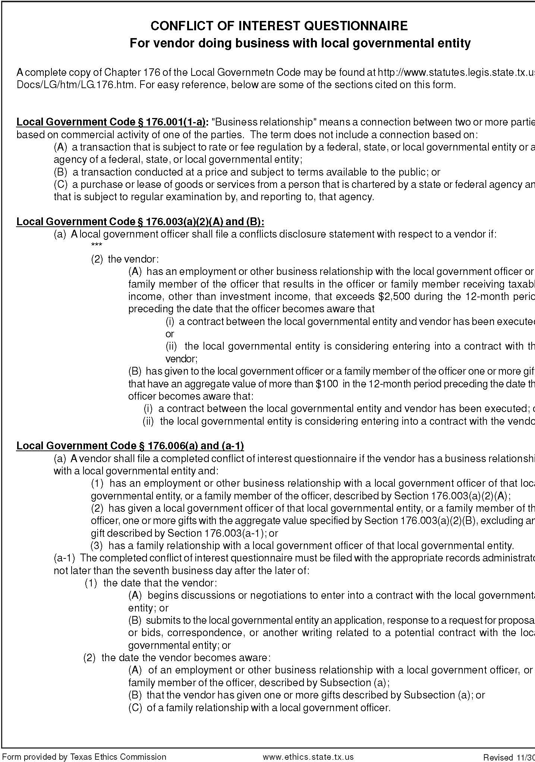

House Bill 89 Verification

I, (Person name), the undersigned
representative of_(Company or Business name)

(hereafter referred to as company)
being an adult over the age of eighteen (18) years of age, after being duly sworn by the undersigned notary, do hereby depose and verify under oath that the company named- above, under the provisions of Subtitle F, Title 10, Government Code Chapter 2270:

  - Does not boycott Israel currently; and
  - Will not boycott Israel during the term of the contract.

Pursuant to Section 2270.001, Texas Government Code:
  - “Boycott Israel” means refusing to deal with, terminating business activities with, or otherwise taking any action that is intended to penalize, inflict economic harm on, or limit commercial relations specifically with Israel, or with a person or entity doing business in Israel or in an Israeli-controlled territory, but does not include an action made for ordinary business purposes; and
  - “Company” means a for-profit sole proprietorship, organization, association, corporation, partnership, joint venture, limited partnership, limited liability partnership, or any limited liability company, including a wholly owned subsidiary, majority-owned subsidiary, parent company or affiliate of those entities or business associations that exist to make a profit.

_

DATE SIGNATURE OF COMPANY REPRESENTATIVE

On this the day of , 20 , personally appeared , the above-named person, who after by me being duly sworn, did swear and confirm that the above is true and correct.

NOTARY SEAL
NOTARY
SIGNATURE

Date

Attachment A

2019 DATA NETWORK CABLING Part I - GENERAL SPECIFICATIONS
  - IMPORTANT FUNDING INFORMATION

    - This RFP is subject to E-Rate and District funding availability and other considerations.

    - It is the intent of the Mesquite Independent School District (“MISD”) to participate in the federal E-rate program to subsidize the purchase of the data network cabling listed within this RFP. Therefore, the award of the contract is contingent upon the award of funding from the Schools and Libraries Division (“SLD”) for E-Rate funding Year 2019. Installation of E-rate Eligible equipment must be completed over a (15) month period beginning July 1, 2019 and ending no later than September 30, 2019 unless the SLD grants an extension of time to complete the work.

    - All vendors must be considered “eligible vendors” and have a valid Service Provider Identification Number (SPIN) assigned by the Schools and Libraries Division. The vendor will be required to comply with the following specific recommendations of the E-Rate funding program:

    - The successful responder shall not start any portion of any and all contracts resulting from this RFP unless and until MISD provides a written Notice to Proceed. It is anticipated that Notice to Proceed will not be given for several months after the signing of any or all contracts resulting from this RFP, and in any case not before July 1, 2019. The Notice to Proceed shall apply only to the portion of the contract or contracts as specified in the Notice to Proceed.

    - Mesquite Independent School District reserves the right to cancel any and all contracts resulting from this RFP at any time at the sole convenience of Mesquite Independent School District. Mesquite Independent School District reserves the right to alter any or all parts of any or all contracts resulting from this RFP at any time at the sole convenience of Mesquite Independent School District.

    - Responders to this RFP are directed to review the delivery dates of each item of this RFP. The delivery date shall be interpreted such that no item is delivered prior to its delivery date unless authorized by written notice from MISD. Further, the delivery date shall be interpreted such that no item is delivered later than (30) days after the scheduled delivery date unless authorized by written notice from MISD. If the item is not delivered according to it delivery date, MISD reserves the right to cancel all or any portion of that item at the sole convenience of Mesquite Independent School District.

    - Cancellation charges shall not apply on any item if MISD submits written notice to the provider at least (60) days prior to the delivery date. Cancellation charges shall be adjusted at the sole discretion of MISD based on the item or items being canceled and the time of cancellation relative to the delivery date.

    - Special Conditions:

      - Prices are to remain firm through SLD approval, execution, and duration of the proposed contract. In the event of a price decrease for service or from the manufacturer, said decrease shall be passed on to the District and documented with new price information sent to the Mesquite Independent School District Purchasing Department.

      - All proposals should be submitted in a form that clearly addresses each of the requirements listed. The proposal must include the company’s Service Provider Identification Number (SPIN) as issued by the Schools and Libraries Division.

      - The district reserves the right to award multiple contracts on the same project to multiple vendors in order to optimize available funds and/or construction time limits. In awarding one or more contracts, MISD may of course take multiple factors into account, but be advised that in each case, price will be MISD’s primary consideration.

      - The Mesquite Independent School District reserves the right not to enter into a contract. All contracts are contingent upon School Board Approval.

      - All bidders should be advised that contract(s) for this project is contingent upon availability of funding.

      - Successful bidders understand and agree that MISD will not be liable for any E-rate invoice submitted to the Universal Services Administrative Company (USAC) for payment if, due to the bidder’s negligence, USAC refuses to pay the invoice. If USAC refuses to pay an E- rate invoice for any other reason, MISD will not be liable to the bidder for the amount of that invoice unless and until the bidder has fully exhausted the administrative appeals process.

      - Multi-year contracts or contracts with 3 additional renewal options for structured cabling services will be considered based on price and availability of funds.

  - DESCRIPTION

    - The Mesquite Independent School District (also referred to as Mesquite ISD, MISD and the owner) is seeking a design and cost proposal for the installation of a data cabling infrastructure at 3 schools. Although these locations are listed under one RFP they may be awarded as 3 separate contracts. Mesquite ISD reserves the right to evaluate and award each individual school contract to the contractor submitting a proposal with the best value for that school or to award all schools to one contractor with the overall best value.

    - It is the intent of this specification that the contractor shall provide and install all equipment, equipment racks, materials, cabling, patch cables, patch panels, hardware and labor required to deliver a complete and fully functional computer (data) network cabling infrastructure as specified.

    - In order to meet project deadlines the majority of this work may be required to be performed after normal school hours and weekends. The earliest time the work day can begin during normal school days is 4:00 PM.

    - The preferred product for this RFP is CommScope’s Systimax Structured cabling product or equivalent. MISD will accept and evaluate other manufacturer's products as outlined in section 1.17. All data wiring and components must meet or exceed the ANSI/EIA/TIA 568 Revision D standards. Wiring shall be terminated in accordance with CommScope Company’s SYSTIMAX Structured Cabling Specification.

    - It is the intent of this project to keep the majority of the existing system in operation throughout the duration of this project. The contractor shall schedule these installations to minimize service interruption. After the completion of the final stage of construction of the data network cabling infrastructure and after the owner has switched from the existing network cabling to the new network cabling the contractor shall completely remove all existing data network and voice cabling, racks, cable management devices, faceplates and unused hardware.

    - These facilities currently have voice/data cabling infrastructures which are currently in use. This infrastructure includes, in most cases, two voice and 4 data cables homerun from each individual classroom and office to the nearest MDF/IDF. These facilities currently have at least one computer lab with approximately 45 data drops. These cables are terminated on RJ 45 patch panel located in the television cabinet in that room. These facilities also have fiber optic cable that homeruns from the MDF to an outside termination can. The purpose for this tie cable is to feed voice and data services to the portable buildings. All portable building tie cable shall remain unless otherwise directed within these specifications.

    - The contractor shall use existing voice/data outlet boxes and cut-in rings where possible. This may require that the existing and new cabling temporarily share the same space until the owner has switched over to the new cabling system. At this time the contractor shall remove the old cabling and faceplate and secure the new faceplate to the existing outlet box or cut-in ring. It is the owner’s intent to avoid cutting unnecessary holes into the existing structures. This work shall be coordinated with the owner.

    - This project shall include the following locations:

Agnew Middle School 729 Wilkinson, Mesquite, TX 75149 Mesquite High School 300 East Davis St. Mesquite, TX 75149 Shaw Elementary 707 Purple Sage, Mesquite, TX 75149

    - Most locations within these facilities have a lift out ceiling tile structure which will allow easy access to the cable paths. In areas where ceilings or walls are inaccessible the contractor shall provide and install an approved brushed aluminum raceway.

  - SCOPE OF WORK

    - The contractor shall provide and install all equipment, equipment racks, materials, cabling, patch cables, patch panels, hardware and labor required to deliver a complete and fully functional computer (data) network cabling infrastructure as specified.

    - The project shall consist of the installation of data wiring and all associated termination equipment and hardware required to provide data services to all classrooms and offices. Each office, classroom and other designated areas shall require one or more data drops as noted on project drawings.

    - The contractor shall be responsible for the layout, assembly and termination of all wiring in each of the designated MDF, IDF and computer lab locations. The contractor shall be responsible for the accuracy of final labeling, testing and documentation for the project as outlined in this specification.

    - The contractor shall coordinate the MDF and IDF room layouts with the owner. No equipment shall be mounted or installed in the MDF or IDF rooms without approval of the owner.

    - The contractor shall layout the data racks so that no more than four
(4) 48 port patch panels are mounted in a single data rack. Contractor shall provide and install a patch cable management panel directly below each 48 port patch panels. The contractor shall be required to provide a drawing showing the intended layout and mounting position of each piece of hardware to be mounted within the designated room prior to the mounting of any hardware.

    - The data system wiring shall be installed in a star-topology type configuration. The star shall begin at the MDF where the 1000Base-SX switch shall be located. The MDF switch cabling shall branch out to each of the IDF switches by means of a plenum 24-strand 50 micron Multimode Fiber-Optic cable. Data drops from the MDF switches and IDF switches shall be installed to provide a shared Gigabit networking environment. Individual data drops shall be starred from the MDF and IDF locations to their jack locations with plenum Category 6 cabling. The MDF and IDF locations shall provide connection to all data jacks in its vicinity as determined by the owner. All terminations shall meet or exceed Category 6 ratings.

    - The contractor shall provide Category 6 patch cables in 6’ lengths at the MDF and IDF switch locations to accommodate one-hundred percent (100%) connectivity of local data drops to the owner provided switches. The contractor shall provide Category 6 patch cables in 1’ lengths at the Computer Lab switch locations to accommodate one-hundred percent (100%) connectivity of local data drops.

    - Except where noted on the project drawings data drops within all computer labs shall be cabled within the classroom. An exception is made for the wireless access point data drop within these rooms such that this data drop is to be homerun to the nearest MDF/IDF. Cat6 cables in computer labs shall be installed in a star-topology type configuration to a Category 6 patch panel located inside the TV cabinet or other area called out on the project drawings. All patch panels and wire management panels inside these cabinets shall be installed in a 14” Desktop Rack Rail. A service loop shall be provided to allow the rack rail to be pulled out and rotated for service. As directed on the project drawings the contractor shall install a 6 strand 50 micron multimode fiber optic tie cable to these computer. The fiber optic tie cable shall homerun to the MDF unless directed otherwise on the project drawings.

    - Data drops for Wireless Access Points shall terminate with an RJ45 modular connector that conforms to the MPTL standards as established in TIA 568-2.D. A minimum of 10’ service loop shall be left neatly coiled and supported above the ceiling and located at the existing wireless access point.

    - Data drops for cameras shall terminate with an RJ45 modular connector that conforms to the MPTL standards as established in TIA 568-
2.D. A minimum of 20’ service loop shall be left neatly coiled and supported above the ceiling. Data drops for indoor cameras shall be located at the camera. Data drops for outdoor cameras shall be left at the existing outside wall penetration with a service loop length as directed by the project drawings.

    - Data drops for ceiling mounted video projectors and shall terminate with an orange CAT6 RJ45 jack and shall be snapped into the existing single- gang faceplate.

    - Contractor shall install 5 data drops in each classroom for teacher and student use. These drops shall be installed as indicated on the project drawings.

    - Contractor shall install data drops in each office and other designated areas. These drops shall be installed as indicated on the project drawings.

    - Contractor shall include a “Total Drop Count” with their bid. This count shall be itemized per data closet. This “Total Drop Count” provided by the contractor shall not relieve the contractor of the responsibility to provide all data drops indicated in this specification and/or reflected on the project drawings.

    - It shall be the responsibility of the contractor to verify any site layout and/or measurements. If an on-site inspection is desired, the contractor shall contact the owner’s project manager to make arrangements for an on-site inspection.

    - Contractor shall clean all work areas, remove trash, boxes and debris on a daily basis. Ceiling tiles removed during installation shall be replaced before the end of the work day. Contractor shall provide protective covers for desks, computers and equipment during time of work.

    - Contractor shall store and protect all materials throughout the project. If space is available the contractor may be able to store materials on site. Storage of these materials shall be preapproved by the owner’s project manager.

    - The contractor shall be responsible for keeping the existing system working throughout this project. The contractor shall notify the owner if the installation of the new data drops renders any part of the existing system to be out of service. This work shall be scheduled through the MISD project manager to minimize service interruption.

    - The contractor shall comply with all MISD Policies. A copy of the policy manual will be provided upon request. Contractors shall wear nametags at all times.

    - The owner may require other structured cabling work to be completed during this project. Any additional work shall be handled through a change order procedure. The contactor shall include on their bid form the cost for additional data drops.

    - The contractor is fully responsible for managing their staff on this project. All jobs shall be staffed with the appropriate manpower in order to meet all project deadlines.

    - The contractor shall make their staff aware that MISD custodial staff is on-site and working after normal business hours. All work shall be coordinated so that it does not obstruct the custodial staff from performing their duties.

    - Contractor shall be responsible for completely removing existing voice cabling, data cabling and other unused components such as equipment racks and old patch panels. Unused components shall be stored in a safe area and MISD Technical Services Department shall be notified for pick-up. The contractor shall have salvage rights to the old cabling.

  - SUBMITTALS

    - Submittal documentation shall include all information necessary to fully explain design features, appearance, function, fabrication and installation of the equipment, and shall include a complete bill of materials, details, layouts, schedules, schematics, etc., as necessary to be incorporated in the design and fabrication of the system. Submittals shall include but are not limited to the following:

      - Manufacturer’s cut sheets and specification sheets on all equipment and all items provided by the contractor.

      - All block diagrams and wiring diagrams showing typical connections of all equipment.

      - Riser diagrams depicting the intended layout of all wall mounted equipment.

      - Elevation drawings of system control cabinet(s) showing the relative position of all major components.

  - DOCUMENTATION

    - The contractor shall provide a complete set of accurate As-Built Documentation Package. The As-Built drawings shall be generated on a CADD system and shall reflect that type of quality. No hand drawn As-Built drawings will be accepted. The As-Built drawings and documentation shall be marked to reflect the following information:

- Cable paths for all distribution cables.

- Locations of all devices installed throughout the facility.

- A wire number listing corresponding to each wire and its associated jack number. Wire and jack numbers on drawings shall match labels on all installed cables and plates.

- System head-end location and all other secondary equipment locations.

- All final device control settings.

- Serial number listing for all equipment provided.

    - The contractor shall provide on disk a copy of the As-Built drawings in AutoCAD 2017 format or higher. These files shall be identical to the printed As-Built drawings.

    - The contractor shall provide two (2) complete sets of all service manuals for all equipment provided by the contractor. The service manuals shall include all information such as schematic drawings, block diagrams and alignment procedures as necessary for the repair and maintenance of the equipment. Service manuals shall be the original manufacturer’s copy provided with the equipment. Photocopies shall only be accepted if the quantity of equipment units provided is less than two (2). Photocopies shall be first generation copies of the original.

    - The contractor shall keep a complete set of As-Built drawings and service manuals through the entire warranty period. This set shall be in addition to the two (2) sets to be provided to the owner.

    - The contractor shall provide two (2) complete sets of all operation manuals for all equipment provided by the contractor. Operation manuals shall be the original manufacturer’s copy provided with the equipment. Photocopies shall only be accepted if the quantity of equipment units provided is less than two (2). Photocopies shall be first generation copies of the original.

    - The contractor shall provide two (2) sets of simple step-by-step operating instructions. These instructions shall be one document, quick-step guide, written in easy to understand terms, for basic day-to-day operation of the system and its components. This instruction shall be targeted at an individual who is unfamiliar with the system and operating it for the first time.

    - The contractor shall prepare and bind all two (2) sets of complete As-Built documentation including warranty information into 8 1/2” x 11” three- ring binders.

  - SYSTEM ACCEPTANCE

    - The contractor’s project manager shall perform a walk through and a punch list of the system prior to the contractor’s announcement of completion. All punch list items noted during this walk-through and all other punch list items noted during the installation shall be completed before announcement of final completion. Announcement of completion shall be in writing.

    - The owner shall perform a walk-through and a punch list after announcement of final completion. All items on this punch list shall be completed before system acceptance. Correction of items on the punch list shall be noted in writing detailing what actions were taken to correct the problem. Any item on the punch list which, in the opinion of the contractor, is not the contractor’s responsibility shall be noted as such in writing.

  - WARRANTY
    - The contractor shall provide a one (1) year warranty of the installed system against defects in materials and workmanship. All labor, materials and/or transportation shall be provided at no expense to the owner during normal working hours. The warranty period shall begin no sooner than the date of final acceptance (in writing) by the owner.

    - The contractor shall respond to warranty issues within twenty-four
(24) hours from the time the call is reported. The contractor shall correct the problem(s) and bring the system(s) back to full operational capacity within seventy-two (72) hours.

    - The proposed contractor shall provide with their bid, detailed guarantees and warranties that apply to their services, equipment and software proposed. The contractor shall pay freight charges both ways on equipment under warranty repair. This warranty is in lieu of any other warranty unless the manufacturer’s is longer than one (1) years. The warranty period shall begin upon written final acceptance of completion of the project. A document of final acceptance shall be issued at the time of final approval and acceptance by the owner.

  - QUALITY ASSURANCE

    - The contractor shall be an established electronic communications installation contractor that has had and currently maintains a locally run and operated business for a minimum of five (5) years.

    - The contractor’s on-site supervisor in charge of installing the wiring and equipment outlined in this specification shall have in his/her possession a copy of this specification and a complete set of submittal drawings for easy reference while on the project site. This on-site supervisor shall demonstrate sufficient knowledge of the information contained herein if requested.

    - Specialty tools and supplies, outlined in this specification, shall be in the possession of the contractor’s personnel at all times while they are performing the task(s) for which these specialty items are intended. These specialty items shall also be on hand during system(s) checkouts and inspections.

    - The owner may request each prospective contractor to attend a pre-bid conference.

    - The proposed contractor shall provide, attached to bid documents, an itemized listing of all equipment, cabling and hardware to be provided and installed per these specifications and the project drawings. Items shall be laid out in specification order and include manufacturer, manufacturer’s exact part number, any associated parts and/or sub-assemblies required, and any other pertinent data necessary to completely identify each item. The acceptance of a bid which includes this listing shall not be misinterpreted to represent an instant approval or authorization for any item outlined in this specification to be substituted. The acceptance of a bid which includes this listing shall not relieve the contractor of the responsibility of gaining proper written substitution authorization.

    - All items shall be new and be the most current revision of that item. All items shall be delivered in first class condition, including all packaged accessories and containers suitable for shipment and storage.

  - SUBCONTRACTORS

    - The contractor is specifically advised that the owner must approve any person, firm or other party to whom it proposes to award a subcontract under this project contract.

    - Before using a subcontractor, the contractor shall satisfy himself that the subcontractor he will propose to the owner as part of his contract can satisfy all of the requirements expressed in these project documents as it applies to the portion of the contract to be subbed out. The owner reserves the right to reject any subcontractor if the evidence submitted by, or investigation of, such proposed subcontractor fails to satisfy the owner that said subcontractor is properly qualified and capable of carrying out the obligations of this project’s contract and to complete the work contemplated therein.

  - CONTRACTOR QUALIFICATIONS

    - The proposed contractor shall be fully experienced in the design and installation data systems as specified herein and shall furnish with their bid an itemized list of installations of the type specified herein. The list shall include the name of the project, date of completion, the amount of the contract and the name of a person to contact for reference.

  - LIQUIDATED DAMAGES FOR FAILURE TO ENTER INTO CONTRACT

    - Should the successful contractor, after receiving notice of acceptance of his proposal, fail or refuse to execute and deliver the project contract and bonds required within the time outlined in the contract documents, the security deposited provided with his proposal shall be forfeited as liquidated damages to the owner.

  - TIME OF COMPLETION

    - The contractor shall agree to commence work on or before a date to be specified in a written “Notice to Proceed” by the owner and to fully complete the project within the time limit established by the contract documents.

  - CONDITIONS OF WORK

    - It shall be the responsibility of the contractor to fully inform themselves of the conditions relating to the construction of this project and the employment of labor thereon. Failure to do so shall not relieve the successful contractor of their obligation to furnish all materials and labor necessary to carry out the provisions of the contract. Insofar as possible, the contractor, in carrying out the work, must employ such methods and/or means as to not cause any interruption of or interference with the daily work routing of the facility.

  - ADDENDA AND INTERPRETATION

    - Any interpretation as to the meaning or intent of the project drawings, specifications or other pre-proposal documents shall be made to any contractor upon request to the owner. Any and all such interpretations and/or supplemental instructions shall be in the form of written addenda to the specifications, which if issued shall be mailed or faxed to all contractors (at the respective addresses or fax numbers furnished for such purposes). This information shall be provided no later than one (1) day prior to the date fixed for the acceptance of the proposals. Failure of any contractor to receive any such addendum or interpretation shall not relieve such contractor from any obligation under their proposal as submitted. All addenda so issued shall become part of the contract documents.

  - LAWS AND REGULATIONS

    - The contractor’s attention shall be directed to the fact that all applicable Federal and State Laws, Municipal Ordinances, Local Codes and any other rules and regulations of all authorities having jurisdiction over this project shall apply to the contract throughout. All shall be deemed to be included in the contract the same as though herein written out in.

    - It shall be the responsibility of the proposed contractor to make himself aware of local codes, fire codes, permit requirements and other details concerning the installation of this project

  - METHOD OF AWARD - “BEST VALUE”

    - The contract shall be awarded to the responsible contractor submitting the best value, which complies with the terms and conditions of the proposal documents, provided it is in the best interest of the owner to accept

the contractor’s proposal. The heaviest weighted factor in our bid evaluations to determine best value shall be the cost of eligible goods/services.

    - The contractor to whom the award is made shall be notified at the earliest practical date. The owner, however, reserves the right to reject any and all proposals and to waive any informality in proposals received whenever such rejection or waiver is in the best interest of the owner.

    - The owner reserves the right to reject the proposal of any contractor, who has previously failed to perform properly or to complete previous projects of a similar nature on time; Who is not logistically in a position to perform the contract, Who is not properly staffed to perform the contract, Who has habitually and without just cause neglected the payment of bills or otherwise disregarded his obligations to subcontractors, material men or employees. In determining the lowest responsible contractor, the following elements, in addition to those mentioned above, shall be considered: whether the contractor (1) maintains a permanent place of business; (2) has adequate plant equipment available to do the work properly and expeditiously; (3) has appropriate technical experience. The ability of a contractor to obtain a performance bond shall not be regarded as the sole test of such contractor’s competence or responsibility.

    - With the submitted proposal, contractors are invited to call special attention by listing any option, enhancements, warranties or special amenities which in their opinion would add to the overall value and effectiveness of this specified project. The owner reserves the right to evaluate all proposals based upon the overall value of the proposal and exercise their best judgment so as to serve the best interest of the district. Consideration and/or determination shall include but not be limited to: experience; skill; ability; business judgment; financial capacity; equipment; bonding; previous performance; reputation; promptness; and estimated time of completion.

    - Where required, proposal unit prices on item quantities specified shall be extended and show total. In case of errors in extensions, unit prices shall govern.

    - Proposal prices shall be firm for acceptance for 60 days from the proposal acceptance date. No proposals may be withdrawn without written approval after a contract has been signed or partial performance of the proposal agreement has begun.

    - Failure to manually sign proposal forms shall disqualify the proposal. The person signing the proposal shall show their title or authority to bind their firm to a contract.

    - The owner reserves the right to accept or reject all or any part of any proposal, waive minor technicalities, and award the contract to best serve the interest and requirements of the district.

    - The contractor shall indicate “all” or “none” on the proposal documents if the above stated conditions are not acceptable.

  - OBLIGATIONS OF THE PROPOSED CONTRACTOR

    - At the time of acceptance of the proposals, each contractor shall be presumed to have completely read and be thoroughly familiar with this specification, project drawings, all other pre-proposal documents (including all addenda) and contract documents provided by the Architect. The failure or omission of any contractor to examine any form, instrument or document shall in no way relieve the contractor from any obligation in respect to their proposal.

  - SUBSTITUTIONS AND/OR ALTERNATIVE PROPOSALS

    - Substitution request will not be considered if they are implied in the product submittals or drawings. The contractor shall plainly and clearly call out that they are requesting substitution or approval of an alternate product.

    - The equipment listed in this specification shall meet the educational and construction requirements and needs of the owner as to design, quality, durability, appearance and function. Substitutions and or alternative proposals offered by the contractor shall be strictly judged and evaluated against these requirements.

    - Along with their written document requesting substitution approval the contractor shall also submit the following:

      - Manufacture’s product data sheets
      - Shop Drawings
      - Detailed product specifications

PART II - EQUIPMENT SPECIFICATIONS

  - WIRING/INSTALLATION PRACTICE

    - The quality of wiring in this facility is essential to aid the owner’s staff in providing future service. A detailed inspection of all wiring installed by the contractor shall be conducted and approved prior to final payment. This document cannot over emphasize the importance of this requirement. The successful contractor is required to make every effort to install all wiring, terminations and devices in a neat and professional manner.

    - System wiring and equipment installation shall be in accordance with good engineering practices as established by the EIA and the NEC. Wiring shall meet or exceed all state and local electrical codes. The entire project shall meet or exceed but is not limited to the following standards:

      - ANSI/EIA/TIA – 568 Revision D
      - ANSI/EIA/TIA - 569
      - TIA/EIA - 606
      - TIA/EIA – 607
      - TIA/EIA - TSB 67
      - TIA/EIA - TSB 72
      - BICSI-TDMM

    - All communications cabling shall comply with TIA/EIA 568D and the National Electric Code articles 725, 760, 770 and 800 and all local codes.

    - All wiring shall test free of all grounds and shorts.

    - All horizontal wiring shall be installed in a neat and professional manner. Special care shall be taken so as not to route wiring diagonally across the ceiling.

    - Under no circumstances shall wiring be laid on or across ceiling tiles.

    - All wiring shall be grouped, bundled and tie wrapped. Wiring shall be suspended using J-hooks or other suitable type hangers tied every 48” or less to prevent sagging. The contractor shall not tie or suspend wiring to sprinkler pipes, electrical conduits or insulated ceiling joists. Where J-hooks are mounted to the wall they shall be placed as to be secured to a stud within the wall. Where multiple contractors are involved pulling different cable types the data cabling contractor shall paint orange in color a 1” area at the tip of all J-Hooks in order to identify cable paths from other trades. This work shall be performed prior to installing J-Hooks.

Approved product:

- J-Hooks (Qty: As req’d to meet spec.)
  - Erico (Caddy), model CAT-12, CAT-21 and CAT-32 or approved equivalent.

    - Under floor wiring shall be suspended to the overhead structure and shall be securely mounted and clamped every 48” or less using appropriate mounting hardware. Wiring shall not sag or touch the ground under any circumstance. Wiring shall not be routed across floor access door.

    - Wiring which requires routing through steel walls or other abrasive surfaces shall be protected using rubber grommets, conduit sleeves or other appropriate protective devices.

    - All horizontal wiring shall run parallel to walls. Turns and room entries shall make ninety (90) degree angles while maintaining the manufacturer’s minimum specified bend radius.

    - Wire routes shall not cut diagonally across ceilings.

    - Cable routes shall be designed so that wiring shall not cross more than one occupied space, unless specifically noted on the original project drawings.

    - All vertical wiring bundles shall be plumb and straight. Bundles shall be tied and secured to the surface at intervals of 8” minimum. A sufficient, but not excessive, length of coiled wiring shall be provided as a service loop above all equipment racks and connecting hardware. All service loops shall be neatly coiled and secured.

    - All wiring, regardless of length, shall be properly marked and identified using computer generated labels that are permanently affixed at each end of each wire. Hand written labels will not be accepted. All labels shall be installed 1” from the final termination at each end. All markings shall be properly identified so as to match the final set of As-Built drawings furnished by the contractor. All labeling shall meet ANSI and TIA/EIA 606 standards.

    - The contractor shall establish and maintain the following labeling convention:

      - The MDF and each IDF and classroom switch shall be assigned a single digit designation (ex. A, B, C, D, etc.).

      - Each wire leading from one of the above locations to its wall plate shall be numbered sequentially (ex. 1, 2, 3, 4, etc.).

      - As an example, there are four (4) rooms, each containing three (3) data drops. Rooms 1 and 2 are to be fed from the MDF (designated A) and rooms 3 and 4 are to be fed from an IDF closet (designated B). Wiring and Jack Plate labeling for Room 1 would be “A1”, “A2” and “A3”. Room 2 would continue on with “A4”, “A5” and “A6”. The associated patch panel located in the MDF equipment rack would be labeled sequentially “A1”, “A2”, “A3”, “A4”, “A5” and “A6”, etc. Following this convention, Room 3’s data drops would be labeled “B1”, “B2” and “B3”. Room 4’s data drops would follow with “B4”, “B5” and “B6”. Again, the associated patch panel in the IDF equipment rack would be labeled sequentially “B1”, “B2”, “B3”, “B4”, “B5” and “B6”, etc. This labeling method shall be maintained throughout the facility.

      - Once each wire designation has been established, the wire shall be labeled on both ends, the jack shall be labeled and the patch port where the wire is terminated on the patch panel shall all be labeled with the same designation.

    - The contractor shall provide all necessary transient protection on the AC power feed and on all station lines entering or leaving the building.

The contractor shall note on the As-Built drawings, the type and location of these devices as well as all wiring information.

    - The contractor shall make himself aware of all adjacent AC power and other high voltage circuits so as to give adequate separation between high and low voltage wiring.

    - All installed devices such as wall plates, wall racks and rack mounted equipment shall be mounted plumb and square. If pre-existing backbones are not square, then it shall be the responsibility of the contractor to reposition the box(s) to be square and plumb.

    - All wiring shall be plenum rated unless otherwise specified.

    - All wiring regardless of how or where installed shall be neatly dressed and properly secured.

    - All vertical wiring installed inside data switch rooms and wiring closet shall be installed using Panduit tie wrap mounts. Wiring shall be combed and dressed in a neat and professional manner. All wiring shall be dressed and bundled from the entry point of the data switch room or wiring closet all the way to the equipment rack for termination. All excess wire shall be evenly cut and dressed.

    - Fiber-Optic cabling shall be protected by a plenum rated inter-duct or shall have a plenum rated outer armored jacket.

    - All fiber optic cable shall be terminated with SC type connectors.

    - All fiber optic cables shall be a multimode type cable and use a 50 micron core and shall support Ethernet, Fast Ethernet, 1000base-SX and 1000base-LX.

    - All copper data cables shall meet or exceed Category 6 and shall be installed using Category 6 type wire connections and Category 6 jack panels.

    - All wiring shall be tested for continuity, data cables graded and certified. All fiber termination documentation shall show total signal loss from end to end. Test results shall be delivered to the owner with the As-Built documentation.

    - The contractor shall make every effort to maintain a consistent and uniform level when installing horizontal wiring throughout corridors. Minimal deviations are acceptable only to traverse around overhead obstacles while maintaining the manufacturer’s specified bend radius. Once an obstacle has been passed, the contractor shall return the horizontal wiring to the previously established uniform level.

    - All operational wiring shall be properly terminated. Spare wiring shall be labeled, denoting the intended use of the spare and the location of the other end of the wire. Both ends shall be neatly coiled and secured above the ceiling grid.

    - The contractor shall strictly follow the manufactures specified bend radius and pulling tension for all cabling used on this project.

    - The contractor shall avoid routing wiring under mechanical equipment.

    - The contractor shall not penetrate floors, walls or ceilings without prior consent of the owner, Architect or General Contractor. Holes around conduit sleeves which penetrate between floors, walls and ceilings shall be completely filled with matching material. If needed, floor tiles or other coverings shall be replaced around sleeves.

    - The owner will not accept exposed wiring. If conduits are not provided, then the contractor shall install wiring within the walls. If it is not possible to install wiring within the walls, then the contractor shall furnish and install a wire raceway type product that is pre-approved by the owner prior to installation. Refer to Section 2.2.

    - When necessary to mount terminating devices within equipment rooms or closets, careful coordination of previously designated or installed device locations shall be considered. The contractor shall make himself familiar with the rack or equipment requirements specified by the owner. The contractor shall layout the rack so that no more than four (4) 48-port patch panels are mounted in a data rack. The contractor shall be required to provide a drawing showing the intended layout and mounting position of each piece of equipment to be mounted within the designated room prior to the mounting of any components. This drawing shall be part of the submittal package.

    - All wiring required to be installed within equipment racks shall be routed separately from high-voltage. All wiring shall be neatly bundled in like signal level bundles, secured and positioned so that all wiring is perpendicular and at 90 degrees from high-voltage wiring. Details showing rack equipment and wiring layout shall be furnished to the owner prior to installation as part of the submittal package.

    - The contractor shall provide all wiring and terminations as marked on the project drawings. The contractor shall provide and install all wiring and terminations as required to meet system specifications.

    - All wiring penetrations through fire-rated walls, floors and ceilings shall be completely filled with fire-rated caulk. Provide fire-resistant material of a type and composition necessary to restore fire rating to a wall, floor or ceiling penetration.

    - Any holes required to be cut in concrete shall be drilled using a coring machine or drill designed for that purpose. No air tools will be permitted.

    - Typical MDF and IDF racks shall be the Ortronics Mighty Mo 6 cable management rack or approved equivalent . Typical computer lab racks shall be either a Chatsworth wall-mount swing-gate rack or a Middle Atlantic desktop rail or approved equivalent(s).

    - All equipment racks and equipment shall be connected to an earth ground as specified within the NEC codes.

    - It is the responsibility of the contractor to remove all debris from the project site. All areas shall be wiped clean and floors broom swept clean.

Approved Equipment List (All Qty’s are As Req’d):

- Cat 6 Data Jack Insert
  - Systimax, model MGS400-112 Material ID 700206683 or approved equivalent.

- Face Plates 3 Port, 4port, 6 port Plastic
  - Systimax, model M13L-246 Material ID 108168519
  - Systimax, model M14L-246 Material ID 108168550
  - Systimax, model M16L-246 Material ID 108168592 or approved equivalent.

- Blank Insert
  - Systimax, model M20AP-246 Material ID 107067860 or approved equivalent.

- Cat 6, 4 Pair Data Cable, Color Blue
  - Systimax, model 2071E or approved equivalent.

- 50 micron multimode plenum fiber
  - 6 Strand Armored Jacket, Systimax LazrSpeed 550, model P-006-DZ-5K-FSUAQ, Material ID 760128181 or approved equivalent
  - 24 Strand Armored Jacket, Systimax LazrSpeed 550, model P-024-DZ-5K-FSUAQ Material ID 760127910 or approved equivalent.

- Enterprise-Uniprise Fiber Shelves
  - All Enterprise-Uniprise Fiber Shelves and panels or approved equivalent are approved. Select appropriate shelf or panel to meets fiber termination needs of each MDF and IDF. Example part number for a 2U Internal Sliding Shelf 760231456 SD-2U

- CAT 6 Modular Patch Panels
  - Systimax, model 360-IPR-1100-E-GS3-2U-48, Material ID 760152579 or approved equivalent.

- 2RU Wire Management Panels
  - Ortronics, model OR-80804485 or approved equivalent.

- Mighty Mo 6 Rack
  - Ortronics, model OR-MM6706 or approved equivalent.

- Wall-Mount Swing-Gate Rack
  - Chatsworth, model 11791-725 or approved equivalent.

- Desktop Rail Rack
  - Middle Atlantic Products, model DR-8 or approved equivalent

  - CONDUIT AND WIRE RACEWAY

    - All conduit and raceway shall be provided by and installed by the contractor.

    - All conduit, wire raceway and associated hardware specified herein shall be installed and conform to the latest NEC codes. Article 300 and 348 of the NEC code provides specific codes relating to EMT installation.

    - The contractor shall provide all cable, conduit, mounting hardware, junction boxes and any other hardware or materials required to complete the project.

    - All conduit and raceway shall be plumb and ran perpendicular to walls at 90 degree angles. Splice boxes and pull boxes shall be appropriately sized and shall be furnished as required. If possible, all junction boxes shall be mounted inside of buildings. Conduit bend radius shall be 18” minimum. Junction boxes shall be 18” x 18” x 4”.

    - If new conduit is installed near or adjacent to existing conduit, the new conduit shall be installed to conform to the routing and layout of the existing conduit.

    - Surface mounted raceways shall be secured with screws. No raceway shall be installed using only double-sided tape.

    - All wiring within classrooms and offices shall be concealed inside walls where possible. In applications where this is not possible wires shall be installed inside an approved surface mounted raceway.

Approved Equipment List (All Qty’s are As Req’d):

- Wiremode AL2000 series metal raceway with various fittings or
approved equivalent.

-----End of Section-----

ATTACHMENT C APPENDIX A:
UNIVERSAL SERVICE (E-RATE) REQUIREMENTS

To warrant consideration for an award of contract resulting from this Request for Proposal, vendors must agree to participation in the Universal Service Support Mechanism for Schools and Libraries (commonly known as “E-rate”) as provided for and authorized under the federal Telecommunications Act of 1996 (Reference 47 U.S.C. § 254, “Universal Service”). Vendors acknowledge that any contractual relationship resulting from this solicitation of proposals may be partially or entirely dependent upon the successful receipt of Universal Service Fund (“USF”) subsidies. To ensure compliance with all applicable USF regulations, program mandates and auditing requirements, vendors must comply with the following:

- USF Knowledge
Vendor shall have, at a minimum, a working knowledge of the federal Universal Service Support Mechanism for Schools and Libraries (commonly known as “E-rate”).

- USF Registration
Vendor shall submit with its proposal a valid Service Provider Identification Number (“SPIN”) and a valid Federal Communications Commission Registration Number (“FCCRN”).

- USF Participation
Vendor shall agree to participate in the E-rate Program and to cooperate fully and in all respects with the District, the Universal Service Administrative Company (“USAC”), and any agency or organization administering the E-rate Program to ensure that the District receives all of the E-rate funding for which it has applied and to which it is entitled in connection with Vendor’s services and/or products.

- Lowest Corresponding Price
The Lowest Corresponding Price Rule (“LCP Rule”), 47 CFR § 54.511 (b), prohibits Vendor from ever charging the District more for E-rate eligible goods or services than it charges similarly situated non-residential customers for similar goods or services, unless it can prove that the lowest corresponding price (“LCP”) is not “compensatory.”

  - The District is not obligated to ask for the LCP; it must receive it.
  - If, at the time of delivery, the LCP is lower than the agreed-upon price, Vendor must charge the LCP.
  - Promotional rates that Vendor offers for a period of more than 90 days must be included among the comparable rates upon which the LCP is determined.
  - There is a rebuttable presumption that rates offered within the previous three years are still compensatory.
  - Vendor may not avoid the LCP Rule by arguing that none of its non-residential customers are identically situated to the District or that none of its contracts cover goods or services identical to those sought by the District.
  - The FCC will permit Vendor to charge the District more than the LCP only when it can prove to the agency that the LCP is not “compensatory” – i.e., that it will face demonstrably and significantly higher costs to provide its goods and/or services to the District than it would to provide similar goods and/or services to similarly situated non-

residential customers. Some factors that could affect the cost of service are volume, mileage from facility, and length of contract.

- USF Documentation
Vendor shall provide to District staff and/or the District’s E-rate consultant within a commercially reasonable period of time, all of the information and documentation that the Vendor has or that Vendor reasonably can acquire that the District may need to prepare its E- rate applications and/or to document transactions eligible for Erate support.

- Invoicing Procedures
Vendor shall itemize, price, and invoice separately any materials or services that are ineligible for E-rate funding. Vendor must include the following information on all invoices to the District for E-rate eligible equipment and/or services:

- Date of invoice
- Date(s) of service
- Funding Request Number (“FRN”)
- Vendor’s signature on invoice attesting to the accuracy and completeness of all charges
- Detailed description of services performed and materials supplied that matches District’s contract specifications, Form 470 and Form 471 descriptions of same
- Clear, concise breakdown of amount(s) to be billed to USAC (discounted portion of eligible charges) and amount(s) to be billed to the District (non-discounted amount of eligible charges)
- Invoice on Vendor’s letterhead or on a Vendor-generated form
- District’s Billed Entity Number
- District’s Federal Communications Commission Registration Number
- Proper E-rate discount percentage as set forth by the applicable FRN and USAC funding commitment decision letter (“FCDL”)

- USF Discounted Invoicing and Reimbursement Processes
Vendor shall, at the District’s request, either (a) invoice the District only for the non-discounted amounts due on Erate- approved transactions and simultaneously invoice the Universal Service Administrative Company (“USAC”) for the balance [Discounted Invoice Process] or (b) invoice the District in full for eligible products and services [Reimbursement or “BEAR” Process].

  - Discounted Invoice Process
Invoicing
Within fourteen (14) days from the date that Vendor delivers to the District, E-rate approved materials or services, when delivery of such services triggers a payment obligation under Vendor’s contract with the District, Vendor must invoice the District for its share of the prediscount cost of those materials or services.

Timely Filing
Vendor shall be solely responsible for timely filing invoices with USAC. Accordingly, Vendor understands and agrees that District will NOT be liable to Vendor and Vendor shall have no recourse against the District for any discounted amount that Vendor submits late to USAC for payment, if USAC refuses to pay the invoice due to late filing.

Invoice Rejection
Vendor understands and agrees that District shall not be liable to Vendor and Vendor shall have no recourse against the District for any discounted amount that Vendor submits to USAC for payment if Vendor is at fault for USAC’s refusal to pay; if the District is at fault, the District shall not be liable to Vendor and Vendor shall have no recourse against the District for the amount at issue until both the District and the Vendor have exhausted their administrative remedies of appeal to USAC and/or the FCC.

District Approval
Vendor shall submit to the District for its review and approval before submitting it to USAC for payment, a copy of every invoice that Vendor intends to submit for services that it has provided or, in appropriate circumstances, will be providing to the District. The District shall not unreasonably delay or withhold approval of Vendor’s USAC invoices. As Vendor is solely responsible for timely filing invoices with USAC, it understands that it must submit invoices to the District sufficiently in advance of any USAC filing deadline to ensure that there will be adequate time remaining for it to meet the USAC filing deadline after the District has had a reasonable opportunity to review and approve them.

  - Reimbursement Process
Service Provider Annual Certification
Vendor understands that the District’s ability to file a FCC Form 472 to start the BEAR process is dependent upon the Vendor filing a FCC Form 473, Service Provider Annual Certification Form for the relevant funding year. Moreover, Vendor understands and agrees that its failure to file the Form 473 in a timely manner will adversely affect the District’s operations and may prohibit the District from being able to receive reimbursement monies that it is entitled to receive. If the District is unable to receive reimbursement money due to the lack of a Form 473 from the Vendor, the Vendor will be liable to the District for any monies that the District was unable to collect from the USF program due to the Vendors lack of a Form 473.

  - Delayed USF Funding Commitment
Vendor understands that, due to circumstances beyond the District’s control, the District may not receive an E-rate funding commitment by the beginning of the E-rate funding year, July 1, for the services it intends to purchase from Vendor during that funding year.

Retroactive Invoicing
When E-rate funding is approved, Vendor shall invoice USAC for the discounted amount the District is owed retroactive to July 1st of the funding year or to whenever approved service to the District began, whichever date is later.

  - USF Audit and Document Retention Requirement
Vendor shall maintain all bids, quotes, records, correspondence, receipts, vouchers, delivery information, memoranda and other data relating to Vendor’s services to the District. All such records shall be retained for ten (10) years following completion of services and shall be subject to inspection and audit by the District. Vendor shall include in all subcontractor agreements for services, provisions requiring subcontractors to maintain the same records and allowing the District the same right to inspect and audit those records as set forth herein.

In addition to the foregoing, Vendor will create, implement and enforce an internal E-rate audit process that ensures that Vendor complies with all E-rate program rules and regulations. This process must include the following:

- Separating ineligible project management and other professional services costs, if any, from other charges

- Where labor is involved, maintaining detailed, signed individual timesheets

- Ensuring that ineligible charges are not submitted to USAC

- Invoicing to USAC that is consistent with the contract and the District’s 470 and 471

- Ensuring that services or products are not provided to the District without District’s express written permission or official purchase authorization ─ Ensuring that District- approved substitute services or products are prominently noted on invoices submitted to USAC and the District

- Where applicable, non-recurring services should be provided prior to September 30th and recurring services provided prior to June 30th of the relevant E-rate funding year ─ Supporting documentation sufficient to evidence that what was approved per the FCDL and provided to the District, was actually provided to the District and when

- If E-rate eligible services and/or installation or equipment costs are included as part of a larger contract or service/equipment billing, support for the allocation of E-rate eligible amounts and reconciliation of that total to the total amount billed ─ If E-rate eligible services or equipment are allocated to multiple sites, support for the allocation consistent with the amount and locations identified in the Form 471

- Documenting that E-rate funded services were provided within the allowable contract period and program year ─ Charging proper FRN(s)

- Ensuring that invoices and USAC forms are submitted to the District in a timely manner

- Ensuring that USAC forms are filled out completely, accurately and on time

- Maintaining fixed asset list of E-rate-supported equipment provided to the District with detailed information for each item (model number, serial number, product description) and made available to the District in electronic format

Contract Term Modification
The District will reserve the right to extend or abbreviate the contract period if such extension or abbreviation is necessary to make the Contract term coincide with an E-rate “program year” or an extended service end date for an E-rate program year pursuant to a “service delivery deadline extension,” as those terms are defined by the Federal Communications Commission (“FCC”) and/or the Universal Service Administrative Company (“USAC”).

60 59 58 57 56 1
I JI..

,. ·,,' ' '··•.. '
[,,:I •
- 0 - 1 I - IJ 55
61 54

:r::
. ' 66 6 5 u
  - V 64 6 3 SCIE NCE 'SCIEN C E
□STO RA GE

' w LAB L A B
---

L . :
"111"11"11'
11 111 1

t 6 7 ,::J
I
.
Q'
'
62 I 52 51
68
''' " '"""""
"
'w''u"u".w" ."u".u" ' _

{ ! '.. •. ,. ,. ·-, < 49
!b

2 t><l 2
i
2 t><l2

    - 48
- GIRLS RR

6
2
E;J=i::-:·'-· lK

C
PREP
L ABo
ENSE M BLE

PRAC TJCE
!

2 ' -------'---.-- 6 2
Homerun this drop to MDF.
2
V
ROOM DD
V
6
2
BAND

To/
2 =:";---,
V
------w
6
2 - -··

---
2
V

...
Js.- 8:I
□
2t>.<l2

2N 2

MDF-

"2'
= , - IZSI

2
- - ---- ,·. -
H ALL
CJ
D

_(! I:::;
STORA GE

"2'
1 '.-j
---
I I I I

BOYS R
u -  'j  w | NE CH,

= g]
A RI

L I F t
1r T 4>
a 2 Iv I '1a!:?J-_

ME CH ,

2 E'JIDF i
Homerun this drop to MDF.

Homerun this drop to MDF.
X
42g i:BO ILER

41 R O OM '
::...-

2

2
V
"2'

-----"I-ZS1I
-

□□
2

"---- =--

2 I
1<;]-5_-,.
6 6
2 2
--------

'

K I T HE N

6
2
' , RO ON □
I -i::;....

2

6
2

2 2
X X
2 2 2
42
$! ffi"' Bl:..'"'W:"...
CH ITTR
-□a4r
=/I I I I I I I I I
1 1 11 i'ITIIT1i 1 1 1m
-- m"" l.§M.f!-- Hi- l I II II 11
1 1 1 1 1 1 1 1 1 1 1 11

2
X
2
=----
$:,"].:I'""'
2
V

• •
-=--.-. .
2
X
2

2 2
V V

N ECH .

...

J

TE ACHERS '

=·---

.., ................
. I I I

.................,,
, I I
"
Ill
=-
"='

" -,---­-
_EJbj; 11 Edi_
L OUNGE
2
- V 7--f'

C A F E T□R I UM V <
2

2 t><l 2
2 1><12
2 1><12 2 1>

L

♦
♦

•

I
I

NORTH

D O CJ

G Y M N A S I UM

. I
=

I DF- C
♦

D(j PD\./ER POL E DROP
<j DATA DROP
{/f\ CIRCL E DENO T ES FLOOR DRO P

r.::::::li S QUARE DENOTES
l::::::Jj CEILING DROP

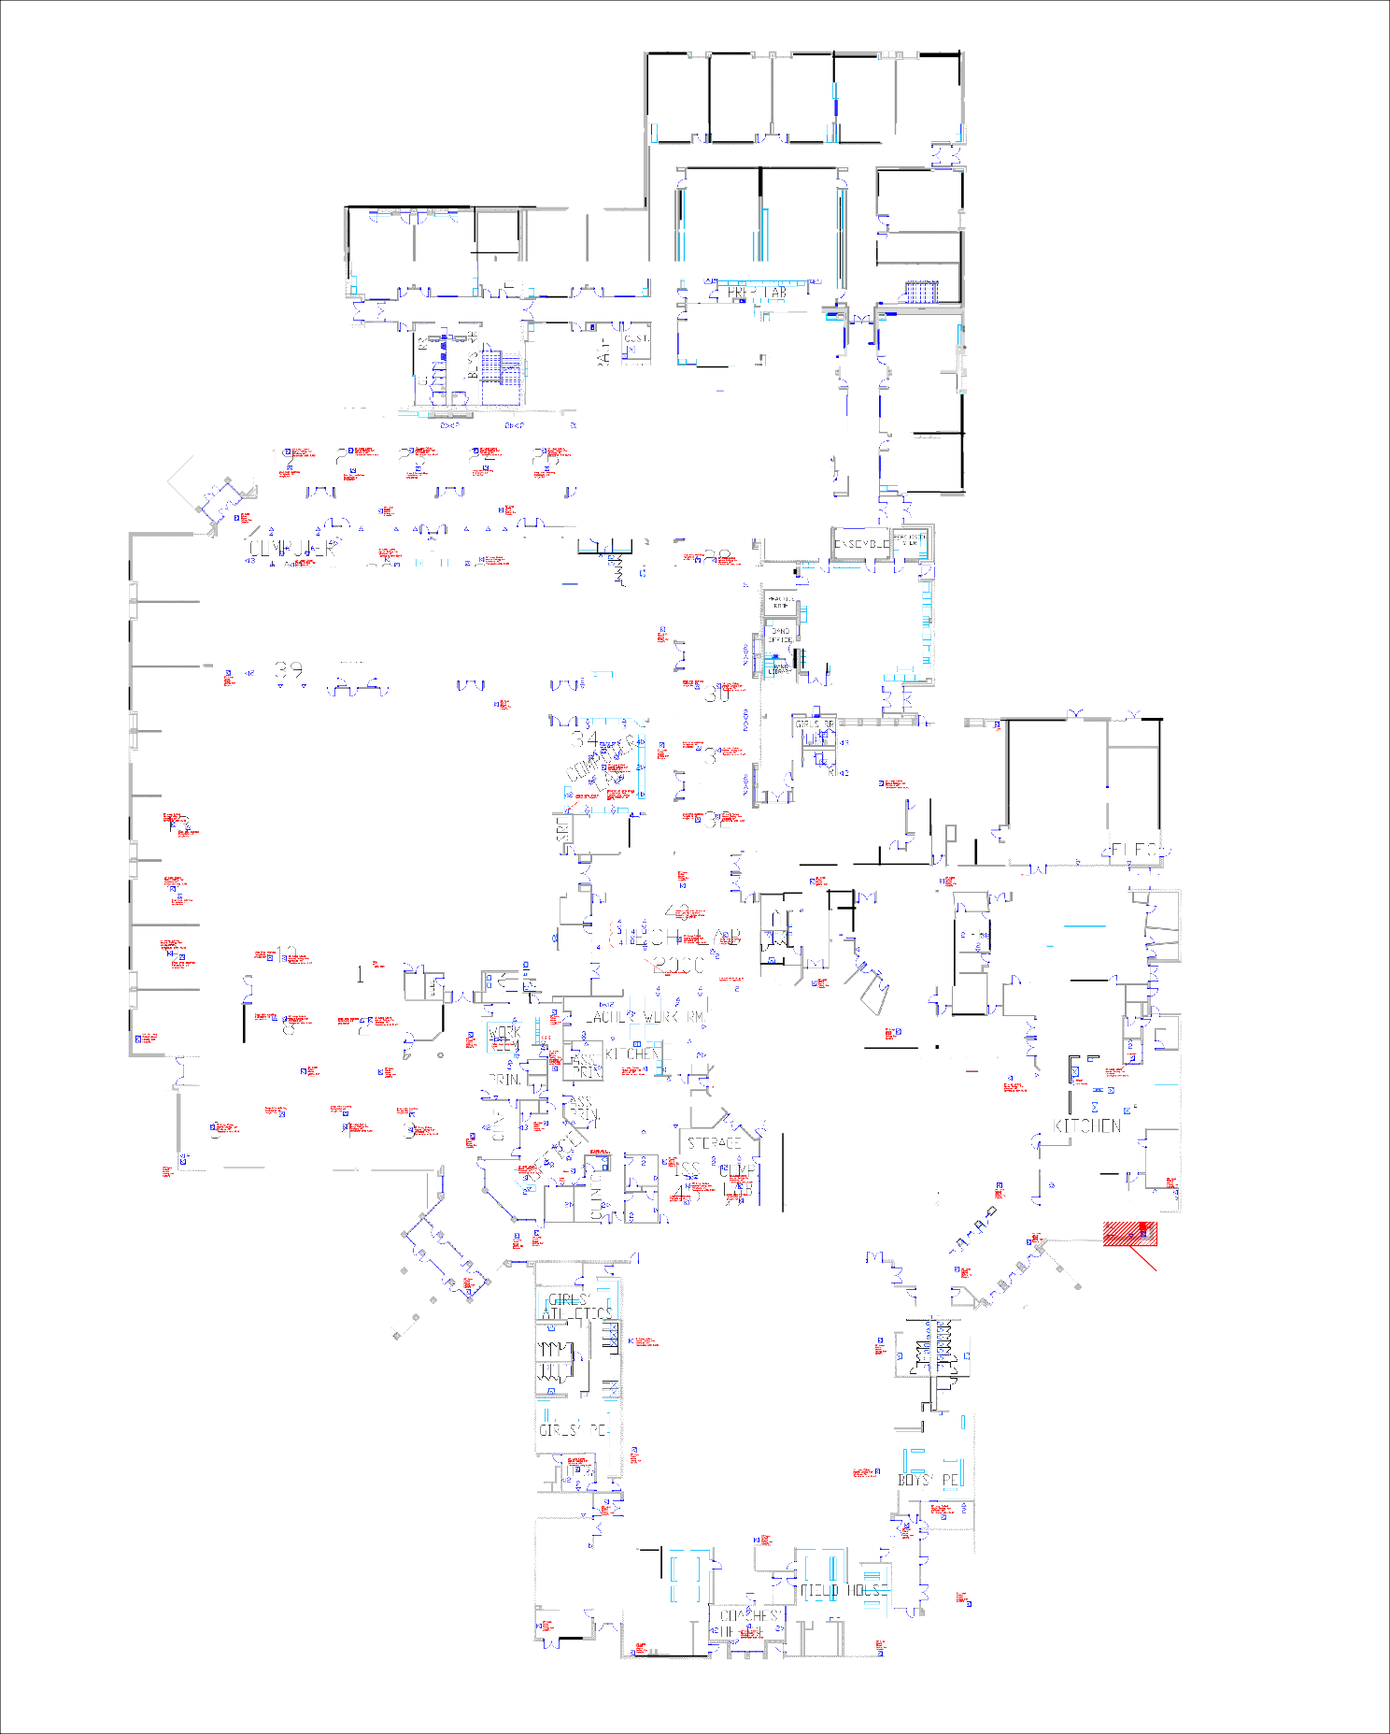

Ill

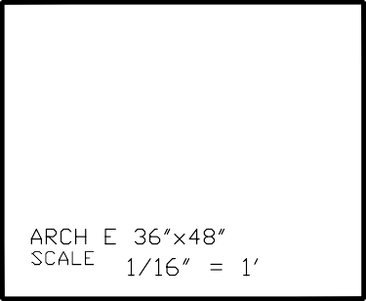

MDF-A IDF - B

Cr=J,

=-"..--w

"2 :s."...--

"'":.

:::i

::.....
=•"'-=
"

GYMNASIUM
D<1 PD\./ER POL E DROP
<J DATA DROP
"
0'\ C IRC LE DENOTES
FLOOR DROP

SQUARE DENOTES
tSJ
CE ILI NG DROP

\ C J
.
) rl '

Isl
$::...·':
_'[-'

:::Oi:,.:.=...-. ?[
, =-, -..
" 20
AR T

.
p : :CD ® CD:: 9

rJ =a----- ""g .c.
02 21><12
407
g";::
405

21><12

403

e.'_"U:"'-151
20

KITCHEN
©
::.. -

2
□FF ICE
"2
-MUSIC
....... CAF ET□RIU M
:;-•-

i§_':
- C

. ..-....151
- ;-; ..---'A
"
s_-e='Eil

gJ---·-
151 ...,.
E<:J-----
MECH. "--:.·,...,.,.

"
- o
EJ-9::-
= •"'-1;] --
--"--
[g:£.":1>7Jl_} - _{l/} 2
f
-
o- " ..
rcrfo
\J
- ;" o")l '
MECH.
]

-\......r.../ e--.- j§t_J
- ,,:;v,::_CJ7C:------------
2
" "

5....
-"
- - 1>
@
- - rT7 1 1§.':

c ,,

:::: =:-
1;i
=--
- s.-
isJS. - "

C\_
Lff:"':kro-..--- -
sfr-

Is·ls_-.-
C□UNS,
"
g.e::
6

=w:-::­
(4J\

.,- L , .
.,.. -!=..-"t-.;·"--

,-lt"..U·:",-,.
410
02 ==-­
"
gJ-:::...­ -.,.,
Isl-=:!'-?-·--
4 06
21><12
,-=.­-
, ---
IZSI :--::.'".·.-f.Z"-"..,
402
[ B 2 1>

i::,....
"
20
ff- -
"
-
r: "2
s.- ·2=:"-.-:..:..

2N 2
" ·e-.e::.I>

IZSI )rr:.!C, t>
··=-.·=..... - -
l)IT7s
_...,
2t><l2
<2
106
--"--

<!=-::-
"
L=-•"-:'..=

21><12
- 5:-="_.....,:.
=:-:- I>

X
2l><i2
l':';l::,0-
02
::::,- 21><12

,,,
,,
=--X·

2 1><12

w.:::,­
408
·=··-
=::-
x
20

Isl & :.

'
21><12
l02
02

, v '
gc ' 2
'"
=l:!";-':i:,-

IZ,Sl:-...--
.,.
MDF
02
C "C
'
' 0 0
102
104
0 2 2N 2
203
20 1 2N2

1© 4

205
1'"... IZSt!l. '"f.-Z
207
2,
2, '
108
112

171 lt.'-.""!./::'­
2N2
-, -
<2
7
110

02
209
-_ 1:-::li ...,

<J=-lt-
_Q_j 211

2N2
2,

C
-­
2N2

-,i; ' - v

213
20 "4
215
04
[5 D H 41>

ee:
a u
,=;. .-1· 1,

°"'·::.-..•-­=
- --­--
TEST:IS .
3, g.e:: I>
ge: l><-li:£.-
_ /; v
- -=:."..-....12:Si
-i;,-':,,-... [>

309
307
305
301
2 IZSIL=.:'•
:=:-.".l..
, L ..,.,.-.I.Z.S,I
·=•=:-.."..::..
=".;.,,_
:,, .....,,_
:=...-"'-=
g
:=:-."".'l..
o4 01 4 40
'-

:, if... 2
"
LIBRARY
I DF""\..:7
°v 6.· -
-: '--'7.) .,..
=- is]
.)

C'\ "
-..
C'"\ \..J ,' 1':":i 03
SPEECH
2
05
n =I:'::-::-

I:'....
-- ri
"
r.::.,
"r.::., "
!<;ls_-
.
I]!]
----

308
171)t.'-."f.Z""..,
306
304
302
1s1::...-
E.-
--
202
, ...,
204
206

, .,.

::- [>

- -- ­-
V
gJl=t..-"a- .
171::.. ...
- • - =
- ­
gi lt.. -
1!::!1. ....,-
"
!:::'- El
"'-"
IZSI='.o:.;--'
IZSI-=::-;..;---..-.
IZSI::.. ...
.,..,..
IZSI -:.-.... -
<] =I:""
IZSI:=... --:...=..
<]=l:-""
IZSI-::..-. •
,.,
--- - IZSI
=- L'"'W:"' IZSI
=:-•....::..
!§'C t>
-

,J0_F2f=-= '::' -- 21><12
=- 21><12
g.c.
21> <12
.c.
g.e::
21><!2
=--
2 N 2
-/;.-I'"-
2N 2 --
21><12 ::...._2 1 0 21> <12 2 1 2 21><12
214
21><12 216
5..- ""

v :t£11,;,.,
=·-
V □ V
- -©- - -©- - -©- - -©-
V " v.l'"... "
=· IJ;, RJI?-'" n -
5.,1:E";J 2 1>
.)

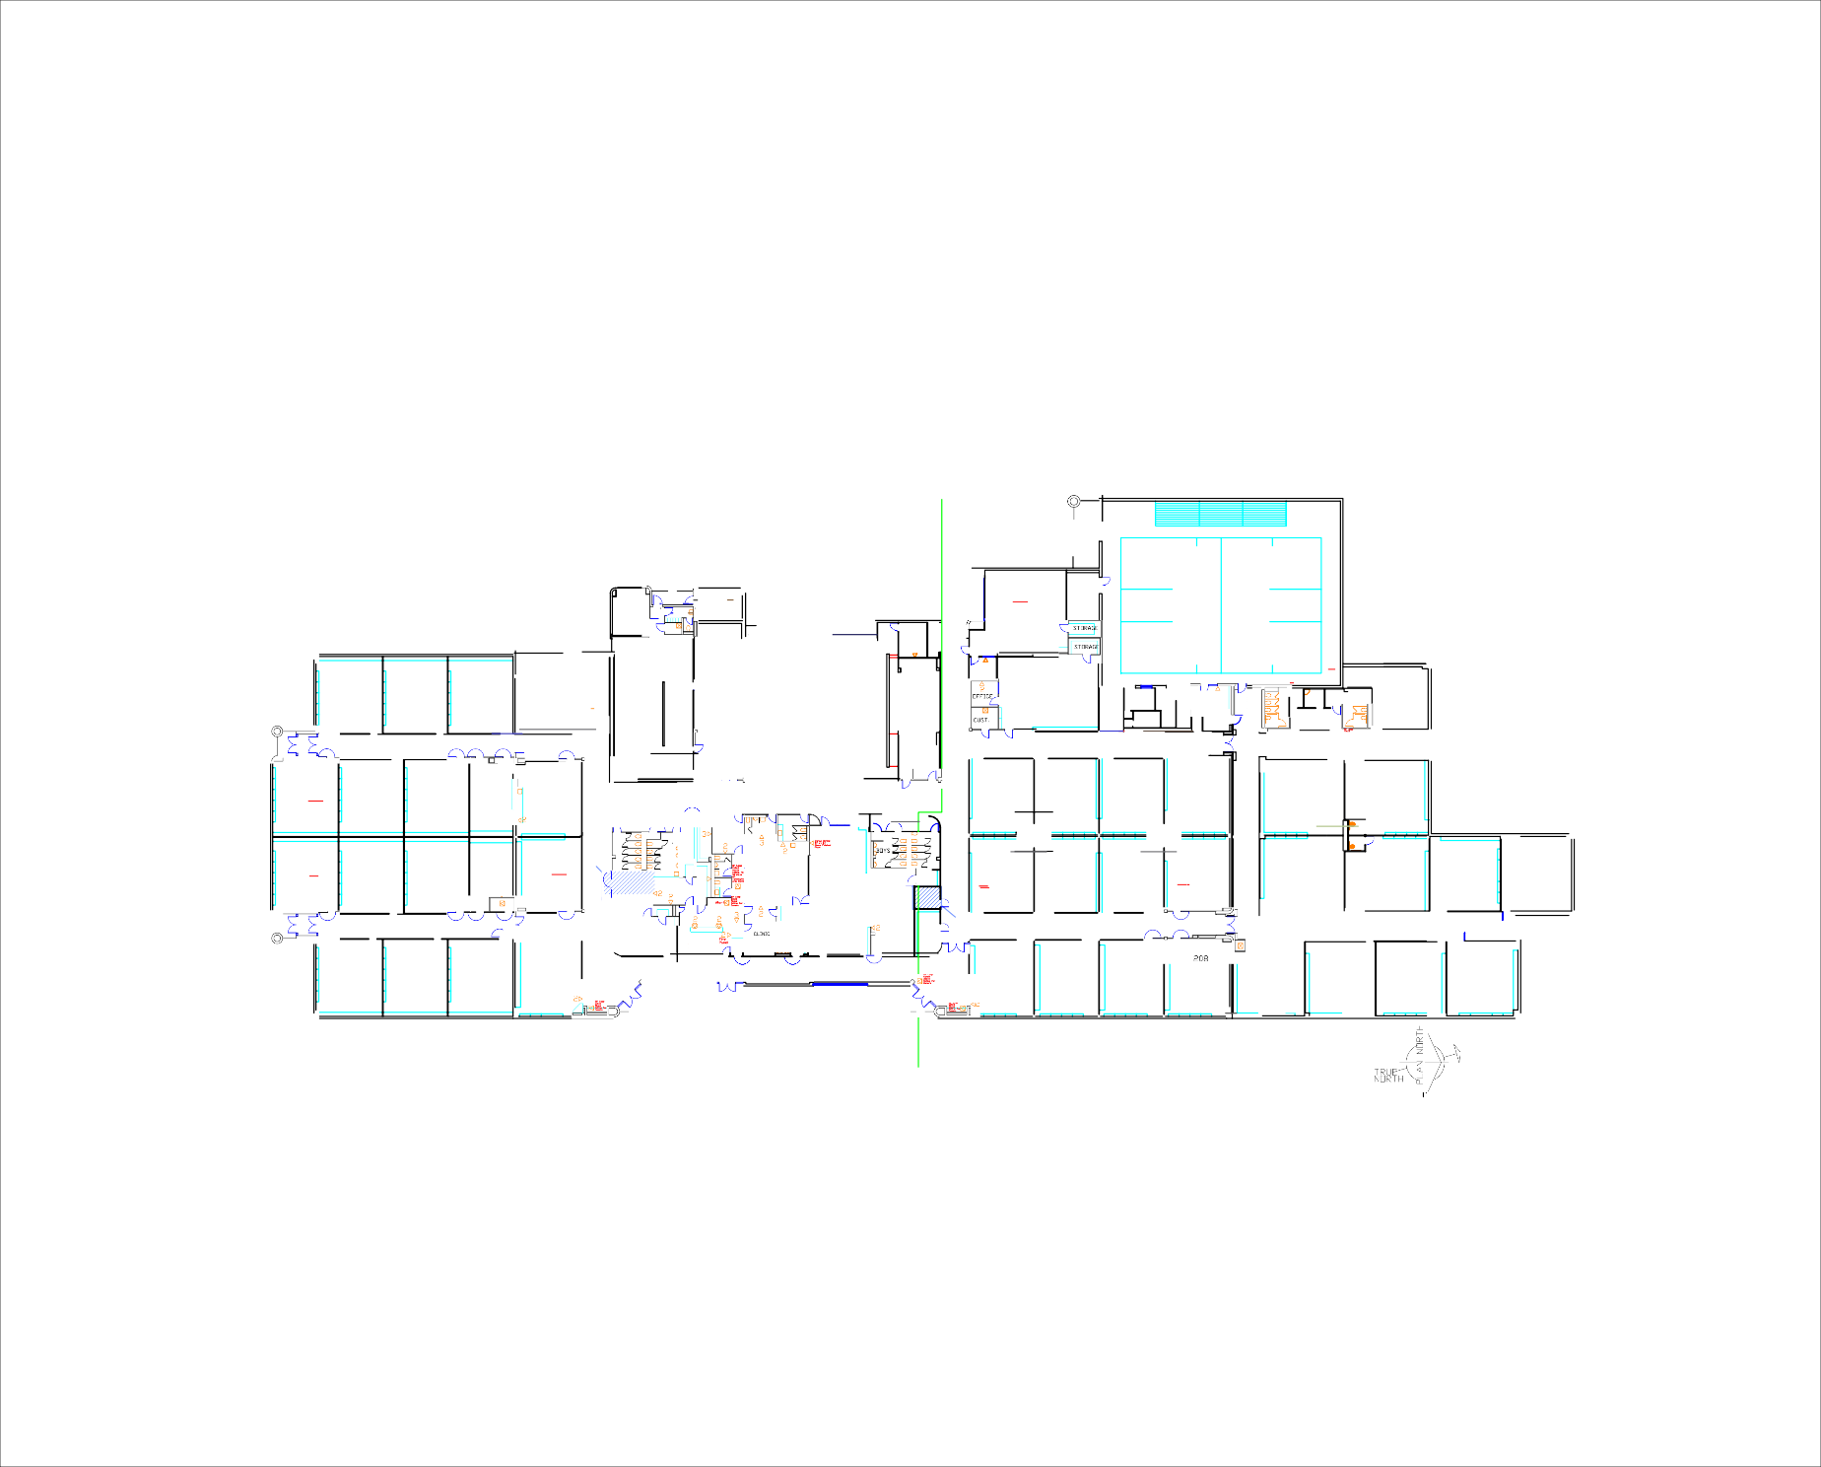
MDF - A ID F- B
V
V "

RUBY SHA ELEMENTARY SCHOOL FLOOR PLAN MESQUITE INDEPENDENT SCHOOL DISTRICT
707 Pur ple So.ge - Me s quit e , Te xos 75149

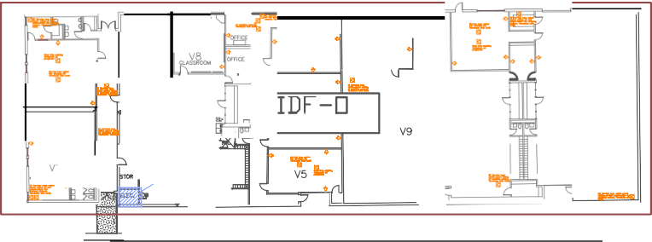
"•I"' -• •

"•I"'
.•...

... -•
12
I
a"I"' ·

"I"'
1A

,1\a
V7 ..... --

"I"'

"I"'

110

I DF- □ m:,1 =
' ­
....

MESQUITE HIGH SCHOOL VOCATIONAL BUILDING
MESQUITE INDEPENDENT SCHOOL DISTRICT
300 Eas t Dav is Street - Mesq uite, Texas 75149

A·,6 --

A1'

A·1-2 -

A10

0 2 I
..
l5t a"
,

CONFERENCE
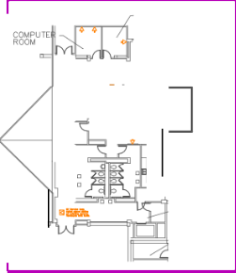
0000
.

\ •ORK ROOM
B
.
G

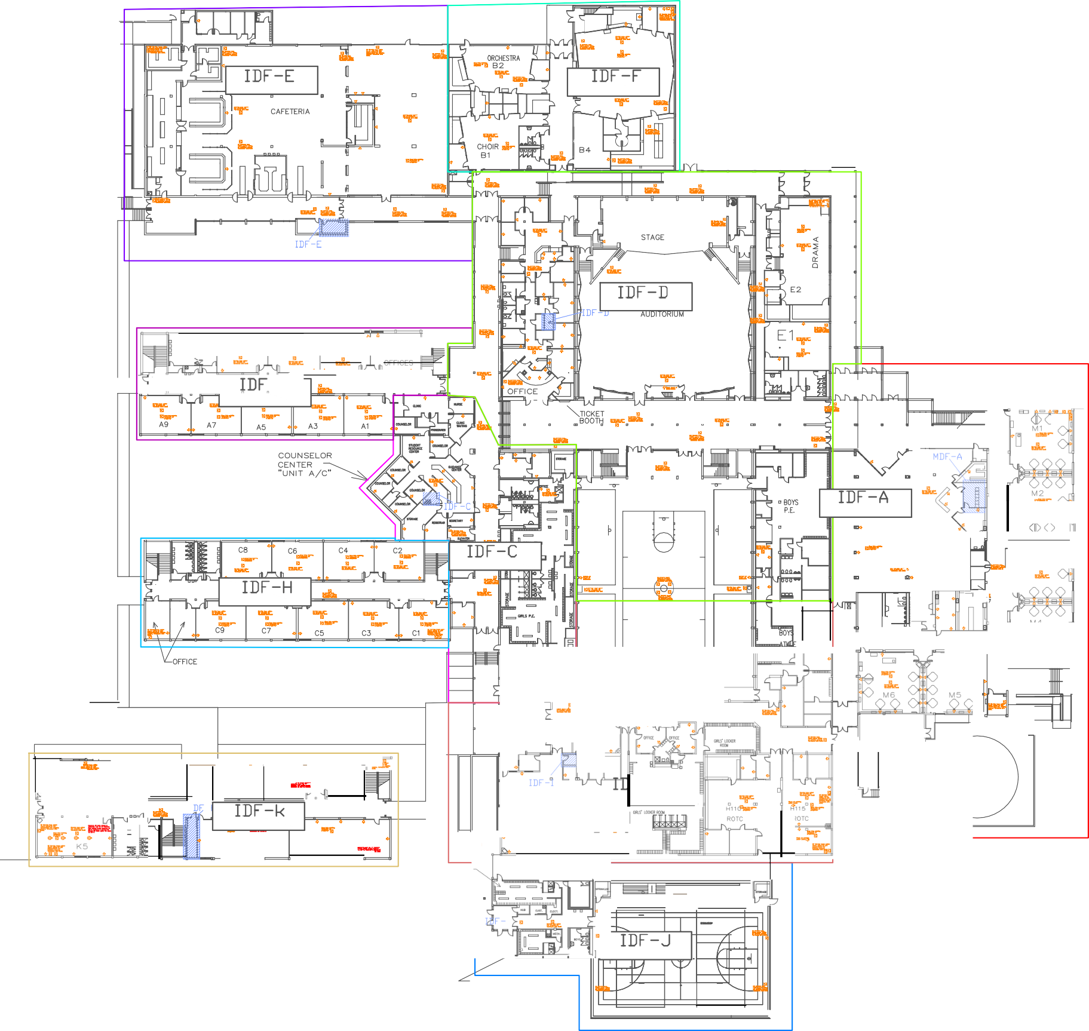
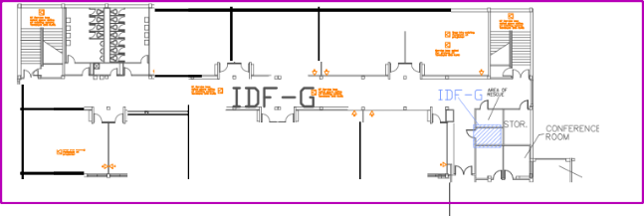
.::.0

".F..•I• IF
"I"
A18
AP
..·:.-. -
".T.".
·A-15·
A13
di.<

"I"
I D,F.,-....
ANITOR
- A-ll-
ELEVATOR

2nd FLOOR - A
WORK ROO'-'

EQUIP ROOM

2nd FLOOR - A C

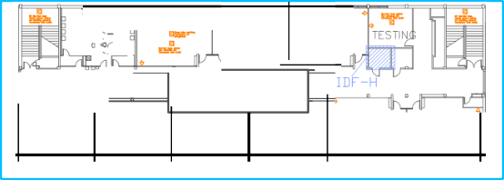
' • C1'

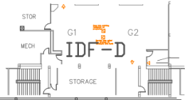
C12 C10

I .- WORK
,- ROOM

.::•.•c• I
. . . IL.
- -IDF - H ....
--
·--
--
..--i.
.
--

""If
C18

""If
C17
•T•

""If
C16

"I"
C13
- --
Cl 5
"I"
- --

"I"
C11

2nd FLOOR C

2nd FLOOR - G

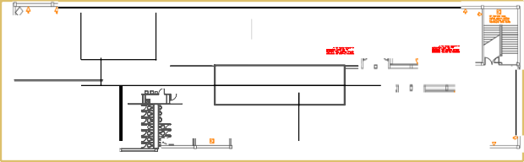
0- "0- 'II o1-'lf9. ....l,jK:10 D 11> l0- o,Pf;K' SII II> 0-
·-
K>6 K1'
--
- -
j,,, ? I A•8••
T AS AA 1 7 1 I I II ":,; ..:.c
-... .....,.., 1h
-..,.....,..
,1.

·-· --

- '"18;1a t

- . ., ' I
•
  - ·--
-
on "1 KS -
iffJF - K
..•.-.r . .

' II •
K15
-•
    - o-'l';a:-....o- 0-
2nd FLOOR - K

IDF-B

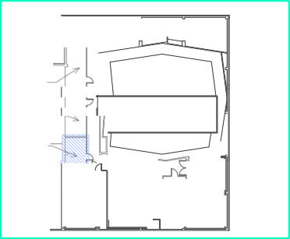
, Jo.II _,..
1 7

. Yv-i" □ -
_f:;]11111111111-11111111 813
I 1M
diic

....
.i..,_, 8

·-- I M3 j

      - , , , , , , . 812
.,.,....

L
-,. 811

d' -t"I"I"

f 1 □ '" H lltal'&

fE
: rv'-""= a,o
,k B9
UL
SLJ ,_,. ..
, ' " IDF-F

n
r-, "

... -

...

JY1.JY]F * I

"I"

-• ·

41 a;

.....
CE -
. . J r-· ..
-
.Ji,.
□□F"

ECH
RM
s s

COOLI N G
, I DF ! F .
LJ BB• ,lee I 85
1
2nd F LOOR _ B lh =

..!. p K7
,.---'.--J"-- •
,k ;-,,..
- l •
I -
A• - . ,
K4 '""ij.f'""\
K2
...
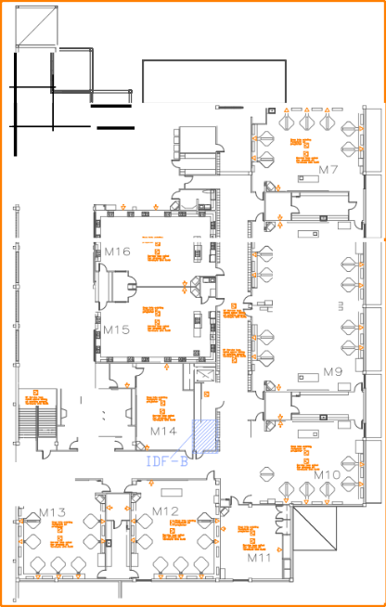
- - -r&7 s:. □ .. 0:, .. □
r

TOWER

2nd FLOOR - M

I
•
0, .... 0,
- -
v'!"

if!!::.

• "ill2: •
K 1 -· -·
--·
-.....
GIRLS' LOCKER
"
•
.. - 4 .. ...
d ii,,.. " m " "1 I
.. t, Hl03
TECH 2000

ROTC

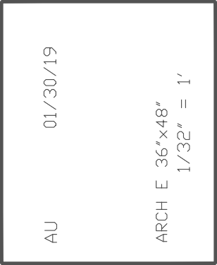
L"L"' dJ..I

BOYS' LOCKER •
,,..... j Of" ;o

MESQUITE HIGH
SCHOOL
SECOND
FLOOR

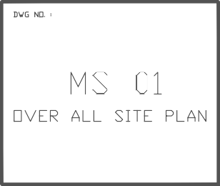
MESQU TE H GH SCHOOL F RST FLOOR
MESQUITE INDEPENDEN T SCHOOL DISTRICT
300 East Davis Street - Mesq uite, Texa s 751 49

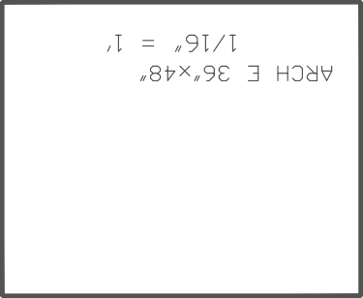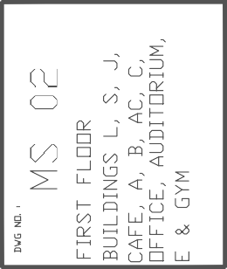

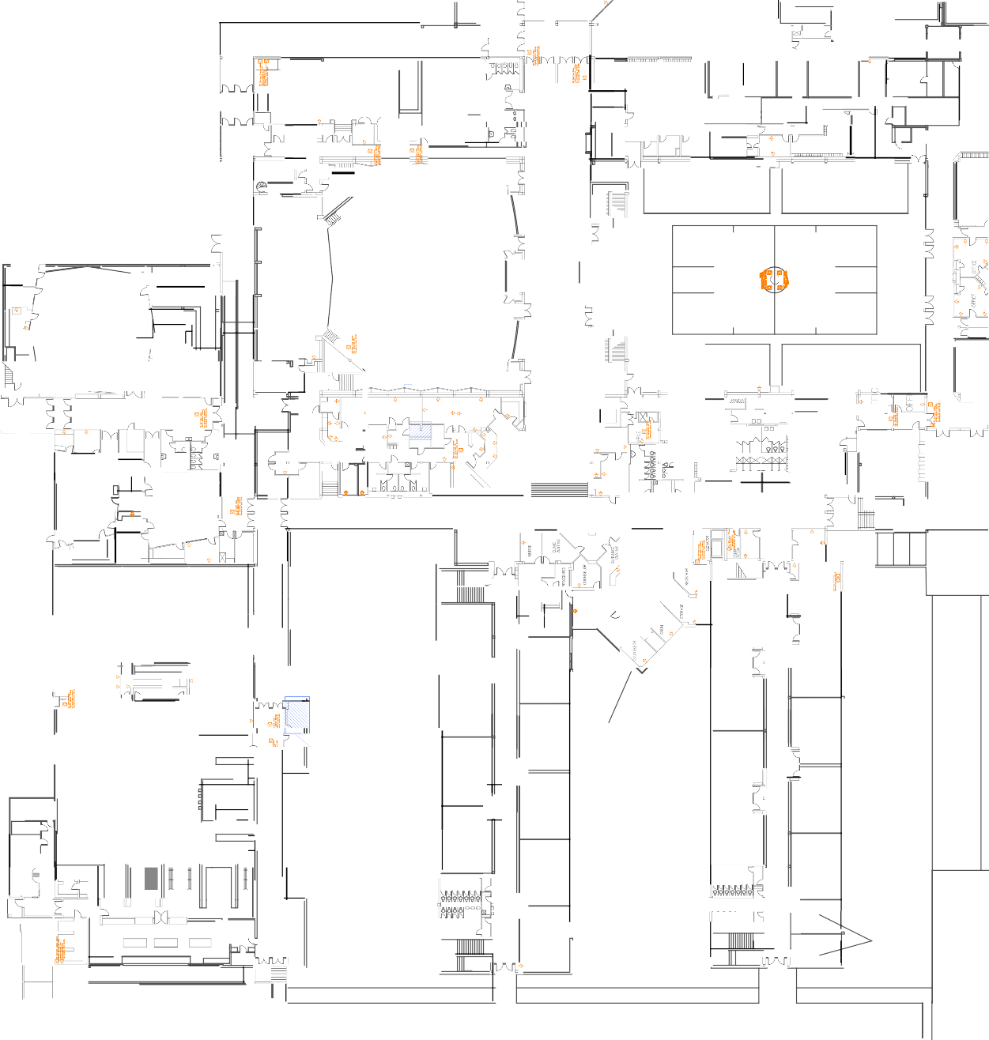
l_ _J

g

itt
" g

111111 11 1111
I :::::"
,11• ILJ 0

0 I.J... _{Q)}
11
:;:;0 _o
Q_2
s:1-0u,O
□ H e I iJ=.l, 1JiI{! liJ FD ..2..=. v =
"
FT C ==1=" ==== === "1!jli!jl'i == '-,:S

N '-- _c _c
Q) +-' (I)
_o
0
ISZI1fi
!l!l
,,"«I

= "·- - E _Q..),
vlAlvecJO
{, 1.• 1•i I
.I1i.'!

o...,, 0 ::J •
-+-' L Q L
U) '-I- L (l)
C C
•- C C Q) :S:
2
0 _o 0
OL(l)C:,
_(/)cE.o >,

"!H 1ttirs2I
N <> i!I" "lH
w
w . lkl- 1,r = °' e
1

u>;- .
ow
m Q_
□ □
"◊.

MiJU
fy
s11-1 cr,,...,,w'.'.li-,
>-
0 f---
□
QJ

• = · ::
311r,
.,

0 . _o
E u
6 ==-tl R

L ..C: (/) -C:,
0 0 - Q)
-,., LD Ql 01.J... -,.,
0 - 0
O-o_o-u,
L O- !......
-+-' C O - ·­
C O O -0
0 l:; .(l) 0 (/)
0 (/) -+-' +-' 0

' 1s2h1J
'ill'

1

1211fii
!iii

.1,11'

:SC
:::J
Cl'.'.

I,! Cl
I1,j!11S21
e

e

p
IQ!1fii
!i!!
D

D

:co
Q
"1,,,1:
m

--□-
",I
I.I

I,!'

--□-

CD:

9

- 'I

"
.i 0
6

!,n
I11I• "
!I!!
5i
"!l!i
,,,ia
!,fi
w
(5
<{
f--­
(f)
0
f---
0
:::J
<{
e
121,fii

s:°
".1',11'· F:
.! :9
"i!i

,., {, 0Zn I,! ,1g
!ei!i

- ===lLlo
I
1'!,11121 "iH

,I

[Il
It,J!!1S21

"1-
.I',{·
"

r=I
I
I.J...
r=I
1"t1i''IS2I
f--- :i:e
Wf---
"U'0o

_Q_

iii

J,!
p
- 1!
I,!
_Q_ 9

'.:7
C J,,
lfi 0
Si

" ,lI'f-i
- C ' J

[Il
f--- rn
/
" w w "

,.,
I,,,!i!QI

, 111
8

,Iii """
'
e !lli"
?
w
·= ="I
I I 0
,
e<
"-' ''': JS9 ! 0 (
=

=
= 0
w 2

J1I1•I ISZI
!J!i" _{I}
uo,---

iii o 1 11 I I
e
/ B I
0""
I '"3 I
!. "
"'I' C

<C !i!I
f---
" uw; ,.,,
D"
,,,{.,,

,Ii
fii t I I ,e, IKJ•

' '"
' '
"
' ""01slL?i
I

3'.l\/ Ol
JOV OIS
l l C z- C
' .,
<I-

I N 1 'i1"
ffi !
0
f,'

,Ii

"•1' !rs;:i COl'.'. ,-
I, ! I [I]
•
,IP,
•
!1!i"

  - 11.,1

' '
,.,
1t

1fii

,Iii
!I

JOV OIS
~
rs;:i11it
1111 "'1I•lI
AF°

C

1111

m u

,11•
I
.,!,fI i
.l;,i
! ! 1e9121
"!l!1
El

u
_/r _ _ _----,
r=-I
, ,.I
I,.

V
1,1I9
"
0:::
0
0
_J

1211fii ,fii121
Ml ,lI'b
- ◊
□
□
m
_llii.
e - s I

z

a cC
I,
J•'i LL
f
" ,., i•ll 111,
,l !
i> i1ltil'i21 IS2I -u f-
·

,.,
1t rQ'I
0u
N Ul i> 0"

z
""" I,
C
(J)

1,1 "
,IP,
l,i <t w

u u u
s0 ,
!'ii• 111
uN ISZI 1S21 JJ! e z
0:::

,,!ifi I !!1" t::: 4 - -
U
:2
i,!
LL

121J')i
r JI= n r l
t 0 C: I.
i.
e I I :ii
::/
"r""

!l!i,
11(1
V • e
1.• lH I
1
z 1 j!1S21 121 n

, 1 1 11 ,t121 121
!,I
!.
I.
m •' C
l,! u
_J
"

= i,!ic tf !LU 'll =
= =r ;i ' h^{-"}.'8?',,. e "
u 'IH""'!1I' e C "
IS2I IS2Ii!i

<I-
0

'<T{ " !,
<I-
I,
,qi {,

,lij •·t
6 I u
i> "!!!le "
- •1 0

m=J
I :m 2$;'?;?:?: w
i> e,!!fie "rj•IS2I I,SI2I
,c, l1,jt1lS21 ,I!S2I U)

I J 1,1 '.2
w_J
u
er: "<' e f.
::r::

<{
r.

Cwl'.'.
f---
uw_
11: • I.J...
!,! r=I
lD l 'ISH2I rsil "Jj'' B
1l i
<(
B J •4
(/] w
f--- f--­
z
::J z z
0u wu,:::i
ID i1i2i1 IS2I 1•1'! 8 8
u I,!
"4
u
(J)

<{ ,
r
lpli I
9fii f•

::r::

. □ u □
z "!1!1 ,•1'121 1lSH21 LO
c1l ..r
z .1!!
f,
1,1" i ll""
I'!,! "u
C)

::r::

11!
,Ill f. e
co "m'
t,! □ "

11?121
"!l!l
ill '·l C "
u 1S21 1S21!r,JI1

,11• l,!

I
C<Dr" " I'!,! "
,I.
I, w

,,!JI!!
V
c;: ;;:-')
D O D D

"II IS2Il ISl2lI
C I'!,1.
i>

i>
DODO
""
<C

0 0 0
".,,, ''ii'm
I',!! "u
  - 4 w
f-
=:)
a

(J)

C I z TT l l u w
u_
DODO S--Jo ' 0 2

□ □
l
t
,111
I!

on□□
1, !tt m I I
,j! 1521 IS2I <(
u_

4 I I
1il1

l2I

I I
W' I,! IIIY L ,jiriljSil

Contractor Shall install a 24 strand 50 micron MM fiber optic tie cable homerun from the MDF to all IDF's. IDF K Shall ha ve a 36 strand fiber. Cable route shall be as directed by owner.

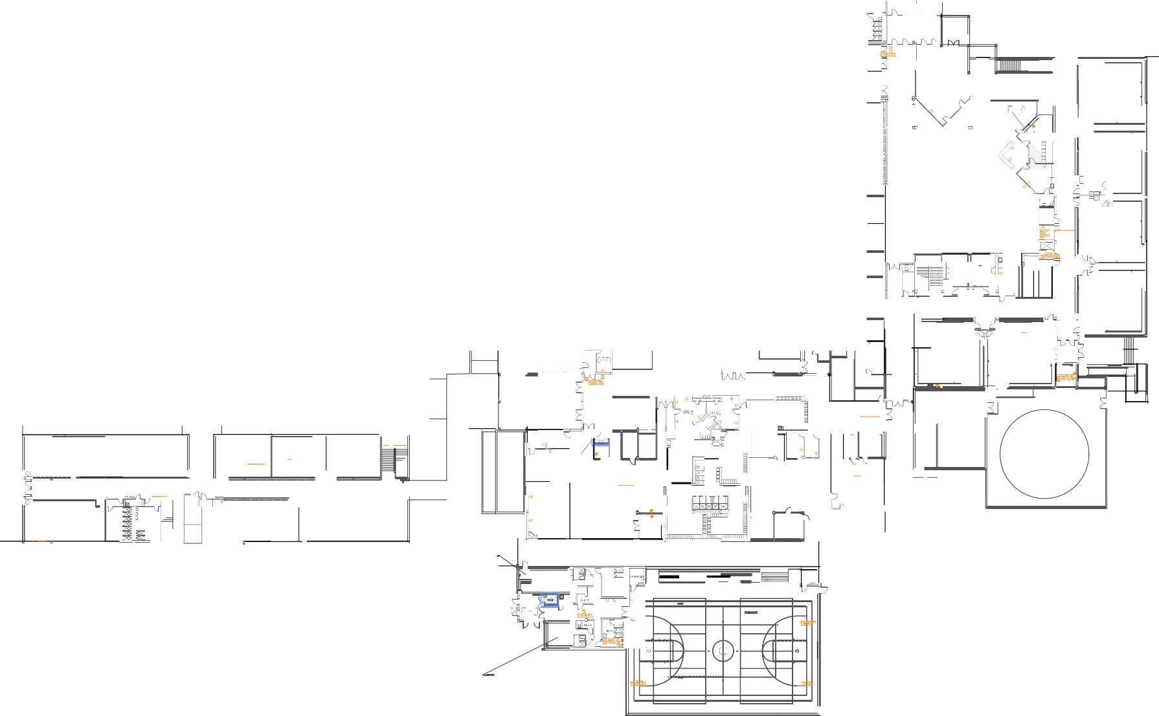
1 1

= c. ca EJ '

0
--==-----=
-"

---
"-:...
""u

E:J O •

MD - 5 Z'o=o

J -
□ 1
--=1 "
q
o'il== ox a◊x= 1
M 2

o L I B R A R Y
--.... I:;]
    - ::."-..--:.."':...
LDJ
.,.=-:=-:;"- 0 I>

CD<> B

gi5:r-
""
<]• z-::=_-..:, 0
p
D 'JV() o

s;:--:;..:::, EJ
"' !ID>
"-"=--
□
: t:?15. <·LroJi
M =·- - O ·D
!:: -=t
ot>

,,.::...-:..-:...
::.".."%E..J-:...""'_{i:..=:--=-}
r-=:-.::n.

l )
7 67
..,
<>
·=
- o7 o7
I<•

•
Q O O
l L.B XB XB I
()()()
M4
roi "=,... O ·
LJ " _{D}
<], S:::---i=i?.:. 0 I>

- D 4
L
1 □_{I}
=--

6 0
I -0-1'
I D= 9={=y o

- ,--. -t:-:,.."1:s::1::-
L
o o = ·

T R A IN I N G R M
(;, oo<)

E
Q
Q
1-"I I <
"
- ... DD

V n-fF""'Hc
-n--n,--
,,....-

Q
I
D
- - II <>
0 0 M6
LAri⁰ 0 0
J
o o
_ 00 ,9 L 7 = '7

nl l

0 0

EJ .::.

0 V
5:=El:---
i EAM ROOM
--:.

111 I 1111 1111 1111 11,

GIRLS' LOCKER
ROOM
r:-=:o..m

,::;...='":.::.-,=.":.-,,.&I
'

E CH
I II , _. -

- --

JYUV1"

D 0 D
_
=-
-·­=--
,c,' _ _ --dJI-:
0 9 c6
D = o:Jv\f' 4 R J!
I RM

;;;.. .:::-
T-
-
-·--.·.

:-::---.=..-,..
:7..-:'_-.:::--:,-:::-..,
·• e:-:=_ic.

:-::::,::,,-ll::!-
J'.l...=ir
-··
...,...,..
K 4 fnfi,.
fii R6
"E;l=-
- - ,.,.r.:---

=......
<>"
,,,, _

K2
=-

I:: /".--::-

7 1

4
C O O L I N G
--
I DF - 1
TO WE R
<>
□

" ..
- ,r;,
=- 1:l'r"
Isl " - -::::---· "

- K 7 ,--- - - - - □ ?
- '7
0 0
H1 0 3

TECH 2 0 0 0
- -1,
r = -
:,;;-:.=.'::,"'. ..- lw<'I
=::..--
1! JIIlI

--a'L
I

o=
-
IDF-K
""""'-I":.":-:"-=­
0- □
- [IJ ..!='1":=....r..:. □
GIRLS' LOCKER ROOM
□ e:f ""
H 1 1 e,.r.1<1-= ; •
:r. "□
H115 b
=""'I'=,;;
,,-..,.,.,..=

0 0
*© f?l
@ •"!!"@• @• @•
.•□D
©l· ©l· EJ ©l· ©l·
Lr1
1;/;-'.;1/'.
" 4
4 LJ '4 'J; . )
. - . , <>
·•
ROTC
RO TC

:..-.=,--'::.:'-... =EJ_r.t:,".', --i,:r.:-:-..----:- -.-. -·-­-
$$::::"
-d•' -•
=t:.i..
r:- ₀
00 ,(> •I>
,_,_J\_
4• q,_,_ _,..

=..."l::r- =
- "
n
:- :..
□ II
• "

===-=--=-"-t--=-- K S
U I t el
D □
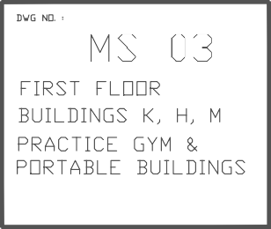
-"--=
=
K 3 :."..7-'::.
K1 ..::...,.-:;=:-'..: 1:
I! '.":".=
0
= ";' -

Contractor Shall install a 6 strand 50
micron MM fiber optic tie cable
homerun from the IDF-K to all
Computer labs on K Floor. Cable
route shall be as directed by owner.
GIRL S' LOCK ER
R
0
-' ==
0 ===
CUST.
=:.:-:":.--..,:.-,
I d I - STORAGE:
, " d

- i!E---.S
0
i= " "
) =
'

BOYS' LOCK ER ".
&I "::;;_
_Q_ .I
, $'.:;",':.',".'
"
I _Q_ ,
-"a
:;:::i

MESQU TE H GH SCHOOL F RST FLOOR
©l• ©l.:..J;L ,2 · ©l• •I>

COMPU TE
ROOM .
CONFERENCE
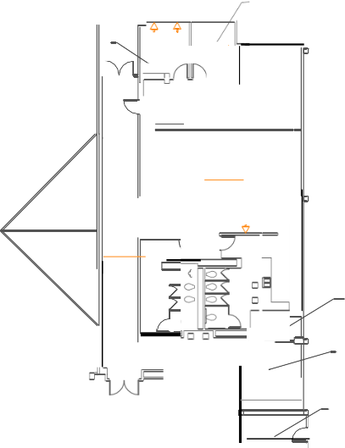
ROOM

JI

n a "I 0 0
::..."-:."':.., 0
0 A16

:: ::::-.,;n,, 0
-i;;
,0 D

,[><J•

m n n
A14 A1 2

•N•

'l D 0
A10
=
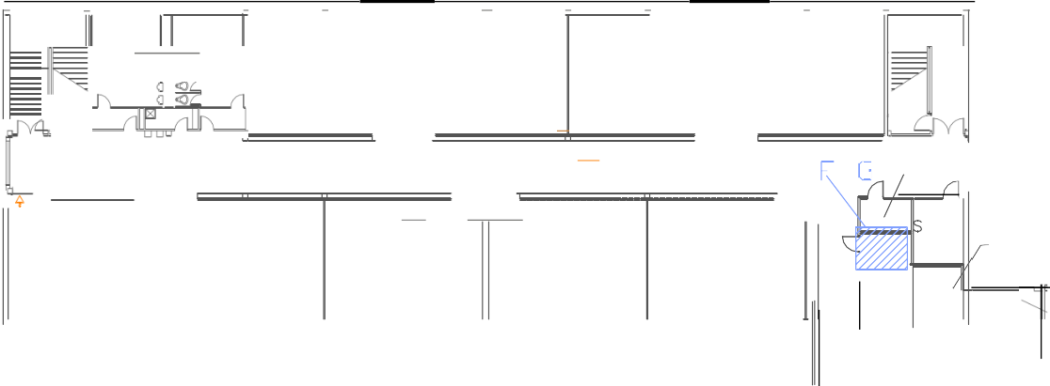
ID I
"
sz..J B
WO R K ROOM

0 "' 0 1s:J5:i=:r" El;;J:'3.- Isl -------

$_::-0
-;.-.:":.-t:' ....
J8
Isl

□ ' "' D "
" " .,.,
--"-
::...--=..-:.. Is-l -

E: -:.t:. .:7.- ::.-...:::'II."'
•
'::"'
i:."=:-.ir:-.:. r

- i5-.,:a-.E::1 B:Jr,
0
w
_2
.

0 0
ID 4RaRsCc•u,OF
EACHER
LOUNGE

::...-:..-=­
=

E: -:.t:. -=-
* * 11 .:A
l:'.:.t""--
--,-
i$..:a -
0 0 ill'J] i5
* *
TOR.
i,r-:.t:.

CONFERENCE
ROOM
::.=:-,=
"
"
0
0

0

J AN ITOR

"gJ=r- Isl=:'I""'
"
gi=::- 1s=;1"---
Isl=-::-
::.'."."=--:..
ELE VATOR

A18 •N• A1 7 A15 •I> <I' A13 A1 1 ,o- rvij

2nd FLOOR - A

orl

WORK ROOM
Isl =
1\_
]ID IO

EQUI P ROOM

::..."-:..-:... 0

7"°0>' '°'-

D C1 4

•l><l'

•t> e::-e=_:;::,

- -"-

2nd FLOOR A C

r -::::-.= D
<O 0
C12
C1 0 " "
$'..$.

D - "' D Isl='.\""" ls:J$::r"'
0
o
,0
<OL 0
-e.::-::"-_-......
e,E":»_:,
.
-
=:L"i::::.

Ei;]t:.=::-0
TE STIN

"'l)'

\_.J_ "

0
:::...=.-::-..m- """"'
**

w ----"- 0
Isl:::.:...--:::."-':-o=.
* *
0

0 rill 0 ¼

STOR
liJ

MECH
*
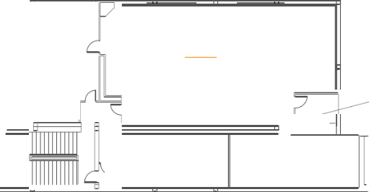
G1 - G2
-::,-- -r

, i:--::::f,"..'. ,i_:-;,,;-;";;".";l;f."..',
e=--r-
-::.--..::-:r
E==-:.t:. e:-::_i:;::.
WORK
I b R OOM
•
8 B

"-=-" - ,",₌--··-
"""=---­
I"sl=-
1"s=;1"---
"E;-J=--."t:r-

8 B
11 11 11 11 11 11 F

C18

•N•
C1 7
C16
,,a, C1 5
C1 3 ,[> <], C11 1
STOR AGE
g- 1111 1111 111

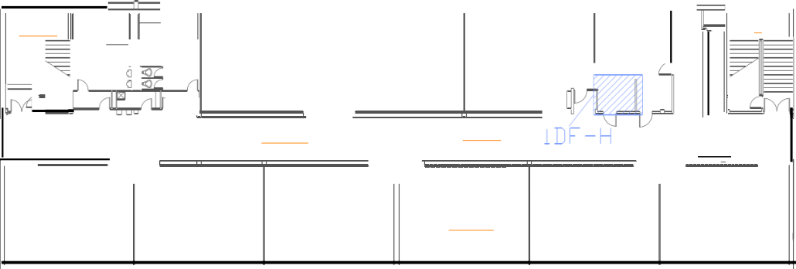
2nd FL OOR - C 2nd FLOOR - G

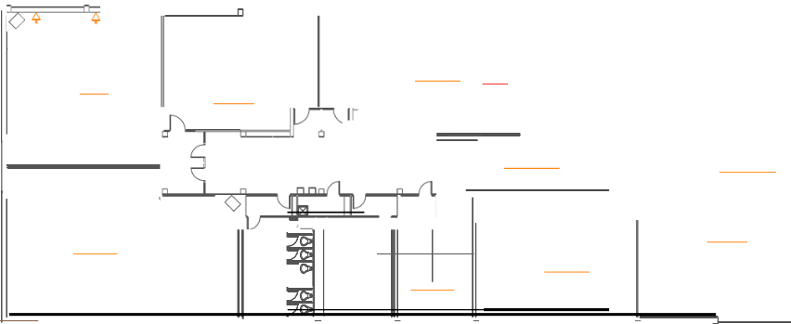
K1 6 ""
Contractor Shall install a 24
515',
Isl ...,
4
strand 50 micron MM fiber optic

•l><l•
,

K14
©>- ©>- l?l ©>- -El- @-
I:'.=:--_- .,
"
-:::.--..:-::'II-."'

K12

ee- •O
--..­

K10
r=.=::-
@•T @• ie;",_,;;; @• @•
---

<> KS
t::.."l:r"
--.-
©>T ©> " ©> ©>
1:'.=.-:---

" ;-.-."=-:...

tie cable homerun from the MDF

1:-...l:::f"'
r-
*
0 *
i

i:c-,;,, .::."
1fL-- 'b·----­ t> D lr jl,lj lJ cl
5 l.. /1fit"\ fi
i=lf,'!f-l::: •
□•
,.-=,:-- ;:;;·; -.--
,='l..r"-:"-=.
□ 'O' -..- ; -,:

to all IDF's. Cable route shall be as directed by owner.

.;
i 0

- o, D
"!!--""::-.1!"a

.
:c..--.-==--:...",,",' """"'1:·.-"..':.=-:...
' =:,/'...

* e- -'(:..·:=Ir.*-

-o -,,
=5""

';'":""" !,,:"':I!..-;:,-:..

..=g]_:i:;:, E;-J--=,:... 0 D
  - 0
F:".".=_.w;:. =--" ....
©>T ©>
I-:'-."=.:.----
€), €),

K 1 5 .,g
; e'-=
K1 3
'""
K11 "
K9 <>

=='1 u
u 0 "
0 m 0

2nd FLOOR K I
v . 1::,. = t:,. = t:, =
□

l!=l □□□ LJOOO di lfl :i!a".
-r=-.=,:,:-
M 1 7 .;.:.
([) ([) ([) e-
9 = 'fi" D
e-
<l /'\ _q'ir"
;:-;.::::,,:...,
- M 7
1° I

B 1 2
"
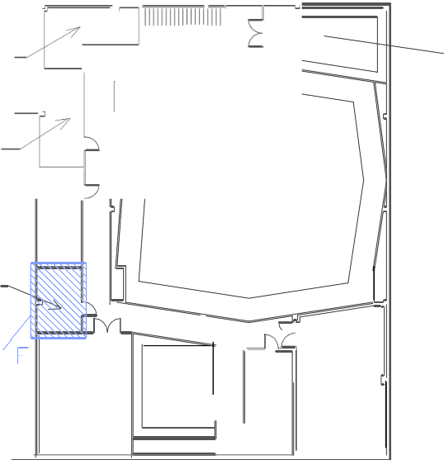
<:
B1 3

=:s
if.'" ::.
i
--CJ

-=g-] -
□1

---

"
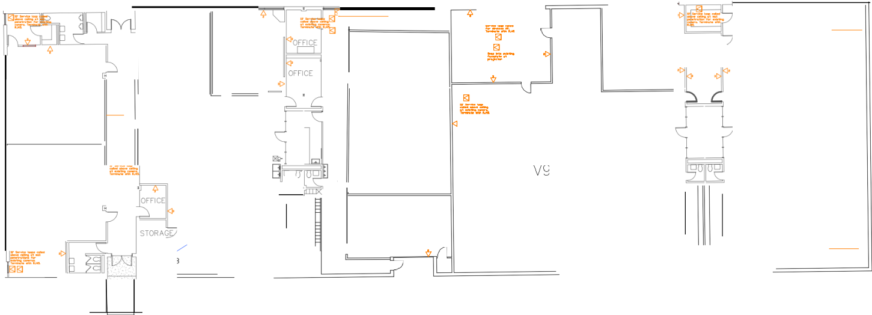
FE"..::C.
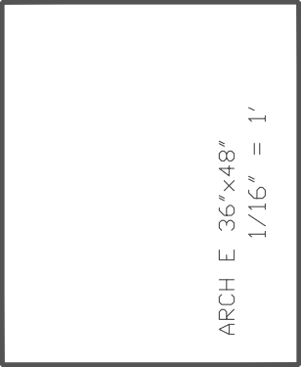
v"s

1::.= --.:,, -
--::---..-r..... ◊
V7" =",...

..r":.
"
$".'cl"""

::.:".-..-::::::-.,=-:...

B 11

B1 0
z
=- -;,
e_,-.,".=...:..r,-,. I
-::::M. 8

=fu
CLASSROOM • " "'

z::..,::_:i:;:,
V"2
"
'
.-..-:"::.
- ::-""="==-
----i\ -

<· •O
-:i::::.

e::..,::_:i:;:,
'
"
B9 ,

:...-:::.-:...
"
::::::-
- • =

) =-1,-
lo I- 9
D

E:--i=..r":.
"
= V4
"
..r":.
•
"

, ,ER=
V6 f;J &::- z::..,::_:i:;:,
"
<>
..=.,r.­,,. *
"

V10
"
IDF-

@J 0 C
B8 B7 B6 B5
-= - - - 11 1111 11111111111 ' - •r I
o7 o7
J o7

E: -.1.t:.
M14

IDF-

:=..-.=--=-:
--+
,sr:,, D
* r--c:,
ol
-t::,..",l::,-0
e--
e- ::::,
M 1 0 D

V1 IDF - □ ;!-<=1
vs !\k,-.
- -i:.-=-­:---ffi'
' I'- [' ( W W e-0

5, I II t •
MESQUITE HIGH
7 771

SCHOOL VOCATIONAL BUILDING

e,:..=:-a ::gi

2nd

FL OOR - B

;
D<l<·)

M 'i­i"
_.".,:t"

'v = 'v =

s-'!-:E:;J-

MESQUITE INDEPENDENT SCHOOL DISTRICT
300 Eas t D a vis Str ee t - Mesqu ite, Te xas 751 49
0 =--=
□ =Q9=9 c. , ::i J
0
-z.,:";i,:,--r-.,., Pl
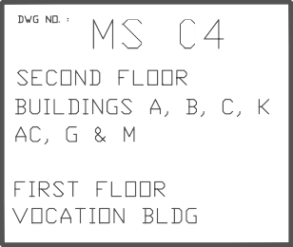
M 1 1

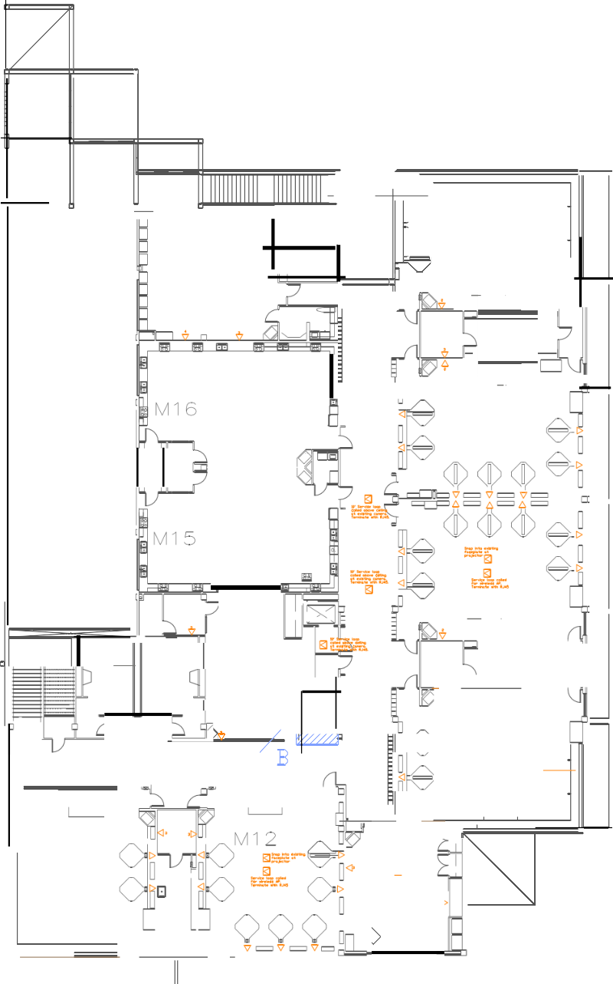
2nd FL OOR - M

