District Effectiveness Report
CURRICULUM
January 2019

Executive Summary

Mesquite ISD curriculum is designed to provide high quality curriculum documents, instructional resources, and support to all campuses. We believe that a strong, viable curriculum is critical to the success of all our teachers and stu dents.

Our vision is to provide a curriculum that is challenging, fosters lifelong learning, and is characterized as being: Meaningful - students find purpose in their learning
Socially Responsible - students learn to communicate and collaborate becoming aware of their citizenship role
Grounded in Each Subject's Content - students will develop skills, knowledge, and abilities for college and career readiness Emphasizes Thinking Skills - students will think critically, creatively, and solve problems

Our mission for the Instructional Services Department is to ensure that all students develop the knowledge, skills, and attributes they will need to excel in life, learning and work, now and in the future. The curriculum provides the scope and sequence for learning . The teacher in the classroom provides the innovation and expertiseto engage stu dentsin the learning process. Our curriculum staff provides quality professional learning opportunities in subject area content knowledge while expanding and strengthening classroom instructional pract ices.

"Studentsare, or should be, at the center of schools and schooling. Engaging students in work that results in their need to learn material that is essential to their education as citizens in a democracy and to their right to claim to be well-educated human beings is the primary business of schools" (Schlechty 8).

Sch lechty, Phillip. Engaging Studen ts: The Next Level a f Working on the Work. San Fran cisco: Jossey-Ba ss, 2011. Print .

l l P a g e

.

CURRICULUM
January 2019

Achievements

- Teachers have 24/ 7 access to quality curriculum that includes a scope and sequence and instructional resources
- Strong PreK-2 Literacy Initiative targeting improving literacy practices for both administrators and teachers so that all primary students are reading on grade level
  - Early literacy specialist coaching on every elementary campus
  - Teacher coaching for appro ximately 450 teachers for this school year
  - 3 day Coaches Academy Training and follow up coaching days
  - Executive Coaching for select leadership
  - Spring Fling and Fall Book Ball for all Campus Literacy Teams
  - Read Play Talk website and Read Play Talk fair
- The core content coordinat ors, with support from the facilitators, are serving as a viable support for campuses struggling with curricular issues, providing additional planning, resources, and professional learning to ensure teachers are able to differentiate and to help form a better understanding of
formati ve assessment
- Successful utilization of Edgenuity as a digital resource for credit recovery
- Provided Elevate sessionsfor administrators to have a more complete understanding of curricular issues
- A strong group of curriculum coordinators and facilitators who have great content knowledge
  - Stay current with the latest TEA changes and being sure our teachers have that information
  - Work on creating, revising, and maintaining quality curriculum for teacher use
  - Create district checkpoints with great correlation to STAAR as summative assessments to focus on areas of need and areas of strength
- Strong partnerships established with area businesses, churches, and community organizations support our students who are in need of food, clothing, and shelter

CURRICULUM
January 2019

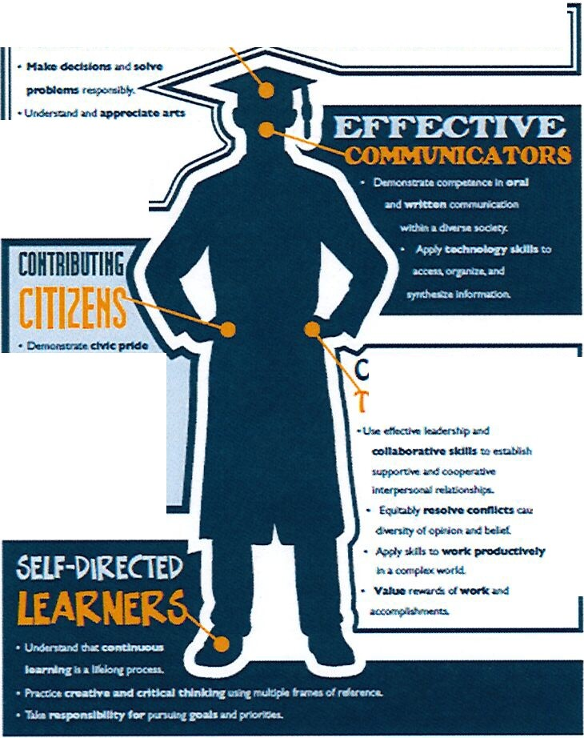Profile of a Graduate
PERCEPTIVE THINKERS- ADAPTIVE PROBLEM SOLVERS
- Pr tpll"l!.t.
-
....s...............
d
- o...iop ... Mil wj
-
...........-,..
OLLABORATIUE
EAM MEMBERS
-
-""'-
<ho
.. IICeldep•....Kie
.
- CONllcU ao.....io,
PRORLE ru GRADUATE

District Effectiveness Report
CURRICULUM
January 2019

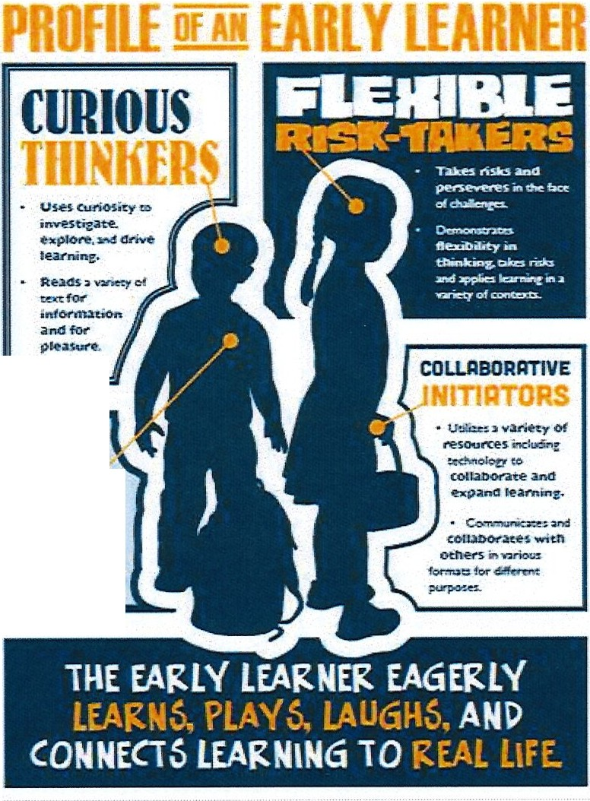Profile of an Early Learner
tlfllDllUI
..,,.._ __
br.;,br.
c Ssion
'IM1!Pa.th)'

District Effectiveness Report
CURRICULUM
January 2019

Challenges

- Teacher turnover and elementary teachers changing of grade levels are concerns for sustaining consistency and forward progress

- Content personnel work diligently to assist campuses needing support and to provide curriculum content and resources; however, due to the number of requests, often the response time is longer than desired
- The PreK program is under-utilized by the community due to several factors such as half-day versus full-day, lack of transportation, and location of programs
- Increasing the number of students enrolling and being successful in Dual Credit due to new SACS requirements

- Sustaining the focus on the PreK-2"d grade Literacy Initiative and expanding the number of teachers being coached in effective literacy practices
- Adjusting practices of the curriculum department to meet the expectations regarding lesson design and innovation

- Further integrating content development with technology to develop student and teacher competencies

- Providing every teacher in every classroom with curriculum documents, resources, and content knowledge to differentiate for all students

SI Page

District Effectiveness Report
CURRICULUM
January 2019
Description

Curriculum
In Mesquite ISO, curriculum forms the basis, the foundation, of instruction . It is viewed as one of the critical elements in the instruct ional process. The curriculum in core subjects gives teachers the "what" to teach so that they can concentrate on the art of instruction. Each teacher is provided 24/7 access to the curriculum, resources, and student data from home or work.
Curriculum is truly actualized at the campus level through comprehensive planning by teacher t eams. The delivery of the curriculum at a rigorous, engaging level is a critical element of instruction requiring in-depth study and planning. Scheduled planning for grade levels and departments ensures that teachers have the t ime to work through the curriculum together for a deep understanding of the TEKS and understand how best to present it to the students. To assist with resources, administrators attend planning meetings to be aware of upcoming curriculum and to assess instructional needs. Many campuses have participated in a district-developed professional learning on the topic of planning designed to help teachers get the most out of the time they have for grade level/subject planning.
The State Board of Edu cat ion has adopted a curriculum framework for Texas schools . The Texas Education Agency {TEA) website lists the standards for curriculum in the stat e. Each public school district in the state is required to use these standards to provide written curriculum for the district in grades PreK-12. The standards in Texas and in MISD are the Texas Essential Knowledge and Skills - the TEKS. The TEKS provide a framework for the written, tested, and taught curriculum. As state standards change, local curricula are altered to accommodate those revisions. For example, the state of Texas says with state-wide TEKS that it should not matter what district or what campus within the district a fourth grader attends. Every fourth grader must have the opportunity to learn the TEKS for his/her grade level in any school or fourth grade classroom in the district and state.

"The curriculum tells you 'what' not 'how.' The HOW is the artistry in education ." --George Couros

District Effectiveness Report

CURRICULUM
January 2019

Texas public schools have a TEKS based assessment program called STAAR (State of Texas Assessments of Academic Readiness). The TEKS are the framework for STAAR assessment objectives. A thorough understanding ofthe grade level TEKS is essential for student success in the classroom, on the state assessment, and as reflected in the state accountability system. STAAR is the majority of the accountability system that measures the strength of the daily instructional program through the performance of students.
The curriculum in MISD is housed in a web-based system called Eduphoria-Forethought. All teachers have access to grade level/course curriculum, resources, and their students' data each year . This information is available to teachers 24/7 from home or work. It includes a sequence, units of study for each nine weeks for elementary and six weeks for secondary, specific lessons, and resources necessary to teach the lessons. Teachers of secondary courses or elementary grade levels work with subject area coordinators and facilitators to write and then refine the curriculum each year.
The curriculum in MISD provides the course scope and sequ ence. Teachers are expected to follow the scope and sequence so that students are prepared for district level assessments called checkpoints. These assessments are summative and give teachers opportunity to know what concepts students have mastered and what concepts need more instruction or re-teaching. Instructional maps that outline what is taught each reporting period are available to teachers, parents, and administrators on the district website.
Content Staff Development
Our coordinators and facilitators work diligently to provide high quality, content professional learning to teachers . Each school year on district staff development days, professional learning is provided based on a district level needs assessment. Then careful planning and resource allocation is used to provide sessions . In addition, there may be targeted areas of improvement where substitutes are hired and teachers are pulled for more intensive training. Thus far in the current school year, over 200 training opportunities have been provided by the curriculum department. After each session participant feedback is received from participants. Consistently, the feedback from teachers is very positive and they feel the sessions are beneficial for use in the classroom .

District Effectiveness Report
CURRICULUM
January 2019

Checkpoints
Checkpoints are about changing instruction to meet students' needs. District checkpoints are distributed the morning of the assessment.
Right after the tests are administered, they are scanned into Eduphoria, for immediate feedback for the teacher. Teachers give input on checkpoint s, and it is submitted on the Checkpoint Feedbac k Form via the district website. The corr elation between the district checkpoints and state assessment results for the past two years have been highly correlated. The District -level Data Analysis Team (DAT} meetings for campuses after checkpoints provide additional support and resources as needed.

Checkpoints are used for the following reasons:

  - To assure the scope and sequence of the curriculum is being followed

  - To give objective, valid , and timely data that can be used to adjust instruction and focus int erventions

  - To help campuses identify what works well so that strategies can be more widely replicated to improve student success

  - To info rm the principal of who needs intervention and support, first for teachers, then for students

  - To measure value added

  - To keep everyone focused on what is important - student learning

Correlation Charts be t ween District Checkpoints and STAAR

Correlation Chart of District Checkpoints to STAAR Results 2017-2018
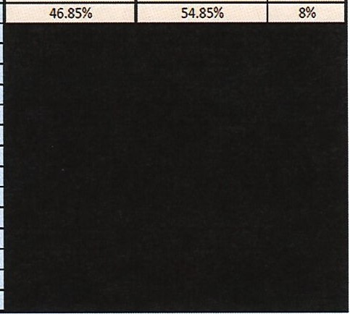
MesquiteISO
 |  | STAAR Percent Score•
 |  | 60.43% | 4%
 |  | 61.26% | -1%
 |  | 53.98% | 0%
 |  | 54.40% | -2%
 |  | 54.26% | 0%
 |  | 58.01% | 3%
50.28% |  |  | 1%

 |  |  |  | DCP Summarized Percent Score•
 | DCP Summarized Percent Score• | STAAR Percent Score'
3rd Rea ding | 61.38% | 62.90% | 2% | 56.20%
3rd Math | 64.76% | 63.52% | -1% | 62.59%
4th Reading | 63.79% | 62.55% | -1% | 54.09%
4th Math | 62.13% | 62.87% | 1% | 56.60%
4th Writing | 57.25% | 54.77% | -2% | 54.45%
h Rea ding | 64.04% | 64.91% | 1% | 54.86%
5th Math | 65.19% | 65.55% | 0% | 49.75%
5th Science | 62.71% | 67.47% | 5%
6th Re adin2 | 61.86% | 60.78% | -1%
6th Math | 60.09% | 54.12% | -6%
7th Reading | 58.95% | 59.99% | 1%
7th Math | 51.85% | 47.52% | -4%
7th Writing | 59.53% | 58.59% | -1%
8th Reading | 62.19% | 64.40% | 2%
8th Math | n. 23% | 64.71% | -8%
8th Science | 70.51% | 66.41% | -4%
8th Social Studies | 63. 29% | 55.98% | -7%
Algebra I | 57 .9 2% | 57.25% | -1%
Biolol!V | 65.3 4% | 65.64% | 0%
US History | 64.98% | 65.49% | 1%
En2lish I | 62 .90 % | 56.46% | -6%
English II | 63 . 90% | 64.09% | 0%

*Based on Percent Score NOT Passing Percentage
·•sTAAR1 s t AdministrationOnly

Continuous Improvement

The curriculum department has several ways to insure that curriculum and checkpoint feedback is given in a timely and structured way. On the curriculum department tab on the district website, there is a place for teachers to provide coordinators/facilitatorswith real-time feedback on specific areas of concern with subject/grade level curriculum or the checkpoint process. If a resource is missing or possibly a link not working, that issue can be resolved immediately in Eduphoria Forethought. Allthe feedback is tracked by the Assistant Superintendent of Instructional Services to determine if additional time and/or attention needs to be added to a particular content area. In addition to the feedback links, teachers contact coordinators/facilitators regularly via email or phone for curriculum concerns/clarifications.
At the conclusion of each academic year, our coordinators, facilitators, and select teachers utilize state assessment results to make modifications, additions, and changes to scope and sequence of district curriculum. This internal curriculum auditing process occurs routinely to insure the curriculum is tailored to the needs of MISD student s.

PreK-2"d Grade Literacy
Cont inuing to strengthen the PreK-2 Literacy Initiative targeting improving literacy practices for both administrators and teachers so that all primary students are reading on grade level

o 3 day Coaches Academy Training and 5 follow up coaching days
- Executive Coaching for selected administrators
- Teacher Coaching for 120 teachers for this school year
- Fall Book Ball and Spring Fling for all Campus Literacy Teams
- Read Play Talk website
- Annual Read Play Talk fair
- A Read Play Talk board was organized to reach the community
- An early literacy facilitator at each elementary campus to focus on PreK-2 literacy development

ISIP-ER is a computer-based assessment that requires no teacher testing or manual scoring. Teachers monitor students as they test on the computer. This diagnostic assessment is nationally-normed, child-friendly, and offers immediate access to student data for the teacher. ISIP-ER then offers more difficult test items when a student answers correctly and less diff icu lt items when an incorrect response is recorded . This gives the teacher a true picture ofthe early reading skills that each student has mastered. Intervention lessons are then recommended based upon each child's individual needs.

Tier 1 students are on track and performing at or above grade level. Tier 2 are at some risk and may be in need of intervention in one or more of the areas tested on a subt est. Tier 3 students are at risk, are performing seriously below grade level, and are in need of intensive int ervent ion .
Duringthe school year, the goal is to move students at Tiers 2 and 3 up to Tier 1. Teachers must also continue to monitor students at Tier 1 making sure to build their reading skills sufficiently throughout the year.

Early Literacy Results 2017-18

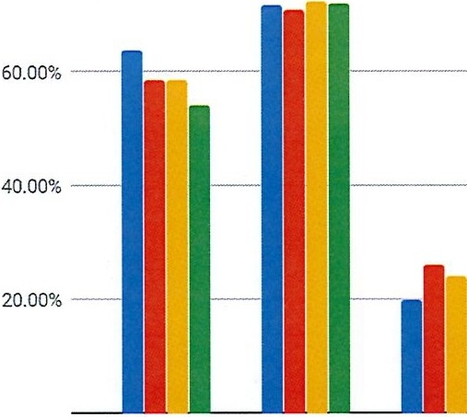
Kindergarten ISIP End of Year Data

80.00%-------------------------------------- • 2014-2015

• 2015-2016

• 2016-2017

• 2017-2018
.c
Q)
i=
...
'-'
co
"Q)'
C:
Q)

Q)
a.
0.00%
; <.,,i'
<,;, ·f'"
" -
s ?;
-<."l-'\
-{,/1-
<,;",'-'°" -
ti l
-{,e'J,
lfl nll l
,-<,e"J
-{,e"J
, f:, -
s ?;
<,;, cy.""
{:, -
c:.:,<;i'l>

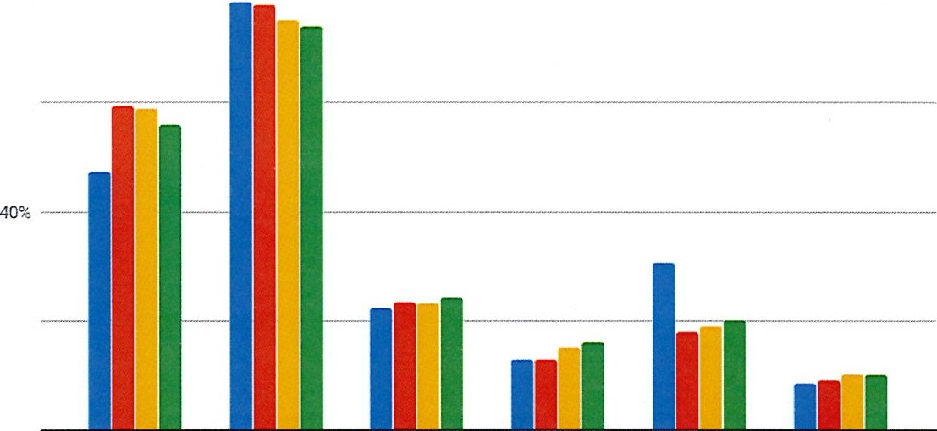Early Literacy Results 2017-18
1st Grade ISIP End of Year Data

80% -------------------------------------------------- •
•
-
6%0
• 2017-2018
qi
i=
.s;;;
<)
"Cl'/
<ii
E
Cl/

Cl/
Cl.
20 %
0%
-<si'
<;;,<"-'1l"' -
-,;,,e\'\
\e\'l­
-<_,e\'l­
s ?i -""-'·'.;:.
<;;, ' /"-.;:.·
s ?i', "-'
-<_,e\'1>
,,,,-.;:.·
s ?i
-<_,e\'1>
i,,,, -

2014-2015
2015-2016
2017-2016

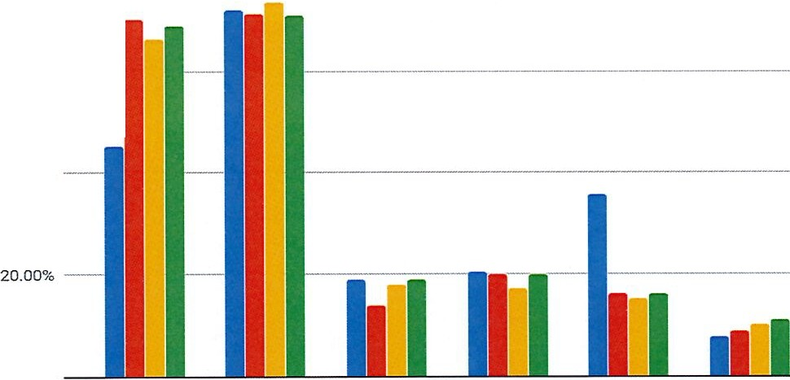Early Literacy Results 2017 -18
znct Grade ISIP End of Year Data
80.00 % ------------------------------------------

60.00% --
Q)
i=
.c.
(.)
"Q) '
'lo
'E
Q)
40.00%
Q)
a.
0.00%
_-<.,e\

• 201 4- 201 5
• 2015-2016
• 2016-2017
• 2017-2018
:<.,e\"
"""'',;,'0
s
.-<.,e\"
?,,::,.,,;,'0
-<:_,e\'l..
,,;,'0'
.-<.,e\'l..
_-<.,e\"!>
s ?>
,,;,'0
,,;,'0
,:,.,,;'<,:;--
s 'I>

14 IP age

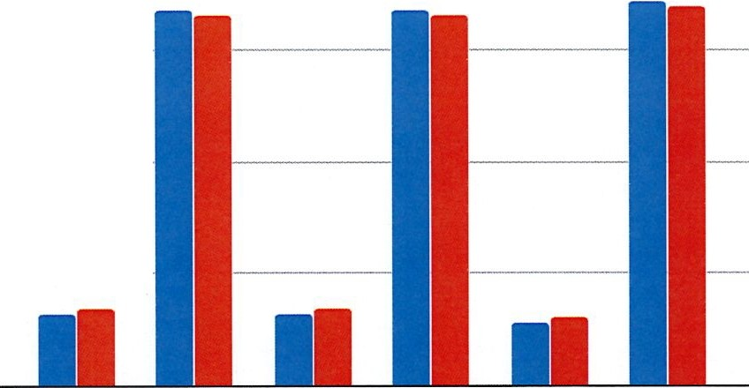
50.00 % - - - - - - -1
Q)

Q)
a. 25.00 %
0.00%
1st At- 1st On- 2nd At - 2nd On- Risk Level Risk Level

Early Literacy Results 2017 -18

At-Risk vs. On-Level If Reported As Last Year
100.00%
• 2016-2017
• 2017-2018
75.00 %
c
Cl)

Q)
-
-0
c?5
0
"E
K At -Risk K On­ Level

Early Literacy Results 2017-18

  - 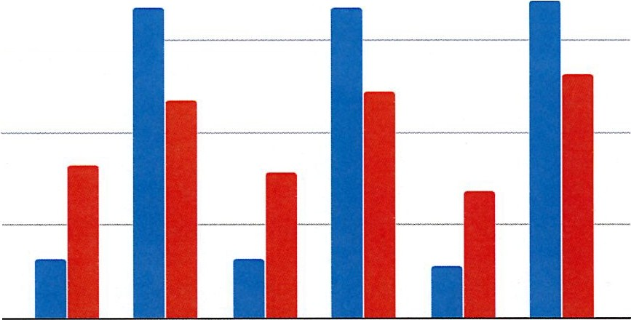Beginning in 2017-2018, TEA determined that Tier 1 is on-level and Tiers 2 and 3 are considered at-risk .
At-Risk vs. On-Leve l
1 00 .00 % -------------------------- • 2016-2017
• 2017-2018

7 5.00 %
E
en

(I.)
-
"t"5O
50.00 %
0
E
(I.)
()
:V
a. 25.00 % ----
0%.0
K At-Risk K On­
Level
1st At­ Risk
1st On- 2nd At- 2nd On-
Level Risk Level

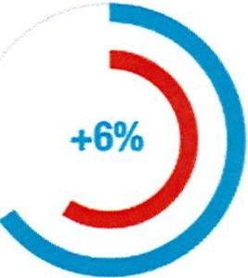
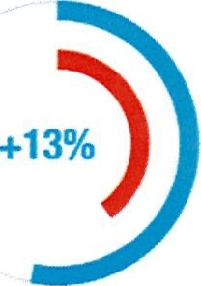
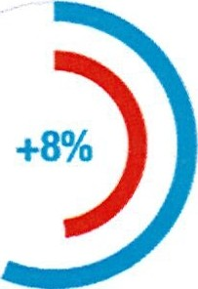
January 2019

Early Literacy Results 2017-18

ISIP Tier 1 Data
2017-2018 English ISIP Reading Assessment
BOY EOY
Kindergarten
Grade 1
Grade 2

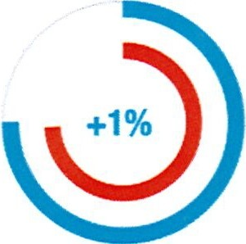
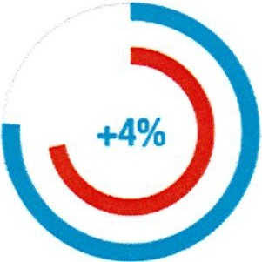
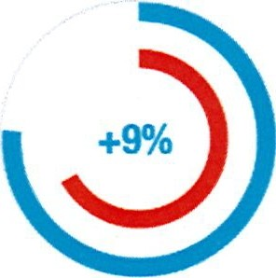January 2019
ORA Data

2017-2018 DRAAII Grades
BOY EOY
e2L Coached Gradual
Not Coac hed All Coached Release Model

Early Literacy Results 2017-18

CURRICULUM
January 2019

Early Literacy Results 2017 -18

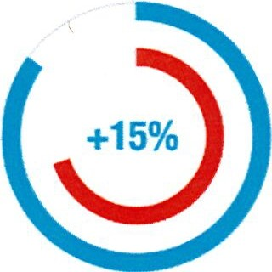
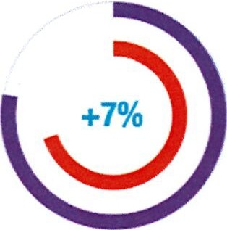19 J Page
3rd Grade STAAR Data
2017-2018 STAAR Reading Assessment Grade 3 Assessment
District Grade 3 (2501) All Coached (77) e2l Coached Gradual Release Model (20)

% Ap proaches Grade Level

CURRICULUM
January 2019

Course Revision Process
In the fall of each academic year, high school and middle school teachers are asked to submit proposals for new courses or changes in courses for the next school year. A new course proposal must first be discussed with the school principal before being submitted for district consideration. The principal's approval assumes discussion of student need, cost, additional personnel, and suitability has taken place. The changes proposed can be an addition of a new course, a request for honors credit for a course, a request for an innovative course submission to TEA, a deletion of a present course, or a change in course requirements or prerequisites for a course. Once the principal has agreed to the course submission, the request is reviewed by curriculum coordinators and the Assistant Superintendent of Instructional Services for input and review.
An agenda is set for the Course Revision meeting to review all the curriculum course changes submitted. The principals, registrars, coordinators and central office administrators meet to conduct open and forthright discussions about the logistics, benefits, and concerns regarding the proposed changes. From those discussions, the determination is made for what courses will be presented to the Board of Trustees for consideration and approval. The changes are then made to the Course Description Guides for high school and middle school that will beposted
online for course selection for the following school year. _ _ _ _ _ _

MESOUITE I NDEPENDE NT SCHOOL DIS TRI CT
- --
2019-2020
20 IP age

- District Effectiveness Report
CURRICULUM
January 2019

Graduation Requirements

MISD students are under a specific graduat ion plan based on the year the student entered high school. Most current high school students are on the House Bill 5 graduation plans that include a Foundation plan, Endorsements, Performance Acknowledgements and Distinguished Level of Achievement .

Our high school registrars and counselors are tracking students on selected endorsements. The HB 5 graduation plans require our gth graders and their parents to be knowledgeable of the choices students are making for their graduation plan. It is a new way to think about courses taken for a diploma. Unlike past graduation plans, students will not be sampling elective courses in a variety of areas; now they will be concentrating on elective courses in a single area that will earn an endorsement .

Currently our district is offering courses to earn all 5 of the endorsement areas. Within those endorsements are various options of courses a student may take to earn the required number of credits. The STEM endorsement has 11 options; the Business and Industry endorsement has 38 options; the Public Service endorsement has 17 options; the Arts and Humanities endorsement has 20 options; and finally, the Multi-Disciplinary endorsement has 6 options. That is a total of 92 options offered to our students graduating under the HB 5 plans.

District Effectiveness Report
CURRICULUM
January 2019

1
'7 ' ' '
o"' Pc-{"<. ,

POFDRMIJICE
ICkNOWLEDGJIENTS
...
....
, _
GRADUATION
PLAN
-­
....w....
........ :.....-11
DlmN.GUISNED LEVEL OF AQIIEYDl£NT

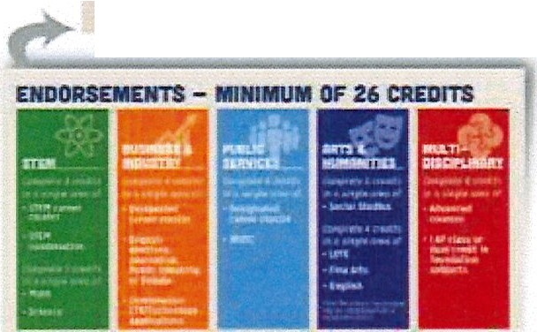Ill Jll:a0111U!ln: 1 ..i,!llo:>,u1lloh-oomPrJ, .,,.,.,...1-.- ..,.......
..-t---C
·
-..·.....-....-...,..,,,...,...,._

FDUNDmON HIG".H SCHOOL PROGRAM - 211 CREDITS
(.... i<>:ol li>:Sa ll:IC!Cl:I • '""'°•IG..- tcr, -,.,....

• l'-..._·l"IJ""'1 rt·'ll""
'""" ·lfl_. , r-·1""'"1

• ll(rl, -! - "-lll(b..1.-,4. Lrnr •

District Effectiveness Report
CURRICULUM
January 2019

96.00%

94.00%

92.00%

90.00%

88.00%

86.00%
5-Year Mesquite ISD Graduation Trends

- -- - - - - - - - - - r- -- ·-·· - - --- -

1 - - -

1- - I -
-
1---- r- __

84.00% -
-
82.00%
------
80.00%

,

----
,
1---- 1- -

78.00%
76.00% - - - ---- -I-
89.70%
IH8HEIIEIIII

- District
Hispanic
-- AA-- -- White Econ Dis SPED

--
--- r

• 2012 89.90%
---

_,I_
88.20%
89.50%
92.70% 88.20%- - ----
90.20% 83.70%
91.10-% - - - ----- 89.20% -- 85.20%

• 2013 91.30%
• 2014 90.90% ! 90.70%·--1- ..
·-
----·I- --
93.60%
91.50% --
91.00%
----
84.10%

• 2015 90.10% - -r
90.30%
92.60% 86.50% -- 90.30% 82.10%

• 2016 91%
89%
93.50% 91.60% 90.50 % 87.60%
·----

CURRICULUM
January 2019

Curriculum Personnel Language Arts/Reading-Elementary- Andrea Bailey, Coordinator

Instructional Services--Tara Nichols, Director

Bilingual/ESL-Carolina Portillo, Director Daniel Ruvalcaba, BEES Facilitator Maribel Amador, Lead Teacher Anaida Cestero-Padilla, Lead Teacher Alma Vazquez, Lead Teacher
Juan Coronado, Lead Teacher Nakita Ruiz, Lead Teacher
Christi Troutman, ESL Lead Teacher Toni Cerda, ESL Lead Teacher
Career & Technical-Kristi Krajca, Director
Leigh Farley, Coordinator
Jennifer Martin, Coordinator Business Technology Carolyn Porterfield, CTE Counselor Facilitator Karissa Samuel, CTE Community Facilitator
Digital Content-Andrea Oliver Dixon, Coordinator
Dyslexia-Jennifer Faust, Facilitator Karla Suits, Facilitator Kristin Davis, Tester
Nancy Almanza, Tester
Fine Arts-Steve Andre, Director
Cathy Warnock, Elementary Music Facilitator Laurie Huff, Art / Theatre Facilitator
Gifted/Talented-Russ Weeks, Coordinator Debbie Johnson, Gifted Facilitator Tikka Walters, Gifted Facilitator
Sheila Hill, Literacy Facilitator
Alissa Tubbs, Early Literacy Specialist Kathy Shada, Lit eracy Facilitator
Language Arts and Reading-Secondary;
Journalism; Languages other than English -Kyle Frit sche, Coordinator Marie McAlpin, Facilitator
Mathematics-Dr. Lesley Edwards, Coordinator Sherry Beddow, Elem . Math Facilitator Amy Deaton, MS Math Facilitator Jennifer Johnson , HS Math Facilitator
Physical Education/Health - Wendi Hatley, Coordinator
Science-Patrick Haney, Coordinator
Jan Wilson, Elem. Science Facilitator Sherry M cDaniel s, Elem . Science Facilitator Dr. Lori Turley, MS Science Facilitator Keshia Lavergne, HS Science Facilitator Leslie Barnhill, Planetarium Facilitator
Social Studies-Daniel Norwood, Coordinator Britni Parks, Elem. Soc. Studies Facilitator
Atrice Adeniyi, Secondary Soc. Studies Facilitator
Title 1 & Homeless Liaison-Jennifer Hulme, Coordinator Cynthia Patino, Family Engagement Facilitator Sandy Travis, Family Engagement Facilitator Tom Edwards , Lead Social Worker
Jennifer Davis, Parent Support Counselor Karen Morgan-Miller, Title 1 Social Worker Jasmine Battles, Title 1 Social Worker
Tyra Fort, Title 1 Social Worker
Carlos Banuelos , Family Support Liaison

CURRICULUM
January 2019

Effectiveness Indicators

In the area of curriculum, we are responsible for students from prekindergarten through graduation . Last year our district partnered with local daycares to begin a three-year-old PreK program. Students in this program are still required to meet the eligibility requirements but are given an earlier start. We are currently partnering with two daycares and have 130 three-year-olds enrolled.

Prekindergarten

The Texas Legislature determines eligibility requirements for free, public prekindergarten in Texas. When the Texas Legislature established the prekindergarten program the intent was, and still is, to provide early learning experiences to students who are most at risk for school failure. Therefore, the eligibility is limit ed. Legislative intent is that a high-quality prekindergarten program can mitigate the impact ofthe at-risk characteristics, thereby assisting these students to become school ready when they enter kindergart en. To be eligible to attend Pre-K, a student must meet one of the criteria listed below:

  - The student is limited in ability to speak and understand the English language.
  - The student is from a family whose income will qualify the student for a free or reduced lunch according to income eligibility guidelines used in the National School Lunch Pr ogr am.
  - The student is homeless as determined by appropriate staff.
  - The student is the child of an active duty member of the armed forces of the United States.
  - The student is the child of a member of the armed forces of the United States who was injured or killed while serving on active duty.
  - The student has ever been in the conservatorship (foster care) of the Department of Family and Protective Services following an adversary hearing.

CURRICULUM
January 2019

3 & 4-Year-Old Pre-K Enro llm ent 2011-2018

a Bilingual (4yrold) a General Ed (4yr ol d) • Bilingual (3yr old) • General Ed (3yr old)

700 -----

600

----
1-- ----

soo
------

·-
t - ·-

400

300

200

100

0
2011

2012

2013

2014

20S1

2016 2017

201S

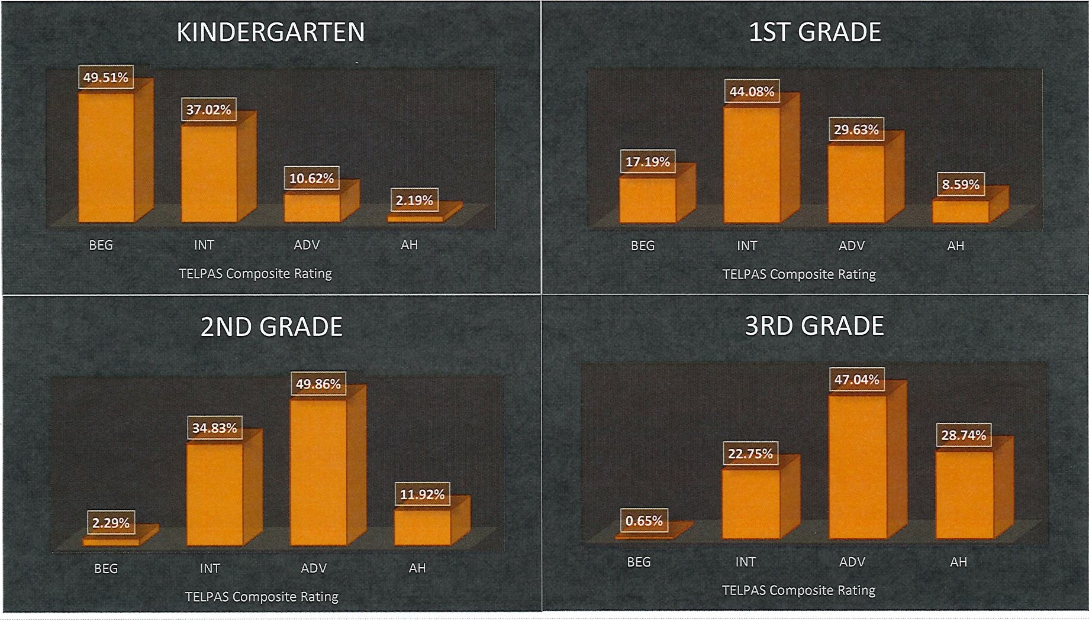
TELPAS Results

CURRICULUM
January 2019

TELPAS Results
CURRICULUM
January 2019

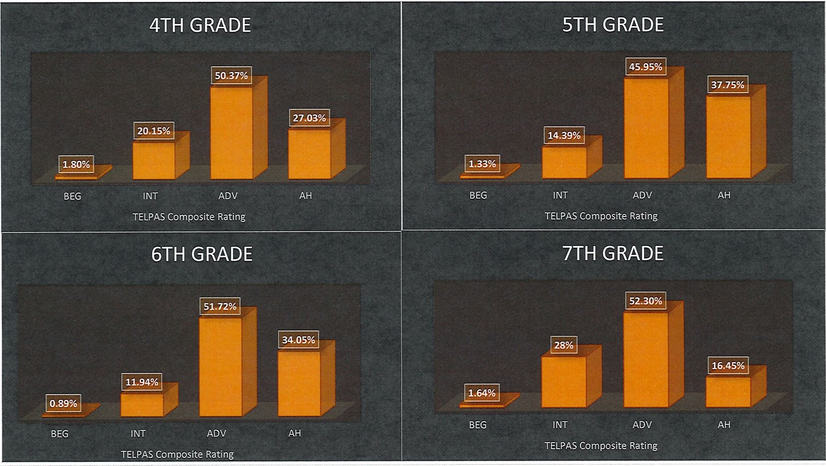
28 I Page

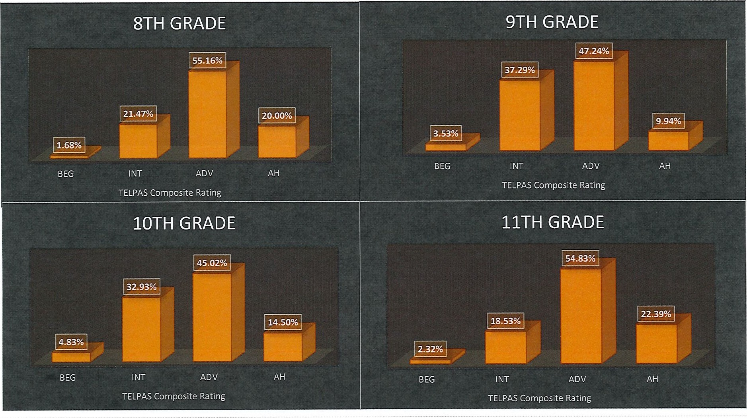
TELPAS Results
CURRICULUM
January 2019

3 & 4-Year-Old Pre-K Enrollment 2011-2018
29 I Page

TELPAS Results
CURRICULUM
January 2019

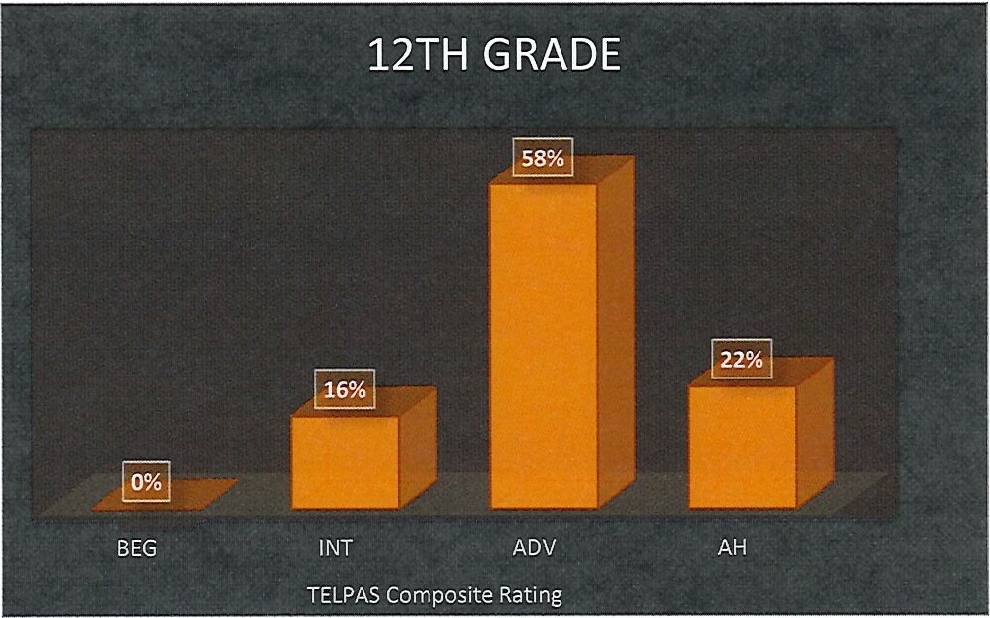

30 I P age

CURRICULUM
January 2019

MISD STAAR Reading Trends

STAAR Reading Approaches
---------,

80
70
60
so
40
30
20
10
0
Grade 3 Grade 4 Grade 5 Grade 6 Grade 7 Grade 8 English I English II

• 2016 a 2017 a 2018

CURRICULUM
January 2019

MISD STAAR Writing Trends

STAAR Writing Approaches
70
60
so
40
30
20
10
0
Grade 4 Grade 7

a 2016 • 2017 Iii 2018

CURRICULUM
January 2019

MISD STAAR Math Tre nds

90
STAAR Math Approaches
80
70
60
50
40
30
20
10
0
Grade 3 Grade 4 Grade 5

Grade 6 Grade 7 Grade 8

Algebra I

a 2016 • 2017 • 2018

CURRICULUM
January 2019

State STAAR Science Trends

100
90
80
70
60
so
40
30
20
10
0
STAAR Science Approaches

Grade 5 Grade 8
• 2016 a 2017 • 2018

Biology

- I P age

CURRICULUM
January 2019

State STAAR Social Studies Trends

,,,-- STAAR Social Studies Approaches

90
80
70
60
so
40
30
20
10
0
Grade 8

a 2016 2018

US History

- I Page

District Effectiveness Report

CURRICULUM
January 2019

Dual Credit

Courses are offered to high school students through an off icial agreement between Dallas County Community College and MISD. These specific, pre-approved courses meet both district and college guidelines in order to provide credit for both high school and college when a grade of C or higher is earned. No grade points are awarded for these courses except when taken in MISD during the school day. There are specified enrollment procedures that must be followed. New requirements from Southern Association of Colleges and Schools (SACS) will impact our dual credit numbers beginning next year due to dual credit classes must be stand-alone classes beginning in 2019-2020.

Mesquite ISD Dual Credit History
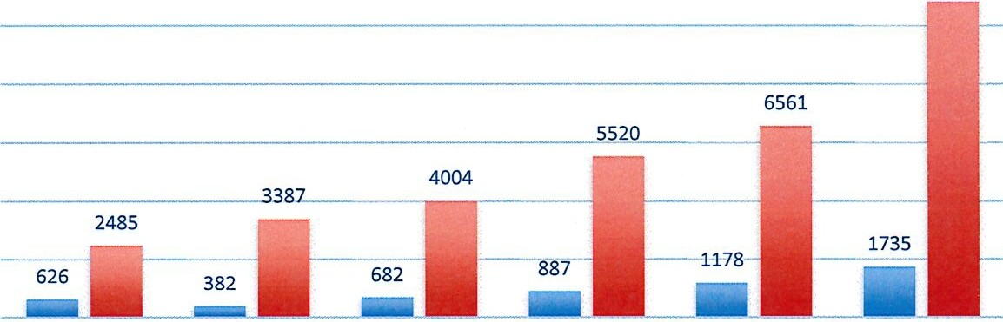
12000 10812
10000

8000

6000

4000

2000

0
2012-2013 2013-2014 2014-2015 2015-2016 2016-2017 2017-2018

    - Number of Students • Dual Credit Hours Earned
- J Page

CURRICULUM
January 2019

AdvancedPlacement
Advanced Placement is a program created by the College Board which offers college-level curricula and examinations to high school student s. American colleges and universities may grant placement and course credit to students who obtain high scores on the examinations. The AP curriculum for each of the various subjects is created for the College Board by a panel of experts and college-level educators in that field of study. For a high school course to have the designation, the course must be audited by the College Board to ascertain that it satisfies the AP curriculum. If the course is appro ved, the school may use the AP designation .

2012 | 2013 |  | 2014 | 2015 |  | 2016 |  | 2017 | 2018
AP Scholar 51  APScholar | 80 |  | 121 | 159 |  | 199 |  | 218 | 297
with Ho nors 12 | 27 |  | 25 | 35 |  | 27 |  | 38 | 36
APScholar
with I 1 1 | I | 9 I 14 |  | I | 36 | I | 32 I 39 I |  |  | 48
National AP I 0 | I | 1 I |  | 1 | I | 2 | I | 5 I |  | 5 | I | 6

- I Page
Distinction
Scholar

CURRICULUM
January 2019

Advanced Placement Exams

AP Exams Taken 2012-2018

4000
3500
3000
2500
2000
1500
1000
500 I _..._..._..._..._...
Q
I I I I I I
2012 2013 2014 2015 2016 2017 2018

- AP Tests Taken

1600
1400
1200
1000
800
600
400
200
0 ,

Students Passing AP Exams 2012-2018

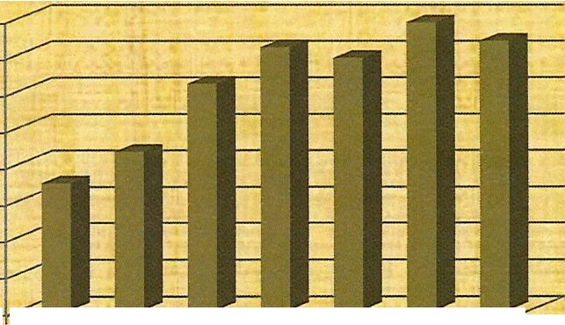
, ,

- AP Exams Passed
2012 2013 2014 2015 2016 2017 2018

CURRICULUM
January 2019

ational Merit Award History

One of the efforts Mesquite utilizes to prepare students for college admission requirements is the PSAT 8/9 given to all Mesquite ISD students in gth grade and the PSAT given to all students in 10th grade. Once a student takes the PSAT, they then have access to the College Board website and can access college entrance prep materials to aid in the increase of college entrance exam scores such as the SAT. Mesquite ISD identifies top performing students in grade 8 and provides additional test prep assistance throughout their high school career culminating in grade 11, when they take the PSAT/ NMSQT, a co-sponsored program by the College Board and National Merit Scholarship Corporation. It measures critical reading, math problem-solving, and writing skills. This test gives 11th grade students a chance to enter National Merit Scholarship Corporation scholarship programs. The following chart represents national merit award history for Mesquite ISD. National Merit Semifinalists are notified in the fall of their senior year.

f. 2 013 |  | 20 1 4 | 20 1 5 | 2016 | 2017 | 2018
National Merit Finalist |  |  | 0 | 0 | 4 | 0
National Hispanic Scholar | 2 | 9 | 2 | 5 | 2 | 2
National Merit Commended | 4 | 2 | 8 | 6 | 8 | 2
National Merit Semifinalist | 1 | 1 | 0 | 0 | 4 | 0
Total | 10 | 13 | 10 | 11 | 12 | 4

CURRICULUM
January 2019

AVID
AVID-Advancement Via Individual Determination-fostersa safe, open culture, high expectations for teachers and students, and collaboration in all classrooms. AVID's mission is to close the achievement gap by preparing all students for college readiness and success in a global societ y. AVID started in Mesquite ISO in 2006. Currently in Mesquite ISO, we have 2 high school campuses that have an AVID program-North Mesquite and West Mesquite. We also have 4 middle school campuses who begin the AVID pathway-A.C. New, Frasier, McDonald and Vanston. Alisha Chapman is our district AVID Director and she has just recently completed all her training requirements for this position. At the recent AVID Summer Institute, one of our West Mesquite High School graduates, Cristal Contreras, was asked to speak. Here is the link to her speech:

htt ps:/ / www.youtube.com/watch?v=3Gbi-onV7aA

Last year, two AVID student s, one from North Mesquite and one from West Mesquite were named as Dell Scholars. This year we have been notified we have 7 semi-finalists (4 from North Mesquite and 3 from West Mesquite). We are very proud of these students and this great accomplishment.

40 I Page

CURRICULUM
January 2019

AVID Mesquite Independent School District
2017-2018 AVID Seniors
The- po s tseeond:u"y/NSC ebb for AVlD seniors from the 2018 y r is not ye-t :.:t.Y:Jii l b l .
Demographics

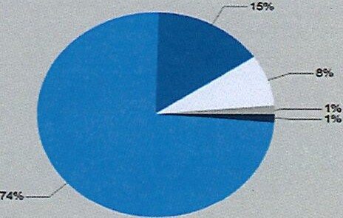
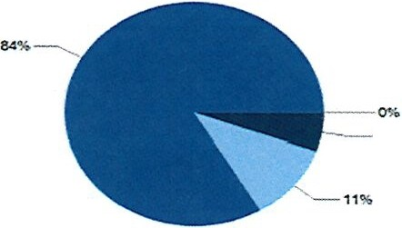Precollegiate Testing
5%

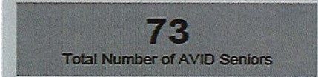- Took the SAT - Tool< Soth the SAT and ACT Took the ACT - Took Noitn0<
-
---
89%
c• 1a1A • IJ
---
a
22%
9lglllfl J
_
-.........._Or
- -- 0,--lcan
0.....

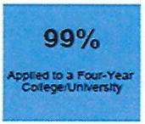
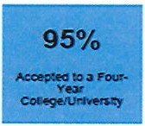
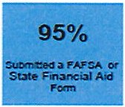
Pos-tSecondary
= -

Academic Rigor

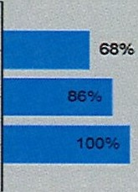
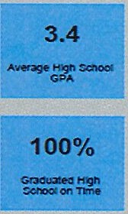
Took Collega
--

TookatLNolOne
eo.neo1

F-Y-

L. 74%

- Plarnngto Attenda Tw<>-Y ear - Other Post-High SCl>Ool Plan Planrmgto Attenda Four-Year
•c:auru« r,go•r - IIJA V'I/Da a,.
-°'t-
lm-l«-- a­--a....-y- --..........

41 I P a g e

CURRICULUM
January 2019

Cost of Program

Supplies & Materials,
$980,750

Other, $476,200

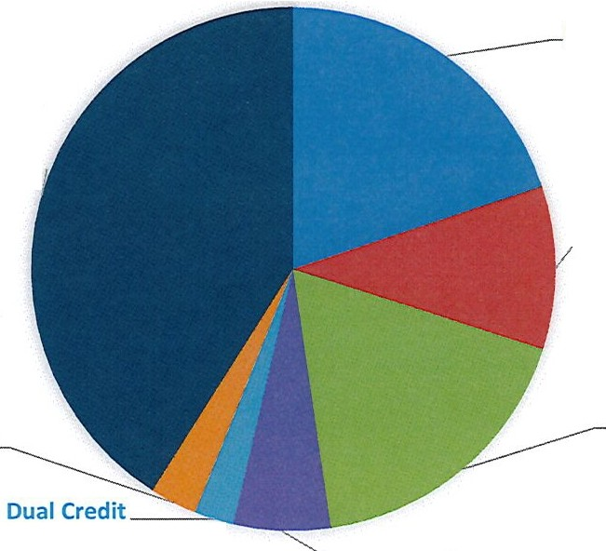
Curriculum Staff Develo pme nt,
$70,000

Stipends,
$58 ,000 AVID, $143,000
Pla neta rium,
$240,750

Acce le rat io n,
$425,000

------

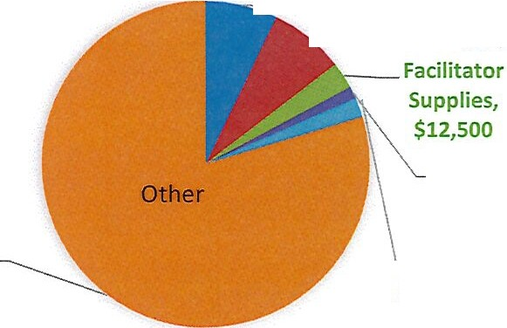Contracted Services,
$379,500

- - --- · -- -- Literacy Initiative, Trave l ,
- - $34,000 $35,200
i...

Gree n Team,
$6,000

Science Fa ir,
$9 , 000

42 I P a g e

CURRICULUM
January 2019

Vision for the Future

Curriculum and instruction personnel strive to provide every teacher in every classroom with curriculum documents, resources, and content knowledge to differentiate for all students. The curriculum should assist teachers to teach highly engaging, innovative lessons consistently in every classroom. Teachers need the tools to provide ongoing formative assessment to adjust instruction to meet the needs of every student. Our department exists to provide resources for teachers and administrators. We endeavor to provide support for every campus as they achieve their excellence goals. There are program improvements and new challenges that will be met in the future. The long range vision for the future includes
the following:

- A dedicated curriculum writer for each subject and level to ensure consistency and lead quality curriculum development
- Full day prekindergarten with transportation provided to serve more 4-year-old students
- More integration with content development and technology to further student competencies
- Expand advanced academics options to reach goal of 80% participation
- Training teachers and specialist on the coaching model in multiple content areas in order to elevate the level of teaching and learning
- Continue to be a part of the puzzle that strives to Serve, Empower, and Elevate all educators in our district!

43 I P age

