Mesquite Independent School District

2020‐2021 Oﬃcial Budget
3819 Towne Crossing Blvd.
Mesquite, Texas 75150 Dallas County

Dr. David Vroonland Superintendent
Issued by:

Pete D. Pape Assistant Superintendent
Finance & Operations

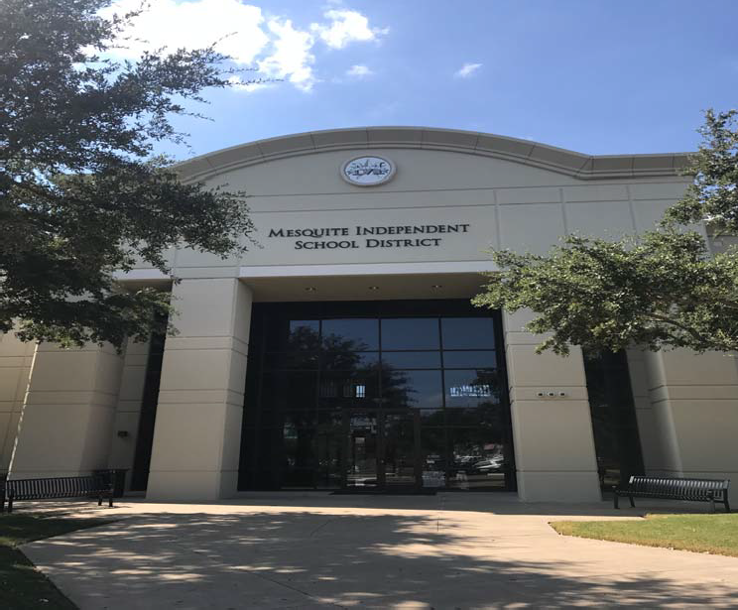

Available online at www.mesquiteisd.org

This Meritorious Budget Award is presented to

MESQUITE INDEPENDENT SCHOOL DISTRICT
for excellence in the preparation and issuance of its budget for the Fiscal Year 2019-2020.
The budget adheres to the principles and standards
of ASBO International's Meritorious Budget Award criteria.

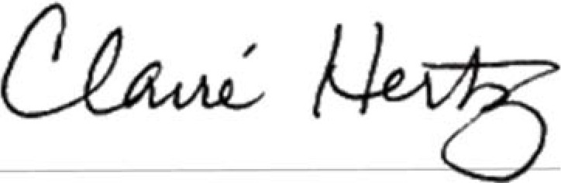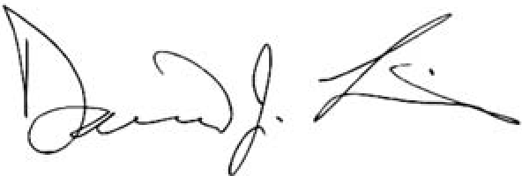

Claire Hertz, SFO
President
David J. Lewis Executive Director

Table of Contents

Executive Summary 1
Executive Summary Table of Contents 2
Board of Trustees/Administrative Oﬃcials 3
Consultants and Advisors 4
Executive Summary 5‐6
District Details 7‐9
Mission Statement 10
Budget Process 11‐12
Budget Timeline 13
Budget Highlights 14
General Fund 15
Estimated Revenues 16
Expenditures 17
General Fund 18
Student Nutrition Fund 19‐20
Debt Service Fund 21
General Obligation Debt 22
General Obligation Bonds 23
Capital Projects 24
Taxable Values and Tax Rate 25‐27
Enrollment Growth 28
Student Enrollment Summary 29
Student Enrollment by Campus 30‐31
Staﬃng 32
Graduation Rates 33
2020 Accountability 34
Financial Integrity Rating System of Texas (FIRST) and Future Budget Years 35
Future Budget Years 36
Revenue and Budget 5 Year Estimations 37‐38
Budget Contact 39

Organizational Section 40
Organizational Section Table of Contents 41
Significant Facts about Mesquite Independent School District 42
Mesquite ISD Attendance Zones 2020‐2021 43
Enrollment Growth 44
Student Enrollment Summary 45
Student Enrollment by Campus 46‐47
Student Ethnicity Percentages 48
Mesquite ISD Contact Information 49‐51
Mesquite ISD School Calendar 2020‐2021 52
Organizational Chart 53

Organizational Section (cont.)
Board of Trustees 54‐56
MISD Vision 57
Strategic Plan 58
Financial Policies/Basis of Accounting 59‐68
Account Code Structure/Basic System Expenditure Code Structure 69‐70
Function Codes 71‐75
Account Code Structure 76‐80
Budget Policies 81‐91
Budget Timeline 92

Financial Section 93
Financial Section Table of Contents 94
Introduction 95
Funding Public Education 96‐97
Property Tax Levies & Collections 98
Comparison of Combined M&O and I&S Tax Rates 99
Long Range Assumptions 100
Budget Administration & Management Process 101‐103
Assumptions & Priorities for the 2020‐2021 Budget 104‐106
Financial Section Overview 107
2020‐2021 General/Debt Service/Student Nutrition Funds 108
General/Debt Service/Student Nutrition Funds—Revenues by Object 109‐110
General/Debt Service/Student Nutrition Funds—Expenditures by Object 111‐114
General Fund 115
Revenues & Expenditures 116‐117
Revenues by Object 118‐119
Expenditures by Object 120‐123
Student Nutrition Fund 124‐126
Revenues by Object 127
Expenditures by Object 128‐129
Debt Service Fund 130‐132
Revenues by Object 133
Expenditures by Object 134
Aggregate Unlimited Tax Bonds 135
Outstanding Debt 136
Capital Projects Fund Overview 137
2018 Bond Package 138‐142
Department Budgets 143
Budget Trends 144
Revenue and Budget 5 Year Estimation 145‐146
Future Budget Years 147
MISD Buildings 148‐151
Defined Benefit Pension Plan 152‐153
OPED Liability 154

Informational Section 155
Informational Section Table of Contents 156‐157
Taxable Value Information 158
Assess Value History 2000‐2020 159
Taxable Value History and Future Projections 160
Property Tax Levies & Collections 161
Top Ten Taxpayers 2019 162
Tax Rate Impact to District’s Taxpayers 163
Taxable Values & Tax Rate 164‐165
Student & Enrollment by Campus 166
Student Enrollment Summary 167
Student Enrollment by Campus 168‐169
Enrollment 170
Staﬃng 171
Debt Service Fund 172‐173
Principal Outstanding 174
Aggregate Unlimited Tax Bonds 175
Capital Improvement Program Impact on Tax Rate (Outstanding Debt Only) 176
Dropout Rate 177
2020 Accountability 178
MISD 2019‐2020 Accomplishments 179‐183
Graduation Rates 184
ISIP‐Early Reading 185
Free/Reduced Lunch Numbers 186
Campus Budget and Performance Information
Achziger Elementary School 187
Austin Elementary School 188
Beasley Elementary School 189
Black Elementary School 190
Cannaday Elementary School 191
Florence Elementary School 192
Floyd Elementary School 193
Galloway Elementary School 194
Gentry Elementary School 195
Gray Elementary School 196
Hanby Elementary School 197
Henrie Elementary School 198
Hodges Elementary School 199
Kimball Elementary School 200
Lawrence Elementary School 201
Mackey Elementary School 202
McKenzie Elementary School 203
McWhorter Elementary School 204

Informational Section (cont.)
Moss Elementary School 205
Motley Elementary School 206
Pirrung Elementary School 207
Porter Elementary School 208
Price Elementary School 209
Range Elementary School 210
Rugel Elementary School 211
Rutherford Elementary School 212
Seabourn Elementary School 214
Shands Elementary School 215
Shaw Elementary School 216
Smith Elementary School 217
Thompson Elementary School 218
Tisinger Elementary School 219
Tosch Elementary School 220
Agnew Middle School 221
Berry Middle School 222
Fraiser Middle School 223
Kimbrough Middle School 224
McDonald Middle School 225
New Middle School 226
Terry Middle School 227
Vanston Middle School 228
Wilkinson Middle School 229
Horn High School 230
Mesquite High School 231
North Mesquite High School 232
Poteet High School 233
West Mesquite High School. 234
Mesquite Academy 235
Learning Center 236
Athletics 237
Glossary of Terms 238‐247

List of Tables

Executive Summary
Table 1: General Fund Revenues 16
Table 2: General Fund Expenditures 17
Table 3: General Funds 18
Table 4: Student Nutrition Fund – Statement of Revenues and Expenditures 19‐20
Table 5: Student Nutrition ‐ Fund Balance 20
Table 6: Debt Service Fund 21
Table 7: General Obligation Bonds 23
Table 8: Taxable Value Projections 25
Table 9: Tax Rate History 26
Table 10: Tax Rate Impact to District’s Taxpayers 27
Table 11: Property Tax Due 27
Table 12: Student Enrollment Summary 29
Table 13: Student Enrollment by Campus 30‐31
Table 14: Staﬃng History 32
Table 15: Graduation Rates 33
Table 16: 2019 Accountability 34
Table 17: Future Budget Years 36
Table 18: Revenue and Budget 5 Year Estimations 37‐38

Organizational Section
Table 19: Student Enrollment Summary 45
Table 20: Student Enrollment by Campus 46‐47
Table 21: Student Ethnicity Percentages 48

Financial Section
Table 22: Funding Public Education 97
Table 23: Property Tax Levies & Collections 98
Table 24: Comparison of Combined M&O and I&S Tax Rates 99
Table 25: 2020‐2021 General/Debt Service/Student Nutrition 108
Table 26: General/Debt Service/Student Nutrition ‐ Revenues by Object 109‐110
Table 27: General/Debt Service/Student Nutrition ‐ Expenditures by Object 111‐114
Table 28: General Fund ‐ Revenues & Expenditures 116
Table 29: General Fund ‐ Revenues & Expenditures 117
Table 30: General Fund ‐ Revenues by Object 118‐119
Table 31: General Fund ‐ Expenditures by Object 120‐123
Table 32: Student Nutrition Fund 125‐126
Table 33: Fund Balance for Student Nutrition 126
Table 34: Student Nutrition ‐ Revenues by Object. 127

Financial Section (cont.)
Table 35: Student Nutrition ‐ Revenues by Expenditure 128‐129
Table 36: Debt Service Fund 132
Table 37: Debt Service Fund ‐ Revenues by Object 133
Table 38: Debt Service Fund ‐ Expenditures by Object 134
Table 39: Debt Service Fund ‐ Aggregate Unlimited Tax Bonds 135
Table 40: Capital Improvement Program Impact on Tax Rate (Outstanding Debt Only) 136
Table 41: 2018 Bond Package 138‐142
Table 42: Department Budgets 143
Table 43: Revenue Budget 5 Year Estimations 145‐146
Table 44: Future Budget Years 147
Table 45: Buildings 148‐151

Informational Section
Table 46: Assessed Value History 159
Table 47: Taxable Value History and Future Projections 160
Table 48: Property Tax Levies and Collections 161
Table 49: 2019 Top Ten Taxpayers 162
Table 50: Tax Rate Impact to District’s Taxpayers 163
Table 51: Taxable Value Projections 164
Table 52: Property Tax History 165
Table 53: Student Enrollment Summary 167
Table 54: Student Enrollment by Campus 168‐169
Table 55: Enrollment 170
Table 56: Staﬃng History 171
Table 57: Principal Outstanding 174
Table 58: Debt Service, Aggregate Unlimited Tax Bonds 175
Table 59: Capital Improvement Program Impact on Tax Rate (Outstanding Debt Only) 176
Table 60: Dropout Rate 177
Table 61: 2019 Accountability 178
Table 62: Graduation Rates 184
Table 63: Overall English & Spanish ISIP Totals 185
Table 64: Free/Reduced Lunch Numbers 186

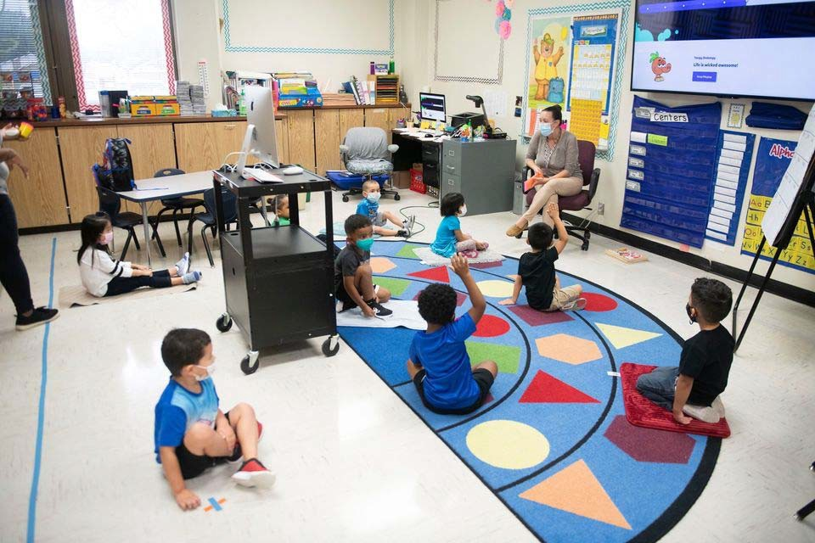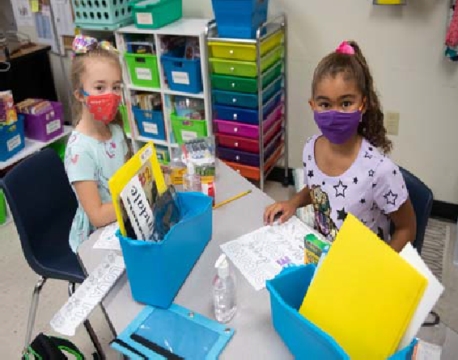Mesquite Independent School District

Executive Summary

Executive Summary
Board of Trustees/Administrative Oﬃcials 3
Consultants and Advisors 4
Executive Summary 5‐6
District Details 7‐9
Mission Statement 10
Budget Process 11‐12
Budget Timeline 13
Budget Highlights 14
General Fund 15
Estimated Revenues 16
Expenditures 17
General Fund 18
Student Nutrition Fund 19‐20
Debt Service Fund 21
General Obligation Debt 22
General Obligation Bonds 23
Capital Projects 24
Taxable Values and Tax Rate 25‐27
Enrollment Growth 28
Student Enrollment Summary 29
Student Enrollment by Campus 30‐31
Staﬃng 32
Graduation Rates 33
2020 Accountability 34
Financial Integrity Rating System of Texas (FIRST) and Future Budget Years 35
Future Budget Years 36
Revenue and Budget 5 Year Estimations 37‐38
Budget Contact 39

3819 Towne Crossing Blvd.
Mesquite, TX 75150

Board of Trustees

Gary Bingham, President Eddie Rose, Vice President
Archemides Faulkner, Secretary Elaine Whitlock, Assistant Secretary Gregg Everett, Member
Robert Seward, Member Kevin Carbo, Member

Administrative Oﬃcials

Dr. David Vroonland, Superintendent of Schools Beth Nicholas, Deputy Superintendent
Pete D. Pape, Assistant Superintendent for Finance & Operations
Dr. Karyn Cummings, Assistant Superintendent for Administrative Services Dr. Treva Franklin, Assistant Superintendent for Curriculum & Instruction Mary Randall, Assistant Superintendent for Personnel Services
Dr. Angel Rivera, Chief of Strategic Initiatives & Community Engagement Laura Jobe, Executive Director for Communications

Consultants and Advisors

General Counsel Gary Grimes Mesquite, TX

Auditors Weaver and Tidwell, L.L.P. Dallas, Texas

Financial Advisor First Southwest, a Division of Hilltop Securities, Inc.
Dallas, Texas

Bond Counsel Norton Rose Fulbright US LLP Dallas, Texas

Depository Bank Prosperity Bank Balch Springs, Texas

Executive Summary

We are pleased to present the 2020‐2021 Budget Book for Mesquite Independent School District. This budget represents the revenue and spending plan for the District for the 2020‐2021 fiscal year, which begins September 1, 2020 and ends August 31, 2021. It has been prepared in accordance with state regulations and local policies. The budget includes the three major funds requiring Board approval for the fiscal year – General Fund, Student Nutrition Fund, and Debt Service Fund. The budget also includes Capital Projects Funds that do not require a legally adopted budget.

The budget is developed per the Board policies CE (Legal and Local) which stipulate that the “Superintendent shall prepare, or cause to be prepared, a proposed budget covering all estimated revenue and expenditures of the District for the following fiscal year.” The Texas Education Agency, which exercises oversight of Texas School District financial aﬀairs, requires a legally adopted budget for the General Fund, Food Services Fund, and the Debt Service Fund.

The 2020‐2021 budget presentation for Mesquite ISD is designed to provide quality, useful information to its citizens concerning the District’s financial plan for education programs and services for the coming 2020‐2021 fiscal year. It is prepared in a manner to help our citizens, staﬀ, and Board of Trustees understand how resources are allocated and the goals the District desires to achieve.

The budget book is organized to present the information in a user‐friendly format that meets the criteria set forth in the Meritorious Budget Award program administered by the Association of School Business Oﬃcials (ASBO) organization. The budget book contains the following sections:

- Executive Summary – reflects the key, important information within the budget book. This section gives the reader an insight to the remainder of the budget book. This section high‐ lights and summarizes the key components within the budget book.

- Organizational Section – provides the framework for the budget development as well as the District’s organizational and financial structure. Contains detail information on the budget process and policies, account code structure, and District financial policies and procedures.

Executive Summary (cont.)

- Financial Section – presents the financial information and budgetary projections for the coming fiscal year. The schedules highlight the three governmental funds requiring legally‐ adopted budgets as well as capital project funds. These schedules reflect historical, current, and future financial data.

- Informational Section – provides additional financial, staﬃng, and student information. This section provides actual budget data, tax values information, enrollment data, and other schedules to highlight useful budget information for the District’s citizens.

Facts about Mesquite Independent School District

The Mesquite Independent School District is an independent public educational agency operating un‐ der applicable laws and regulations of the State of Texas. The Mesquite ISD Board of Trustees (“Board”) is the level of government, which has oversight responsibility and control over all activities related to public school education within the District. The District receives funding from local, state, and federal government sources and must comply with all the requirements of these funding source entities. However, the District is not included in any other governmental “reporting entity” as defined in generally accepted accounting principles.

Mesquite ISD encompasses Mesquite, Balch Springs, Garland and Dallas. The district has nearly 39,000 students and operates 33 elementary schools, 10 middle schools, and 5 high schools.

Mesquite Independent School District District Details

Excellence Always

Mesquite ISD’s 5,000+ employees work in unison for Excellence Always. They seek new heights of achievement while ensuring the best educational experience for every student, preparing him or her for continued success beyond graduation. Each school day, nearly 39,000 students on 49 quality campuses are exposed to caring, highly qualified teachers and the most current technological learning innovations.
Five belief statements guide all daily decisions and interactions aﬀecting students and their families:
- Each student holds unique value and infinite promise.
- Experiences that foster collaboration, communication, curiosity and contextual learning prepare students for a competitive workforce.
- Our democracy depends on educational experiences that develop responsible citizens.
- MISD employees form a passionate learning family committed to professional growth.
- A diverse and involved community positively impacts our students.

A Great Place to Work

MISD is a dynamic, diverse district with a family‐like, close‐knit atmosphere often associated with districts much smaller in size. In the 2019‐20 school year, MISD’s new hires included 53 proud graduates of our schools. MISD boasts a lower‐than‐average turnover rate. Mesquite ISD’s Board of Trustees strives to keep salaries and benefits competitive so that the district can attract and retain the best educators and other staﬀ members.

We also value our teachers who are called to make a diﬀerence. In 2016, Mesquite ISD launched a groundbreaking program that allows teachers to grow professionally and financially – all while staying in the classroom. Under the Excellence in Teaching Incentive Program, Mesquite ISD teachers can add up to $12,000 to their annual salary in just six years by completing advanced training and other requirements. No other district in the country is making this type of investment in its staﬀ.

Early Literacy Initiative

We know learning does not begin when students start school. A child’s learning begins the moment he or she enters the world. For that reason, Mesquite ISD and our community are committed to creating bookworms from birth through an early literacy initiative we call ReadPlayTalk. Our families are

encouraged to read, play and talk with their children every single day. By 2021, every student in Mesquite ISD will be reading on grade level by the third grade. Why? Because early literacy is the greatest single predictor of high school graduation and success into adulthood. Partnerships with local businesses, organizations and city services are helping to spread the message of ReadPlayTalk and making this simple model a part of our community’s culture.

Rich Academic Oﬀerings

A focus on college and career readiness is a hallmark of the district’s academic programs. Last year, students earned 12,672 dual credit hours. The district has also launched an elementary honors pro‐ gram designed to encourage elementary students to take higher‐level classes; the goal is to have 80 percent of 8th‐graders taking at least one pre‐AP or honors class.

In 2021, the district will open a choice career high school where students can streamline and focus their education toward their chosen careers in high‐demand, high‐paying fields. In addition, the district will oﬀer four‐year academies at each of its traditional high schools, giving students the opportunity to attend a high school outside their attendance zone if they choose to enroll in an academy oﬀered at a specific campus.

Career and Technical Education (CTE) in MISD provides a kaleidoscope of opportunities for students to explore and plan for future success. CTE courses oﬀer opportunities for students to learn skills they may use in high school, in a career after graduation, or as a financial means to help pursue higher education. In high school, our students enjoy options to earn 15 professional certifications and advanced training in even more industries.

Mesquite ISD oﬀers the AVID program on selected campuses. AVID (Advancement via Individual Determination) is a rigorous program that transforms average students into high performers. This proven program uses mentoring and special learning opportunities to teach skills and instill attitudes that foster success in high school and college.

Programs to Address Diﬀerent Needs
Mesquite Academy serves secondary students who are not on track to graduate from high school in four years. The Academy oﬀers a flexible learning environment driven by the case‐by‐case needs of individual students. The Academy oﬀers an eﬃcient environment for acceleration by limiting class loads. Blended learning utilizes teacher‐driven lessons accompanied by online curriculum, promoting a focused approach for course completion. Customized interventions and weekly meetings monitor students’ individual progress for meeting the requirements for graduation. After catching up to their

cohort, students may choose to return to their home campus or to complete high school at the Academy.

Approximately 29 percent of Mesquite ISD students are limited in their English proficiency (LEP). LEP students are served by MISD’s elementary 50/50 enrichment bilingual program – with instruction in both English and Spanish – as well as English as a Second Language (ESL) programs at elementary and secondary levels.

The MISD Gifted and Talented Program serves students in all grade levels. Gifted students have diﬀerent needs, and their needs must be met through a diﬀerentiated curriculum. Teachers who have completed additional specialized training—enabling them to lead these classes in exciting, motivating ways—teach these programs. The district has also launched an advanced academics initiative de‐ signed to give all elementary students an honors program experience and ensure that 80% of eighth‐ graders will be enrolled in at least one pre‐AP course.

Broad Extra‐Curricular Options
MISD’s numerous extra‐curricular programs give students opportunities to develop relationships with peers through a team environment, an awareness of health and fitness, and the ability to sharpen leadership skills while working with others. Extra‐curricular programs include athletics, academic com‐ petitions, fine arts and a variety of clubs and organizations. Because students who are involved at school tend to stay in school, one of the district's objectives is to ensure that every student takes part in a school organization or extra‐curricular program.

Studying the fine arts is a great way to get involved in a lifelong activity. Classes such as band, choir, orchestra, art and theater provide students the ability to realize their talents and the opportunity for individual and team recognition. On the elementary campuses, general music classes and fine arts field trips are part of the curriculum and expose students to a variety of cultural experiences. For seven consecutive years, MISD has been selected as one of the Best Communities for Music Education by the National Association of Music Merchants.

Safety First
School safety is a top priority for families and Mesquite ISD. Our campuses warmly welcome visitors while maintaining strict security standards. School Resource Oﬃcers are trusted role models and staﬀ members at middle and high schools, building relationships that keep students on the right track and making good choices. All visitors must be buzzed into the school building by a secretary.

Mesquite Independent School District Mission Statement

The mission of Mesquite ISD is to develop an inspiring and innovative learning community that educates and empowers students to pursue excellence.

At MISD, we believe:
  - Each student holds unique value and infinite promise.
  - Experiences that foster collaboration, communication, curiosity, and contextual learning prepare students for a competitive workforce.
  - Our democracy depends on educational experiences that develop responsible citizens.
  - MISD employees form a passionate learning family committed to professional growth.
  - A diverse and involved community positively impacts our students.

Our Vision: Excellence Always

We developed a Strategic Plan with the community to implement in 2017. We have developed the budget to help implement each of these objectives:

  - Build Teacher Capacity and understand needs of students with strategies.
  - Early literacy with community involvement and design a comprehensive literacy framework.
  - District support system for retaining and developing employees and to recruit employees.
  - Build network of community leaders to advocate and participate in financial opportunity.
  - Develop a facility plan to address current and future enrollment, and develop innovative spaces.
  - Culture that promotes empathy and empowerment to engage all ordinances.
  - Exhibit an authentic representation of the district in communications.

The members of the cabinet place in the budget request any strategies that require funds. We work to fund all needs of the campuses to implement these goals. The M&O has paid for the building of sever‐ al wings and buildings, and professional development to meet these goals.

Mesquite Independent School District Budget Process

The overall budget process has rules and laws that must be met as set by the State of Texas. The Texas Education Code Sections 44.002‐44.006 establish the legal basis for school district budget development. Along with these legal requirements, the District also follows a standard process to develop each fiscal year’s budget. The budgeting process is comprised of five major phases: planning, preparation, adoption, implementation, and evaluation. The budgetary process begins with sound planning. Planning defines the goals and objectives of campuses and the school district and develops programs to attain those goals and objectives. Campuses are allocated budgetary resources based on their unique student demographics. Each campus uses a committee to allocate their resources to best ad‐ here to their goals, which are laid out in the Campus Improvement Plan which is developed annually and submitted to the Texas Education Agency (TEA). The District plan specifies district goals and re‐ sources are allocated in the budget to help achieve these goals. Budgetary resource allocations are the preparation phase of budgeting. The allocations cannot be made until plans and programs have been established.

The adoption stage of the budget process occurs in the month of August each year, prior to the start of the fiscal year on September 1st. The Board of Trustees has the responsibility of adopting the budget before setting the tax rate to support the budget. A public hearing for the budget and the proposed tax rate must occur before oﬃcial legal adoption by the Board of Trustees. After adoption, the implementation of the budget is performed by the Business Oﬃce, with the cooperation of other District administrators. Implementation also includes establishing controls over revenues and expenditures, budget amendments, and informational reporting on the budget.

Finally, the budget is evaluated for its eﬀectiveness in attaining goals and objectives. Evaluation typically involves an examination of: how funds were expended, what outcomes resulted from the expenditure of funds, and to what degree these outcomes achieved the objectives stated during the planning phase. This evaluation phase is important in determining the following year’s budgetary allocations. The evaluation culminates in the performance of the annual audit performed by an independent CPA Firm. The audit results must be reviewed and approved by the Board and sent to the State by the end of January each year.

In summary, budget preparation is not a one‐time exercise to determine how a school district will allocate funds. Rather, school district budget preparation is part of a continuous cycle of planning and evaluation to achieve district goals.

Budget Process (cont.)

The preparation, adoption and revision of the budget are the result of a process covering the entire year. The following is the budget calendar for the 2020‐2021 fiscal year.

- Budget Planning November‐January
- Budget Preparation February‐June
- Board Adoption August (includes Board of Trustee review in July & Aug.)
- Budget Evaluation September‐October
- Audited Financial Statements January

A comprehensive budget calendar is included in the Executive Summary and the Organizational Section.

The one major change that took place in the budget development was the opening of Woolley Middle School. The district realigned two elementary attendance zones to Woolley Middle School.

Staﬃng was allocated to best serve the needs of our students. The district ensured all students and schools were set to reach the goals of the district.

Budget Timeline

  - Budget Priorities 11‐1‐2019
  - Workshop with Board 12‐9‐2019
  - Campuses & Development Input 2‐1‐2020
  - Comptroller Values 1‐31‐2020
  - Board Sets Workshop Priorities 4‐13‐2020
  - Board Approves Priorities 4‐13‐2020
  - Preliminary 2020 Values 5‐18‐2020
  - Board Update on Status of Budget Development 5‐11‐2020
  - Final Property Values 8‐20‐2020
  - Board Approves Preliminary Budget 7‐27‐2020
  - Publish Public Notice 7‐30‐2020
  - Amend 2019‐2020 Budget 8‐10‐2020
  - Hold Public Meeting 8‐10‐2020
  - Approve 2020‐2021 Budget 8‐10‐2020
  - Adopt Tax Rate 9‐14‐2020

- Budget Priorities are developed by the cabinet with their departments input.
- Budget Workshop is when the Board approves the priorities and adds any additional priorities that they would like to have addressed.

2020‐2021 Budget Highlights

The Annual Budget was developed to align to the Districts’ Strategic Plan. The district is developing a transition plan by continuing to monitor and adjust priorities and district goals. For 2020‐2021 professional employees received a flat raise of $1,000 and paraprofessionals received a flat raise of
$500. The District budgeted $1,763,510 in stipends for teachers who completed the ETIP requirements.

Woolley Middle School opened in 2020‐2021 to alleviate overcrowding and plan for enrollment growth.

  - Salary Increase of $1,000 for all Professional Personnel
  - Salary increase of $500 for all Paraprofessional and Auxiliary Support Personnel
  - Option for minimum one‐time payment of $500 for all employees
  - Provides funds for Mentor Programs for Teachers
  - Provides Computer/Computer Program Upgrades
  - Adds seatbelts for buses
  - Locker room additions at Hanby Stadium
  - Provides funds for AYO which leverages AI to tailor learning paths
  - Provides funds for certain staﬀ/furniture/equipment for Vanguard HS

General Fund

The General Fund is commonly referred to as the “Operating Fund” or “Local Maintenance Fund”. State aid and local tax revenue make up the bulk of revenues received by this fund. This fund is used to pay general operating expenses such as salaries, utilities, supplies, and contracted services throughout the District.

The General Fund 2020‐2021 revenue is budgeted to increase $2.4 million from the state and $5.0 million from local taxes. The General Fund Balance is estimated to be $121,400,000 for 2019‐2020 and projected to be $118,400,000 for the 2020‐2021 school year due to lower enrollment and student attendance due to COVID‐19.

2020‐2021 General Fund Estimated Revenues

- Local Revenue |  | $ 102,936,700
- State Revenue |  | $ 283,775,600
- Other Sources |  | $ 550,000
- Federal Revenue |  | $ 6,050,000
Total Estimated Revenues |  | $ 393,312,300
 | Table 1
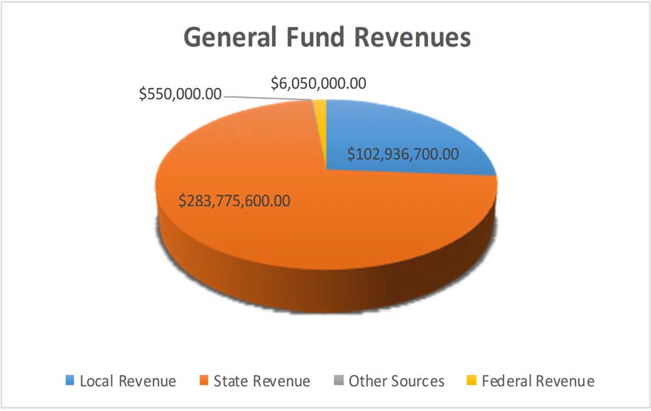

MISD Adopted Budget

2020‐2021 General Fund Expenditures Table 2
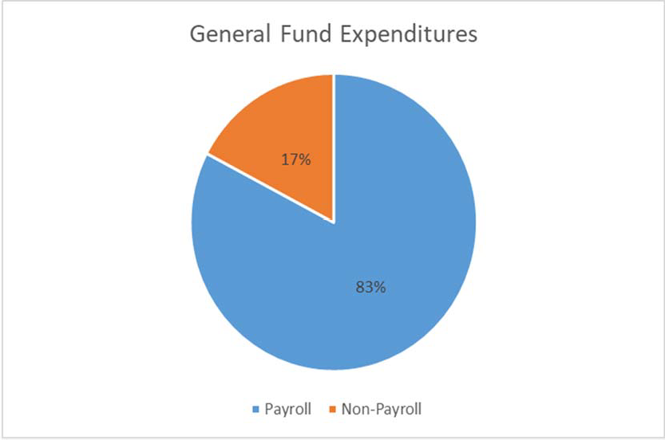

MISD Adopted Budget

General Fund

Revenue | 2016‐2017 | 2017‐2018 | 2018‐2019 | 2019‐2020 | 2020‐2021
Local Revenue | $ 81,681,576.67 | $ 90,177,275.12 | $ 96,682,291.79 | $ 96,941,792.13 | $ 102,936,700.00
State Revenue | $ 264,460,611.10 | $ 264,513,648.83 | $ 260,207,641.93 | $ 275,297,197.37 | $ 283,775,600.00
Federal Revenue | $ 3,720,967.08 | $ 3,448,413.03 | $ 5,471,041.71 | $ 3,974,706.06 | $ 6,050,000.00
Other Sources | $ 425,290.94 | $ 563,534.07 | $ 3,522,349.52 | $ 431,601.73 | $ 550,000.00
Total Revenue | $ 350,288,445.79 | $ 358,702,871.05 | $ 365,883,324.95 | $ 376,645,297.29 | $ 393,312,300.00

Expenditures  General | $ 766,611.25 | $ 814,255.83 | $ 742,683.97 | $ 6,651,364.21 | $ 1,000,000.00
Instruction | $ 203,626,504.50 | $ 210,892,297.88 | $ 209,438,154.06 | $ 214,495,801.89 | $ 234,546,500.00
Instructional Resources & Media | $ 5,808,045.01 | $ 6,000,596.95 | $ 5,882,019.37 | $ 5,806,598.31 | $ 6,601,550.00
Staﬀ Development | $ 3,434,673.34 | $ 3,482,493.42 | $ 3,701,144.53 | $ 3,829,565.78 | $ 5,895,850.00
Instructional Administration | $ 6,031,665.99 | $ 6,953,161.87 | $ 6,677,436.00 | $ 6,889,244.65 | $ 8,040,600.00
Campus Administration | $ 17,824,236.52 | $ 18,898,997.79 | $ 19,250,135.47 | $ 19,744,666.86 | $ 21,033,450.00
Guidance & Counseling | $ 13,958,037.24 | $ 15,099,774.47 | $ 15,162,938.89 | $ 16,426,435.89 | $ 18,504,900.00
Social Work Services | $ 217,139.40 | $ 238,317.17 | $ 215,053.74 | $ 220,715.30 | $ 221,500.00
Health Services | $ 3,633,255.16 | $ 3,837,758.94 | $ 3,896,096.24 | $ 3,994,528.74 | $ 4,265,800.00
Student Transportation | $ 5,533,277.06 | $ 5,317,300.56 | $ 6,599,515.92 | $ 6,623,511.16 | $ 7,683,200.00
Food Services | $ 1,220,182.11 | $ 1,138,655.90 | $ 1,262,468.10 | $ 1,228,215.08 | $ 1,433,700.00
CoCurricular/Extra Curricular | $ 9,705,573.78 | $ 9,921,683.29 | $ 11,241,039.79 | $ 9,165,383.09 | $ 10,075,000.00
General Administration | $ 7,907,330.17 | $ 8,269,954.44 | $ 8,481,422.79 | $ 9,190,687.60 | $ 9,765,800.00
Plant Maintenance & Operating | $ 33,739,386.92 | $ 3,567,139.38 | $ 34,940,324.49 | $ 35,540,862.75 | $ 37,700,950.00
Security Services | $ 3,408,242.23 | $ 3,305,098.05 | $ 3,786,211.49 | $ 4,166,517.62 | $ 4,026,400.00
Data Processing | $ 8,230,435.89 | $ 7,101,942.97 | $ 8,220,691.27 | $ 8,768,885.30 | $ 11,947,000.00
Community Services | $ 112,286.53 | $ 261,668.82 | $ 268,665.69 | $ 264,578.82 | $ 284,700.00
Debt Services | $ ‐ | $ 0.00 | $ 0.00 | $ 0.00 | $ ‐
Facility Acquisition/Construction | $ 13,343,955.32 | $ 27,593,017.49 | $ 15,325,999.88 | $ 13,083,393.02 | $ 4,895,200.00
JJAEP | $ 85,308.00 | $ 63,762.00 | $ 50,424.00 | $ 23,484.00 | $ 130,000.00
Tax Increment Fund | $ 3,416,855.96 | $ 3,627,332.00 | $ 3,216,776.00 | $ 3,183,867.00 | $ 3,600,000.00
Other Intergovernmental | $ 344,842.00 | $ 368,753.00 | $ 406,205.00 | $ 419,493.00 | $ 420,000.00
Total Expenditures | $ 342,347,844.38 | $ 366,753,962.22 | $ 358,765,406.69 | $ 369,717,800.07 | $ 392,072,100.00
Beginning Fund Balance | $ 112,403,105.74 | $ 120,343,707.15 $ 112,292,615.98 $ 119,410,534.24 |  |  | $ 126,338,105.63
Ending Fund Balance | $ 120,343,707.15 | $ 112,292,615.98 $ 119,410,534.24 $ 126,338,105.63 |  |  | $ 127,578,305.63

Student Nutrition Fund

2017 AUDITED 2018 AUDITED 2019 AUDITED 2020 UNAUDTIED 2021 BUDGET

Local Revenue
Earnings From Investments | $ 37,206.98 | $ 91,664.35 | $ 193,849.58 | $ 115,454.68 | $ 100,000.00
Gifts & Bequests | $ 0.00 | $ 0.00 | $ 0.00 | $ 60,000.00 | $ 100,000.00
Misc/Fines, Wellness, & Etc. | $ 112,066.81 | $ 69,284.69 | $ 46,475.77 | $ 53,688.92 | $ 50,000.00
Food Services Activity | $ 3,159,059.25 | $ 3,325,456.91 | $ 3,130,456.91 | $ 2,126,072.48 | $ 2,463,100.00
Extra/Cocurricular Activity | $ 0.00 | $ 0.00 | $ 0.00 | $ 0.00 | $ 0.00
Activity Fund |  |  | $ 461.94 | $ 0.00 | $ 0.00
Transfer In | $ 48,915.11 | $ 64,224.38 | $ 41,328.72 | $ 32,057.62 | $ 75,000.00
Other/Non‐Revenue | $ 0.00 | $ 0.00 | $ 0.00 | $ 0.00 | $ 0.00
Grand Total | $ 3,357,248.15 | $ 3,550,630.33 | $ 3,412,303.56 | $ 2,387,273.70 | $ 2,788,100.00
State Revenue
Miscellaneous State Programs | $ 131,099.07 | $ 127,614.18 | $ 124,976.48 | $ 121.564.24 | $ 116,500.00
Other State Agencies | $ 178,096.63 | $ 146,059.11 | $ 183,608.46 | $ 3,407,041.70 | $ 425,000.00
Grand Total | $ 309,195.70 | $ 273,673.29 | $ 308,584.94 | $ 3,528,605.94 | $ 541,500.00
Federal Revenue
School Breakfast Program | $ 3,166,768.17 | $ 3,423,908.74 | $ 3,450,297.09 | $ 3,075,165.70 | $ 3,427,900.00
National School Lunch | $ 13,111,135.78 | $ 14,013,846.84 | $ 13,939,614.82 | $ 10,501,650.55 | $ 13,960,100.00
USDA Donated Commodities | $ 1,692,845.00 | $ 1,717,639.49 | $ 1,675,143.70 | $ 1,699,613.35 | $ 1,719,600.00
Other Federal Revenues | $ 0.00 | $ 0.00 | $ 0.00 | $ 0.00 | $ 0.00
Direct Federal Revenue | $ 51,667.00 | $ ‐ | $ 0.00 | $ 0.00 | $ 0.00
Grand Total | $ 18,022,415.95 | $ 19,155,395.07 | $ 19,065,055.81 | $ 15,276,429.60 | $ 19,107,600.00

Table 4 (cont.)

2017 AUDITED 2018 AUDITED 2019 AUDITED 2020 UNAUDITED 2021 BUDGET

Expenditures
Payroll Costs | $ 8,434,860.31 | $ 8,701,960.94 | $ 8,430,241.16 | $ 8,469,164.53 | $ 9,046,900.00
Contracted Services | $ 103,587.46 | $ 154,949.54 | $ 127,700.66 | $ 90,190.11 | $ 60,400.00
Supplies & Materials | $ 11,336,714.21 | $ 11,378,992.68 | $ 11,490,336.84 | $ 10,107,109.52 | $ 14,081,600.00
Other Operating Cost | $ 15,278.35 | $ 37,839.20 | $ 28,724.14 | $ 24,306.95 | $ 32,500.00
Fixed Assets | $ 514,773.99 | $ 1,156,370.28 | $ 2,217,303.22 | $ 918,259.09 | $ 2,467,000.00
Other Uses | $ 391,200.00 | $ 391,200.00 | $ 391,200.00 | $ 391,200.00 | $ 400,000.00
Grand Total | $ 20,796,414.32 | $ 21,821,312.64 | $ 22,685,506.02 | $ 20,000,230.20 | $ 26,088,400.00
Beginning Fund Balance | $ 5,103,143.75 | $ 5,995,589.23 | $ 7,153,975.28 | $ 7,254,413.57 | $ 8,446,492.61
Ending Fund Balance | $ 5,995,589.23 | $ 7,153,975.28 | $ 7,254,413.57 | $ 8,446,492.61 | $ 4,795,292.61

Table 5
ENDING FUND BALANCE
$4,795,292.61
$5,995,589.23
$7,254,413.57
$7,153,975.28
$8,446,492.61
Fund Balance for Student Nutrition

MISD 2019/20 Financial Audit

Table 6
Mesquite Independent School District Debt Service Fund

 | 2017 AUDITED | 2018 AUDITED | 2019 AUDITED 2020 UNAUDITED 2021 BUDGET
Local Revenue
Taxes, Current Year Levy | $ 28,544,340.42 | $ 31,305,318.69 | $ 39,049,957.19 $ 42,681,896.72 $ 44,600,000.00
Taxes Prior Year | $ 273,206.57 | $ 257,983.90 | $ 173,027.87 $ 322,890.24 $ 300,000.00
Penalties, Interest & Other TA | $ 330,987.39 | $ 347,747.75 | $ 452,930.90 $ 460,346.08 $ 400,000.00
Earnings From Investments | $ 421,979.11 | $ 895,547.43 | $ 1,336,037.02 $ 783,387.17 $ 700,000.00
Grand Total | $ 29,570,513.49 | $ 32,806,597.77 | $ 41,011,952.98 $ 44,248,520.21 $ 46,000,000.00
State Revenue  Misc. State Programs | $ 21,922,615.00 | $ 24,619,635.00 | $ 24,037,151.00 $ 20,376,022.00 $ 17,450,000.00
Grand Total | $ 21,922,615.00 | $ 24,619,635.00 | $ 24,037,151.00 $ 20,376,022.00 $ 17,450,000.00
Expenditures  Bond Principal | $ 29,284,996.20 | $ 26,395,259.95 | $ 28,778,581.98 $ 24,405,377.70 $ 23,282,000.00
Interest on Bonds | $ 19,582,867.51 | $ 25,708,507.74 | $ 33,776,655.94 $ 35,627,558.79 $ 38,800,000.00
Debt Service Fees | $ 367,038.13 | $ 206,547.22 | $ 197,868.35 $ 394,628.75 $ 600,000.00
Grand Total | $ 49,234,901.84 | $ 52,310,314.91 | $ 62,753,106.27 $ 60,427,565.24 $ 62,682,000.00
Other Financing Sources
Refunding Bond Issuance | $ 12,803,007.85 | $ 0.00 | $ 0.00 $ 11,940,000.00 $ 0.00
Sale of Bonds | $ ‐ | $ 0.00 | $ 0.00 $ 0.00 $ 0.00
Transfer In | $ ‐ | $ 0.00 | $ 0.00 $ 0.00 $ 0.00
Premium/Discount | $ 11,071,275.15 | $ 0.00 | $ 0.00 $ 2,001,805.40 $ 0.00
Other Resources | $ ‐ | $ 0.00 | $ 0.00 $ 0.00 $ 0.00
Other Uses | $ 23,625,401.36 | $ 0.00 | $ 0.00 $ 13,974,861,88 $ 0.00
Grand Total | $ 248,881.64 | $ 0.00 | $ 0.00 $ 33,056.48 $ 0.00
Beginning Fund Balance | $ 15,079,282.62 | $ 17,088,627.63 | $ 22,204,545.49 $ 24,500,543.20 $ 28,664,463.69
Ending Fund Balance | $ 17,088,627.63 | $ 22,204,545.49 | $ 24,500,543.20 $ 28,664,463.69 $ 29,432,463.69

General Obligation Debt

For the past decade and the foreseeable future, the District has and will continue to experience bond elections authorizing new bonds an a continual issuance of bonds. In the past, the District has received a primary bond rating of AAA through the State of Texas Permanent School Fund (PSF). The District’s underlying rating from Fitch was an AA+ and S&P rating was AA.

The state funding formula provides for two types of debt service support—the Instructional Facility Allotment (IFA) and the Existing Debt Allotment (EDA). These allotments are both weighted to take into consideration the property wealth per student of the receiving districts.

The Legislature’s practice of rolling forward new debt into EDA ensures that MISD’s debt is equalized to the highest levels.

IFA funds target debt repayment for new construction, and due to limited funding at the state level, Mesquite ISD continues to receive funds from the IFA. The District expects to receive approximately
$4,315,642.

The EDA funding, created in 1999 supports the repayment of debt that is already outstanding. The District expects to receive $14,739,359.

For 2020‐2021, the Debt Service Fund has budgeted revenues for $63,450,000. The debt service tax rate is set at $0.48.

The major growth in enrollment over the past ten years has caused the District to call for several bond elections to authorize construction of new school facilities. The District’s financial advisor, Jason Hughes with First Southwest, works with the District to eﬀectively structure its debt capacity.

General Obligation Bonds

The primary type of bond debt instrument is the General Obligation Bond. This debt instrument re‐ quires voter approval. Mesquite ISD’s rating as stated below by Fitch and Standard & Poor is due to excellent financial and administrative practices.

The following table depicts bonded debt facts:

Table 7
The Districts AA from S&P:
“Sustained very strong finance with available reserves averaging slightly more than 30% of expenditures during the past four fiscal years.”
The District’s AA+ rating from Fitch:
“The district has demonstrated a strong commitment to supporting financial flexibility. Budgeting is conservative and typically includes capital projects and management has been proactive in maintaining operational balance throughout economic cycles”
AAA
AA+Fitch AAStandards & Poor
Bond Rate (Texas Permanent School Guaranteed)
Bond Rate (underlying)
$748,039,388.90
Outstanding Bonded Debt as of 8‐31‐20.
MISD Debt Book‐Hilltop Securities

* The Bond Debt Service schedule is located in Table 39 on page 135.

Capital Projects

This governmental fund budgeted at $ 110,004,000 for 2020‐2021 is established to account for proceeds on the modified accrual basis from the sale of bonds and other resources to be used for Board authorized acquisition, construction, or renovation as well as furnishing and equipping of major capital facilities.

The last bond package was approved in May 2018. The bond included Woolley Middle School , Elementary School #34, Vanguard High School , athletic updates, roofs, and expansions to several of our facilities, technology infrastructure updates, and additional school buses.

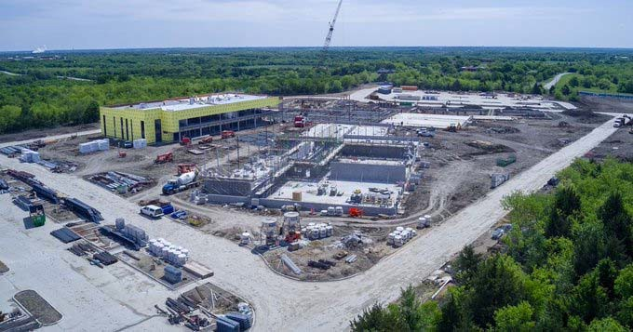

Taxable Values and Tax Rate

The appraisal process is conducted by the Dallas County Appraisal District (DCAD). Properties are required to be appraised at 100% of market value. A ten percent appraisal cap controls runaway proper‐ ty value growth. The DCAD submits preliminary values to the school district by May 1. These values are usually a conservative estimate of the final certified values that are provided by July 25th. The preliminary values are good estimates upon which to base the tax levies for the operating and debt service budgets. Once the certified values are received by the district, the tax rate adoption and budgeting process can be completed for the new fiscal year.

Table 8
Taxable Value Projections
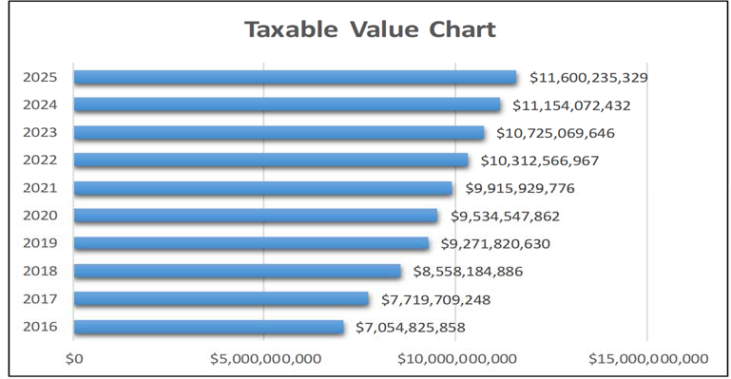
Dallas County Appraisal District

For budget purposes, the tax levy is computed from the New Taxable Value at a 99% collection rate. The actual taxes to be collected on the Freeze Taxable Values are added back. The Freeze Taxable Value is the property values of citizens over 65 years old. Their tax levy is frozen when they turn 65 and can never rise any higher no matter what happens to property values or tax rates. The combination of the Net Taxable Value levy on Frozen Values the Total Levy for the year.

The Maintenance and Operations tax rate supports the major educational and operational programs of the District for such expenses as staﬀ salaries, utilities, supplies, materials, equipment, etc. The M&O rate for 2020‐2021 is $ 0.9664.

The Debt Service rate tax rate supports payments of principal and interest for the debt authorized by the voters. The total amount of debt service payable each year less any state aide is divided by the taxable property values to determine the rate. For the 2020‐2021, the debt service rate is $0.48.

Table 9
Tax Rate History

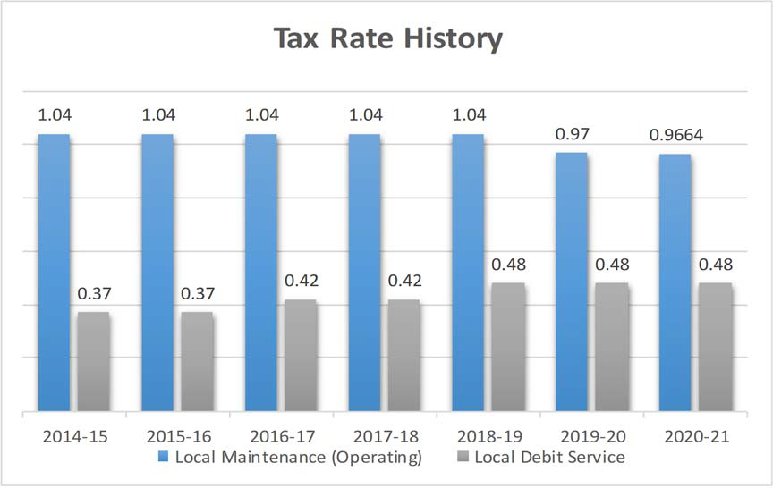

The yearly impact of the M&O tax rate and the Debt Service (Interest & Sinking or I&S) tax rate for the District’s taxpayers is shown in Table 8. The numbers show the eﬀect of the total tax rate along with the increases in property values over the past several years. The table uses the average home value in the District over the past 8 years to reflect the tax increase trend.

Table 10
Tax Rate Impact to District’s Taxpayers

 | 2016‐2017 | 2017‐2018 | 2018‐2019 | 2019‐2020 | 2020‐2021
Assessed/Market Value of a Home | $ 110,608.00 | $ 128,823.00 | $ 146,319.00 | $ 147,607.71 | $ 169,135.00
Average Taxable Value | $ 85,881.00 | $ 99,152.00 | $ 113,294.00 | $ 115,607.00 | $ 138,608.00
Total Property Tax Rate | $ 1.46 | $ 1.46 | $ 1.52 | $ 1.45 | $ 1.4464
Property Tax Due | $ 1,253.86 | $ 1,447.62 | $ 1,722.06 | $ 1,676.30 | $ 2,004.83
Increase in Taxes | $ 91.19 | $ 193.76 | $ 274.44 | $ (45.76) | $ 185.14
Property Tax Percent Increase from Prior Year | 7.8% | 15.5% | 19.0% | ‐2.70% | 19.6 %
This schedule shows the trends in property values and tax rates. Each year the Dallas County Appraisal District appraises property based on market conditions such as sales in the surrounding areas. The above schedules shows how market conditions have aﬀected the assessed value through 2020‐2021 based on the overall appraisal value trends in the District. As shown above, the average value of a residence in the District continues to rise annually.

Table 11
2020‐2021
2019‐2020
2018‐2019
2017‐2018
2016‐2017
$2,500.00

$2,000.00

$1,500.00

$1,000.00

$500.00

$‐
Property Tax Due
MISD Internal Data

Mesquite Independent School District Enrollment Growth

Student enrollment numbers for Mesquite Independent School District are declining. Total K‐12 enrollment was 39,638 in 2019 to 38,381 in 2020.

The 2020‐2021 school year will see a significant decrease in enrollment.

The previous enrollment growth along with a demographers estimate that the District will continue to experience some annual growth over the next years.

As subdivisions identified by the demographers begin to build homes and apartments the District expects to experience annual growth beginning in school year 2022‐2023.

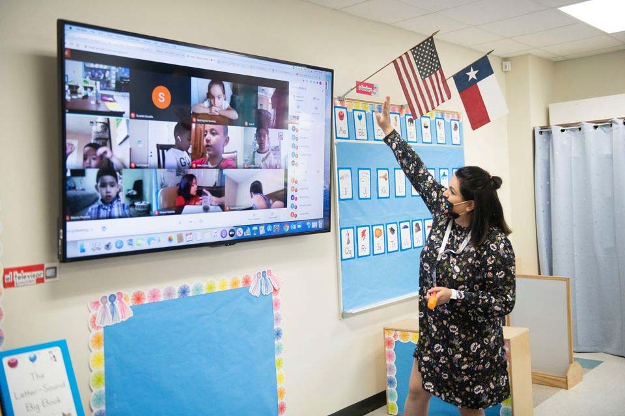

Table 12
Mesquite ISD Oﬃcial Budget 2020‐2021
Executive Summary
29
Mesquite ISD Student Enrollment Summary

Campus Type | Actual 2016‐17 | Actual 2017‐18 | Actual 2018‐19 | Actual 2019‐20 | Current Year 2020‐21 | Projected 2020‐21 | Projected 2021‐22 | Projected 2022‐23 | Projected 2023‐24
High Schools | 11,892 | 12,023 | 12,367 | 12,029 | 12,105 | 12,383 | 12,796 | 13,189 | 13,377
Middle Schools | 7,078 | 7,163 | 9,973 | 9,907 | 9,570 | 10,012 | 9,772 | 9,390 | 8,893
Elementary Schools | 21,882 | 21,643 | 18,497 | 17,695 | 16,701 | 17,240 | 17,014 | 16,951 | 17,029
Mesquite Academy | 167 | 187 | 280 | * | *
JJAEP |  |  |  | 7 | 5 | 5 | 5 | 5 | 5
Total Enrollment | 41,019 | 41,016 | 41,117 | 39,638 | 38,381 | 39,640 | 39,587 | 39,535 | 39,304

* Student enrollment included in high school count.
Texas Education Agency‐District TAPER Report

Table 13
Executive Summary
Mesquite ISD Oﬃcial Budget 2020‐2021
30

Mesquite ISD Student Enrollment by Campus

Campus | Actual 2016‐17 | Actual 2017‐18 | Actual 2018‐19 | Actual 2019‐20 | Current Year 2020‐21 | Projected 2020‐21 | Projected 2021‐22 | Projected 2022‐23 | Projected 2023‐24
Mesquite High School | 2,864 | 2,904 | 2,829 | 2,625 | 2,561 | 2,633 | 2,684 | 2,805 | 2,877
North Mesquite High School | 2,818 | 2,808 | 2,864 | 2,522 | 2,415 | 2,462 | 2,400 | 2,380 | 2,436
West Mesquite High School | 2,057 | 2,077 | 2,137 | 2,162 | 2,280 | 2,270 | 2,381 | 2,487 | 2,501
Poteet High School | 1,791 | 1,848 | 1,853 | 1,822 | 1,750 | 1,856 | 1,876 | 1,940 | 1,936
Horn High School | 2,362 | 2,386 | 2,684 | 2,898 | 3,099 | 3,162 | 3,455 | 3,577 | 3,627
Agnew Middle School | 797 | 831 | 1,280 | 1,228 | 1,227 | 1,258 | 1,190 | 1,153 | 1,039
Vanston Middle School | 812 | 805 | 969 | 923 | 847 | 909 | 917 | 900 | 868
Wilkinson Middle School | 954 | 974 | 926 | 790 | 797 | 845 | 806 | 760 | 678
McDonald Middle School | 1,034 | 1,002 | 909 | 908 | 923 | 945 | 896 | 843 | 780
New Middle School | 867 | 926 | 931 | 935 | 831 | 913 | 880 | 810 | 768
Kimbrough Middle School | 871 | 825 | 1,222 | 1,357 | 1,260 | 1,336 | 1,346 | 1,291 | 1,257
Berry Middle School | 899 | 904 | 1,116 | 1,103 | 613 | 673 | 671 | 656 | 658
Terry Middle School | 844 | 896 | 1,440 | 1,463 | 1,039 | 1,054 | 996 | 928 | 897
Fraiser Middle School | 0 | 0 | 1,180 | 1,200 | 1,126 | 1,190 | 1,160 | 1,072 | 993
Woolley Middle School | 0 | 0 | 0 | 0 | 907 | 889 | 910 | 977 | 955
Black Elementary School | 665 | 639 | 606 | 656 | 626 | 629 | 628 | 618 | 627
Florence Elementary School | 582 | 654 | 543 | 548 | 467 | 508 | 503 | 496 | 501
Galloway Elementary School | 732 | 732 | 489 | 461 | 420 | 449 | 436 | 431 | 430
Hanby Elementary School | 923 | 929 | 835 | 838 | 740 | 836 | 856 | 855 | 872
Hodges Elementary School | 853 | 767 | 610 | 545 | 514 | 527 | 520 | 530 | 521
McWhorter Elementary School | 956 | 870 | 719 | 633 | 549 | 581 | 542 | 509 | 495
Motley Elementary School | 499 | 455 | 370 | 338 | 276 | 325 | 300 | 281 | 269
Range Elementary School | 743 | 763 | 653 | 601 | 580 | 555 | 539 | 527 | 519
Rugel Elementary School | 476 | 458 | 355 | 355 | 321 | 331 | 315 | 319 | 315
Rutherford Elementary School | 459 | 474 | 645 | 659 | 648 | 630 | 613 | 596 | 585
Shands Elementary School | 927 | 825 | 655 | 629 | 622 | 582 | 541 | 522 | 487
Tisinger Elementary School | 792 | 824 | 819 | 660 | 631 | 627 | 599 | 599 | 600
Tosch Elementary School | 938 | 872 | 658 | 594 | 617 | 555 | 549 | 535 | 537
Seabourn Elementary School | 554 | 724 | 700 | 661 | 578 | 673 | 691 | 704 | 715
Lawrence Elementary School | 416 | 440 | 368 | 334 | 283 | 325 | 313 | 317 | 314
Floyd Elementary School | 818 | 798 | 579 | 604 | 455 | 609 | 622 | 646 | 673
Porter Elementary School | 619 | 605 | 427 | 421 | 389 | 431 | 395 | 405 | 389

Table 13 (cont.)
Executive Summary
Mesquite ISD Oﬃcial Budget 2020‐2021
31

Mesquite ISD Student Enrollment by Campus (cont.)

Campus | Actual 2016‐17 | Actual 2017‐18 | Actual 2018‐19 | Actual 2019‐20 | Current Year 2020‐21 | Projected 2020‐21 | Projected 2021‐22 | Projected 2022‐23 | Projected 2023‐24
McKenzie Elementary School | 598 | 538 | 493 | 454 | 414 | 419 | 407 | 403 | 385
Beasley Elementary School | 476 | 467 | 378 | 374 | 359 | 363 | 359 | 361 | 361
Price Elementary School | 450 | 451 | 359 | 348 | 299 | 345 | 333 | 339 | 348
Shaw Elementary School | 891 | 884 | 582 | 577 | 555 | 575 | 571 | 566 | 584
Kimball Elementary School | 284 | 242 | 192 | 188 | 211 | 186 | 192 | 188 | 204
Pirrung Elementary School | 441 | 434 | 438 | 392 | 396 | 346 | 336 | 328 | 321
Cannaday Elementary School | 513 | 564 | 575 | 590 | 582 | 576 | 575 | 572 | 560
Austin Elementary School | 505 | 471 | 471 | 390 | 343 | 387 | 386 | 390 | 397
Moss Elementary School | 483 | 434 | 391 | 380 | 323 | 358 | 352 | 343 | 355
Thompson Elementary School | 554 | 565 | 529 | 523 | 566 | 558 | 563 | 559 | 550
Gray Elementary School | 635 | 634 | 512 | 450 | 431 | 442 | 436 | 437 | 438
Smith Elementary School | 531 | 494 | 425 | 437 | 545 | 446 | 447 | 448 | 474
Gentry Elementary School | 883 | 916 | 654 | 617 | 624 | 614 | 609 | 624 | 610
Mackey Elementary School | 757 | 788 | 678 | 615 | 650 | 602 | 598 | 590 | 604
Achziger Elementary School | 978 | 971 | 854 | 912 | 827 | 969 | 1022 | 1,070 | 1,142
Henrie Elementary School | 951 | 961 | 935 | 911 | 860 | 881 | 866 | 843 | 847
Mesquite Academy | 167 | 187 | 280 | * | *
JJAEP |  |  |  | 7 | 5 | 5 | 5 | 5 | 5
TOTAL | 41,019 | 41,016 | 41,117 | 39,638 | 38,381 | 39,640 | 39,587 | 39,535 | 39,304

* Student enrollment included in high school count.
District Demographic Report‐2020

Staﬃng

A significant portion of the annual operating budget is dedicated to staﬃng and the related salary and benefits costs (approx. 80% ‐ $314,111,600) . To eﬀectively control operating costs of the District, ongoing monitoring must be performed for all staﬃng areas. State laws place restrictions on classroom staﬃng for the kindergarten through 4th grade levels to a 22:1 ratio. To go above this ratio level, the District would need to obtain approved waivers from the state’s Education commissioner. At the secondary level along with grade 5, the District strives to maintain a 28:1 ratio, though certain classes may exceed this level or be much lower. The District allocates its available financial resources to have the greatest eﬀect on student achievement.

Table 14
Mesquite Independent School District Staﬃng History

School Years  Teachers  (Classroom, Interventionists, Special Programs) | 16‐17  2738 | 17‐18  2738 | 18‐19  2748 | 19‐20  2751 | 20‐21  2789
Professional Support | 432 | 532 | 546 | 566 | 585
(Directors, Counselors, Librarians, Campus Oﬃce Staﬀ,
Central Oﬃce Staﬀ)
School Leadership | 132 | 132 | 133 | 141 | 145
(Principals, Asst. Principals)
Central Administration | 124 | 11 | 9 | 28 | 30
(Superintendent, Asst. Superintendents, Cabinet‐Level Positions)
Paraprofessional | 802 | 802 | 807 | 810 | 837
Auxiliary | 1,156 | 1,156 | 1,138 | 1135 | 1101
Total Staﬀ | 5,384 | 5,371 | 5.381 | 5431 | 5489
Student Enrollment (Total Membership‐Fall Snapshot) | 40,718 | 41,025 | 41,022 | 39,638 | 38,381
Staﬃng Ratios
Teaching Staﬀ | 14.87 | 14.98 | 14.93 | 14.41 | 13.76
Total Staﬀ | 7.56 | 7.64 | 7.62 | 7.30 | 6.99
Texas Education Agency‐District TAPER Report

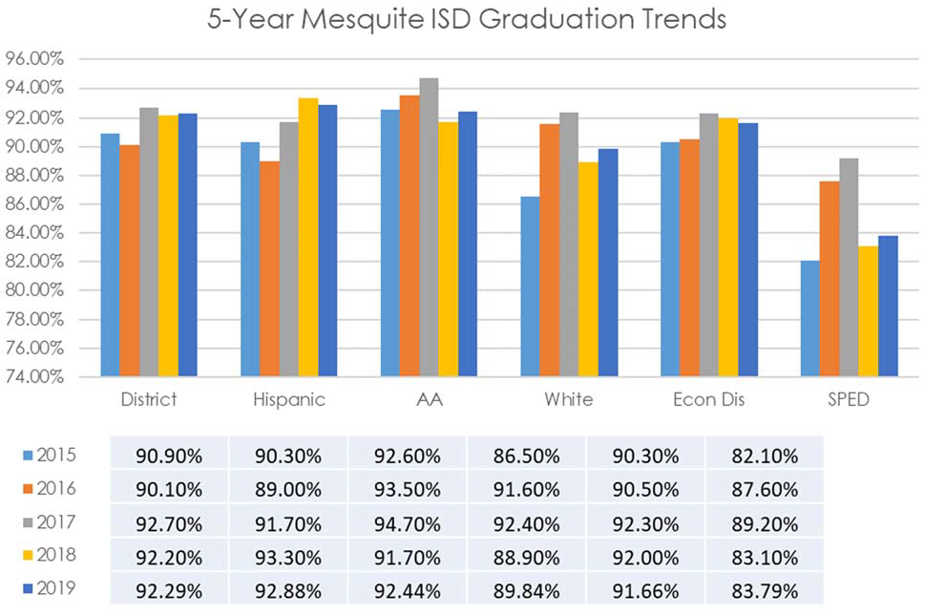Graduation Rates Table 15

Texas Education Agency‐District TAPER Report

Mesquite ISD maintains one of the highest graduation rates for districts that are similar in demographic makeup and size. Graduation rates remain consistently above the region and the state rates.

Mesquite Independent School District 2020 Accountability Ratings
Due to COVID, the STARR test was not administered. The district and all campuses received a rating of “Not Rated: Declared State of Disaster” and retained 2019 ratings. The district retained an 87 ‐ B. All campuses retained their 2019 overall ratings.

Table 16
2019 Accountability Ratings
CAMPUS | OVERALL PERFORMANCE  GRADE
Elementary Schools
Achziger | C
Austin | B
Beasley | B
Black | C
Cannaday | C
Florence | B
Floyd | C
Galloway | B
Gentry | B
Gray | B
Hanby | B
Henrie | B
Hodges | C
Kimball | A
Lawrence | B
Mackey | B
McKenzie | B
McWhorter | C
Moss | B
Motley | A
Pirrung | B
Porter | A
Price | C
Range | C
Rugel | B

CAMPUS | OVERALL PERFORMANCE  GRADE
Rutherford | B
Seabourn | C
Shands | B
Shaw | C
Smith | B
Thompson | C
Tisinger | C
Tosch | C
Middle Schools
Agnew | C
Berry | B
Frasier | C
Kimbrough | C
McDonald | C
New | C
Terry | C
Vanston | C
Wilkinson | A
High Schools
HHS | B
MHS | B
NMHS | B
PHS | B
WMHS | B
Mesquite Academy | Not Rated
Texas Education Agency‐District TAPER Report

Financial Integrity Rating System of Texas (FIRST)

Senate Bill 218 of the 77th Legislature (2001) authorized the implementation of a financial accountability rating system, which is oﬃcially referred to as School FIRST. The primary goal of School FIRST is to improve the management of school district financial resources. School FIRST was developed in consultation with the Comptroller of Public Accounts, and its development also benefited from the many comments that were received from school district and regional education service center personnel. The School FIRST rating is based upon an analysis of staﬀ and student data reported for the school year and actual financial data.

Mesquite ISD received a rating of Superior and a letter grade of A with a score of 98.

Each school district must hold an announced public meeting to distribute the financial management report that explains the district’s performance under each of the 20 indicators and the district’s rating. Each district is encouraged to provide additional information in the financial management performance report that is beneficial to taxpayers by noting special circumstance.

Future Budget Years

Budgeted revenue for local taxes and state aid in 2020‐2021 are based on the funding laws enacted by the 86th Texas Legislature. All projections for future revenue are based on these laws staying in place.

Enrollment numbers reflect the projections shown by our demographer’s report at the low growth rate. The attendance rate of 96% reflects the history of attendance in the district and is used to calculate the Average Daily Attendance (ADA) number. This number is a major driver in determining the amount of state funding for each fiscal year.

The Maintenance and Operations tax rate is assumed to remain at $0.9664 per $100 of taxable value. A Tax Ratification Election will be discussed during the 2021‐2022 budget development as a way to increase revenue.

Salary increases are assumed to be 2% per year along with non‐payroll expenditure increases each year. Additions to teaching and administrative staﬀ are included for the opening of Vanguard High School.

Table 17
Mesquite Independent School District Future Budget Years

General Fund | 2020‐2021 | 2021‐2022 | 2022‐2023 | 2023‐2024 | 2024‐2025
Revenues | $ 393,312,300 | $ 403,345,952 | $ 411,599,345 | $ 418,747,773 | $ 428,537,419
Expenditures | $ 392,072,100 | $ 400,754,650 | $ 408,261,750 | $ 404,525,000
Net | $ 1,240,200 | $ 2,591,302 | $ 3,337,595 | $ 14,222,773 | $ 428,537,419
Beginning Fund Balance | $ 104,576,779 | $ 105,816,979 | $ 108,408,281 | $ 111,745,876 | $ 125,968,649
Ending Fund Balance | $ 105,816,979 | $ 108,408,281 | $ 111,745,876 | $ 125,968,649 | $ 554,506,068
Debt Service Fund
Revenues | $ 63,450,000 | $ 60,000,000 | $ 59,900,000 | $ 63,000,000 | $ 66,000,000
Expenditures | $ 62,682,000 | $ 58,000,000 | $ 57,900,000 | $ 63,000,000 | $ 66,000,000
Net | $ 768,000 | $ 2,000,000 | $ 2,000,000 | $ ‐ | $ ‐
Beginning Fund Balance | $ 24,845,490 | $ 24,077,490 | $ 22,077,490 | $ 20,077,490 | $ 20,077,490
Ending Fund Balance | $ 24,077,490 | $ 22,077,490 | $ 20,077,490 | $ 20,077,490 | $ 20,077,490
Student Nutrition Fund
Revenues | $ 22,437,200 | $ 23,100,000 | $ 23,300,000 | $ 23,500,000 | $ 23,700,000
Expenditures | $ 26,088,400 | $ 23,085,000 | $ 23,385,000 | $ 23,500,000 | $ 23,700,000
Net | $ (3,651,200) | $ 15,000 | $ (85,000) | $ ‐ | $ ‐
Beginning Fund Balance | $ 7,235,506 | $ 3,584,306 | $ 3,599,306 | $ 3,514,306 | $ 3,514,306
Ending Fund Balance | $ 3,584,306 | $ 3,599,306 | $ 3,514,306 | $ 3,514,306 | $ 3,514,306
Capital Projects Fund
Revenues | $ 3,000,000 | $ 125,000 | $ 50,000
Expenditures | $ 110,004,000 | $ 49,750,000 | $ 17,174,366
Net | $ (107,004,000) | $ (49,625,000) | $ (17,124,366)
Beginning Fund Balance | $ 173,753,366 | $ 66,749,366 | $ 17,124,366
Ending Fund Balance | $ 66,749,366 | $ 17,124,366 | $ ‐

MISD Internal Data

Table 18
Executive Summary
Mesquite ISD Oﬃcial Budget 2020‐2021
37
Mesquite Independent School District Revenue and Budget 5 Year Estimations

Property Growth Prediction |  |  | 10% | 10% | 4% | 4% | 2% | 3% | 4% | 4%
Student Enrollment |  | 2016‐2017 | 2017‐2018 | 2018‐2019 | 2019‐2020 | 2020‐2021 | 2021‐2022 | 2022‐2023 | 2023‐2024 | 2024‐2025
Growth Factor Projected‐Demographer (Low) |  | 40,886 | 40,923 | 40,888 | 40,965 | 40,996 | 41,169 | 39,257 | 39,307 | 39,307
Growth Factor Projected‐Demographer (Moderate) |  | 40,886 | 40,923 | 41,053 | 41,249 | 41,401 | 41,700 | 40,455 | 40,142 | 40,142
Growth Factor Used for Revenue Planning |  |  | 269 | 0 | 125 | ‐650 | 0 | 0 | 100 | 200
Refined ADA‐Formula |  | 38,786 | 38,530 | 38,530 | 38,655 | 38,755 | 38,855 | 38,530 | 38,545 | 38,545
Summary of Total State/Local M&O |  | Audited | Audited | Audited | Budgeted | Budgeted | Budgeted | Budgeted | Budgeted | Budgeted
Revenue |  | Revenue | Revenue | Revenue | Revenue | Revenue | Revenue | Revenue | Revenue | Revenue
 |  | 2016‐2017 | 2017‐2018 | 2018‐2019 | 2019‐2020 | 2020‐2021 | 2021‐2022 | 2022‐2023 | 2023‐2024 | 2023‐2024
State Revenue |  | $ 264,460,611 | $ 264,513,649 | $ 260,207,642 | $ 275,208,206 | $ 283,775,600 | $ 298,432,850 | $ 303,432,850 | $ 306,201,618 | $ 311,701,618
$
Local Revenue $ 81,681,577 $ 90,177,275 $ 96,682,294 $ 96,140,828 $ 98,150,100 $ 103,116,495 $ 107,241,155 $ 111,530,801
100,113,102
Federal Revenue | $ 3,720,967 |  | $ 3,448,413 | $ 5,471,041 | $ 3,974,706 | $ 6,050,000 | $ 4,250,000 | $ 4,500,000 | $ 4,750,000 | $ 4,750,000
Other Sources | $ 425,291 |  | $ 563,534 | $ 3,522,350 | $ 431,602 | $ 550,000 | $ 550,000 | $ 550,000 | $ 555,000 | $ 555,000
Total M&O Revenue | $ 350,288,446 |  | $ 358,702,871 | $ 365,883,325 | $ 375,755,342 | $ 393,312,300 | $ 403,345,952 | $ 411,599,345 | $ 418,747,773 | $ 428,537,419
 | Audited |  | Audited | Audited | Budgeted | Budgeted | Budgeted | Budgeted | Budgeted | Budgeted
 | Expenditures |  | Expenditures | Expenditures | Expenditures | Expenditures | Expenditures | Expenditures | Expenditures | Expenditures
 | 2016‐2017 |  | 2017‐2018 | 2018‐2019 | 2019‐2020 | 2020‐2021 | 2021‐2022 | 2022‐2023 | 2023‐2024 | 2023‐2024
Expenditures
General $ 766,611 $ 814,256 |  |  |  | $ 742,684 | $ 6,651,290 | $ 1,000,000 | $ 600,000 | $ 600,000 | $ 600,000 | $ 600,000
Instruction $ 203,626,505 $ 210,892,298 |  |  |  | $ 209,440,357 | $ 214,495,802 | $ 234,546,500 | $ 256,000,000 | $ 262,000,000 | $ 268,000,000 | $ 274,000,000
Instructional Resources | $ 5,808,045 |  | $ 6,000,600 | $ 5,882,019 $ 5,806,598 |  | $ 6,601,550 | $ 6,393,950 | $ 6,495,950 | $ 6,495,950 | $ 6,495,950
Staﬀ Development | $ 3,434,673 |  | $ 3,482,493 | $ 3,701,139 $ 3,829,566 |  | $ 5,895,850 | $ 5,000,000 | $ 5,005,000 | $ 5,005,000 | $ 5,005,000
Instructional Leadership | $ 6,031,666 |  | $ 6,953,161 | $ 6,677,436 $ 6,889,245 |  | $ 8,040,600 | $ 7,000,000 | $ 7,200,000 | $ 7,200,000 | $ 7,200,000
School Administration | $ 17,824,237 |  | $ 18,898,996 | $ 19,250,145 $ 19,744,667 |  | $ 21,033,450 | $ 20,900,000 | $ 21,000,000 | $ 21,000,000 | $ 21,000,000
Guidance & Counseling Services | $ 13,958,037 |  | $ 15,099,777 | $ 15,162,952 $ 16,426,436 |  | $ 18,504,900 | $ 16,800,000 | $ 17,000,000 | $ 17,000,000 | $ 17,000,000
Social Work Services | $ 217,139 |  | $ 238,316 | $ 215,053 $ 220,715 |  | $ 221,500 | $ 220,000 | $ 220,000 | $ 220,000 | $ 220,000
Health Services | $ 3,633,255 |  | $ 3,837,760 | $ 3,896,097 $ 3,994,529 |  | $ 4,265,800 | $ 4,305,000 | $ 4,405,000 | $ 4,405,000 | $ 4,405,000
Transportation Services | $ 5,533,277 |  | $ 5,317,298 | $ 6,599,519 $ 6,623,511 |  | $ 7,683,200 | $ 6,800,000 | $ 6,850,000 | $ 6,850,000 | $ 6,850,000
Food Service | $ 1,220,182 |  | $ 1,138,656 | $ 1,262,470 $ 1,228,215 |  | $ 1,433,700 | $ 1,500,000 | $ 1,600,000 | $ 1,600,000 | $ 1,600,000
Extra Curricular Services | $ 9,705,576 |  | $ 9,921,687 | $ 11,241,059 $ 9,165,383 |  | $ 10,075,000 | $ 10,046,200 | $ 10,046,200 | $ 10,046,200 | $ 10,046,200
General Administration | $ 7,907,330 |  | $ 8,269,953 | $ 8,481,425 $ 9,190,688 |  | $ 9,765,800 | $ 9,500,000 | $ 9,600,000 | $ 9,600,000 | $ 9,600,000

Table 18 (cont.)

 | Audited  Expenditures | Audited  Expenditures | Audited  Expenditures | Budgeted  Expenditures | Budgeted  Expenditures | Budgeted  Expenditures | Budgeted  Expenditures | Budgeted  Expenditures | Budgeted  Expenditures
 | 2016‐2017 | 2017‐2018 | 2018‐2019 | 2019‐2020 | 2020‐2021 | 2021‐2022 | 2022‐2023 | 2023‐2024 | 2023‐2024
Expenditures
Maintenance | $ 33,739,387 | $ 33,567,138 | $ 34,940,328 | $ 35,540,863 | $ 37,700,950 | $ 37,500,000 | $ 38,000,000 | $ 38,000,000 | $ 38,000,000
Security | $ 3,408,242 | $ 3,305,098 | $ 3,786,216 | $ 4,166,518 | $ 4,026,400 | $ 3,825,000 | $ 3,850,000 | $ 3,850,000 | $ 3,850,000
Data Processing | $ 8,230,436 | $ 7,101,945 | $ 8,220,692 | $ 8,768,885 | $ 11,947,000 | $ 8,525,000 | $ 8,550,000 | $ 8,550,000 | $ 8,550,000
Community Services | $ 112,286 | $ 261,670 | $ 268,672 | $ 264,579 | $ 284,700 | $ 279,500 | $ 279,600 | $ 279,600 | $ 279,600
Juvenile Justice Alternative | $ 85,308 | $ 63,762 | $ 15,325,998 | $ 13,083,393 | $ 4,895,200 | $ 130,000 | $ 130,000 | $ 130,000 | $ 130,000
Tax Increment Zones | $ 3,416,856 | $ 3,627,332 | $ 50,424 | $ 23,484 | $ 130,000 | $ ‐ | $ ‐ | $ ‐ | $ ‐
FAC Acquisition/Construction | $ 13,343,955 | $ 27,589,504 | $ 3,216,624 | $ 3,183,867 | $ 3,600,000 | $ 5,000,000 | $ 5,000,000 | $ 5,000,000 | $ 5,000,000
Intergovernmental Charges | $ 344,842 | $ 368,753 | $ 406,205 | $ 419,493 | $ 420,000 | $ 430,000 | $ 430,000 | $ 430,000 | $ 430,000

TOTAL EXPENDITURES $ 342,347,846 $ 366,750,453 $ 358,767,514 $ 369,717,726 $ 392,072,100 $ 400,754,650 $ 408,261,750 $ 414,261,750 $ 420,261,750

Current Fund Balance $ 112,402,842 $ 120,343,442 $ 112,295,860 $ 119,411,670 $ 125,449,287 $ 126,689,487 $ 129,280,789 $ 132,618,384 $ 137,104,407

Revenues ‐ Expenditures $ 7,940,600 $ (8,047,582)
$
7,115,811 $ 6,037,616 $ 1,240,200 $ 2,591,302 $ 3,337,595 $ 4,486,023 $ 8,275,669

Mesquite ISD Oﬃcial Budget 2020‐2021
Executive Summary
38
Predicted Fund Balance $ 120,343,442 $ 112,295,860 $ 119,411,670 $ 125,449,287 $ 126,689,487 $ 129,280,789 $ 132,618,384 $ 137,104,407 $ 145,380,076

Board Policy ‐ 22% Fund Balance $ 77,063,458 $ 78,914,632 $ 80,494,331 $ 82,666,175 $ 86,528,706 $ 88,736,109 $ 90,551,856 $ 92,124,510 $ 94,278,232

MISD Internal Data

Mesquite Independent School District Budget Contact

Individuals who have questions regarding this budget document should contact Pete Pape, Asst. Superintendent for Finance & Operations at 972‐882‐7409 or ppape@mesquiteisd.org. They may also contact Amanda Burns, Executive Director of Business Services at 972‐882‐7319 or aburns@mesquiteisd.org.

Budgeting a school district’s revenues and expenditures is a challenging process, especially in times of reduced funding from the state. However, we believe the budget document demonstrates reasonable and prudent eﬀort to provide the needs of the students, families, and community members. It is our goal to provide the best possible education for our students, while being food stewards of the tax‐ payers’ dollars.

We appreciate the support from the Mesquite Independent School Board of Trustees for developing, implementing, and maintaining an excellent education program for the children of our school district.

Dr. David Vroonland Pete D. Pape
Superintendent Assistant Superintendent Finance & Operations

Executive Summary
39 Mesquite ISD Oﬃcial Budget 2020‐2021

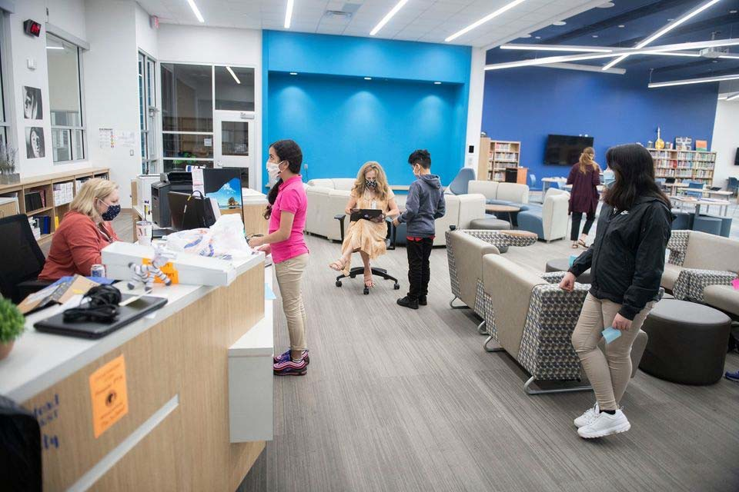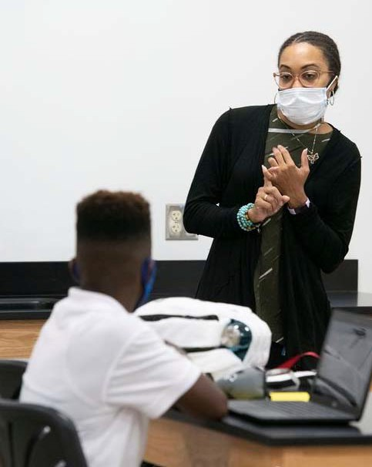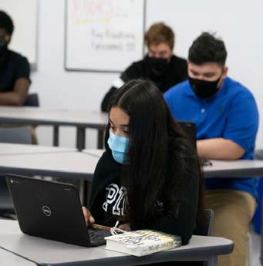

Mesquite Independent School District

Organizational Section

Organizational Section
Significant Facts about Mesquite Independent School District 42
Mesquite ISD Attendance Zones 2020‐2021 43
Enrollment Growth 44
Student Enrollment Summary 45
Student Enrollment by Campus 46‐47
Student Ethnicity Percentages 48
Mesquite ISD Contact Information 49‐51
Mesquite ISD School Calendar 2020‐2021 52
Organizational Chart 53
Board of Trustees 54‐56
MISD Vision 57
Strategic Plan 58
Financial Policies/Basis of Accounting 59‐68
Account Code Structure/Basic System Expenditure Code Structure 69‐70
Function Codes 71‐75
Account Code Structure 76‐80
Budget Policies 81‐91
Budget Timeline 92

Significant Facts about Mesquite Independent School District

The District provides education services to all children with in is designated boundaries. These services include qualifying infants through 12th grade. For the 2020‐2021 school year, the District is composed of 33 elementary schools, 10 middle schools, 5 high schools, 1 academy and 1 discipline alternative education program. We also oﬀer a bilingual elementary school program for students who speak Spanish as their first language.

The projected enrollment for the 2020‐2021 school year is 39,640 students.

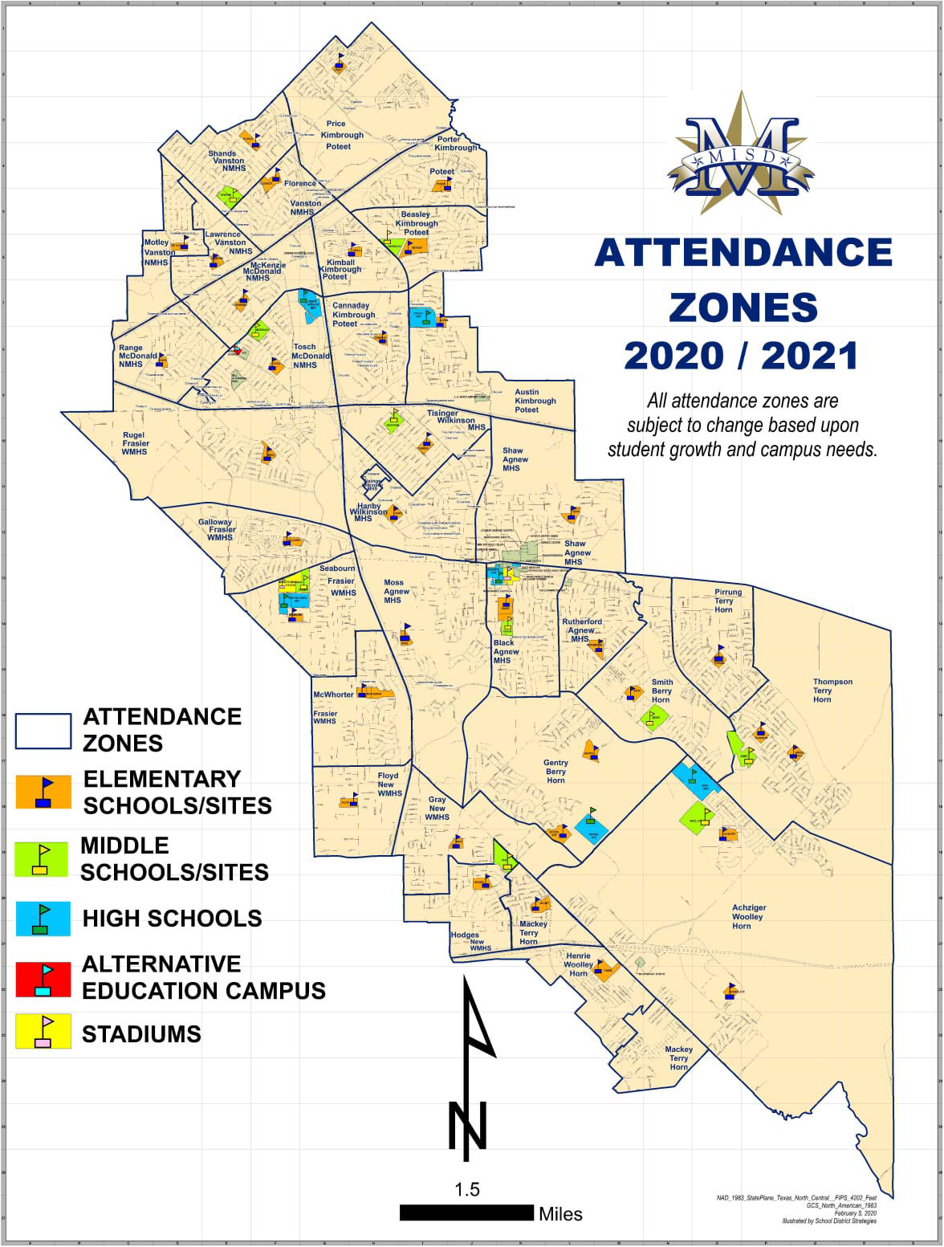

Mesquite Independent School District Enrollment Growth

Student enrollment numbers for Mesquite Independent School District are remaining steady. Total K‐12 enrollment was 39,638 in 2019 and predicted 39,640 in 2020.

The previous enrollment growth along with a demographers estimate that the District will continue to experience some decline in growth over the next years.

Student enrollment growth in the past facilitated the district building portables. The enrollment growth has slowed down and the district is trying to get rid of portables. They are the most expensive goal of our strategic plan. The replacing of portables with additions of classrooms. Through the process of moving students in the 6th grade to the middle school, we were able to significantly reduce our portables. The projects have then been developed to continue to reduce the portable in the district.

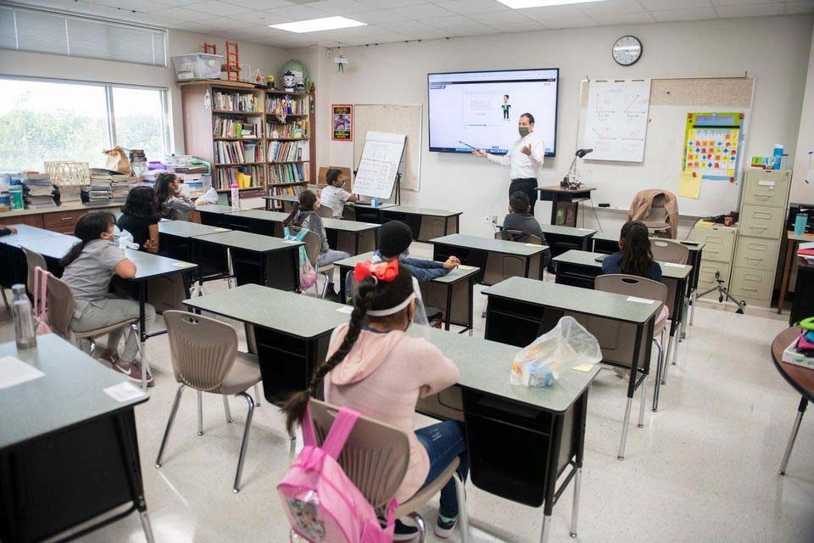

Table 19
Organizational Section
45
Mesquite ISD Oﬃcial Budget 2020‐2021

Mesquite ISD Student Enrollment Summary

Campus Type | Actual  2016‐17 | Actual  2017‐18 | Actual  2018‐19 | Actual  2019‐20 | Current Year  2020‐21 | Projected  2020‐21 | Projected  2021‐22 | Projected  2022‐23 | Projected  2023‐24
High Schools | 11,892 | 12,023 | 12,367 | 12,029 | 12,105 | 12,383 | 12,796 | 13,189 | 13,377
Middle Schools | 7,078 | 7,163 | 9,973 | 9,907 | 9,570 | 10,012 | 9,772 | 9,390 | 8,893
Elementary Schools | 21,882 | 21,643 | 18,497 | 17,695 | 16,701 | 17,240 | 17,014 | 16,951 | 17,029
Mesquite Academy | 167 | 187 | 280 | * | *
JJAEP |  |  |  | 7 | 5 | 5 | 5 | 5 | 5
Total Enrollment | 41,019 | 41,016 | 41,117 | 39,638 | 38,381 | 39,640 | 39,587 | 39,535 | 39,304
* Student enrollment included in high school count.

Texas Education Agency‐District TAPER Report

Table 20
Organizational Section
Mesquite ISD Oﬃcial Budget 2020‐2021
46
Mesquite ISD Student Enrollment by Campus

Campus | Actual  2016‐17 | Actual  2017‐18 | Actual  2018‐19 | Actual  2019‐20 | Current Year  2020‐21 | Projected  2020‐21 | Projected  2021‐22 | Projected  2022‐23 | Projected  2023‐24
Mesquite High School | 2,864 | 2,904 | 2,829 | 2,625 | 2,561 | 2,633 | 2,684 | 2,805 | 2,877
North Mesquite High School | 2,818 | 2,808 | 2,864 | 2,522 | 2,415 | 2,462 | 2,400 | 2,380 | 2,436
West Mesquite High School | 2,057 | 2,077 | 2,137 | 2,162 | 2,280 | 2,270 | 2,381 | 2,487 | 2,501
Poteet High School | 1,791 | 1,848 | 1,853 | 1,822 | 1,750 | 1,856 | 1,876 | 1,940 | 1,936
Horn High School | 2,362 | 2,386 | 2,684 | 2,898 | 3,099 | 3,162 | 3,455 | 3,577 | 3,627
Agnew Middle School | 797 | 831 | 1,280 | 1,228 | 1,227 | 1,258 | 1,190 | 1,153 | 1,039
Vanston Middle School | 812 | 805 | 969 | 923 | 847 | 909 | 917 | 900 | 868
Wilkinson Middle School | 954 | 974 | 926 | 790 | 797 | 845 | 806 | 760 | 678
McDonald Middle School | 1,034 | 1,002 | 909 | 908 | 923 | 945 | 896 | 843 | 780
New Middle School | 867 | 926 | 931 | 935 | 831 | 913 | 880 | 810 | 768
Kimbrough Middle School | 871 | 825 | 1,222 | 1,357 | 1,260 | 1,336 | 1,346 | 1,291 | 1,257
Berry Middle School | 899 | 904 | 1,116 | 1,103 | 613 | 673 | 671 | 656 | 658
Terry Middle School | 844 | 896 | 1,440 | 1,463 | 1,039 | 1,054 | 996 | 928 | 897
Fraiser Middle School | 0 | 0 | 1,180 | 1,200 | 1,126 | 1,190 | 1,160 | 1,072 | 993
Woolley Middle School | 0 | 0 | 0 | 0 | 907 | 889 | 910 | 977 | 955
Black Elementary School | 665 | 639 | 606 | 656 | 626 | 629 | 628 | 618 | 627
Florence Elementary School | 582 | 654 | 543 | 548 | 467 | 508 | 503 | 496 | 501
Galloway Elementary School | 732 | 732 | 489 | 461 | 420 | 449 | 436 | 431 | 430
Hanby Elementary School | 923 | 929 | 835 | 838 | 740 | 836 | 856 | 855 | 872
Hodges Elementary School | 853 | 767 | 610 | 545 | 514 | 527 | 520 | 530 | 521
McWhorter Elementary School | 956 | 870 | 719 | 633 | 549 | 581 | 542 | 509 | 495
Motley Elementary School | 499 | 455 | 370 | 338 | 276 | 325 | 300 | 281 | 269
Range Elementary School | 743 | 763 | 653 | 601 | 580 | 555 | 539 | 527 | 519
Rugel Elementary School | 476 | 458 | 355 | 355 | 321 | 331 | 315 | 319 | 315
Rutherford Elementary School | 459 | 474 | 645 | 659 | 648 | 630 | 613 | 596 | 585
Shands Elementary School | 927 | 825 | 655 | 629 | 622 | 582 | 541 | 522 | 487
Tisinger Elementary School | 792 | 824 | 819 | 660 | 631 | 627 | 599 | 599 | 600
Tosch Elementary School | 938 | 872 | 658 | 594 | 617 | 555 | 549 | 535 | 537
Seabourn Elementary School | 554 | 724 | 700 | 661 | 578 | 673 | 691 | 704 | 715
Lawrence Elementary School | 416 | 440 | 368 | 334 | 283 | 325 | 313 | 317 | 314
Floyd Elementary School | 818 | 798 | 579 | 604 | 455 | 609 | 622 | 646 | 673
Porter Elementary School | 619 | 605 | 427 | 421 | 389 | 431 | 395 | 405 | 389

Table 20 (cont.)
Organizational Section
Mesquite ISD Oﬃcial Budget 2020‐2021
47

Mesquite ISD Student Enrollment by Campus (cont.)

Campus | Actual 2016‐17 | Actual 2017‐18 | Actual 2018‐19 | Actual 2019‐20 | Current Year 2020‐21 | Projected 2020‐21 | Projected 2021‐22 | Projected 2022‐23 | Projected 2023‐24
McKenzie Elementary School | 598 | 538 | 493 | 454 | 414 | 419 | 407 | 403 | 385
Beasley Elementary School | 476 | 467 | 378 | 374 | 359 | 363 | 359 | 361 | 361
Price Elementary School | 450 | 451 | 359 | 348 | 299 | 345 | 333 | 339 | 348
Shaw Elementary School | 891 | 884 | 582 | 577 | 555 | 575 | 571 | 566 | 584
Kimball Elementary School | 284 | 242 | 192 | 188 | 211 | 186 | 192 | 188 | 204
Pirrung Elementary School | 441 | 434 | 438 | 392 | 396 | 346 | 336 | 328 | 321
Cannaday Elementary School | 513 | 564 | 575 | 590 | 582 | 576 | 575 | 572 | 560
Austin Elementary School | 505 | 471 | 471 | 390 | 343 | 387 | 386 | 390 | 397
Moss Elementary School | 483 | 434 | 391 | 380 | 323 | 358 | 352 | 343 | 355
Thompson Elementary School | 554 | 565 | 529 | 523 | 566 | 558 | 563 | 559 | 550
Gray Elementary School | 635 | 634 | 512 | 450 | 431 | 442 | 436 | 437 | 438
Smith Elementary School | 531 | 494 | 425 | 437 | 545 | 446 | 447 | 448 | 474
Gentry Elementary School | 883 | 916 | 654 | 617 | 624 | 614 | 609 | 624 | 610
Mackey Elementary School | 757 | 788 | 678 | 615 | 650 | 602 | 598 | 590 | 604
Achziger Elementary School | 978 | 971 | 854 | 912 | 827 | 969 | 1022 | 1,070 | 1,142
Henrie Elementary School | 951 | 961 | 935 | 911 | 860 | 881 | 866 | 843 | 847
Mesquite Academy | 167 | 187 | 280 | * | *
JJAEP |  |  |  | 7 | 5 | 5 | 5 | 5 | 5
TOTAL | 41,019 | 41,016 | 41,117 | 39,638 | 38,381 | 39,640 | 39,587 | 39,535 | 39,304
- Student enrollment included in high school count.
District Demographic Report‐2020

Table 21
Mesquite Independent School District Student Ethnicity Percentages

Federal Race | 2015‐2016 | 2016‐2017 | 2017‐2018 | 2018‐2019 | 2019‐2020
Hispanic/Latino | 55.7 | 56.1 | 58.08 | 59.44 | 59.02
American Indian or Alaska Native | 0.4 | 0.7 | 0.49 | 0.45 | 0.76
Asian | 1.6 | 1.6 | 1.52 | 1.38 | 1.27
Native Hawaiian or Pacific Islander | 0.1 | 0.1 | 0.07 | 0.08 | 0.07
Black or African American | 25.1 | 24.7 | 24.83 | 24.54 | 24.67
White | 15 | 14.9 | 13.03 | 12.08 | 12.07
Two or more races | 2.1 | 2 | 1.99 | 2.03 | 2.14

Elementary Schools
Mesquite ISD Contact Information

Achziger Elementary 3300 Ridgeranch Road
Mesquite, TX 75181 972‐290‐4180

Austin Elementary 3020 Poteet Drive
Mesquite, TX 75150 972‐882‐7220

Beasley Elementary 919 Green Canyon
Mesquite, TX 75150 972‐882‐5160

Black Elementary 328 E. Newsom Road Mesquite, TX 75149 972‐882‐7240

Cannaday Elementary 2701 Chisolm Trail
Mesquite, TX 75150 972‐882‐5060

Florence Elementary 4600 Ashwood Drive
Mesquite, TX 75150 972‐290‐4080

Floyd Elementary
3025 Hickory Tree Road Balch Springs, TX 75180 972‐882‐7100

Galloway Elementary 200 Clary Drive
Mesquite, TX 75149 972‐882‐5101

Gentry Elementary 1901 Twin Oaks Dr. Mesquite, TX 75181 972‐290‐4140
Gray Elementary 3500 Pioneer Road
Balch Springs, TX 75180 972‐882‐7280

Hanby Elementary 480 Gross Road
Mesquite, TX 75149 972‐882‐5040

Henrie Elementary
253 West Lawson Road Dallas, TX 75253 972‐290‐4200

Hodges Elementary 14401 Spring Oaks Balch Springs, TX 75180 972‐290‐4040

Kimball Elementary 4010 Coryell
Mesquite, TX 75150 972‐290‐4120

Lawrence Elementary 3811 Richman
Mesquite, TX 75150 972‐882‐7000

Mackey Elementary 14900 N. Spring Ranch Balch Springs, TX 75180 972‐290‐4160

McKenzie Elementary 3535 Stephens Green
Mesquite, TX 75150 972‐882‐5140

McWhorter Elementary 1700 Hickory Tree
Mesquite, TX 75149 972‐882‐7020
Moss Elementary 1208 New Market
Mesquite, TX 75149 972‐882‐7130

Motley Elementary 3719 Moon Drive
Mesquite, TX 75150 972‐882‐5080

Pirrung Elementary 1500 Valley Creek
Mesquite, TX 75181 972‐882‐7170

Porter Elementary 517 Via Avenida
Mesquite, TX 75150 972‐290‐4000

Price Elementary 630 Stroud Lane
Garland, TX 75043 972‐290‐4100

Range Elementary 4060 Emerald Dr.
Mesquite, TX 75150 972‐882‐5180

Rugel Elementary 2701 Sybil
Mesquite, TX 75149 972‐882‐7260

Rutherford Elementary 1100 Rutherford Drive
Mesquite, TX 75149 972‐290‐4060

Seabourn Elementary 2249 Picadilly Blvd.
Mesquite, TX 75149 972‐882‐7040
Shands Elementary 4836 Shands
Mesquite, TX 75150 972‐290‐4020

Shaw Elementary 707 Purple Sage
Mesquite, TX 75149 972‐882‐7060

Smith Elementary
2300 Mesquite Valley Rd. Mesquite, TX 75149 972‐882‐7080

Thompson Elementary 2525 Helen Lane
Mesquite, TX 75181 972‐882‐7190

Tisinger Elementary 1701 Hillcrest
Mesquite, TX 75149 972‐882‐5120

Tosch Elementary 2424 Larchmont
Mesquite, TX 75150 972‐882‐5000

Middle Schools
Agnew Middle School 729 Wilkinson
Mesquite, TX 75149 972‐882‐5750

Berry Middle School 2675 Bear Dr.
Mesquite, TX 75181 972‐882‐5850

Fraiser Middle School 2250 W. Scyene Road Mesquite, TX 75149 972‐290‐4300

Kimbrough Middle School 3900 North Galloway
Mesquite, TX 75150 972‐882‐5900

McDonald Middle School 2930 Town East
Mesquite, TX 75150 972‐882‐5700

New Middle School 3700 South Beltline
Mesquite, TX 75181 972‐882‐5600

Terry Middle School
2351 Edwards Church Road Mesquite, TX 75181 972‐882‐5650

Vanston Middle School 3230 Karla
Mesquite, TX 75150 972‐882‐5801

Wilkinson Middle School 2100 Crest Park
Mesquite, TX 75149 972‐882‐5950

Woolley Middle School 3200 Blue Sky Road Mesquite, TX 75181 972‐290‐4350

High Schools
Horn High School
3300 E. Cartwright Road Mesquite, TX 75181 972‐882‐5200

Mesquite High School 300 East Davis
Mesquite, TX 75149 972‐882‐7800

North Mesquite High School 18201 LBJ Freeway
Mesquite, TX 75150 972‐882‐7900

Poteet High School 3300 Poteet Drive
Mesquite, TX 75150 972‐882‐5300

West Mesquite High School 2500 Memorial Blvd.
Mesquite, TX 75149 972‐882‐7600

Mesquite Academy 2704 Motley
Mesquite, TX 75150 972‐882‐7570

Facilities
Administration Building 3819 Towne Crossing Blvd. Mesquite, TX 75150 972‐288‐6411

Administrative Annex 329 East Davis Street Mesquite, TX 75149 972‐882‐7400

L.A. Berry Support Complex 2133 North Belt Line Road Mesquite, TX 75149 972‐882‐5402

Florence Annex 105 Florence Street
Mesquite, TX 75149
Food & Nutrition Services Building 405 E. Davis Street
Mesquite, TX 75149 972‐882‐5500

Learning Center 230 Pioneer
Mesquite, TX 75149 972‐882‐7150

Professional Development Center 3819 Towne Crossing Blvd.
Mesquite, TX 75150 972‐882‐7393

Russell Planetarium 2501 Memorial
Mesquite, TX 75149 972‐882‐7750

Service Center 800 East Kearney
Mesquite, TX 75149 972‐882‐5551

Student Support Center 714 E. Kimbrough St.
Mesquite, TX 75149 972‐882‐7700

Teacher Center 200 Pioneer Road
Mesquite, TX 75149

Technology Excellence Center 612 East Davis
Mesquite, TX 75149

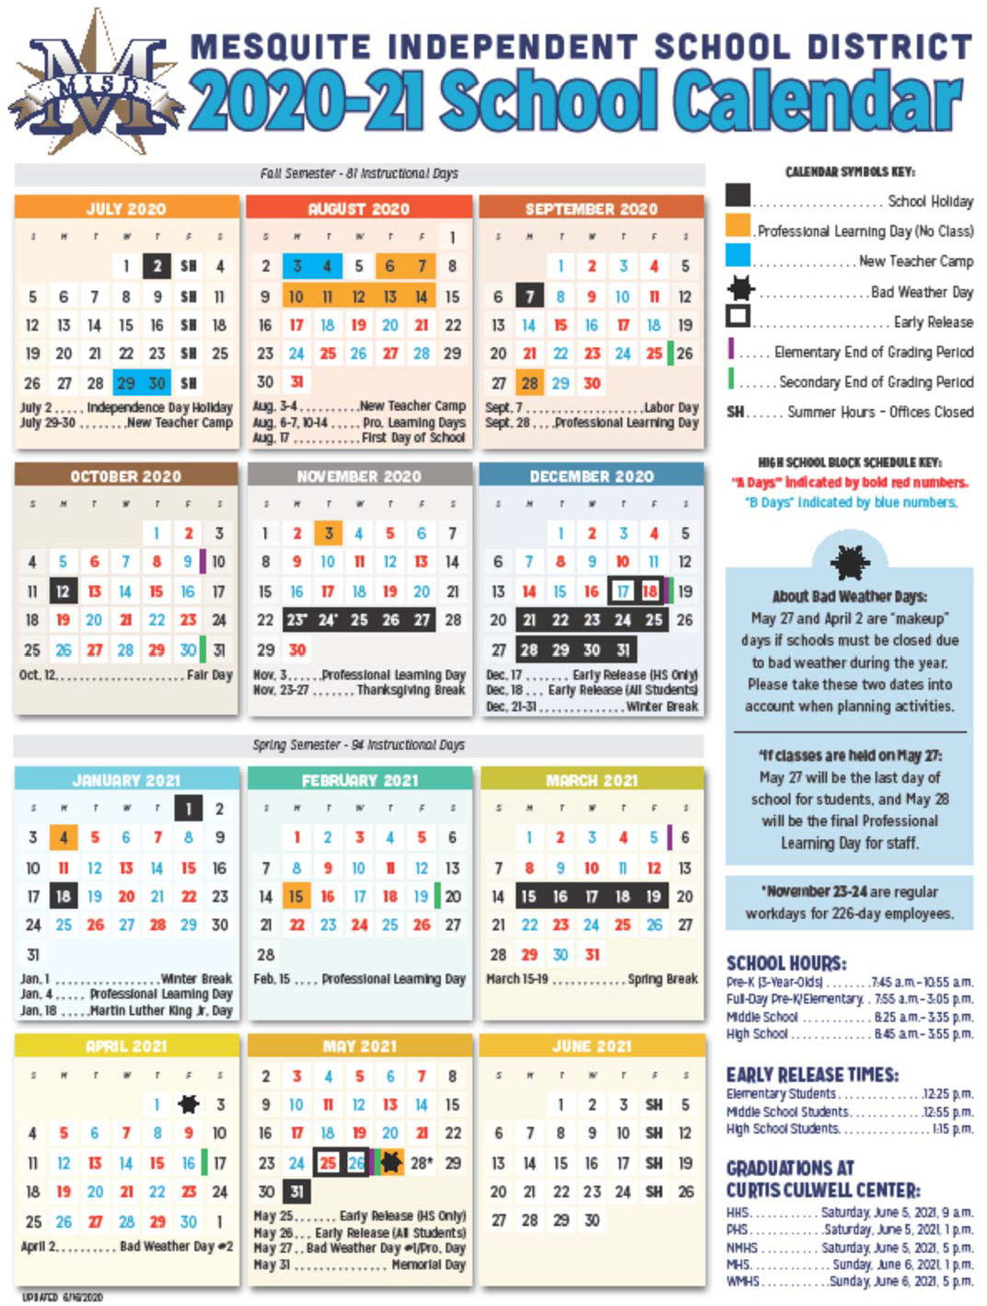

Mesquite Independent School District Organizational Chart

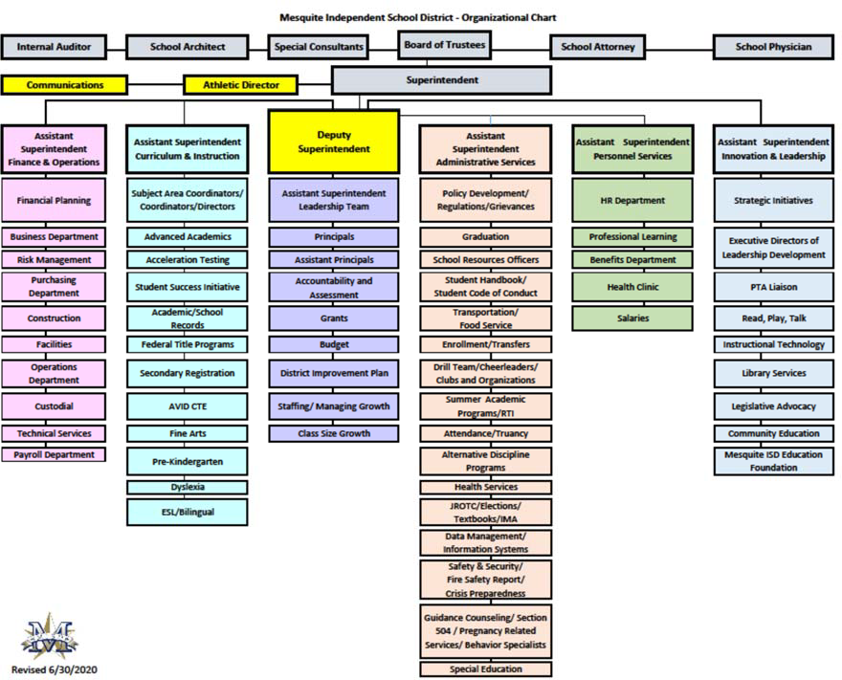

Dr. David Vroonland, Superintendent of Schools Beth Nicholas, Deputy Superintendent
Pete D. Pape, Assistant Superintendent for Finance & Operations
Dr. Karyn Cummings, Assistant Superintendent for Administrative Services Dr. Treva Franklin, Assistant Superintendent for Curriculum & Instruction Mary Randall, Assistant Superintendent for Personnel Services
Dr. Angel Rivera, Chief of Strategic Initiatives & Community Engagement

Gary Bingham, President ‐ Place 3 – Elected to the board in 1996. A 1975 Mesquite High School graduate; Gary earned his bachelor's of Business of Administration in 1979 from Stephen F. Austin. He owns Gary Bingham & Associates Insurance Agency. He and his wife Cecelia have two children, Samantha and Adam and two grandchildren.

Eddie Rose, Vice President – Place 2—Elected to the board in 2016. He graduated from Stephen F. Austin State University; he earned his BA degree (criminal justice) in 1991. He is the Arson Investigator with the Mesquite Fire Department and has been with them since 1985. Eddie is married to Misty, an Assistant Principal for Mesquite ISD; they have three children: Reed, who is a senior at Sam Houston State, Hayden, a freshman at Texas A&M, and Gracie, a fourth grader at Kimball Elementary.

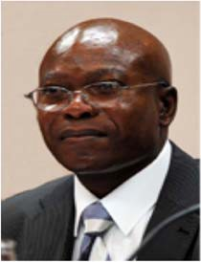Archimedes Faulkner, Secretary ‐ Place 1 ‐ Elected to the board in 2010. He graduated from Freetown, Sierra Leone; Prince of Wales Secondary School; Archimedes earned his BBA degree from Schiller International University, London England in 1988 and his master’s degree in 1993 from Texas Christian University in Ft. Worth, Texas. He is a Financial Services Professional, Spectrum Financial Group, a Member of Mass Mutual Financial Group. He and his wife, Josephine, a certified family nurse practitioner (FNP) at VPN have three children: Tinny is a lawyer in Seattle, Awadagin, graduated from MIT in 2016 and is currently in the graduate program at UC Berkley, and Omodele senior at SMU.

Elaine Whitlock, Assistant Secretary ‐ Place 6 ‐ Elected to the Board in 2015. She is a 1964 Mesquite High School graduate and a graduate of Texas Tech University. She received her Master’s degree from Texas A&M ‐Commerce and Mid‐Management Certification from Texas Women’s University. She retired in 2011 as an elementary principal after serving 38 years in education, with 37 in MISD. She is married to Larry and they have four daughters, Leslie, Kelly, Laura and Amanda and four grandchildren.

Greg Everett – Place 4 – He served on the board for an 18‐year period, from 1991‐2009, and was re‐elected in May, 2014. He graduated from North Mesquite HS in 1974, and attended Eastfield College. He is department manager for Levy and Son in Dallas. He and his wife Ramona have three children, Matthew, Daniel and Emily and three grandchildren.

Robert Seward – Place 5 ‐ Elected to the board in 1993. A 1968 Mesquite High School graduate, Seward earned his bachelors of Business Administration in accounting in 1976 from North Texas State University. He is retired from Luminant. Robert was elected as the 2008‐09 Texas Association of School Boards (TASB) President. He and his wife Marjorie have two children, Craig and Christy and three grandchildren.

Kevin Carbo– Place 7 – Elected to the Board in 1996 and served until 2014. He was re‐elected in November of 2015. He graduated from “Colegio San Antonio” in Puerto Rico. Kevin earned his BBA –
Finance from Dallas Baptist University in 1995 and received his MBA from University of Dallas in 1999. He is employed at City of Dallas in the Aviation Dept. as Business Operations Analysis. He and his wife Jossie have two children, Jessica and Kevin, Jr. and three grandchildren. Jessi‐ ca and Kevin, Jr. attended Mesquite schools K‐12, and graduated from Mesquite High School. His involvement with MISD started in the 80’s as a member of several PTA’s and he was 1st. Vice‐President of the Mesquite Council of PTA’s.

Mesquite Independent School District ‐ Strategic Plan 2017‐2020
Organizational Section
Mesquite ISD Oﬃcial Budget 2020‐2021
58
Excellence Always  At MISD, we believe:  - Each student holds a unique value and infinite promise.  - Experiences that foster collaboration, communication, curiosity, and contex‐ tual learning prepare students for a competitive workforce.  - Our democracy depends on educational experiences that develop responsible citizens.  - MISD employees form a passionate learning family committed to profes‐ sional growth.  - A diverse and involved community positively impacts our students.  Our Vision Excellence Always  Our Mission  The Mission of Mesquite ISD is to develop an inspiring and innovative learning community that Educates and Empowers students to pursue Excellence. | Categories | Objectives |  |  | Strategies |  | Action Plans | 17‐18 18‐19 19‐20
 | Teaching & Learning | Every learning environ‐ ment will be conducive to innovative instruction and meet the social, emotional and academic needs of our students and teachers. |  | 1.1 | Build teacher capacity to develop diﬀerentiation and personalization by infusing the 4 ‐ C's and integrating technology. | 1.1.1 | Create, model and establish personalized professional learning programs for  teachers in order to empower growth and innovation. | 1.1.1  1.1.2  1.1.3 | 1.1.1
 |  |  |  |  |  | 1.1.2  1.1.3 | Create and implement a framework for instructional teacher leadership.  Develop a technology framework and implement the plan district‐wide.
 |  |  |  | 1.2 | Understand the social, emotional and academic needs of our students and apply strategies to meet and exceed these needs. | 1.2.1  1.2.2 | Increase specialized staﬀ to work with teachers and administrators to provide support and retain a highly eﬀective staﬀ on each campus.  Improve, expand, and form community, school, and district partnerships that focus on social and emotional needs of students |  | 1.2.1 | 1.2.2
 |  |  |  | 2.1 | Actively pursue community involve‐ ment in the early literacy initiative. | 2.1.1  2.1.2 | Develop partnerships with community businesses and organizations that will promote literacy throughout the community.  Implement community‐based parent education around parenting and the early literacy initiative. |  |  | 2.1.1
 | Early Literacy | Every student will read on grade level by 3rd grade. |  |  |  |  |  |  | 2.1.2
 |  |  |  | 2.2 | Design a comprehensive early literacy framework. | 2.2.1 | Develop and implement a birth to school program that is based on the literacy framework ensuring all students will be reading on grade level by the end of 3rd grade. | 2.2.1 | 2.2.1
 |  |  |  |  |  | 2.2.2 | Maximize the number of literacy materials to the hands of our students, both at home and at school. |  | 2.2.2
 | Human Resources | Create a culture of excellence by maximiz‐ ing human capital. |  | 3.1 | Establish a district support system that focuses on retention and devel‐ opment of highly qualified employ‐ ees. | 3.1.1  3.1.2 | Develop and implement a plant to retain highly eﬀective staﬀ within the dis‐ trict.  Develop and implement a system that promotes the growth of highly eﬀective staﬀ. | 3.1.1  3.1.2
 |  |  |  | 3.2 | Establish a district process to attract and recruit highly qualified employ‐ ees. | 3.2.1  3.2.2 | Establish a district process to recruit highly qualified employees.  Establish a district process to attract highly qualified employees. | 3.2.1  3.2.2
 |  |  |  | 4.1 | Build a network of community stake‐ holders to advocate for financial resources. | 4.1.1  4.1.2 | Create an ongoing group that is tasked with building, equipping, training and guiding a network of community stakeholders  Create an internal group that is tasked with building, informing, equipping, training, and guiding a network of community stakeholders to address identi‐ fied financial needs. |  |  | 4.1.1
 | Funding and Finance | Maximize financial resources to further the  missions of MISD. |  |  |  |  |  |  |  | 4.1.2
 |  |  |  |  |  | 4.2.1 | Maximize opportunities to cultivate partnerships with community businesses that will provide educational and financial support to our district.
 |  |  |  | 4.2 | Engage the business community to  participate in resource development and educational opportunities. |  |  |  |  | 4.2.1
 | Facilities | Design, create and sustain innovative and adaptable space solu‐ tions that meet changing enrollment and learning  needs. |  | 5.1 | Develop a facility plan that continual‐ ly evaluates and addresses current and future enrollment needs. | 5.1.1  5.1.2 | Develop and implement a plant that addresses campus growth by building new structures or renovating existing structures.  Develop and implement a plan that addresses future enrollment needs and overcrowding at current campuses. | 5.1.1  5.1.2
 |  |  |  | 5.2 | Evaluate and develop a plan that  creates diﬀerent models for every level of learning needs | 5.2.1  5.2.2 | Develop criteria for designing new learning spaces that are flexible, adaptable, and facilitate collaborative work to maximize learning for all students.  Develop a plan for evaluating a adapting existing spaces to enhance capacity for flexibility and collaborative work in order to meet the learning |  | 5.2.1
 |  |  |  |  |  |  |  |  | 5.2.2
 | Community Engagement | Promote community participation in every MISD campus |  | 6.1 | Create a culture that promotes empa‐ thy and empowerment for a diverse community of participants. | 6.1.1  6.1.2 | Empower stakeholders to take action in activities related to their city and their students' education.  Create welcoming school environment events that expand opportunities to build relationships, collaborate and mentor. |  |  | 6.1.1  6.1.2
 |  |  |  | 6.2 | Collaborate with the community to create awareness of opportunities for involvement. | 6.2.1 | Develop, at every campus, opportunities for parents and community members to connect and contribute at schools. |  |  | 6.2.1
 |  |  |  | 7.1 | Develop a plan to better engage all audiences. | 7.1.1  7.1.2 | Design and employ a mobile application to inform all stakeholders of MISD news and events, and to highlight noteworthy happenings through the year.  Develop capacity within the district to provide all communication in Spanish. |  | 7.1.1
 | Communications | Communication will be eﬀectively fostered between the District and the community. |  |  |  |  |  |  | 7.1.2
 |  |  |  | 7.2 | Exhibit an authentic representation of District | 7.2.1  7.2.2 | Develop and implement a plan to utilize stakeholders from various groups to communicate an accurate and compelling representation of Mesquite ISD.  Develop and implement a plan to maximize communication of our district's excellence with all stakeholders through various forms of technology and platforms. |  |  | 7.2.1
 |  |  |  |  |  |  |  |  | 7.2.2
Highlighted items are extended one more year from 2017‐18 to 2018‐19 school year.

Financial Policies/Basis of Accounting

Financial and budgeting principles and policies adopted by the Texas Education Agency through the Financial Accountability Resource Guide (FASRG) are oﬃcial rules and constitute minimum budgeting, accounting, auditing, and reporting requirements. The Agency’s intent in prescribing these rules is to cause the budgeting and financial accounting and reporting system of independent school districts to conform with generally accepted accounting principles (GAAP) established by the Governmental Ac‐ counting Standards Board (GASB) and the Financial Accounting Standards Board (FASB) for accounting treatments not specified in GASB pronouncements.

A summary of the state mandated principles and policies that Mesquite ISD follows are:

Generally Accepted Accounting Principles (GAAP) – The Mesquite ISD accounting system is kept in accordance with generally accepted accounting principles and presents fairly and with full disclosure the funds and activities and results of financial operations in such a manner to determine and demonstrate compliance with finance‐related legal and contractual provisions. Whenever conflicts exist be‐ tween legal requirements and generally accepted accounting principles, and additional schedules and/ or narrative explanations are attached as necessary to satisfy or report legal compliance responsibilities and accountabilities.

Fund Accounting – The accounting system is organized and operated on a fund basis. All funds of Mesquite ISD are accounted for and included on the end‐of‐year combined balance sheet. A fund is de‐ fined as a fiscal and accounting entity with a self‐balancing set of accounts recording cash and other financial resources, together with all related liabilities and residual equities or balances, and changes therein, which are segregated for the purpose of carrying in specific activities or attaining certain objectives in accordance with special regulations, restrictions, or limitations.

Account Groups – The accounting system provides account groups to account for general capital assets and general long‐term debt of governmental funds. Capital assets and long‐term debt of
fiduciary funds are accounted for through those funds and are excluded from the account groups as detailed in the Account Code section.

Central Accounting – Accounting for funds of the Mesquite Independent School District are on an organization‐wide basis covering all funds and account groups. Governmental and fiduciary fund types are the account responsibility of the District’s business oﬃce.

Capital Assets – Capital assets are accounted for at historical cost. Donated capital assets are recorded at the estimated fair value at the time received. Capital assets include land, buildings, improvements other than buildings, vehicles, machinery, infrastructure, works of art and historical treasures, furniture and equipment that:

  - Are not consumed as a result of use.
  - Have a useful life of at least seven years and a per unit (or group of similar items) cost of
$5,000 or more.
  - Can be controllable, identified by a permanent or assigned number or label, and be reasonably accounted for through a fiscal inventory system.
  - Groups of like items may be included in the inventory system.

Depreciation ‐ Depreciation of capital assets is over their estimated useful lives unless they are either inexhaustible or are infrastructure assets using the modified approach. Depreciation of capital assets should be reported in the government‐wide statement of activities; and the statement of changes in fiduciary net assets.

Budgetary Basis of Accounting – The budgetary basis of accounting is consistently applied in budgeting, recording and reporting foundation school program (FSP) revenues in PEIMS information. Under the budgetary basis, earned and material FSP revenues that are collectible beyond 60 days are to be treated consistently for budgeting, recording, and reporting through PEIMS and for tax rollback rate calculation purposes.

Budgetary Control/Encumbrance Accounting – The oﬃcial school District budget of Mesquite ISD, as adopted, is recorded in the general ledger. Revenues and expenditures authorized in the budget are controlled in the accounting records and reported in the financial statements. By State law, only the General Fund, Debt Service Fund and Student Nutrition Fund must be included in the

oﬃcial budget. To control budgeted fund commitments, the accounting system employs encumbrance accounting. Encumbrances are documented by contract, purchase orders, or other evidence showing binding commitments for goods or services.

Appropriations lapse at year end. At that time each outstanding encumbrance is evaluated. An adjust‐ ment is made to the fund balance for the value of the outstanding encumbrances in the current year and financial reports.

Uniform Classifications and Terminology – Mesquite ISD uses the fund codes, mandatory account classifications and terminology prescribed in the Texas Education Agency Financial Accounting Resource Guide. General ledger accounts prescribing a double entry system and distribution of related payroll expenses with payroll are uniformly used throughout the budgeting, accounting and financial reporting system.

Fund Equity and Other Credits – Fund equity is comprised of investments in capital assets (other cred‐ it); contributed capital; net assets; reserved fund balance; unreserved, designated fund balance; and unreserved, undesignated fund balance.

Type of Funds
The following types of funds are used by state and local governments, including Mesquite Independent School District.

Governmental Funds

- The General Fund – to account for all financial resources except those required to be accounted for in another fund. The principal sources of revenue include local property taxes, interest on fund investments, and other operating revenue. Expenditures include all costs necessary for the daily operation of the school and the District.

- Debt Service Funds – to account for the accumulation of resources for, and the payment of, general long‐term debt principal and interest. Debt service funds are required if they are legally mandated and/or if financial resources are being accumulated for principal and interest payment maturing in future years. The primary source of revenue for this fund is local property taxes.

Budgeted funds are used in operation but not included in the legally approved budget by the Board of Trustees are listed below:

Special Revenue Funds – to account for the proceeds of specific revenue sources (other than trust for individuals, private organizations, or other governments or for major capital projects) that are legally restricted to expenditure for specific purposes.

Capital Projects Funds – to account for financial resources to be used for the acquisition or construction of major capital facilities (other than those financed by proprietary funds or in trust funds for individuals, private organizations, or other governments). Capital outlays financed from general obligation bond proceeds should be accounted for through a capital projects fund.

  - Proprietary Funds

- Enterprise Funds – to report any activity for which a fee is charged to external users for goods or services. Activities are required to be reported as enterprise funds if any one of the following criteria is met.

  - The activity is financed with debt that is secured solely by a pledge of the net revenues from fees and charges of the activity.
  - Debt that is secured by a pledge of net revenue from fees and charges and the full faith and credit of a related primary government or component unit – even if that government is not expected to make any payments – is not payable solely from fees and charges of the activity.
  - Laws or regulations require that the activity’s costs of providing services, including capital costs (such as depreciation or debt service), be recovered with fees and charges, rather than with taxes or similar revenues.
  - The pricing policies of the activity establish fees and charges designed to recover its costs, including capital costs (such as depreciation or debt service).

Internal Service Funds – to report any activity that provides goods or services to other funds, departments, or agencies of the primary government and its component units, or to other governments, on a cost‐reimbursement basis.

- Internal service funds should be used only if the reporting government is the predominant participant in the activity. Otherwise, the activity should be reported as an enterprise fund.

  - Fiduciary Funds

- Trust and Agency Funds – to account for assets held by a governmental unit in a trustee capacity or as an agent for individuals, private organizations, other government units, and/or other funds. Trust and agency funds therefore cannot be used to sup‐ port the government’s own programs.

Number of Funds

Mesquite ISD maintains the number of funds necessary to carry on its functions required by law or contract. Funds comply with the properly defined code structures as established by the Texas Education Agency.

Reporting Capital Assets

A clear distinction is made between general capital assets and capital assets of proprietary and fiduciary funds. Capital assets or proprietary funds should be reported in both the government‐wide and fund financial statements. Capital assets of fiduciary funds are reported only in the statement of fiduciary net assets. All other capital assets of the governmental unit are general capital assets. They are not reported as assets in governmental funds but are reported in the governmental activities column in the government‐wide statement of net assets.

Reporting of Long‐Term Liabilities

A clear distinction is made between fund long‐term liabilities and general long‐term liabilities. Long‐ term liabilities directly related to and expected to be paid from proprietary funds are reported in the proprietary fund statement of net assets and in the government‐wide statement of net assets.

Long‐term liabilities directly related to and expected to be paid from fiduciary funds are reported in the statement of fiduciary net assets. All other un‐matured general long‐term liabilities of the governmental entity are not reported in governmental funds but should be reported in the governmental activities column in the government‐wide statement of net assets.

Accrual Basis of Government Accounting

The modified accrual basis of accounting or accrual basis of accounting, as appropriate, is utilized in measuring financial position and operating results.

  - Governmental fund revenues and expenditures are recognized on the modified accrual basis. Revenues are recognized in the accounting period in which they be‐ come available and measurable. Expenditures are recognized in the accounting period in which the fund liability is incurred, if measurable, except of un‐matured interest on general long‐term debt, which is recognized when due.

  - Proprietary fund statements net assets and revenues, expenses and changes in fund net assets are recognized on the accrual basis. Revenues are recognized in the account period in which they are earned and become measurable; expenses are recognized in the period incurred, if measurable; expenses are recognized in the period incurred, if measurable.

  - Fiduciary funds are reported using the economic resources measurement focus and the accrual basis of accounting, except for the recognition of certain liabilities of defined benefit pension plans and certain post‐employment healthcare plans.

  - Transfers are recognized in the account period in which the interfund receivable and payable arise.

Budgetary Control and Budgetary Reporting

An annual budget is adopted by Mesquite ISD Board of Trustees.

The accounting system provides the basis for appropriate budgetary control.

Budgetary comparison schedules are presented as required with supplementary information for the general fund and for each major special revenue fund that has a legally adopted annual budget. The budgetary comparison schedule is prepared with both the original and the final appropriated budgets for the reporting period as well as actual inflows, outflows, and balances, stated on the government’s budgetary basis.

The budget is considered to be balanced when the sum estimated revenues and other sources equals appropriations and other uses for each fund. Whenever circumstances require the District to adopt a budget that is not balanced, full disclosure of the circumstances surrounding the decision are reported to the Board of Trustees and in District budget documents.

Transfer, Revenue, Expenditure, and Expense Account Classification

Transfers are classified separately from revenues and expenditures or expenses in the basic financial statements.

- Proceeds of general long‐term debt issues are classified separately from revenues and expenditures in the governmental fund financial statements.

- Governmental fund revenues are classified by fund and source. Expenditures are classified by fund and source. Expenditures are classified by fund, function (or pro‐ gram), organization unit, activity, character, and principal classes of objects.

- Proprietary fund revenues are reported by major sources, and expenses are classified in essentially the same manner as those of similar business organizations, functions, or activities.

- The statement of activities presents governmental activities at least at the level of detail required in the governmental fund statement of revenues, expenditures, and changes in fund balance at a minimum by function.

SIGNIFICANT FINANCIAL POLICIES AND PROCEDURES

The following financial policies and procedures of the District significantly influence the development of the annual budget.

Cash Management
The District’s cash management goals are safety, liquidity and yield. Specifically:
  - Ensure proper collateralization of deposits;
  - Ensure adequate balances to cover cash disbursement needs;
  - Maximize interest earning while, at the same time, maximizing safety and liquidity;
  - Minimize bank charges.

Investment Policies
The Board of Trustees has adopted a written investment policy regarding the investment of its funds as defined in the Public Funds Investment Act of 1995 (and amended by the legislature in 1997). This policy authorizes the District to invest in obligations of the U. S. Treasury, the State of Texas, or certain U. S. Agencies, certificates of deposit, repurchase agreements, commercial paper, bankers’ acceptances and public funds investment pools as permitted by Chapter 2256, Texas Government Code.

The main goal of the investment program is to ensure its safety, as well as to maximize financial returns within current market conditions in accordance with the District’s investment policy. Assets of the District shall be invested in instruments whose maturities do not exceed one year from the time of purchase. The investment portfolio shall be diversified in terms of investment instruments, maturity scheduling, and financial institutions to reduce risk of loss.

A quarterly and annual investment report is prepared in accordance with the District’s Investment Policies and submitted to the Board. The District’s auditors perform a compliance audit of management controls on investments and adherence to the investment policy as well as a review of the monthly reports sent to the Board.

Debt Administration
Debt Service is a major area of cost due to the District’s building program, which is primarily financed by the sale of general obligation bonds. Under state law, there is no explicit bonded indebtedness limitation, although a tax rate test eﬀectively imposes a limit on the incurrence of debt.

Chapter 45 of the Texas Education Code, as amended, requires a district to demonstrate to the Texas Attorney General that it has the prospective ability to pay debt service on a proposed issue of bonds, together with debt service on other outstanding “new debt” of the district, from a tax levied at a rate of
$0.50 per $100 of assessed valuation before bonds may be issued.

In demonstrating the ability to pay debt service at a rate of $0.50, a district may take into account State allotments which eﬀectively reduce the district’s local share of debt service. Once the prospective ability to pay such tax has been shown and the bonds are issued, a district may levy an unlimited tax to pay debt service.

All principal and interest payments are due February 15th and August 15 of each year. On February 1st of each year, outstanding taxes become delinquent, which permits the collection of a large majority of taxes levied before the long term debt payments are due.

The District presently carries the highest rating of “AAA” with S&P and “AAA” with Fitch, Inc. However, these ratings are based upon the Permanent School Fund Guarantee provided by the State of Texas.
The district’s current underlying ratings are “AA” by S&P and “AA+” by Fitch.

Fund Balance Levels

Policy CE Local states that the adopted budget shall maintain an annual fund balance in the general operating fund that is equal to at least 22 percent of total operating expenditures, unless the Board declares an emergency by resolution or other Board action.

Fund balance is the excess of assets over liabilities in a governmental fund. The District understands the importance of maintaining an adequate fund balance and strives to develop a balanced budget in each fiscal year. The District defines a balanced budget as one in which anticipated revenues equal or exceed anticipated expenditures thus creating no need to utilize the District’s “savings account,” or fund balance.

The reserved fund balance is that portion of fund balance that is not available for appropriation or that has been legally segregated for specific purposes. The unreserved fund balance is composed of as‐ signed and unassigned portions. The unassigned portion represent that portion of fund balance that is available for budgeting in future periods. Assigned fund balances represent tentative plans for future use of financial resources.

Account Code Structure

Section 44.007 of the Texas Education Code (Code or TEC) requires that a standard school district fiscal accounting system be adopted by each school district. The system must meet at least the minimum requirements prescribed by the State Board of Education and also be subject to review and comment by the state auditor. Additionally, the accounting system must conform to Generally Accepted Ac‐ counting Principles (GAPP). This section further requires that a report be provided at the time that the school district budget is filed, showing financial information suﬃcient to enable the state board of edu‐ cation to monitor the funding process and to determine educational system costs by school district, campus and program.

The Texas Education Code, Section 44.008, requires each school district to have an annual independent audit conducted that meets the minimum requirements of the state board of education, subject to re‐ view and comment by the state auditor. The annual audit must include the performance of certain audit procedures for the purpose of reviewing the accuracy of the fiscal information provided by the district through the Public Education Information Management System (PEIMS). The audit procedures are to be adequate to detect material errors in the school district’s fiscal data to be reported through the PEIMS system for the fiscal period under audit.

A major purpose of the following accounting code structure is to establish the standard school district fiscal accounting system required by law. Although certain codes within the overview may be used at local option, the sequence of the codes within the structure, and the funds and chart of accounts, are to be uniformly used by all school districts in accordance with generally accepted accounting principles.

Basic System Expenditure Code Structure

Fund Code
It is a mandatory three digit code used for all financial transactions to identify the fund group and specific funds. Within the code, the first digit refers to the fund group and the send and third digits specify the fund.

Basic Expenditure Code Structure (cont.)

Function Code
It is a mandatory two digit code which identifies the purpose of the transaction. The first digit identifies the major service area and the second digit refers to the specific function within the area.

Object Code
It is a mandatory four digit code identifying the nature and object of an account, a transaction, or a source. The first digit identifies the type of account or transaction, the second digit identifies the major area and the third and fourth digits provide further sub classifications.

Sub‐Object Code
It is an optional code to provide special accountability for specific programs or areas.

Organization Code
It is a mandatory three digit code to identify the campus or facility.

Fiscal Year Code
It is a mandatory single digit code to identify the specific fiscal year of the transaction or the project year.

Program Intent Code
It is a mandatory two digit code to designate transactions or services to specific programs provided to students.

Function Codes

Instruction
This function is used for activities that deal directly with the interaction between teachers and students. Teaching may be provided for students in a school classroom, in another location such as a home or hospital, and in other learning situations. It may also be provided through some other approved medium such as television, radio, telephone, telecommunications, multimedia and correspondence. This function includes expenditures/expenses for direct classroom instruction and other activities that deliver, enhance or direct the delivery of learning situations to students.

Instructional Resources & Media Services
This function is used for expenditures/expenses that are directly and exclusively used for resource centers, establishing and maintaining libraries and other major facilities dealing with educational resources and media.

Curriculum Development & Instructional Staﬀ Development
This function is used for expenditures/expenses that are directly and exclusively used to aid instruction‐ al staﬀ in planning, developing and evaluating the process of providing learning experiences for students. Expenditures and expenses include in‐service training and other staﬀ development for instructional or instructional‐related personnel (Functions 11, 12 and 13) of the school district. This function also includes expenditures and expenses related to research and development activities that investigate, experiment, and/or follow‐through with the development of new or modified instructional methods, techniques, procedures, services, etc.

21 Instructional Leadership
This function is used for expenditures/expenses that are directly used for managing, directing, supervising, and providing leadership for staﬀ who provide general and specific instructional services.

23 School Leadership
This function is used for expenditures/expenses that are used to direct and manage a school campus. They include the activities performed by the principal, assistant principals and other assistants while they:

- Supervise all operations of the campus.
- Evaluate staﬀ members of the campus.
- Assign duties to staﬀ members maintaining the records of the students on the campus.
- Coordinate school instructional activities with those of the entire school district.

Guidance, Counseling & Evaluation Services
This function is used for expenditures/expenses that are directly and exclusively used for assessing and testing students’ abilities, aptitudes and interests; counseling students with respect to career and educational opportunities and helping them establish realistic goals. The function includes costs of psycho‐ logical services, identification of individual characteristics, testing, educational counseling, student evaluation and occupational counseling.

Social Work Services
This function is used for expenditures/expenses that are directly and exclusively used for activities such as:
  - Investing and diagnosing student social needs arising out of the home, school or community.
  - Casework and group work services for the child, parent or both.
  - Interpreting the social needs of students for other staﬀ members.
  - Promoting modification of the circumstances surrounding the individual student, which are related to his or her social needs. (This includes referrals to and interaction with other governmental agencies).

Health Services
This function is used for expenditures/expenses that are directly and exclusively used for providing physical health services which are not direct instruction. This includes activities that provide students with appropriate medical, dental and nursing services.

Student (Pupil) Transportation
This function is used for expenditures/expenses that are incurred for transporting students to and from school. Expenditures/expenses for regular bus routes to and from school are to be recorded using Pro‐ gram Intent Code 99 (Undistributed), and Organization Code 999 (Undistributed) or Organization Code 998 (Unallocated, Local Option). Expenditures/expenses for transportation specifically and exclusively for purposes of transporting students relating to enhanced program intents such as Career and Technology and Services to Student with Disabilities (Special Education), etc., are to be recorded in Function 34 with the appropriate program intent codes.

Food Services
This function is used for food service operation expenditures/expenses, including the cost of food, labor, and other expenditures/expenses necessary for the preparation, transportation and storage of food to provide to students and staﬀ. Expenditures/expenses are used directly and exclusively for supervision and maintenance of a food service operation.

Co‐curricular/Extracurricular Activities
This function is used for expenditures/expenses for school‐sponsored activities during or after the school day that are not essential to the delivery of services for Function 11, the Function code 20 series or other Function code 30 series. These activities are generally designed to provide students with experiences such as motivation and the enjoyment and improvement of skills in either a competitive or noncompetitive setting. These activities include student groups such as Future Farmers of America (FFA), National Honor Society, etc. Co‐curricular activities are those activities that are not essential to instruction but enhance the curriculum and include University Interscholastic League competition such as one‐act plays, speech, debate, band, etc. Activities are those that do not enhance the instructional program, including athletics, that normally involve competition between schools (and frequently involve oﬀsetting gate receipts or fees such as football, baseball, volleyball, track and tennis). Also included are related activities (such as pom squad and cheerleading) that exist because of athletics.

41 General Administration
This function is for expenditures that are for purposes of managing or governing the school district as an overall entity. This function covers multiple activities that are not directly and exclusively used for costs applicable to specific functions. General administration is an indirect cost applicable to other expenditure functions of a school district.

Program Intent Code 99 is to be used for all expenditures for Function 41. The organization codes specified in the 700 organization code group are the only organization codes to be used with Function 41 costs and may not be used in any other function, other than specific costs in Function 53 (Data Processing) that relate to the functions of the business oﬃce.

Plant Maintenance & Operations
This function is used for expenditures/expenses for activities to keep the physical plant and grounds open, clean, comfortable and in eﬀective working condition and state of repair. This function is used to record expenditures/expenses for the maintenance and operation of the physical plant and grounds.
This function also includes expenditures/expenses associated with warehousing and receiving services.

Security and Monitoring Services
This function is used for expenditures/expenses that are for activities to keep student and staﬀ surroundings safe, whether in transit to or from school, on a campus or participating in school‐sponsored events at another location.

Data Processing Services
This function is for expenditures/expenses for data processing services, whether in‐house or contract‐ ed. Examples of Function 53 costs are costs for computer facility management, computer processing, systems development, analysis and design, and those interfacing costs associated with general types of technical assistance to data users. Specific types of applications include attendance accounting, grade reporting, financial accounting and human resources/personnel. Personal Computers (PC’s) that are stand alone are to be charged to the appropriate function. Peripherals including terminals and printers are to be charged to the appropriate function. Costs associated with mainframe, minicomputers and networked or stand‐alone microcomputers that provide services to multiple functions are to be recorded here. For data processing expenditures associated with business oﬃce functions such as accounting and payroll, Organization Code 750 is to be used.

61 Community Services
This function is used for expenditures that are for activities or purposes other than regular public education and adult basic education services. These types of expenditures are used for services or activities relating to the whole community or some segment of the community. This includes providing

resources to non‐public schools, institutions of higher education, and any proprietary types of services incurred for outside entities in the community.

71 Debt Service
This function is used for expenditures that are for the retirement of recurring bond, capital lease principal, and other debt, related debt service fees, and for all debt interest. Note principal for short‐term loans (one year or less in duration) is to be recorded in the liability account 2122, Notes Payable Cur‐ rent Year.

81 Facilities Acquisition & Construction
This function is used by school districts for expenditures that are for acquiring, equipping, and/or making additions to real property and sites, including lease and capital lease transactions.

99 Tax Appraisal and Collection
This function is used to report administrative functions not required to be reported in function 41. The fees for property appraisal are paid from this function.

Mesquite Independent School District Account Code Structure

Revenue Object Codes
Local

5711 Taxes, Current Year Levy 5712 Taxes, Prior Years
5719 Penalties, Interest and Other Tax Revenues 5722 SSA ‐ Local Revenues from Member Districts 5735 Tuition & Fees
5736 Tuition ‐ Regional Day School/Sunnyvale 5737 Summer School
5739 Tuition & Fees
5742 Earnings from Investments 5743 Rental from School Property 5744 Gifts & Bequests
5748 Net Receipts Clearing/Patrol
5749 Miscellaneous/Fines, Wellness & Etc. 5751 Food Services Activity
5752 Athletic Activity Revenue 5753 Extra/Cocurricular Activity 5754 Internal Service Fund 5755 Activity Fund

State
5811 Per Capita/Apportionment
5812 Foundation/Entitlements
5826 Supplemental Pre‐K 5829 Misc. State Programs 5831 TRS On Behalf Benefit
5832 TRS Supplemental Compensation 5869 Other

Federal

5919 Federal Revenues Distributed Other than State or Federal Entities 5921 School Breakfast Program
5922 National School Lunch Program 5923 USDA Donated Commodities

5929 Other Federal Revenue
5931 School Health and Related Service 5932 Medicaid ADM Claiming
5940 Federal Distributed Directly 5949 District Federal Revenues
5952 Federal Revenue from Fiscal AG

Expenditure Object Codes 6100 Payroll Costs
6112 Professional Substitutes 6116 Professional Extra Duty Pay 6117 Career Ladder
6118 Professional Stipends
6119 Professional Salary
6121 Extra Duty/Support 6122 Support Salaries Sub 6125 Support Salaries
6126 Support Salaries/Hourly
6129 Paraprofessional Personnel
6131 Contract Buyouts
6134 Employee Allowances
6141 Social Security/Medicare 6142 Health & Life Insurance 6143Workers’ Compensation 6144 TRS on Behalf Benefit
6145Unemployment Compensation 6146 Teacher Retirement/TRS Care 6147 Sick/Vacation Retirement 6148 Plan Behavior Health
6149 Employee Benefits

6200 Professional & Contracted Services
6211 Legal Services

6212 Audit Services
6213Tax Appraisal & Collection 6217 Data Processing Service 6219 Professional Service
6221Staﬀ Tuition Fees 6223 Student Tuition
6239 Education Service Center 6244Technology Maint/Repairs 6245Audio Visual Maint/Repairs 6246Building Maintenance/Repairs
6247Vehicle Maintenance/Repairs 6249Contracted Maintenance & Repair 6255 Water
6256 Telephone
6257 Electricity
6258 Gas
6259 Other Utilities
6264 Copier Rental
6265 Equip Rental
6266 Vehicle Rental
6277 Building Rental
6269 Other Rental
6291 Consulting Services
6299 Miscellaneous Contracted Services

6300 Supplies & Materials
6311 Vehicle Fuels
6315 Custodial Supplies
6316 Supplies Buildings
6319 Other Supplies
6321 Textbooks
6325 Reading Materials/Books
6326 Magazines
6329 Reading Material/Other
6334 Testing‐Materials

6341 Food/Food Service
6342 Non‐Food/Food Service 6344USDA Donated Commodities 6349 Food Service Supplies
6395 Electronics $100‐$5000
6396 Computer Supplies 6397 Furniture Under $5000 6398Equipment $300‐$5000
6399 General Supplies

6400 Other Operating Costs
6411 Travel/Employees
6412 Travel/Students
6413 Stipends/Non‐Employee
6419 Travel/Non‐Employee
6425 Property Insurance
6426 Liability Insurance
6427 Bonding Insurance
6428 Athletic Insurance
6429Other Insurance Escrow 6434 Election Expenses
6494Student Transportation ‐ Buses 6495 Dues
6497Awards ‐ Graduation 6498 Resource Oﬃcer 6499 Misc. Operating Exp

6500 Debt Service
6511 Bond Principal
6512 Lease Principal 6521Interest on Bonds 6522 Lease Interest 6599Debt Service Fees

6600 Capital Equipment
6614 Land Purchase
6624 Building Purchase/Construction
6626 Fees/Buildings
6631 Vehicles>$5000
6635 Electronic Equip>$5000
6637 Furniture>$5000
6639 Equipment>$5,000
6649 Other Equipment<$5,000
6669 Library Books

Budget Policies

The State, the Texas Education Agency (TEA), and each local district formulate legal requirements for school district budgets.

Legal Requirements
Sections 44.002 through 44.006 of the Texas Education Code establish the legal basis for budget development in Texas school districts. The following items summarize the legal requirement from the code.

- The Superintendent is the budget oﬃcer for the District and prepares or causes the budget to be prepared. TEA recommends an interactive approach between the board of trustees and the superintendent be taken to establish the budget process and define related roles and responsibilities.

- The district budget must be prepared by a date set by the State Board of Education, currently August 20.

- The President of the Board of Trustees must call a public meeting of the Board of Trustees, giving ten days public notice in a newspaper, for the adoption of the district budget. Any taxpayer in the district may be present and participate in the meeting.

- No funds may be expended in any manner other than as provided for in the adopted budget. The Board does have the authority to amend the budget or adopt supplementary emergency budgets to cover unforeseen expenditures.

- The budget must be prepared in accordance with GAAP (Generally Accepted Accounting Principles) and state guidelines. The budget is prepared on a modified accrual basis, which is the same basis of accounting used in the district’s audited financial statements.

- The budget must be legally adopted before the adoption of the tax rate.

TEA has developed additional requirements for school district budget preparation as follows:

- The budget must be adopted by the board of trustees, inclusive of amendments, no later than August 31.

- Minutes from district board meetings will be used by TEA to record adoption of any amendments to the budget.

- Budgets for the General Fund, Student Nutrition Fund and the Debt Service Fund must be included in the oﬃcial district budget. These budgets must be prepared and approved at least at the fund and function levels to comply with the state’s legal level of control man‐ dates. A school district must amend the oﬃcial budget before exceeding a functional expenditure category in the total district budget.

- The oﬃcially adopted budget must be filed with TEA through PEIMS (Public Education Information Management System) by the date prescribed in the annual system guidelines. Revenues, other sources, other uses, and fund balances must be reported by fund, object, fiscal year, and amount. Expenditures must be reported by fund, function, object, organization, fiscal year, program intent, and amount.

- The annual financial and compliance report should reflect the amended budget amounts on the schedule comparing budget and actual amounts. The requirement for filing the amended budget with TEA is satisfied when the district files its Annual Financial and Compliance report.

LOCAL DISTRICT REQUIREMENTS ANNUAL OPERATING BUDGET CE (LEGAL)
Authorized Expenditures

The District shall not lend its credit or gratuitously grant public money or things of value in aid of any individual, association, or corporation. Tex. Const. Art. III, Sec. 52; Brazoria County v. Perry, 537 S.W.2nd 89 (Tex. Civ. App. – Houston [1st Dist.] 1976, no writ)

The District shall not grant any extra compensation, fee, or allowance to a public oﬃcer, agent, servant, or contractor after service has been rendered or a contract entered into and performed in whole or in part. Nor shall the District pay or authorize the payment of any claim against the District under any agreement or contract made without authority of law. Tex. Const. Art. III, Sec. 53; Harlingen Indep.
Sch. Dist. v. C.H. Page and Bro., 48 S.W.2d 983 (Comm. App.1932)

The state and county available funds disbursed to the District shall be used exclusively for salaries of professional certified staﬀ and for interest on money borrowed on short time to pay such salaries, when salaries become due before school funds for the current year become available. Loans for paying professional certified staﬀ salaries may not be paid out of funds other than those for the current year. Education Code 45.105(b).

Local funds from District taxes, tuition fees, other sources, and state funds not designated for a specific purpose may be used for salaries of any personnel and for purchasing appliances and supplies; for the payment of insurance premiums; for buying school sites; for buying, building, repairing, and renting school buildings, including acquisition of school buildings and sites by leasing through annual payments with an ultimate option to purchase [see CHG]; and for other purposes necessary in the conduct of the public schools to be determined by the Board. Education Code 45.105 (c).

No public funds of the District may be spent in any manner other than as provided for in the budget adopted by the Board. Education Code 44.006(a

Use of District Resources
Except as provided by Education Code 45.109(a‐1) and (a‐w) [see CX], the Board shall not enter into an agreement authorizing the use of District employees, property, or resources for the provision of materials or labor for the design, construction, or renovation of improvements to real property not owned or leased by the District. Education Code 11.168

The Board may not use state or local funds or other resources of the District to electioneer for or against any candidate, measure, or political party. Education Code 11.169

Commitment of Current Revenue
A contract for the acquisition, including lease, of real or personal property is a commitment of the District current revenue only, provided the contract contains either or both of the following provisions.

- Retains to the Board the continuing right to terminate the contract at the expiration of each budget period during the term of the contract.

- Is conditioned on a best eﬀorts attempt by the Board to obtain and appropriate funds for payment of the contract. Local Gov’t Code 271.903

Fund Balance
Policy CE Local states that the adopted budget shall maintain an annual fund balance in the general operating fund that is equal to at least 22 percent of total operating expenditures, unless the Board declares an emergency by resolution or other Board action.

Fiscal Year

The Board may determine if the District’s fiscal year begins on July 1 or September 1 of each year. Edu‐ cation Code 44.0011

Budget Preparation
The Superintendent shall prepare, or cause to be prepared, a proposed budget covering all estimated revenue and proposed expenditures of the District for the following fiscal year. Education Code 44.002

Deadlines
The proposed budget shall be prepared on or before a date set by the State Board of Education, currently August 20 (June 19 if the Districts uses a July 1 fiscal year start date). Education Code 44.002(a); 19 TAC 109.1(a), 109.41

The adopted budget must be filed with the Texas Education Agency on or before the date established in the Financial Accountability System Resource Guide. Education Code 44.005; 19 TAC 1091(a)

Public Meeting
After the proposed budget has been prepared, the Board President shall call a Board meeting for the purpose of adopting a budget for the succeeding fiscal year. Any taxpayer of the District may be pre‐ sent and participate in the meeting. Education Code 44.004(a), (f)

The meeting must comply with the notice requirements of the Open Meetings Act. Gov’t Code 551.041, 551.043

Published Notice
The Board President shall also provide for publication of notice of the budget and proposed tax rate meeting in a daily, weekly, or bi‐weekly newspaper published in the District. If no daily, weekly, or bi‐ weekly is published in the District, the President shall provide for publication of notice in at least one newspaper of general circulation in the county in which the District’s central administrative oﬃce is located. The notice shall be published not earlier than the 30th day or later than the tenth day before the date of the hearing.

Form of Notice
The published notice of the public meeting to discuss and adopt the budget and the proposed tax rate must meet the size, format, and content requirements dictated by law.

The notice is not valid if it does not substantially conform to the language and format prescribed by the comptroller.

If the District has not complied with the published notice requirements in the PUBLISHED NOTICE or the FORM OF NOTICE described above, and the failure to comply was not in good faith, a person who owns taxable property in the District is entitled to an injunction restraining the collection of taxes by the District. An action to enjoin the collection of taxes must be filed before the date the District delivers substantially all of its tax bills. Education Code 44.004(b) – (e)

Publication of Notice
Concurrently with the publication of notice of the budget under Education Code 44.004, the District shall post a summary of the proposed budget on the District’s Internet Web site or, if the District has no Internet Web site, in the District’s central administrative oﬃce.

The budget summary must include a comparison to the previous year’s actual spending and information relating to per student and aggregate spending on:
- Instruction;
- Instructional support;
- Central administration;
- District operations;

- Debt service; and
- Any other category designated by the Commissioner.

Education Code 44.0041

Budget Adoption
The Board shall adopt a budget to cover all expenditures for the succeeding fiscal year at the meeting called for that purpose and before the adoption of the tax rate for the tax year in which the fiscal year covered by the budget begins. Education Code 44.004(f) – (g)

Publication of Adopted Budget
On final approval of the budget by the Board, the District shall post on the District’s Internet Web site a copy of the budget adopted by the Board. The District’s Web site must prominently display the electronic link to the adopted budget.

The District shall maintain the adopted budget on the District’s Web site until the third anniversary of the date the budget was adopted.

Education Code 39.084

Budget Amendments
The Board shall have the authority to amend the approved budget or to adopt a supplementary emergency budget to cover necessary unforeseen expenses.

Copies of any amendment or supplementary budget must be prepared and filed in accordance with State Board rules.

Education Code 44.006

Annual Operating Budget CE (Local)

Fiscal Year
The District shall operate on a fiscal year beginning September 1 and ending August 31.

Budget Planning
Budget planning shall be an integral part of overall program planning so that the budget eﬀectively reflects the District’s programs and activities and provides the resources to implement them. In the budget planning process, general educational goals, specific program goals, and alternatives for achieving program goals shall be considered, as well as input from the District and campus level planning and decision‐making committees. Budget planning and evaluation are continuous processes and shall be a part of each month’s activities.

Budget Meeting
The annual public meeting to discuss the proposed budget and tax rate shall be conducted as follows:

- The Board President shall request at the beginning of the meeting that all persons who desire to speak on the proposed budget and/or tax rate sign up on the sheet provided.

- Prior to the beginning of the meeting, the Board may establish time limits for speakers.

- Speakers shall confine their remarks to the appropriation of funds as contained in the pro‐ posed budget and/or the tax rate.

- No oﬃcer or employee of the District shall be required to respond to questions from speakers at the meeting.

Authorized Expenditures
The adopted budget provides authority to expend funds for the purposes indicated and in accordance with state law, Board policy, and the District’s approved purchasing procedures. The expenditure of funds shall be under the direction of the Superintendent or designee who shall ensure that funds are expended in accordance with the adopted budget.

Budget Amendments
The Board shall amend the budget when a change is made increasing any one of the functional spending categories or increasing revenue object accounts and other resources.

Objectives of Budgeting
The objectives of budgeting are outlined by the Texas Education Agency in the Financial Accountability System Resource Guide.

Performance evaluation allows citizens and taxpayers to hold policy makers and administrators ac‐ countable for their actions. Because accountability to citizens often is stated explicitly in state laws and constitutions, it is considered a cornerstone of budgeting and financial reporting. The Governmental Accounting Standards Board (GASB) recognizes its importance with these objectives in its GASB Concepts Statement No. 1 (Section 100.177):

- Financial reporting should provide information to determine whether current‐year revenues were suﬃcient to pay for current‐year services.

- Financial reporting should demonstrate whether resources were obtained and used in accordance with the entity’s legally adopted budget. It should also demonstrate compliance with other finance‐related legal or contractual requirements.

- Financial reporting should provide information to assist users in assessing the service eﬀorts, costs and accomplishments of the governmental entity.

Meeting these objectives requires budget preparation to include several concepts recognizing account‐ ability. Often these concepts have been mandated for state and local public sector budgets.

They include requirements that budget should:

- Be balanced so that current revenues are suﬃcient to pay for current services.

- Be prepared in accordance with all applicable federal, state, and local legal mandates and requirements.
- Provide a basis for the evaluation of a government’s service eﬀorts, costs and accomplishments.

Note: Although the objective of balanced budgets is generally applicable to all school districts to ensure long‐term fiscal health, variations of this objective which are considered appropriate for some school districts over short‐term periods are available. For example, the balanced budget objective may be met through the use of fund balance reserves to pay for current services during certain periods. Such uses of fund balance reserves must be in accordance with applicable state and local fund balance policies.

Budget Development Process
The budgeting process is comprised of five major phases: Planning, Preparation, Adoption, Implementation, and Evaluation.

The budgetary process begins with sound planning. Planning defines the goals and objectives of campuses; the school district develops programs to attain those goals and objectives. Once these pro‐ grams and plans have been established, budgetary resource allocations are made to support them.
Budgetary resource allocations are the preparation phase of budgeting. The allocations cannot be made, however, until plans and programs have been established.

The budget is evaluated for its eﬀectiveness in attaining goals and objectives. Evaluation typically involves an examination of how funds were expended, what outcomes resulted from the expenditure of funds, and to what degree these outcomes achieved the objectives state during the planning phase.
This evaluation phase is important in determining the following year’s budgetary allocations. In summary, budget preparation is not a one‐time exercise to determine how a school district will allocate funds. Rather, school district budget preparation is part of a continuous cycle of planning and evaluation to achieve district goals.

The budget process emphasizes accountability. As a general rule, the designated campus employee who has been given the authority to initiate expenditure decisions is the one who should budget for the expenditure. The District’s business oﬃce staﬀ prepares preliminary revenue estimates by February of each year. Based on these revenue assumptions, the campuses receive allotments per student diﬀerentiated between secondary and elementary levels. These allotments are multiplied by the projected enrollments to generate a budget sum for each campus. The campus administrator prepares a

detailed budget based on specific goals and objectives. The allotment is designed to cover non‐payroll related expenses.

Staﬃng requests and salary and benefit increases are calculated at the central oﬃce level each year. The review process for net staﬀ is contingent upon projected enrollment growth. Since payroll‐related costs comprise approximately 80% of the District’s operational budget, careful consideration is given to each request for both instructional and non‐instructional positions.

Budgets for non‐campus organizations are determined on a justified need basis. These budgets are reviewed by the respective pyramid head of each area. The Chief Financial Oﬃcer is responsible for compiling all pertinent budget data and projections. This includes estimates of state funding, taxable values, tax rates, and projected utility costs.

Capital improvements are budgeted on a project basis spanning multiple years. Bond proceeds and related interest are accounted for in separate funds for the construction and equipping of school facilities, to purchase school sites, and to renovate or repair existing facilities. The Board of Trustees does not formally adopt the capital project funds on an annual basis.

Each major construction contract is approved based on existing availability of bond proceeds. However, the impact of capital project fund budgets must be considered during the annual budgets for all other funds. Future operating costs (staﬃng, utilities, custodial services, etc.) associated with capital improvements and new facilities must be projected and included in the general fund budget. Repayment of bonds issued for capital projects must be included in the debt service fund projections.

Budget Amendments
Principals and program managers may request the transfer of available budgeted funds. However, any transfer of funds that modifies an expenditure function is approved by the Board of Trustees. At the last meeting of the fiscal year, a formal final amended budget is approved by the Board of Trustees.

Adopted Budget
The oﬃcially adopted district budget, as amended, must be filed with TEA through PEIMS (Public Edu‐ cation Information Management System) by the date prescribed in the annual system guidelines.

Monthly Reporting
The district’s financial statements and investments are presented to the Board of Trustees on a monthly basis.

Annual Audit
The final state of the budget cycle is the approval by the Board of Trustees of the audited financial statements part of which includes budget to actual comparisons.

Budget Timeline

  - Budget Priorities 11‐1‐2019

  - Workshop with Board 12‐9‐2019

  - Campuses & Development Input 2‐1‐2020

  - Comptroller Values 1‐31‐2020

  - Board Sets Workshop Priorities 4‐13‐2020

  - Board Approves Priorities 4‐13‐2020

  - Preliminary 2020 Values 5‐18‐2020

  - Board Update on Status of Budget Development 5‐11‐2020

  - Final Property Values 8‐20‐2020

  - Board Approves Preliminary Budget 7‐27‐2020

  - Publish Public Notice 7‐30‐2020

  - Amend 2019‐2020 Budget 8‐10‐2020

  - Hold Public Meeting 8‐10‐2020

  - Approve 2020‐2021 Budget 8‐10‐2020

  - Adopt Tax Rate 9‐14‐2020

  - Budget Priorities are developed by the cabinet with their departments input.
  - Budget Workshop is when the Board approves the priorities and adds any additional priorities that they would like to have addressed.

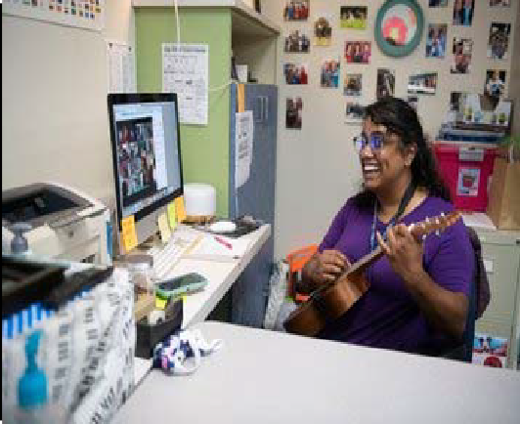
Mesquite Independent School District

Financial Section

Financial Section
Introduction 95
Funding Public Education 96‐97
Property Tax Levies & Collections 98
Comparison of Combined M&O and I&S Tax Rates 99
Long Range Assumptions 100
Budget Administration & Management Process 101‐103
Assumptions & Priorities for the 2020‐2021 Budget 104‐106
Financial Section Overview 107
2020‐2021 General/Debt Service/Student Nutrition Funds 108
General/Debt Service/Student Nutrition Funds—Revenues by Object 109‐110
General/Debt Service/Student Nutrition Funds—Expenditures by Object 111‐114
General Fund 115
Revenues & Expenditures 116‐117
Revenues by Object 118‐119
Expenditures by Object 120‐123
Student Nutrition Fund 124‐126
Revenues by Object 127
Expenditures by Object 128‐129
Debt Service Fund 130‐132
Revenues by Object 133
Expenditures by Object 134
Aggregate Unlimited Tax Bonds 135
Outstanding Debt 136
Capital Projects Fund Overview 137
2018 Bond Package 138‐142
Department Budgets 143
Budget Trends 144
Revenue and Budget 5 Year Estimation 145‐146
Future Budget Years 147
MISD Buildings 148‐151
Defined Benefit Pension Plan 152‐153
OPED Liability 154

Introduction

The Financial Section provides specific fiscal information regarding the various funds of the District. By law, the Board of Trustees must approve annual budgets for the General Fund, Student Nutrition Fund and the Debt Service Fund. These three funds are included in this section.

The Financial Section begins with the Combined Budget Summary of the General Fund, Student Nutrition Fund and Debt Service Fund. After the summary, the remaining section provides the reader with specific information about each of the three funds named above.

In addition to these funds, Capital Project Funds are included as information only. The budget process for the Capital Projects Funds is established at the point in time that the Board approves the sale of authorized bonds for specific projects. The Capital Projects budgets are typically multi‐year budgets encompassing the entire construction period of each separate project. Separate sub‐funds are created to account for each respective bond sale and unique program codes are used to track specific projects within each sub‐fund.

The fund balance is expected to increase $7 million for 2019‐2020. The 2020‐2021 year fund balance shows revenues equaling expenditures.

Funding Public Education

Where does funding for public education come from?

Overtime, this has drastically changed and continues to change across the nation and within the state of Texas. A survey of state education agencies was conducted by the Editorial Project in Education Re‐ search Center that identified five major approaches to state educational funding:
- Foundation formulas
- Equalization methods
- Local‐eﬀort equalization formulas
- Flat grant funding
- Full state funding

States may implement these fiscal mechanisms individually or in combination. For Mesquite ISD, funding is provided by foundation formulas and local‐eﬀort equalization eﬀorts. For most districts across the nation, the foundation formula is the most common method of school funding, employed in 37 states and the District of Columbia. Under this approach, districts are guaranteed a minimum amount of funding and requires districts to raise a local portion of this amount through a state‐mandated tax rate. The diﬀerence between the foundation amount and the district’s contribution determines the amount of state aid needed.

The actual costs to provide educational services are not the same for all students and all schools. Particular categories or students may have extraordinary education needs that require more intensive or diﬀerent (i.e. higher‐cost) services. For example, a cognitively disabled student who requires specialized instruction, transportation, or other services might cost more to educate than the average general education student.

Because of this, Mesquite ISD receives weights and allotments with certain types of students. Across the nation, 46 states receive some sort of weight or adjustment as part of their core school finance formula and each state varies on their amounts.

On the following page is a table for weights Mesquite ISD receives based on student characteristics:

Weights Given Based on Student Characteristics
Program | Description | Weight
Special Education | Funding for students with learning disabilities based on the student placement. | 1.1 ‐ 5.0
Compensatory Education | Additional funding for low‐performing students as determined through the federal free and reduced price lunch program. | 0.225 or 2.75 for pregnant  students
Bilingual Education | Additional funding to non‐native English speakers | 0.05—0.15
CTE | Additional funding based on career and vocational skills enroll‐ ment in grades 7‐12 | 1.35
Early Education | Funds used to improve reading | 0.10—0.20
Dyslexia | Funds to improve support for dyslexic students | 0.10

Mesquite Independent School District Property Tax Levies & Collections

Fiscal Year | M&O Rate | I&S Rate | Total Tax Rate | Taxable Values | Total Levy | Total Collections | %
2010 | 1.04 | 0.37 | 1.42 | $ 6,467,873,468 | $ 87,516,422.80 | $ 85,695,026.13 | 98.17
2011 | 1.04 | 0.37 | 1.42 | $ 6,120,707,473 | $ 86,272,906.71 | $ 84,461,934.62 | 98.64
2012 | 1.04 | 0.37 | 1.42 | $ 6,045,576,816 | $ 84,374,630.05 | $ 82,766,517.40 | 98.56
2013 | 1.04 | 0.37 | 1.42 | $ 5,875,851,693 | $ 84,516,846.54 | $ 83,134,933.19 | 98.65
2014 | 1.04 | 0.36 | 1.41 | $ 5,899,012,680 | $ 88,617,735.37 | $ 86,607,563.74 | 98.56
2015 | 1.04 | 0.36 | 1.41 | $ 6,188,134,529 | $ 89,248,543.57 | $ 87,466,306.41 | 99.17
2016 | 1.04 | 0.42 | 1.46 | $ 6,862,131,352 | $ 103,000,459.01 | $ 99,288,581.66 | 98.66
2017 | 1.04 | 0.42 | 1.46 | $ 7,054,825,858 | $ 107,713,254.33 | $ 108,857,664.18 | 98.68
2018 | 1.04 | 0.48 | 1.52 | $ 7,960,549,178 | $ 125,639,017.39 | $ 123,786,579.44 | 98.53
2019 | 0.97 | 0.48 | 1.45 | $ 9,271,820,630 | $ 130,792,671.63 | $ 129,188,292.72 | 98.77
2020 | 0.9664 | 0.48 | 1.4464 | $ 9,534,547,862

Comparison of Tax Rates

The tax rate for 2020‐2021 will be 1.4464. The tax rate is comprised of two component rates each having separate and state laws governing them—Maintenance and Operations (M&O) tax rate and Debt Service (I&S) tax rate.

Table 24

Combined Tax Rate
I&S
M&O
2021
2020
2019
2018
2017
2016
2015
0.37
0.37
0.42
0.42
0.48
0.48
0.48
0.9664
0.97
1.04
1.04
1.04
1.04
1.04
1.4464
1.41
1.41
Comparison of Combined M&O and I&S Tax Rates
1.52
1.46 1.46 1.45

Long‐Range Projection Assumptions

    - Enrollment numbers reflect the projections shown in our demographer’s report. The attendance rate of 96% is used to calculate the annual Average Daily Attendance (ADA) number. This number is a major driver in determining the amount of state funding for each fiscal year.

    - The Maintenance and Operation (M&O) tax rate is the state compressed rate of $0.9664 per
$100 of taxable value. No current plans to hold a Tax Ratification Election (TRE) to increase the rate.

    - Budget projections are planned to include an eﬀort to maintain a strong, healthy fund balance reserve of at least 22‐25% of operating expenditures to preserve financial and cash flow stability.

    - Vanguard High School will open in 2021 which will require additional staﬃng and operations budgets.

    - Re‐allocating staﬀ as well as some potential increases in the operations budgets.

Budget Administration & Management Process
Following the budget adoption, the process of administering and managing the budget begins. The process is ongoing throughout the fiscal year to ensure that accounts do not exceed authorized amounts and that they are used for the intended proper and legal uses.

Expenditure Control and Approval

Mesquite ISD uses a detailed account code called a line item. This code is segmented into fund, function, object, sub‐object, organization, fiscal year, program intent and a local option use code. Organization codes are considered cost centers and have corresponding designated personnel assigned to each. There are exceptions to this rule. If a designated personnel has district‐wide responsibility, some costs are allocated to line items with multiple organization codes.

Each designated personnel is authorized to approve expenditures for the funds within their budgets. The District uses the Munis Financial Management system to account for these funds. This system monitors line items to ensure that account balances are not exceeded. Designated personnel may amend their budgets with the same functional level. For instance, supply funds for various grade levels may be redistributed based on the designated personnel’s approval since they are all under the same functional category.

Purchasing

The District’s Purchasing Department is responsible for all formal sealed bids and competitive sealed proposals. All District contracts, except contracts for the purchase of produce valued at $50,000 or more in the aggregate for each 12‐month period, are made by the method that provides the best value for the District:

- Competitive solicitations; quotes and bids.
- Competitive sealed proposals.
- A request for proposals for services other than construction services.
- A catalog purchase as provided by Government Code Chapter 2157, Subchapter B.
- An inter‐local contract.
- The reverse auction procedure as defined by Government Code 2155.062(d).

Requests for Qualifications, Competitive Sealed Proposals and Formal Sealed Bids are advertised per Local Govt. Code 271.025.

Purchase orders are required for purchases of all tangible goods and services. A campus department representative enters a requisition into the accounting system. The account is automatically checked for availability of funds. If funds are available, the requisition is submitted for approval to the denied/re‐routed by Purchasing Department personnel. Requisitions being denied are re‐ turned to the requestor for correction. These items may then be resubmitted for approval once revised. Requests for technology items, computers, peripherals or software are submitted through Eduphoria and reviewed by the Information Technology staﬀ. If approved, a requisition is entered. Once approved, requisitions are batch updated in the financial software. The funds are encumbered and accounting is updated to provide necessary budget control during the batch update process. The requisition number changes to a valid purchase order number during this process. Each purchase order is printed at the requestor printer and then mailed, emailed or faxed to the appropriate vendor based on the vendor setup.

After the goods have been physically received, or services completed, the recipient enters the in‐ formation acknowledging receipt into the financial accounting system. The Accounts Payable Department receives the invoice and matches it to the correct purchase order number and the correct vendor. The encumbrance is then liquidated at the time of payment.

Credit Cards

Currently, the Superintendent and Cabinet Members have a district level credit card. Departments and campuses can check out cards. A purchase order is required for payment of any charges on credit card statement, receipts are received in the accounting system. These bills are paid on a weekly basis.

Expense Reimbursements

Proper documentation and verification is necessary for expenses such as travel to be reimbursed. Verification includes such things as hotel, parking, cab, shuttle and airfare receipts, conference registration forms and mileage logs detailing dates of travel, destination and number of miles traveled. These transactions are submitted through a check requisition, signed by the requestor and principal or department head, and forwarded to the Business Oﬃce for approval and payment processing.

Budget Amendments

Periodic budget amendments are necessary during the course of the fiscal year to ensure that functional categories maintain a positive balance. Budget amendments are initiated by the Asst. Supt of Business Services. Board approval is required for budget amendments where funds are moved be‐ tween functional categories.

Reporting to the Texas Education Agency

The District submits its annual budget, student attendance information and its end‐of‐year financial status through a system called Public Education Information Management System (PEIMS). Transmission dates are established by TEA. The PEIMS system provides TEA and districts across the state with a wealth of demographic and financial information.

Monthly Financial Report

At each regular monthly Board meeting, the District’s accounting staﬀ prepares a function by function report for informational purposes. This report is prepared showing the summary of revenues and expenditures both on a monthly and year‐to‐date basis. These reports also show a percentage of revenues collected and a percentage of budgets expended. In addition to these fund reports, information regarding investments are presented to the Board of Trustees on a quarterly basis.

General Fund Reserve Policy

The board has adopted a 22% to 25% of Budget for the General Fund Reserve.

Internal Controls

Cash Handling Regulation is part of the annual training for all secretaries, principals, club sponsors and anyone else who might handle cash. These requirements are maintained in the district Business Services Handbook.

The district has an Internal Auditor who reports directly to the Board. The auditor will audit many diﬀerent aspects of the district during the school year on a rotating basis.

Assumptions and Priorities for the 2020‐2021 Budget Mesquite Independent School District

Assumptions form the framework of budget development. Four critical factors drive the budget revenue assumptions: the value of the property in the district, the tax rate, the number of students in the average daily attendance and state funding formulas.

Assumptions

- State Finance Provisions
  - There are no changes at this time to the state funding system
ͦ Fiscal Impact: No change from the previous year

- Local Revenue and Tax Rates
  - Local Property Values showed a 9% growth before COVID‐19
  - Maintenance an Operating Tax rate will decrease
  - TEA will not calculate the compression rate until July
  - FY 21 School Board may increase M&O tax rate $ .01 with a unanimous vote
  - Interest and Sinking tax rate $0.48 will remain the same
ͦ Fiscal Impact: Not sure until receive rates

- Enrollment
  - Refined ADA down a estimated 662
  - Planning on no growth
ͦ Fiscal Impact: $2,400,000 reduction over previous budget

- Fund Balance
  - Unassigned fund balance is $119,411,826

- Reallocations
  - Construction ‐ $ 10,603,515
  - Moved to Comp Ed ‐ $1,424,836
ͦ Fiscal Impact: $ 12,028,351

- Allocations (HB3)
  - Early Education Allotment—$5,500,000
  - College Career Military Readiness Allotment ‐ $467,500
ͦ Fiscal Impact: $5,500,000

District Priorities for the Maintenance and Operations Budget

- New Personnel
  - Full Day Pre‐K Teachers (Reductions in Elementary Personnel created enough positions to not add)
  - Secondary Teachers ‐ Growth at HHS and WMHS ‐ $1,755,000
  - Three Dyslexia Teachers ‐ $210,000
  - Facilitator CCMR ‐ $70,000
  - Facilitator Pre‐K ‐ $70,000
  - Crossing Guards ‐ $20,000
  - Vanston Middle School Custodian ‐ $30,000
ͦ Fiscal Impact: $2,155,000

- Budget Additions
  - Reading Academies—$1,270,000
  - Phonics Curriculum ‐ $980,000
  - Diagnostic Tool Grade 1‐2 ‐ $250,000
  - UIL Stipends ‐ $2,500
  - Google Cloud ‐ $170,000
ͦ Fiscal Impact: $2,672,500

- Salaries/Adjustments
  - Senior Buyer, Security System, Licensed Alarm Tech Stipends, Lead Custodian Sup. ‐
$26,000
ͦ Fiscal Impact: $26,000
  - Pay Raise for Employees
ͦ Fiscal Impact: 1% ‐ $2,500,000
ͦ Fiscal Impact: 2% ‐ $5,000,000

- One Time Expenditures
  - Bus Seatbelts ‐ $1,000,000
  - Soft Serve Project ‐ $2,800,000
  - Consultant ‐ $50,000
ͦ Fiscal Impact: $3,850,000

District Priorities for the Maintenance and Operations Budget continued

- Capital Projects
  - Porter Elementary Addition
  - Terry Gym
  - Vanston Gym & Classrooms
  - Berry Gym
  - Agnew Gym
  - Choice High School
  - A.C. New Gym & Addition
  - Wilkinson Gym
  - McDonald Gym
  - Kimbrough Gym
  - Cannaday Elementary Addition
  - Capital Projects and Equipment

Mesquite Independent School District Financial Section Overview

This financial section provides fiscal information regarding the various funds of the District. The School Board of Trustees for Mesquite ISD approves annual expenditure budgets for the General fund, Student Nutrition Fund, and Debt Service Fund. These three funds make up the Governmental Funds. All other funds include proprietary funds, fiduciary funds, special revenue funds, and capital project funds.

In this section, a pyramid approach is presented by beginning with a Combined Statement of Revenues and Expenditures for all three Governmental funds together followed by schedules providing financial information for each of the funds.

The District’s budget is organized into the following fund categories:

General Fund
Used to pay for salaries and benefits of District staﬀ, classroom resources, utilities, maintenance, custodial work, grounds upkeep, transportation, etc. Mainly to pay for the general operations of the District’s facilities and staﬀ.

Student Nutrition Fund
Used for the operation of the District’s program to provide meals to the District’s students.

Debt Service Fund
Used to pay the annual principal and interest requirements resulting from the sale of bonds by the District with approval from the District’s voters via a bond election. These bonds are sold to fund the construction of instructional buildings, other facilities, technology needs, and general maintenance projects.

Table 25
Financial Section
Mesquite Independent School District 2020‐2021 General/Debt Service/Student Nutrition Funds

Expenditures
General Fund Student Nutrition Fund Debt Service Fund
$ 392,072,100.00 $ 26,088,400.00 $ 62,682,000.00

Revenue
General Fund Student Nutrition Fund Debt Service Fund
$ 393,312,300.00 $ 22,437,200.00 $ 63,450,000.00

Mesquite ISD Oﬃcial Budget 2020‐2021
108

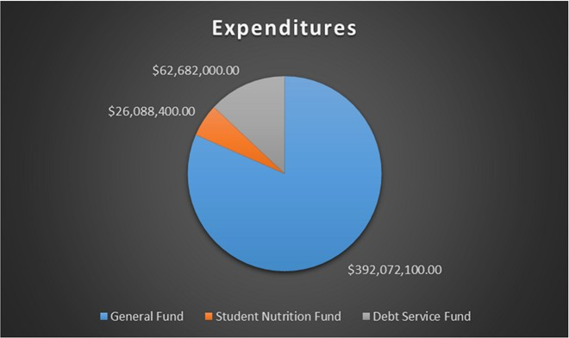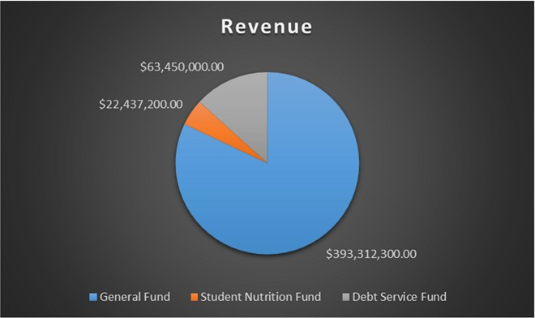

General/Debt Service/Student Nutrition Funds ‐ Revenues by Object
Financial Section

 | 2014 AUDITED | 2015 AUDITED | 2016 AUDITED | 2017 AUDITED | 2018 AUDITED 2019 AUDITED |  | 2020 UNAUDITED | 2021 BUDGET
5711 ‐ TAXES, CURRENT YEAR LEVY | $ 81,882,944.35 | $ 86,535,995.39 | $ 87,403,595.79 | $ 99,225,644.66 | $ 108,823,338.77 $ 123,658,383.26 |  | $ 128,935,084.36 | $ 134,516,700.00
5712 ‐ TAXES PRIOR YEAR | $ 1,031,126.72 | $ 803,309.22 | $ 1,298,062.28 | $ 1,045,083.77 | $ 948,833.74 $ 658,792.76 |  | $ 1,461,488.21 | $ 1,050,000.00
5719 ‐ PENALTIES, INTEREST & OTHER TA | $ 1,287,792.48 | $ 940,289.00 | $ 1,129,925.60 | $ 1,167,492.05 | $ 1,206,083.08 $ 1,426,438.58 |  | $ 1,450,802.04 | $ 1,250,000.00
5721 ‐ LOCAL FROM SALE OF WADA | $ ‐ | $ ‐ | $ ‐ |  | $ ‐ $ ‐ |  | $ ‐ | $ ‐
5735 ‐ TUITUION & FEES | $ 217,980.00 | $ 214,810.00 | $ 186,030.00 | $ 183,180.00 | $ 184,212.00 $ 191,535.00 |  | $ 128,915.00 | $ 200,000.00
5736 ‐ TUITION‐REG DAY SCHOOL/SUNNYVA | $ ‐ | $ ‐ | $ ‐ |  | $ ‐ $ ‐ |  | $ 5,725.00 | $ ‐
5737 ‐ SUMMER SCHOOL | $ 99,213.52 | $ 101,833.75 | $ 92,617.01 | $ 100,298.00 | $ 70,274.00 $ 64,780.00 |  | $ 83,166.33 | $ 80,000.00
5738 ‐ OTHER STUDENT TUITION | $ ‐ | $ ‐ | $ ‐ |  | $ ‐ $ ‐ |  | $ 405,248.00 | $ ‐
5739 ‐ TUITION AND FEES | $ 537,127.21 | $ 621,258.12 | $ 773,763.46 | $ 17,901.00 | $ 18,275.00 $ 17,418.00 |  | $ 13,595.00 | $ 25,000.00
5742 ‐ EARNINGS FROM INVESTMENTS | $ 600,708.88 | $ 556,041.93 | $ 1,443,415.45 | $ 1,737,829.12 | $ 4,040,644.03 $ 5,161,422.19 |  | $ 4,098,804.87 | $ 3,850,000.00
5743 ‐ RENTAL FROM SCHOOL PROPERTY | $ 465,625.90 | $ 473,306.19 | $ 451,146.54 | $ 603,822.57 | $ 542,236.67 $ 369,999.15 |  | $ 257,555.30 | $ 300,000.00
5744 ‐ GIFTS & BEQUESTS | $ 177,171.39 | $ 174,758.12 | $ 300,209.52 | $ 163,838.75 | $ 249,274.48 $ 296,464.72 |  | $ 336,573.57 | $ 405,000.00
5745 ‐ INSURANCE RECOVERY | $ 54,944.94 | $ 32,530.93 | $ 26,857.17 | $ 1,896,755.12 | $ 522,483.78 $ 726,244.11 |  | $ 161,719.05 | $ 250,000.00
5746 ‐ TAX INCREMENT FUND | $ 38,000.00 | $ 60,562.00 | $ ‐ | $ ‐ | $ ‐ $ ‐ |  | $ ‐ | $ ‐
5748 ‐ NET RECEIPTS CLEARING/PATROL | $ 160,320.59 | $ 185,843.57 | $ 194,336.70 | $ 204,557.29 | $ 196,642.48 $ 200,561.19 |  | $ 195,424.54 | $ 200,000.00
5749 ‐ MISC/FINES, WELLNESS, & ETC. | $ 608,730.47 | $ 1,004,195.31 | $ 1,461,969.23 | $ 1,219,885.46 | $ 2,495,331.46 $ 1,099,131.91 |  | $ 966,459.97 | $ 2,830,000.00
5751 ‐ FOOD SERVICES ACTIVITY | $ 4,292,109.02 | $ 3,444,883.21 | $ 3,197,860.52 | $ 3,159,059.25 | $ 3,325,456.91 $ 3,130,187.55 |  | $ 2,126,072.48 | $ 2,463,100.00
5752 ‐ ATHLETIC ACTIVITY REVENUE | $ 801,254.32 | $ 758,438.86 | $ 789,016.09 | $ 809,620.02 | $ 823,155.88 $ 567,624.45 |  | $ 701,001.69 | $ 900,000.00
5753 ‐ EXTRA/COCURRICULAR ACTIVITY | $ 1,805,320.20 | $ 2,354,978.98 | $ 2,788,412.13 | $ 2,905,256.27 | $ 2,898,776.64 $ 3,340,235.03 |  | $ 2,146,040.01 | $ 3,200,000.00
5755 ‐ ACTIVITY FUND | $ 113,379.77 | $ 112,752.17 | $ 140,187.32 | $ 120,198.77 | $ 125,259.92 $ 131,039.45 |  | $ 71,853.00 | $ 130,000.00
5757 ‐ TAXABLE ITEMS SALE | $ 615,335.80 | $ 424,081.66 | $ 4.80 | $ 4.80 | $ ‐ $ 24,962.26 |  | $ ‐ | $ ‐
5761 ‐ SUCESSOR‐IN‐INTEREST CED | $ ‐ | $ ‐ | $ ‐ |  | $ ‐ $ ‐ |  | $ ‐ | $ ‐
5769 ‐ COUNTY AVAILABLE | $ ‐ | $ ‐ | $ ‐ |  | $ ‐ $ ‐ |  | $ ‐ | $ ‐
5811 ‐ PER CAPITA/APPORTIONMENT | $ 9,678,221.00 | $ 9,949,005.00 | $ 6,877,475.00 | $ 5,120,812.00 | $ 8,011,935.00 $ 18,653,252.00 |  | $ 12,090,407.00 | $ 14,839,400.00
5812 ‐ FOUNDATION/ENTITLEMENTS | $ 214,199,065.00 | $ 224,825,736.00 | $ 241,648,409.00 | $ 34,408,940.00 | $ 241,130,678.97 $ 225,197,086.90 |  | $ 244,910,670.97 | $ 251,565,600.00
5819 ‐ OTHER FOUNDATION SCHOOL PROGRA | $ ‐ |  |  |  |  | $ 432,819.28 | $ ‐ | $ ‐

5826 ‐ SUPPLEMENTAL PRE‐K
Mesquite ISD Oﬃcial Budget 2020‐2021
5827 ‐ YEAR ROUND SCHOOL INCENTIVE
5829 ‐ MISCELLANEOUS STATE PROGRAMS
$ 7,076.51
$ ‐
$ 22,475,982.81
$ 67,634.28 $ 69,468.00 $ ‐ $ ‐ $ ‐ $ ‐
$ ‐ $ ‐ $ ‐ $ ‐ $ ‐ $ ‐ $ ‐
$ 21,035,279.97 $ 23,611,653.29 $ 22,132,381.68 $ 24,754,034.03 $ 4,169,444.21 $ 20,514,386.24 $ 17,576,500.00

109

General/Debt Service/Student Nutrition Funds ‐ Revenues by Object (cont.)
Financial Section

5831 ‐ TRS ON‐BEHALF BENEFIT
5836 ‐ REVENUE FROM OTHER TX GOVERNME
5839 ‐ OTHER STATE AGENCIES
5921 ‐ SCHOOL BREAKFAST PROGRAM
5922 ‐ NATIONAL SCHOOL LUNCH
5923 ‐ USDA DONATED COMMODITIES
5929 ‐ OTHER FEDERAL REVENUES
5931 ‐ SCHOOL HEALTH AND RELATED SERV
5932 ‐ MEDICAID ADM CLAIMING
5949 ‐ DIRECT FEDERAL REVENUE
7901 ‐ REFUNDING BOND ISSUANCE
7911 ‐ SALE OF BONDS

7912 ‐ SALE OF PROPERTY
110
7913 ‐ LEASE‐PURCHASE PROCEEDS

7915 ‐ TRANSFER IN
7916 ‐ PREMIUM/DISCOUNT
7949 ‐ OTHER RESOURCES
7989 ‐ OTHER/NON‐REVENUE
7998 ‐ GAIN/LOSS INVESTMENT
Mesquite ISD Oﬃcial Budget 2020‐2021

7999 ‐ RESIDUAL EQUITY TRANSFERS IN
Grand Total

2014 AUDITED
$ 13,034,276.14
$ ‐
$ 214,301.42
$ 2,638,938.56
$ 12,057,981.77
$ 1,346,694.33
$ ‐
$ 995,585.26
$ 93,142.83
$ 534,373.66
$ 54,200,000.00
$ ‐

$ 37,094.51
$ 4,159,461.50

$ 450,568.42
$ 6,628,003.45
$ ‐
$ 24,036.26
$ ‐

$ ‐
$ 437,563,888.99

2015 AUDITED 2016 AUDITED 2017 AUDITED 2018 AUDITED 2019 AUDITED 2020 UNAUDITED 2021 BUDGET
$ 13,914,380.01 $ 14,404,912.84 $ 14,852,191.49 $ 15,364,250.01 $ 15,917,167.02 $ 18,279,319.40 $ 17,360,600.00
$ ‐ $ ‐ $ ‐ $ ‐ $ ‐ $ ‐
$ 241,490.05 $ 227,293.69 $ 178,096.63 $ 146,059.11 $ 183,608.46 $ 3,407,041.70 $ 425,000.00
$ 2,890,059.30 $ 3,188,154.17 $ ,166,768.17 $ 3,423,908.74 $ 3,450,297.29 $ 3,075,165.70 $ 3,427,900.00
$ 12,849,345.97 $ 13,676,494.83 $ 13,111,135.78 $ 14,013,846.84 $ 13,939,614.82 $ 10,501,650.55 $ 13,960,100.00
$ 1,263,276.24 $ 1,590,842.63 $ 1,692,845.00 $ 1,717,639.49 $ 1,675,143.70 $ 1,699,613.35 $ 1,719,600.00
$ ‐ $ ‐ $ ‐ $ 2,889,560.50 $ 4,997,323.33 $ 3,439,995.30 $ ‐
$ 2,829,209.28 $ 3,539,645.75 $ 3,172,020.90 $ 46,876.61 $ ‐ $ ‐ $ 5,500,000.00
$ 67,327.63 $ 102,961.40 $ 58,618.67 $ 511,975.92 $ 473,718.38 $ 534,710.76 $ ‐
$ 499,680.94 $ 462,446.86 $ 541,994.51 $ 236,558.45 $ 3,172,478.24 $ 72,459.35 $ 550,000.00
$ 75,874,666.05 $ 39,160,000.00 $ 12,803,007.85 $ ‐ $ ‐ $ ‐ $ ‐
$ ‐ $ ‐ $ ‐ $ 391,200.00 $ 391,200.00 $ 391,200.00 $ ‐

$ 66,789.25 $ 77,290.13 $ 34,050.82 $ ‐ $ $ ‐ $ 150,000.00
$ ‐ $ ‐ $ ‐ $ ‐ $ ‐ $ ‐

$ 449,358.05 $ 432,249.16 $ 440,115.11 $ ‐ $ $ ‐ $ 475,000.00
$ 29,396,644.45 $ 8,369,934.00 $ 11,071,275.15 $ ‐ $ ‐ $ ‐ $ ‐
$ ‐ $ ‐ $ ‐ $ ‐ $ ‐ $ ‐ $ ‐
$ 647.57 $ 294.37 $ 40.12 $ ‐ $ ‐ $ ‐ $ ‐
$ ‐ $ ‐ $ ‐ $ ‐

$ ‐ $ ‐ $ ‐ $ ‐
$ 495,020,398.45 $ 459,116,925.13 $ 47,344,720.78 $ 439,108,802.51 $ 453,718,373.24 $ 462,462,148.74 $ 479,199,500.00

General/Debt Service/Student Nutrition Funds ‐ Expenditures by Object
Financial Section
Mesquite ISD Oﬃcial Budget 2020‐2021
111

 | 2014 AUDITED | 2015 AUDITED | 2016 AUDITED | 2017 AUDITED | 2018 AUDITED | 2019 AUDITED 2020 UNAUDTIED |  | 2021 BUDGET
6112 ‐ PROFESSIONAL SUBSTITUTES | $ 2,036,549.43 | $ 2,173,216.43 | $ 2,219,638.77 | $ 2,228,443.79 | $ 2,358,408.16 | $ 2,510,675.31 $ 1,781,482.63 |  | $ 2,334,950.00
6116 ‐ PROFESSIONAL EXTRA DUTY PAY | $ 4,913,436.77 | $ 5,007,043.15 | $ 5,157,514.38 | $ 4,997,807.01 | $ 5,094,645.00 | $ 5,184,145.56 $ 4,563,581.58 |  | $ 9,156,350.00
6117 ‐ CAREER LADDER | $ 208,089.59 | $ 165,648.40 | $ 135,072.48 | $ 112,113.40 | $ 85,756.68 | $ 74,221.80 $ 66,000.00 |  | $ 71,050.00
6118 ‐ PROFESSIONAL STIPENDS | $ 2,647,562.40 | $ 2,799,974.41 | $ 2,863,102.78 | $ 2,937,503.68 | $ 3,031,401.78 | $ 2,968,795.74 $ 3,379,983.43 |  | $ 3,545,100.00
6119 ‐ PROFESSIONAL SALARY | $ 164,604,155.35 | $ 169,690,357.52 | $ 178,158,078.53 | $179,375,942.20 | $ 190,892,699.76 | $ 190,098,558.80 $ 193,458,908.52 |  | $ 210,752,500.00
6121 ‐ EXTRA DUTY/SUPPORT | $ 1,692,401.15 | $ 1,766,951.15 | $ 1,935,075.84 | $ 2,286,294.49 | $ 2,316,731.02 | $ 2,659,042.65 $ 2,992,977.76 |  | $ 3,542,350.00
6122 ‐ SUPPORT SALARIES ‐ SUBS | $ 526,610.29 | $ 672,088.11 | $ 820,652.91 | $ 768,560.13 | $ 678,452.85 | $ 617,854.91 $ 522,442.15 |  | $ 696,650.00
6125 ‐ SUPPORT SALARIES | $ 32,972,882.44 | $ 35,356,903.91 | $ 37,069,481.59 | $ 39,503,678.63 | $ 41,005,060.92 | $ 41,126,702.56 $ 42,968,690.60 |  | $ 45,838,800.00
6126 ‐ SUPPORT SALARIES/HOURLY | $ 1,404,890.28 | $ 1,406,933.29 | $ 1,387,645.88 | $ 1,375,572.77 | $ 1,386,551.28 | $ 1,411,899.20 $ 1,532,309.06 |  | $ 1,952,850.00
6131 ‐ CONTRACT BUYOUTS | $ ‐ | $ ‐ | $ ‐ |  |  | $ ‐ |  | $ ‐
6134 ‐ EMPLOYEE ALLOWANCES | $ 450,899.71 | $ 456,652.07 | $ 454,754.16 | $ 293,590.09 | $ 216,329.12 | $ 219,853.53 $ 210,091.99 |  | $ 230,100.00
6141 ‐ SOCIAL SECURITY/MEDICARE | $ 2,750,177.26 | $ 2,885,598.69 | $ 3,029,172.96 | $ 3,197,258.43 | $ 3,277,439.31 | $ 3,366,460.29 $ | 3,543,774.38 | $ 4,085,500.00
6142 ‐ HEALTH & LIFE INSURANCE | $ 10,163,958.48 | $ 10,975,692.80 | $ 11,138,981.22 | $ 11,354,828.89 | $ 11,396,341.31 | $ 11,045,082.49 $ | 10,710,269.88 | $ 11,211,550.00
6143 ‐ WORKERS' COMPENSATION | $ 1,028,060.04 | $ 1,024,911.24 | $ 1,025,232.72 | $ 1,024,370.64 | $ 1,026,541.68 | $ 1,027,866.36 $ | 1,027,617.60 | $ 1,229,950.00
6144 ‐ TRS ON‐BEHALF BENEFIT | $ 13,034,276.14 | $ 13,914,380.01 | $ 14,404,912.84 | $ 14,852,191.49 | $ 15,364,250.01 | $ 15,917,167.02 $ | 18,279,053.66 | $ 17,089,000.00
6145 ‐ UNEMPLOYMENT COMPENSATION | $ 53,172.50 | $ 63,188.91 | $ 80,039.31 | $ 74,863.53 | $ 101,947.85 | $ 41,489.05 $ | 362,497.30 | $ 90,000.00
6146 ‐ TEACHER RETIREMENT/TRS CARE | $ 4,537,390.68 | $ 7,119,852.34 | $ 7,401,075.52 | $ 7,795,914.81 | $ 8,797,244.34 | $ 8,936,002.07 $ | 9,828,512.67 | $ 10,771,800.00
6147 ‐ SICK/VACATION RETIREMENT | $ 263,050.74 | $ 277,327.70 | $ 881,879.83 | $ 344,558.58 | $ 485,002.58 | $ 322,715.95 $ | 323,326.32 | $ 440,000.00
6148 ‐ PLAN BEHAVIOR HEALTH | $ 108,512.25 | $ 110,791.25 | $ 112,458.50 | $ 114,010.75 | $ 114,805.25 | $ 114,919.00 $ | 112,252.00 | $ 120,000.00
6149 ‐ EMPLOYEE BENEFITS | $ 65,122.25 | $ 84,276.00 | $ 74,697.00 | $ 75,774.00 | $ 75,213.00 | $ 82,26.50 $ | 80,758.50 | $ ‐
6211 ‐ LEGAL SERVICE | $ 207,394.86 | $ 187,373.08 | $ 148,004.61 | $ 176,022.38 | $ 167,752.76 | $ 211,835.27 $ | 330,152.02 | $ 305,000.00
6212 ‐ AUDIT SERVICES | $ 118,500.00 | $ 110,000.00 | $ 110,000.00 | $ 142,000.00 | $ 125,000.00 | $ 125,000.00 $ | 150,000.00 | $ 120,000.00
6213 ‐ TAX COLLECTION | $ 638,715.07 | $ 655,744.25 | $ 706,234.72 | $ 753,392.74 | $ 759,747.70 | $ 784,839.78 $ | 876,724.08 | $ 820,000.00
6214 ‐ LOBBYING EXPENSE | $ ‐ |  |  |  |  | $ | 7,228.26 | $ ‐
6217 ‐ DATA PROCESSING SERVICE | $ 265,100.28 | $ ‐ | $ ‐ | $ ‐ | $ ‐ | $ ‐ $ | ‐ | $ ‐
6219 ‐ PROFESSIONAL SERVICE |  | $ 50,208.75 | $ 40,000.00 | $ 40,000.00 | $ 40,000.00 | $ ‐ $ | ‐ | $ ‐

Financial Section
Mesquite ISD Oﬃcial Budget 2020‐2021
112

 | 2014 AUDITED | 2015 AUDITED | 2016 AUDITED | 2017 AUDITED | 2018 AUDITED | 2019 AUDITED | 2020 UNAUDITED | 2021 BUDGET
6221 ‐ STAFF TUITION FEES | $ 687,730.94 | $ 710,551.81 | $ 656,991.86 | $ 339,398.63 | $ 91,951.20 | $ 81,136.28 | $ 115,962.00 | $ 1,075,000.00
6223 ‐ STUDENT TUITION‐OTHER THAN PUB | $ 116,569.17 | $ 266,271.81 | $ 262,036.43 | $ 604,556.70 | $ 766,210.63 | $ 65,575.98 | $ 171,400.26 | $ 630,000.00
6239 ‐ EDUCATION SERVICE CENTER | $ 77,941.00 | $ 108,935.32 | $ 105,022.80 | $ 122,370.23 | $ 168,326.80 | $ 126,452.20 | $ 318,622.76 | $ 211,250.00
6244 ‐ TECHNOLOGY MAINT/REPAIRS | $ ‐ | $ ‐ | $ 1,159.00 | $ ‐ | $ ‐ | $ 10,825.53 | $ ‐ | $ 1,000.00
6245 ‐ AUDIO VISUAL MAINT/REPAIRS | $ 3,766.39 | $ 7,448.91 | $ 5,230.37 | $ 1,445.12 | $ 5,097.86 | $ 4,191.92 | $ 1,638.47 | $ 12,000.00
6246 ‐ BUILDING MAINTENANCE/REPAIRS | $ 1,875,959.84 | $ 2,004,082.40 | $ 2,718,973.80 | $ 1,944,156.71 | $ 2,656,745.59 | $ 2,628,119.46 | $ 3,938,830.78 | $ 2,658,500.00
6247 ‐ VEHICLE MAINTENANCE/REPAIRS | $ 86,033.13 | $ 70,302.51 | $ 38,231.19 | $ 84,030.38 | $ 123,927.37 | $ 84,290.13 | $ 48,820.89 | $ 91,000.00
6249 ‐ CONTRACTED MAINT/REPAIR | $ 1,589,228.59 | $ 1,854,003.46 | $ 2,136,209.87 | $ 2,398,239.46 | $ 2,266,326.31 | $ 2,905,579.21 | $ 3,839,000.55 | $ 3,070,250.00
6255 ‐ WATER | $ 1,473,425.04 | $ 1,694,383.54 | $ 2,209,632.87 | $ 2,149,570.79 | $ 2,464,137.46 | $ 2,271,896.95 | $ 2,924,900.98 | $ 3,189,700.00
6256 ‐ TELEPHONE | $ 602,912.26 | $ 983,051.45 | $ 347,685.94 | $ 472,419.23 | $ 450,955.52 | $ 333,964.30 | $ 321,590.15 | $ 312,900.00
6257 ‐ ELECTRICITY | $ 5,573,878.67 | $ 5,468,992.67 | $ 5,494,408.65 | $ 5,686,606.95 | $ 4,924,684.79 | $ 4,329,388.23 | $ 4,194,973.88 | $ 5,001,300.00
6258 ‐ GAS | $ 699,585.07 | $ 534,070.28 | $ 404,750.01 | $ 456,381.56 | $ 524,860.75 | $ 393,066.41 | $ 308,548.85 | $ 700,000.00
6259 ‐ OTHER UTILITIES | $ 68,662.65 | $ 75,015.85 | $ 721,307.90 | $ 445,495.95 | $ 273,578.18 | $ 269,236.96 | $ 90,047.79 | $ 286,000.00
6264 ‐ COPIER RENTAL | $ 1,115,057.97 | $ 1,513,674.50 | $ 1,532,132.24 | $ 1,215,867.74 | $ 1,369,324.22 | $ 1,483,529.35 | $ 1,479,472.43 | $ 1,530,000.00
6265 ‐ EQUIP RENTAL | $ 867.00 | $ 42,817.12 | $ 16,680.93 | $ 22,311.23 | $ 41,940.29 | $ 50,712.10 | $ 78,421.38 | $ 63,850.00
6266 ‐ VEHICLE RENTAL | $ 55,610.33 | $ 49,848.89 | $ 115,588.80 | $ 116,292.00 | $ 91,670.75 | $ 90,258.86 | $ 123,794.58 | $ 89,500.00
6267 ‐ BUILDING RENTAL | $ 769,307.25 | $ 937,434.00 | $ 937,434.00 | $ 937,434.00 | $ 938,159.00 | $ 938,209.00 | $ 234,358.50 | $ ‐
6269 ‐ OTHER RENTAL | $ 3,405.70 | $ 3,590.67 | $ 1,270.29 | $ 4,624.33 | $ 4,132.27 | $ 25,883.50 | $ 19,991.14 | $ 7,000.00
6291 ‐ CONSULTING SERVICES | $ 15,700.00 | $ 13,200.00 | $ 146,500.00 | $ 50,000.00 | $ 259,182.50 | $ 648,978.50 | $ 571,602.41 | $ 160,000.00
6299 ‐ MISC CONTRACTED SERVICE | $ 4,657,876.89 | $ 4,633,112.02 | $ 5,080,452.64 | $ 5,416,949.32 | $ 4,963,073.44 | $ 6,175,101.75 | $ 5,723,588.21 | $ 6,759,750.00
6311 ‐ VEHICLE FUELS | $ 579,957.56 | $ 647,663.02 | $ 375,216.10 | $ 624,808.08 | $ 724,579.79 | $ 1,023,991.88 | $ 716,814.35 | $ 1,271,200.00
6315 ‐ CUSTODIAL SUPPLIES | $ 820,625.61 | $ 885,908.56 | $ 924,243.33 | $ 936,662.17 | $ 1,009,868.11 | $ 1,002,835.75 | $ 992,176.81 | $ 1,062,200.00
6316 ‐ SUPPLIES BUILDINGS | $ 1,483,975.47 | $ 1,462,464.68 | $ 1,801,022.58 | $ 1,451,942.24 | $ 1,360,572.97 | $ 1,524,931.62 | $ 1,228,886.54 | $ 2,324,800.00
6317 ‐ COMPUTER SUPPLIES/M&O | $ 2,373.76 | $ ‐ | $ ‐ | $ ‐ | $ ‐ | $ ‐ | $ ‐ | $ ‐
6319 ‐ OTHER SUPPLIES | $ 937,248.27 | $ 1,240,499.03 | $ 1,109,485.73 | $ 980,473.23 | $ 892,301.75 | $ 1,517,055.22 | $ 1,827,114.52 | $ 2,176,100.00
6321 ‐ TEXTBOOKS | $ 92,285.32 | $ 304,505.21 | $ 145,891.36 | $ 173,185.62 | $ 132,097.30 | $ 5,071.51 | $ 537.63 | $ 285,000.00
6325 ‐ READING MATERIALS/BOOKS | $ 99,200.64 | $ 112,767.15 | $ 174,600.54 | $ 136,522.80 | $ 103,861.98 | $ 126,135.97 | $ 336,472.76 | $ 49,300.00
6326 ‐ MAGAZINES | $ 176,593.55 | $ 151,454.71 | $ 10,845.02 | $ 26,117.02 | $ 29,796.78 | $ 11,632.23 | $ 14,092.99 | $ 29,200.00
6327 ‐ TEXTBOOK (STATE ADOPTED) | $ ‐ | $ ‐ | $ ‐ | $ ‐ | $ ‐ | $ ‐ | $ ‐ | $ ‐
6329 ‐ READING MATERIAL/OTHER | $ 42,574.02 | $ 48,997.08 | $ 84,434.78 | $ 41,388.70 | $ 39,911.37 | $ 22,530.56 | $ 16,858.10 | $ 40,500.00

Financial Section
Mesquite ISD Oﬃcial Budget 2020‐2021
113

 | 2014 AUDITED | 2015 AUDITED | 2016 AUDITED | 2017 AUDITED | 2018 AUDITED | 2019 AUDITED | 2020 UNAUDITED | 2021 BUDGET
6334 ‐ TESTING‐MATERIALS | $ 142,318.97 | $ 215,318.05 | $ 171,226.64 | $ 216,830.07 | $ 346,420.35 | $ 168,388.59 | $ 538,459.67 | $ 421,500.00
6341 ‐ FOOD/FOOD SERVICE | $ 9,475,562.52 | $ 9,080,743.66 | $ 9,697,224.76 | $ 8,632,744.75 | $ 8,469,470.39 | $ 8,718,811.49 | $ 7,497,940.47 | $ 10,943,500.00
6342 ‐ NON‐FOOD/FOOD SERVICE | $ 940,316.59 | $ 983,581.63 | $ 1,031,191.39 | $ 876,757.23 | $ 930,796.29 | $ 902,474.63 | $ 775,171.61 | $ 1,119,500.00
6344 ‐ USDA DONATED COMMODITIES | $ 1,346,694.33 | $ 1,263,276.24 | $ 1,590,842.63 | $ 1,692,845.00 | $ 1,717,639.49 | $ 1,675,143.70 | $ 1,699,613.35 | $ 1,843,700.00
6349 ‐ FOOD SERVICE SUPPLIES | $ 58,686.59 | $ 32,165.29 | $ 174,494.96 | $ 118,366.75 | $ 62,458.35 | $ 22,543.48 | $ 62,703.58 | $ 77,250.00
6395 ‐ ELECTRONICS $100‐$5,000 | $ 642,874.60 | $ 442,063.07 | $ 543,505.95 | $ 592,104.30 | $ 723,539.36 | $ 653,354.19 | $ 697,924.09 | $ 260,650.00
6396 ‐ COMPUTER SUPPLIES | $ 2,111,745.60 | $ 1,314,871.07 | $ 1,101,758.99 | $ 1,544,035.63 | $ 1,557,765.83 | $ 1,251,710.04 | $ 929,660.69 | $ 2,023,050.00
6397 ‐ FURNITURE UNDER $5,000 | $ 247,473.66 | $ 255,468.52 | $ 339,294.35 | $ 245,111.55 | $ 293,349.65 | $ 379,284.81 | $ 446,872.74 | $ 26,700.00
6398 ‐ EQUIPMENT $300‐$5,000 | $ 581,744.17 | $ 276,478.89 | $ 398,901.31 | $ 466,725.06 | $ 894,555.32 | $ 549,680.16 | $ 726,791.21 | $ 207,300.00
6399 ‐ GENERAL SUPPLIES | $ 7,035,783.75 | $ 9,012,096.93 | $ 8,794,451.08 | $ 9,242,910.05 | $ 8,274,158.33 | $ 8,073,804.75 | $ 8,092,818.41 | $ 15,951,150.00
6411 ‐ TRAVEL/EMPLOYEE | $ 484,699.48 | $ 510,620.94 | $ 593,433.03 | $ 713,272.22 | $ 588,934.17 | $ 575,049.23 | $ 368,460.04 | $ 846,600.00
6412 ‐ TRAVEL/STUDENTS | $ 540,804.06 | $ 539,192.62 | $ 756,445.31 | $ 903,435.12 | $ 1,054,021.66 | $ 1,362,796.98 | $ 844,543.59 | $ 844,550.00
6413 ‐ STIPENDS/NON‐EMPLOYEE | $ ‐ | $ ‐ | $ ‐ | $ ‐ | $ ‐ | $ ‐ | $ ‐ | $ ‐
6419 ‐ TRAVEL/NON‐EMPLOYEE | $ 24,297.16 | $ 23,852.71 | $ 38,744.83 | $ 54,617.21 | $ 57,471.77 | $ 86,867.82 | $ 23,665.17 | $ 70,500.00
6425 ‐ PROPERTY INSURANCE | $ 822,443.89 | $ 633,529.81 | $ 649,496.18 | $ 781,873.10 | $ 950,175.59 | $ 1,349,493.30 | $ 1,555,794.21 | $ 1,500,500.00
6426 ‐ LIABILITY INSURANCE | $ 210.00 | $ 113,879.00 | $ 113,609.00 | $ 122,061.00 | $ 124,740.00 | $ 126,858.00 | $ 228,942.00 | $ 130,000.00
6427 ‐ BONDING INSURANCE | $ 2,698.00 | $ 1,988.00 | $ 3,053.00 | $ 2,627.00 | $ 1,562.00 | $ 2,272.00 | $ 3,479.00 | $ 4,000.00
6428 ‐ ATHLETIC INSURANCE | $ 225,676.00 | $ 225,676.00 | $ 228,287.00 | $ 197,539.00 | $ 197,539.00 | $ 202,539.00 | $ 190,885.00 | $ 210,000.00
6429 ‐ OTHER INSURANCE ESCROW | $ ‐ | $ ‐ | $ ‐ | $ ‐ | $ ‐ | $ ‐ | $ ‐ | $ ‐
6434 ‐ ELECTION EXPENSES | $ 44,601.40 | $ 70,636.98 | $ 41,974.53 | $ ‐ | $ 60,720.44 | $ 11,700.17 | $ ‐ | $ 50,000.00
6491 ‐ REQUIRED PUBLIC NOTICES |  |  |  |  | $ 1,832.78 | $ 5,919.50 | $ 4,432.90 | $ 17,200.00
6494 ‐ STUDENT TRANSPORTATION‐BUSES | $ 1,056,618.58 | $ 1,034,128.61 | $ 1,112,245.90 | $ 1,155,078.08 | $ 1,336,539.66 | $ 1,198,774.85 | $ 904,802.55 | $ 1,296,550.00
6495 ‐ DUES | $ 123,557.86 | $ 126,064.64 | $ 161,598.80 | $ 195,074.92 | $ 181,900.61 | $ 207,765.35 | $ 274,370.14 | $ 167,100.00
6497 ‐ AWARDS‐GRADUATION | $ 247,262.76 | $ 268,083.34 | $ 268,024.78 | $ 283,302.50 | $ 319,345.42 | $ 307,543.93 | $ 303,899.34 | $ 282,550.00
6498 ‐ RESOURCE OFFICER | $ 1,229,312.65 | $ 1,078,465.86 | $ 1,114,475.71 | $ 1,178,241.59 | $ 1,224,836.59 | $ 1,573,894.43 | $ 1,704,380.09 | $ 1,615,000.00
6499 ‐ MISC OPERATING EXP | $ 5,081,603.18 | $ 5,119,806.94 | $ 5,332,730.65 | $ 6,022,966.74 | $ 6,328,478.26 | $ 5,966,029.65 | $ 5,325,127.69 | $ 6,204,150.00

General/Debt Service/Student Nutrition Funds ‐ Expenditures by Object (cont.)
Financial Section
Mesquite ISD Oﬃcial Budget 2020‐2021
114

 | 2014 AUDITED | 2015 AUDITED | 2016 AUDITED | 2017 AUDITED | 2018 AUDITED | 2019 AUDITED | 2020 UNAUDITED | 2021 BUDGET
6511 ‐ BOND PRINCIPAL | $ 26,849,345.03 | $ 29,467,730.60 | $ 27,973,534.85 | $ 29,284,996.20 | $ 26,395,259.95 | $ 28,543,375.40 | $ 24,405,377.70 | $ 23,282,000.00
6512 ‐ LEASE PRINCIPAL | $ 1,398,929.81 | $ 1,398,923.65 | $ 1,398,926.73 | $ ‐ | $ ‐ | $ ‐ | $ ‐ | $ ‐
6521 ‐ INTEREST ON BONDS | $ 13,431,931.96 | $ 14,352,258.87 | $ 18,253,323.17 | $ 19,582,867.51 | $ 25,708,507.74 | $ 34,011,862.52 | $ 35,627,558.79 | $ 38,800,000.00
6522 ‐ LEASE INTEREST | $ ‐ | $ ‐ | $ ‐ | $ ‐ | $ ‐ | $ ‐ | $ ‐ | $ ‐
6599 ‐ DEBT SERVICE FEES | $ 738,233.96 | $ 1,394,568.21 | $ 871,168.37 | $ 367,038.13 | $ 206,547.22 | $ 197,868.35 | $ 394,628.75 | $ 600,000.00
6614 ‐ LAND PURCHASE | $ ‐ | $ ‐ | $ ‐ | $ 353,162.89 |  | $ 971,503.65 | $ 2,857.23 | $ ‐
6624 ‐ BUILDING PURCHASE/CONSTRUCTION | $ 6,195,948.91 | $ ‐ | $ 3,657,549.40 | $ 7,296,647.23 | $ 13,804,610.17 | $ 7,833,818.84 | $ 9,040,991.32 | $ ‐
6625 ‐ BUILDING IMPROVEMENT | $ 1,007,060.19 | $ 13,094,902.57 | $ 3,376,791.50 | $ 992,392.33 | $ 9,259,374.39 | $ 4,445,070.17 | $ 2,091,188.42 | $ 1,330,000.00
6626 ‐ FEES/BUILDING | $ 1,147,917.92 | $ 249,953.85 | $ 121,775.21 | $ 993,534.36 | $ 470,323.89 | $ 919,979.26 | $ 396,193.04 | $ 70,000.00
6631 ‐ VEHICLE>$5,000 | $ 376,147.29 | $ 921,829.86 | $ 711,545.72 | $ 1,373,474.12 | $ 63,777.25 | $ 1,031,179.17 | $ 187,758.48 | $ 188,000.00
6635 ‐ ELECTRONIC EQUIP>$5,000 | $ 5,796,359.89 | $ 4,063,868.45 | $ 7,030,429.56 | $ 10,409,625.42 | $ 8,393,329.88 | $ 8,564,470.84 | $ 6,400,771.24 | $ 7,017,000.00
6637 ‐ FURNITURE>$5,000 | $ 236,826.77 | $ 89,028.55 | $ 1,026,427.37 | $ 1,673,972.33 | $ 808,587.84 | $ 327,645.58 | $ 317,964.61 | $ 20,000.00
6639 ‐ EQUIPMENT>$5,000  6644 ‐ FURN<$5,000  6645 ‐ TECH EQUIP<$5,000  6649 ‐ OTHER EQUIP<$5,000 | $ 3,341,657.39  $ ‐  $ ‐  $ ‐ | $ 2,701,899.49  $ ‐  $ ‐  $ ‐ | $ 3,401,698.81  $ ‐  $ ‐  $ ‐ | $ 2,612,400.44  $ ‐ | $ 2,995,836.28  $ ‐ | $ 3,422,862.80  $ ‐ | $ 3,863,217.41  $ ‐ | $ 4,113,900.00  $ ‐  $ ‐  $ ‐
6659 ‐ LEASE PURCHASE | $ 4,159,461.50 | $ ‐ | $ ‐ | $ ‐ |  |  |  | $ ‐
6669 ‐ LIBRARY BOOKS | $ 265,703.63 | $ 539,034.32 | $ 414,451.27 | $ 378,776.84 | $ 401,130.68 | $ 429,825.18 | $ 426,706.84 | $ 417,800.00
8911 ‐ TRANSFERS OUT | $ 896,987.77 | $ 927,893.21 | $ 733,001.66 | $ 1,157,811.25 | $ 1,205,455.83 | $ 1,133,883.97 | $ 7,042,490.04 | $ 1,400,000.00
8949 ‐ OTHER USES | $ 61,009,835.52 | $ 104,594,784.91 | $ 47,916,562.32 | $ 23,625,401.36 | $ ‐ | $ ‐ | $ 13,974,861.88 | $ ‐
8989 ‐ MISCELLANEOUS OTHER/NON‐OPERAT  8999 ‐ TRANSFERS OUT  Grand Total | $ ‐  $ ‐  $ 427,718,593.39 | $ ‐  $ ‐  $ 489,198,825.45 | $ ‐  $ ‐  $ 448,055,342.30 | $436,004,561.90 | $ 440,885,589.77 | $ 444,204,018.98 | $ 464,120,457.39 | $ ‐  $ ‐  $ 480,842,500.00

Mesquite Independent School District General Fund

Revenue

For the 2020‐2021 fiscal year, revenues are anticipated to increase by $2.4 million without any adjustments for COVID‐19. Further explanation follows outlining the major changes to General Fund revenue for 2020‐2021.

Expenditures

The focus on the expenditure budgeting begins with payroll and benefits. As this makes up 80% of most districts budgets, the Board of Trustees approved $1,000 raises for all professional employees and $500 for all paraprofessional/auxiliary employees.

Fund Balance

The General Fund unobligated fund balance is expected to increase by $2.0 million for fiscal year 2020‐2021.

State aid and local property taxes are integrally joined to the biennial state budget process. Local taxable values increased 2.8% for 2020‐2021.

Table 28
Mesquite Independent School District General Fund ‐ Revenues & Expenditures

Revenue | 2016‐2017 | 2017‐2018 | 2018‐2019 | 2019‐2020 | 2020‐2021
Local Revenue | $ 81,681,576.67 | $ 90,177,275.12 | $ 96,682,291.79 | $ 96,941,792.13 | $ 102,936,700.00
State Revenue | $ 264,460,611.10 | $ 264,513,648.83 | $ 260,207,641.93 | $ 275,297,197.37 | $ 283,775,600.00
Federal Revenue | $ 3,720,967.08 | $ 3,448,413.03 | $ 5,471,041.71 | $ 3,974,706.06 | $ 6,050,000.00
Other Sources | $ 425,290.94 | $ 563,534.07 | $ 3,522,349.52 | $ 431,601.73 | $ 550,000.00
Total Revenue | $ 350,288,445.79 | $ 358,702,871.05 | $ 365,883,324.95 | $ 376,645,297.29 | $ 393,312,300.00
Expenditures  General | $ 766,611.25 | $ 814,255.83 | $ 742,683.97 | $ 6,651,364.21 | $ 1,000,000.00
Instruction | $ 203,626,504.50 | $ 210,892,297.88 | $ 209,438,154.06 | $ 214,495,801.89 | $ 234,546,500.00
Instructional Resources & Media | $ 5,808,045.01 | $ 6,000,596.95 | $ 5,882,019.37 | $ 5,806,598.31 | $ 6,601,550.00
Staﬀ Development | $ 3,434,673.34 | $ 3,482,493.42 | $ 3,701,144.53 | $ 3,829,565.78 | $ 5,895,850.00
Instructional Administration | $ 6,031,665.99 | $ 6,953,161.87 | $ 6,677,436.00 | $ 6,889,244.65 | $ 8,040,600.00
Campus Administration | $ 17,824,236.52 | $ 18,898,997.79 | $ 19,250,135.47 | $ 19,744,666.86 | $ 21,033,450.00
Guidance & Counseling | $ 13,958,037.24 | $ 15,099,774.47 | $ 15,162,938.89 | $ 16,426,435.89 | $ 18,504,900.00
Social Work Services | $ 217,139.40 | $ 238,317.17 | $ 215,053.74 | $ 220,715.30 | $ 221,500.00
Health Services | $ 3,633,255.16 | $ 3,837,758.94 | $ 3,896,096.24 | $ 3,994,528.74 | $ 4,265,800.00
Student Transportation | $ 5,533,277.06 | $ 5,317,300.56 | $ 6,599,515.92 | $ 6,623,511.16 | $ 7,683,200.00
Food Services | $ 1,220,182.11 | $ 1,138,655.90 | $ 1,262,468.10 | $ 1,228,215.08 | $ 1,433,700.00
CoCurricular/Extra Curricular | $ 9,705,573.78 | $ 9,921,683.29 | $ 11,241,039.79 | $ 9,165,383.09 | $ 10,075,000.00
General Administration | $ 7,907,330.17 | $ 8,269,954.44 | $ 8,481,422.79 | $ 9,190,687.60 | $ 9,765,800.00
Plant Maintenance & Operating | $ 33,739,386.92 | $ 3,567,139.38 | $ 34,940,324.49 | $ 35,540,862.75 | $ 37,700,950.00
Security Services | $ 3,408,242.23 | $ 3,305,098.05 | $ 3,786,211.49 | $ 4,166,517.62 | $ 4,026,400.00
Data Processing | $ 8,230,435.89 | $ 7,101,942.97 | $ 8,220,691.27 | $ 8,768,885.30 | $ 11,947,000.00
Community Services | $ 112,286.53 | $ 261,668.82 | $ 268,665.69 | $ 264,578.82 | $ 284,700.00
Debt Services | $ ‐ | $ 0.00 | $ 0.00 | $ 0.00 | $ ‐
Facility Acquisition/Construction | $ 13,343,955.32 | $ 27,593,017.49 | $ 15,325,999.88 | $ 13,083,393.02 | $ 4,895,200.00
JJAEP | $ 85,308.00 | $ 63,762.00 | $ 50,424.00 | $ 23,484.00 | $ 130,000.00
Tax Increment Fund | $ 3,416,855.96 | $ 3,627,332.00 | $ 3,216,776.00 | $ 3,183,867.00 | $ 3,600,000.00
Other Intergovernmental | $ 344,842.00 | $ 368,753.00 | $ 406,205.00 | $ 419,493.00 | $ 420,000.00
Total Expenditures | $ 342,347,844.38 | $ 366,753,962.22 | $ 358,765,406.69 | $ 369,717,800.07 | $ 392,072,100.00
Beginning Fund Balance | $ 112,403,105.74 | $ 120,343,707.15 $ 112,292,615.98 |  | $ 119,410,534.24 | $ 126,338,105.63
Ending Fund Balance | $ 120,343,707.15 | $ 112,292,615.98 $ 119,410,534.24 |  | $ 126,338,105.63 | $ 127,578,305.63

General Fund Revenues & Expenditures
Financial Section
Mesquite ISD Oﬃcial Budget 2020‐2021
117

Revenue | 2014 AUDITED | 2015 AUDITED | 2016 AUDITED | 2017 AUDITED | 2018 AUDITED | 2019 AUDITED | 2020 UNAUDITED | 2021 BUDGETED | 2022 BUDGETED
Local | $ 67,967,922.00 | $ 72,058,282.00 | $ 74,614,814.00 | $ 81,681,576.67 | $ 90,177,275.12 | $ 96,682,291.79 | $ 96,941,792.13 | $102,936,700.00 | $104,074,796.00
State | $ 236,927,023.00 | $248,763,500.00 | $263,006,276.00 | $264,460,611.10 | $264,513,648.83 | $260,207,641.93 | $ 275,297,197.37 | $283,775,600.00 | $280,432,850.00
Federal | $ 1,607,101.00 | $ 3,396,217.00 | $ 4,105,054.00 | $ 3,720,967.08 | $ 3,448,413.03 | $ 5,471,041.71 | $ 3,974,706.06 | $ 6,050,000.00 | $ 3,550,000.00
Other Sources | $ 4,611,792.00 | $ 458,636.00 | $ 468,784.00 | $ 425,290.94 | $ 563,534.07 | $ 3,522,349.52 | $ 431,601.73 | $ 550,000.00 | $ 550,000.00
Grand Total | $ 311,113,838.00 | $324,676,635.00 | $342,194,928.00 | $350,288,445.79 | $358,702,871.05 | $365,883,324.95 | $ 376,645,297.29 | $393,312,300.00 | $388,607,646.00
Expenditures  Payroll Costs | $ 236,713,941.00 | $248,393,226.00 | $ 60,006,603.08 | $264,278,417.00 | $279,002,860.96 | $279,295,475.63 | $ 287,275,365.50 | $314,111,600.00 | $309,607,646.00
Contracted Services | $ 20,482,087.00 | $ 21,774,000.00 | $ 23,808,218.18 | $ 23,475,977.99 | $ 23,321,835.85 | $ 23,910,371.01 | $ 25,779,480.26 | $ 27,033,600.00 | $ 22,500,000.00
Supplies & Materials | $ 14,621,156.00 | $ 16,224,113.00 | $ 15,703,504.10 | $ 16,662,816.04 | $ 16,184,150.73 | $ 16,139,043.74 | $ 16,493,800.00 | $ 26,031,000.00 | $ 22,000,000.00
Other Operating Costs | $ 9,860,075.00 | $ 9,721,587.00 | $ 10,390,770.33 | $ 11,594,810.13 | $ 12,390,258.75 | $ 12,948,780.07 | $ 11,708,474.77 | $ 13,206,200.00 | $ 13,500,000.00
Debt Service Fees | $ 1,398,930.00 | $ 1,398,924.00 | $ 1,398,926.73 | $ ‐ | $ ‐ | $ ‐ | $ ‐ | $ ‐ | $ ‐
Fixed Assets | $ 21,397,749.00 | $ 19,349,100.00 | $ 18,226,689.17 | $ 25,569,211.97 | $ 35,040,600.10 | $ 25,729,052.27 | $ 21,809,389.50 | $ 10,689,700.00 | $ 20,000,000.00
Other Uses | $ 505,788.00 | $ 536,693.00 | $ 341,801.66 | $ 766,611.25 | $ 814,255.83 | $ 742,683.97 | $ 6,651,290.04 | $ 1,000,000.00 | $ 1,000,000.00
Grand Total | $ 304,979,726.00 | $317,397,643.00 | $329,876,513.25 | $342,347,844.38 | $366,753,962.22 | $358,765,406.69 | $ 369,717,800.07 | $392,072,100.00 | $388,607,646.00

General Fund ‐ Revenues by Object
Financial Section
Mesquite ISD Oﬃcial Budget 2020‐2021
118

2014 AUDITED 2015 AUDITED 2016 AUDITED 2017 AUDITED 2018 AUDITED 2019 AUDITED 2020 UNAUDITED 2021 BUDGET

5711 ‐ TAXES, CURRENT YEAR LEVY | $ 60,076,470.24 | $ 63,827,998.30 | $ 64,467,930.82 | $ 70,681,304.24 $ 77,518,020.08 | $ 84,608,426.07 $ | 86,253,187.64 | $ 89,916,700.00
5712 ‐ TAXES PRIOR YEAR | $ 751,347.57 | $ 593,334.13 | $ 959,685.87 | $ 771,877.20 $ 690,849.84 | $ 485,764.89 $ | 1,138,597.97 | $ 750,000.00
5719 ‐ PENALTIES, INTEREST & OTHER TA | $ 953,844.66 | $ 689,215.42 | $ 847,009.02 | $ 836,504.66 $ 858,335.33 | $ 973,507.68 $ | 990,455.96 | $ 850,000.00
5721 ‐ LOCAL FROM SALE OF WADA | $ ‐ | $ ‐ | $ ‐ |  | $ | ‐ | $ ‐
5735 ‐ TUITUION & FEES | $ 217,980.00 | $ 214,810.00 | $ 186,030.00 | $ 183,180.00 $ 184,212.00 | $ 191,535.00 $ | 128,915.00 | $ 200,000.00
5736 ‐ TUITION‐REG DAY SCHOOL/SUNNYVALE | $ ‐ | $ ‐ | $ ‐ | $ ‐ | $ | 5,725.00 | $ ‐
5737 ‐ SUMMER SCHOOL | $ 99,213.52 | $ 101,833.75 | $ 92,617.01 | $ 100,298.00 $ 70,274.00 | $ 64,780.00 $ | 83,166.33 | $ 80,000.00
5738 ‐ OTHER STUDENT TUITION | $ ‐ | $ ‐ | $ ‐ |  | $ | 405,248.00 | $ ‐
5739 ‐ TUITION AND FEES | $ 537,127.21 | $ 621,258.12 | $ 773,763.46 | $ 17,901.00 $ 18,275.00 | $ 17,418.00 $ | 13,595.00 | $ 25,000.00
5742 ‐ EARNINGS FROM INVESTMENTS | $ 498,460.98 | $ 428,384.83 | $ 1,135,648.01 | $ 1,278,643.03 $ 3,053,432.25 | $ 3,631,535.59 $ | 3,199,963.02 | $ 3,050,000.00
5743 ‐ RENTAL FROM SCHOOL PROPERTY | $ 465,625.90 | $ 473,306.19 | $ 451,146.54 | $ 603,822.57 $ 542,236.67 | $ 369,999.15 $ | 257,555.30 | $ 300,000.00
5744 ‐ GIFTS & BEQUESTS | $ 177,171.39 | $ 174,758.12 | $ 300,209.52 | $ 163,838.75 $ 249,274.48 | $ 296,464.72 $ | 276,573.57 | $ 305,000.00
5745 ‐ INSURANCE RECOVERY | $ 54,944.94 | $ 32,530.93 | $ 26,857.17 | $ 1,896,755.12 $ 522,483.78 | $ 726,244.11 $ | 161,719.05 | $ 250,000.00
5746 ‐ TAX INCREMENT FUND | $ 38,000.00 | $ 60,562.00 | $ ‐ | $ ‐ $ ‐ | $ ‐ $ | ‐ | $ ‐
5748 ‐ NET RECEIPTS CLEARING/PATROL | $ 160,320.59 | $ 185,843.57 | $ 194,336.70 | $ 204,557.29 $ 196,642.48 | $ 200,561.19 $ | 195,424.54 | $ 200,000.00
5749 ‐ MISC/FINES, WELLNESS, & ETC. | $ 602,125.00 | $ 1,004,195.31 | $ 1,461,969.23 | $ 1,107,814.95 $ 2,426,046.77 | $ 1,052,656.14 $ | 912,771.05 | $ 2,780,000.00
5752 ‐ ATHLETIC ACTIVITY REVENUE | $ 801,254.32 | $ 758,438.86 | $ 789,016.09 | $ 809,620.02 $ 823,155.88 | $ 567,624.45 $ | 701,001.69 | $ 900,000.00
5753 ‐ EXTRA/COCURRICULAR ACTIVITY | $ 1,805,320.20 | $ 2,354,978.98 | $ 2,788,412.13 | $ 2,905,256.27 $ 2,898,776.64 | $ 3,340,235.03 $ | 2,146,040.01 | $ 3,200,000.00
5755 ‐ ACTIVITY FUND | $ 113,379.77 | $ 112,752.17 | $ 140,187.32 | $ 120,198.77 $ 125,259.92 | $ 130,577.51 $ | 71,853.00 | $ 130,000.00
5757 ‐ TAXABLE ITEMS SALE | $ 615,335.80 | $ 424,081.66 | $ 4.80 | $ 4.80 $ ‐ | $ 24,962.26 $ | ‐ | $ ‐
5761 ‐ SUCESSOR‐IN‐INTEREST CED | $ ‐ | $ ‐ | $ ‐ |  |  |  | $ ‐
5769 ‐ COUNTY AVAILABLE | $ ‐ | $ ‐ | $ ‐ |  |  |  | $ ‐
5811 ‐ PER CAPITA/APPORTIONMENT | $ 9,678,221.00 | $ 9,949,005.00 | $ 6,877,475.00 | $ 15,120,812.00 $ 8,011,935.00 | $ 18,653,252.00 $ | 12,090,407.00 | $ 14,839,400.00
5812 ‐ FOUNDATION/ENTITLEMENTS | $ 214,199,065.00 | $ 224,825,736.00 | $ 241,648,409.00 | $ 234,408,940.00 $ 241,130,678.97 | $ 225,197,086.90 $ | 244,910,670.97 | $251,565,600.00
5819 ‐ OTHER FOUNDATION SCHOOL PROGRA |  |  |  |  | $ 432,819.28 |  | $0.00
5826 ‐ SUPPLEMENTAL PRE‐K | $ 7,076.51 | $ 67,634.28 | $ 69,468.00 |  |  |  | $ ‐
5827 ‐ YEAR ROUND SCHOOL INCENTIVE | $ ‐ | $ ‐ | $ ‐ | $ ‐ $ ‐ | $ ‐ |  | $ ‐
5829 ‐ MISCELLANEOUS STATE PROGRAMS | $ 8,384.00 | $ 6,579.00 | $ 6,011.22 | $ 78,667.61 $ 6,784.85 | $ 7,316.73 $ | 16,800.00 | $ 10,000.00

General Fund ‐ Revenues by Object (cont.)

5831 ‐ TRS ON‐BEHALF BENEFIT

2014 AUDITED
$ 13,034,276.14

2015 AUDITED 2016 AUDITED 2017 AUDITED 2018 AUDITED 2019 AUDITED 2020 UNAUDITED 2021 BUDGET
$ 13,914,380.01 $ 1 4,404,912.84 $ 14,852,191.49 $ 15,364,250.01 $ 15,917,167.02 $ 18,279,319.40 $ 17,360,600.00

5836 ‐ REVENUE FROM OTHER TX GOVERNME  5839 ‐ OTHER STATE AGENCIES  5929 ‐ OTHER FEDERAL REVENUES | $ ‐  $ ‐  $ ‐ | $ ‐  $ 166.00  $ ‐ | $ ‐  $ ‐  $ ‐ |  |  |  | $ ‐  $ ‐
5931 ‐ SCHOOL HEALTH AND RELATED SERV | $ 995,585.26 | $ 2,829,209.28 | $ 3,539,645.75 | $ 3,172,020.90 $ 2,889,560.50 | $ 4,997,323.33 | $ 3,439,995.30 | $ 5,500,000.00
5932 ‐ MEDICAID ADM CLAIMING | $ 93,142.83 | $ 67,327.63 | $ 102,961.40 | $ 58,618.67 $ 46,876.61 | $ ‐ $ ‐
5949 ‐ DIRECT FEDERAL REVENUE | $ 518,373.66 | $ 499,680.94 | $ 462,446.86 | $ 490,327.51 $ 511,975.92 | $ 473,718.38 | $ 534,710.76 | $ 550,000.00
7912 ‐ SALE OF PROPERTY | $ 37,094.51 | $ 66,789.25 | $ 77,290.13 | $ 34,050.82 $ 172,334.07 | $ 3,131,149.52 | $ 40,401.73 | $ 150,000.00
7913 ‐ LEASE‐PURCHASE PROCEEDS | $ 4,159,461.50 | $ ‐ | $ ‐ |  |  |  | $ ‐
7915 ‐ TRANSFER IN | $ 391,200.00 | $ 391,200.00 | $ 391,200.00 | $ 391,200.00 $ 391,200.00 | $ 391,200.00 | $ 391,200.00 | $ 400,000.00
7989 ‐ OTHER/NON‐REVENUE | $ 24,036.26 | $ 647.57 | $ 294.37 | $ 40.12 |  |  | $ ‐
7998 ‐ GAIN/LOSS INVESTMENT | $ ‐ | $ ‐ | $ ‐ |  |  |  | $ ‐
7999 ‐ RESIDUAL EQUITY TRANSFERS IN | $ ‐ | $ ‐ | $ ‐ |  |  |  | $ ‐

Grand Total
$ 311,113,838.76
$ 324,676,637.30 $ 342,194,928.66 $ 350,288,445.79 $ 358,702,871.05 $ 365,883,324.95 $ 376,645,297.29 $393,312,300.00

Financial Section
Mesquite ISD Oﬃcial Budget 2020‐2021
119

General Fund ‐ Expenditures by Object
Financial Section
Mesquite ISD Oﬃcial Budget 2020‐2021
120

 | 2014 AUDITED | 2015 AUDITED | 2016 AUDITED | 2017 AUDITED | 2018 AUDITED | 2019 AUDITED 2020 UNAUDTIED | 2021 BUDGET
6112 ‐ PROFESSIONAL SUBSTITUTES | $ 2,036,549.43 | $ 2,173,216.43 | $ 2,219,638.77 | $ 2,228,443.79 | $ 2,358,408.16 | $ 2,510,675.31 $ 1,781,482.63 | $ 2,334,950.00
6116 ‐ PROFESSIONAL EXTRA DUTY PAY | $ 4,703,436.77 | $ 4,790,043.15 | $ 4,938,014.38 | $ 4,784,307.01 | $ 4,883,145.00 | $ 4,978,145.56 $ 4,375,581.58 | $ 8,889,350.00
6117 ‐ CAREER LADDER | $ 208,089.59 | $ 165,648.40 | $ 135,072.48 | $ 112,113.40 | $ 85,756.68 | $ 74,221.80 $ 66,000.00 | $ 71,050.00
6118 ‐ PROFESSIONAL STIPENDS | $ 2,640,589.31 | $ 2,791,081.21 | $ 2,854,400.61 | $ 2,923,614.94 | $ 3,029,851.18 | $ 2,968,795.74 $ 3,379,983.43 | $ 3,545,100.00
6119 ‐ PROFESSIONAL SALARY | $ 164,469,557.65 | $ 169,556,273.28 | $ 177,952,802.02 | $ 179,143,605.89 | $ 190,660,101.31 | $ 189,854,284.76 $ 193,157,831.68 | $ 210,448,000.00
6121 ‐ EXTRA DUTY/SUPPORT | $ 1,539,816.87 | $ 1,638,887.84 | $ 1,778,205.09 | $ 2,141,399.14 | $ 2,236,833.02 | $ 2,513,799.27 $ 2,799,809.52 | $ 3,292,350.00
6122 ‐ SUPPORT SALARIES ‐ SUBS | $ 426,360.19 | $ 504,935.67 | $ 545,975.79 | $ 549,999.59 | $ 476,819.70 | 476,940.27 $ 376,151.08 | $ 516,550.00
6125 ‐ SUPPORT SALARIES | $ 27,766,437.04 | $ 29,721,249.98 | $ 30,958,062.80 | $ 33,272,831.71 | $ 34,446,013.62 | $ 34,741,623.22 $ 36,568,496.19 | $ 39,138,900.00
6126 ‐ SUPPORT SALARIES/HOURLY | $ 1,392,025.14 | $ 1,403,875.81 | $ 1,378,478.16 | $ 1,371,974.70 | $ 1,364,875.49 | $ 1,401,679.19 $ 1,526,404.67 | $ 1,942,850.00
6131 ‐ CONTRACT BUYOUTS | $ ‐ | $ ‐ | $ ‐ |  |  | $ ‐ | $ ‐
6134 ‐ EMPLOYEE ALLOWANCES | $ 439,141.99 | $ 445,017.53 | $ 441,816.94 | $ 284,286.06 | $ 216,329.12 | 219,853.53 $ 210,091.99 | $ 230,100.00
6141 ‐ SOCIAL SECURITY/MEDICARE | $ 2,676,659.92 | $ 2,804,805.91 | $ 2,939,432.65 | $ 3,103,122.10 | $ 3,184,129.01 | $ 3,273,745.33 $ 3,448,252.05 | $ 3,983,400.00
6142 ‐ HEALTH & LIFE INSURANCE | $ 9,757,914.48 | $ 10,344,226.39 | $ 10,468,054.35 | $ 10,665,381.79 | $ 10,685,421.82 | $ 10,395,700.27 $ 10,140,585.47 | $ 10,623,650.00
6143 ‐ WORKERS' COMPENSATION | $ 1,000,503.48 | $ 995,942.88 | $ 993,301.92 | $ 994,169.64 | $ 997,584.36 | 998,345.52 $ 997,149.00 | $ 1,191,450.00
6144 ‐ TRS ON‐BEHALF BENEFIT | $ 13,034,276.14 | $ 13,914,380.01 | $ 14,404,912.84 | $ 14,852,191.49 | $ 15,364,250.01 | $ 15,917,167.02 $ 18,279,053.66 | $ 17,089,000.00
6145 ‐ UNEMPLOYMENT COMPENSATION | $ 53,172.50 | $ 63,188.91 | $ 80,039.31 | $ 74,863.53 | $ 101,947.85 | $ 41,489.05 $ 362,497.30 | $ 90,000.00
6146 ‐ TEACHER RETIREMENT/TRS CARE | $ 4,137,404.83 | $ 6,608,317.41 | $ 6,851,534.64 | $ 7,241,768.89 | $ 8,236,373.80 | 8,411,825.34 $ 9,328,603.43 | $ 10,164,900.00
6147 ‐ SICK/VACATION RETIREMENT | $ 258,370.74 | $ 277,067.70 | $ 879,704.83 | $ 344,558.58 | $ 485,002.58 | $ 320,000.95 $ 284,381.32 | $ 440,000.00
6148 ‐ PLAN BEHAVIOR HEALTH | $ 108,512.25 | $ 110,791.25 | $ 112,458.50 | $ 114,010.75 | $ 114,805.25 | 114,919.00 $ 112,252.00 | $ 120,000.00
6149 ‐ EMPLOYEE BENEFITS | $ 65,122.25 | $ 84,276.00 | $ 74,697.00 | $ 75,774.00 | $ 75,213.00 | $ 82,264.50 $ 80,758.50 | $ ‐
6211 ‐ LEGAL SERVICE | $ 207,394.86 | $ 187,373.08 | $ 148,004.61 | $ 176,022.38 | $ 167,752.76 | 211,835.27 $ 330,152.02 | $ 305,000.00
6212 ‐ AUDIT SERVICES | $ 118,500.00 | $ 110,000.00 | $ 110,000.00 | $ 142,000.00 | $ 125,000.00 | $ 125,000.00 $ 150,000.00 | $ 120,000.00
6213 ‐ TAX COLLECTION | $ 638,715.07 | $ 655,744.25 | $ 706,234.72 | $ 753,392.74 | $ 759,747.70 | 784,839.78 $ 876,724.08 | $ 820,000.00
6214 ‐ LOBBYING EXPENSE  6217 ‐ DATA PROCESSING SERVICE | $ ‐  $ 265,100.28 | $ ‐ | $ ‐ | $ ‐ | $ ‐ | $ 7,228.26  $ ‐ $ ‐ | $ ‐  $ ‐
6219 ‐ PROFESSIONAL SERVICE | $ 687,730.94 | $ 50,208.75 | $ 40,000.00 | $ 40,000.00 | $ 40,000.00 | $ ‐ $ ‐ | $ ‐
6221 ‐ STAFF TUITION FEES | $ 116,569.17 | $ 710,551.81 | $ 656,991.86 | $ 339,398.63 | $ 91,951.20 | 81,136.28 $ 115,962.00 | $ 1,075,000.00
6223 ‐ STUDENT TUITION‐OTHER THAN PUB | $ 77,941.00 | $ 266,271.81 | $ 262,036.43 | $ 604,556.70 | $ 766,210.63 | $ 65,575.98 $ 171,400.26 | $ 630,000.00
6239 ‐ EDUCATION SERVICE CENTER | $ ‐ | $ 108,815.32 | $ 105,022.80 | $ 122,245.23 | $ 168,326.80 | 126,452.20 $ 318,597.76 | $ 211,250.00
6244 ‐ TECHNOLOGY MAINT/REPAIRS | $ 3,766.39 | $ ‐ | $ 1,159.00 | $ ‐ | $ ‐ | 10,825.53 $ ‐ | $ 1,000.00
6245 ‐ AUDIO VISUAL MAINT/REPAIRS |  | $ 7,448.91 | $ 5,230.37 | $ 1,445.12 | $ 5,097.86 | $ 4,191.92 $ 1,638.47 | $ 12,000.00

Financial Section
Mesquite ISD Oﬃcial Budget 2020‐2021
121

2014 AUDITED 2015 AUDITED 2016 AUDITED 2017 AUDITED 2018 AUDITED 2019 AUDITED 2020 UNAUDTIED 2021 BUDGET

6246 ‐ BUILDING MAINTENANCE/REPAIRS | $ 1,800,568.18 | $ 1,998,232.40 | $ 2,713,173.80 | $ 1,946,406.71 | $ 2,656,745.59 | $ 2,619,906.07 $ | 3,937,730.78 | $ 2,658,500.00
6247 ‐ VEHICLE MAINTENANCE/REPAIRS | $ 84,994.85 | $ 68,986.25 | $ 37,828.10 | $ 84,030.38 | $ 123,927.37 | $ 84,290.13 $ | 48,820.89 | $ 91,000.00
6249 ‐ CONTRACTED MAINT/REPAIR | $ 1,529,702.60 | $ 1,852,407.14 | $ 2,103,015.55 | $ 2,363,137.46 | $ 2,191,455.31 | $ 2,859,409.38 $ | 3,788,521.55 | $ 3,065,250.00
6255 ‐ WATER | $ 1,473,425.04 | $ 1,694,383.54 | $ 2,209,632.87 | $ 2,149,570.79 | $ 2,464,137.46 | $ 2,271,896.95 $ | 2,924,900.98 | $ 3,189,700.00
6256 ‐ TELEPHONE | $ 602,912.26 | $ 983,051.45 | $ 347,685.94 | $ 472,419.23 | $ 450,955.52 | $ 333,964.30 $ | 321,590.15 | $ 312,900.00
6257 ‐ ELECTRICITY | $ 5,573,878.67 | $ 5,468,992.67 | $ 5,494,408.65 | $ 5,686,606.95 | $ 4,924,684.79 | $ 4,329,388.23 $ | 4,194,973.88 | $ 5,001,300.00
6258 ‐ GAS | $ 699,585.07 | $ 534,070.28 | $ 404,750.01 | $ 456,381.56 | $ 524,860.75 | $ 393,066.41 $ | 308,548.85 | $ 700,000.00
6259 ‐ OTHER UTILITIES | $ 68,662.65 | $ 75,015.85 | $ 721,307.90 | $ 445,495.95 | $ 273,578.18 | $ 269,236.96 $ | 90,047.79 | $ 286,000.00
6264 ‐ COPIER RENTAL | $ 1,111,032.12 | $ 1,507,513.46 | $ 1,525,971.20 | $ 1,210,944.89 | $ 1,364,014.10 | $ 1,478,219.23 $ | 1,474,162.31 | $ 1,524,600.00
6265 ‐ EQUIP RENTAL | $ 867.00 | $ 42,817.12 | $ 16,680.93 | $ 22,311.23 | $ 41,940.29 | $ 50,712.10 $ | 78,421.38 | $ 63,850.00
6266 ‐ VEHICLE RENTAL | $ 55,610.33 | $ 49,848.89 | $ 115,588.80 | $ 116,292.00 | $ 91,670.75 | $ 90,258.86 $ | 123,794.58 | $ 89,500.00
6267 ‐ BUILDING RENTAL | $ 769,307.25 | $ 937,434.00 | $ 937,434.00 | $ 937,434.00 | $ 938,159.00 | $ 938,209.00 $ | 234,358.50 | $ ‐
6269 ‐ OTHER RENTAL | $ 3,405.70 | $ 3,590.67 | $ 1,270.29 | $ 4,624.33 | $ 4,132.27 | $ 25,883.50 $ | 19,991.14 | $ 7,000.00
6291 ‐ CONSULTING SERVICES | $ 15,700.00 | $ 13,200.00 | $ 146,500.00 | $ 50,000.00 | $ 259,182.50 | $ 648,978.50 $ | 571,602.41 | $ 160,000.00
6299 ‐ MISC CONTRACTED SERVICE | $ 4,576,717.77 | $ 4,448,042.23 | $ 4,998,290.35 | $ 5,351,261.71 | $ 4,888,305.02 | $ 6,107,094.43 $ | 5,690,312.22 | $ 6,709,750.00
6311 ‐ VEHICLE FUELS | $ 575,608.52 | $ 644,412.53 | $ 373,325.16 | $ 622,874.56 | $ 722,907.41 | $ 1,022,707.23 $ | 716,546.26 | $ 1,270,200.00
6315 ‐ CUSTODIAL SUPPLIES | $ 820,625.61 | $ 885,908.56 | $ 924,243.33 | $ 936,662.17 | $ 1,009,868.11 | $ 1,002,835.75 $ | 992,176.81 | $ 1,062,200.00
6316 ‐ SUPPLIES BUILDINGS | $ 1,483,975.47 | $ 1,462,464.68 | $ 1,801,022.58 | $ 1,451,942.24 | $ 1,360,572.97 | $ 1,524,931.62 $ | 1,226,751.28 | $ 2,324,800.00
6317 ‐ COMPUTER SUPPLIES/M&O | $ 2,373.76 | $ ‐ | $ ‐ | $ ‐ | $ ‐ | $ ‐ $ | ‐ | $ ‐
6319 ‐ OTHER SUPPLIES | $ 937,248.27 | $ 1,195,744.87 | $ 1,109,485.73 | $ 980,473.23 | $ 892,301.75 | $ 1,517,055.22 $ | 1,827,114.52 | $ 2,166,100.00
6321 ‐ TEXTBOOKS | $ 92,285.32 | $ 304,505.21 | $ 145,891.36 | $ 173,185.62 | $ 132,097.30 | $ 5,071.51 $ | 537.63 | $ 285,000.00
6325 ‐ READING MATERIALS/BOOKS | $ 99,200.64 | $ 112,652.15 | $ 174,600.54 | $ 136,522.80 | $ 103,861.98 | $ 126,135.97 $ | 336,472.76 | $ 49,300.00
6326 ‐ MAGAZINES | $ 176,593.55 | $ 151,454.71 | $ 10,845.02 | $ 26,117.02 | $ 29,796.78 | $ 11,632.23 $ | 14,092.99 | $ 29,200.00
6327 ‐ TEXTBOOK (STATE ADOPTED) | $ ‐ | $ ‐ | $ ‐ | $ ‐ | $ ‐ | $ ‐ $ | ‐ | $ ‐
6329 ‐ READING MATERIAL/OTHER | $ 42,574.02 | $ 48,997.08 | $ 84,434.78 | $ 41,388.70 | $ 39,911.37 | $ 22,530.56 $ | 16,858.10 | $ 40,500.00
6334 ‐ TESTING‐MATERIALS | $ 142,318.97 | $ 215,318.05 | $ 171,226.64 | $ 216,830.07 | $ 346,420.35 | $ 168,388.59 $ | 538,459.67 | $ 421,500.00
6341 ‐ FOOD/FOOD SERVICE | $ 78,525.41 | $ 81,498.46 | $ 98,014.72 | $ 86,470.44 | $ 81,185.67 | $ 92,568.36 $ | 53,160.55 | $ 100,000.00
6342 ‐ NON‐FOOD/FOOD SERVICE | $ 7,546.02 | $ 6,423.48 | $ 13,541.80 | $ 7,937.70 | $ 3,408.30 | $ 4,672.96 $ | 3,361.19 | $ 10,000.00
6349 ‐ FOOD SERVICE SUPPLIES | $ ‐ | $ 85.70 | $ ‐ | $ 4,246.96 | $ 459.39 | $ 338.60 $ | 382.72 | $ 750.00
6395 ‐ ELECTRONICS $100‐$5,000 | $ 636,074.12 | $ 427,428.94 | $ 541,952.56 | $ 588,091.85 | $ 715,795.15 | $ 650,630.14 $ | 690,472.21 | $ 260,650.00

Financial Section
Mesquite ISD Oﬃcial Budget 2020‐2021
122

2014 AUDITED 2015 AUDITED 2016 AUDITED 2017 AUDITED 2018 AUDITED 2019 AUDITED 2020 UNAUDITED 2021 BUDGET
6396 ‐ COMPUTER SUPPLIES | $ 2,110,922.84 | $ 1,309,186.51 | $ 1,075,055.61 | $ 1,538,968.86 | $ 1,553,438.77 | $ 1,249,680.12 | $ 926,732.56 | $ 2,018,050.00
6397 ‐ FURNITURE UNDER $5,000 | $ 247,121.66 | $ 250,571.25 | $ 338,628.35 | $ 243,288.49 | $ 293,349.65 | $ 319,985.65 | $ 445,647.78 | $ 26,700.00
6398 ‐ EQUIPMENT $300‐$5,000 | $ 202,808.13 | $ 179,492.87 | $ 274,753.54 | $ 433,350.79 | $ 794,970.53 | $ 435,136.24 | $ 689,442.14 | $ 69,500.00
6399 ‐ GENERAL SUPPLIES | $ 6,965,354.01 | $ 8,947,968.22 | $ 8,566,482.38 | $ 9,174,464.54 | $ 8,103,805.25 | $ 7,984,742.99 | $ 8,015,590.83 | $ 15,896,550.00
6411 ‐ TRAVEL/EMPLOYEE | $ 471,261.98 | $ 493,729.85 | $ 576,935.56 | $ 704,669.31 | $ 578,506.24 | $ 561,591.66 | $ 360,579.18 | $ 821,600.00
6412 ‐ TRAVEL/STUDENTS | $ 540,804.06 | $ 539,192.62 | $ 756,445.31 | $ 903,435.12 | $ 1,054,021.66 | $ 1,362,796.98 | $ 844,543.59 | $ 844,550.00
6413 ‐ STIPENDS/NON‐EMPLOYEE | $ ‐ | $ ‐ | $ ‐ | $ ‐ | $ ‐ | $ ‐ | $ ‐ | $ ‐
6419 ‐ TRAVEL/NON‐EMPLOYEE | $ 24,297.16 | $ 23,852.71 | $ 38,744.83 | $ 54,617.21 | $ 57,471.77 | $ 86,867.82 | $ 23,665.17 | $ 70,500.00
6425 ‐ PROPERTY INSURANCE | $ 822,443.89 | $ 633,529.81 | $ 649,496.18 | $ 781,873.10 | $ 950,175.59 | $ 1,349,493.30 | $ 1,555,794.21 | $ 1,500,500.00
6426 ‐ LIABILITY INSURANCE | $ 210.00 | $ 113,879.00 | $ 113,609.00 | $ 122,061.00 | $ 124,740.00 | $ 126,858.00 | $ 228,942.00 | $ 130,000.00
6427 ‐ BONDING INSURANCE | $ 2,698.00 | $ 1,988.00 | $ 3,053.00 | $ 2,627.00 | $ 1,562.00 | $ 2,272.00 | $ 3,479.00 | $ 4,000.00
6428 ‐ ATHLETIC INSURANCE | $ 225,676.00 | $ 225,676.00 | $ 228,287.00 | $ 197,539.00 | $ 197,539.00 | $ 202,539.00 | $ 190,885.00 | $ 210,000.00
6429 ‐ OTHER INSURANCE ESCROW | $ ‐ | $ ‐ | $ ‐ | $ ‐ | $ ‐ | $ ‐ | $ ‐ | $ ‐
6434 ‐ ELECTION EXPENSES | $ 44,601.40 | $ 70,636.98 | $ 41,974.53 | $ ‐ | $ 60,720.44 | $ 11,700.17 | $ ‐ | $ 50,000.00
6491 ‐ REQUIRED PUBLIC NOTICES |  |  |  |  | $ 1,832.78 | $ 5,919.50 | $ 4,432.90 | $ 17,200.00
6494 ‐ STUDENT TRANSPORTATION‐BUSES | $ 1,056,618.58 | $ 1,034,128.61 | $ 1,112,245.90 | $ 1,155,078.08 | $ 1,336,539.66 | $ 1,198,774.85 | $ 904,802.55 | $ 1,296,550.00
6495 ‐ DUES | $ 122,704.36 | $ 125,094.64 | $ 160,075.80 | $ 193,854.92 | $ 180,830.61 | $ 205,603.35 | $ 271,409.64 | $ 164,600.00
6497 ‐ AWARDS‐GRADUATION | $ 247,262.76 | $ 268,083.34 | $ 268,024.78 | $ 283,302.50 | $ 319,345.42 | $ 307,543.93 | $ 303,899.34 | $ 282,550.00
6498 ‐ RESOURCE OFFICER | $ 1,229,312.65 | $ 1,078,465.86 | $ 1,114,475.71 | $ 1,178,241.59 | $ 1,224,836.59 | $ 1,573,894.43 | $ 1,704,380.09 | $ 1,615,000.00
6499 ‐ MISC OPERATING EXP | $ 5,072,184.15 | $ 5,113,329.87 | $ 5,327,402.73 | $ 6,017,511.30 | $ 6,302,136.99 | $ 5,952,925.08 | $ 5,311,662.10 | $ 6,199,150.00
6512 ‐ LEASE PRINCIPAL | $ 1,398,929.81 | $ 1,398,923.65 | $ 1,398,926.73 | $ ‐ | $ ‐ | $ ‐ | $ ‐ | $ ‐
6522 ‐ LEASE INTEREST | $ ‐ | $ ‐ | $ ‐ | $ ‐ | $ ‐ | $ ‐ | $ ‐ | $ ‐
6614 ‐ LAND PURCHASE | $ ‐ | $ ‐ | $ ‐ | $ 353,162.89 | $ | $ 971,503.65 | $ 2,857.23 | $ ‐
6624 ‐ BUILDING PURCHASE/CONSTRUCTION | $ 6,195,948.91 | $ ‐ | $ 3,657,549.40 | $ 7,296,647.23 | $ 13,804,610.17 | $ 7,833,818.84 | $ 9,040,991.32 | $ ‐
6625 ‐ BUILDING IMPROVEMENT | $ 1,007,060.19 | $ 13,094,902.57 | $ 3,376,791.50 | $ 992,392.33 | $ 9,259,374.39 | $ 4,445,070.17 | $ 2,091,188.42 | $ 1,330,000.00
6626 ‐ FEES/BUILDING | $ 1,147,917.92 | $ 249,953.85 | $ 100,786.60 | $ 993,534.36 | $ 470,323.89 | $ 919,979.26 | $ 396,193.04 | $ 70,000.00
6631 ‐ VEHICLE>$5,000 | $ 376,147.29 | $ 898,272.18 | $ 613,459.36 | $ 1,373,474.12 | $ 34,603.49 | $ 1,031,179.17 | $ 187,758.48 | $ 188,000.00
6635 ‐ ELECTRONIC EQUIP>$5,000 | $ 5,786,536.89 | $ 4,042,961.46 | $ 6,952,350.21 | $ 10,409,625.42 | $ 8,364,356.36 | $ 8,523,007.32 | $ 6,226,467.01 | $ 6,965,000.00
6637 ‐ FURNITURE>$5,000 | $ 221,594.77 | $ 65,314.36 | $ 1,026,427.37 | $ 1,673,972.33 | $ 782,690.78 | $ 295,968.22 | $ 305,239.92 | $ 20,000.00
6639 ‐ EQUIPMENT>$5,000 | $ 2,237,377.70 | $ 458,661.17 | $ 2,084,873.46 | $ 2,097,626.45 | $ 1,923,510.34 | $ 1,278,700.46 | $ 3,131,987.24 | $ 1,698,900.00

General Fund ‐ Expenditures by Object (cont.)

2014 AUDITED

2015 AUDITED 2016 AUDITED 2017 AUDITED 2018 AUDITED 2019 AUDITED 2020 UNAUDTIED 2021 BUDGET
‐
6644 ‐ FURN<$5,000 | $ ‐ | $ ‐ | $ ‐ |  |  | $
6645 ‐ TECH EQUIP<$5,000 | $ ‐ | $ ‐ | $ ‐ |  |  | $
6649 ‐ OTHER EQUIP<$5,000 | $ ‐ | $ ‐ | $ ‐ | $ ‐ $ ‐ | $ ‐ $ ‐ | $
6659 ‐ LEASE PURCHASE | $ 4,159,461.50 | $ ‐ | $ ‐ | $ ‐ |  | $
6669 ‐ LIBRARY BOOKS | $ 265,703.63 | $ 539,034.32 | $ 414,451.27 | $ 378,776.84 $ 401,130.68 | $ 429,825.18 $ 426,706.84 | $
8911 ‐ TRANSFERS OUT | $ 505,787.77 | $ 536,693.21 | $ 341,801.66 | $ 766,611.25 $ 814,255.83 | $ 742,683.97 $ 6,651,290.04 | $
8989 ‐ MISCELLANEOUS OTHER/NON‐ OPERAT | $ ‐ | $ ‐ | $ ‐ |  |  | $
8999 ‐ TRANSFERS OUT | $ ‐ | $ ‐ | $ ‐ |  |  | $

‐
‐
‐
417,800.00
1,000,000.00

Grand Total
‐
‐
$ 304,979,725.46 $ 317,397,642.97 $ 329,876,513.25 $ 342,347,844.38 $ 366,753,962.22 $ 358,765,406.69 $ 369,717,800.07 $ 392,072,100.00

Financial Section
Mesquite ISD Oﬃcial Budget 2020‐2021
123

Mesquite Independent School District Student Nutrition Fund

The emphasis of the Food Services program is to provide a nutritional meal program that follows the Federal Guidelines. Monthly monitoring of student participation and expenses will allow the operation to stay within the budget.

Revenue
Sales of meals, a’ la carte items and federal reimbursements will provide the necessary funds to meet the budget developed.

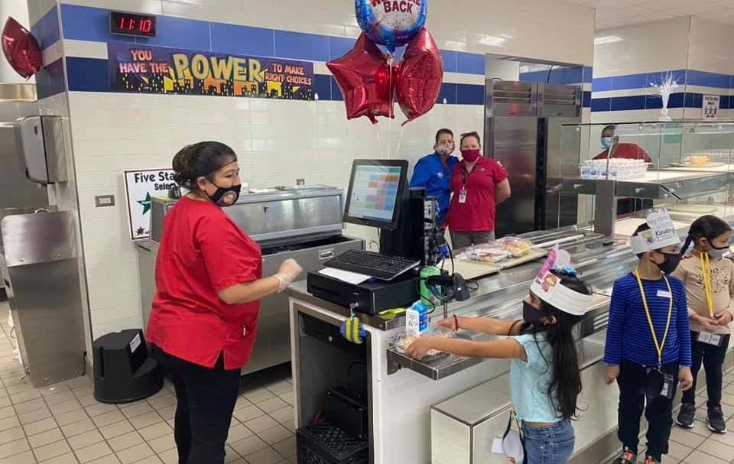

Table 32
Mesquite Independent School District Student Nutrition Fund

2017 AUDITED 2018 AUDITED 2019 AUDITED 2020 UNAUDTIED 2021 BUDGET

Local Revenue
Earnings From Investments | $ 37,206.98 | $ 91,664.35 | $ 193,849.58 | $ 115,454.68 | $ 100,000.00
Gifts & Bequests | $ 0.00 | $ 0.00 | $ 0.00 | $ 60,000.00 | $ 100,000.00
Misc/Fines, Wellness, & Etc. | $ 112,066.81 | $ 69,284.69 | $ 46,475.77 | $ 53,688.92 | $ 50,000.00
Food Services Activity | $ 3,159,059.25 | $ 3,325,456.91 | $ 3,130,456.91 | $ 2,126,072.48 | $ 2,463,100.00
Extra/Cocurricular Activity | $ 0.00 | $ 0.00 | $ 0.00 | $ 0.00 | $ 0.00
Activity Fund |  |  | $ 461.94 | $ 0.00 | $ 0.00
Transfer In | $ 48,915.11 | $ 64,224.38 | $ 41,328.72 | $ 32,057.62 | $ 75,000.00
Other/Non‐Revenue | $ 0.00 | $ 0.00 | $ 0.00 | $ 0.00 | $ 0.00
Grand Total | $ 3,357,248.15 | $ 3,550,630.33 | $ 3,412,303.56 | $ 2,387,273.70 | $ 2,788,100.00
State Revenue
Miscellaneous State Programs | $ 131,099.07 | $ 127,614.18 | $ 124,976.48 | $ 121.564.24 | $ 116,500.00
Other State Agencies | $ 178,096.63 | $ 146,059.11 | $ 183,608.46 | $ 3,407,041.70 | $ 425,000.00
Grand Total | $ 309,195.70 | $ 273,673.29 | $ 308,584.94 | $ 3,528,605.94 | $ 541,500.00
Federal Revenue
School Breakfast Program | $ 3,166,768.17 | $ 3,423,908.74 | $ 3,450,297.09 | $ 3,075,165.70 | $ 3,427,900.00
National School Lunch | $ 13,111,135.78 | $ 14,013,846.84 | $ 13,939,614.82 | $ 10,501,650.55 | $ 13,960,100.00
USDA Donated Commodities | $ 1,692,845.00 | $ 1,717,639.49 | $ 1,675,143.70 | $ 1,699,613.35 | $ 1,719,600.00
Other Federal Revenues | $ 0.00 | $ 0.00 | $ 0.00 | $ 0.00 | $ 0.00
Direct Federal Revenue | $ 51,667.00 | $ ‐ | $ 0.00 | $ 0.00 | $ 0.00
Grand Total | $ 18,022,415.95 | $ 19,155,395.07 | $ 19,065,055.81 | $ 15,276,429.60 | $ 19,107,600.00

Table 32 (cont.)

2017 AUDITED 2018 AUDITED 2019 AUDITED 2020 UNAUDITED 2021 BUDGET

Expenditures
Payroll Costs | $ 8,434,860.31 | $ 8,701,960.94 | $ 8,430,241.16 | $ 8,469,164.53 | $ 9,046,900.00
Contracted Services | $ 103,587.46 | $ 154,949.54 | $ 127,700.66 | $ 90,190.11 | $ 60,400.00
Supplies & Materials | $ 11,336,714.21 | $ 11,378,992.68 | $ 11,490,336.84 | $ 10,107,109.52 | $ 14,081,600.00
Other Operating Cost | $ 15,278.35 | $ 37,839.20 | $ 28,724.14 | $ 24,306.95 | $ 32,500.00
Fixed Assets | $ 514,773.99 | $ 1,156,370.28 | $ 2,217,303.22 | $ 918,259.09 | $ 2,467,000.00
Other Uses | $ 391,200.00 | $ 391,200.00 | $ 391,200.00 | $ 391,200.00 | $ 400,000.00
Grand Total | $ 20,796,414.32 | $ 21,821,312.64 | $ 22,685,506.02 | $ 20,000,230.20 | $ 26,088,400.00
Beginning Fund Balance | $ 5,103,143.75 | $ 5,995,589.23 | $ 7,153,975.28 | $ 7,254,413.57 | $ 8,446,492.61
Ending Fund Balance | $ 5,995,589.23 | $ 7,153,975.28 | $ 7,254,413.57 | $ 8,446,492.61 | $ 4,795,292.61

Table 33
ENDING FUND BALANCE
$4,795,292.61
$5,995,589.23
$7,254,413.57
$7,153,975.28
$8,446,492.61
Fund Balance for Student Nutrition
MISD 2019/20 Financial Audit

127
Financial Section
Mesquite ISD Oﬃcial Budget 2020‐2021

 | 2014 AUDITED | 2015 AUDITED | 2016 AUDITED | 2017 AUDITED | 2018 AUDITED | 2019 AUDITED | 2020 UNAUDITED | 2021 BUDGET
5742 ‐ EARNINGS FROM INVESTMENTS | $ 26,108.77 | $ 16,521.82 | $ 28,671.02 | $ 37,206.98 | $ 91,664.35 | $ 193,849.58 | $ 115,454.68 | $ 100,000.00
5744 ‐ GIFTS & BEQUESTS | $ ‐ | $ ‐ | $ ‐ | $ ‐ | $ ‐ | $ ‐ | $ 60,000.00 | $ 100,000.00
5749 ‐ MISC/FINES, WELLNESS, & ETC. | $ 6,605.47 | $ ‐ | $ ‐ | $ 112,066.81 | $ 69,284.69 | $ 46,475.77 | $ 53,688.92 | $ 50,000.00
5751 ‐ FOOD SERVICES ACTIVITY | $ 4,292,109.02 | $ 3,444,883.21 | $ 3,197,860.52 | $ 3,159,059.25 | $ 3,325,456.91 | $ 3,130,187.55 | $ 2,126,072.48 | $ 2,463,100.00
5753 ‐ EXTRA/COCURRICULAR ACTIVITY | $ ‐ | $ ‐ | $ ‐ | $ ‐ | $ ‐ | $ ‐ | $ ‐
5755 ‐ ACTIVITY FUND | $ ‐ | $ ‐ | $ ‐ |  |  | $ 461.94 | $ ‐
5829 ‐ MISCELLANEOUS STATE PROGRAMS | $ 122,754.81 | $ 124,671.97 | $ 128,225.07 | $ 131,099.07 | $ 127,614.18 | $ 124,976.48 | $ 121,564.24 | $ 116,500.00
5839 ‐ OTHER STATE AGENCIES | $ 214,301.42 | $ 241,324.05 | $ 227,293.69 | $ 178,096.63 | $ 146,059.11 | $ 183,608.46 | $ 3,407,041.70 | $ 425,000.00
5921 ‐ SCHOOL BREAKFAST PROGRAM | $ 2,638,938.56 | $ 2,890,059.30 | $ 3,188,154.17 | $ 3,166,768.17 | $ 3,423,908.74 | $ 3,450,297.29 | $ 3,075,165.70 | $ 3,427,900.00
5922 ‐ NATIONAL SCHOOL LUNCH | $ 12,057,981.77 | $ 12,849,345.97 | $ 13,676,494.83 | $ 13,111,135.78 | $ 14,013,846.84 | $ 13,939,614.82 | $ 10,501,650.55 | $ 3,960,100.00
5923 ‐ USDA DONATED COMMODITIES | $ 1,346,694.33 | $ 1,263,276.24 | $ 1,590,842.63 | $ 1,692,845.00 | $ 1,717,639.49 | $ 1,675,143.70 | $ 1,699,613.35 | $ 1,719,600.00
5929 ‐ OTHER FEDERAL REVENUES | $ ‐ | $ ‐ | $ ‐ | $ ‐ | $ ‐ | $ ‐ | $ ‐
5949 ‐ DIRECT FEDERAL REVENUE | $ 16,000.00 | $ ‐ | $ ‐ | $ 51,667.00 |  |  | $ ‐
7915 ‐ TRANSFER IN | $ 59,368.42 | $ 58,158.05 | $ 41,049.16 | $ 48,915.11 | $ 64,224.38 | $ 41,328.72 | $ 32,057.62 | $ 75,000.00
7989 ‐ OTHER/NON‐REVENUE | $ ‐ | $ ‐ | $ ‐ | $ ‐ | $ ‐ | $ ‐ | $ ‐
Grand Total | $ 20,780,862.57 | $ 20,888,240.61 | $ 22,078,591.09 | $ 21,688,859.80 | $ 22,979,698.69 | $ 22,785,944.31 | $ 21,192,309.24 | $ 22,437,200.00

128
Financial Section
Mesquite ISD Oﬃcial Budget 2020‐2021

 | 2014 AUDITED | 2015 AUDITED | 2016 AUDITED | 2017 AUDITED | 2018 AUDITED | 2019 AUDITED | 2020 UNAUDITED | 2021 BUDGET
6116 ‐ PROFESSIONAL EXTRA DUTY PAY | $ 210,000.00 | $ 217,000.00 | $ 219,500.00 | $ 213,500.00 | $ 211,500.00 | $ 206,000.00 | $ 188,000.00 | $ 267,000.00
6118 ‐ PROFESSIONAL STIPENDS | $ 6,973.09 | $ 8,893.20 | $ 8,702.17 | $ 13,888.74 | $ 1,550.60 | $ ‐ | $ ‐ | $ ‐
6119 ‐ PROFESSIONAL SALARY | $ 134,597.70 | $ 134,084.24 | $ 205,276.51 | $ 232,336.31 | $ 232,598.45 | $ 244,274.04 | $ 301,076.84 | $ 304,500.00
6121 ‐ EXTRA DUTY/SUPPORT | $ 152,584.28 | $ 128,063.31 | $ 156,870.75 | $ 144,895.35 | $ 79,898.00 | $ 145,243.38 | $ 193,168.24 | $ 250,000.00
6122 ‐ SUPPORT SALARIES ‐ SUBS | $ 100,250.10 | $ 167,152.44 | $ 274,677.12 | $ 218,560.54 | $ 201,633.15 | $ 140,914.64 | $ 146,291.07 | $ 180,100.00
6125 ‐ SUPPORT SALARIES | $ 5,206,445.40 | $ 5,635,653.93 | $ 6,111,418.79 | $ 6,230,846.92 | $ 6,559,047.30 | $ 6,385,079.34 | $ 6,400,194.41 | $ 6,699,900.00
6126 ‐ SUPPORT SALARIES/HOURLY | $ 12,865.14 | $ 3,057.48 | $ 9,167.72 | $ 3,598.07 | $ 21,675.79 | $ 10,220.01 | $ 5,904.39 | $ 10,000.00
6134 ‐ EMPLOYEE ALLOWANCES | $ 11,757.72 | $ 11,634.54 | $ 12,937.22 | $ 9,304.03 | $ ‐ | $ ‐ | $ ‐ | $ ‐
6141 ‐ SOCIAL SECURITY/MEDICARE | $ 73,517.34 | $ 80,792.78 | $ 89,740.31 | $ 94,136.33 | $ 93,310.30 | $ 92,714.96 | $ 95,522.33 | $ 102,100.00
6142 ‐ HEALTH & LIFE INSURANCE | $ 406,044.00 | $ 631,466.41 | $ 670,926.87 | $ 689,447.10 | $ 710,919.49 | $ 649,382.22 | $ 569,684.41 | $ 587,900.00
6143 ‐ WORKERS' COMPENSATION | $ 27,556.56 | $ 28,968.36 | $ 31,930.80 | $ 30,201.00 | $ 28,957.32 | $ 29,520.84 | $ 30,468.60 | $ 38,500.00
6144 ‐ TRS ON‐BEHALF BENEFIT | $ ‐ | $ ‐ | $ ‐ |  |  |  |  | $ ‐
6145 ‐ UNEMPLOYMENT COMPENSATION | $ ‐ | $ ‐ | $ ‐ |  | $ ‐ | $ ‐ | $ ‐ | $ ‐
6146 ‐ TEACHER RETIREMENT/TRS CARE | $ 399,985.85 | $ 511,534.93 | $ 549,540.88 | $ 554,145.92 | $ 560,870.54 | $ 524,176.73 | $ 499,909.24 | $ 606,900.00
6147 ‐ SICK/VACATION RETIREMENT | $ 4,680.00 | $ 260.00 | $ 2,175.00 |  | $ ‐ | $ 2,715.00 | $ 38,945.00 | $ ‐
6149 ‐ EMPLOYEE BENEFITS | $ ‐ | $ ‐ | $ ‐ |  | $ ‐ | $ ‐ | $ ‐ | $ ‐
6219 ‐ PROFESSIONAL SERVICE | $ ‐ | $ ‐ | $ ‐ |  |  |  |  | $ ‐
6239 ‐ EDUCATION SERVICE CENTER | $ ‐ | $ 120.00 | $ ‐ | $ 125.00 |  |  | $ 25.00 | $ ‐
6246 ‐ BUILDING MAINTENANCE/REPAIRS | $ 75,391.66 | $ 5,850.00 | $ 5,800.00 | $ 2,250.00 | $ ‐ | $ 8,213.39 | $ 1,100.00 | $ ‐
6247 ‐ VEHICLE MAINTENANCE/REPAIRS | $ 1,038.28 | $ 1,316.26 | $ 403.09 | $ ‐ | $ ‐ | $ ‐ | $ ‐ | $ ‐
6249 ‐ CONTRACTED MAINT/REPAIR | $ 59,525.99 | $ 1,596.32 | $ 33,194.32 | $ 35,102.00 | $ 74,871.00 | $ 46,169.83 | $ 50,479.00 | $ 5,000.00
6256 ‐ TELEPHONE | $ ‐ | $ ‐ | $ ‐ |  |  |  |  | $ ‐
6264 ‐ COPIER RENTAL | $ 4,025.85 | $ 6,161.04 | $ 6,161.04 | $ 4,922.85 | $ 5,310.12 | $ 5,310.12 | $ 5,310.12 | $ 5,400.00
6266 ‐ VEHICLE RENTAL | $ ‐ | $ ‐ | $ ‐ |  |  |  |  | $ ‐
6299 ‐ MISC CONTRACTED SERVICE | $ 81,159.12 | $ 185,069.79 | $ 82,162.29 | $ 65,687.61 | $ 74,768.42 | $ 68,007.32 | $ 33,275.99 | $ 50,000.00
6311 ‐ VEHICLE FUELS | $ 4,349.04 | $ 3,250.49 | $ 1,890.94 | $ 1,933.52 | $ 1,672.38 | $ 1,284.65 | $ 268.09 | $ 1,000.00
6316 ‐ SUPPLIES BUILDINGS  6319 ‐ OTHER SUPPLIES | $ ‐ | $ 44,754.16 | $ ‐ | $ ‐ | $ ‐ | $ ‐ | $ 2,135.26  $ ‐ | $ ‐  $ 10,000.00
6325 ‐ READING MATERIALS/BOOKS | $ ‐ | $ 115.00 | $ ‐ |  |  |  |  | $ ‐
6326 ‐ MAGAZINES | $ 9,397,037.11 | $ ‐ | $ ‐ |  |  |  |  | $ ‐
6341 ‐ FOOD/FOOD SERVICE |  | $ 8,999,245.20 | $ 9,599,210.04 | $ 8,546,274.31 | $ 8,388,284.72 | $ 8,626,243.13 | $ 7,444,779.92 | $ 10,843,500.00

Student Nutrition ‐ Expenditures by Object (cont.)
129
Financial Section
Mesquite ISD Oﬃcial Budget 2020‐2021

 | 2014 AUDITED | 2015 AUDITED | 2016 AUDITED | 2017 AUDITED | 2018 AUDITED | 2019 AUDITED | 2020 UNAUDITED | 2021 BUDGET
6342 ‐ NON‐FOOD/FOOD SERVICE | $ 932,770.57 | $ 977,158.15 | $ 1,017,649.59 | $ 868,819.53 | $ 927,387.99 | $ 897,801.67 | $ 771,810.42 | $ 1,109,500.00
6344 ‐ USDA DONATED COMMODITIES | $ 1,346,694.33 | $ 1,263,276.24 | $ 1,590,842.63 | $ 1,692,845.00 | $ 1,717,639.49 | $ 1,675,143.70 | $ 1,699,613.35 | $ 1,843,700.00
6349 ‐ FOOD SERVICE SUPPLIES | $ 58,686.59 | $ 32,079.59 | $ 174,494.96 | $ 114,119.79 | $ 61,998.96 | $ 22,204.88 | $ 62,320.86 | $ 76,500.00
6395 ‐ ELECTRONICS $100‐$5,000 | $ 6,800.48 | $ 14,634.13 | $ 1,553.39 | $ 4,012.45 | $ 7,744.21 | $ 2,724.05 | $ 7,451.88 | $ ‐
6396 ‐ COMPUTER SUPPLIES | $ 822.76 | $ 5,684.56 | $ 26,703.38 | $ 5,066.77 | $ 4,327.06 | $ 2,029.92 | $ 2,928.13 | $ 5,000.00
6397 ‐ FURNITURE UNDER $5,000 | $ 352.00 | $ 4,897.27 | $ 666.00 | $ 1,823.06 | $ ‐ | $ 59,299.16 | $ 1,224.96 | $ ‐
6398 ‐ EQUIPMENT $300‐$5,000 | $ 378,936.04 | $ 96,986.02 | $ 124,147.77 | $ 33,374.27 | $ 99,584.79 | $ 114,543.92 | $ 37,349.07 | $ 137,800.00
6399 ‐ GENERAL SUPPLIES | $ 70,429.74 | $ 64,128.71 | $ 227,968.70 | $ 68,445.51 | $ 170,353.08 | $ 89,061.76 | $ 77,227.58 | $ 54,600.00
6411 ‐ TRAVEL/EMPLOYEE | $ 13,437.50 | $ 16,891.09 | $ 16,497.47 | $ 8,602.91 | $ 10,427.93 | $ 13,457.57 | $ 7,880.86 | $ 25,000.00
6495 ‐ DUES | $ 853.50 | $ 970.00 | $ 1,523.00 | $ 1,220.00 | $ 1,070.00 | $ 2,162.00 | $ 2,960.50 | $ 2,500.00
6499 ‐ MISC OPERATING EXP | $ 9,419.03 | $ 6,477.07 | $ 5,327.92 | $ 5,455.44 | $ 26,341.27 | $ 13,104.57 | $ 13,465.59 | $ 5,000.00
6625 ‐ BUILDING IMPROVEMENT | $ ‐ | $ ‐ | $ ‐ |  |  |  |  | $ ‐
6626 ‐ FEES/BUILDING |  |  | $ 20,988.61 |  |  |  |  | $ ‐
6631 ‐ VEHICLE>$5,000 |  | $ 23,557.68 | $ 98,086.36 | $ ‐ | $ 29,173.76 | $ ‐ | $ ‐ | $ ‐
6635 ‐ ELECTRONIC EQUIP>$5,000 | $ 9,823.00 | $ 20,906.99 | $ 78,079.35 | $ ‐ | $ 28,973.52 | $ 41,463.52 | $ 174,304.23 | $ 52,000.00
6637 ‐ FURNITURE>$5,000 | $ 15,232.00 | $ 23,714.19 | $ ‐ | $ ‐ | $ 25,897.06 | $ 31,677.36 | $ 12,724.69 | $ ‐
6639 ‐ EQUIPMENT>$5,000 | $ 1,104,279.69 | $ 2,243,238.32 | $ 1,316,825.35 | $ 514,773.99 | $ 1,072,325.94 | $ 2,144,162.34 | $ 731,230.17 | $ 2,415,000.00
6645 ‐ TECH EQUIP<$5,000 | $ ‐ | $ ‐ | $ ‐ |  |  |  |  | $ ‐
6649 ‐ OTHER EQUIP<$5,000 | $ ‐ | $ ‐ | $ ‐ |  |  |  |  | $ ‐
8911 ‐ TRANSFERS OUT | $ 391,200.00 | $ 391,200.00 | $ 391,200.00 | $ 391,200.00 | $ 391,200.00 | $ 391,200.00 | $ 391,200.00 | $ 400,000.00
Grand Total | $ 20,709,521.46 | $ 21,991,839.89 | $ 23,164,240.34 | $ 20,796,414.32 | $ 21,821,312.64 | $ 22,685,506.02 | $ 20,000,230.20 | $ 26,088,400.00

Mesquite Independent School District Debt Service Fund

Over the past 10 years and in the near future, the District has and will continue to have a need to con‐ duct bond sales. A school district is authorized to issue bonds and levy taxes for payment of bonds subject to voter approval of a proposition submitted to the voters under Texas Education Code (TEX)
  - (b)(1). A debt service fund is a government fund, with budgetary control, that must be used to account for general long‐term debt principal and interest for debt issues and other long‐term debts for which a tax has been dedicated. A separate bank account must be kept for this fund and a separate tax rate is assessed to fund the debt payments based on the scheduled maturities. The debt tax rate (or Interest and Sinking – I&S tax rate) is approved by the Board of Trustees annually and is calculated based on the scheduled debt requirements and the taxable property values certified by the DAC.

TEC 45.003(1), as amended, requires a district to demonstrate to the Texas Attorney General that it has the prospective ability to pay debt service on a proposed issue of bonds, together with debt service on other outstanding “new debt” of the district, from a tax levied at a rate of $0.50 per $100 of assessed valuation before bonds may be issued.

Once the prospective ability to pay such tax has been shown and the bonds are issued, a district may levy a tax to pay the annual debt service. Mesquite ISD is presently taxing at $0.48 per $100 of taxable value for the Interest and Sinking fund.

The District was rated by S & P Global with a rating of AA/Stable and by Fitch Ratings as AA+.

Revenue

The primary source of revenue for the debt service fund is an ad valorem tax raised from levying the Interest and Sinking (I&S) tax rate. The district is presently taxing at $0.48 per $100 of taxable value. The state laws governing debt tax rates limit a school district to a maximum tax rate of $0.50, thus leaving the District with $0.02 per $100 taxable available for future bond sales.

Other sources of revenue are state funds provided as part of the Existing Debt Allotment (EDA) pro‐ gram and the Instructional Facilities (IFA) program, along with investment earnings from fund cash balances.

The EDA is provided for existing debt issued by school districts to produce a guaranteed yield in State and local revenue per student for each cent of debt service tax levy. In general, a district’s bonds are eligible for the allotment if, during the previous State biennium, the district (1) made payments on such bonds or (2) levied and collected taxes for the payment of principal and interest on such bonds.

The IFA guarantees each school district a specified dollar amount per student in state and local funds for each cent of tax eﬀort to pay principal and interest on eligible bond used to construct, acquire, renovate, or improve instructional facilities. To receive an IFA, a school district must apply to the Commissioner of Education before issuing the bonds to be paid with State assistance. These funds are allocated to school districts based upon property wealth per student. Districts with the lowest amounts will receive funding first.

Expenditures

The expenditures from the Debt Service fund consist mainly of the semi‐annual principal and interest requirements from existing bond debt. Currently, these payments total approximately $62,000,000.

Current Debt Levels and legal Debt Limits

The State limits the District to issuing debt in an amount in which the levy of the I & S tax rate in a maximum amount of $0.50, along with State IFA and/or EDA funds, is suﬃcient to cover maximum annual debt service at the time of issuance of the bonds.

Debt Levels on Current and Future Budgets

The current outstanding debt plus anticipated debt to be issued associated with the District’s authorized but unissued voter authority is projected to be services with a maximum I & S tax rate of $0.48.

Table 36
Mesquite Independent School District Debt Service Fund

 | 2017 AUDITED | 2018 AUDITED | 2019 AUDITED | 2020 UNAUDITED 2021 BUDGET
Local Revenue
Taxes, Current Year Levy | $ 28,544,340.42 | $ 31,305,318.69 | $ 39,049,957.19 | $ 42,681,896.72 $ 44,600,000.00
Taxes Prior Year | $ 273,206.57 | $ 257,983.90 | $ 173,027.87 | $ 322,890.24 $ 300,000.00
Penalties, Interest & Other TA | $ 330,987.39 | $ 347,747.75 | $ 452,930.90 | $ 460,346.08 $ 400,000.00
Earnings From Investments | $ 421,979.11 | $ 895,547.43 | $ 1,336,037.02 | $ 783,387.17 $ 700,000.00
Grand Total | $ 29,570,513.49 | $ 32,806,597.77 | $ 41,011,952.98 | $ 44,248,520.21 $ 46,000,000.00
State Revenue  Misc. State Programs | $ 21,922,615.00 | $ 24,619,635.00 | $ 24,037,151.00 | $ 20,376,022.00 $ 17,450,000.00
Grand Total | $ 21,922,615.00 | $ 24,619,635.00 | $ 24,037,151.00 | $ 20,376,022.00 $ 17,450,000.00
Expenditures  Bond Principal | $ 29,284,996.20 | $ 26,395,259.95 | $ 28,778,581.98 | $ 24,405,377.70 $ 23,282,000.00
Interest on Bonds | $ 19,582,867.51 | $ 25,708,507.74 | $ 33,776,655.94 | $ 35,627,558.79 $ 38,800,000.00
Debt Service Fees | $ 367,038.13 | $ 206,547.22 | $ 197,868.35 | $ 394,628.75 $ 600,000.00
Grand Total | $ 49,234,901.84 | $ 52,310,314.91 | $ 62,753,106.27 | $ 60,427,565.24 $ 62,682,000.00
Other Financing Sources
Refunding Bond Issuance | $ 12,803,007.85 | $ 0.00 | $ 0.00 | $ 11,940,000.00 $ 0.00
Sale of Bonds | $ ‐ | $ 0.00 | $ 0.00 | $ 0.00 $ 0.00
Transfer In | $ ‐ | $ 0.00 | $ 0.00 | $ 0.00 $ 0.00
Premium/Discount | $ 11,071,275.15 | $ 0.00 | $ 0.00 | $ 2,001,805.40 $ 0.00
Other Resources | $ ‐ | $ 0.00 | $ 0.00 | $ 0.00 $ 0.00
Other Uses | $ 23,625,401.36 | $ 0.00 | $ 0.00 | $ 13,974,861,88 $ 0.00
Grand Total | $ 248,881.64 | $ 0.00 | $ 0.00 | $ 33,056.48 $ 0.00
Beginning Fund Balance | $ 15,079,282.62 | $ 17,088,627.63 | $ 22,204,545.49 | $ 24,500,543.20 $ 28,664,463.69
Ending Fund Balance | $ 17,088,627.63 | $ 22,204,545.49 | $ 24,500,543.20 | $ 28,664,463.69 $ 29,432,463.69

133
Financial Section
Mesquite ISD Oﬃcial Budget 2020‐2021

 | 2014 AUDITED | 2015 AUDITED | 2016 AUDITED | 2017 AUDITED | 2018 AUDITED | 2019 AUDITED | 2020 UNAUDTIED | 2021 BUDGET
5711 ‐ TAXES, CURRENT YEAR LEVY | $ 21,806,474.11 | $ 22,707,997.09 | $ 22,935,664.97 | $ 28,544,340.42 | $ 31,305,318.69 | $ 39,049,957.19 | $ 42,681,896.72 | $ 44,600,000.00
5712 ‐ TAXES PRIOR YEAR | $ 279,779.15 | $ 209,975.09 | $ 338,376.41 | $ 273,206.57 | $ 257,983.90 | $ 173,027.87 | $ 322,890.24 | $ 300,000.00
5719 ‐ PENALTIES, INTEREST & OTHER TA | $ 333,947.82 | $ 251,073.58 | $ 282,916.58 | $ 330,987.39 | $ 347,747.75 | $ 452,930.90 | $ 460,346.08 | $ 400,000.00
5742 ‐ EARNINGS FROM INVESTMENTS | $ 76,139.13 | $ 111,135.28 | $ 279,096.42 | $ 421,979.11 | $ 895,547.43 | $ 1,336,037.02 | $ 783,387.17 | $ 700,000.00
5746 ‐ TAX INCREMENT FUND | $ ‐ | $ ‐ | $ ‐ | $ ‐ | $ ‐ | $ ‐ | $ ‐
5749 ‐ MISC/FINES, WELLNESS, & ETC. | $ ‐ | $ ‐ | $ ‐ | $ 3.70 | $ ‐ | $ ‐ | $ ‐
5812 ‐ FOUNDATION/ENTITLEMENTS | $ ‐ | $ ‐ | $ ‐ | $ ‐ | $ ‐ | $ ‐ | $ ‐
5829 ‐ MISCELLANEOUS STATE PROGRAMS | $ 22,344,844.00 | $ 20,904,029.00 | $ 23,477,417.00 | $ 21,922,615.00 | $ 24,619,635.00 | $ 24,037,151.00 | $ 20,376,022.00 | $ 17,450,000.00
7901 ‐ REFUNDING BOND ISSUANCE | $ 54,200,000.00 | $ 75,874,666.05 | $ 39,160,000.00 | $ 12,803,007.85 | $ ‐ | $ ‐ | $ ‐
7911 ‐ SALE OF BONDS | $ ‐ | $ ‐ | $ ‐ | $ ‐ | $ ‐ | $ ‐ | $ ‐
7915 ‐ TRANSFER IN | $ ‐ | $ ‐ | $ ‐ | $ ‐ | $ ‐ | $ ‐ | $ ‐
7916 ‐ PREMIUM/DISCOUNT | $ 6,628,003.45 | $ 29,396,644.45 | $ 8,369,934.00 | $ 11,071,275.15 | $ ‐ | $ ‐ | $ ‐
7949 ‐ OTHER RESOURCES | $ ‐ | $ ‐ | $ ‐ | $ ‐ | $ ‐ | $ ‐ | $ ‐
Grand Total | $ 105,669,187.66 | $ 149,55,520.54 | $ 94,843,405.38 | $ 75,367,415.19 | $ 57,426,232.77 | $ 65,049,103.98 | $ 64,624,542.21 | $ 63,450,000.00

134
Financial Section
Mesquite ISD Oﬃcial Budget 2020‐2021

 | 2014 AUDITED | 2015 AUDITED | 2016 AUDITED | 2017 AUDITED | 2018 AUDITED | 2019 AUDITED | 2020 UNAUDTIED | 2021 BUDGET
6511 ‐ BOND PRINCIPAL | $ 26,849,345.03 | $ 29,467,730.60 | $ 27,973,534.85 | $ 29,284,996.20 | $ 26,395,259.95 | $ 28,543,375.40 | $ 24,405,377.70 | $ 23,282,000.00
6521 ‐ INTEREST ON BONDS | $ 13,431,931.96 | $ 14,352,258.87 | $ 18,253,323.17 | $ 19,582,867.51 | $ 25,708,507.74 | $ 34,011,862.52 | $ 35,627,558.79 | $ 38,800,000.00
6599 ‐ DEBT SERVICE FEES | $ 738,233.96 | $ 1,394,568.21 | $ 871,168.37 | $ 367,038.13 | $ 206,547.22 | $ 197,868.35 | $ 394,628.75 | $ 600,000.00
8949 ‐ OTHER USES | $ 61,009,835.52 | $ 104,594,784.91 | $ 47,916,562.32 | $ 23,625,401.36 | $ ‐ | $ ‐ | $ 13,974,861.88 | $ ‐
Grand Total | $ 102,029,346.47 | $ 149,809,342.59 | $ 95,014,588.71 | $ 72,860,303.20 | $ 52,310,314.91 | $ 62,753,106.27 | $ 74,402,427.12 | $ 62,682,000.00

Table 39

BOND DEBT SERVICE
Mesquite ISD, Texas All Outstanding Debt As of FYE 8/31/2020

Period Ending Principal Interest Compounded
 |  |  | Interest
8/31/2021 | 23,431,113.40 | 32,670,076.57 | 5,723,886.60 | 61,825,076.57
8/31/2022 | 19,153,707.20 | 31,425,247.66 | 5,806,292.80 | 56,385,247.66
8/31/2023 | 19,729,980.20 | 30,590,652.26 | 5,840,019.80 | 56,160,652.26
8/31/2024 | 25,770,329.00 | 29,711,775.96 | 919,671.00 | 56,401,775.96
8/31/2025 | 26,935,000.00 | 28,704,950.06 |  | 55,639,950.06
8/31/2026 | 27,475,000.00 | 27,493,351.66 |  | 54,968,351.66
8/31/2027 | 27,667,396.35 | 26,298,507.86 | 907,603.65 | 54,873,507.86
8/31/2028 | 28,705,201.85 | 25,152,122.86 | 969,798.15 | 54,827,122.86
8/31/2029 | 27,798,810.60 | 24,009,558.76 | 1,031,189.40 | 52,839,558.76
8/31/2030 | 28,417,674.90 | 22,844,656.26 | 1,087,325.10 | 52,349,656.26
8/31/2031 | 30,275,175.40 | 21,679,981.26 | 1,139,824.60 | 53,094,981.26
8/31/2032 | 31,520,000.00 | 20,440,656.26 |  | 51,960,656.26
8/31/2033 | 31,980,000.00 | 19,104,906.26 |  | 51,084,906.26
8/31/2034 | 33,075,000.00 | 17,626,106.26 |  | 50,701,106.26
8/31/2035 | 34,525,000.00 | 16,181,856.26 |  | 50,706,856.26
8/31/2036 | 33,370,000.00 | 14,638,406.26 |  | 48,008,406.26
8/31/2037 | 34,795,000.00 | 13,215,012.50 |  | 48,010,012.50
8/31/2038 | 36,275,000.00 | 11,731,937.50 |  | 48,006,937.50
8/31/2039 | 37,840,000.00 | 10,166,812.50 |  | 48,006,812.50
8/31/2040 | 38,265,000.00 | 8,532,200.00 |  | 46,797,200.00
8/31/2041 | 37,990,000.00 | 6,811,200.00 |  | 44,801,200.00
8/31/2042 | 33,800,000.00 | 5,111,550.00 |  | 38,911,550.00
8/31/2043 | 19,725,000.00 | 3,629,400.00 |  | 23,354,400.00
8/31/2044 | 20,580,000.00 | 2,772,850.00 |  | 23,352,850.00
8/31/2045 | 14,280,000.00 | 1,878,700.00 |  | 16,158,700.00
8/31/2046 | 7,820,000.00 | 1,233,000.00 |  | 9,053,000.00
8/31/2047 | 8,215,000.00 | 842,000.00 |  | 9,057,000.00
8/31/2048 | 8,625,000.00 | 431,250.00 |  | 9,056,250.00
 | 748,039,388.90 | 454,928,724.97 | 23,425,611.10 | 1,226,393,724.97

Debt Service

Table 40

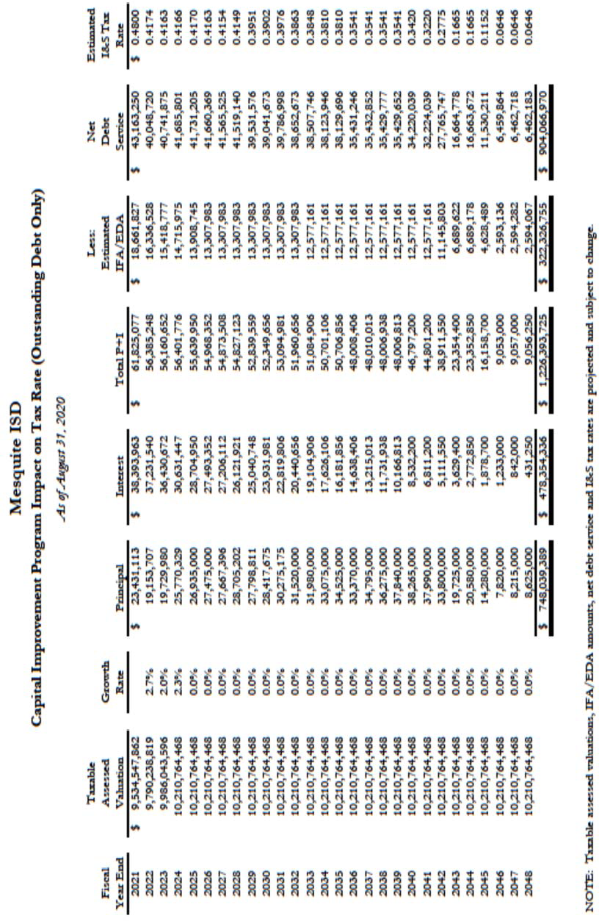

Mesquite Independent School District Capital Projects Fund Overview

Capital Projects Funds are used to account for the proceeds of General Obligation bonds, related interest earnings, expenditures of these fund for the construction and equipping of school facilities, to purchased school land sites, purchase school buses, purchase technology, purchase large equipment, purchase trucks and renovations or repair of existing facilities. Projects are determined and prioritized through School Board and staﬀ review along with input from the community. Enrollment and program additions / changes are major considerations in identifying and prioritizing District needs. Once all high‐priority projects are identified, a bond election is held to obtain the community’s approval / authorization for the District to see bonds to fund the projects’ construction.

Capital projects are defined as a project that is distinguishable from other tasks or work being per‐ formed, has a schedule with a definitive beginning and ending, does not occur routinely, and results in a capital improvement or acquisition.

The capital project budgets are prepared on a project basis. Each major construction contract is approved based on existing availability of bond proceeds and/or authorized but not yet sold bonds. However, the impact of the Capital Projects Fund’s projects must be considered when developing the annual budgets for all other funds. Future operating costs (staﬃng, utilities, etc.) must be projected and included in future budgets.

Repayment of bonds issued to fund these capital projects must be included in the Debt Service Fund projections.

The bond authorization election was approved by voters in May 2015 for a new total of
$280,000,000. This bond package addressed enrollment growth with 4 new elementary schools, 1 new middle school, 5 new middle school additions, 3 high school additions, new roofs, athletic improvements, buses and new equipment.

The most recent bond authorization election was approved by voters in May 2018 for a new total of
$325,000,000. This bond package addressed the enrollment growth and the need to get rid of portables with 1 new elementary, 1 new middle school, 1 choice high school, several additions, new roofs, athletic improvements, buses and new technology infrastructure.

138
Financial Section
Mesquite ISD Oﬃcial Budget 2020‐2021
Bond Package 2018  $325,000,000 | Start Date | End Date | Item | Total Cost | 2018  Construction  Bond Program | 2018  Construction  Bond Program | 2018  Construction  Bond Program | 2018  Construction  Bond Program | 2018  Construction  Bond Program
 |  |  |  |  | 2018‐2019 | 2019‐2020 | 2020‐2021 | 2021‐2022 | 2022‐2023
Price of Project |  |  | $ 60,305,658.00
Woolley Middle School | S‐2018 | F‐2020 | Architect/Engineer | $ 3,472,279.00 | $ 2,140,279.00 | $ 1,323,000.00 | $ 72,000.00
 |  |  | GMP | $ 48,917,079.00 | $ 16,305,500.00 | $ 32,611,380.00 | $ 4,000,000.00
 |  |  | Misc. Cost | $ 4,247,520.00 | $ 4,000,000.00 | $ 247,520.00 | $ ‐
 |  |  | MISD Furniture | $ 3,668,781.00 |  | $ 3,668,781.00 | $ ‐
Price of Project |  |  | $ 10,984,797.00
Porter Elementary | S‐2018 | F‐2020 | Architect/Engineer | $ 902,150.00 | $ 251,064.00 | $ 246,552.00 | $ 40,000.00
 |  |  | Construction Manager | $ 9,404,426.00 | $ 1,850,000.00 | $ 6,269,616.00 | $ 1,436,000.00
 |  |  | Misc. Cost | $ 208,000.00 | $ 50,000.00 | $ 104,000.00 | $ ‐
 |  |  | MISD Furniture | $ 470,220.00 | $ ‐ | $ 470,220.00 | $ ‐
Price of Project |  |  | $ 10,477,293.00
Vanston MS Gym & Add | F‐2018 | F‐2020 | Architect/Engineer | $ 668,247.00 | $ 429,408.00 | $ 184,392.00 | $ 36,000.00
 |  |  | GMP | $ 8,997,660.00 | $ 2,538,460.00 | $ 5,998,440.00 | $ 1,205,200.00
 |  |  | Misc. Cost | $ 136,561.00 | $ 25,000.00 | $ 102,420.00 | $ ‐
 |  |  | MISD Furniture | $ 674,825.00 | $ ‐ | $ 674,825.00 | $ ‐
Price of Project |  |  | $ 6,875,082.00
Terry MS Gym | F‐2018 | F‐2020 | Architect/Engineer | $ 524,985.00 | $ 204,600.00 | $ 349,992.00 | $ 24,000.00
 |  |  | GMP | $ 5,907,065.00 | $ 99,999.00 | $ 4,725,660.00 | $ 1,796,000.00
 |  |  | Misc. Cost | $ ‐ | $ ‐ | $ ‐ | $ ‐
 |  |  | MISD Furniture | $ 443,032.00 | $ ‐ | $ 443,032.00 | $ ‐

139
Financial Section
Mesquite ISD Oﬃcial Budget 2020‐2021
Bond Package 2018  $325,000,000 | Start Date | End Date | Item | Total Cost | 2018  Construction Bond Program | 2018  Construction Bond Program | 2018  Construction Bond Program | 2018  Construction Bond Program | 2018  Construction Bond Program
 |  |  |  |  | 2018‐2019 | 2019‐2020 | 2020‐2021 | 2021‐2022 | 2022‐2023
Price of Project |  |  | $ 6,576,047.00
Berry MS Gym | SP‐2019 | S‐2021 | Architect/Engineer | $ 496,958.00 | $ 204,600.00 | $ 331,308.00 | $ 22,200.00
 |  |  | GMP | $ 5,654,965.00 | $ 99,999.00 | $ 4,523,976.00 | $ 1,652,000.00
 |  |  | Misc. Cost | $ ‐ | $ ‐ | $ ‐ | $ ‐
 |  |  | MISD Furniture | $ 424,124.00 | $ ‐ | $ 424,124.00 | $ ‐
Price of Project |  |  | $ 6,836,706.00
Agnew MS Gym | SP‐2019 | SP‐2021 | Architect/Engineer | $ 515,828.00 | $ 204,600.00 | $ 343,896.00 | $ 22,000.00
 |  |  | GMP | $ 5,879,886.00 | $ 99,999.00 | $ 4,703,916.00 | $ 1,572,000.00
 |  |  | Misc. Cost | $ ‐ | $ ‐ | $ ‐ | $ ‐
 |  |  | MISD Furniture | $ 440,992.00 | $ ‐ | $ 440,992.00 | $ ‐
Price of Project |  |  | $ 89,751,081.00
Vanguard HS | S‐2019 | F‐2021 | Architect/Engineer | $ 4,437,961.00 | $ 1,937,500.00 | $ 1,976,064.00 | $ 695,000.00
 |  |  | GMP | $ 70,577,600.00 | $ | $ 49,492,428.00 | $ 40,800,000.00
 |  |  | Misc. Cost | $ 620,000.00 | $ ‐ | $ 73,155.00 | $ 528,000.00
 |  |  | MISD Furniture | $ 14,115,520.00 | $ ‐ | $ ‐ | $ 14,115,520.00
Price of Project |  |  | $ 12,170,960.00
A. C. New | S‐2019 | F‐2021 | Architect/Engineer | $741,511.00 | $ ‐ | $ 593,208.00 | $ 216,000.00
(Gym, Classrooms, Café) |  |  | GMP | $10,487,860.00 | $ ‐ | $ 1,747,974.00 | $ 7,646,700.00
 |  |  | Misc. Cost | $155,000.00 | $ ‐ | $ 116,250.00 | $ 38,750.00
 |  |  | MISD Furniture | $786,590.00 | $ ‐ | $ ‐ | $ 788,588.00

140
Financial Section
Mesquite ISD Oﬃcial Budget 2020‐2021
Bond Package 2018  $325,000,000 | Start Date | End Date | Item | Total Cost | 2018  Construction Bond Program | 2018  Construction Bond Program | 2018  Construction Bond Program | 2018  Construction Bond Program | 2018  Construction Bond Program
 |  |  |  |  | 2018‐2019 | 2019‐2020 | 2020‐2021 | 2021‐2022 | 2022‐2023

Price of Project |  |  | $ 7,277,136.00
Wilkinson Gym | S‐2019 | F‐2020 | Architect/Engineer | $ 459,056.00 |  | $ 306,000.00 | $ 192,000.00
 |  |  | GMP | $ 6,142,400.00 |  | $ 1,083,951.00 | $ 4,800,000.00
 |  |  | Misc. Cost | $ 215,000.00 |  | $ 107,500.00 | $ 107,500.00
 |  |  | MISD Furniture | $ 460,680.00 |  | $ ‐ | $ 460,680.00
Price of Project |  |  | $ 7,277,136.00
McDonald Gym | S‐2019 | F‐2020 | Architect/Engineer | $459,056.00 |  | $ 306,000.00 | $ 192,000.00
 |  |  | GMP | $6,142,400.00 |  | $ 10,839,951.00 | $ 4,800,00.00
 |  |  | Misc. Cost | $215,000.00 |  | $ 107,500.00 | $ 107,500.00
 |  |  | MISD Furniture | $460,680.00 |  | $ ‐ | $ 460,680.00
Price of Project |  |  | $ 7,277,136.00
KMS Gym | S‐2019 | F‐2020 | Architect/Engineer | $ 459,056.00 |  | $ 306,000.00 | $ 192,000.00
 |  |  | GMP | $6,142,400.00 |  | $ 1,083,951.00 | $ 4,800,00.00
 |  |  | Misc. Cost | $215,000.00 |  | $ 107,500.00 | $ 107,500.00
 |  |  | MISD Furniture | $460,680.00 |  | $ ‐ | $ 460,680.00
Price of Project |  |  | $ 36,500,000.00
Elementary 34 | F‐2020 | F‐2022 | Architect/Engineer
 |  |  | GMP
 |  |  | Misc. Cost
 |  |  | MISD Furniture

141
Financial Section
Mesquite ISD Oﬃcial Budget 2020‐2021

Bond Package 2018  $325,000,000 | Start Date | End Date | Item | Total Cost | 2018  Construction  Bond Program | 2018  Construction  Bond Program | 2018  Construction  Bond Program | 2018  Construction  Bond Program | 2018  Construction  Bond Program
 |  |  |  |  | 2018‐2019 | 2019‐2020 | 2020‐2021 | 2021‐2022 | 2022‐2023
Price of Project |  |  | $ 8,904,681.00
Cannaday | F‐2020 | F‐2022 | Architect/Engineer | $ 552,000.00 |  | $ 384,000.00 | $ 168,000.00
 |  |  | GMP | $ 8,147,000.00 |  | $ 1,475,288.00 | $ 6,084,000.00
 |  |  | Misc. Cost | $ 215,000.00 |  | $ 161,250.00 | $ 53,750.00
 |  |  | MISD Furniture | $ 567,756.00 |  | $ ‐ | $ 567,756.00
Price of Project |  |  | $ 4,000,000.00
H. S. Auditoriums | F‐2020 | F‐2022 | Architect/Engineer |  |  | $ 3,000,000.00
 |  |  | GMP
 |  |  | Misc. Cost
 |  |  | MISD Furniture
Price of Project |  |  | $ 23,000,000.00
Roofs | F‐2018 | F‐2024 | Architect/Engineer
 |  |  | GMP
 |  |  | Misc. Cost |  | $ 1,848,200.00 | $ 3,542,078.00 | $ 2,219,544.00 | $ 3,667,878.00 | $ 5 ,371,067.00
 |  |  | MISD Furniture
Price of Project |  |  | $ 17,500,000.00
 |  |  | Architect/Engineer
Capital Projects | F‐2018 | F‐2024 | GMP
HVAC, Buses, Trucks, Equipment |  |  | Misc. Cost |  | $ 3,087,300.00 | $ 3,500,000.00 | $ 3,500,000.00 | $ 3,500,000.00 | $ 3,500,000.00
 |  |  | MISD Furniture

142
Financial Section
Mesquite ISD Oﬃcial Budget 2020‐2021

Bond Package 2018  $325,000,000 | Start Date | End Date | Item | Total Cost | 2018  Construction  Bond Program | 2018  Construction Bond  Program | 2018  Construction  Bond Program | 2018  Construction  Bond Program | 2018  Construction  Bond Program
 |  |  |  |  | 2018‐2019 | 2019‐2020 | 2020‐2021 | 2021‐2022 | 2022‐2023
Price of Project |  |  | $ 5,000,000.00
Technology Infrastructure | F‐2018 | F‐2024 | Architect/Engineer
 |  |  | GMP
 |  |  | Misc. Cost |  | $ 896,000.00 | $ 1,000,000.00 | $ 1,000,000.00 | $ 1,000,000.00 | $ 1,000,000.00
 |  |  | MISD Furniture
Price of Project |  |  | $ 5,000,000.00
Resurface Tracks & Tennis Courts Repairs to Athletics Facility Lighting on Tennis Courts | F‐2018 | F‐2024 | Architect/Engineer
 |  |  | GMP
 |  |  | Misc. Cost |  | $ 886,000.00 | $ 1,000,000.00 | $ 1,000,000.00 | $ 1,000,000.00 | $ 1,000,000.00
 |  |  | MISD Furniture
Price of Project |  |  | $ 3,000,000.00
Turf Fields | F‐2018 | F‐2024 | Architect/Engineer
 |  |  | GMP
 |  |  | Misc. Cost |  | $ 2,000,000.00 | $ 1,000,000.00
 |  |  | MISD Furniture
Total |  |  | $ 328,713,713.00 |  | $ 39,168,508.00 | $ 141,711,090.00 | $ 107,979,348.00 | $ 9,167,878.00 | $ 10,871,067.00

Table 42 Department Budgets

Non‐Campus Dept. | 2017 AUDITED | 2018 AUDITED | 2019 AUDITED | 2020 UNAUDITED | 2021 BUDGET
699‐Summer School | $ 178,808.79 | $ 109,446.31 | $ 117,969.23 | $ 163,332.08 | $ 184,550.00
701‐Superintendent Oﬃce | $ 756,938.63 | $ 736,184.30 | $ 660,470.90 | $ 692,062.59 | $ 799,900.00
702‐Board Members | $ 120,523.30 | $ 193,210.39 | $ 181,273.86 | $ 127,814.55 | $ 200,100.00
703‐Tax Costs | $ 753,392.74 | $ 759,747.70 | $ 784,839.78 | $ 876,724.08 | $ 820,000.00
710‐General Administration | $ 611,632.37 | $ 680,740.09 | $ 643,305.42 | $ 1,212,207.74 | $ 757,400.00
711‐Asst. Supt.‐Plan & Innovation | $ 1,122,134.22 | $ 790,762.30 | $ 217.15 | $ 342,995.46 | $ 377,000.00
712‐Asst. Supt.‐Admin Services | $ 249,178.18 | $ 275,610.02 | $ 273,359.49 | $ 286,824.98 | $ 288,900.00
732‐Governmental Aﬀairs | $ 393.87 | $ 159,501.00 | $ 463,091.57 | $ 710,385.19 | $ 1,799,600.00
733‐Asst. Supt.‐Business Services | $ 1,718,890.78 | $ 1,756,347.91 | $ 2,302,978.53 | $ 1,952,805.84 | $ 2,391,300.00
734‐Asst. Supt.‐Personnel | $ 2,738,653.73 | $ 1,857,830.46 | $ 1,916,899.42 | $ 1,898,509.65 | $ 1,996,800.00
735‐Fixed Assets | $ 104,472.49 | $ 172,913.19 | $ 169,716.93 | $ 155,179.86 | $ 171,900.00
736‐Purchasing | $ 329,747.63 | $ 332,639.30 | $ 345,121.49 | $ 340,383.83 | $ 368,700.00
740‐Information Systems | $ 1,879,032.43 | $ 1,694,129.42 | $ 1,736,209.91 | $ 1,739,765.69 | $ 2,057,400.00
741‐Technical Services | $ 6,940,374.38 | $ 3,751,061.64 | $ ‐ | $ 11,319.28 | $ ‐
743‐Service Center | $ 590,381.75 | $ 37,109.60 | $ 33,519.73 | $ 53,738.31 | $ 35,400.00
744‐Instsructional Technology | $ 5,402,330.56 | $ 954,520.27 | $ 529.42 | $ ‐ | $ ‐
746‐Communications | $ 848,098.63 | $ 828,399.57 | $ 759,259.76 | $ 732,354.99 | $ 941,000.00
800‐General Administration | $ 1,177,782.25 | $ 1,670,318.97 | $ 1,043,123.66 | $ 1,182,651.23 | $ 1,608,600.00
840‐Middle School Game Workers | $ 168,880.46 | $ 172,035.59 | $ 172,544.01 | $ 61,105.46 | $ 103,700.00
871‐Special Education | $ 5,598,244.44 | $ 5,930,425.51 | $ 5,346,501.14 | $ 6,006,106.35 | $ 6,253,000.00
872‐Deaf Ed | $ 11,237.83 | $ 1,971.00 | $ 1,332.69 | $ 1,021.97 | $ 2,500.00
885‐Exec Dir‐Leadership‐Lloyd | $ 488,554.86 | $ 16,447.65 | $ 3,991.23 | $ 1,001.30 | $ 5,000.00
886‐Exec Dir‐Leadership‐Carpenter | $ 2,313.05 | $ 4,696.40 | $ 3,153.17 | $ 4,314.80 | $ 5,000.00
887‐Exec Dir‐Leadership‐Feinglas | $ 219,346.15 | $ 7,665.85 | $ 6,109.93 | $ 5,366.96 | $ 5,200.00
888‐Exec Dir‐Leadership‐Hammett | $ 22,413.40 | $ 6,450.55 | $ (9,713.73) | $ 3,012.59 | $ 5,000.00
889‐Exec Dir‐Leadership‐McAda | $ 550,491.91 | $ 755,419.99 | $ 725,221.36 | $ 698,676.56 | $ 926,800.00
890‐Deputy Superintendent | $ 5,633,033.47 | $ 5,458,442.33 | $ 4,731,980.29 | $ 4,391,017.89 | $ 3,529,500.00
892‐Title I Oﬃce | $ 3,257.17 | $ 18,108.93 | $ 8,373.01 | $ 10,963.58 | $ 8,400.00
893‐Asst. Supt‐Instructional Serv | $ 2,544,168.52 | $ 2,822,450.16 | $ 3,924,382.17 | $ 4,046,838.09 | $ 10,278,200.00
894‐Advanced Academics Coord. | $ 421,559.25 | $ 517,909.86 | $ 567,341.62 | $ 638,110.45 | $ 795,300.00
895‐Fine Arts Director | $ 520,732.04 | $ 512,674.10 | $ 508,963.04 | $ 549,868.75 | $ 585,000.00
896‐ROTC Oﬃce | $ 197,675.49 | $ 212,436.05 | $ 203,601.63 | $ 231,400.06 | $ 230,900.00
897‐CTE Director | $ 455,327.14 | $ 516,335.33 | $ 769,292.64 | $ 587,685.03 | $ 1,557,200.00
898‐Student Services | $ 3,985,281.72 | $ 2,659,189.77 | $ 2,543,270.83 | $ 2,899,390.18 | $ 5,586,000.00
900‐General Administration | $ 23,895,223.45 | $ 25,006,668.32 | $ 25,362,961.21 | $ 27,044,541.21 | $ 33,437,700.00
905‐Administration Bldg. | $ 8,648,045.88 | $ 392,861.50 | $ 6,900,246.52 | $ 8,664,344.58 | $ 493,400.00
907‐Athletic Oﬃce | $ 725,487.90 | $ 703,490.54 | $ 661,901.77 | $ 636,434.83 | $ 659,500.00
909‐Exec. Dir ‐ Construction | $ 399,270.48 | $ 393,125.00 | $ 465,200.24 | $ 490,802.71 | $ 688,100.00
910‐Exec. Dir. ‐ Facilities Mgmt. | $ 11,107,779.85 | $ 11,891,607.56 | $ 12,233,755.56 | $ 12,820,123.73 | $ 13,443,600.00
912‐Energy Management | $ 842.39 | $ ‐ | $ 17,265.00 | $ 15,910.00 | $ ‐
915‐Transportation | $ 5,839,272.62 | $ 5,301,980.02 | $ 6,572,430.76 | $ 6,559,905.82 | $ 7,493,600.00
920‐EMS | $ 418,521.38 | $ 479,880.35 | $ 471,456.61 | $ 503,205.26 | $ 562,100.00
921‐Planetarium | $ 215,190.58 | $ 205,317.42 | $ 191,417.77 | $ 383,224.21 | $ 387,550.00
922‐Radio Station | $ 383,288.04 | $ 403,766.30 | $ 329,702.39 | $ 329,866.21 | $ 351,600.00
923‐Tower | $ 126,572.72 | $ 150,715.69 | $ 158,083.66 | $ 205,298.40 | $ 189,100.00
925‐Library Services | $ 819,001.90 | $ 1,020,535.51 | $ 1,000,738.85 | $ 582,083.31 | $ 1,042,300.00
931‐LA Berry Support Complex | $ 1,113,430.15 | $ 1,086,345.12 | $ 1,224,643.07 | $ 1,229,457.80 | $ 1,386,400.00
940‐Student Support Center | $ 139,635.69 | $ 146,264.56 | $ 117,753.32 | $ 120,516.28 | $ 117,000.00
944‐Technology Excellence Center | $ 203,228.26 | $ 367,528.27 | $ 294,051.92 | $ 151,147.20 | $ 108,500.00
948‐Professional Dev. Ctr. | $ 2,056,178.20 | $ 1,429,449.00 | $ 1,422,983.13 | $ 568,026.77 | $ ‐
950‐School Patrol | $ 398,453.46 | $ 404,813.92 | $ 410,353.94 | $ 436,369.23 | $ 493,900.00
976‐Catering | $ 296,294.39 | $ 292,218.84 | $ 323,791.03 | $ 285,487.54 | $ 367,450.00
990‐Stadiums | $ 662,406.16 | $ 732,781.07 | $ 1,164,823.42 | $ 2,566,864.29 | $ 1,518,500.00
999‐Print Shop | $ 38,478.55 | $ 116,440.58 | $ 142,547.74 | $ 145,677.94 | $ 143,300.00

Mesquite Independent School District Budget Trends
The Budget for the next 5 years shows that there are many changes ahead. The Demographer predicts a flat rate of growth for the next couple of years and then an increase as new housing becomes available. At this time, we are seeing a decline in enrollment.

The expenditures for the district for buildings out of fund balance will end in the next two years. The district has made significant gains in moving students in facilities as requested by the strategic plan.

The district will open Vanguard High School in one year and this will eﬀect the general fund of the district. This high school will help reduce the size of the other high schools and provide a diﬀerent type of opportunity for students who would like to have a diﬀerent high school experience.

The Student Nutrition Fund shows a consistent source of revenue. The students are participating with 75% of our students on the Federal Lunch Program. The fund balance will be used to replace aging equipment and cover for loses due to COVID‐19 causing a reduction in the meals being prepared.

The Debt Service Fund will continue to pay the district debt bill. The district is planning to sale another
$92 million in debt in a year. This has already been approved by the tax payers and will be used to move the Capital Projects program forward.

Table 43
Financial Section
145
Mesquite ISD Oﬃcial Budget 2020‐2021
Mesquite Independent School District Revenue and Budget 5 Year Estimations

Property Growth Prediction |  |  | 10% | 10% | 4% | 4% | 2% | 3% | 4% | 4%
Student Enrollment |  | 2016‐2017 | 2017‐2018 | 2018‐2019 | 2019‐2020 | 2020‐2021 | 2021‐2022 | 2022‐2023 | 2023‐2024 | 2024‐2025
Growth Factor Projected‐Demographer (Low) |  | 40,886 | 40,923 | 40,888 | 40,965 | 40,996 | 41,169 | 39,257 | 39,307 | 39,307
Growth Factor Projected‐Demographer (Moderate) |  | 40,886 | 40,923 | 41,053 | 41,249 | 41,401 | 41,700 | 40,455 | 40,142 | 40,142
Growth Factor Used for Revenue Planning |  |  | 269 | 0 | 125 | ‐650 | 0 | 0 | 100 | 200
Refined ADA‐Formula |  | 38,786 | 38,530 | 38,530 | 38,655 | 38,755 | 38,855 | 38,530 | 38,545 | 38,545
Summary of Total State/Local M&O |  | Audited | Audited | Audited | Budgeted | Budgeted | Budgeted | Budgeted | Budgeted | Budgeted
Revenue |  | Revenue | Revenue | Revenue | Revenue | Revenue | Revenue | Revenue | Revenue | Revenue
 |  | 2016‐2017 | 2017‐2018 | 2018‐2019 | 2019‐2020 | 2020‐2021 | 2021‐2022 | 2022‐2023 | 2023‐2024 | 2023‐2024
State Revenue |  | $ 264,460,611 | $ 264,513,649 | $ 260,207,642 | $ 275,208,206 | $ 283,775,600 | $ 298,432,850 | $ 303,432,850 | $ 306,201,618 | $ 311,701,618
Local Revenue $ 81,681,577 $ 90,177,275 $ 96,682,294 $ 96,140,828 $ 98,150,100 $ $ 103,116,495 $ 107,241,155 $ 111,530,801
100,113,102
Federal Revenue | $ 3,720,967 |  | $ 3,448,413 | $ 5,471,041 | $ 3,974,706 | $ 6,050,000 | $ 4,250,000 | $ 4,500,000 | $ 4,750,000 | $ 4,750,000
Other Sources | $ 425,291 |  | $ 563,534 | $ 3,522,350 | $ 431,602 | $ 550,000 | $ 550,000 | $ 550,000 | $ 555,000 | $ 555,000
Total M&O Revenue | $ 350,288,446 |  | $ 358,702,871 | $ 365,883,325 | $ 375,755,342 | $ 393,312,300 | $ 403,345,952 | $ 411,599,345 | $ 418,747,773 | $ 428,537,419
 | Audited |  | Audited | Audited | Budgeted | Budgeted | Budgeted | Budgeted | Budgeted | Budgeted
 | Expenditures |  | Expenditures | Expenditures | Expenditures | Expenditures | Expenditures | Expenditures | Expenditures | Expenditures
 | 2016‐2017 |  | 2017‐2018 | 2018‐2019 | 2019‐2020 | 2020‐2021 | 2021‐2022 | 2022‐2023 | 2023‐2024 | 2023‐2024
Expenditures
General $ 766,611 $ 814,256 |  |  |  | $ 742,684 | $ 6,651,290 | $ 1,000,000 | $ 600,000 | $ 600,000 | $ 600,000 | $ 600,000
Instruction $ 203,626,505 $ 210,892,298 |  |  |  | $ 209,440,357 | $ 214,495,802 | $ 234,546,500 | $ 256,000,000 | $ 262,000,000 | $ 268,000,000 | $ 274,000,000
Instructional Resources | $ 5,808,045 |  | $ 6,000,600 | $ 5,882,019 $ 5,806,598 |  | $ 6,601,550 | $ 6,393,950 | $ 6,495,950 | $ 6,495,950 | $ 6,495,950
Staﬀ Development | $ 3,434,673 |  | $ 3,482,493 | $ 3,701,139 $ 3,829,566 |  | $ 5,895,850 | $ 5,000,000 | $ 5,005,000 | $ 5,005,000 | $ 5,005,000
Instructional Leadership | $ 6,031,666 |  | $ 6,953,161 | $ 6,677,436 $ 6,889,245 |  | $ 8,040,600 | $ 7,000,000 | $ 7,200,000 | $ 7,200,000 | $ 7,200,000
School Administration | $ 17,824,237 |  | $ 18,898,996 | $ 19,250,145 $ 19,744,667 |  | $ 21,033,450 | $ 20,900,000 | $ 21,000,000 | $ 21,000,000 | $ 21,000,000
Guidance & Counseling Services | $ 13,958,037 |  | $ 15,099,777 | $ 15,162,952 $ 16,426,436 |  | $ 18,504,900 | $ 16,800,000 | $ 17,000,000 | $ 17,000,000 | $ 17,000,000
Social Work Services | $ 217,139 |  | $ 238,316 | $ 215,053 $ 220,715 |  | $ 221,500 | $ 220,000 | $ 220,000 | $ 220,000 | $ 220,000
Health Services | $ 3,633,255 |  | $ 3,837,760 | $ 3,896,097 $ 3,994,529 |  | $ 4,265,800 | $ 4,305,000 | $ 4,405,000 | $ 4,405,000 | $ 4,405,000
Transportation Services | $ 5,533,277 |  | $ 5,317,298 | $ 6,599,519 $ 6,623,511 |  | $ 7,683,200 | $ 6,800,000 | $ 6,850,000 | $ 6,850,000 | $ 6,850,000
Food Service | $ 1,220,182 |  | $ 1,138,656 | $ 1,262,470 $ 1,228,215 |  | $ 1,433,700 | $ 1,500,000 | $ 1,600,000 | $ 1,600,000 | $ 1,600,000
Extra Curricular Services | $ 9,705,576 |  | $ 9,921,687 | $ 11,241,059 $ 9,165,383 |  | $ 10,075,000 | $ 10,046,200 | $ 10,046,200 | $ 10,046,200 | $ 10,046,200
General Administration | $ 7,907,330 |  | $ 8,269,953 | $ 8,481,425 $ 9,190,688 |  | $ 9,765,800 | $ 9,500,000 | $ 9,600,000 | $ 9,600,000 | $ 9,600,000

Table 43 (cont.)

 | Audited Expenditures | Audited Expenditures | Audited Expenditures | Budgeted Expenditures | Budgeted Expenditures | Budgeted Expenditures | Budgeted Expenditures | Budgeted Expenditures | Budgeted Expenditures
 | 2016‐2017 | 2017‐2018 | 2018‐2019 | 2019‐2020 | 2020‐2021 | 2021‐2022 | 2022‐2023 | 2023‐2024 | 2023‐2024
Expenditures
Maintenance | $ 33,739,387 | $ 33,567,138 | $ 34,940,328 | $ 35,540,863 | $ 37,700,950 | $ 37,500,000 | $ 38,000,000 | $ 38,000,000 | $ 38,000,000
Security | $ 3,408,242 | $ 3,305,098 | $ 3,786,216 | $ 4,166,518 | $ 4,026,400 | $ 3,825,000 | $ 3,850,000 | $ 3,850,000 | $ 3,850,000
Data Processing | $ 8,230,436 | $ 7,101,945 | $ 8,220,692 | $ 8,768,885 | $ 11,947,000 | $ 8,525,000 | $ 8,550,000 | $ 8,550,000 | $ 8,550,000
Community Services | $ 112,286 | $ 261,670 | $ 268,672 | $ 264,579 | $ 284,700 | $ 279,500 | $ 279,600 | $ 279,600 | $ 279,600
Juvenile Justice Alternative | $ 85,308 | $ 63,762 | $ 15,325,998 | $ 13,083,393 | $ 4,895,200 | $ 130,000 | $ 130,000 | $ 130,000 | $ 130,000
Tax Increment Zones | $ 3,416,856 | $ 3,627,332 | $ 50,424 | $ 23,484 | $ 130,000 | $ ‐ | $ ‐ | $ ‐ | $ ‐
FAC Acquisition/Construction | $ 13,343,955 | $ 27,589,504 | $ 3,216,624 | $ 3,183,867 | $ 3,600,000 | $ 5,000,000 | $ 5,000,000 | $ 5,000,000 | $ 5,000,000
Intergovernmental Charges | $ 344,842 | $ 368,753 | $ 406,205 | $ 419,493 | $ 420,000 | $ 430,000 | $ 430,000 | $ 430,000 | $ 430,000

TOTAL EXPENDITURES $ 342,347,846 $ 366,750,453 $ 358,767,514 $ 369,717,726 $ 392,072,100 $ 400,754,650 $ 408,261,750 $ 414,261,750 $ 420,261,750

Current Fund Balance $ 112,402,842 $ 120,343,442 $ 112,295,860 $ 119,411,670 $ 125,449,287 $ 126,689,487 $ 129,280,789 $ 132,618,384 $ 137,104,407

Revenues ‐ Expenditures $ 7,940,600 $ (8,047,582)
$
7,115,811 $ 6,037,616 $ 1,240,200 $ 2,591,302 $ 3,337,595 $ 4,486,023 $ 8,275,669

Financial Section
146
Mesquite ISD Oﬃcial Budget 2020‐2021
Predicted Fund Balance $ 120,343,442 $ 112,295,860 $ 119,411,670 $ 125,449,287 $ 126,689,487 $ 129,280,789 $ 132,618,384 $ 137,104,407 $ 145,380,076

Board Policy ‐ 22% Fund Balance $ 77,063,458 $ 78,914,632 $ 80,494,331 $ 82,666,175 $ 86,528,706 $ 88,736,109 $ 90,551,856 $ 92,124,510 $ 94,278,232

MISD Internal Data

Future Budget Years

General Fund | 2020‐2021 | 2021‐2022 | 2022‐2023 | 2023‐2024 | 2024‐2025
Revenues | $ 393,312,300 | $ 403,345,952 | $ 411,599,345 | $ 418,747,773 | $ 428,537,419
Expenditures | $ 392,072,100 | $ 400,754,650 | $ 408,261,750 | $ 404,525,000
Net | $ 1,240,200 | $ 2,591,302 | $ 3,337,595 | $ 14,222,773 | $ 428,537,419
Beginning Fund Balance | $ 104,576,779 | $ 105,816,979 | $ 108,408,281 | $ 111,745,876 | $ 125,968,649
Ending Fund Balance | $ 105,816,979 | $ 108,408,281 | $ 111,745,876 | $ 125,968,649 | $ 554,506,068
Debt Service Fund
Revenues | $ 63,450,000 | $ 60,000,000 | $ 59,900,000 | $ 63,000,000 | $ 66,000,000
Expenditures | $ 62,682,000 | $ 58,000,000 | $ 57,900,000 | $ 63,000,000 | $ 66,000,000
Net | $ 768,000 | $ 2,000,000 | $ 2,000,000 | $ ‐ | $ ‐
Beginning Fund Balance | $ 24,845,490 | $ 24,077,490 | $ 22,077,490 | $ 20,077,490 | $ 20,077,490
Ending Fund Balance | $ 24,077,490 | $ 22,077,490 | $ 20,077,490 | $ 20,077,490 | $ 20,077,490
Student Nutrition Fund
Revenues | $ 22,437,200 | $ 23,100,000 | $ 23,300,000 | $ 23,500,000 | $ 23,700,000
Expenditures | $ 26,088,400 | $ 23,085,000 | $ 23,385,000 | $ 23,500,000 | $ 23,700,000
Net | $ (3,651,200) | $ 15,000 | $ (85,000) | $ ‐ | $ ‐
Beginning Fund Balance | $ 7,235,506 | $ 3,584,306 | $ 3,599,306 | $ 3,514,306 | $ 3,514,306
Ending Fund Balance | $ 3,584,306 | $ 3,599,306 | $ 3,514,306 | $ 3,514,306 | $ 3,514,306
Capital Projects Fund
Revenues | $ 3,000,000 | $ 125,000 | $ 50,000
Expenditures | $ 110,004,000 | $ 49,750,000 | $ 17,174,366
Net | $ (107,004,000) | $ (49,625,000) | $ (17,124,366)
Beginning Fund Balance | $ 173,753,366 | $ 66,749,366 | $ 17,124,366
Ending Fund Balance | $ 66,749,366 | $ 17,124,366 | $ ‐

*The District has sold its last authorized amount and the remainder of the Capital Projects Funds will be expended on bond projects w/the exception of $6M which are local funds.

Buildings

ELEMENTARY CAMPUSES | INITIAL YEARS  OF SERVICE | BUILDING  SQ.FT. | NUMBER OF  PORTABLE  CLASSROOM | PORTABLE  SQ.FT. | TOTAL BUILDING/  PORTABLE SQ.FT.
Achziger | 2009 | 87,545 | 3 | 2,688 | 90,233
Austin | 1989 | 55,197 | 0 | 0 | 55,197
Beasley | 1981 | 48,341 | 0 | 0 | 48,341
Black | 1953 | 82,301 | 0 | 0 | 82,301
Cannaday | 1988 | 55,287 | 11 | 9,856 | 65,143
Florence | 1965 | 96,415 | 0 | 0 | 96,415
Floyd | 1972 | 87,993 | 0 | 0 | 87,993
Galloway | 1963 | 80,361 | 0 | 0 | 80,361
Gentry | 2003 | 79,000 | 0 | 0 | 79,000
Gray | 1999 | 67,350 | 2 | 1,792 | 69,142
Hanby | 1962 | 109,472 | 0 | 0 | 109,472
Henrie | 2015 | 114,848 | 0 | 0 | 114,848
Hodges | 1964 | 75,185 | 0 | 0 | 75,185
Kimball | 1985 | 42,191 | 5 | 4,480 | 46,671
Lawrence | 1967 | 45,329 | 4 | 3,264 | 48,593
Mackey | 2004 | 79,000 | 0 | 0 | 79,000
McKenzie | 1980 | 64,898 | 0 | 0 | 64,898
McWhorter | 1960 | 84,000 | 2 | 1,792 | 85,792
Moss | 1992 | 55,632 | 0 | 0 | 55,632
Motley | 1962 | 42,395 | 5 | 4,352 | 46,747

ELEMENTARY CAMPUSES | INITIAL YEARS  OF SERVICE | BUILDING  SQ. FT. |  | NUMBER OF  PORTABLE  CLASSROOM |  | PORTABLE  SQ. FT. |  | TOTAL BUILDING/  PORTABLE SQ. FT.
Pirrung | 1987 | 58,205 |  | 0 |  | 0 |  | 58,205
Porter | 1979 | 57,367 |  | 13 |  | 10,228 |  | 67,595
Price | 1981 | 49,675 |  | 0 |  | 0 |  | 49,675
Range | 1962 | 96,115 |  | 0 |  | 0 |  | 96,115
Rugel | 1965 | 62,209 |  | 0 |  | 0 |  | 62,209
Rutherford | 1965 | 97,472 |  | 0 |  | 0 |  | 97,472
Seabourn | 1966 | 92,115 |  | 0 |  | 0 |  | 92,115
Shands | 1964 | 83,970 |  | 0 |  | 0 |  | 83,970
Shaw | 1983 | 65,497 |  | 0 |  | 0 |  | 65,497
Smith | 1998 | 67,350 |  | 0 |  | 0 |  | 67,350
Thompson | 1995 | 69,600 |  | 0 |  | 0 |  | 69,600
Tisinger | 1958 | 94,736 |  | 0 |  | 0 |  | 94,736
Tosch | 1966 | 83,970 |  | 0 |  | 0 |  | 83,970
Total Elementary (33) |  | 2,431,021 |  | 45 |  | 38,452 |  | 2,469,473
SECONDARY CAMPUSES
Agnew Middle School | 1958 | 203,979 |  | 0 |  | 0 |  | 203,979
Berry Middle School | 1997 | 161,102 |  | 6 |  | 5,376 |  | 166,478
Frasier Middle School | 2018 | 193,000 |  | 0 |  | 0 |  | 193,000
Kimbrough Middle School | 1993 | 170,007 |  | 0 |  | 0 |  | 170,007
McDonald Middle School | 1972 | 139,783 |  | 0 |  | 0 |  | 139,783

SECONDARY CAMPUSES | INITIAL YEARS  OF SERVICE | BUILDING  SQ. FT. |  | NUMBER OF  PORTABLE  CLASSROOM |  | PORTABLE  SQ. FT. |  | TOTAL BUILDING/  PORTABLE SQ. FT.
New Middle School | 1987 | 137,210 |  | 3 |  | 3,072 |  | 140,282
Terry Middle School | 2006 | 153,658 |  | 28 |  | 24,696 |  | 178,354
Vanston Middle School | 1959 | 166,287 |  | 0 |  | 0 |  | 166,287
Wilkinson Middle School | 1961 | 154,350 |  | 0 |  | 0 |  | 154,350
Woolley Middle School | 2020 | 193,000 |  | 0 |  | 0 |  | 193,000
Horn High School | 2000 | 450,374 |  | 3 |  | 3,232 |  | 453,606
Mesquite High School | 1963 | 364,026 |  | 17 |  | 14,833 |  | 378,859
Area Vocational School (MHS) |  | 21,320 |  | 0 |  | 0 |  | 21,320
North Mesquite High School | 1969 | 347,868 |  | 20 |  | 18,576 |  | 366,444
Industrial Technology Bldg (NMHS) |  | 18,834 |  | 0 |  | 0 |  | 18,834
Poteet High School | 1986 | 317,062 |  | 11 |  | 10,624 |  | 327,686
West Mesquite High School | 1976 | 355,296 |  | 1 |  | 768 |  | 356,064
Total Secondary (15) |  | 3,547,156 |  | 89 |  | 81,177 |  | 3,628,333

ALTERNATIVE CAMPUSES
Mesquite Academy | 1995 | 44,956 |  | 0 |  | 0 |  | 44,956
Learning Center | 2004 | 38,111 |  | 0 |  | 0 |  | 38,111
Total Alternative (2) |  | 83,067 |  | 0 |  | 0 |  | 83,067

Total Instructional (50) 6,061,244 134 119,629 6,180,873

SUPPORT BUILDINGS | INITIAL YEARS  OF SERVICE | BUILDING  SQ. FT. | NUMBER OF  PORTABLE  CLASSROOM |  | PORTABLE  SQ. FT. |  | TOTAL BUILDING/  PORTABLE SQ. FT.
Administration & PDC | 2016 | 110,662 |  |  |  |  | 110,662
Administration Annex | 1972 | 16,700 |  |  |  |  | 16,700
Athletics | 1967 | 5,651 |  |  |  |  | 5,651
Berry Support Complex | 1977 | 65,915 |  |  |  |  | 65,915
Communications Tower | 1992 | 2,211 |  |  |  |  | 2,211
Florence Annex | 2005 | 2,000 |  |  |  |  | 2,000
Food Services | 1961 | 6,308 |  |  |  |  | 6,308
Lawson Warehouse 1970 |  | 12,000 |  |  |  |  | 12,000
Maintenance #2
Learning Center ‐ Parent Engage‐ 2005 38,111 38,111
ment/Teacher Store/Clothes Closet
Maintenance #1 201 E. Lawson | 1970 | 10,464 |  |  |  |  |  | 10,464
Maintenance #3 Carpenter Shop | 1958 | 8,400 |  |  |  |  |  | 8,400
Maintenance #4 Grounds Bldg. | 2012 | 3,814 |  |  |  |  |  | 3,814
MEHC Clinic | 2007 | 4,400 |  | 1 |  | 704 |  | 5,104
Russell Planetarium | 1977 | 7,588 |  |  |  |  |  | 7,588
Safe Landing |  | 1,472 |  |  |  |  |  | 1,472
Service Center | 1993 | 84,436 |  | 5 |  | 3,200 |  | 87,636
Service Center Annex | 2005 | 9,100 |  |  |  |  |  | 9,100
Student Support Center | 2000 | 28,600 |  |  |  |  |  | 28,600
Technology Excellence Center | 2013 | 23,142 |  |  |  |  |  | 23,142
Transportation Center | 1987 | 17,614 |  | 1 |  | 1,792 |  | 19,406
Total Support Buildings (20) |  | 458,588 |  | 7 |  | 5,696 |  | 464,284

Total District (70) 6,519,832 141 125,325 6,645,157

Defined Benefit Pension Plan

Plan Description

The District participates in a cost‐sharing multiple‐employer defined benefit pension that has a special funding situation. The plan is administered by the Teacher Retirement System of Texas. TRS’s defined benefit pension plan is established and administered in accordance with the Texas Constitution, Article XVI, Section 67 and Texas Government Code, Title 8, Subtitle C. The pension trust fund is a qualified pension trust under Section 401(a) of the Internal Revenue Code. The Texas Legislature establishes benefits and contribution rates within the guidelines of the Texas Constitution. The pension’s Board of Trustees does not have the authority to establish or amend benefit terms.

All employees of public, state‐supported education institutions in Texas who are employed for one‐ half or more of the standard work load and who are not exempted from membership under Texas Government Code, Title 8, Section 822.002 are covered by the system.

Contributions

Contribution requirements are established or amended pursuant to Article 16, section 67 of the Texas Constitution which requires the Texas legislature to establish a member contribution rate of not less than 6% of the member’s annual compensation and a state contribution rate of not less than 6% and not more than 10% of the aggregate annual compensation paid to members of the system during the fiscal year. Texas Government Code section 821.006 prohibits benefit improvements, if as a result of the particular action, the time required to amortize TRS’ unfunded actuarial liabilities would be increased to a period that exceeds 31 years, or, if the amortization period already exceeds 31 years, the period would be increased by such action.

Employee contribution rates are set in state statute, Texas Government Code 825.402. Senate Bill 1458 of the 83rd Texas Legislature amended Texas Government Code 825.402 for member contributions and established employee contribution rates for fiscal years 2014 thru 2017. The 83rd Texas Legislature, General Appropriations Act established the employer contribution rates for fiscal years 2014 and 2015. The 84th Texas Legislature, General Appropriations Act (GAA) established the employer contribution rates for Plan fiscal years 2015 and 2016

Defined Benefit Pension Plan (cont.)

Contribution Rates
2019  Member | 7.7%
Non‐Employer Contributing Entity | 6.8%
Employers | 6.8%
2019 Employer Contributions | $8,180,743
2019 Member Contributions | $19,641,545
2019 NECE On‐behalf Contributions | $11,482,782
Retiree Health Plan

The MISD contributes to the Texas Public School Retired Employees Group Insurance Program (TRS‐ Care), a cost‐sharing multiple‐employer defined benefit postemployment health care plan administered by the Teacher Retirement System of Texas. TRS‐Care Retired Plan provides health care cover‐ age for certain persons (and their dependents) who retired under the Teacher Retirement System of Texas. The statutory authority for the program is Texas Insurance Code, Chapter 1575. Section 1575.052 grants the TRS Board of Trustees the authority to establish and amend basic and optional group insurance coverage for participants.

Contribution requirements are not actuarially determined, but are legally established each biennium by the Texas Legislature. The contribution rates set by the 85th Legislature are:

Members Retirement Contribution | 7.7%
Member TRS Care Contribution | .65%
Reporting Entity TRS—Care Contribution | .75%
State Contribution | 7.5%
Federal TRS ‐ Care | 1.25%

OPEB Liability

As of 8/31/20

At August 31, 2019, the District reported a liability of $133,666,300 for its proportionate share of the TRS’s net pension liability. This liability reflects a reduction for State pension support provided to the District. The amount recognized by the District as its proportionate share of the net pension liability, the related State support, and the total portion of the net pension liability that was associated with the District were as follows:

District’s proportionate share of the collective net pension liability | $ 133,666,300
State’s proportionate share that is associated with District | 187,735,644
Total | $ 321,401,944

The net pension liability was measured as of August 31, 2017 and the total pension liability used to calculate the net pension liability was determined by an actuarial valuation as of that date. The employer’s proportion of the net pension liability was based on the employer’s contributions to the pension plan relative to the contributions of all employers to the plan for the period September 1, 2017 thru August 31, 2018.

At August 31, 2018 the employer’s proportion of the collective net pension liability was .02428423% which was an increase of .00096422% from its proportion measured as of August 31, 2017.

For the fiscal year ended August 31, 2019, the District recognized pension expense of $29,058,038 and revenue of $18,580,825 for support provided by the State. (Annual Financial Report, 2019)

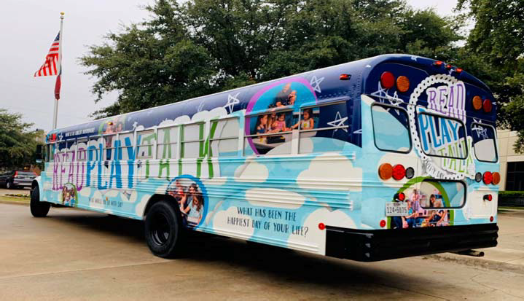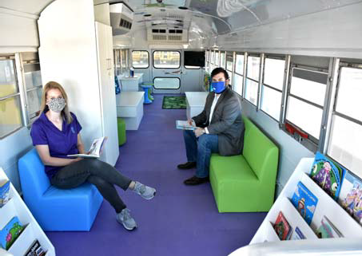

Mesquite Independent School District

Informational Section

155 Mesquite ISD Oﬃcial Budget 2020‐2021

Informational Section

Taxable Value Information 158
Assess Value History 2000‐2020 159
Taxable Value History and Future Projections 160
Property Tax Levies & Collections 161
Top Ten Taxpayers 2019 162
Tax Rate Impact to District’s Taxpayers 163
Taxable Values & Tax Rate 164‐165
Student & Enrollment By Campus 166
Student Enrollment Summary 167
Student Enrollment by Campus 168‐169
Enrollment 170
Staﬃng 171
Debt Service Fund 172‐173
Principal Outstanding 174
Aggregate Unlimited Tax Bonds 175
Capital Improvement Program Impact on Tax Rate (Outstanding Debt Only) 176
Dropout Rate 177
2020 Accountability 178
MISD 2019‐2020 Accomplishments 179‐183
Graduation Rates 184
ISIP‐Early Reading 185
Free/Reduced Lunch Numbers 186
Campus Budget and Performance Information
Achziger Elementary School 187
Austin Elementary School 188
Beasley Elementary School 189
Black Elementary School 190
Cannaday Elementary School 191
Florence Elementary School 192
Floyd Elementary School 193
Galloway Elementary School 194
Gentry Elementary School 195
Gray Elementary School 196
Hanby Elementary School 197
Henrie Elementary School 198
Hodges Elementary School 199
Kimball Elementary School 200
Lawrence Elementary School 201
Mackey Elementary School 202
McKenzie Elementary School 203
McWhorter Elementary School 204
Moss Elementary School 205
Informational Section (cont.)
Motley Elementary School 206
Pirrung Elementary School 207
Porter Elementary School 208
Price Elementary School 209
Range Elementary School 210
Rugel Elementary School 211
Rutherford Elementary School. 212
Seabourn Elementary School 213
Shands Elementary School 214
Shaw Elementary School 215
Smith Elementary School 216
Thompson Elementary School 217
Tisinger Elementary School 218
Tosch Elementary School 219
Agnew Middle School 220
Berry Middle School 221
Fraiser Middle School 222
Kimbrough Middle School 223
McDonald Middle School 224
New Middle School 225
Terry Middle School 226
Vanston Middle School 227
Wilkinson Middle School 228
Woolley Middle School 229
Horn High School 230
Mesquite High School 231
North Mesquite High School 232
Poteet High School 233
West Mesquite High School 234
Mesquite Academy 235
Learning Center 236
Athletics 237

Glossary of Terms 238‐247

Taxable Value Information

On January 1 each year the property values are rendered for appraisal. The appraisal process is con‐ ducted by the Dallas Central Appraisal District (DCAD). Properties are required to be appraised at 100% market value. A 10% annual appraisal cap increase has been implemented by the Texas State Legislature.

The DCAD submits preliminary values to the school district by April 30. These values are usually a conservative estimate of the ultimate certified values that come by July 25. The preliminary values are good estimates upon which to base the tax levies for the operating and debt service budgets. Once the certified values are received by the District, the tax rate adoption and budgeting process can be completed for the new fiscal year.

The tables on the following pages depict the increasing growth rate of property values.

Mesquite Independent School District Assessed Value History
2000‐2020

Tax Year as of Jan. 1 Total Assessed Value Assessed Value of New Construction
2000‐2001 | $ 4,626,978,196 | $ 157,387,000
2001‐2002 | $ 4,984,958,356 | $ 146,854,000
2002‐2003 | $ 5,562,556,711 | $ 190,125,000
2003‐2004 | $ 5,872,033,385 | $ 156,783,000
2004‐2005 | $ 5,293,286,904 | $ 216,662,000
2005‐2006 | $ 6,193,034,206 | $ 121,051,000
2006‐2007 | $ 6,417,581,830 | $ 143, 711,000
2007‐2008 | $ 6,758,783,540 | $ 170,066,000
2008‐2009 | $ 6,821,420,639 | $ 106,366,000
2009‐2010 | $ 6,467,873,468 | $ 50,469,000
2010‐2011 | $ 6,120,707,473 | $ 38,998,000
2011‐2012 | $ 6,045,576,816 | $ 43,939,772
2012‐2013 | $ 5,875,851,693 | $ 28,938,000
2013‐2014 | $ 5,899,012,680 | $ 26,744,000
2014‐2015 | $ 6,188,134,529 | $ 23,848,000
2015‐2016 | $ 6,862,131,352 | $ 27,863,177
2016‐2017 | $ 7,054,825,858 | $ 51,746,880
2017‐2018 | $ 7,960,549,178 | $ 121,003,577
2018‐2019 | $ 8,558,184,886 | $ 94,176,575
2019‐2020 | $ 9,271,820,630 | $ 142,419,254
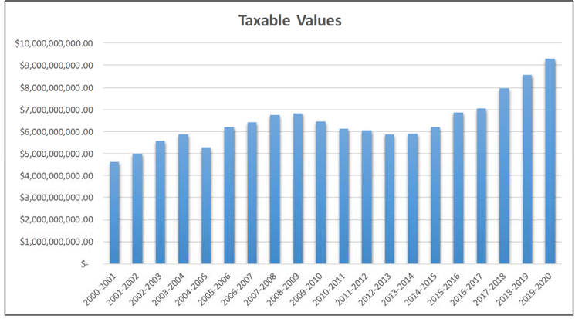

Taxable Value History and Future Projections

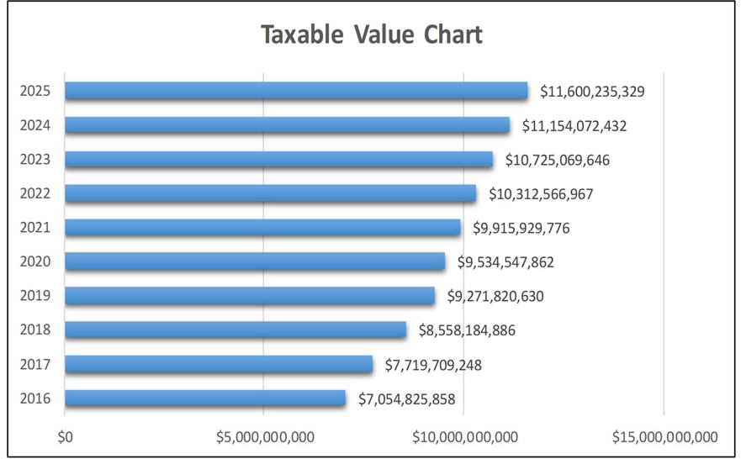

    - Predictions are based on a 4% growth

Property Tax Levies & Collections

Fiscal  Year | M&O  Rate | I&S Rate | Total Tax  Rate | Taxable Values | Total Levy | Total Collections | %
2010 | 1.04 | 0.37 | 1.42 | $ 6,467,873,468 | $ 87,516,422.80 | $ 85,695,026.13 | 98.17
2011 | 1.04 | 0.37 | 1.42 | $ 6,120,707,473 | $ 86,272,906.71 | $ 84,461,934.62 | 98.64
2012 | 1.04 | 0.37 | 1.42 | $ 6,045,576,816 | $ 84,374,630.05 | $ 82,766,517.40 | 98.56
2013 | 1.04 | 0.37 | 1.42 | $ 5,875,851,693 | $ 84,516,846.54 | $ 83,134,933.19 | 98.65
2014 | 1.04 | 0.36 | 1.41 | $ 5,899,012,680 | $ 88,617,735.37 | $ 86,607,563.74 | 98.56
2015 | 1.04 | 0.36 | 1.41 | $ 6,188,134,529 | $ 89,248,543.57 | $ 87,466,306.41 | 99.17
2016 | 1.04 | 0.42 | 1.46 | $ 6,862,131,352 | $ 103,000,459.01 | $ 99,288,581.66 | 98.66
2017 | 1.04 | 0.42 | 1.46 | $ 7,054,825,858 | $ 107,713,254.33 | $ 108,857,664.18 | 98.68
2018 | 1.04 | 0.46 | 1.52 | $ 7,960,549,178 | $ 125,639,017.39 | $ 123,786,579.44 | 98.53
2019 | 0.97 | 0.48 | 1.45 | $ 9,271,820,630 | $ 130,792,671.63 | $ 129,188,292.72 | 98.77
2020 | 0.9664 | 0.48 | 1.4464 | $ 9,534,547,862

Property taxes are calculated on 100% of market values less appropriate exemptions. Taxes are calculated on each $100 of taxable value.

It is important to note that taxes collected for the 2020‐2021 school year are taxes that are billed in October for tax year 2020. They are not due until February 1 without penalty.

2019 Top Ten Taxpayers

Item | Principal Taxpayer | Type of Property | 2019 Valuation
1 | Town East Mall | Shopping Mall | $ 136,090,990
2 | Pepsi Cola | Soft Drink Bottling | $ 70,261,310
3 | Market East Associates LLC | Shopping Center | $ 65,500,000
4 | Ashley Furniture Ind | Furniture Manufacturer | $ 65,899,420
5 | Oncor Electric Delivery | Electric Utility | $ 49,439,750
6 | Ocean Barons LP | Apartment Complex | $ 46,500,000
7 | IRIS USA Inc. | Manufacturer | $ 40,164,910
8 | United Parcel Service | Package Delivery | $ 36,377,110
9 | SPI Misson Ranch LLC | Apartment Complex | $ 34,100,000
10 | BRE DDR Marketplace | Shopping Center & Restaurants | $ 34,000,000

The yearly impact of the M&O tax rate and the Debt Service (Interest & Sinking or I&S) tax rate for the District’s taxpayers is shown in Table 8. The numbers show the eﬀect of the total tax rate along with the increases in property values over the past several years. The table uses the average home value in the District over the past 8 years to reflect the tax increase trend.

Table 50
Tax Rate Impact to District’s Taxpayers

 | 2016‐2017 | 2017‐2018 | 2018‐2019 | 2019‐2020 | 2020‐2021
Assessed/Market Value of a Home | $ 110,608.00 | $ 128,823.00 | $ 146,319.00 | $ 147,607.71 | $ 169,135.00
Average Taxable Value | $ 85,881.00 | $ 99,152.00 | $ 113,294.00 | $ 115,607.00 | $ 138,608.00
Total Property Tax Rate | $ 1.46 | $ 1.46 | $ 1.52 | $ 1.45 | $ 1.4464
Property Tax Due | $ 1,253.86 | $ 1,447.62 | $ 1,722.06 | $ 1,676.30 | $ 2,004.83
Increase in Taxes | $ 91.19 | $ 193.76 | $ 274.44 | $ (45.76) | $ 185.14
Property Tax Percent Increase from Prior  Year | 7.8% | 15.5% | 19.0% | ‐2.70% | 19.6 %

This schedule shows the trends in property values and tax rates. Each year the Dallas Central Apprais‐ al District appraises property based on market conditions such as sales in the surrounding areas. The above schedules shows how market conditions have aﬀected the assessed value through 2019‐2020 based on the overall appraisal value trends in the District. As shown above, the average value of a residence in the District continues to rise annually.
2020‐2021
2019‐2020
2018‐2019
2017‐2018
2016‐2017
$‐
$500.00
$1,000.00
$1,500.00
$2,000.00
$2,500.00
Property Tax Due

Mesquite Independent School District Taxable Values and Tax Rate
The appraisal process is conducted by the Dallas County Appraisal District (DCAD). Properties are required to be appraised at 100% of market value. A ten percent appraisal cap controls runaway proper‐ ty value growth. The DCAD submits preliminary values to the school district by May 1. These values are usually a conservative estimate of the final certified values that are provided by July 25th. The preliminary values are good estimates upon which to base the tax levies for the operating and debt service budgets. Once the certified values are received by the district, the tax rate adoption and budgeting process can be completed for the new fiscal year.

Table 51
Taxable Value Projections
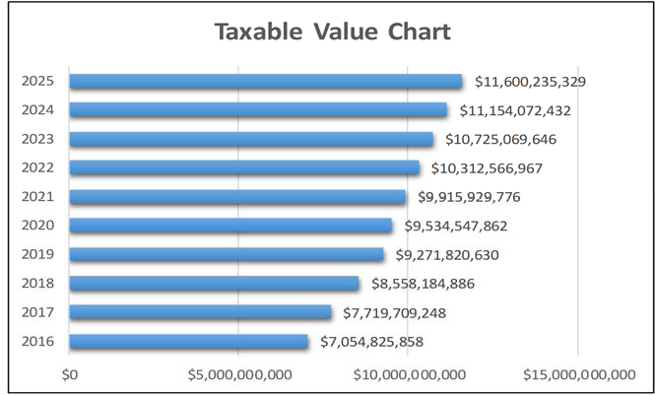
Dallas County Appraisal District

For budget purposes, the tax levy is computed from the New Taxable Value at a 99% collection rate. The actual taxes to be collected on the Freeze Taxable Values are added back. The Freeze Taxable Value is the property values of citizens over 65 years old. Their tax levy is frozen when they turn 65 and can never rise any higher not matter what happens to property values or tax rates. The combination of the Net Taxable Value levy on Frozen Values the Total Levy for the year.

The Maintenance and Operations tax rate supports the major educational and operational programs of the District for such expenses as staﬀ salaries, utilities, supplies, materials, equipment, etc. The M&O rate for 2020‐2021 is $0.9664.

The Debt Service rate tax rate supports payments of principal and interest for the debt authorized by the voters. The total amount of debt service payable each year less any state aid is divided by the taxable property values to determine the rate. For the 2020‐2021, the debt service rate is $0.48.

Table 52 Tax Rate History

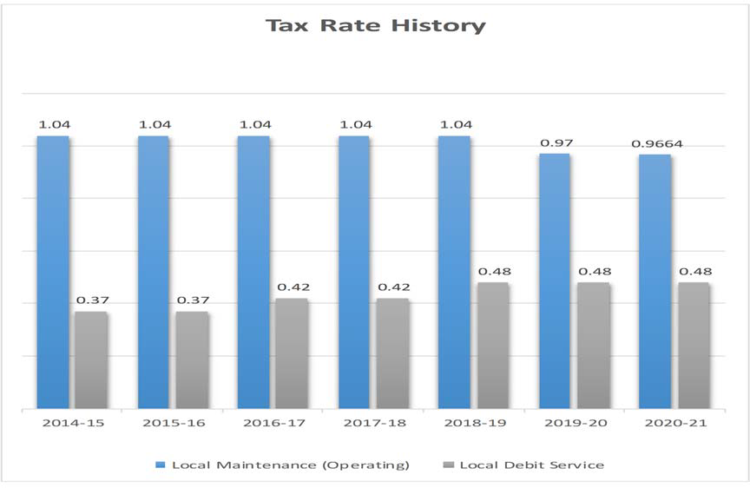

Mesquite Independent School District Student & Enrollment By Campus

Over the past 10 years, Mesquite ISD has experienced significant increases in the student population. Total PK‐12 enrollment rose from 37,205 in 2009‐2010 to 41,016 in 2017‐2018. Starting with the school year 2016‐2017 you can see the enrollment stabilizing.

District enrollment projections are produced using demographic data specific to Mesquite ISD. The district’s demographer reviews overall population and household growth trends, the cohort survival rates for each grade level, and how the local birth rate relates to incoming kindergarten enrollment. Additionally, GIS analysis of enrolled student data and quarterly housing surveys are used to deter‐ mine student yields per single‐family home and apartment unit, the rate of new home construction per subdivision, and the impact that current and future residential developments will have on district enrollment. Presently in 2020‐2021, the decrease in birthrate is reflected in Kindergarten through Second grades, particularly Pre‐K due to COVID. This is causing a decrease in enrollment in those grades. However, as subdivisions begin to build homes and apartments the district expects to experience annual growth beginning in school year 2022‐2023.

Table 53
Informational Section
Mesquite ISD Oﬃcial Budget 2020‐2021
167

Mesquite ISD Student Enrollment Summary

Campus Type | Actual  2016‐17 | Actual  2017‐18 | Actual  2018‐19 | Actual  2019‐20 | Current Year  2020‐21 | Projected  2020‐21 | Projected  2021‐22 | Projected  2022‐23 | Projected  2023‐24
High Schools | 11,892 | 12,023 | 12,367 | 12,029 | 12,105 | 12,383 | 12,796 | 13,189 | 13,377
Middle Schools | 7,078 | 7,163 | 9,973 | 9,907 | 9,570 | 10,012 | 9,772 | 9,390 | 8,893
Elementary Schools | 21,882 | 21,643 | 18,497 | 17,695 | 16,701 | 17,240 | 17,014 | 16,951 | 17,029
Mesquite Academy | 167 | 187 | 280 | * | *
JJAEP |  |  |  | 7 | 5 | 5 | 5 | 5 | 5
Total Enrollment | 41,019 | 41,016 | 41,117 | 39,638 | 38,381 | 39,640 | 39,587 | 39,535 | 39,304

* Student enrollment included in high school count.
Texas Education Agency‐District TAPER Report

Table 54
Informational Section
Mesquite ISD Oﬃcial Budget 2020‐2021
168
Mesquite ISD Student Enrollment by Campus

Campus | Actual  2016‐17 | Actual  2017‐18 | Actual  2018‐19 | Actual  2019‐20 | Current Year  2020‐21 | Projected  2020‐21 | Projected  2021‐22 | Projected  2022‐23 | Projected  2023‐24
Mesquite High School | 2,864 | 2,904 | 2,829 | 2,625 | 2,561 | 2,633 | 2,684 | 2,805 | 2,877
North Mesquite High School | 2,818 | 2,808 | 2,864 | 2,522 | 2,415 | 2,462 | 2,400 | 2,380 | 2,436
West Mesquite High School | 2,057 | 2,077 | 2,137 | 2,162 | 2,280 | 2,270 | 2,381 | 2,487 | 2,501
Poteet High School | 1,791 | 1,848 | 1,853 | 1,822 | 1,750 | 1,856 | 1,876 | 1,940 | 1,936
Horn High School | 2,362 | 2,386 | 2,684 | 2,898 | 3,099 | 3,162 | 3,455 | 3,577 | 3,627
Agnew Middle School | 797 | 831 | 1,280 | 1,228 | 1,227 | 1,258 | 1,190 | 1,153 | 1,039
Vanston Middle School | 812 | 805 | 969 | 923 | 847 | 909 | 917 | 900 | 868
Wilkinson Middle School | 954 | 974 | 926 | 790 | 797 | 845 | 806 | 760 | 678
McDonald Middle School | 1,034 | 1,002 | 909 | 908 | 923 | 945 | 896 | 843 | 780
New Middle School | 867 | 926 | 931 | 935 | 831 | 913 | 880 | 810 | 768
Kimbrough Middle School | 871 | 825 | 1,222 | 1,357 | 1,260 | 1,336 | 1,346 | 1,291 | 1,257
Berry Middle School | 899 | 904 | 1,116 | 1,103 | 613 | 673 | 671 | 656 | 658
Terry Middle School | 844 | 896 | 1,440 | 1,463 | 1,039 | 1,054 | 996 | 928 | 897
Fraiser Middle School | 0 | 0 | 1,180 | 1,200 | 1,126 | 1,190 | 1,160 | 1,072 | 993
Woolley Middle School | 0 | 0 | 0 | 0 | 907 | 889 | 910 | 977 | 955
Black Elementary School | 665 | 639 | 606 | 656 | 626 | 629 | 628 | 618 | 627
Florence Elementary School | 582 | 654 | 543 | 548 | 467 | 508 | 503 | 496 | 501
Galloway Elementary School | 732 | 732 | 489 | 461 | 420 | 449 | 436 | 431 | 430
Hanby Elementary School | 923 | 929 | 835 | 838 | 740 | 836 | 856 | 855 | 872
Hodges Elementary School | 853 | 767 | 610 | 545 | 514 | 527 | 520 | 530 | 521
McWhorter Elementary School | 956 | 870 | 719 | 633 | 549 | 581 | 542 | 509 | 495
Motley Elementary School | 499 | 455 | 370 | 338 | 276 | 325 | 300 | 281 | 269
Range Elementary School | 743 | 763 | 653 | 601 | 580 | 555 | 539 | 527 | 519
Rugel Elementary School | 476 | 458 | 355 | 355 | 321 | 331 | 315 | 319 | 315
Rutherford Elementary School | 459 | 474 | 645 | 659 | 648 | 630 | 613 | 596 | 585
Shands Elementary School | 927 | 825 | 655 | 629 | 622 | 582 | 541 | 522 | 487
Tisinger Elementary School | 792 | 824 | 819 | 660 | 631 | 627 | 599 | 599 | 600
Tosch Elementary School | 938 | 872 | 658 | 594 | 617 | 555 | 549 | 535 | 537
Seabourn Elementary School | 554 | 724 | 700 | 661 | 578 | 673 | 691 | 704 | 715
Lawrence Elementary School | 416 | 440 | 368 | 334 | 283 | 325 | 313 | 317 | 314
Floyd Elementary School | 818 | 798 | 579 | 604 | 455 | 609 | 622 | 646 | 673
Porter Elementary School | 619 | 605 | 427 | 421 | 389 | 431 | 395 | 405 | 389

Table 54 (cont.)
Informational Section
Mesquite ISD Oﬃcial Budget 2020‐2021
169

Mesquite ISD Student Enrollment by Campus (cont.)

Campus | Actual 2016‐17 | Actual 2017‐18 | Actual 2018‐19 | Actual 2019‐20 | Current Year 2020‐21 | Projected 2020‐21 | Projected 2021‐22 | Projected 2022‐23 | Projected 2023‐24
McKenzie Elementary School | 598 | 538 | 493 | 454 | 414 | 419 | 407 | 403 | 385
Beasley Elementary School | 476 | 467 | 378 | 374 | 359 | 363 | 359 | 361 | 361
Price Elementary School | 450 | 451 | 359 | 348 | 299 | 345 | 333 | 339 | 348
Shaw Elementary School | 891 | 884 | 582 | 577 | 555 | 575 | 571 | 566 | 584
Kimball Elementary School | 284 | 242 | 192 | 188 | 211 | 186 | 192 | 188 | 204
Pirrung Elementary School | 441 | 434 | 438 | 392 | 396 | 346 | 336 | 328 | 321
Cannaday Elementary School | 513 | 564 | 575 | 590 | 582 | 576 | 575 | 572 | 560
Austin Elementary School | 505 | 471 | 471 | 390 | 343 | 387 | 386 | 390 | 397
Moss Elementary School | 483 | 434 | 391 | 380 | 323 | 358 | 352 | 343 | 355
Thompson Elementary School | 554 | 565 | 529 | 523 | 566 | 558 | 563 | 559 | 550
Gray Elementary School | 635 | 634 | 512 | 450 | 431 | 442 | 436 | 437 | 438
Smith Elementary School | 531 | 494 | 425 | 437 | 545 | 446 | 447 | 448 | 474
Gentry Elementary School | 883 | 916 | 654 | 617 | 624 | 614 | 609 | 624 | 610
Mackey Elementary School | 757 | 788 | 678 | 615 | 650 | 602 | 598 | 590 | 604
Achziger Elementary School | 978 | 971 | 854 | 912 | 827 | 969 | 1022 | 1,070 | 1,142
Henrie Elementary School | 951 | 961 | 935 | 911 | 860 | 881 | 866 | 843 | 847
Mesquite Academy | 167 | 187 | 280 | * | *
JJAEP |  |  |  | 7 | 5 | 5 | 5 | 5 | 5
TOTAL | 41,019 | 41,016 | 41,117 | 39,638 | 38,381 | 39,640 | 39,587 | 39,535 | 39,304

- Student enrollment included in high school count.
District Demographic Report‐2020

Table 55
Mesquite Independent School District Enrollment
Campus | Enrollment 19‐20 | Enrollment 20‐21
Achziger | 912 | 827
Austin | 390 | 343
Beasley | 374 | 359
Black | 656 | 626
Cannaday | 590 | 582
Florence | 548 | 467
Floyd | 604 | 455
Galloway | 461 | 420
Gentry | 617 | 624
Gray | 450 | 431
Hanby | 838 | 740
Henrie | 911 | 860
Hodges | 545 | 514
Kimball | 188 | 211
Lawrence | 334 | 283
Mackey | 615 | 650
McKenzie | 454 | 414
McWhorter | 633 | 549
Moss | 380 | 323
Motley | 338 | 276
Pirrung | 392 | 396
Porter | 421 | 389
Price | 348 | 299
Range | 601 | 580
Rugel | 355 | 321
Rutherford | 659 | 648

Campus | Enrollment 19‐20 | Enrollment 20‐21
Seabourn | 661 | 578
Shands | 629 | 622
Shaw | 577 | 555
Smith | 437 | 545
Thompson | 523 | 566
Tisinger | 660 | 631
Tosch | 594 | 617
Agnew MS | 1,228 | 1,227
Berry MS | 1,103 | 613
Fraiser MS | 1,200 | 1,126
Kimbrough MS | 1,357 | 1,260
McDonald MS | 908 | 923
New MS | 935 | 831
Terry MS | 1,463 | 1,039
Vanston MS | 923 | 847
Wilkinson MS | 790 | 797
Woolley MS | 0 | 907
Horn HS | 2,898 | 3,099
Mesquite HS | 2,625 | 2,561
North Mesquite HS | 2,522 | 2,415
Poteet HS | 1,822 | 1,750
West Mesquite HS | 2,162 | 2,280

Staﬃng
A significant portion of the annual operating budget is dedicated to staﬃng and the related salary and benefits costs (approx. 80%). To eﬀectively control operating costs of the District, on‐going monitoring must be performed for all staﬃng areas. State laws place restrictions on classroom staﬃng for the kindergarten through 4th grade levels to a 22:1 ratio. To go above this ratio level, the District would need to obtain approved waivers from the state’s Education commissioner. At the secondary level along with grade 5, the District strives to maintain a 28:1 ratio, though certain classes may exceed this level or be much lower.

Table 56
Mesquite Independent School District Staﬃng History

School Years  Teachers  (Classroom, Interventionists, Special Programs) | 16‐17  2738 | 17‐18  2738 | 18‐19  2748 | 19‐20  2751 | 20‐21  2789
Professional Support | 432 | 532 | 546 | 566 | 585
(Directors, Counselors, Librarians, Campus Oﬃce Staﬀ,
Central Oﬃce Staﬀ)
School Leadership | 132 | 132 | 133 | 141 | 145
(Principals, Asst. Principals)
Central Administration | 124 | 11 | 9 | 28 | 30
(Superintendent, Asst. Superintendents, Cabinet‐Level | Positions)
Paraprofessional | 802 | 802 | 807 | 810 | 837
Auxiliary | 1,156 | 1,156 | 1,138 | 1135 | 1101
Total Staﬀ | 5,384 | 5,371 | 5.381 | 5431 | 5489
Student Enrollment (Total Membership‐Fall Snapshot) | 40,718 | 41,025 | 41,022 | 39,638 | 38,290
Staﬃng Ratios  Teaching Staﬀ | 14.87 | 14.98 | 14.93 | 14.41 | 13.73
Total Staﬀ | 7.56 | 7.64 | 7.62 | 7.30 | 6.98

Texas Education Agency‐District TAPER Report

Debt Service Fund

Over the past 10 years and in the near future, the District has and will continue to have a need to con‐ duct bond sales. `A school district is authorized to issue bonds and levy taxes for payment of bonds subject to voter approval of a proposition submitted to the voters under Texas Education Code (TEX)
  - (b)(1). A debt service fund is a government fund, with budgetary control, that must be used to account for general long‐term debt principal and interest for debt issues and other long‐term debts for which a tax has been dedicated. A separate bank account must be kept for this fund and a separate tax rate is assessed to fund the debt payments based on the scheduled maturities. The debt tax rate (or Interest and Sinking – I&S tax rate) is approved by the Board of Trustees annually and is calculated based on the scheduled debt requirements and the taxable property values certified by the DAC.

TEC 45.003(1), as amended, requires a district to demonstrate to the Texas Attorney General that it has the prospective ability to pay debt service on a proposed issue of bonds, together with debt service on other outstanding “new debt” of the district, from a tax levied at a rate of $0.50 per $100 of assessed valuation before bonds may be issued.

Once the prospective ability to pay such tax has been shown and the bonds are issued, a district may levy a tax to pay the annual debt service. Mesquite ISD is presently taxing at $0.48 per $100 of taxable value for the Interest and Sinking fund.

The District was rated by S & P Global with a rating of AA/Stable and by Fitch Ratings as AA+.

Revenue

The primary source of revenue for the debt service fund is an ad valorem tax raised from levying the Interest and Sinking (I&S) tax rate. The district is presently taxing at $0.48 per $100 of taxable value. The state laws governing debt tax rates limit a school district to a maximum tax rate of $0.50, thus leaving the District with $0.02 per $100 taxable available for future bond sales.

Other sources of revenue are state funds provided as part of the Existing Debt Allotment (EDA) pro‐ gram and the Instructional Facilities (IFA) program, along with investment earnings from fund cash balances.

The EDA is provided for existing debt issued by school districts to produce a guaranteed yield in State and local revenue per student for each cent of debt service tax levy. In general, a district’s bonds are eligible for the allotment if, during the previous State biennium, the district (1) made payments on such bonds or (2) levied and collected taxes for the payment of principal and interest on such bonds.

The IFA guarantees each school district a specified dollar amount per student in state and local funds for each cent of tax eﬀort to pay principal and interest on eligible bond used to construct, acquire, renovate, or improve instructional facilities. To receive an IFA, a school district must apply to the Commissioner of Education before issuing the bonds to be paid with State assistance. These funds are allocated to school districts based upon property wealth per student. Districts with the lowest amounts will receive funding first.

Expenditures

The expenditures from the Debt Service fund consist mainly of the semi‐annual principal and interest requirements from existing bond debt. Currently, these payments total approximately $62,000,000.

Mesquite Independent School District Principal Outstanding as of August 31, 2020

Series | Principal  Outstanding
Unlimited Tax School Building Bonds, Series 2019 | $ 84,740,000
Unlimited Tax School Building Bonds, Series 2018 | 118,645,000
Unlimited Tax Refunding Bonds, Series 2017A | 12,803,008
Unlimited Tax School Building Bonds, Series 2017B | 83,350,000
Unlimited Tax Refunding Bonds, Series 2016A | 16,890,000
Unlimited Tax Refunding Bonds, Series 2016B | 22,270,000
Unlimited Tax School Building Bonds, Series 2016C | 91,375,000
Unlimited Tax School Building Bonds, Series 2015A | 27,020,000
Unlimited Tax Refunding Bonds, Series 2015B | 21,309,996
Unlimited Tax Refunding Bonds, Series 2015C | 27,496,135
Unlimited Tax Refunding Bonds, Series 2015D | 27,068,535
Unlimited Tax School Building Bonds, Series 2015E | 71,870,000
Unlimited Tax School Building Bonds, Series 2014A | 24,045,000
Unlimited Tax Refunding Bonds, Series 2014B | 54,200,000
Unlimited Tax Refunding Bonds, Series 2013 | 8,760,000
Unlimited Tax Refunding Bonds, Series 2012 | 36,409,259
Var. Rate School Building Unlimited Tax Bonds, Series 2003A | 30,000,000
 | $ 758,251,933

BOND DEBT SERVICE
Mesquite ISD, Texas All Outstanding Debt As of FYE 8/31/2020

Compounded
Period Ending | Principal | Interest  Interest | Debt Service
8/31/2021 | 23,431,113.40 | 32,670,076.57 5,723,886.60 | 61,825,076.57
8/31/2022 | 19,153,707.20 | 31,425,247.66 5,806,292.80 | 56,385,247.66
8/31/2023 | 19,729,980.20 | 30,590,652.26 5,840,019.80 | 56,160,652.26
8/31/2024 | 25,770,329.00 | 29,711,775.96 919,671.00 | 56,401,775.96
8/31/2025 | 26,935,000.00 | 28,704,950.06 | 55,639,950.06
8/31/2026 | 27,475,000.00 | 27,493,351.66 | 54,968,351.66
8/31/2027 | 27,667,396.35 | 26,298,507.86 907,603.65 | 54,873,507.86
8/31/2028 | 28,705,201.85 | 25,152,122.86 969,798.15 | 54,827,122.86
8/31/2029 | 27,798,810.60 | 24,009,558.76 1,031,189.40 | 52,839,558.76
8/31/2030 | 28,417,674.90 | 22,844,656.26 1,087,325.10 | 52,349,656.26
8/31/2031 | 30,275,175.40 | 21,679,981.26 1,139,824.60 | 53,094,981.26
8/31/2032 | 31,520,000.00 | 20,440,656.26 | 51,960,656.26
8/31/2033 | 31,980,000.00 | 19,104,906.26 | 51,084,906.26
8/31/2034 | 33,075,000.00 | 17,626,106.26 | 50,701,106.26
8/31/2035 | 34,525,000.00 | 16,181,856.26 | 50,706,856.26
8/31/2036 | 33,370,000.00 | 14,638,406.26 | 48,008,406.26
8/31/2037 | 34,795,000.00 | 13,215,012.50 | 48,010,012.50
8/31/2038 | 36,275,000.00 | 11,731,937.50 | 48,006,937.50
8/31/2039 | 37,840,000.00 | 10,166,812.50 | 48,006,812.50
8/31/2040 | 38,265,000.00 | 8,532,200.00 | 46,797,200.00
8/31/2041 | 37,990,000.00 | 6,811,200.00 | 44,801,200.00
8/31/2042 | 33,800,000.00 | 5,111,550.00 | 38,911,550.00
8/31/2043 | 19,725,000.00 | 3,629,400.00 | 23,354,400.00
8/31/2044 | 20,580,000.00 | 2,772,850.00 | 23,352,850.00
8/31/2045 | 14,280,000.00 | 1,878,700.00 | 16,158,700.00
8/31/2046 | 7,820,000.00 | 1,233,000.00 | 9,053,000.00
8/31/2047 | 8,215,000.00 | 842,000.00 | 9,057,000.00
8/31/2048 | 8,625,000.00 | 431,250.00 | 9,056,250.00
 | 748,039,388.90 | 454,928,724.97 23,425,611.10 | 1,226,393,724.97

Table 59

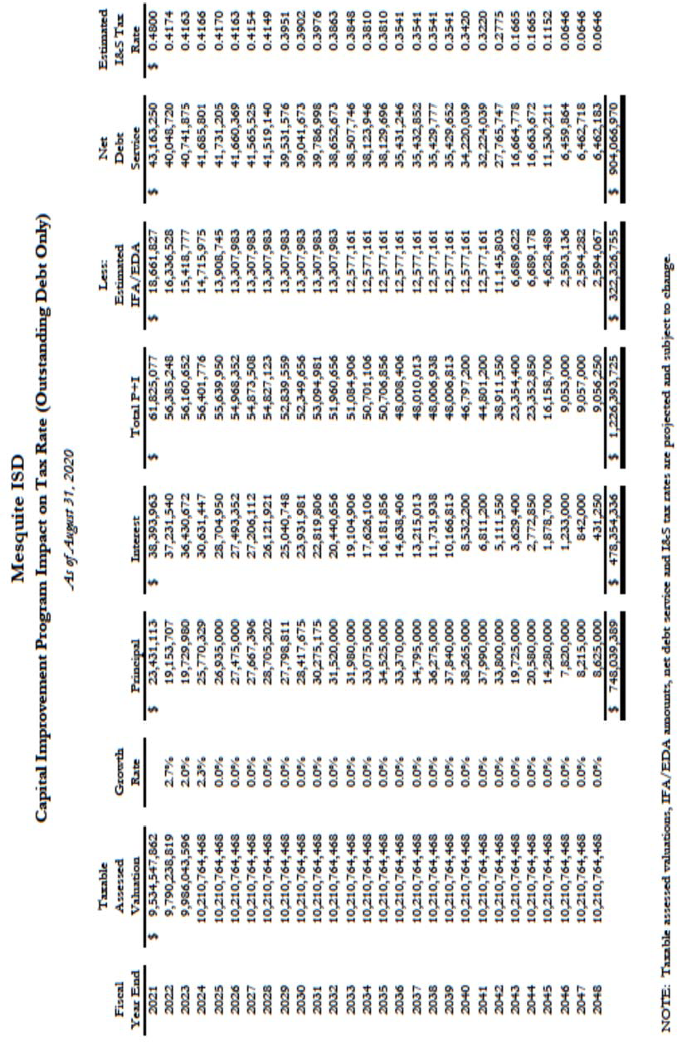

Table 60
Mesquite Independent School District Dropout Rate

All Secondary: Grades 7 – 12
School Year | State Annual Dropout Rate | District
 |  | Annual Dropout Rate | Total Dropouts | At‐Risk Students | Non At‐Risk Students
2018—2019 | 1.4% | 0.8% | 148 | 96 | 52
2017—2018 | 1.4% | 1.1% | 207 | 139 | 68
2016 – 2017 | 1.4% | 1.2% | 227 | 153 | 74
2015 – 2016 | 1.4% | 1.4% | 272 | 182 | 90
2014 – 2015 | 1.5% | 1.5% | 289 | 153 | 136
2013 – 2014 | 1.6% | 1.3% | 254 | 136 | 118
2012 – 2013 | 1.6% | 1.2% | 219 | 107 | 112
High School: Grades 9 – 12
School Year | State Annual Dropout Rate | District
 |  | Annual  Dropout Rate | Total Dropouts
2018—2019 | 1.9% | 1.0% | 125
2017—2018 | 1.9% | 1.4% | 181
2016 – 2017 | 1.9% | 1.7% | Not Reported
2015 – 2016 | 2.0% | 2.0% | 252
2014 – 2015 | 2.1% | 2.1% | 264
2013 – 2014 | 2.2% | 1.9% | 229
2012 – 2013 | 2.2% | 1.6% | 196

Middle School: Grades 7 – 8
School Year | State Annual Dropout Rate | District
 |  | Annual  Dropout Rate | Total Dropouts
2018—2019 | 0.4% | 0.3% | 23
2017—2018 | 0.4% | 0.4% | 26
2016 – 2017 | 0.3% | 0.2% | Not Reported
2015 – 2016 | 0.4% | 0.3% | 20
2014 – 2015 | 0.3% | 0.4% | 25
2013 – 2014 | 0.5% | 0.4% | 25
2012 – 2013 | 0.4% | 0.4% | 23

2020 Accountability Ratings
Due to COVID, the STARR test was not administered. The district and all campuses received a rating of “Not Rated: Declared State of Disaster” and retained 2019 ratings. The district retained an 87 ‐ B. All campuses retained their 2019 overall ratings.

Table 61
2019 Accountability Ratings
CAMPUS | OVERALL PERFORMANCE  GRADE
Elementary Schools
Achziger | C
Austin | B
Beasley | B
Black | C
Cannaday | C
Florence | B
Floyd | C
Galloway | B
Gentry | B
Gray | B
Hanby | B
Henrie | B
Hodges | C
Kimball | A
Lawrence | B
Mackey | B
McKenzie | B
McWhorter | C
Moss | B
Motley | A
Pirrung | B
Porter | A
Price | C
Range | C
Rugel | B

CAMPUS | OVERALL PERFORMANCE GRADE
Rutherford | B
Seabourn | C
Shands | B
Shaw | C
Smith | B
Thompson | C
Tisinger | C
Tosch | C
Middle Schools
Agnew | C
Berry | B
Frasier | C
Kimbrough | C
McDonald | C
New | C
Terry | C
Vanston | C
Wilkinson | A
High Schools
HHS | B
MHS | B
NMHS | B
PHS | B
WMHS | B
Mesquite Academy | Not Rated
Texas Education Agency‐District TAPER Report

Mesquite Independent School District 2019‐2020 Accomplishments

Fine Arts Accolades
    - Mesquite ISD was once again named as one of the, “Best Communities for Music Education” by the NAMM Foundation.
    - Poteet HS Marching Band once again advanced to the Texas State Marching Band Competition
    - 148 Medals earned at Regional VASE Competition.
    - 12 high school students advanced to the State VASE competition. State VASE was canceled due to the Coronavirus Pandemic.
    - MISD had 13 orchestras earn the UIL Sweepstakes award. All other Spring UIL Events were canceled due to the Coronavirus Pandemic.
    - Over 1000 students earned some sort of individual award or recognition (all city, all region, solo & ensemble, …).
    - 192 students earned a position in one of the TMEA All Region Ensembles.
    - MISD had 4 students earn a position in the Texas All State Band.
    - Over 400 students earned a first division rating at UIL Solo & Ensemble Contest.
    - North Mesquite HS Men’s Choir performed before a standing room only crowd at the 2020 Texas Music Educators Association Convention in San Antonio.

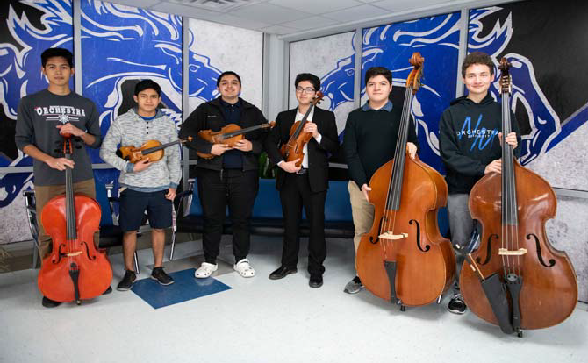

Career & Technical Education Excellence

      - Career & Technical Education students earned 946 industry certifications and licenses in the 2019‐2020 school year.
      - Students in Health Science, Automotive, Child Guidance and Ready, Set, Teach! courses earned a total of 1730 dual credit hours.
      - CTE piloted a Certified Nurse Assistant (CNA) program in conjunction with Eastfield College at North Mesquite High School.
      - The CTE department implemented the new CTE related electives for middle school; Investigating Careers and College and Career Readiness.
      - CTE worked with WRA Architects and our MISD construction department to design and complete an entire remodel of the cosmetology lab at West Mesquite High School.
      - Our department added Tech Apps courses such as Computer Science and Robotics under the CTE umbrella.
      - Two of our new CTE teachers were named First Class Teacher of the Year.
      - One of our CTE teachers at West Mesquite High School was named Teacher of the Year.
      - 318 of the 520 students that participated at the regional level of our Career & Technical Stu‐ dent Organizations (CTSOs), advanced to the state level.
      - CTE had 10 students competing in CTSOs selected to represent us nationally.
      - FCCLA National Qualifiers for Financial Fitness: OVERALL People’s Choice, Top Evaluators Score, and Top People’s Choice was earned by Adriana Resendiz and Haily Mendoza from West Mesquite High School.
      - Presley Hopkins, Clarissa Martinez, and Alejandra Jimenez, all seniors at John Horn High School, took 1st place in the virtual FCCLA State Conference.
      - National Qualifier, Mabel Hoang from Mesquite High School, placed 3rd in Advanced Word Processing at the Business Professionals of America (BPA) State competition.
      - National Qualifiers, Orions Obadeyi and Zion Jackson from Mesquite High School and Jeanette Pardo from West Mesquite High School placed 2nd in Broadcast News Team at the Business Professionals of America (BPA) State competition

Mesquite Education Foundation
      - Education Foundation gave $202,000 to campuses to fund innovative grants for the 2020‐2021 school year through 2019‐2020 fundraising.
      - The Foundation has funded just under $3 million in grants since 2004.
      - Foundation raised over $55,000 in net proceeds from the 2019 Amazing Santa Color 5K.
      - Foundation raised $125,000 in net proceeds from the 2020 Lone Star Legacy Gala and Concert.
- Employees of MISD contributed & pledged $125,000 in financial support to the Education Foundation through the Employee Giving Campaign for the 2019‐20 school year.
      - Foundation Board has budgeted an approximate 25% reduction in fundraising income for the 2020‐2021 school year due to the economic impact of the pandemic. $150,000 is budgeted for grant funding.

ReadPlayTalk
      - The second annual ReadPlayTalk Festival was held on Saturday, September 28 at Town East Mall. This year’s event was combined with the Experience Excellence Expo, where each feeder pattern was able to showcase the diﬀerent clubs, programs, and activities that are oﬀered in the feeder schools. There were 34 vendor booths of organizations and businesses from the community. Stage entertainment was provided by various community members, school groups, and a DJ. Through the sales of bounce house admission, snacks, and face painting, over $3,000 was raised for the ReadPlayTalk initiative.
      - The fourth annual ReadPlayTalk Fair was scheduled for Saturday, March 21. Unfortunately, this event was cancelled due to the rise of the COVID‐19 pandemic. However, because of pledged sponsorships from ReadPlayTalk Community Partners, the event still profited $3,000.
      - There has been immense progress on The ReadPlayTalk Bus. The exterior wrapping was completed in January 2020. The seats were removed, flooring was installed, and the bus was painted in March 2020. Construction and Tech Services have worked together to build and install a variety of furniture pieces and technology. Local business are donating funds towards The ReadPlayTalk Bus, and their donations are making the purchases of furniture pieces, books, and activities that will be featured on the bus possible. The bus is expected to be completed in Fall 2020.

Academic Achievements
      - Mesquite ISD overall state rating is a B (87) with a B (81) in the Achievement Domain, a B
(89) in the School Progress Domain, and a B (82) in the Closing Gap Domain.
      - College, Career, Military Ready (CCMR) increased from 46% for the 2017 graduating class, to 59% of the 2018 graduating class, to 65% of the 2019 graduating class. That is a 19% in‐ crease over 3 years.
      - Due to COVID, students completed 3,092 Advanced Placement tests from home and up‐ loaded completed tests to College Board.
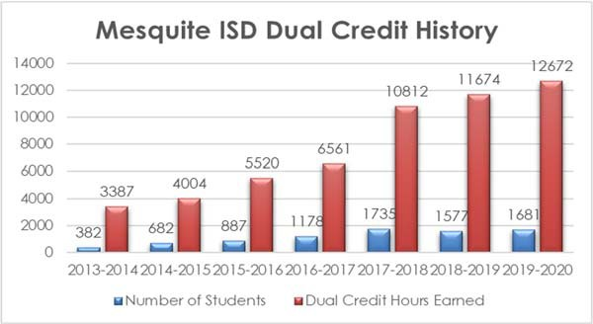

      - MISD held its first virtual district‐wide college decision day recognizing students for their college acceptance.
      - Advanced academics is oﬀered at every elementary school providing challenges without grades to every child. Think tanks around novels read, coding clubs, chess clubs, robotics clubs, and STEM clubs are examples of oﬀerings. MISD extends advanced academic oﬀerings into the summer through Camp Invention for grades 3‐5. Due to COVID Camp Invention (grades 3‐5) was done virtually this year and Virtual Invention Project Middle School Camp was added. Both camps had maximum capacity enrollment.
      - Kimball Elementary Destination Imagination Team advanced to global finals and attended the Virtual Global Finals event.

Athletics

      - On Average 5,000‐ 5,500 students participate annually in MISD Athletics.
      - MISD Athletics had 120 athletes receive scholarships last year for the 19‐20 school year.
      - MISD has 312 Coaches and 12 Licensed Athletic Trainers serving MISD athletes.
      - MISD has an athletic oﬃce staﬀ of 5 full time and 4 part time employees serving our district.
      - MISD Athletics is considered to be a leader in the development of student‐athlete safety protocols (Concussion Return to Play Policy‐Lightning Policy‐Heat Policy‐Drug Testing Policy)
      - MISD Coaches are trained yearly with an 8 hour Coaches Staﬀ Development Training and are required to comply with having over 10 trainings or certifications to meet district, state, and UIL requirements.
      - MISD is one of only a handful of school districts to employee a full time Athletic Director of Strength and Nutrition who is certified by the National Strength Coaches Association.
      - High School Athletics oﬀers Football, Volleyball, Tennis, Cross Country, Basketball, Track, Golf, Baseball, Softball, Swim and Soccer.
      - Middle School Athletics oﬀers Football, Volleyball, Tennis, Basketball, Track, Non Competitive Golf and is looking to pilot Middle School Soccer in the future.
      - MISD Athletics now oﬀers 6th Grade Pre Athletics PE in order to introduce Athletics to 6th graders.
      - MISD Athletics hosts over 400 Varsity Events alone District Wide in Mesquite.
      - MISD Athletic Department hosts over 2,200 athletics events each year in Mesquite at over 25 diﬀerent Venues within Mesquite. (7th Grade through Varsity)
      - MISD has 8 former athletes playing professional sports.
      - MISD Athletics had 52 varsity athletes recognized as academic All State by the THSCA and TGCA.
      - MISD Athletics aligns with the Districts Core Values by implementing community service and character development initiatives at each of our campuses athletic programs.

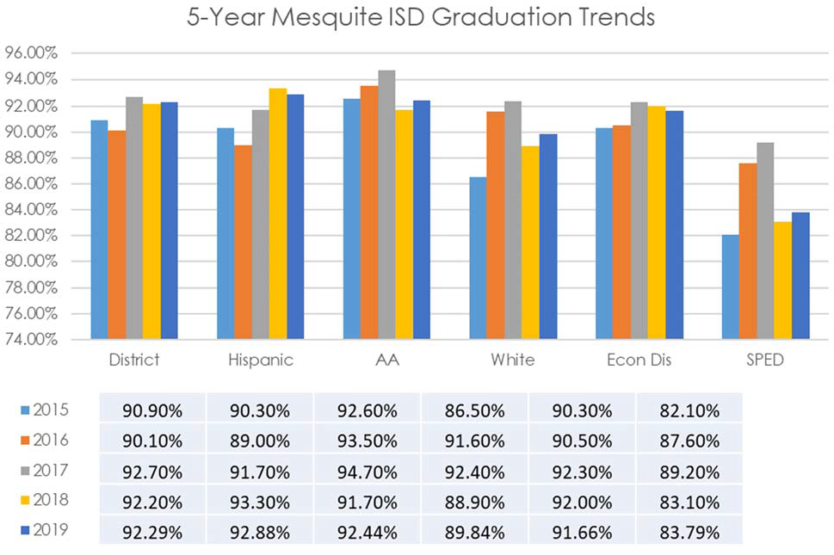Graduation Rates Table 62

Texas Education Agency‐District TAPER Report

Mesquite ISD maintains one of the highest graduation rates for districts that are similar in demographic makeup and size. Graduation rates remain consistently above the region and the state rates.

ISIP‐Early Reading (ISIP‐ER)

ISIP‐Early Reading (ISIP‐ER)
ISIP‐ER is a computer‐based assessment that requires no teacher testing or manual scoring. Teachers monitor students as they test on the computer. This diagnostic assessment is nationally‐normed, child‐ friendly, and oﬀers immediate access to student data for the teacher. While being assessed, students begin with the test oﬀered to all children in their grade. ISIP‐ER then oﬀers more diﬃcult test items when a student answers correctly and less diﬃcult items when an incorrect response is recorded. This gives the teacher a true picture of the early reading skills that each student has mastered. Intervention lessons are then recommended based upon each child’s individual needs.
Tier 1 students are on track and performing at or above grade level. Tier 2 are at some risk and may be in need of intervention in one or more of the areas tested on a subtest. Tier 3 students are at risk, are performing seriously below grade level, and are in need of intensive intervention. During the school year, the goal is to move students at Tiers 2 and 3 up to Tier 1. Teachers must also continue to monitor students at Tier 1 making sure to build their reading skills suﬃciently throughout the year.
Due to the COVID pandemic, End of Year Assessments were not administered at the end of the 2019‐ 20 school year. The chart reflects the data from the previous year and notes that assessments were not done.

Table 63
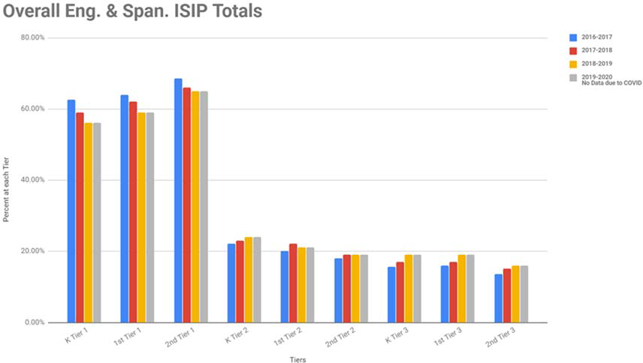

Table 64
Mesquite Independent School District Free/Reduced Lunch Numbers

SY | Enrollment | Free | Reduced | Other | Total F&R | Percent
2012‐2013 | 39,127 | 24,197 | 3,212 | 41 | 27,409 | 70.05%
2013‐2014 | 39,912 | 24,784 | 3,255 | 98 | 28,039 | 70.25%
2014‐2015 | 40,296 | 25,819 | 3,683 | 31 | 29,502 | 73.21%
2015‐2016 | 40,827 | 26,848 | 3,716 | 67 | 30,564 | 74.86%
2016‐2017 | 41,038 | 26,553 | 4,165 | 61 | 30,718 | 74.85%
2017‐2018 | 41,029 | 26,195 | 4,320 | 61 | 30,515 | 74.37%
2018‐2019 | 40,379 | 27,658 | 3,711 | 86 | 31,369 | 77.69%
2019‐2020 | 39,856 | 26,657 | 4,363 | 77 | 31,020 | 77.83%

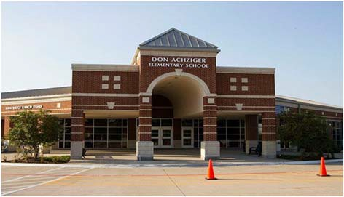Don Achziger Elementary School

Kristi Gregory, Principal

Excellence Always
 | 2016‐2017 | 2017‐2018 | 2018‐2019 | 2019‐2020 | 2020‐2021
Enrollment | 978 | 971 | 854 | 912 | 827
Student/Teacher Ratio | 17.4 | 18.7 | 16.4 | 16.7
Staﬀ FTE's
Professional | 70.9 | 66.9 | 64 | 66.5
Teachers | 55.9 | 51.9 | 52 | 54.5
Professional Support | 12 | 12 | 10 | 9
Campus Administration | 3 | 3 | 2 | 3
Support
Educational Aides | 17 | 17 | 17 | 17
Total | 87.9 | 83.9 | 81 | 83.5
Expenditures | 2017 AUDITED | 2018 AUDITED | 2019 AUDITED | 2020 UNAUDITED | 2021 BUDGET
Payroll Costs | $ 4,292,880.37 | $ 4,716,703.82 | $ 4,314,102.89 | $ 4,703,983.36 | $ 4,544,300.00
Contracted Services | $ 243,438.71 | $ 130,761.96 | $ 128,935.47 | $ 120,856.54 | $ 39,600.00
Supplies and Materials | $ 109,358.75 | $ 110,672.91 | $ 92,759.47 | $ 135,040.81 | $ 105,000.00
Other Operating Costs | $ 29,839.28 | $ 33,955.90 | $ 32,602.54 | $ 22,946.56 | $ 32,500.00
Fixed Assets | $ 12,721.20 | $ 10,304.91 | $ 312,292.57 | $ 4,486.26 | $ 0.00
Grand Total | $ 4,688,238.31 | $ 5,002,399.50 | $ 4,880,692.94 | $ 4,987,313.53 | $ 4,821,400.00
Expenditures by Intent
 | 2017 AUDITED | 2018 AUDITED | 2019 AUDITED | 2020 UNAUDITED | 2021 BUDGET
Basic | $ 2,912,939.06 | $ 3,112,244.69 | $ 3,089,273.21 | $ 2,957,209.77 | $ 2,661,700.00
Gifted | $ 652.86 | $ 645.80 | $ 242.50 | $ 610.76 | $ 650.00
Special Education | $ 631,901.37 | $ 593,304.81 | $ 559,270.72 | $ 669,937.61 | $ 686,250.00
Compensatory |  |  |  | $ 70,022.57 | $ 0.00
Bilingual | $ 66,856.73 | $ 67,494.83 | $ 64,420.94 | $ 302,266.43 | $ 70,650.00
SCE to Title I | $ 169,502.75 | $ 301,271.68 | $ 270,110.83 | $ 401.98 | $ 320,250.00
Pre‐Kindergarten | $ 12.08 | $ ‐ | $ 62,507.63 | $ 18,147.02 | $ 35,600.00
Pre‐Kindergarten‐Comp Ed | $ 16,329.72 | $ 17,115.36 | $ 17,156.18 | $ 102,392.12 | $ 45,800.00
Pre‐Kindergarten Bilingual Ed | $ 64,527.37 | $ 61,072.53 | $ 123,123.71 | $ 29,280.86 | $ 60,100.00
Other Instructional Area | $ 825,516.37 | $ 849,249.80 | $ 694,587.22 | $ 837,044.41 | $ 93,000.00
 |  |  |  |  | $ 847,400.00
Grand Total $ 4,688,238.31 $ 5,002,399.50 $ 4,880,692.94 $ 4,987,313.53 $ 4,821,400.00

Per Student Cost $ 4,793.70 $ 5,151.80 $ 5,715.10 $ 5,468.55 $ 5,829.99

Assessment Results | 2017 STAAR | 2018 STAAR | 2019 STAAR | 2020 STAAR | 2021 STAAR
Reading | 73% | 76% | 80% | NA
Mathematics | 75% | 78% | 76% | NA
Writing | 61% | 63% | 50% | NA
Science | 68% | 86% | 76% | NA

**Information obtained from the TEA PEIMS Standard Report and Munis Accounting

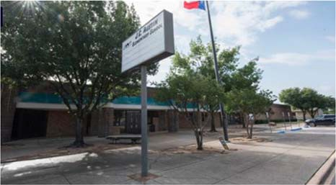
J. C. Austin Elementary School
Dr. Jonathan Royle, Principal

 | 2016‐2017 | 2017‐2018 | 2018‐2019 | 2019‐2020 | 2020‐2021
Enrollment | 505 | 471 | 471 | 390 | 343
Student/Teacher Ratio | 15.7 | 16.8 | 18.6 | 15.4
Staﬀ FTE's
Professional | 39.1 | 35.1 | 31.6 | 31.8
Teachers | 32.1 | 28.1 | 25.3 | 25.4
Professional Support | 5 | 5 | 4.3 | 4.4
Campus Administration | 2 | 2 | 2 | 2
Support
Educational Aides | 7 | 7 | 5 | 5
Total | 46.1 | 42.1 | 36.6 | 36.8
Expenditures
 | 2017 AUDITED | 2018 AUDITED | 2019 AUDITED | 2020 UNAUDITED | 2021 BUDGET
Payroll Costs | $ 2,459,702.97 | $ 2,649,768.77 | $ 2,191,624.18 | $ 2,403,308.74 | $ 2,517,400.00
Contracted Services | $ 109,299.57 | $ 97,717.16 | $ 106,863.62 | $ 109,429.78 | $ 120,600.00
Supplies and Materials | $ 67,499.63 | $ 70,147.66 | $ 55,790.44 | $ 48,120.25 | $ 56,900.00
Other Operating Costs | $ 16,783.51 | $ 17,220.14 | $ 16,782.33 | $ 14,626.41 | $ 17,700.00
Fixed Assets | $ 76,663.02 | $ 97,744.96 | $ 56,948.56 | $ 1,252.26 | $ 0.00
Grand Total | $ 2,729,948.70 | $ 2,932,598.69 | $ 2,428,009.13 | $ 2,576,737.44 | $ 2,712,600.00
Expenditures by Intent
 | 2017 AUDITED | 2018 AUDITED | 2019 AUDITED | 2020 UNAUDITED | 2021 BUDGET
Basic | $ 1,633,291.51 | $ 1,669,079.16 | $ 1,388,408.12 | $ 1,408,844.51 | $ 1,433,200.00
Gifted | $ ‐ | $ 154.95 | $ 0.00 | $ 0.00 | $ 650.00
Special Education | $ 197,342.05 | $ 196,027.34 | $ 79,545.63 | $ 160,938.62 | $ 158,100.00
Compensatory |  |  |  | $ 154,085.79 | $ 0.00
Bilingual | $ 134,607.77 | $ 143,094.31 | $ 145,812.35 | $ 59,821.47 | $ 156,400.00
SCE to Support Title I | $ 28,877.40 | $ 62,380.39 | $ 66,924.75 | $ 64,159.52 | $ 134,400.00
Pre‐Kindergarten | $ 55,893.23 | $ 56,559.41 | $ 61,492.48 | $ 17,837.22 | $ 32,850.00
Pre‐Kindergarten‐Comp Ed | $ 21,387.13 | $ 20,013.06 | $ 17,068.21 | $ 3,568.44 | $ 18,950.00
Other Instructional Area | $ 658,549.61 | $ 785,290.07 | $ 668,757.59 | $ 707,481.87 | $ 32,150.00
$ 745,900.00
Grand Total $ 2,729,948.70 $ 2,932,598.69 $ 2,428,009.13 $ 2,576,737.44 $ 2,712,600.00

Per Student Cost $ 5,405.84 $ 6,226.32 $ 5,155.01 $ 6,607.02 $ 7,908.45

Assessment Results | 2017 STAAR | 2018 STAAR | 2019 STAAR | 2020 STAAR | 2021 STAAR
Reading | 67% | 72% | 83% | NA
Mathematics | 76% | 82% | 81% | NA
Writing | 51% | 73% | 68% | NA
Science | 63% | 83% | 78% | NA

**Information obtained from the TEA PEIMS Standard Report and Munis Accounting

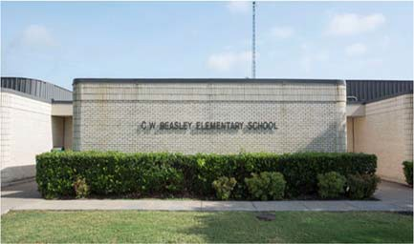C.W. Beasley Elementary School

Kelly McCollom, Principal

Our Vision is "Beasley Pride: Creating students that embody positive attitude, responsibility, integrity, dedication and excellence in all they do!"

 | 2016‐2017 | 2017‐2018 | 2018‐2019 | 2019‐2020 | 2020‐2021
Enrollment | 466 | 467 | 388 | 374 | 359
Student/Teacher Ratio Staﬀ FTE's  Professional | 15.8  37.3 | 17.6  34.3 | 14.5  34.4 | 14.5  31.8
Teachers | 29.5 | 26.5 | 26.7 | 25.8
Professional Support | 5.8 | 5.8 | 5.7 | 4
Campus Administration Support  Educational Aides | 2  8.8 | 2  8.8 | 2  8.9 | 2  7
Total | 46.1 | 46.1 | 43.3 | 38.8
Expenditures | 2017 AUDITED | 2018 AUDITED | 2019 AUDITED | 2020 UNAUDITED | 2021 BUDGET
Payroll Costs | $ 2,401,213.52 | $ 2,643,452.93 | $ 2,495,641.49 | $ 2,505,526.29 | $ 2,727,800.00
Contracted Services | $ 106,950.20 | $ 82,705.44 | $ 87,690.14 | $ 67,152.65 | $ 82,100.00
Supplies and Materials | $ 44,784.42 | $ 51,835.41 | $ 49,331.72 | $ 59,570.22 | $ 54,100.00
Other Operating Costs | $ 22,834.58 | $ 25,368.97 | $ 24,606.32 | $ 18,381.99 | $ 18,800.00
Fixed Assets | $ 9,899.34 | $ 961.30 | $ 57,225.08 | $ 4,486.26 | $ 0.00
Grand Total | $ 2,585,682.06 | $ 2,804,324.05 | $ 2,714,494.75 | $ 2,655,117.41 | $ 2,882,800.00
Expenditures by Intent

Basic $ 1,500,106.12 $ 1,676,309.55 $ 1,598,736.33 $ 1,507,557.14 $ 1,545,700.00
2017 AUDITED
2018 AUDITED 2019 AUDITED 2020 UNAUDITED 2021 BUDGET
Gifted | $ ‐ | $ 550.67 | $ 61.56 | $ 0.00 | $ 650.00
Special Education | $ 359,762.67 | $ 345,171.66 | $ 340,676.73 | $ 275,030.67 | $ 284,700.00
Compensatory |  | $ ‐ |  |  | $ 0.00
Bilingual | $ 58,365.74 | $ 59,743.21 | $ 61,267.07 | $ 65,327.01 | $ 66,850.00
SCE to Support Title I | $ 27,167.81 | $ 57,138.23 | $ 59,107.37 | $ 68,736.70 | $ 137,050.00
Pre‐Kindergarten |  |  |  | $ 0.00 | $ 35,200.00
Pre‐kindergarten ‐ Comp Ed |  |  |  | $ 0.00 | $ 26,300.00
Early Education Allotment |  |  |  | $ 22,041.42 | $ 34,500.00
Dyslexia |  |  |  | $ 69,230.30 | $ 70,100.00
Other Instructional Area | $ 640,279.72 | $ 665,410.73 | $ 654,645.69 | $ 647,194.17 | $ 681,750.00
Grand Total | $ 2,585,682.06 | $ 2,804,324.05 | $ 2,714,494.75 | $ 2,655,117.41 | $ 2,882,800.00
Per Student Cost | $ 5,548.67 | $ 6,004.98 | $ 6,996.12 | $ 7,099.24 | $ 8,030.08
Assessment Results | 2017 STAAR | 2018 STAAR | 2019 STAAR | 2020 STAAR | 2021 STAAR
Reading | 73% | 72% | 75% | NA
Mathematics | 77% | 77% | 76% | NA
Writing | 56% | 52% | 52% | NA
Science | 75% | 87% | 66% | NA

**Information obtained from the TEA PEIMS Standard Report and Munis Accounting

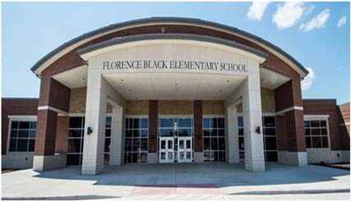Florence Black Elementary

Darla Franklin, Principal

The Tradition of Excellence Begins Here!
Dream It! Believe It! Achieve It!

 | 2016‐2017 | 2017‐2018 | 2018‐2019 | 2019‐2020 | 2020‐2021
Enrollment | 655 | 639 | 652 | 656 | 626
Student/Teacher Ratio  Staﬀ FTE's  Professional | 17.9  46 | 18.6  44 | 16.4  48.5 | 17.1  47
Teachers | 36.4 | 34.4 | 39.7 | 38.2
Professional Support | 7.6 | 7.6 | 6.8 | 6.8
Campus Administration  Support  Educational Aides | 2  8 | 2  8 | 2  9.6 | 2  9.7
Total | 54 | 52 | 58.1 | 56.7
Expenditures | 2017 AUDITED | 2018 AUDITED | 2019 AUDITED | 2020 UNAUDITED | 2021 BUDGET
Payroll Costs | $ 3,015,471.60 | $ 3,216,925.71 | $ 3,325,030.55 | $ 3,424,441.94 | $ 3,670,800.00
Contracted Services | $ 130,162.77 | $ 178,493.80 | $ 106,800.34 | $ 112,175.24 | $ 127,100.00
Supplies and Materials | $ 81,084.42 | $ 68,622.62 | $ 68,749.15 | $ 81,826.00 | $ 84,700.00
Other Operating Costs | $ 25,091.82 | $ 26,115.05 | $ 29,453.85 | $ 19,448.34 | $ 26,400.00
Fixed Assets | $ 3,729.12 | $ 152,478.92 | $ 105,210.60 | $ 4,486.26 | $ 0.00
Grand Total | $ 3,255,539.73 | $ 3,642,636.10 | $ 3,635,244.49 | $ 3,642,377.78 | $ 3,909,000.00
Expenditures by Intent | 2017 AUDITED | 2018 AUDITED | 2019 AUDITED | 2020 UNAUDITED | 2021 BUDGET
Basic | $ 1,861,528.15 | $ 2,180,894.50 | $ 2,203,979.55 | $ 2,143,709.11 | $ 2,193,350.00
Gifted | $ 558.44 | $ 649.98 | $ 133.32 | $ 0.00 | $ 650.00
Special Education | $ 417,437.27 | $ 409,446.61 | $ 392,851.31 | $ 411,346.21 | $ 420,750.00
Compensatory | $ ‐ | $ ‐ |  |  | $ 0.00
Bilingual | $ 69,654.78 | $ 71,128.19 | $ 73,684.35 | $ 67,419.07 | $ 70,100.00
SCE to Support Title I | $ 101,994.57 | $ 103,821.85 | $ 138,579.38 | $ 142,148.26 | $ 240,750.00
Pre‐Kindergarten | $ 69,727.25 | $ 61,053.75 | $ 62,298.74 | $ 69,087.25 | $ 36,250.00
Pre‐Kindergarten ‐ Comp Ed | $ 19,159.04 | $ 19,556.31 | $ 20,054.81 | $ 19,938.75 | $ 44,300.00
Pre‐Kindergarten ‐ Bilingual Ed |  |  |  | $ 0.00 | $ 35,200.00
Early Educational Allotment |  |  |  | $ 26,251.06 | $ 70,050.00
Other Instructional Area | $ 715,480.23 | $ 796,084.91 | $ 743,663.03 | $ 762,478.07 | $ 797,600.00
Grand Total | $ 3,255,539.73 | $ 3,642,636.10 | $ 3,635,244.49 | $ 3,642,377.78 | $ 3,909,000.00
Per Student Cost | $ 4,970.29 | $ 5,700.53 | $ 5,575.53 | $ 5,552.41 | $ 6,244.41
Assessment Results | 2017 STAAR | 2018 STAAR | 2019 STAAR | 2020 STAAR | 2021 STAAR
Reading | 60% | 73% | 78% | NA
Mathematics | 74% | 75% | 79% | NA
Writing | 43% | 57% | 61% | NA
Science | 65% | 62% | 71% | NA

**Information obtained from the TEA PEIMS Standard Report and Munis Accounting

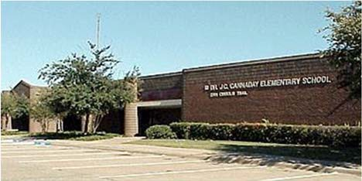
J.C. Cannaday Elementary School
Lauren Chism, Principal
Add Value to Every Child Every Day

Enrollment | 2016‐2017  513 | 2017‐2018  564 | 2018‐2019  575 | 2019‐2020  590 | 2020‐2021  582
Student/Teacher Ratio  Staﬀ FTE's Professional | 15.5  41.9 | 14.8  36.9 | 15.5  45.1 | 15.0  47.3
Teachers | 33.1 | 38.1 | 37.2 | 39.3
Professional Support | 6.8 | 6.8 | 5.9 | 6
Campus Administration  Support  Educational Aides | 2  10 | 2  10 | 2  11 | 2  12
Total | 51.9 | 46.9 | 56 | 59.3
Expenditures | 2017 AUDITED | 2018 AUDITED | 2019 AUDITED | 2020 UNAUDITED | 2021 BUDGET
Payroll Costs | $ 2,598,667.06 | $ 2,912,354.91 | $ 3,240,110.74 | $ 3,560,501.91 | $ 3,676,000.00
Contracted Services | $ 104,268.35 | $ 105,349.68 | $ 89,948.34 | $ 102,886.54 | $ 123,800.00
Supplies and Materials | $ 72,812.79 | $ 71,671.60 | $ 80,959.88 | $ 114,254.72 | $ 137,800.00
Other Operating Costs | $ 21,729.32 | $ 23,413.70 | $ 27,309.30 | $ 17,683.46 | $ 25,800.00
Fixed Assets | $ 4,966.81 | $ 16,261.39 | $ 205,541.20 | $ 7,720.26 | $ 0.00
Grand Total | $ 2,802,444.33 | $ 3,129,051.28 | $ 3,643,869.46 | $ 3,803,046.89 | $ 3,963,400.00
Expenditures by Intent | 2017 AUDITED | 2018 AUDITED | 2019 AUDITED | 2020 UNAUDITED | 2021 BUDGET
Basic | $ 1,653,784.91 | $ 1,741,289.61 | $ 2,274,696.70 | $ 2,269,086.58 | $ 2,166,550.00
Gifted | $ ‐ | $ 258.54 | $ 117.46 | $ 0.00 | $ 650.00
Special Education | $ 389,233.67 | $ 439,613.30 | $ 401,383.05 | $ 427,552.48 | $ 429,100.00
Bilingual | $ 56,505.87 | $ 62,437.94 | $ 67,407.40 | $ 72,256.53 | $ 0.00
SCE to Support Title I | $ 102,052.62 | $ 264,448.70 | $ 258,328.95 | $ 319,496.77 | $ 73,550.00
Pre‐Kindergarten |  |  |  | $ 0.00 | $ 336,550.00
Pre‐Kindergarten ‐ Comp Ed |  |  |  | $ 0.00 | $ 35,200.00
Pre‐Kindergarten ‐ Bilingual Ed |  |  |  | $ 0.00 | $ 52,600.00
Early Education Allotment |  |  |  | $ 44,383.32 | $ 35,200.00
Other Instructional Area | $ 600,867.26 | $ 621,003.19 | $ 641,935.90 | $ 670,271.21 | $ 69,000.00
 |  |  |  |  | $ 765,000.00
Grand Total | $ 2,802,444.33 | $ 3,129,051.28 | $ 3,643,869.46 | $ 3,803,046.89 | $ 3,963,400.00
Per Student Cost | $ 5,462.85 | $ 5,547.96 | $ 6,337.16 | $ 6,445.84 | $ 6,809.97
Assessment Results | 2017 STAAR | 2018 STAAR | 2019 STAAR | 2020 STAAR | 2021 STAAR
Reading |  | 67% | 70% | NA
Mathematics | 77% | 77% | 73% | NA
Writing | 66% | 59% | 67% | NA
Science | 81% | 73% | 64% | NA

**Information obtained from the TEA PEIMS Standard Report and Munis Accounting

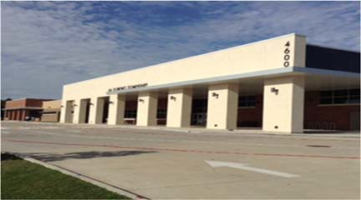J. H. Florence Elementary School

Dr. LaDonna Gulley, Principal

"We are Florence STRONG: Not only do we teach for academic success, but our students are taught to be the best they can be every day by showing respect, understanding how to work as a team, being responsible, owning up when necessary, being able to negotiate resolutions, and giving back to their respective com‐

 | 2016‐2017 | 2017‐2018 | 2018‐2019 | 2019‐2020 | 2020‐2021
Enrollment | 582 | 654 | 579 | 548 | 467
Student/Teacher Ratio Staﬀ FTE's  Professional | 14.1  52.1 | 17.5  48.1 | 14.4  51 | 14  51
Teachers | 41.3 | 37.3 | 40.2 | 39.2
Professional Support | 8.8 | 8.8 | 8.8 | 9.8
Campus Administration Support  Educational Aides | 2  21.9 | 2  21.9 | 2  18.7 | 2  20.6
Total | 74 | 70 | 69.7 | 71.6
Expenditures | 2017 AUDITED | 2018 AUDITED | 2019 AUDITED | 2020 UNAUDITED | 2021 BUDGET
Payroll Costs | $ 2,843,993.87 | $ 3,194,745.43 | $ 3,011,537.16 | $ 3,183,585.01 | $ 3,114,900.00
Contracted Services | $ 94,212.28 | $ 100,714.92 | $ 100,918.59 | $ 103,919.93 | $ 115,200.00
Supplies and Materials | $ 181,935.03 | $ 98,732.41 | $ 75,061.26 | $ 75,656.86 | $ 76,350.00
Other Operating Costs | $ 22,750.31 | $ 21,517.84 | $ 27,313.90 | $ 23,260.35 | $ 23,000.00
Fixed Assets | $ 494,504.96 | $ 2,175.55 | $ 77,754.60 | $ 19,568.09 | $ 0.00
Grand Total | $ 3,637,396.45 | $ 3,417,886.15 | $ 3,292,585.51 | $ 3,405,990.24 | $ 3,329,450.00
Expenditures by Intent | 2017 AUDITED | 2018 AUDITED | 2019 AUDITED | 2020 UNAUDITED | 2021 BUDGET
Basic | $ 1,738,998.56 | $ 1,914,872.95 | $ 1,741,402.89 | $ 1,662,816.42 | $ 1,528,750.00
Gifted | $ 721.40 | $ 213.89 | $ 207,737.21 | $ 211,272.18 | $ 203,650.00
Special Education | $ 373,565.13 | $ 441,508.74 | $ 301,482.66 | $ 3 49,365.66 | $ 350,400.00
Bilingual | $ 54,916.86 | $ 62,460.19 | $ 63,456.89 | $ 64,970.59 | $ 0.00
SCE to Support Title I | $ 137,496.23 | $ 138,990.51 | $ 134,909.44 | $ 168,142.57 | $ 68,400.00
Pre‐Kindergarten | $ 57,856.26 | $ 59,214.50 | $ 57,760.53 | $ 58,375.90 | $ 204,900.00
Prekindergarten‐Comp Ed | $ 42,454.89 | $ 43,397.89 | $ 44,433.62 | $ 46,352.36 | $ 30,750.00
Prekindergarten‐Bilingual Ed | $ 59,350.87 | $ 61,039.15 | $ 57,462.59 | $ 48,493.55 | $ 49,900.00
Early Education Allotment |  |  |  | $ 7,097.68 | $ 32,650.00
Dyslexia |  |  |  | $ 65,739.88 | $ 62,000.00
Other Instructional Area | $ 1,172,036.25 | $ 696,188.33 | $ 683,939.68 | $ 723,363.45 | $ 66,800.00
$ 731,250.00
Grand Total | $ 3,637,396.45 | $ 3,417,886.15 | $ 3,292,585.51 | $ 3,405,990.24 | $ 3,329,450.00
Per Student Cost | $ 6,249.82 | $ 5,226.13 | $ 5,686.68 | $ 6,215.31 | $ 7,129.44
Assessment Results | 2017 STAAR | 2018 STAAR | 2019 STAAR | 2020 STAAR | 2021 STAAR
Reading | 71% | 71% | 70% | NA
Mathematics | 86% | 86% | 73% | NA
Writing | 81% | 72% | 67% | NA
Science | 67% | 77% | 64% | NA

**Information obtained from the TEA PEIMS Standard Report and Munis Accounting

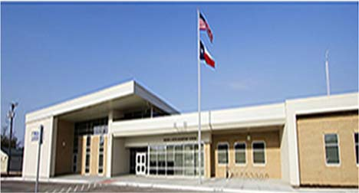Walter E. Floyd Elementary School

Kelsey Bowles, Principal

Every Child, Every Need, Every Day!

 | 2016‐2017 | 2017‐2018 | 2018‐2019 | 2019‐2020 | 2020‐2021
Enrollment | 818 | 798 | 567 | 604 | 455
Student/Teacher Ratio  Staﬀ FTE's  Professional | 15.8  61.7 | 18.6  52.7 | 15.5  45.3 | 16.4  44.3
Teachers | 51.9 | 42.9 | 36.5 | 36.8
Professional Support | 7.8 | 7.8 | 6.8 | 6
Campus Administration  Support  Educational Aides | 2  11 | 2  11 | 2  8.8 | 1.5  9
Total | 72.7 | 63.7 | 54.1 | 53.3
Expenditures
 | 2017 AUDITED | 2018 AUDITED | 2019 AUDITED | 2020 UNAUDITED | 2021 BUDGET
Payroll Costs | $ 3,951,449.88 | $ 4,147,465.61 | $ 3,092,704.75 | $ 3,281,403.10 | $ 3,554,400.00
Contracted Services | $ 128,462.57 | $ 119,601.14 | $ 92,239.22 | $ 97,904.06 | $ 123,300.00
Supplies and Materials | $ 106,604.95 | $ 97,255.60 | $ 73,813.82 | $ 147,703.77 | $ 93,400.00
Other Operating Costs | $ 46,882.36 | $ 46,011.24 | $ 43,913.93 | $ 31,637.72 | $ 33,000.00
Fixed Assets | $ 9,355.58 | $ 154,420.79 | $ 101,818.34 | $ 93,665.01 | $ 0.00
Grand Total | $ 4,242,755.34 | $ 4,564,754.38 | $ 3,404,490.06 | $ 3,652,313.66 | $ 3,804,100.00
Expenditures by Intent

Basic | $ 2,774,406.55 | $ 3,082,298.16 | $ 2,129,604.11 | $ 1,854,587.20 | $ 1,891,900.00
Gifted | $ ‐ | $ 251.32 | $ 0.00 | $ 0.00 | $ 650.00
Special Education | $ 361,464.67 | $ 352,121.79 | $ 272,393.57 | $ 301,511.36 | $ 314,600.00
Bilingual | $ 122,637.89 | $ 65,406.24 | $ 64,052.63 | $ 67,944.46 | $ 0.00
SCE to Support Title I | $ 253,093.53 | $ 264,402.52 | $ 182,853.95 | $ 253,467.64 | $ 70,950.00
Pre‐Kindergarten | $ ‐ | $ ‐ | $ 0.00 | $ 7,900.00 | $ 250,750.00
Pre‐Kindergarten ‐ Comp Ed | $ ‐ | $ 20,932.87 | $ 21,343.39 | $ 23,464.73 | $ 36,700.00
Pre‐Kindergarten ‐ Bilingual Ed | $ ‐ | $ 61,888.14 | $ 63,301.25 | $ 66,411.77 | $ 77,450.00
Early Education Allotment |  |  |  | $ 309,587.59 | $ 70,950.00
Other Instructional Area | $ 731,152.70 | $ 717,453.34 | $ 670,941.16 | $ 767,438.91 | $ 358,000.00
$ 732,150.00
2017 AUDITED
2018 AUDITED 2019 AUDITED 2020 UNAUDITED 2021 BUDGET
Grand Total $ 4,242,755.34 $ 4,564,754.38 $ 3,404,490.06 $ 3,652,313.66 $ 3,804,100.00

Per Student Cost $ 5,186.74 $ 5,720.24 $ 6,004.39 $ 6,046.88 $ 8,360.66

Assessment Results | 2017 STAAR | 2018 STAAR | 2019 STAAR | 2020 STAAR | 2021 STAAR
Reading |  | 57% | 63% | NA
Mathematics | 68% | 63% | 67% | NA
Writing | 45% | 40% | 54% | NA
Science | 55% | 49% | 59% | NA

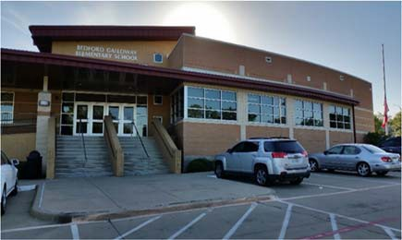April Sarpy, Principal

To provide every child the opportunity to achieve his/her fullest potential in a collaborative and nurturing learning environment.

 | 2016‐2017 | 2017‐2018 | 2018‐2019 | 2019‐2020 | 2020‐2021
Enrollment | 732 | 732 | 502 | 461 | 420
Student/Teacher Ratio Staﬀ FTE's  Professional | 16.4  53.4 | 19.5  46.4 | 13.8  44.4 | 14  41
Teachers | 44.6 | 37.6 | 36.4 | 33
Professional Support | 6.8 | 6.8 | 6 | 6
Campus Administration Support  Educational Aides | 2  13.3 | 2  13.3 | 2  8 | 2  8.8
Total | 66.7 | 59.7 | 52.4 | 49.8
Expenditures
 | 2017 AUDITED | 2018 AUDITED | 2019 AUDITED | 2020 UNAUDITED | 2021 BUDGET
Payroll Costs | $ 3,452,414.40 | $ 3,643,264.40 | $ 3,125,916.97 | $ 3,058,053.82 | $ 3,034,800.00
Contracted Services | $ 108,494.52 | $ 100,097.83 | $ 90,829.72 | $ 86,718.31 | $ 100,000.00
Supplies and Materials | $ 92,888.92 | $ 107,466.27 | $ 75,908.06 | $ 92,607.62 | $ 80,200.00
Other Operating Costs | $ 32,937.23 | $ 35,422.23 | $ 33,331.34 | $ 19,415.02 | $ 24,300.00
Fixed Assets | $ 14,045.99 | $ 162,890.91 | $ 640,224.27 | $ 10,768.62 | $ 0.00
Grand Total | $ 3,700,781.06 | $ 4,049,141.64 | $ 3,966,210.36 | $ 3,267,563.39 | $ 3,239,300.00
Expenditures by Intent

Basic | $ 2,333,071.95 | $ 2,665,777.99 | $ 2,078,885.18 | $ 1,834,278.82 | $ 1,718,350.00
Gifted | $ ‐ | $ ‐ | $ ‐ | $ 0.00 | $ 650.00
Special Education | $ 329,256.61 | $ 276,956.16 | $ 373,078.71 | $ 396,953.43 | $ 409,100.00
Bilingual | $ 68,981.64 | $ 69,863.90 | $ 70,255.16 | $ 70,791.24 | $ 0.00
SCE to Support Title I | $ 174,393.84 | $ 205,559.46 | $ 131,299.26 | $ 187,923.61 | $ 74,650.00
Pre‐Kindergarten | $ ‐ | $ ‐ | $ ‐ | $ 0.00 | $ 158,550.00
Prekindergarten‐Comp Ed | $ 20,550.90 | $ 21,127.92 | $ 21,546.21 | $ 22,918.09 | $ 35,200.00
Prekindergarten‐Bilingual Ed | $ 62,918.03 | $ 65,365.77 | $ 65,860.83 | $ 68,779.18 | $ 50,000.00
Early Education Allotment |  |  |  | $ 24,491.82 | $ 36,100.00
Other Instructional Area | $ 711,608.09 | $ 744,490.44 | $ 1,225,285.01 | $ 661,427.20 | $ 69,900.00
$ 686,800.00
2017 AUDITED
2018 AUDITED 2019 AUDITED 2020 UNAUDITED 2021 BUDGET
Grand Total $ 3,700,781.06 $ 4,049,141.64 $ 3,966,210.36 $ 3,267,563.39 $ 3,239,300.00

Per Student Cost $ 5,055.71 $ 5,531.61 $ 6,765.73 $ 7,087.99 $ 7,712.62

Assessment Results | 2017 STAAR | 2018 STAAR | 2019 STAAR | 2020 STAAR | 2021 STAAR
Reading | 67% | 66% | 73% | NA
Mathematics | 78% | 81% | 81% | NA
Writing | 53% | 50% | 67% | NA
Science | 70% | 72% | 74% | NA

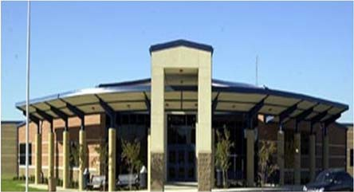Rashunda Price, Principal

Connect, Inspire, TEACH AND LEAD BIG!

 | 2016‐2017 | 2017‐2018 | 2018‐2019 | 2019‐2020 | 2020‐2021
Enrollment | 883 | 916 | 654 | 617 | 624
Student/Teacher Ratio | 17.3 | 21.8 | 15.8 | 15.4
Staﬀ FTE's
Professional | 60.3 | 51 | 48.4 | 48
Teachers | 51.1 | 42.1 | 41.5 | 40
Professional Support | 7.2 | 7.2 | 4.9 | 6
Campus Administration | 2 | 2 | 2 | 2
Support
Educational Aides | 13 | 13 | 11.9 | 11
Total | 73.3 | 64.3 | 60.3 | 59
Expenditures
 | 2017 AUDITED | 2018 AUDITED | 2019 AUDITED | 2020 UNAUDITED | 2021 BUDGET
Payroll Costs | $ 4,031,481.16 | $ 4,331,846.39 | $ 3,688,192.70 | $ 3,757,876.03 | $ 3,834,200.00
Contracted Services | $ 134,757.87 | $ 134,324.36 | $ 110,670.22 | $ 120,517.46 | $ 133,300.00
Supplies and Materials | $ 89,473.12 | $ 82,003.73 | $ 78,917.56 | $ 98,289.03 | $ 81,300.00
Other Operating Costs | $ 38,640.80 | $ 35,364.26 | $ 37,308.13 | $ 30,670.07 | $ 29,700.00
Fixed Assets | $ 19,563.36 | $ 172,371.90 | $ 93,023.68 | $ 4,203.00 | $ 0.00
Grand Total | $ 4,313,916.31 | $ 4,755,910.64 | $ 4,008,112.29 | $ 4,011,555.59 | $ 4,078,500.00
Expenditures by Intent
2017 AUDITED 2018 AUDITED 2019 AUDITED 2020 UNAUDITED 2021 BUDGET
Basic | $ 2,740,423.86 | $ 3,157,834.60 | $ 2,535,333.11 | $ 2,404,653.00 | $ 2,291,600.00
Gifted | $ 305.24 | $ 139.98 | $ ‐ | $ 55.96 | $ 650.00
Special Education | $ 467,153.30 | $ 453,979.49 | $ 449,213.08 | $ 479,535.65 | $ 491,550.00
Compensatory | $ ‐ | $ ‐ |  |  | $ 0.00
Bilingual | $ 61,206.89 | $ 63,410.78 | $ 64,248.09 | $ 68,037.16 | $ 71,650.00
SCE to Title I | $ 198,200.35 | $ 205,076.07 | $ 146,945.60 | $ 115,743.81 | $ 178,050.00
Pre‐Kindergarten |  |  |  | $ 0.00 | $ 35,200.00
Pre‐Kindergarten‐Comp Ed | $ 21,504.16 | $ 22,167.12 | $ 22,417.74 | $ 23,105.69 | $ 50,650.00
Pre‐Kindergarten Bilingual Ed | $ 61,819.96 | $ 66,657.14 | $ 30,406.62 | $ 70,902.48 | $ 36,800.00
Early Education Allotment |  |  |  | $ 26,707.06 | $ 70,700.00
Dyslexia |  |  |  | $ 70,054.33 | $ 71,300.00
Other Instructional Area | $ 763,302.55 | $ 786,645.46 | $ 759,548.05 | $ 752,760.45 | $ 780,350.00
Grand Total | $ 4,313,916.31 | $ 4,755,910.64 | $ 4,008,112.29 | $ 4,011,555.59 | $ 4,078,500.00
Per Student Cost | $ 4,885.52 | $ 5,192.04 | $ 6,128.61 | $ 6,501.71 | $ 6,536.06
Assessment Results | 2017 STAAR | 2018 STAAR | 2019 STAAR | 2020 STAAR | 2021 STAAR
Reading | 83% | 78% | 81% | NA
Mathematics | 87% | 87% | 85% | NA
Writing | 74% | 63% | 67% | NA
Science | 86% | 79% | 90% | NA

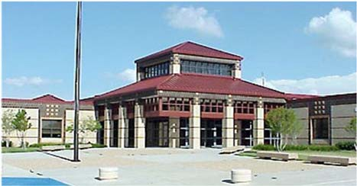W. O. Gray Elementary School

2017 AUDITED 2018 AUDITED 2019 AUDITED 2020 UNAUDITED 2021 BUDGET
Dr. Jennifer LaPlante, Principal

Excellence for All
 | 2016‐2017 | 2017‐2018 | 2018‐2019 | 2019‐2020 | 2020‐2021
Enrollment | 635 | 634 | 512 | 450 | 431
Student/Teacher Ratio  Staﬀ FTE's  Professional | 16.3  47.6 | 16.8  46.6 | 15.0  42.1 | 14.8  38.4
Teachers | 38.8 | 37.8 | 34.1 | 30.4
Professional Support | 6.8 | 6.8 | 6 | 6
Campus Administration  Support  Educational Aides | 2  14 | 2  14 | 2  10.6 | 2  11
Total | 61.6 | 60.6 | 52.7 | 49.4
Expenditures | 2017 AUDITED | 2018 AUDITED | 2019 AUDITED | 2020 UNAUDITED | 2021 BUDGET
Payroll Costs | $ 2,819,385.66 | $ 3,097,419.36 | $ 2,782,063.10 | $ 2,613,656.87 | $ 2,567,200.00
Contracted Services | $ 106,883.67 | $ 116,697.56 | $ 109,140.00 | $ 95,915.54 | $ 113,100.00
Supplies and Materials | $ 82,431.12 | $ 91,555.55 | $ 81,812.44 | $ 80,470.58 | $ 71,200.00
Other Operating Costs | $ 27,469.19 | $ 27,459.16 | $ 29,949.76 | $ 21,120.24 | $ 22,200.00
Fixed Assets | $ 6,063.89 | $ 167,411.63 | $ 81,126.76 | $ 22,395.26 | $ 0.00
Grand Total | $ 3,042,233.53 | $ 3,500,543.26 | $ 3,084,092.06 | $ 2,833,558.49 | $ 2,773,700.00
Expenditures by Intent

Basic | $ 1,760,020.02 | $ 2,281,246.73 | $ 1,927,020.50 | $ 1,607,450.92 | $ 1,519,000.00
Gifted | $ ‐ | $ ‐ | $ ‐ | $ 0.00 | $ 650.00
Special Education | $ 156,679.39 | $ 146,486.47 | $ 109,922.74 | $ 107,833.49 | $ 114,850.00
Bilingual | $ 65,606.14 | $ 64,460.42 | $ 61,774.37 | $ 64,065.26 | $ 0.00
SCE to Support Title I | $ 167,930.72 | $ 148,580.22 | $ 140,962.22 | $ 217,329.08 | $ 70,000.00
Pre‐Kindergarten | $ 63,327.75 | $ 65,169.52 | $ 65,764.09 | $ 67,605.37 | $ 165,100.00
Pre‐Kindergarten Comp Ed | $ 53,547.80 | $ 39,377.86 | $ 34,002.04 | $ 38,365.29 | $ 34,800.00
Pre‐Kindergarten Bilingual | $ 119,577.47 | $ 63,029.72 | $ 63,689.63 | $ 41,587.94 | $ 40,600.00
Early Education Allotment |  |  |  | $ 7,119.40 | $ 34,600.00
Other Instructional Area | $ 655,544.24 | $ 692,192.32 | $ 680,956.47 | $ 682,201.74 | $ 68,200.00
$ 725,900.00
Grand Total $ 3,042,233.53 $ 3,500,543.26 $ 3,084,092.06 $ 2,833,558.49 $ 2,773,700.00

Per Student Cost $ 4,790.92 $ 5,521.36 $ 6,023.62 $ 6,296.80 $ 6,435.50

Assessment Results | 2017 STAAR | 2018 STAAR | 2019 STAAR | 2020 STAAR | 2021 STAAR
Reading | 68% | 71% | 80% | NA
Mathematics | 76% | 82% | 85% | NA
Writing | 35% | 56% | 68% | NA
Science | 65% | 80% | 69% | NA

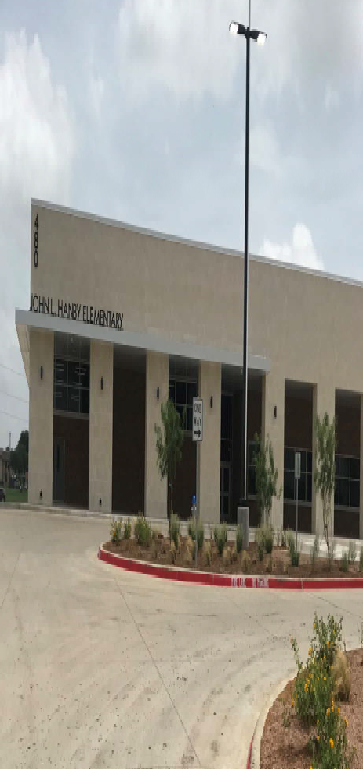Jessica Eaton, Principal

Excellence Always!
 | 2016‐2017 | 2017‐2018 | 2018‐2019 | 2019‐2020 | 2020‐2021
Enrollment | 923 | 929 | 850 | 838 | 740
Student/Teacher Ratio Staﬀ FTE's  Professional | 17.8  64.4 | 18.6  62.4 | 16.7  59.8 | 16.8  58.3
Teachers | 52 | 50 | 50.8 | 49.8
Professional Support | 9.4 | 9.4 | 7 | 7
Campus Administration Support  Educational Aides | 3  16 | 3  16 | 2  15.8 | 1.5  14.2
Total | 80.4 | 78.4 | 75.6 | 72.5
Expenditures | 2017 AUDITED | 2018 AUDITED | 2019 AUDITED | 2020 UNAUDITED | 2021 BUDGET
Payroll Costs | $ 4,355,426.93 | $ 4,582,999.01 | $ 4,135,753.88 | $ 4,281,137.17 | $ 4,421,700.00
Contracted Services | $ 134,990.34 | $ 146,696.70 | $ 109,625.10 | $ 157,755.23 | $ 133,600.00
Supplies and Materials | $ 97,170.11 | $ 185,001.28 | $ 122,854.27 | $ 124,986.84 | $ 108,000.00
Other Operating Costs | $ 36,488.82 | $ 39,060.04 | $ 56,288.23 | $ 32,483.78 | $ 33,900.00
Fixed Assets | $ 5,266.58 | $ 123,258.05 | $ 149,768.56 | $ 4,536.46 | $ 0.00
Grand Total | $ 4,629,342.78 | $ 5,077,015.08 | $ 4,574,290.04 | $ 4,600,899.48 | $ 4,697,200.00
Expenditures by Intent | 2017 AUDITED | 2018 AUDITED | 2019 AUDITIED | 2020 UNAUDITED | 2021 BUDGET
Basic | $ 2,937,392.95 | $ 3,120,630.86 | $ 2,905,558.69 | $ 2,757,225.99 | $ 2,736,550.00
Gifted | $ 315.26 | $ 730.68 | $ ‐ | $ 0.00 | $ 650.00
Special Education | $ 446,288.86 | $ 503,435.65 | $ 498,395.48 | $ 487,697.82 | $ 496,450.00
Bilingual | $ 85,424.27 | $ 86,983.32 | $ 64,656.58 | $ 69,668.41 | $ 0.00
SCE to Support Title I | $ 188,610.51 | $ 169,158.83 | $ 156,399.49 | $ 274,286.24 | $ 72,650.00
Pre‐Kindergarten | $ 71,989.02 | $ 49,204.64 | $ 67,091.73 | $ 71,979.39 | $ 319,800.00
Prekindergarten‐Comp Ed | $ 46,772.35 | $ 42,857.52 | $ 43,637.85 | $ 45,488.65 | $ 72,600.00
Prekindergarten‐Bilingual Ed | $ 65,263.20 | $ 66,263.28 | $ 66,728.68 | $ 70,335.90 | $ 74,200.00
Early Education Allotment |  |  |  | $ 32,333.93 | $ 36,700.00
Other Instructional Area | $ 787,286.36 | $ 1,037,750.30 | $ 771,821.54 | $ 791,883.15 | $ 107,500.00
$ 780,100.00
Grand Total $ 4,629,342.78 $ 5,077,015.08 $ 4,574,290.04 $ 4,600,899.48 $ 4,697,200.00

Per Student Cost $ 5,015.54 $ 5,465.03 $ 5,381.52 $ 5,490.33 $ 6,347.57

Assessment Results | 2017 STAAR | 2018 STAAR | 2019 STAAR | 2020 STAAR | 2021 STAAR
Reading | 69% | 72% | 74% | NA
Mathematics | 77% | 78% | 79% | NA
Writing | 66% | 54% | 58% | NA
Science | 66% | 73% | 72% | NA

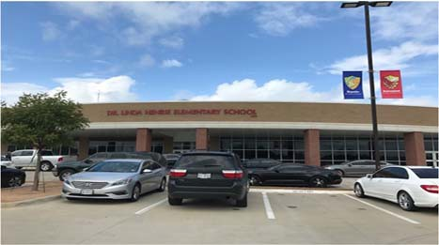
Liz Felton, Principal
The faculty and staﬀ of Henrie Elementary are
committed to the development of the total child, not only through a strong academic pro‐ gram, but also with emphasis on the nurturing and building of each child's self‐esteem.

Enrollment | 2016‐2017  951 | 2017‐2018  961 | 2018‐2019  935 | 2019‐2020  911 | 2020‐2021  860
Student/Teacher Ratio Staﬀ FTE's  Professional | 16.3  70.2 | 17.9  65.2 | 16.0  68.1 | 15.8  68.8
Teachers | 58.4 | 53.4 | 58.3 | 57.8
Professional Support | 8.8 | 8.8 | 7.8 | 8
Campus Administration Support  Educational Aides | 3  14.7 | 3  14.7 | 2  13.7 | 3  14.3
Total | 84.9 | 79.9 | 81.8 | 83.1
Expenditures | 2017 AUDITED | 2018 AUDITED | 2019 AUDITED | 2020 UNAUDITED | 2021 BUDGET
Payroll Costs | $ 4,213,588.12 | $ 4,597,250.37 | $ 4,524,426.20 | $ 4,806,577.39 | $ 4,656,300.00
Contracted Services | $ 138,031.69 | $ 149,605.07 | $ 141,258.21 | $ 109,503.35 | $ 125,700.00
Supplies and Materials | $ 104,013.09 | $ 113,189.38 | $ 140,163.53 | $ 182,725.42 | $ 134,200.00
Other Operating Costs | $ 45,395.80 | $ 37,889.28 | $ 41,296.42 | $ 28,320.68 | $ 37,200.00
Fixed Assets | $ 7,795.00 | $ 3,651.23 | $ 126,927.08 | $ 10,954.26 | $ 0.00
Grand Total | $ 4,508,823.70 | $ 4,901,585.33 | $ 4,974,071.44 | $ 5,138,081.10 | $ 4,953,400.00
Expenditures by Intent
 | 2017 AUDITED | 2018 AUDITED | 2019 AUDITED 2020 UNAUDITED 2021 BUDGET
Basic | $ 3,072,424.84 | $ 3,301,289.07 | $ 3,070,503.78 $ 3,037,167.33 $ 2,567,500.00
Gifted | $ 625.00 | $ 652.82 | $ 237,199.00 | $ 251,456.66 | $ 259,350.00
Special Education | $ 225,415.50 | $ 312,581.93 | $ 325,891.40 | $ 367,808.96 | $ 385,900.00
Compensatory |  | $ ‐ |  |  | $ 0.00
Bilingual | $ 67,794.03 | $ 66,775.01 | $ 41,557.01 | $ 69,382.44 | $ 76,350.00
SCE to Support Title I | $ 219,928.92 | $ 268,087.36 | $ 260,469.52 | $ 313,687.54 | $ 302,950.00
Pre‐Kindergarten |  |  |  | $ 0.00 | $ 35,200.00
Pre‐Kindergarten‐Comp Ed | $ 16,276.23 | $ 16,889.64 | $ 34,963.68 | $ 36,664.35 | $ 117,850.00
Pre‐Kindergarten‐Bilingual Ed | $ 52,767.82 | $ 59,575.63 | $ 129,700.94 | $ 141,036.21 | $ 143,550.00
Early Education Allotment |  |  |  | $ 68,663.46 | $ 174,350.00
Other Instructional Area | $ 853,591.36 | $ 875,733.87 | $ 873,786.11 | $ 852,214.15 | $ 890,400.00
Grand Total | $ 4,508,823.70 | $ 4,901,585.33 | $ 4,974,071.44 | $ 5,138,081.10 | $ 4,953,400.00
Per Student Cost | $ 4,741.14 | $ 5,100.51 | $ 5,319.86 | $ 5,640.05 | $ 5,759.77
Assessment Results | 2017 STAAR | 2018 STAAR | 2019 STAAR | 2020 STAAR | 2021 STAAR
Reading | 76% | 83% | 88% | NA
Mathematics | 80% | 89% | 88% | NA
Writing | 77% | 74% | 76% | NA
Science | 65% | 88% | 82% | NA

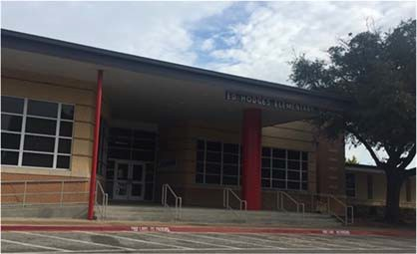Ed Hodges Elementary School

Dr. Kim Broadway, Principal

As a devoted and resolute community of lifelong learners, the mission of Hodges Elementary is to create an empowering, uplifting environment where life‐changing experiences develop resilient ad passionate students who grow into person of integrity and are prepared to make choices, solve problems, take risks, and produce change in our world.
 | 2016‐2017 | 2017‐2018 | 2018‐2019 | 2019‐2020 | 2020‐2021
Enrollment | 853 | 767 | 595 | 545 | 514
Student/Teacher Ratio Staﬀ FTE's  Professional | 17.9  57.2 | 18.08  52.2 | 14.9  48.5 | 14.6  46.3
Teachers | 47.4 | 42.4 | 39.9 | 37.3
Professional Support | 7.8 | 7.8 | 6.6 | 7
Campus Administration Support  Educational Aides | 2  12 | 2  12 | 2  9 | 2  8
Total | 69.2 | 64.2 | 57.5 | 54.3
Expenditures | 2017 AUDITED | 2018 AUDITED | 2019 AUDITED | 2020 UNAUDITED | 2021 BUDGET
Payroll Costs | $ 3,878,411.26 | $ 3,885,275.36 | $ 3,429,688.29 | $ 3,321,812.27 | $ 3,286,400.00
Contracted Services | $ 130,851.45 | $ 135,306.99 | $ 110,674.60 | $ 101,499.19 | $ 117,100.00
Supplies and Materials | $ 108,258.25 | $ 110,752.75 | $ 83,568.14 | $ 85,217.92 | $ 80,600.00
Other Operating Costs | $ 48,012.42 | $ 48,146.87 | $ 44,458.73 | $ 33,173.68 | $ 24,500.00
Fixed Assets | $ 19,165.65 | $ 8,730.93 | $ 265,473.89 | $ 1,252.26 | $ 0.00
Grand Total | $ 4,184,699.03 | $ 4,188,212.90 | $ 3,933,863.65 | $ 3,542,955.32 | $ 3,508,600.00
Expenditures by Program Intent

Basic | $ 2,691,318.53 | $ 2,610,098.18 | $ 2,461,676.51 | $ 2,087,544.24 | $ 1,958,400.00
Gifted | $ 625.00 | $ 200.00 | $ 464.12 | $ 0.00 | $ 650.00
Special Education | $ 292,237.41 | $ 327,750.80 | $ 261,972.23 | $ 225,331.10 | $ 248,300.00
Compensatory |  |  | $ ‐ |  | $ 0.00
Bilingual | $ 68,182.04 | $ 66,705.09 | $ 67,490.38 | $ 70,784.60 | $ 73,350.00
SCE to Support Title I | $ 211,535.39 | $ 228,297.40 | $ 212,575.80 | $ 219,652.52 | $ 242,550.00
Pre‐Kindergarten | $ 61,548.11 | $ 63,468.25 | $ 64,615.65 | $ 0.00 | $ 700.00
Prekindergarten‐Comp Ed | $ 40,170.89 | $ 39,013.82 | $ 38,288.80 | $ 22,049.63 | $ 50,900.00
Prekindergarten‐Bilingual Ed | $ 63,906.66 | $ 63,244.96 | $ 64,461.27 | $ 67,778.65 | $ 35,400.00
Early Education Allotment |  |  |  | $ 6,938.44 | $ 34,700.00
Dyslexia |  |  |  | $ 72,209.26 | $ 73,850.00
Other Instructional Area | $ 755,175.00 | $ 789,434.40 | $ 762,318.89 | $ 770,666.88 | $ 789,800.00
Grand Total | $ 4,184,699.03 | $ 4,188,212.90 | $ 3,933,863.65 | $ 3,542,955.32 | $ 3,508,600.00

Per Student Cost $ 4,905.86 $ 5,460.51 $ 6,611.54 $ 6,500.84 $ 6,826.07

2017 AUDITED 2018 AUDITED 2019 AUDITED 2020 UNAUDITED

Assessment Results | 2017 STAAR | 2018 STAAR | 2019 STAAR | 2020 STAAR | 2021 STAAR
Reading | 61% | 66% | 61% | NA
Mathematics | 71% | 76% | 71% | NA
Writing | 59% | 60% | 46% | NA
Science | 63% | 79% | 66% | NA
**Information obtained from the TEA PEIMS Standard Report and Munis Accounting

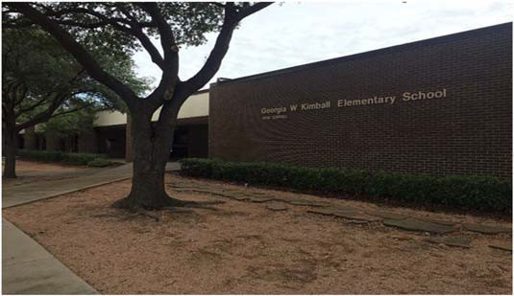Georgia W. Kimball Elementary School

Stacy Sheﬃeld, Principal

Georgia W. Kimball Elementary is a collaborative, driven and includible learning community where we inspire students to embrace challenges. Through our partnership with parents, we develop productive, creative and responsible students who can demonstrate compassion to‐ ward others and become responsible citizens who are lifelong learners.

 | 2016‐2017 | 2017‐2018 | 2018‐2019 | 2019‐2020 | 2020‐2021
Enrollment | 284 | 242 | 192 | 188 | 211
Student/Teacher Ratio | 14.6 | 14.7 | 11.2 | 11
Staﬀ FTE's
Professional | 24.9 | 21.9 | 22 | 21.9
Teachers | 19.5 | 16.5 | 17.2 | 17.1
Professional Support | 4.4 | 4.4 | 3.8 | 3.8
Campus Administration | 1 | 1 | 1 | 1
Support
Educational Aides | 5 | 5 | 6 | 6
Total | 29.9 | 26.9 | 28 | 27.9
Expenditures
 | 2017 AUDITED | 2018 AUDITED | 2019 AUDITED | 2020 UNAUDITED | 2021 BUDGET
Payroll Costs | $ 1,707,720.79 | $ 1,786,928.07 | $ 1,668,156.49 | $ 1,673,302.74 | $ 1,745,100.00
Contracted Services | $ 90,511.28 | $ 77,567.35 | $ 60,022.01 | $ 61,672.18 | $ 70,600.00
Supplies and Materials | $ 41,661.87 | $ 38,119.17 | $ 34,133.45 | $ 53,770.81 | $ 39,400.00
Other Operating Costs | $ 20,921.33 | $ 20,035.40 | $ 19,984.72 | $ 13,158.41 | $ 17,700.00
Fixed Assets | $ 6,969.15 | $ 2,349.23 | $ 33,269.48 | $ 4,486.26 | $ 0.00
Grand Total | $ 1,867,784.42 | $ 1,924,999.22 | $ 1,815,566.15 | $ 1,806,390.40 | $ 1,872,800.00
Expenditures by Intent
 | 2017 AUDITED | 2018 AUDITED | 2019 AUDITED | 2020 UNAUDITED | 2021 BUDGET
Basic | $ 1,020,317.39 | $ 1,068,527.74 | $ 912,242.28 | $ 833,774.46 | $ 770,800.00
Gifted | $ ‐ | $ 253.56 | $ 337.00 | $ 335.27 | $ 650.00
Special Education | $ 192,571.59 | $ 196,655.64 | $ 251,534.09 | $ 239,386.21 | $ 249,200.00
Bilingual | $ 57,298.56 | $ 58,689.74 | $ 60,737.53 | $ 65,956.05 | $ 0.00
SCE to Support Title I | $ 29,464.43 | $ 29,001.00 | $ 34,247.44 | $ 29,064.51 | $ 67,650.00
Pre‐Kindergarten |  |  |  | $ 0.00 | $ 29,100.00
Pre‐Kindergarten ‐ Comp Ed |  |  |  | $ 0.00 | $ 35,200.00
Early Education Allotment |  |  |  | $ 22,041.42 | $ 26,300.00
Dyslexia |  |  |  | $ 38,272.98 | $ 34,500.00
Other Instructional Area | $ 568,132.45 | $ 571,871.54 | $ 556,467.81 | $ 577,559.50 | $ 40,250.00
$ 619,150.00
Grand Total $ 1,867,784.42 $ 1,924,999.22 $ 1,815,566.15 $ 1,806,390.40 $ 1,872,800.00

Per Student Cost $ 6,576.71 $ 7,954.54 $ 9,456.07 $ 9,608.46 $ 8,875.83

Assessment Results | 2017 STAAR | 2018 STAAR | 2019 STAAR | 2020 STAAR | 2021 STAAR
Reading |  | 84% | 88% | NA
Mathematics | 88% | 93% | 92% | NA
Writing | 69% | 62% | 78% | NA
Science | 89% | 89% | 90% | NA

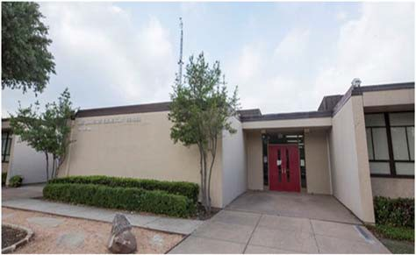J. H. Lawrence Elementary School

Dr. RoShanda Jenkins, Principal

"Every Child, Every Day"
 | 2016‐2017 | 2017‐2018 | 2018‐2019 | 2019‐2020 | 2020‐2021
Enrollment | 386 | 440 | 355 | 334 | 283
Student/Teacher Ratio | 12.9 | 15.2 | 12.7 | 14
Staﬀ FTE's
Professional | 48.8 | 47.8 | 36.9 | 32.8
Teachers | 29.9 | 28.9 | 27.9 | 23.8
Professional Support | 7.9 | 7.9 | 7 | 7
Campus Administration | 11 | 11 | 2 | 2
Support
Educational Aides | 11 | 11 | 12 | 12
Total | 61.6 | 58.8 | 48.9 | 44.8
Expenditures | 2017 AUDITED | 2018 AUDITED | 2019 AUDITED | 2020 UNAUDITED | 2021 BUDGET
Payroll Costs | $ 2,240,796.13 | $ 2,842,625.54 | $ 2,632,416.97 | $ 2,432,930.47 | $ 2,575,400.00
Contracted Services | $ 70,425.01 | $ 115,076.01 | $ 75,006.68 | $ 66,563.26 | $ 78,100.00
Supplies and Materials | $ 55,710.81 | $ 61,540.48 | $ 55,556.67 | $ 46,981.55 | $ 53,600.00
Other Operating Costs | $ 25,232.31 | $ 25,105.11 | $ 24,113.58 | $ 21,248.55 | $ 22,600.00
Fixed Assets | $ 160,438.57 | $ 17,887.46 | $ 774,917.24 | $ 1,252.26 | $ 0.00
Grand Total | $ 2,552,602.83 | $ 3,062,234.60 | $ 3,562,011.14 | $ 2,568,976.09 | $ 2,729,700.00
Expenditures by Intent | 2017 AUDITED | 2018 AUDITED | 2019 AUDITED | 2020 UNAUDITED | 2021 BUDGET
Basic | $ 1,190,390.23 | $ 1,678,313.88 | $ 1,535,969.98 | $ 1,280,661.68 | $ 1,370,700.00
Gifted | $ ‐ | $ ‐ | $ ‐ | $ 0.00 | $ 650.00
Special Education | $ 501,163.63 | $ 431,870.35 | $ 342,757.85 | $ 345,747.97 | $ 353,250.00
Bilingual | $ 55,723.78 | $ 57,561.99 | $ 58,038.66 | $ 68,695.62 | $ 0.00
SCE to Support Title I | $ 57,806.12 | $ 95,853.27 | $ 120,919.05 | $ 142,030.53 | $ 71,200.00
Pre‐Kindergarten | $ 62,371.80 | $ 60,890.09 | $ 62,091.92 | $ 0.00 | $ 171,900.00
Pre‐Kindergarten Comp Ed | $ 19,742.97 | $ 20,263.11 | $ 20,805.53 | $ 0.00 | $ 0.00
Early Education Allotment |  |  |  | $ 0.00 | $ 0.00
Dyslexia |  |  |  | $ 64,356.37 | $ 0.00
Other Instruction Area | $ 665,404.30 | $ 717,481.91 | $ 1,421,428.15 | $ 667,483.92 | $ 65,600.00
 |  |  |  |  | $ 696,400.00
Grand Total | $ 2,552,602.83 | $ 3,062,234.60 | $ 3,562,011.14 | $ 2,568,976.09 | $ 2,729,700.00
Per Student Cost | $ 6,612.96 | $ 6,959.62 | $ 10,033.83 | $ 7,691.55 | $ 9,645.58
Assessment Results | 2017 STAAR | 2018 STAAR | 2019 STAAR | 2020 STAAR | 2021 STAAR
Reading | 66% | 75% | 82% | NA
Mathematics | 75% | 83% | 85% | NA
Writing | 62% | 68% | 64% | NA
Science | 66% | 76% | 85% | NA

2017 AUDITED 2018 AUDITED 2019 AUDITED 2020 UNAUDITED 2021 BUDGET
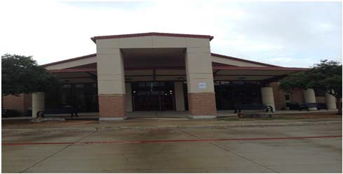Sue Ann Mackey Elementary School
Lynne Noe, Principal

Changing the world one child at a time.

 | 2016‐2017 | 2017‐2018 | 2018‐2019 | 2019‐2020 | 2020‐2021
Enrollment | 757 | 788 | 678 | 615 | 650
Student/Teacher Ratio | 16.6 | 19.4 | 16.7 | 14.4
Staﬀ FTE's
Professional | 55.5 | 50.5 | 49.4 | 51.7
Teachers | 45.7 | 40.7 | 40.7 | 42.7
Professional Support | 7.8 | 7.8 | 6.7 | 7
Campus Administration | 2 | 2 | 2 | 2
Support
Educational Aides | 11 | 11 | 8 | 8
Total | 66.5 | 61.5 | 57.4 | 59.7
Expenditures | 2017 AUDITED | 2018 AUDITED | 2019 AUDITED | 2020 UNAUDITED | 2021 BUDGET
Payroll Costs | $ 3,425,936.80 | $ 3,768,217.49 | $ 3,562,274.84 | $ 3,736,738.61 | $ 3,876,900.00
Contracted Services | $ 117,018.20 | $ 125,746.28 | $ 124,506.21 | $ 136,032.36 | $ 160,500.00
Supplies and Materials | $ 92,782.51 | $ 75,036.53 | $ 67,597.27 | $ 100,971.88 | $ 84,700.00
Other Operating Costs | $ 26,149.65 | $ 26,981.02 | $ 34,736.26 | $ 21,392.14 | $ 24,800.00
Fixed Assets | $ 7,076.10 | $ 184,681.43 | $ 171,714.44 | $ 7,720.26 | $ 0.00
Grand Total | $ 3,668,963.26 | $ 4,180,662.75 | $ 3,960,829.02 | $ 4,002,855.25 | $ 4,146,900.00
Expenditures by Intent

Basic | $ 2,503,792.76 | $ 2,974,177.66 | $ 2,688,259.44 | $ 2,564,902.78 | $ 2,478,050.00
Gifted | $ ‐ | $ 141.89 | $ ‐ | $ 0.00 | $ 650.00
Special Education | $ 227,861.91 | $ 224,879.76 | $ 265,907.00 | $ 287,207.17 | $ 298,650.00
Bilingual | $ 67,528.29 | $ 66,751.07 | $ 58,654.17 | $ 64,608.12 | $ 0.00
SCE to Support Title I | $ 191,052.79 | $ 201,269.86 | $ 155,686.11 | $ 235,432.26 | $ 67,150.00
Pre‐Kindergarten |  |  |  | $ 0.00 | $ 261,100.00
Pre‐Kindergarten ‐ Comp Ed |  |  |  | $ 0.00 | $ 35,200.00
Pre‐Kindergarten ‐ Bilingual Ed |  |  |  | $ 0.00 | $ 52,600.00
Early Education Allotment |  |  |  | $ 43,792.84 | $ 35,200.00
Dyslexia |  |  |  | $ 68,285.41 | $ 69,000.00
Other Instructional Area | $ 678,727.51 | $ 713,442.51 | $ 792,322.30 | $ 738,626.67 | $ 69,050.00
 |  |  |  |  | $ 780,250.00
Grand Total | $ 3,668,963.26 | $ 4,180,662.75 | $ 3,960,829.02 | $ 4,002,855.25 | $ 4,146,900.00
Per Student Cost | $ 4,846.72 | $ 5,305.41 | $ 5,841.93 | $ 6,508.71 | $ 6,379.85
Assessment Results | 2017 STAAR | 2018 STAAR | 2019 STAAR | 2020 STAAR | 2021 STAAR
Reading |  | 61% | 75% | NA
Mathematics | 70% | 72% | 78% | NA
Writing | 49% | 48% | 64% | NA
Science | 59% | 51% | 77% | NA

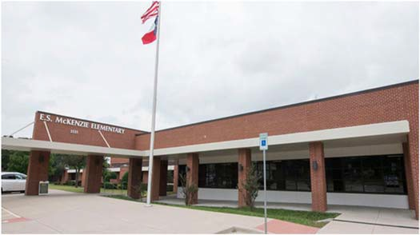E. S. McKenzie Elementary School
2017 AUDITED
2018 AUDITED
2019 AUDTIED 2020 UNAUDITED 2021 BUDGET
Suzanne Langston, Principal

Our Mission at McKenzie Elementary is to foster an inviting climate that involves students, families, staﬀ, and the community as key contributors to educational success. Through innovative practices, we are on a quest to be constantly improving. Together we work to find success in EACH one, SOME way, EVERY day!

 | 2016‐2017 | 2017‐2018 | 2018‐2019 | 2019‐2020 | 2020‐2021
Enrollment | 598 | 538 | 475 | 454 | 414
Student/Teacher Ratio  Staﬀ FTE's  Professional | 17.4  43.2 | 15.6  43.2 | 14.8  40 | 14.5  39
Teachers | 34.4 | 34.4 | 32.2 | 31.4
Professional Support | 6.8 | 6.8 | 5.8 | 5.6
Campus Administration  Support  Educational Aides | 2  8 | 2  8 | 2  7 | 2  7
Total | 51.2 | 51.2 | 47 | 46
Expenditures
 | 2017 AUDITED | 2018 AUDITED | 2019 AUDITED | 2020 UNAUDITED | 2021 BUDGET
Payroll Costs | $ 2,686,639.48 | $ 2,804,763.88 | $ 2,712,756.82 | $ 2,831,379.11 | $ 2,938,900.00
Contracted Services | $ 87,375.45 | $ 80,127.22 | $ 79,050.68 | $ 81,675.37 | $ 93,600.00
Supplies and Materials | $ 63,176.16 | $ 69,451.06 | $ 59,452.14 | $ 68,734.91 | $ 63,800.00
Other Operating Costs | $ 24,823.45 | $ 24,834.77 | $ 25,716.72 | $ 15,969.62 | $ 22,200.00
Fixed Assets | $ 6,003.44 | $ 539,033.49 | $ 230,037.03 | $ 10,151.46 | $ 0.00
Grand Total | $ 2,868,017.98 | $ 3,518,210.42 | $ 3,107,013.39 | $ 3,007,910.47 | $ 3,118,500.00
Expenditures by Intent

Basic | $ 1,916,392.84 | $ 2,000,662.68 | $ 2,096,108.84 | $ 1,972,015.36 | $ 1,924,550.00
Gifted | $ ‐ | $ ‐ | $ ‐ | $ 0.00 | $ 650.00
Special Education | $ 98,841.11 | $ 108,567.23 | $ 88,815.66 | $ 148,746.63 | $ 153,600.00
Bilingual | $ 74,915.80 | $ 77,607.79 | $ 81,567.02 | $ 69,456.31 | $ 0.00
SCE to Support Title I | $ 144,602.39 | $ 145,283.56 | $ 140,122.25 | $ 141,753.56 | $ 71,150.00
Pre‐Kindergarten |  |  |  | $ 0.00 | $ 181,300.00
Pre‐Kindergarten ‐ Comp Ed |  |  |  | $ 0.00 | $ 35,200.00
Early Education Allotment |  |  |  | $ 22,191.92 | $ 26,300.00
Other Instructional Area | $ 633,265.84 | $ 1,186,089.16 | $ 700,399.62 | $ 653,746.69 | $ 34,500.00
 |  |  |  |  | $ 691,250.00
Grand Total | $ 2,868,017.98 | $ 3,518,210.42 | $ 3,107,013.39 | $ 3,007,910.47 | $ 3,118,500.00
Per Student Cost | $ 4,796.02 | $ 6,539.42 | $ 6,541.08 | $ 6,625.35 | $ 7,532.61
Assessment Results | 2017 STAAR | 2018 STAAR | 2019 STAAR | 2020 STAAR | 2021 STAAR
Reading |  | 72% | 76% | NA
Mathematics | 76% | 78% | 83% | NA
Writing | 56% | 52% | 61% | NA
Science | 70% | 70% | 83% | NA

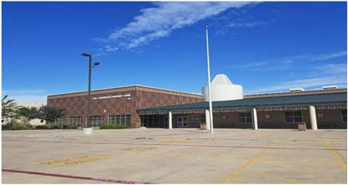Fred A. McWhorter Elementary School

Tammi Froning, Principal

Going the distance for success!

 | 2016‐2017 | 2017‐2018 | 2018‐2019 | 2019‐2020 | 2020‐2021
Enrollment | 956 | 870 | 722 | 633 | 549
Student/Teacher Ratio | 17.9 | 18.8 | 16.5 | 14.7
Staﬀ FTE's  Professional | 65.6 | 58.6 | 52.7 | 52.2
Teachers | 53.2 | 46.2 | 43.7 | 43.2
Professional Support | 9.4 | 9.4 | 7 | 7
Campus Administration  Support  Educational Aides | 3  14.5 | 3  14.5 | 2  12 | 2  11
Total | 80.1 | 73.1 | 64.7 | 63.2
Expenditures | 2017 AUDITED | 2018 AUDITED | 2019 AUDITED | 2020 UNAUDITED | 2021 BUDGET
Payroll Costs | $ 4,213,834.33 | $ 4,527,904.75 | $ 3,768,115.63 | $ 3,890,860.68 | $ 3,655,200.00
Contracted Services | $ 162,071.19 | $ 165,992.77 | $ 136,301.03 | $ 141,503.25 | $ 169,400.00
Supplies and Materials | $ 86,944.99 | $ 81,200.14 | $ 75,718.87 | $ 79,295.71 | $ 86,400.00
Other Operating Costs | $ 27,786.30 | $ 30,301.10 | $ 24,554.53 | $ 17,891.17 | $ 21,100.00
Fixed Assets | $ 10,688.70 | $ 11,916.31 | $ 235,601.54 | $ 26,879.47 | $ 0.00
Grand Total | $ 4,501,325.51 | $ 4,817,315.07 | $ 4,240,291.60 | $ 4,156,430.28 | $ 3,932,100.00
Expenditures by Intent | 2017 AUDITED | 2018 AUDITED | 2019 AUDITED | 2020 UNAUDITED | 2021 BUDGET
Basic | $ 2,775,550.90 | $ 3,066,337.55 | $ 2,710,563.65 | $ 2,445,276.97 | $ 2,160,350.00
Gifted | $ 502.73 | $ 619.42 | $ 584.54 | $ 307.20 | $ 650.00
Special Education | $ 519,773.32 | $ 542,219.51 | $ 425,687.46 | $ 414,449.39 | $ 418,400.00
Bilingual | $ 63,564.49 | $ 64,662.21 | $ 78,047.54 | $ 74,201.06 | $ 0.00
SCE to Support Title I | $ 154,918.41 | $ 146,610.92 | $ 130,596.17 | $ 209,876.15 | $ 70,900.00
Pre‐Kindergarten | $ 73,619.52 | $ 74,864.95 | $ 68,320.19 | $ 66,095.71 | $ 243,550.00
Pre‐Kindergarten‐Comp Ed | $ 40,826.60 | $ 39,799.85 | $ 40,711.29 | $ 43,605.70 | $ 60,950.00
Pre‐Kindergarten‐Bilingual Ed | $ 61,010.54 | $ 62,643.19 | $ 63,783.16 | $ 67,182.63 | $ 46,300.00
Early Education Allotment |  |  |  | $ 7,778.08 | $ 34,650.00
Dyslexia |  |  |  | $ 74,749.31 | $ 34,100.00
Other Instructional Area | $ 811,559.00 | $ 819,557.47 | $ 721,997.60 | $ 752,908.08 | $ 66,950.00
 |  |  |  |  | $ 795,300.00
Grand Total | $ 4,501,325.51 | $ 4,817,315.07 | $ 4,240,291.60 | $ 4,156,430.28 | $ 3,932,100.00
Per Student Cost | $ 4,708.50 | $ 5,537.14 | $ 5,872.98 | $ 6,566.24 | $ 7,162.30
Assessment Results | 2017 STAAR | 2018 STAAR | 2019 STAAR | 2020 STAAR | 2021 STAAR
Reading | 57% | 62% | 71% | NA
Mathematics | 66% | 69% | 73% | NA
Writing | 44% | 43% | 63% | NA
Science | 58% | 60% | 62% | NA

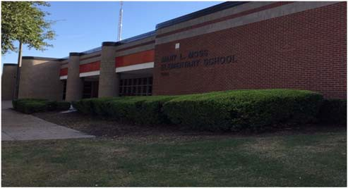Mary L. Moss Elementary School
Michael Pierotti , Principal

All day, Every day, Moss PRIDE.

 | 2016‐2017 | 2017‐2018 | 2018‐2019 | 2019‐2020 | 2020‐2021
Enrollment | 483 | 434 | 391 | 380 | 323
Student/Teacher Ratio  Staﬀ FTE's | 17.3 | 18.9 | 15 | 14.7
Professional | 35.8 | 30.8 | 33.6 | 33.8
Teachers | 28 | 23 | 26 | 25.8
Professional Support | 5.8 | 5.8 | 5.6 | 6
Campus Administration  Support  Educational Aides | 2  4 | 2  4 | 2  7 | 2  6.9
Total | 39.8 | 34.8 | 40.6 | 40.7
Expenditures | 2017 AUDITED | 2018 AUDITED | 2019 AUDITED | 2020 UNAUDITED | 2021 BUDGET
Payroll Costs | $ 2,471,552.15 | $ 2,599,723.77 | $ 2,469,682.46 | $ 2,598,638.98 | $ 2,579,900.00
Contracted Services | $ 124,289.43 | $ 91,106.84 | $ 89,115.91 | $ 153,974.30 | $ 207,500.00
Supplies and Materials | $ 52,105.92 | $ 61,406.85 | $ 49,721.31 | $ 38,239.59 | $ 54,300.00
Other Operating Costs | $ 16,211.32 | $ 18,239.79 | $ 19,744.74 | $ 14,354.44 | $ 21,200.00
Fixed Assets | $ 126,662.62 | $ 4,342.04 | $ 58,466.98 | $ 11,417.58 | $ 0.00
Grand Total | $ 2,790,821.44 | $ 2,774,819.29 | $ 2,686,731.40 | $ 2,816,624.89 | $ 2,862,900.00
Expenditures by Intent | 2017 AUDITED | 2018 AUDITED | 2019 AUDITED | 2020 UNAUDITED | 2021 BUDGET
Basic | $ 1,696,608.90 | $ 1,743,351.06 | $ 1,483,690.08 | $ 1,444,010.71 | $ 1,403,800.00
Gifted | $ 662.90 | $ 632.70 | $ 640.25 | $ 644.50 | $ 650.00
Special Education | $ 206,428.61 | $ 215,206.60 | $ 296,388.89 | $ 325,544.00 | $ 332,800.00
Bilingual | $ 73,469.11 | $ 75,204.91 | $ 81,583.93 | $ 68,689.75 | $ 0.00
SCE to Support Title I | $ 89,191.36 | $ 100,352.73 | $ 108,968.27 | $ 93,684.93 | $ 69,950.00
Pre‐Kindergarten |  |  | $ 62,189.69 | $ 65,878.33 | $ 97,400.00
Pre‐Kindergarten‐Comp Ed |  |  | $ 18,157.08 | $ 18,955.24 | $ 34,200.00
Early Education Allotment |  |  |  | $ 3,228.24 | $ 20,050.00
Dyslexia |  |  |  | $ 67,823.70 | $ 33,600.00
Other Instructional Area | $ 724,460.56 | $ 640,071.29 | $ 635,113.21 | $ 728,165.49 | $ 69,050.00
$ 801,400.00
Grand Total | $ 2,790,821.44 | $ 2,774,819.29 | $ 2,686,731.40 | $ 2,816,624.89 | $ 2,862,900.00
Per Student Cost | $ 5,778.10 | $ 6,393.59 | $ 6,871.44 | $ 7,412.17 | $ 8,863.47
Assessment Results | 2017 STAAR | 2018 STAAR | 2019 STAAR | 2020 STAAR | 2021 STAAR
Reading | 76% | 79% | 76% | NA
Mathematics | 78% | 82% | 82% | NA
Writing | 54% | 60% | 66% | NA
Science | 69% | 85% | 75% | NA

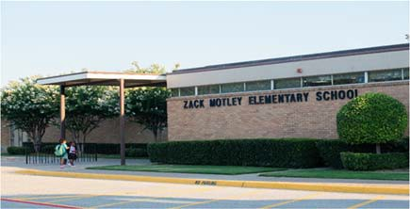Zach Motley Elementary School
Dr. Shawna Delamar, Principal

We will work hard to grow every student every day. At Motley we are a family dedicated and passionate about serving students and their families.
 | 2016‐2017 | 2017‐2018 | 2018‐2019 | 2019‐2020 | 2020‐2021
Enrollment | 499 | 455 | 343 | 338 | 276
Student/Teacher Ratio Staﬀ FTE's  Professional | 16.7  38.5 | 17.6  34.5 | 14.5  31.2 | 15.7  28.9
Teachers | 29.9 | 25.9 | 23.6 | 21.5
Professional Support | 6.6 | 6.6 | 5.6 | 5.4
Campus Administration Support  Educational Aides | 2  10.5 | 2  10.5 | 2  8 | 2  8
Total | 48.5 | 45 | 39.2 | 36.9
Expenditures | 2017 AUDITED | 2018 AUDITED | 2019 AUDITED | 2020 UNAUDITED | 2021 BUDGET
Payroll Costs | $ 2,632,690.41 | $ 2,674,584.27 | $ 2,290,056.03 | $ 2,250,077.17 | $ 2,359,700.00
Contracted Services | $ 97,543.15 | $ 86,764.67 | $ 66,220.61 | $ 72,078.60 | $ 80,400.00
Supplies and Materials | $ 55,312.60 | $ 59,701.63 | $ 46,931.29 | $ 64,955.87 | $ 50,000.00
Other Operating Costs | $ 28,206.50 | $ 32,359.22 | $ 26,852.43 | $ 23,570.78 | $ 17,800.00
Fixed Assets | $ 9,924.70 | $ 113,825.82 | $ 55,842.92 | $ 1,252.26 | $ 0.00
Grand Total | $ 2,823,677.36 | $ 2,967,235.61 | $ 2,485,903.28 | $ 2,411,934.68 | $ 2,507,900.00
Expenditures by Intent | 2017 AUDITED | 2018 AUDITED | 2019 AUDITED | 2020 UNAUDITED | 2021 BUDGET
Basic | $ 1,515,041.15 | $ 1,661,721.12 | $ 1,353,757.98 | $ 1,190,348.12 | $ 1,163,450.00
Gifted | $ 158.94 | $ 451.29 | $ 438.65 | $ 654.52 | $ 650.00
Special Education | $ 271,809.42 | $ 236,056.49 | $ 176,175.05 | $ 185,168.36 | $ 193,150.00
Compensatory | $ 0.00 | $ 0.00 |  |  | $ 0.00
Bilingual | $ 146,164.99 | $ 148,467.31 | $ 86,366.64 | $ 90,364.64 | $ 93,600.00
SCE to Support Title I | $ 121,363.02 | $ 115,429.03 | $ 124,011.91 | $ 84,775.65 | $ 160,350.00
Pre‐Kindergarten | $ 58,292.63 | $ 62,828.17 | $ 63,742.13 | $ 67,251.83 | $ 69,050.00
Pre‐Kindergarten‐Comp Ed | $ 34,110.30 | $ 34,822.50 | $ 32,050.24 | $ 35,320.26 | $ 37,800.00
Pre‐Kindergarten‐Bilingual Ed | $ 57,503.28 | $ 60,160.43 | $ 60,026.84 | $ 64,119.06 | $ 33,700.00
Early Education Allotment |  |  |  | $ 8,856.92 | $ 33,000.00
Dyslexia |  |  |  | $ 70,296.30 | $ 71,400.00
Other Instructional Area | $ 619,233.63 | $ 647,299.27 | $ 589,333.84 | $ 614,779.02 | $ 651,750.00
Grand Total | $ 2,823,677.36 | $ 2,967,235.61 | $ 2,485,903.28 | $ 2,411,934.68 | $ 2,507,900.00
Per Student Cost | $ 5,658.67 | $ 6,521.40 | $ 7,247.53 | $ 7,135.90 | $ 9,086.59
Assessment Results | 2017 STAAR | 2018 STAAR | 2019 STAAR | 2020 STAAR | 2021 STAAR
Reading | 67% | 76% | 84% | NA
Mathematics | 84% | 84% | 85% | NA
Writing | 64% | 66% | 73% | NA
Science | 72% | 87% | 83% | NA

**Information obtained from the TEA PEIMS Standard Report and Munis Accounting

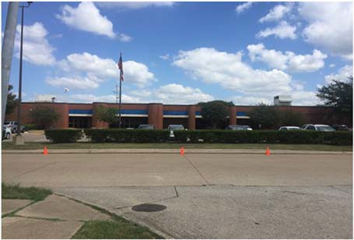Dr. Joey Pirrung Elementary School

Paige Brison, Principal

The mission of Pirrung Elementary is to empower students to excel and become confident, productive citizens as they dis‐ cover their own purposes and transform the lives of others with integrity and kindness.

 | 2016‐2017 | 2017‐2018 | 2018‐2019 | 2019‐2020 | 2020‐2021
Enrollment | 441 | 434 | 438 | 392 | 396
Student/Teacher Ratio  Staﬀ FTE's Professional | 15.9  35.7 | 16.9  33.7 | 16.5  33.5 | 15.5  32.3
Teachers | 27.7 | 25.7 | 26.5 | 25.3
Professional Support | 6 | 6 | 5 | 5
Campus Administration  Support  Educational Aides | 2  6 | 2  6 | 2  7.9 | 2  7
Total | 41.7 | 39.7 | 41.4 | 39.3
Expenditures
 | 2017 AUDITED | 2018 AUDITED | 2019 AUDITED | 2020 UNAUDITED | 2021 BUDGET
Payroll Costs | $ 2,190,943.50 | $ 2,415,778.96 | $ 2,340,085.33 | $ 2,302,446.41 | $ 2,521,100.00
Contracted Services | $ 98,785.69 | $ 111,051.04 | $ 74,406.48 | $ 72,808.91 | $ 88,000.00
Supplies and Materials | $ 56,144.26 | $ 50,621.06 | $ 60,570.72 | $ 64,639.67 | $ 56,100.00
Other Operating Costs | $ 22,162.35 | $ 19,789.82 | $ 24,459.94 | $ 14,404.09 | $ 19,800.00
Fixed Assets | $ 7,238.70 | $ 16,629.71 | $ 646,965.84 | $ 10,640.36 | $ 0.00
Grand Total | $ 2,375,274.50 | $ 2,613,870.59 | $ 3,146,488.31 | $ 2,464,939.44 | $ 2,685,000.00
Expenditures by Intent | 2017 AUDITED | 2018 AUDITED | 2019 AUDITED | 2020 UNAUDITED | 2021 BUDGET
Basic | $ 1,369,184.26 | $ 1,573,519.36 | $ 1,511,433.36 | $ 1,383,859.59 | $ 1,412,500.00
Gifted | $ ‐ | $ ‐ | $ ‐ | $ 0.00 | $ 650.00
Special Education | $ 238,214.62 | $ 215,923.11 | $ 243,319.60 | $ 263,850.04 | $ 272,850.00
Bilingual | $ 101,669.67 | $ 82,011.37 | $ 65,418.88 | $ 69,392.50 | $ 0.00
SCE to Support Title I | $ 39,629.80 | $ 69,601.21 | $ 101,382.99 | $ 67,782.57 | $ 70,700.00
Pre‐Kindergarten | $ ‐ | $ ‐ | $ ‐ | $ 0.00 | $ 144,750.00
Pre‐Kindergarten ‐ Comp Ed |  |  |  | $ 0.00 | $ 35,200.00
Early Education Allotment |  |  |  | $ 22,110.77 | $ 26,300.00
Other Instructional Area | $ 626,576.15 | $ 672,815.54 | $ 1,224,933.48 | $ 657,943.97 | $ 34,500.00
 |  |  |  |  | $ 687,550.00
Grand Total | $ 2,375,274.50 | $ 2,613,870.59 | $ 3,146,488.31 | $ 2,464,939.44 | $ 2,685,000.00
Per Student Cost | $ 5,386.11 | $ 6,022.74 | $ 7,183.76 | $ 6,288.11 | $ 6,780.30
Assessment Results | 2017 STAAR | 2018 STAAR | 2019 STAAR | 2020 STAAR | 2021 STAAR
Reading | 75% | 76% | 80% | NA
Mathematics | 88% | 69% | 77% | NA
Writing | 69% | 52% | 49% | NA
Science | 89% | 60% | 70% | NA

**Information obtained from the TEA PEIMS Standard Report and Munis Accounting

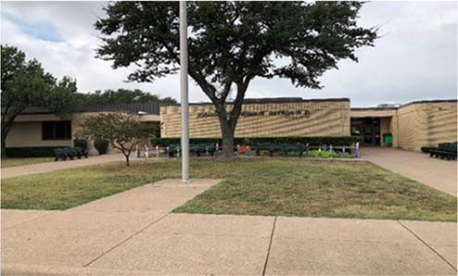
2018‐2019 2019‐2020 2020‐2021
G.R. Porter Elementary School
Becky Rasco, Principal
Porter will be a unified campus with high expectations for critical
thinking, creativity, and problem solving. Providing a nurturing, respectful environment based on supportive relationships be‐ tween teachers, students and parents that encourage every child to be the best they can be.

Enrollment | 2016‐2017  619 | 2017‐2018  605 | 442 | 421 | 389
Student/Teacher Ratio | 16.6 | 19.3 | 15.3 | 14.3
Staﬀ FTE's  Professional | 45.9 | 39.9 | 36.3 | 35.4
Teachers | 37.3 | 31.3 | 28.9 | 29.4
Professional Support | 6.6 | 6.6 | 5.4 | 4
Campus Administration Support  Educational Aides | 2  8 | 2  8 | 2  5.9 | 2  6
Total | 53.9 | 47.9 | 42.2 | 41.4
Expenditures | 2017 AUDITED | 2018 AUDITED | 2019 AUDITED | 2020 UNAUDITED | 2021 BUDGET
Payroll Costs | $ 2,949,723.73 | $ 3,152,588.92 | $ 2,616,568.81 | $ 2,629,410.35 | $ 2,643,400.00
Contracted Services | $ 81,321.35 | $ 84,172.03 | $ 74,556.14 | $ 82,021.46 | $ 82,700.00
Supplies and Materials | $ 70,275.21 | $ 71,594.48 | $ 62,686.40 | $ 87,818.40 | $ 113,400.00
Other Operating Costs | $ 26,584.84 | $ 21,310.11 | $ 22,611.21 | $ 17,569.15 | $ 20,000.00
Fixed Assets | $ 141,278.96 | $ 1,078.91 | $ 67,503.32 | $ 63,096.69 | $ 50,000.00
Grand Total | $ 3,269,184.09 | $ 3,330,744.45 | $ 2,843,925.88 | $ 2,879,916.05 | $ 2,909,500.00
Expenditures by Intent | 2017 AUDITED | 2018 AUDITED | 2019 AUDITED | 2020 UNAUDITED | 2021 BUDGET
Basic | $ 2,150,773.20 | $ 2,148,728.89 | $ 1,744,230.70 | $ 1,702,231.12 | $ 1,607,650.00
Gifted | $ ‐ | $ ‐ | $ ‐ | $ 0.00 | $ 650.00
Special Education | $ 145,120.64 | $ 175,650.12 | $ 150,311.82 | $ 116,820.33 | $ 120,150.00
Bilingual | $ 82,204.24 | $ 71,564.31 | $ 70,974.81 | $ 74,272.49 | $ 0.00
SCE to Support Title I | $ 167,568.64 | $ 191,560.28 | $ 140,395.71 | $ 182,135.07 | $ 75,500.00
Pre‐Kindergarten |  |  |  | $ 0.00 | $ 209,400.00
Pre‐Kindergarten‐Comp Ed | $ 17,222.44 | $ 20,558.89 | $ 25,638.02 | $ 25,087.13 | $ 0.00
Pre‐Kindergarten‐Bilingual | $ 58,154.37 | $ 60,020.57 | $ 60,488.56 | $ 64,409.43 | $ 26,900.00
Early Education Allotment |  |  |  | $ 4,019.94 | $ 33,200.00
Other Instructional Area | $ 648,140.56 | $ 662,661.39 | $ 651,886.26 | $ 710,940.54 | $ 32,500.00
 |  |  |  |  | $ 803,550.00
Grand Total | $ 3,269,184.09 | $ 3,330,744.45 | $ 2,843,925.88 | $ 2,879,916.05 | $ 2,909,500.00
Per Student Cost | $ 5,281.40 | $ 5,505.36 | $ 6,434.22 | $ 6,840.66 | $ 7,479.43
Assessment Results | 2017 STAAR | 2018 STAAR | 2019 STAAR | 2020 STAAR | 2021 STAAR
Reading | 73% | 78% | 87% | NA
Mathematics | 86% | 91% | 93% | NA
Writing | 70% | 68% | 70% | NA
Science | 81% | 76% | 84% | NA

**Information obtained from the TEA PEIMS Standard Report and Munis Accounting

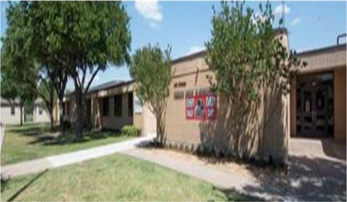Vernon Price Elementary School

Ashley Goodwin, Principal

Excellence Always!
 | 2016‐2017 | 2017‐2018 | 2018‐2019 | 2019‐2020 | 2020‐2021
Enrollment | 450 | 451 | 379 | 348 | 299
Student/Teacher Ratio  Staﬀ FTE's  Professional | 15  37.6 | 18.8  31.6 | 15.4  32.6 | 16.1  29.6
Teachers | 30 | 24 | 24.6 | 21.6
Professional Support | 5.6 | 5.6 | 6 | 6
Campus Administration  Support  Educational Aides | 2  8 | 2  8 | 2  8 | 2  8
Total | 45.6 | 39.6 | 40.6 | 37.6
Expenditures
 | 2017 AUDITED | 2018 AUDITED | 2019 AUDITED | 2020 UNAUDITED | 2021 BUDGET
Payroll Costs | $ 2,580,553.85 | $ 2,574,715.10 | $ 2,262,071.07 | $ 2,251,552.66 | $ 2,332,300.00
Contracted Services | $ 66,369.12 | $ 68,366.19 | $ 66,314.70 | $ 62,071.76 | $ 65,400.00
Supplies and Materials | $ 59,332.82 | $ 46,423.74 | $ 36,937.09 | $ 39,132.42 | $ 51,700.00
Other Operating Costs | $ 20,790.59 | $ 20,089.89 | $ 20,909.95 | $ 19,396.21 | $ 18,600.00
Fixed Assets | $ 111,064.47 | $ 489,268.53 | $ 80,925.96 | $ 50,752.26 | $ 0.00
Grand Total | $ 2,838,110.85 | $ 3,198,863.45 | $ 2,467,158.77 | $ 2,422,905.31 | $ 2,468,000.00
Expenditures by Intent | 2017 AUDITED | 2018 AUDITED | 2019 AUDITED | 2020 UNAUDITED | 2021 BUDGET
Basic | $ 1,745,380.56 | $ 1,624,565.26 | $ 1,298,586.65 | $ 1,180,319.98 | $ 1,152,300.00
Gifted | $ ‐ | $ ‐ | $ ‐ | $ 0.00 | $ 650.00
Special Education | $ 235,382.51 | $ 229,539.73 | $ 312,861.35 | $ 387,826.54 | $ 396,200.00
Bilingual | $ 83,558.64 | $ 64,621.68 | $ 38,106.99 | $ 76,640.94 | $ 0.00
SCE to Support Title I | $ 113,356.97 | $ 100,464.71 | $ 103,754.26 | $ 67,469.82 | $ 78,200.00
Pre‐Kindergarten | $ 38,955.63 | $ 60,376.53 | $ 61,205.91 | $ 65,524.62 | $ 108,000.00
Pre‐Kindergarten ‐ Comp Ed | $ 16,058.10 | $ 16,453.66 | $ 20,524.44 | $ 21,630.97 | $ 33,850.00
Early Education Allotment |  |  |  | $ 3,568.44 | $ 22,650.00
Other Instructional Area | $ 605,418.44 | $ 1,102,841.88 | $ 632,119.17 | $ 619,924.00 | $ 33,150.00
$ 643,000.00
Grand Total | $ 2,838,110.85 | $ 3,198,863.45 | $ 2,467,158.77 | $ 2,422,905.31 | $ 2,468,000.00
Per Student Cost | $ 6,306.91 | $ 7,092.82 | $ 6,509.65 | $ 6,962.37 | $ 8,254.18
Assessment Results | 2017 STAAR | 2018 STAAR | 2019 STAAR | 2020 STAAR | 2021 STAAR
Reading | 59% | 60% | 63% | NA
Mathematics | 63% | 73% | 76% | NA
Writing | 31% | 31% | 50% | NA
Science | 59% | 68% | 75% | NA

**Information obtained from the TEA PEIMS Standard Report and Munis Accounting

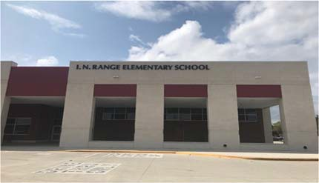N. Range Elementary School

Kelly Locke, Principal

To develop and grow all students academically, socially, and emotionally in order to foster a life‐long desire to learn.
 | 2016‐2017 | 2017‐2018 | 2018‐2019 | 2019‐2020 | 2020‐2021
Enrollment | 743 | 763 | 613 | 601 | 580
Student/Teacher Ratio  Staﬀ FTE's Professional | 16.4  53.6 | 18.5  49.6 | 15.4  47.1 | 15.4  46.5
Teachers | 45.2 | 41.2 | 39.7 | 38.9
Professional Support | 6.4 | 6.4 | 5.4 | 5.6
Campus Administration  Support  Educational Aides | 2  11.3 | 2  11.3 | 2  10.9 | 2  10
Total | 64.9 | 60.9 | 58 | 56.5
Expenditures | 2017 AUDITED | 2018 AUDITED | 2019 AUDITED | 2020 UNAUDITED | 2021 BUDGET
Payroll Costs | $ 3,631,824.62 | $ 3,887,839.59 | $ 3,468,498.44 | $ 3,489,358.24 | $ 3,723,950.00
Contracted Services | $ 119,407.49 | $ 130,148.29 | $ 137,983.85 | $ 236,746.51 | $ 269,500.00
Supplies and Materials | $ 110,360.05 | $ 76,035.05 | $ 92,825.67 | $ 120,943.66 | $ 90,900.00
Other Operating Costs | $ 32,823.72 | $ 33,681.39 | $ 37,699.98 | $ 29,947.73 | $ 22,300.00
Fixed Assets | $ 33,486.28 | $ 2,174.46 | $ 94,696.28 | $ 7,720.26 | $ 0.00
Grand Total | $ 3,927,902.16 | $ 4,129,878.78 | $ 3,831,704.22 | $ 3,884,716.40 | $ 4,106,650.00
Expenditures by Intent | 2017 AUDITED | 2018 AUDITED | 2019 AUDITED | 2020 UNAUDITED | 2021 BUDGET
Basic | $ 2,592,956.96 | $ 2,772,372.85 | $ 2,521,429.50 | $ 2,348,009.86 | $ 2,288,050.00
Gifted | $ 649.95 | $ 645.79 | $ ‐ | $ 0.00 | $ 650.00
Special Education | $ 337,247.24 | $ 356,484.26 | $ 360,438.69 | $ 356,936.88 | $ 369,450.00
Bilingual | $ 63,180.46 | $ 64,923.65 | $ 65,479.16 | $ 68,446.05 | $ 0.00
SCE to Support Title I | $ 156,251.91 | $ 159,600.05 | $ 159,491.86 | $ 158,612.25 | $ 70,500.00
Pre‐Kindergarten |  |  |  | $ 0.00 | $ 231,850.00
Pre‐Kindergarten ‐ Comp Ed |  |  |  | $ 0.00 | $ 69,700.00
Pre‐Kindergarten ‐ Bilingual Ed |  |  |  | $ 0.00 | $ 51,200.00
Early Education Allotment |  |  |  | $ 44,003.24 | $ 700.00
Dyslexia |  |  |  | $ 66,634.12 | $ 69,000.00
Other Instructional Area | $ 777,615.64 | $ 775,852.18 | $ 724,865.01 | $ 842,074.00 | $ 67,800.00
$ 887,750.00
Grand Total | $ 3,927,902.16 | $ 4,129,878.78 | $ 3,831,704.22 | $ 3,884,716.40 | $ 4,106,650.00
Per Student Cost | $ 5,286.54 | $ 5,412.69 | $ 6,250.74 | $ 6,463.75 | $ 7,080.43
Assessment Results | 2017 STAAR | 2018 STAAR | 2019 STAAR | 2020 STAAR | 2021 STAAR
Reading |  | 73% | 72% | NA
Mathematics | 78% | 83% | 73% | NA
Writing | 67% | 58% | 70% | NA
Science | 71% | 75% | 72% | NA

**Information obtained from the TEA PEIMS Standard Report and Munis Accounting

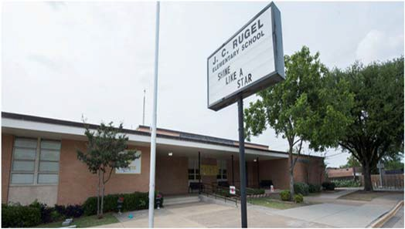J. C. Rugel Elementary School
2017 AUDITED
2018 AUDITED
2019 AUDITED 2020 UNAUDITED 2021 BUDGET

Dr. Amanda Martin, Principal

Rugel All In.
 | 2016‐2017 | 2017‐2018 | 2018‐2019 | 2019‐2020 | 2020‐2021
Enrollment | 476 | 458 | 369 | 355 | 321
Student/Teacher Ratio  Staﬀ FTE's  Professional | 12.9  45.4 | 14  41.4 | 13.9  33.3 | 14  31.4
Teachers | 36.8 | 32.8 | 26.5 | 25.4
Professional Support | 6.6 | 6.6 | 4.8 | 4
Campus Administration  Support  Educational Aides | 2  7 | 2  7 | 2  8 | 2  9
Total | 52.4 | 48.4 | 41.3 | 40.4
Expenditures | 2017 AUDITED | 2018 AUDITED | 2019 AUDITED | 2020 UNAUDITED | 2021 BUDGET
Payroll Costs | $ 2,911,240.14 | $ 3,170,905.76 | $ 2,364,751.62 | $ 2,454,083.62 | $ 2,601,400.00
Contracted Services | $ 133,319.32 | $ 130,461.56 | $ 163,030.34 | $ 74,861.39 | $ 91,700.00
Supplies and Materials | $ 71,608.47 | $ 70,293.28 | $ 57,477.45 | $ 64,181.20 | $ 54,200.00
Other Operating Costs | $ 23,450.28 | $ 25,039.40 | $ 21,517.61 | $ 16,351.45 | $ 17,200.00
Fixed Assets | $ 128,658.43 | $ 701,427.86 | $ 88,063.50 | $ 9,868.20 | $ 0.00
Grand Total | $ 3,268,276.64 | $ 4,098,127.86 | $ 2,694,840.52 | $ 2,619,345.86 | $ 2,764,500.00
Expenditures by Intent

Basic | $ 1,560,651.72 | $ 1,843,204.00 | $ 1,468,841.80 | $ 1,419,723.96 | $ 1,355,900.00
Gifted | $ 492,782.84 | $ 450,192.15 | $ 3,050.00 | $ 200.98 | $ 650.00
Special Education | $ 303,354.03 | $ 374,533.03 | $ 356,603.67 | $ 324,692.89 | $ 338,950.00
Bilingual | $ 65,842.60 | $ 63,524.13 | $ 64,495.69 | $ 68,135.96 | $ 0.00
SCE to Support Title I | $ 95,131.85 | $ 91,289.77 | $ 78,261.78 | $ 67,653.05 | $ 69,800.00
Pre‐Kindergarten |  |  |  | $ 0.00 | $ 137,800.00
Pre‐Kindergarten ‐ Comp Ed |  |  |  | $ 0.00 | $ 35,200.00
Early Education Allotment |  |  |  | $ 21,882.18 | $ 26,300.00
Dyslexia |  |  |  | $ 80,630.36 | $ 34,500.00
Other Instructional Area | $ 750,513.60 | $ 1,275,384.78 | $ 723,587.58 | $ 636,426.48 | $ 81,300.00
$ 684,100.00
Grand Total $ 3,268,276.64 $ 4,098,127.86 $ 2,694,840.52 $ 2,619,345.86 $ 2,764,500.00

Per Student Cost $ 6,866.13 $ 8,947.88 $ 7,303.09 $ 7,378.44 $ 8,612.15

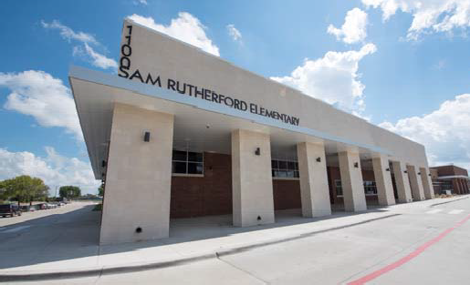Sam Rutherford Elementary School

Holly Grubbs, Principal

Where the Best Begins
 | 2016‐2017 | 2017‐2018 | 2018‐2019 | 2019‐2020 | 2020‐2021
Enrollment | 459 | 474 | 687 | 659 | 648
Student/Teacher Ratio  Staﬀ FTE's  Professional | 17.1  34.2 | 16.3  36.4 | 16.8  48.4 | 15.3  50.3
Teachers | 26.9 | 29 | 41 | 43
Professional Support | 5.3 | 5.4 | 5.4 | 5.3
Campus Administration  Support  Educational Aides | 2  5 | 2  5 | 2  5 | 2  10
Total | 39.2 | 41.4 | 53.4 | 60.3
Expenditures
 | 2017 AUDITED | 2018 AUDITED | 2019 AUDITED | 2020 UNAUDITED | 2021 BUDGET
Payroll Costs | $ 2,337,879.16 | $ 2,644,781.68 | $ 3,615,861.27 | $ 3,825,539.54 | $ 3,932,700.00
Contracted Services | $ 106,676.55 | $ 84,372.60 | $ 72,502.94 | $ 82,032.34 | $ 88,200.00
Supplies and Materials | $ 58,603.62 | $ 165,977.27 | $ 117,295.45 | $ 100,384.86 | $ 92,500.00
Other Operating Costs | $ 20,186.18 | $ 22,736.81 | $ 31,114.03 | $ 22,995.01 | $ 28,900.00
Fixed Assets | $ 4,752.28 | $ 139,958.82 | $ 113,189.06 | $ 6,346.26 | $ 0.00
Grand Total | $ 2,528,097.79 | $ 3,057,827.18 | $ 3,949,962.75 | $ 4,037,298.01 | $ 4,142,300.00
Expenditures by Intent | 2017 AUDITED | 2018 AUDITED | 2019 AUDITED | 2020 UNAUDITED | 2021 BUDGET
Basic | $ 1,501,042.54 | $ 1,702,426.48 | $ 2,597,088.75 | $ 2,594,023.91 | $ 2,491,150.00
Gifted | $ 416.48 | $ 656.85 | $ 537.88 | $ 382.22 | $ 650.00
Special Education | $ 201,452.12 | $ 203,848.24 | $ 336,858.77 | $ 337,153.03 | $ 345,250.00
Compensatory | $ ‐ | $ ‐ |  |  | $ 0.00
Bilingual | $ 82,650.54 | $ 84,130.53 | $ 68,531.59 | $ 74,419.28 | $ 76,250.00
SCE to Support Title I | $ 101,214.25 | $ 112,407.96 | $ 145,907.30 | $ 151,124.32 | $ 240,150.00
Pre‐Kindergarten | $ ‐ | $ 49,147.55 | $ 66,664.49 | $ 73,986.34 | $ 38,700.00
Pre‐Kindergarten ‐ Comp Ed | $ ‐ | $ 17,182.47 | $ 17,837.88 | $ 18,511.10 | $ 46,350.00
Pre‐Kindergarten ‐ Bilingual Ed |  |  |  | $ 0.00 | $ 35,200.00
Early Education Allotment |  |  |  | $ 6,938.44 | $ 72,000.00
Dyslexia |  |  |  | $ 66,939.34 | $ 67,950.00
Other Instructional Area | $ 641,321.86 | $ 888,027.10 | $ 716,536.09 | $ 713,820.03 | $ 728,650.00
Grand Total | $ 2,528,097.79 | $ 3,057,827.18 | $ 3,949,962.75 | $ 4,037,298.01 | $ 4,142,300.00
Per Student Cost | $ 5,507.84 | $ 6,451.11 | $ 5,749.58 | $ 6,126.40 | $ 6,392.44

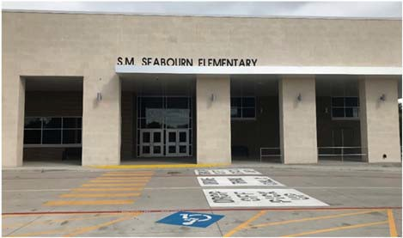S.M. Seabourn Elementary School
Renea Kern, Principal

Seabourn PRIDE ‐
Excellence Always

 | 2016‐2017 | 2017‐2018 | 2018‐2019 | 2019‐2020 | 2020‐2021
Enrollment | 554 | 724 | 680 | 661 | 578
Student/Teacher Ratio  Staﬀ FTE's  Professional | 14.9  46 | 19.5  46 | 17.1  48.7 | 17.8  46.2
Teachers | 37.2 | 37.2 | 39.7 | 37.2
Professional Support | 6.8 | 6.8 | 7 | 7
Campus Administration  Support  Educational Aides | 2  13 | 2  13 | 2  12.8 | 2  12
Total | 59 | 59 | 61.5 | 58.2
Expenditures | 2017 AUDITED | 2018 AUDITED | 2019 AUDITED | 2020 UNAUDITED | 2021 BUDGET
Payroll Costs | $ 2,812,288.13 | $ 3,246,583.96 | $ 3,108,780.43 | $ 3,233,208.14 | $ 3,525,500.00
Contracted Services | $ 88,245.45 | $ 107,164.55 | $ 100,484.60 | $ 125,452.44 | $ 156,300.00
Supplies and Materials | $ 231,340.54 | $ 80,382.06 | $ 77,981.06 | $ 74,887.70 | $ 90,300.00
Other Operating Costs | $ 22,653.08 | $ 24,924.48 | $ 32,716.24 | $ 20,625.93 | $ 24,900.00
Fixed Assets | $ 401,878.45 | $ 641.20 | $ 84,873.06 | $ 1,252.26 | $ 0.00
Grand Total | $ 3,556,405.65 | $ 3,459,696.25 | $ 3,404,835.39 | $ 3,455,426.47 | $ 3,797,000.00
Expenditures by Intent | 2017 AUDITED | 2018 AUDITED | 2019 AUDITED | 2020 UNAUDITED | 2021 BUDGET
Basic | $ 1,788,138.96 | $ 1,925,163.61 | $ 1,860,849.57 | $ 1,810,368.86 | $ 2,010,850.00
Gifted | $ ‐ | $ ‐ | $ ‐ | $ 0.00 | $ 650.00
Special Education | $ 323,747.09 | $ 363,085.50 | $ 375,687.35 | $ 405,322.98 | $ 416,400.00
Bilingual | $ 66,778.78 | $ 63,426.37 | $ 64,161.77 | $ 66,796.21 | $ 0.00
SCE to Support Title I | $ 141,322.37 | $ 138,099.43 | $ 158,507.01 | $ 158,494.03 | $ 71,950.00
Pre‐Kindergarten | $ 60,597.12 | $ 66,880.75 | $ 67,691.10 | $ 67,996.80 | $ 229,050.00
Pre‐Kindergarten‐Comp Ed | $ 22,234.62 | $ 67,706.04 | $ 54,799.52 | $ 56,804.38 | $ 36,850.00
Pre‐Kindergarten‐Bilingual Ed | $ ‐ | $ 111,389.30 | $ 131,482.14 | $ 143,460.31 | $ 61,050.00
Early Education Allotment |  |  |  | $ 8,118.28 | $ 74,850.00
Other Instruction Area | $ 1,153,586.71 | $ 723,945.25 | $ 691,656.93 | $ 738,064.62 | $ 107,300.00
$ 788,050.00
Grand Total $ 3,556,405.65 $ 3,459,696.25 $ 3,404,835.39 $ 3,455,426.47 $ 3,797,000.00

Per Student Cost $ 6,419.50 $ 4,778.59 $ 5,007.11 $ 5,227.57 $ 6,569.20

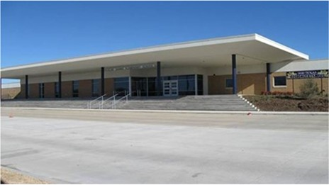Brandi Lewis, Principal
2017 AUDITED
2018 AUDITED
2019 AUDITED 2020 UNAUDITED 2021 BUDGET

Expect Excellence
No Excuses
 | 2016‐2017 | 2017‐2018 | 2018‐2019 | 2019‐2020 | 2020‐2021
Enrollment | 945 | 825 | 664 | 629 | 622
Student/Teacher Ratio  Staﬀ FTE's Professional | 18.3  61.6 | 19.3  52.6 | 16.8  48.5 | 15.6  49.4
Teachers | 51.7 | 42.7 | 39.5 | 40.4
Professional Support | 7.9 | 7.9 | 7 | 7
Campus Administration  Support  Educational Aides | 2  10.9 | 2  10.9 | 2  8.9 | 2  8.9
Total | 72.6 | 63.5 | 57.4 | 58.3
Expenditures
 | 2017 AUDITED | 2018 AUDITED | 2019 AUDITED | 2020 UNAUDITED | 2021 BUDGET
Payroll Costs | $ 4,457,639.73 | $ 4,244,039.40 | $ 3,462,934.40 | $ 3,701,641.93 | $ 3,802,300.00
Contracted Services | $ 106,378.70 | $ 157,919.17 | $ 100,853.05 | $ 106,540.22 | $ 22,900.00
Supplies and Materials | $ 100,185.54 | $ 76,200.75 | $ 77,647.59 | $ 110,754.59 | $ 86,800.00
Other Operating Costs | $ 34,642.14 | $ 38,258.22 | $ 32,073.54 | $ 25,493.73 | $ 27,800.00
Fixed Assets | $ 11,566.30 | $ 188,760.71 | $ 99,809.68 | $ 21,911.52 | $ 0.00
Grand Total | $ 4,710,412.41 | $ 4,705,178.25 | $ 3,773,318.26 | $ 3,966,341.99 | $ 4,039,800.00
Expenditures by Intent

Basic | $ 3,262,408.91 | $ 3,254,141.70 | $ 2,463,182.76 | $ 2,421,647.94 | $ 2,303,600.00
Gifted | $ 131.11 | $ ‐ | $ ‐ | $ 0.00 | $ 650.00
Career & Technology |  | $ ‐ | $ ‐ | $ 0.00 | $ 0.00
Special Education | $ 377,251.46 | $ 387,439.88 | $ 353,749.71 | $ 401,159.71 | $ 412,400.00
Bilingual | $ 76,283.83 | $ 65,242.45 | $ 64,999.03 | $ 66,213.09 | $ 0.00
SCE to Support Title I | $ 205,070.28 | $ 253,367.09 | $ 183,455.97 | $ 283,260.18 | $ 69,100.00
Pre‐Kindergarten |  |  |  | $ 0.00 | $ 295,700.00
Pre‐Kindergarten ‐ Comp Ed |  |  |  | $ 0.00 | $ 35,200.00
Pre‐Kindergarten ‐ Bilingual Ed |  |  |  | $ 0.00 | $ 52,600.00
Early Education Allotment |  |  |  | $ 44,453.19 | $ 35,200.00
Other Instructional Area | $ 789,266.82 | $ 744,987.13 | $ 707,930.79 | $ 749,607.88 | $ 69,000.00
$ 766,350.00
Grand Total | $ 4,710,412.41 | $ 4,705,178.25 | $ 3,773,318.26 | $ 3,966,341.99 | $ 4,039,800.00
Per Student Cost | $ 4,984.56 | $ 5,703.25 | $ 5,682.71 | $ 6,305.79 | $ 6,494.86
Assessment Results | 2017 STAAR | 2018 STAAR | 2019 STAAR | 2020 STAAR | 2021 STAAR
Reading | 65% | 68% | 78% | NA

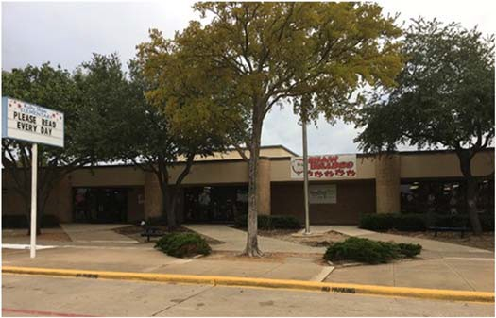Kim Dumaine Banuelos, Principal

The Shaw Bulldog vision is to create and nurture a family of learners where every person is encouraged and empowered to become his or her best.

 | 2016‐2017 | 2017‐2018 | 2018‐2019 | 2019‐2020 | 2020‐2021
Enrollment | 866 | 884 | 505 | 577 | 555
Student/Teacher Ratio  Staﬀ FTE's  Professional | 16.8  62.6 | 21.8  51.6 | 13.4  43.7 | 15.8  45.6
Teachers | 51.6 | 40.6 | 34.7 | 36.6
Professional Support | 9 | 9 | 7 | 7
Campus Administration  Support  Educational Aides | 2  11 | 2  11 | 2  9.9 | 2  11
Total | 73.6 | 62.6 | 53.6 | 56.6
Expenditures | 2017 AUDITED | 2018 AUDITED | 2019 AUDITED | 2020 UNAUDITED | 2021 BUDGET
Payroll Costs | $ 3,717,522.02 | $ 4,118,665.62 | $ 3,181,016.05 | $ 3,281,657.20 | $ 3,504,400.00
Contracted Services | $ 133,854.39 | $ 129,207.03 | $ 111,685.08 | $ 118,578.06 | $ 144,600.00
Supplies and Materials | $ 96,771.72 | $ 110,779.73 | $ 67,571.35 | $ 71,270.13 | $ 77,200.00
Other Operating Costs | $ 42,769.49 | $ 41,811.75 | $ 35,727.38 | $ 27,184.19 | $ 22,200.00
Fixed Assets | $ 180,077.82 | $ 1,884.51 | $ 79,110.24 | $ 4,203.00 | $ 0.00
Grand Total | $ 4,170,995.44 | $ 4,402,348.64 | $ 3,475,110.10 | $ 3,502,892.58 | $ 3,748,400.00
Expenditures by Intent | 2017 AUDITED | 2018 AUDITED | 2019 AUDITED | 2020 UNAUDITED | 2021 BUDGET
Basic | $ 2,830,305.07 | $ 2,957,867.37 | $ 2,040,417.41 | $ 1,968,041.59 | $ 2,081,650.00
Gifted | $ ‐ | $ ‐ | $ ‐ | $ 0.00 | $ 650.00
Special Education | $ 357,418.48 | $ 422,946.45 | $ 457,939.55 | $ 385,284.69 | $ 400,550.00
Bilingual | $ 60,607.68 | $ 72,689.87 | $ 72,684.17 | $ 76,481.52 | $ 0.00
SCE to Support Title I | $ 208,584.65 | $ 244,503.28 | $ 231,035.92 | $ 256,188.69 | $ 80,150.00
Pre‐Kindergarten |  |  |  | $ 0.00 | $ 255,350.00
Pre‐Kindergarten ‐ Comp Ed |  |  |  | $ 0.00 | $ 35,200.00
Early Education Allotment |  |  |  | $ 22,041.42 | $ 26,300.00
Dyslexia |  |  |  | $ 68,671.08 | $ 34,500.00
Other Instructional Area | $ 714,079.56 | $ 704,341.67 | $ 673,033.05 | $ 726,183.59 | $ 69,900.00
$ 764,150.00
Grand Total | $ 4,170,995.44 | $ 4,402,348.64 | $ 3,475,110.10 | $ 3,502,892.58 | $ 3,748,400.00
Per Student Cost | $ 4,816.39 | $ 4,980.03 | $ 6,881.41 | $ 6,070.87 | $ 6,753.87
Assessment Results | 2017 STAAR | 2018 STAAR | 2019 STAAR | 2020 STAAR | 2021 STAAR
Reading |  | 67% | 74% | NA
Mathematics | 68% | 71% | 83% | NA
Writing | 53% | 57% | 57% | NA
Science | 67% | 65% | 76% | NA

**Information obtained from the TEA PEIMS Standard Report and Munis Accounting

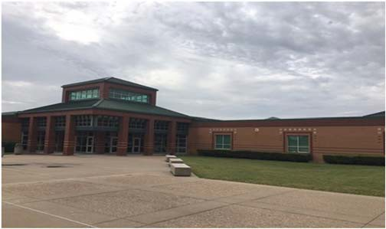B. J. Smith Elementary School

Charlene Goss, Principal

A family that innovatively invests in their school and community.

 | 2016‐2017 | 2017‐2018 | 2018‐2019 | 2019‐2020 | 2020‐2021
Enrollment | 531 | 494 | 425 | 437 | 545
Student/Teacher Ratio  Staﬀ FTE's  Professional | 17.4  37.4 | 16.1  37.4 | 14.3  37.7 | 14.9  37.4
Teachers | 30.6 | 30.6 | 29.7 | 29.4
Professional Support | 4.8 | 4.8 | 6 | 6
Campus Administration  Support  Educational Aides | 2  12 | 2  12 | 2  10.9 | 2  10.8
Total | 49.4 | 49.4 | 48.6 | 48.2
Expenditures
 | 2017 AUDITED | 2018 AUDITED | 2019 AUDITED | 2020 UNAUDITED | 2021 BUDGET
Payroll Costs | $ 2,341,233.62 | $ 2,543,221.31 | $ 2,418,664.15 | $ 2,534,279.17 | $ 2,964,000.00
Contracted Services | $ 125,257.24 | $ 91,392.45 | $ 100,065.95 | $ 92,486.45 | $ 112,100.00
Supplies and Materials | $ 81,257.29 | $ 75,613.36 | $ 55,553.13 | $ 86,009.62 | $ 80,300.00
Other Operating Costs | $ 30,077.99 | $ 22,752.94 | $ 25,690.30 | $ 26,768.14 | $ 23,000.00
Fixed Assets | $ 20,977.88 | $ 5,745.76 | $ 71,729.63 | $ 4,744.93 | $ 0.00
Grand Total | $ 2,598,804.02 | $ 2,738,725.82 | $ 2,671,703.16 | $ 2,744,288.31 | $ 3,179,400.00
Expenditures by Intent | 2017 AUDITED | 2018 AUDITED | 2019 AUDITED | 2020 UNAUDITED | 2021 BUDGET
Basic | $ 1,436,946.42 | $ 1,583,501.68 | $ 1,583,517.62 | $ 1,506,210.67 | $ 1,912,200.00
Gifted | $ ‐ | $ 389.97 | $ 131.10 | $ 0.00 | $ 650.00
Special Education | $ 257,490.38 | $ 260,021.56 | $ 228,241.41 | $ 276,917.73 | $ 284,800.00
Bilingual | $ 38,580.32 | $ 52,944.03 | $ 61,707.64 | $ 65,385.72 | $ 0.00
SCE to Support Title I | $ 30,748.75 | $ 63,876.31 | $ 67,246.35 | $ 139,603.69 | $ 68,650.00
Pre‐Kindergarten | $ 115,594.23 | $ 103,262.95 | $ 61,326.59 | $ 69,049.16 | $ 66,900.00
Pre‐Kindergarten‐Comp Ed | $ 41,178.31 | $ 37,758.02 | $ 16,663.71 | $ 18,434.41 | $ 39,300.00
Pre‐Kindergarten‐Bilingual Ed |  |  |  | $ 0.00 | $ 18,250.00
Early Education Allotment |  |  |  | $ 26,161.66 | $ 32,200.00
Other Instructional Area | $ 678,265.61 | $ 636,971.30 | $ 652,868.74 | $ 642,525.27 | $ 63,750.00
$ 692,700.00
Grand Total | $ 2,598,804.02 | $ 2,738,725.82 | $ 2,671,703.16 | $ 2,744,288.31 | $ 3,179,400.00
Per Student Cost | $ 4,894.17 | $ 5,543.98 | $ 6,286.36 | $ 6,279.84 | $ 5,833.76
Assessment Results | 2017 STAAR | 2018 STAAR | 2019 STAAR | 2020 STAAR | 2021 STAAR
Reading | 70% | 77% | 84% | NA
Mathematics | 65% | 69% | 76% | NA
Writing | 52% | 47% | 67% | NA
Science | 72% | 80% | 87% | NA

**Information obtained from the TEA PEIMS Standard Report and Munis Accounting

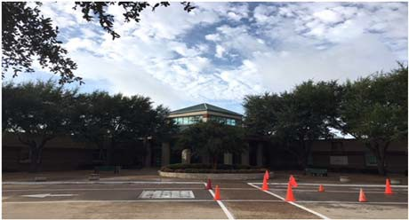Jay R. Thompson Elementary School

Bridgett Mitchell, Principal

Our mission is to ensure the academic and social‐emotional growth of ALL students every day.
 | 2016‐2017 | 2017‐2018 | 2018‐2019 | 2019‐2020 | 2020‐2021
Enrollment | 554 | 565 | 529 | 523 | 566
Student/Teacher Ratio | 16.8 | 17.1 | 16.1 | 16.9
Staﬀ FTE's Professional | 40.8 | 40.8 | 40.4 | 38.9
Teachers | 33 | 33 | 32.9 | 30.9
Professional Support | 5.8 | 5.8 | 5.5 | 6
Campus Administration  Support  Educational Aides | 2  8 | 2  8 | 2  6.9 | 2  8
Total | 48.8 | 48.8 | 47.3 | 46.9
Expenditures | 2017 AUDITED | 2018 AUDITED | 2019 AUDITED | 2020 UNAUDITED | 2021 BUDGET
Payroll Costs | $ 2,566,295.97 | $ 2,931,925.94 | $ 2,852,744.90 | $ 2,937,105.33 | $ 3,145,200.00
Contracted Services | $ 148,601.17 | $ 118,746.91 | $ 96,868.88 | $ 109,170.37 | $ 115,500.00
Supplies and Materials | $ 71,875.28 | $ 57,650.19 | $ 64,411.38 | $ 87,736.68 | $ 72,000.00
Other Operating Costs | $ 28,071.05 | $ 28,487.23 | $ 28,814.03 | $ 21,647.20 | $ 24,200.00
Fixed Assets | $ 4,754.13 | $ 133,965.82 | $ 79,560.55 | $ 4,486.26 | $ 0.00
Grand Total | $ 2,819,597.60 | $ 3,270,776.09 | $ 3,122,399.74 | $ 3,160,145.84 | $ 3,356,900.00
Expenditures by Intent | 2017 AUDITED | 2018 AUDITED | 2019 AUDITED | 2020 UNAUDITED | 2021 BUDGET
Basic | $ 1,755,945.82 | $ 1,981,671.51 | $ 1,930,036.07 | $ 1,792,533.27 | $ 1,819,800.00
Gifted | $ 151.97 | $ 84.00 | $ ‐ | $ 84.00 | $ 650.00
Special Education | $ 281,457.14 | $ 280,428.78 | $ 315,197.49 | $ 344,196.28 | $ 356,900.00
Bilingual | $ 61,468.33 | $ 63,607.57 | $ 64,830.99 | $ 65,297.67 | $ 0.00
SCE to Support Title I | $ 46,522.35 | $ 103,701.48 | $ 72,411.46 | $ 100,214.12 | $ 61,400.00
Pre‐Kindergarten | $ ‐ | $ 43,602.08 | $ 59,678.49 | $ 63,554.05 | $ 152,750.00
Pre‐Kindergarten Comp Ed | $ ‐ | $ 17,461.89 | $ 16,723.11 | $ 17,415.10 | $ 67,950.00
Early Education Allotment |  |  |  | $ 26,097.70 | $ 46,200.00
Dyslexia |  |  |  | $ 68,809.70 | $ 66,650.00
Other Instructional Area | $ 674,051.99 | $ 780,218.78 | $ 663,522.13 | $ 681,943.95 | $ 70,050.00
 |  |  |  |  | $ 714,550.00
Grand Total | $ 2,819,597.60 | $ 3,270,776.09 | $ 3,122,399.74 | $ 3,160,145.84 | $ 3,356,900.00
Per Student Cost | $ 5,089.53 | $ 5,788.98 | $ 5,902.46 | $ 6,042.34 | $ 5,930.92
Assessment Results | 2017 STAAR | 2018 STAAR | 2019 STAAR | 2020 STAAR | 2021 STAAR
Reading | 69% | 69% | 71% | NA
Mathematics | 69% | 74% | 69% | NA
Writing | 56% | 54% | 52% | NA
Science | 45% | 61% | 69% | NA

**Information obtained from the TEA PEIMS Standard Report and Munis Accounting

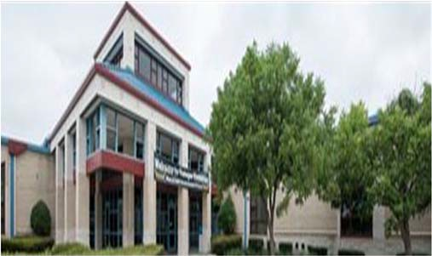Ben Tisinger Elementary School

Amanda Relf, Principal

Where We Inspire A LOVE for Learning in ALL Students

 | 2016‐2017 | 2017‐2018 | 2018‐2019 | 2019‐2020 | 2020‐2021
Enrollment | 792 | 824 | 770 | 660 | 631
Student/Teacher Ratio  Staﬀ FTE's  Professional | 17.4  55.4 | 17  58.4 | 16.1  55.9 | 15.9  50.5
Teachers | 45.4 | 48.4 | 47.9 | 41.5
Professional Support | 8 | 8 | 6 | 7
Campus Administration  Support  Educational Aides | 2  12 | 2  12 | 2  12 | 2  10.9
Total | 67.4 | 70.4 | 67.9 | 61.4
Expenditures | 2017 AUDITED | 2018 AUDITED | 2019 AUDITED | 2020 UNAUDITED | 2021 BUDGET
Payroll Costs | $ 3,610,575.45 | $ 3,770,164.64 | $ 3,797,527.98 | $ 3,615,071.87 | $ 3,703,200.00
Contracted Services | $ 183,993.31 | $ 117,336.81 | $ 149,955.82 | $ 132,593.61 | $ 167,100.00
Supplies and Materials | $ 87,273.12 | $ 76,754.04 | $ 96,980.11 | $ 90,813.31 | $ 85,300.00
Other Operating Costs | $ 25,680.66 | $ 29,859.03 | $ 32,751.96 | $ 20,014.27 | $ 23,700.00
Fixed Assets | $ 9,158.38 | $ 144,052.94 | $ 112,642.76 | $ 4,486.26 | $ 0.00
Grand Total | $ 3,916,680.92 | $ 4,138,167.46 | $ 4,189,858.63 | $ 3,862,979.32 | $ 3,979,300.00
Expenditures by Intent | 2017 AUDITED | 2018 AUDITED | 2019 AUDITED | 2020 UNAUDITED | 2021 BUDGET
Basic | $ 2,446,746.06 | $ 2,699,946.25 | $ 2,765,237.08 | $ 2,362,651.61 | $ 2,319,200.00
Gifted | $ ‐ | $ ‐ | $ ‐ | $ 0.00 | $ 650.00
Special Education | $ 355,849.10 | $ 398,165.47 | $ 392,837.18 | $ 376,000.99 | $ 374,300.00
Compensatory | $ 0.00 |  |  |  | $ 0.00
Bilingual | $ 99,491.92 | $ 45,457.60 | $ 30,769.13 | $ 34,153.01 | $ 36,650.00
SCE to Support Title I | $ 205,705.20 | $ 212,513.61 | $ 207,828.24 | $ 256,574.47 | $ 303,750.00
Pre‐Kindergarten | $ 61,905.07 | $ 60,338.77 | $ 61,019.16 | $ 70,640.91 | $ 70,700.00
Pre‐Kindergarten Comp Ed | $ 22,548.40 | $ 25,719.66 | $ 26,262.21 | $ 27,689.72 | $ 55,250.00
Early Education Allotment |  |  |  | $ 27,817.48 | $ 70,600.00
Other Instruction Area | $ 724,435.17 | $ 696,026.10 | $ 705,905.63 | $ 707,451.13 | $ 748,200.00
Grand Total | $ 3,916,680.92 | $ 4,138,167.46 | $ 4,189,858.63 | $ 3,862,979.32 | $ 3,979,300.00
Per Student Cost | $ 4,945.30 | $ 5,022.05 | $ 5,441.37 | $ 5,853.00 | $ 6,306.34
Assessment Results | 2017 STAAR | 2018 STAAR | 2019 STAAR | 2020 STAAR | 2021 STAAR
Reading | 59% | 59% | 68% | NA
Mathematics | 67% | 71% | 77% | NA
Writing | 50% | 36% | 46% | NA
Science | 78% | 67% | 69% | NA

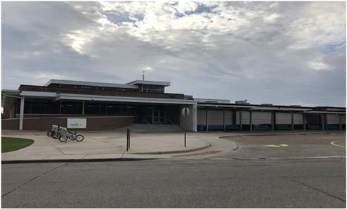Charles A. Tosch Elementary School
Amy Childress, Principal

Excellence Always
 | 2016‐2017 | 2017‐2018 | 2018‐2019 | 2019‐2020 | 2020‐2021
Enrollment | 858 | 872 | 664 | 594 | 617
Student/Teacher Ratio  Staﬀ FTE's Professional | 16.6  63.6 | 22  51.6 | 17.3  47 | 15.8  46.7
Teachers | 51.6 | 39.6 | 38.3 | 37.7
Professional Support | 9 | 9 | 6.7 | 7
Campus Administration  Support  Educational Aides | 3  11 | 3  11 | 2  10 | 2  13
Total | 74.6 | 62.6 | 57 | 59.7
Expenditures | 2017 AUDITED | 2018 AUDITED | 2019 AUDITED | 2020 UNAUDITED | 2021 BUDGET
Payroll Costs | $ 3,961,822.37 | $ 4,158,249.62 | $ 3,188,517.77 | $ 3,321,390.10 | $ 3,517,600.00
Contracted Services | $ 147,643.38 | $ 148,175.93 | $ 125,994.05 | $ 125,850.74 | $ 131,200.00
Supplies and Materials | $ 104,101.88 | $ 96,261.74 | $ 80,847.88 | $ 112,974.13 | $ 79,200.00
Other Operating Costs | $ 29,345.67 | $ 32,560.88 | $ 24,926.29 | $ 18,894.37 | $ 24,100.00
Fixed Assets | $ 10,803.65 | $ 1,200,606.09 | $ 201,434.54 | $ 122,506.42 | $ 0.00
Grand Total | $ 4,253,716.95 | $ 5,635,854.26 | $ 3,621,720.53 | $ 3,701,615.76 | $ 3,752,100.00
Expenditures by Program Intent | 2017 AUDITED | 2018 AUDITED | 2019 AUDITED | 2020 UNAUDITED | 2021 BUDGET
Basic | $ 2,776,255.42 | $ 2,957,359.06 | $ 2,203,650.12 | $ 2,166,906.88 | $ 2,025,350.00
Gifted | $ 99.27 | $ 570.13 | $ ‐ | $ 318.46 | $ 650.00
Special Education | $ 313,004.08 | $ 305,793.98 | $ 191,132.19 | $ 303,367.91 | $ 301,450.00
Bilingual | $ 93,411.38 | $ 95,918.77 | $ 160,069.13 | $ 169,027.15 | $ 0.00
SCE to Support Title I | $ 231,967.52 | $ 229,305.52 | $ 169,679.93 | $ 178,400.79 | $ 173,100.00
Pre‐Kindergarten | $ 59,216.71 | $ 61,682.83 | $ 61,824.75 | $ 63,910.17 | $ 206,600.00
Pre‐Kindergarten Comp Ed | $ 20,688.37 | $ 21,256.21 | $ 21,690.34 | $ 22,421.28 | $ 66,450.00
Pre– Kindergarten‐Bilingual Ed |  | $ 25.99 | $ 685.56 | $ 886.28 | $ 76,300.00
Early Education Allotment |  |  |  | $ 47,967.41 | $ 35,200.00
Other Instruction Area | $ 759,074.20 | $ 1,963,941.77 | $ 812,988.51 | $ 748,409.43 | $ 99,650.00
 |  |  |  |  | $ 767,350.00
Grand Total | $ 4,253,716.95 | $ 5,635,854.26 | $ 3,621,720.53 | $ 3,701,615.76 | $ 3,752,100.00
Per Student Cost | $ 4,957.71 | $ 6,463.14 | $ 5,454.40 | $ 6,231.68 | $ 6,081.20
Assessment Results | 2017 STAAR | 2018 STAAR | 2019 STAAR | 2020 STAAR | 2021 STAAR
Reading | 66% | 74% | 72% | NA
Mathematics | 72% | 77% | 74% | NA
Writing | 53% | 51% | 59% | NA
Science | 68% | 83% | 72% | NA

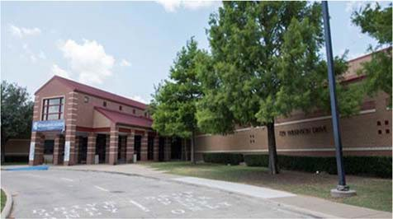Frank B. Agnew Middle School
TJ Reed, Principal

Our mission at Agnew Middle School is to cultivate an innovative learning experience while empowering our students to make their hope a reality.
 | 2016‐2017 | 2017‐2018 | 2018‐2019 | 2019‐2020 | 2020‐2021
Enrollment | 793 | 831 | 1231 | 1228 | 1227
Student/Teacher Ratio Staﬀ FTE's  Professional | 15.5  63.4 | 9.3  101.6 | 16.5  88.2 | 16.4  90.3
Teachers | 51.2 | 89.4 | 74.8 | 74.9
Professional Support | 9.2 | 9.2 | 9.4 | 11.4
Campus Administration Support  Educational Aides | 3  7 | 4  7 | 4  5 | 4  6
Total | 70.4 | 109.6 | 93.2 | 96.3
Expenditures | 2017 AUDITED | 2018 AUDITED | 2019 AUDITED | 2020 UNAUDITED | 2021 BUDGET
Payroll Costs | $ 4,215,373.74 | $ 4,414,238.14 | $ 5,765,103.49 | $ 6,201,257.00 | $ 6,334,600.00
Contracted Services | $ 234,538.85 | $ 205,403.93 | $ 222,528.48 | $ 191,705.96 | $ 238,350.00
Supplies and Materials | $ 168,923.41 | $ 205,428.61 | $ 178,226.80 | $ 203,274.83 | $ 234,800.00
Other Operating Costs | $ 128,450.57 | $ 128,401.01 | $ 145,359.22 | $ 138,676.94 | $ 131,450.00
Fixed Assets $ 731,871.50 |  | $ 10,072,624.46 | $ 678,608.57 | $ 48,066.09 | $ 0.00
Grand Total $ 5,479,158.07 |  | $ 15,026,096.15 | $ 6,989,826.56 | $ 6,782,980.82 | $ 6,939,200.00
Expenditures by Intent | 2017 AUDITED | 2018 AUDITED | 2019 AUDITED | 2020 UNAUDITED | 2021 BUDGET
Basic | $ 2,613,066.66 | $ 2,853,812.69 | $ 4,012,784.99 | $ 4,104,305.70 | $ 4,142,800.00
Gifted | $ 9,236.78 | $ 70,453.89 | $ 40,828.37 | $ 66,305.32 | $ 68,950.00
Career & Technology |  | $ ‐ |  | $ 90,451.74 | $ 94,850.00
Special Education | $ 554,756.83 | $ 514,948.47 | $ 553,528.42 | $ 625,487.55 | $ 645,400.00
Compensatory | $ 5,871.42 | $ 20,227.67 | $ ‐ |  | $ 0.00
Bilingual | $ 64,417.12 | $ 65,407.34 | $ 60,046.66 | $ 0.00 | $ 72,350.00
SCE to Support Title 1 | $ 84,819.64 | $ 138,190.60 | $ 194,771.78 | $ 424,000.07 | $ 378,300.00
Athletics | $ 111,340.33 | $ 101,974.10 | $ 110,929.30 | $ 122,741.98 | $ 127,000.00
Other Instructional Areas $ 1,985,649.29 $ 11,261,081.39 $ 2,016,937.04 $ 1,349,688.46 $ 1,409,550.00
Grand Total $ 5,479,158.07 $ 15,026,096.15 $ 6,989,826.56 $ 6,782,980.82 $ 6,939,200.00

Per Student Cost $ 6,909.40 $ 18,081.94 $ 5,678.17 $ 5,523.60 $ 5,655.42

Assessment Results | 2017 STAAR | 2018 STAAR | 2019 STAAR | 2020 STAAR | 2021 STAAR
Reading | 75% | 70% | 66% | NA
Mathematics | 76% | 80% | 77% | NA
Writing | 66% | 54% | 60% | NA
Social Studies | 46% | 55% | 51% | NA
Science | 69% | 67% | 80% | NA

**Information obtained from the TEA PEIMS Standard Report and Munis Accounting
The 2018 year a wing was added from 199. This is what added to the high expenditure per student.

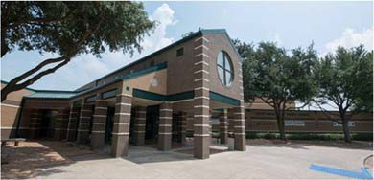Judge Frank Berry Middle School

Angela Wiggins, Principal

Love First: We believe in creating a loving culture of community and value built on positive relationships, servant leadership, and mutual respect.
Standards Focused: We believe that beginning with the end in mind includes: setting high expectations and achievable goals, getting to know our students through engaging and creative activities, delivering TEKS‐focused, diﬀerentiated instruction, and preparing students to be lifelong learners.
Bear PRIDE: WE believe unity, consistency, and a culture of honor exemplifies Bear PRIDE.
 | 2016‐2017 | 2017‐2018 | 2018‐2019 |  | 2019‐2020 | 2020‐20221
Enrollment | 899 | 904 | 1112 |  | 1103 | 613
Student/Teacher Ratio Staﬀ FTE's  Professional | 16.4  64.3 | 14.3  73.4 | 16  74.9 |  | 16.5  79
Teachers | 54.9 | 63 | 69.6 |  | 67
Professional Support | 6.4 | 6.4 | 6.3 |  | 8
Campus Administration  Support | 3 | 4 | 4 |  | 4
Educational Aides | 8.8 | 8.8 | 10 |  | 7.9
Total | 73.1 | 82.2 | 89.9 |  | 86.9
Expenditures | 2017 AUDITED | 2018 AUDITED | 2019 AUDITED |  | 2020 UNAUDITED 2021 BUDGET
Payroll Costs | $ 4,239,591.65 | $ 4,549,388.98 | $ 5,387,070.09 |  | $ 5,532,389.74 | $ 4,519,100.00
Contracted Services | $ 238,926.14 | $ 251,845.41 | $ 215,230.39 |  | $ 193,388.24 | $ 228,600.00
Supplies and Materials | $ 162,533.33 | $ 164,672.55 | $ 180,646.10 |  | $ 190,032.84 | $ 174,650.00
Other Operating Costs | $ 140,146.21 | $ 147,807.42 | $ 132,872.66 |  | $ 113,739.46 | $ 136,700.00
Fixed Assets | $ 95,517.31 | $ 30,063.18 | $ 1,350.00 |  | $ 32,793.65 | $ ‐
Grand Total | $ 4,876,714.64 | $ 5,143,777.54 |  | $ 5,917,169.24 | $ 6,062,343.93 | $ 5,059,050.00
Expenditures by Intent | 2017 AUDITED | 2018 AUDITED |  | 2019 AUDITED | 2020 UNAUDITED | 2021 BUDGET
Basic | $ 2,778,729.77 | $ 2,987,748.28 |  | $ 3,510,270.05 | $ 3,434,348.83 | $ 2,004,650.00
Gifted | $ 90,010.69 | $ 65,736.98 |  | $ 140,525.31 | $ 169,745.15 | $ 171,800.00
Career & Technology |  |  |  |  | $ 74,990.88 | $ 84,850.00
Special Education | $ 441,974.41 | $ 407,819.54 |  | $ 560,158.72 | $ 686,766.42 | $ 1,027,650.00
Compensatory | $ 133,413.27 | $ 201,759.78 |  | $ ‐ |  | $ ‐
Bilingual | $ 39,719.68 | $ 63,834.75 |  | $ 68,719.17 | $ 61,435.37 | $ 63,050.00
SCE to Support Title 1 |  | $ | ‐ | $ 216,458.45 | $ 260,622.57 | $ 259,600.00
Athletics | $ 101,891.25 | $ 105,099.70 |  | $ 101,096.95 | $ 126,913.61 | $ 122,150.00
Other Instructional Areas | $ 1,290,975.57 | $ 1,311,778.51 |  | $ 1,319,940.59 | $ 1,247,521.10 | $ 1,325,300.00
Grand Total | $ 4,876,714.64 | $ 5,143,777.54 |  | $ 5,917,169.24 | $ 6,062,343.93 | $ 5,059,050.00
Per Student Cost | $ 5,424.60 | $ 5,690.02 |  | $ 5,321.20 | $ 5,496.23 | $ 8,252.94
Assessment Results | 2017 STAAR | 2018 STAAR |  | 2019 STAAR | 2020 STAAR | 2021 STAAR
Reading | 71% | 67% |  | 75% | NA
Mathematics | 78% | 77% |  | 83% | NA
Writing | 63% | 61% |  | 70% | NA
Social Studies | 64% | 64% |  | 69% | NA
Science | 80% | 72% |  | 87% | NA

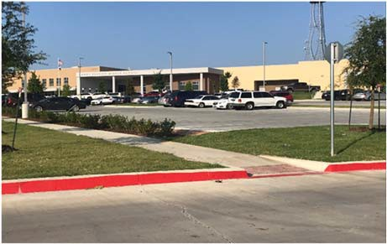Lanny Frasier Middle School

Kristi Morse, Principal

 | 2016‐2017 | 2017‐2018 | 2018‐2019 | 2019‐2020 | 2020‐2021
Enrollment |  |  | 1225 | 1200 | 1126
Student/Teacher Ratio  Staﬀ FTE's  Professional |  |  | 17.7  82.9 | 16.4  88.8
Teachers |  |  | 69.5 | 73.1
Professional Support |  |  | 9.4 | 11.7
Campus Administration  Support  Educational Aides |  |  | 4  8.9 | 4  7.8
Total |  |  | 91.8 | 96.6
Expenditures
 | 2017 AUDITED | 2018 AUDITED | 2019 AUDITED | 2020 UNAUDITED | 2021 BUDGET
Payroll Costs |  | $ 122,325.96 $ | 5,716,744.11 | $ 6,229,339.28 | $ 6,382,500.00
Contracted Services |  | $ 26,433.53 $ | 214,808.76 | $ 207,743.06 | $ 237,300.00
Supplies and Materials |  | $ 676,781.06 $ | 269,980.20 | $ 158,239.73 | $ 210,000.00
Other Operating Costs |  | $ 5,882.79 $ | 132,694.37 | $ 113,905.55 | $ 133,000.00
Fixed Assets |  | $ 1,149,075.34 $ | 62,918.28 | $ 33,881.69 | $ ‐
Grand Total |  | $ 1,980,498.68 $ | 6,397,145.72 | $ 6,743,109.31 | $ 6,962,800.00
Expenditures by Intent | 2017 AUDITED | 2018 AUDITED | 2019 AUDITED | 2020 UNAUDITED | 2021 BUDGET
Basic | $ 11,726.34 $ |  | 3,642,937.25 | $ 3,849,301.78 | $ 3,921,550.00
Gifted | $ 0.00 $ |  | ‐ | $ ‐ | $ 1,000.00
Career & Technology | $ 0.00 $ |  | ‐ | $ 98,127.75 | $ 100,500.00
Special Education | $ (252.55) $ |  | 966,852.30 | $ 1,010,014.98 | $ 1,039,250.00
Compensatory | $ 0.00 |  |  |  | $ ‐
Bilingual | $ 0.00 $ |  | 63,781.50 | $ 65,335.75 | $ 67,450.00
SCE to Support Title 1 | $ 0.00 $ |  | 192,134.87 | $ 321,272.61 | $ 353,100.00
Athletics | $ 1,200.00 $ |  | 101,479.05 | $ 123,299.01 | $ 127,250.00
Other Instructional Areas $ 1,967,824.89 $ 1,429,960.75 $ 1,275,757.43 $ 1,352,700.00
Grand Total $ 1,980,498.68 $ 6,397,145.72 $ 6,743,109.31 $ 6,962,800.00

Per Student Cost |  |  | $ 5,222.16 | $ 5,619.26 | $ 6,183.66
Assessment Results | 2016 STAAR | 2018 STAAR | 2019 STAAR | 2020 STAAR | 2021 STAAR
Reading |  |  | 65% | NA
Mathematics |  |  | 73% | NA
Writing |  |  | 68% | NA
Social Studies |  |  | 54% | NA
Science |  |  | 78% | NA

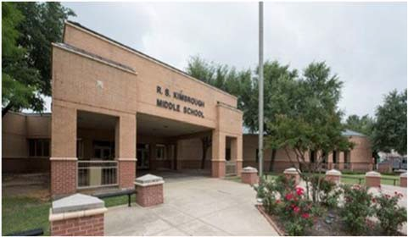R.B. Kimbrough Middle School

Chris Brott, Principal

EVERY student EVERY day
 | 2016‐2017 | 2017‐2018 | 2018‐2019 | 2019‐2020 | 2020‐2021
Enrollment | 849 | 825 | 1342 | 1357 | 1260
Student/Teacher Ratio  Staﬀ FTE's  Professional | 16.3  62.6 | 12.5  77.6 | 18  89 | 17.3  94.6
Teachers | 52.2 | 66.2 | 74.6 | 78.6
Professional Support | 7.4 | 7.4 | 9.4 | 12
Campus Administration  Support  Educational Aides | 3  7.6 | 4  7.6 | 5  7 | 4  8
Total | 70.3 | 85.2 | 96 | 102.6
Expenditures
2017 AUDITED |  | 2018 AUDITED | 2019 AUDITED | 2020 UNAUDITED | 2021 BUDGET
Payroll Costs $ 4,376,854.41 |  | $ 4,535,481.00 | $ 5,948,195.08 | $ 6,716,120.31 | $ 6,758,100.00
Contracted Services | $ 253,443.37 | $ 251,389.22 | $ 244,185.37 | $ 215,777.37 | $ 257,500.00
Supplies and Materials | $ 161,524.64 | $ 174,168.49 | $ 211,912.34 | $ 172,441.62 | $ 256,000.00
Other Operating Costs | $ 146,546.80 | $ 142,715.53 | $ 137,545.74 | $ 120,041.79 | $ 148,800.00
Fixed Assets | $ 393,782.20 | $ 5,339,418.72 | $ 1,283,699.30 | $ 23,458.71 | $ ‐
Grand Total $ 5,332,151.42 $ 10,443,172.96 $ 7,825,537.83 $ 7,247,839.80 $ 7,420,400.00
2019 AUDITED 2020 UNAUDITED 2021 BUDGET
2018 AUDITED
2017 AUDITED
Expenditures by Program Intent
Basic $ 2,611,079.49 $ 2,819,943.44 $ 3,831,188.39 $ 4,102,528.42 $ 4,193,350.00
Gifted | $ 175,732.80 | $ 181,193.51 | $ 164,494.10 | $ 191,010.49 | $ 191,500.00
Career & Technology |  |  |  | $ 61,362.60 | $ 66,950.00
Special Education | $ 675,026.30 | $ 647,443.23 | $ 801,894.51 | $ 989,751.63 | $ 1,000,250.00
Compensatory | $ 72,765.44 | $ 53,308.41 | $ 75.00 |  | $ ‐
Bilingual | $ 59,079.52 | $ 59,836.39 | $ 60,808.04 | $ 61,738.07 | $ 63,500.00
SCE to Support Title 1 |  | $ ‐ | $ 234,369.81 | $ 376,501.72 | $ 333,100.00
Athletics | $ 101,132.10 | $ 104,915.28 | $ 101,213.69 | $ 127,891.83 | $ 128,250.00
Other Instructional Areas $ 1,637,335.77 $ 6,576,532.70 $ 2,631,494.29 $ 1,337,055.04 $ 1,443,500.00
Grand Total $ 5,332,151.42 $ 10,443,172.96 $ 7,825,537.83 $ 7,247,839.80 $ 7,420,400.00

Per Student Cost $ 6,280.51 $ 12,658.39 $ 5,831.25 $ 5,341.08 $ 5,889.21

Assessment Results | 2017 STAAR | 2018 STAAR | 2019 STAAR | 2020 STAAR | 2021 STAAR
Reading | 81% | 74% | 71%
Mathematics | 83% | 78% | 83%
Writing | 73% | 70% | 68%
Social Studies | 67% | 68% | 62%
Science | 80% | 75% | 81%

**Information obtained from the TEA PEIMS Standard Report and Munis Accounting The 2018 school year 199 funds were used to build a wing.

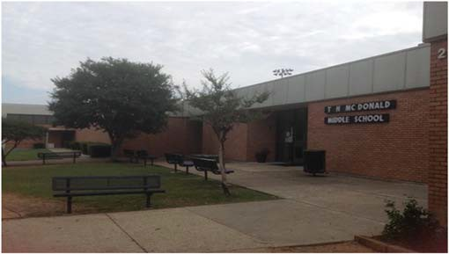T. H. McDonald Middle School

Jordan Simmons, Principal

Believe in all students
 | 2016‐2017 | 2017‐2018 | 2018‐2019 | 2019‐2020 | 2020‐2021
Enrollment | 1034 | 1002 | 883 | 908 | 923
Student/Teacher Ratio | 15.7 | 17.9 | 16.2 | 16.6
Staﬀ FTE's  Professional | 77.3 | 67.3 | 66.7 | 68.1
Teachers | 66 | 56 | 54.5 | 54.8
Professional Support | 8.3 | 8.3 | 9.2 | 10.3
Campus Administration  Support  Educational Aides | 3  5 | 3  5 | 3  5 | 3  5
Total | 82.3 | 72.3 | 71.7 | 73.1
Expenditures
2017 AUDITED |  | 2018 AUDITED | 2019 AUDITED | 2020 UNAUDITED | 2021 BUDGET
Payroll Costs $ 4,908,929.42 |  | $ 5,212,186.50 | $ 4,501,908.94 | $ 4,624,538.32 | $ 4,917,500.00
Contracted Services | $ 228,573.81 | $ 214,112.93 | $ 191,294.03 | $ 173,626.55 | $ 196,850.00
Supplies and Materials | $ 188,667.43 | $ 195,910.47 | $ 166,059.02 | $ 166,098.07 | $ 221,750.00
Other Operating Costs | $ 131,358.69 | $ 128,708.61 | $ 134,216.67 | $ 121,601.78 | $ 134,700.00
Fixed Assets | $ 16,956.25 | $ 2,222,995.78 | $ 475,037.76 | $ 49,424.28 | $ ‐
Grand Total $ 5,474,485.60 $ 7,973,914.29 $ 5,468,516.42 $ 5,135,289.00 $ 5,470,800.00
Expenditures by Intent
2017 AUDITED 2018 AUDITED 2019 AUDITED 2020 UNAUDITED 2021 BUDGET

Basic $ 3,347,933.77 $ 3,670,328.65 $ 2,999,686.78 $ 2,854,464.11 $ 3,088,950.00

Gifted | $ 57,735.49 | $ 53,347.15 | $ 30,200.33 | $ 45,159.19 | $ 46,700.00
Career & Technology |  |  |  | $ 108,234.27 | $ 107,900.00
Special Education | $ 597,669.51 | $ 631,655.61 | $ 507,483.06 | $ 568,121.05 | $ 575,950.00
Compensatory |  | $ 379.00 |  |  | $ ‐
Bilingual | $ 20,628.59 | $ 9,894.44 | $ 9,548.58 | $ 86.01 | $ 250.00
SCE to Support Title I | $ 155,461.48 | $ 157,981.48 | $ 229,250.08 | $ 263,775.07 | $ 284,600.00
Athletics | $ 104,974.91 | $ 107,640.12 | $ 94,668.21 | $ 114,674.68 | $ 119,550.00
Other Instructional $ 1,190,081.85 $ 3,342,687.84 $ 1,597,679.38 $ 1,180,774.62 $ 1,246,900.00
Grand Total $ 5,474,485.60 $ 7,973,914.29 $ 5,468,516.42 $ 5,135,289.00 $ 5,470,800.00

Per Student Cost $ 5,294.47 $ 7,958.00 $ 6,193.11 $ 5,655.60 $ 5,927.19

Assessment Results | 2017 STAAR | 2018 STAAR | 2019 STAAR | 2020 STAAR | 2021 STAAR
Reading | 73% | 69% | 68% | NA
Mathematics | 76% | 78% | 81% | NA
Writing | 62% | 60% | 61% | NA
Social Studies | 52% | 55% | 58% | NA
Science | 70% | 70% | 77% | NA

**Information obtained from the TEA PEIMS Standard Report and Munis Accounting

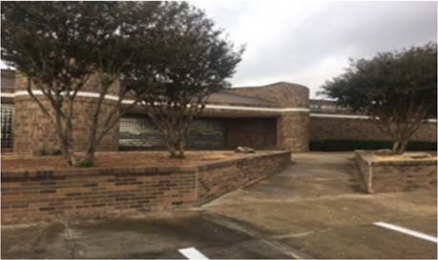A.C. New Middle School

Regina Jackson, Principal

Knights boldly learn and work together to grow as a family!

 | 2016‐2017 | 2017‐2018 | 2018‐2019 | 2019‐2020 | 2020‐2021
Enrollment | 867 | 926 | 910 | 935 | 831
Student/Teacher Ratio Staﬀ FTE's  Professional | 14.5  68.9 | 16.5  65.2 | 13.1  69.7 | 15.7  70.2
Teachers | 59.7 | 56 | 60.3 | 59.5
Professional Support | 6.2 | 6.2 | 6.4 | 7.7
Campus Administration  Support | 3 | 3 | 3 | 3
Educational Aides | 5 | 5 | 5 | 7
Total | 73.9 | 70.2 | 74.7 | 77.2
Expenditures By Character | 2017 AUDITED | 2018 AUDITED | 2019 AUDITED | 2020 UNAUDITED 2021 BUDGET
Payroll Costs | $ 4,494,717.83 | $ 4,833,279.19 | $ 4,568,546.70 | $ 4,940,059.20 | $ 4,954,600.00
Contracted Services | $ 222,283.33 | $ 215,436.39 | $ 183,642.16 | $ 198,747.57 | $ 228,950.00
Supplies and Materials | $ 160,738.34 | $ 161,122.52 | $ 191,632.46 | $ 169,299.34 | $ 217,300.00
Other Operating Costs | $ 96,706.96 | $ 122,295.05 | $ 118,146.16 | $ 98,254.83 | $ 117,600.00
Fixed Assets | $ 32,724.26 | $ 615,951.23 | $ 50,355.00 | $ 194,618.83 | $ ‐
Grand Total $ 5,007,170.72 $ 5,948,084.38 $ 5,112,322.48 $ 5,600,979.77 $ 5,518,450.00

Expenditures by Program Intent
2017 AUDITED |  | 2018 AUDITED | 2019 AUDITED 2020 UNAUDITED 2021 BUDGET
Basic | $ 3,013,666.56 | $ 3,237,250.95 | $ 2,883,645.81 | $ 3,245,667.16 | $ 3,046,450.00
Gifted | $ 77,848.26 | $ 60,808.64 | $ 51,423.61 | $ 44,765.89 | $ 45,800.00
Career & Technology |  |  |  | $ 85,173.95 | $ 86,200.00
Special Education | $ 459,764.34 | $ 552,982.10 | $ 535,413.57 | $ 551,983.04 | $ 577,500.00
Compensatory |  |  | $ 26.49 |  | $ ‐
Bilingual | $ 20,190.13 | $ 16.80 | $ 63,118.01 | $ 71,877.19 | $ 74,600.00
SCE to Support Title I | $ 163,735.48 | $ 245,875.28 | $ 298,361.21 | $ 311,777.97 | $ 312,850.00
Athletics | $ 97,267.95 | $ 104,847.44 | $ 98,853.23 | $ 121,010.03 | $ 121,850.00
Other Instructional $ 1,174,698.00 $ 1,746,303.17 $ 1,181,480.55 $ 1,168,724.54 $ 1,253,200.00
Grand Total | $ 5,007,170.72 | $ 5,948,084.38 | $ 5,112,322.48 | $ 5,600,979.77 | $ 5,518,450.00
Per Student Cost | $ 5,775.28 | $ 6,423.42 | $ 5,617.94 | $ 5,990.35 | $ 6,640.73
Assessment Results | 2017 STAAR | 2018 STAAR | 2019 STAAR | 2020 STAAR | 2021 STAAR
Reading | 69% | 69% | 63% | NA
Mathematics | 78% | 81% | 75% | NA
Writing | 57% | 55% | 55% | NA
Social Studies | 56% | 53% | 57% | NA
Science | 73% | 74% | 76% | NA

**Information obtained from the TEA PEIMS Standard Report and Munis Accounting

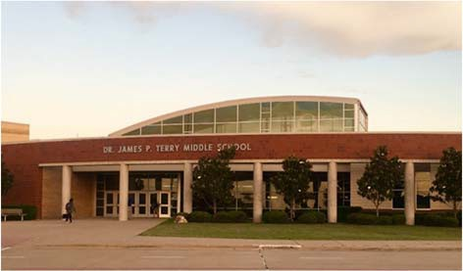Dr. James P. Terry Middle School
2017 AUDITED
2018 AUDITED
2019 AUDITED 2020 UNAUDITED 2021 BUDGET

Kelley Prewitt, Principal

At Terry M.S. we believe in a respectful, collaborative, and student‐ centered environment where teachers build relationships with students and peers, and students are empowered to think independently. Their accomplishments are celebrated all while promoting a culture of positive behavior.
 | 2016‐2017 | 2017‐2018 | 2018‐2019 | 2019‐2020 | 2020‐2021
Enrollment | 836 | 896 | 1425 | 1463 | 1039
Student/Teacher Ratio  Staﬀ FTE's Professional | 16.6  59.7 | 12  84.7 | 16.6  96.4 | 17.5  98.1
Teachers | 50.5 | 74.5 | 86 | 83.5
Professional Support | 6.2 | 6.2 | 7.4 | 10.6
Campus Administration  Support  Educational Aides | 3  8.7 | 4  8.7 | 3  8.8 | 4  8.9
Total | 68.4 | 93.4 | 105.2 | 107
Expenditures | 2017 AUDITED | 2018 AUDITED | 2019 AUDITED | 2020 UNAUDITED | 2021 BUDGET
Payroll Costs | $ 4,175,473.45 | $ 4,443,200.28 | $ 6,648,851.63 | $ 7,002,226.53 | $ 5,742,800.00
Contracted Services | $ 215,734.59 | $ 266,887.94 | $ 265,384.75 | $ 369,560.54 | $ 385,150.00
Supplies and Materials | $ 125,830.97 | $ 189,633.11 | $ 209,260.40 | $ 199,359.01 | $ 220,200.00
Other Operating Costs | $ 137,149.20 | $ 124,836.60 | $ 141,557.61 | $ 118,904.34 | $ 138,300.00
Fixed Assets | $ 15,397.10 | $ 123,206.59 | $ 14,476.95 | $ 194,813.95 | $ ‐
Grand Total | $ 4,669,585.31 | $ 5,147,764.52 | $ 7,279,531.34 | $ 7,884,864.37 | $ 6,486,450.00
Expenditures by Intent

Basic | $ 2,658,397.21 | $ 3,013,303.17 | $ 4,591,490.52 | $ 4,715,333.48 | $ 3,343,650.00
Gifted | $ 68,700.45 | $ 65,702.64 | $ 61,419.03 | $ 55,181.20 | $ 57,400.00
Career & Technology |  |  |  | $ 100,324.48 | $ 103,200.00
Special Education | $ 648,208.27 | $ 640,092.78 | $ 863,533.31 | $ 910,314.95 | $ 807,050.00
Compensatory | $ 9,494.23 | $ 9,011.39 | $ ‐ |  | $ ‐
Bilingual | $ 187.09 | $ ‐ | $ 113,290.23 | $ 123,213.28 | $ 126,450.00
SCE to Support Title 1 |  | $ ‐ | $ 160,470.10 | $ 368,923.64 | $ 385,700.00
Athletics | $ 99,269.54 | $ 97,981.53 | $ 99,526.93 | $ 127,883.25 | $ 126,950.00
Other Instructional Areas $ 1,185,328.52 $ 1,321,673.01 $ 1,389,801.22 $ 1,483,690.09 $ 1,536,050.00
Grand Total | $ 4,669,585.31 | $ 5,147,764.52 | $ 7,279,531.34 | $ 7,884,864.37 | $ 6,486,450.00
Per Student Cost | $ 5,585.63 | $ 5,745.27 | $ 5,108.44 | $ 5,389.52 | $ 6,242.97
Assessment Results | 2017 STAAR | 2018 STAAR | 2019 STAAR | 2020 STAAR | 2021 STAAR
Reading | 75% | 74% | 65% | NA
Mathematics | 78% | 78% | 73% | NA
Writing | 70% | 75% | 62% | NA
Social Studies | 74% | 76% | 63% | NA
Science | 83% | 82% | 74% | NA

Ed F. Vanston Middle School
Melissa Smith, Principal

To establish an educational environment that produces productive members of society who are creative, innovative, and global thinkers. To utilize strategies that promote innovation through problem solving, collaboration and critical thinking. To provide a positive learning environment that empowers our students to succeed academically, as well as acquiring skills necessary to succeed in the 21st century.

 | 2016‐2017 | 2017‐2018 | 2018‐2019 | 2019‐2020 | 2020‐2021
Enrollment | 810 | 805 | 913 | 923 | 847
Student/Teacher Ratio | 14.7 | 13.3 | 15.3 | 15
Staﬀ FTE's
Professional | 65.6 | 70.8 | 71.2 | 73.2
Teachers | 55.1 | 60.3 | 59.8 | 61.7
Professional Support | 7.5 | 7.5 | 8.4 | 8.5
Campus Administration | 3 | 3 | 3 | 3
Support
Educational Aides | 8 | 8 | 9 | 10
Total | 73.5 | 78.8 | 80.2 | 83.2
Expenditures
 | 2017 AUDITED | 2018 AUDITED | 2019 AUDITED | 2020 UNAUDITED | 2021 BUDGET
Payroll Costs | $ 4,083,641.04 | $ 4,409,128.73 | $ 4,753,161.47 | $ 5,046,116.42 | $ 5,155,800.00
Contracted Services | $ 248,981.32 | $ 204,699.41 | $ 191,231.20 | $ 191,239.95 | $ 219,200.00
Supplies and Materials | $ 214,543.38 | $ 168,600.67 | $ 170,984.74 | $ 173,850.82 | $ 210,500.00
Other Operating Costs | $ 131,579.70 | $ 136,068.12 | $ 147,095.72 | $ 119,844.52 | $ 140,850.00
Fixed Assets | $ 92,467.92 | $ 101,922.52 | $ 31,379.12 | $ 192,079.91 | $ ‐
Grand Total | $ 4,771,213.36 | $ 5,020,419.45 | $ 5,293,852.25 | $ 5,723,131.62 | $ 5,726,350.00
Expenditures by Intent
 | 2017 AUDITED | 2018 AUDITED | 2019 AUDITED | 2020 UNAUDITED | 2021 BUDGET
Basic | $ 2,413,282.18 | $ 2,699,503.31 | $ 3,032,626.88 | $ 3,226,622.79 | $ 3,120,950.00
Gifted | $ 67,174.03 | $ 41,326.20 | $ 35,698.43 | $ 56,998.60 | $ 57,200.00
Career & Technology | $ ‐ | $ ‐ | $ ‐ | $ 86,434.92 | $ 89,450.00
Special Education | $ 636,317.89 | $ 672,257.54 | $ 636,329.12 | $ 738,815.88 | $ 732,850.00
Compensatory | $ ‐ |  |  |  | $ ‐
Bilingual | $ 59,895.21 | $ 49,029.70 | $ 64,733.71 | $ 68,260.77 | $ 69,950.00
SCE to Support Title I | $ 177,317.39 | $ 214,555.22 | $ 210,416.01 | $ 242,206.64 | $ 272,100.00
High School Allotment | $ 97,592.50 | $ 108,152.45 | $ 92,894.35 | $ 126,760.55 | $ 121,800.00
Athletics | $ 1,319,634.16 | $ 1,235,595.03 | $ 1,221,153.75 | $ 1,177,031.47 | $ 1,262,050.00
Other Instructional | $ 4,771,213.36 | $ 5,020,419.45 | $ 5,293,852.25 | $ 5,723,131.62 | $ 5,726,350.00
Grand Total
Per Student Cost | $ 5,890.39 | $ 6,236.55 | $ 5,798.30 | $ 6,200.58 | $ 6,760.74
Assessment Results | 2017 STAAR | 2018 STAAR | 2019 STAAR | 2020 STAAR | 2020 STAAR
Reading | 73% | 68% | 65% | NA
Mathematics | 79% | 79% | 80% | NA
Writing | 63% | 55% | 63% | NA
Social Studies | 43% | 43% | 48% | NA
Science | 77% | 80% | 77% | NA

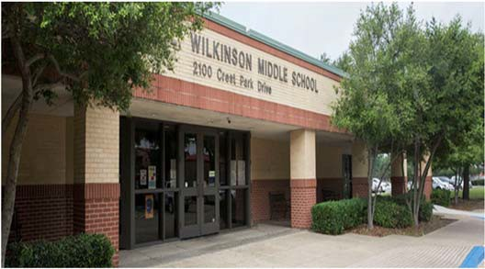Walter L. Wilkinson Middle School

Tomika Johnson, Principal

Wilkinson Vision‐Catch Greatness
 |  | 2016‐2017 | 2017‐2018 | 2018‐2019 | 2019‐2020 | 2020‐2021
Enrollment |  | 954 | 974 | 776 | 790 | 797
Student/Teacher Ratio |  | 14.2 | 16.1 | 13 | 14
Staﬀ FTE's
Professional |  | 76 | 69.2 | 69 | 66.9
Teachers |  | 67.3 | 60.5 | 59.8 | 56.6
Professional Support |  | 5.7 | 5.7 | 6.2 | 7.3
Campus Administration |  | 3 | 3 | 3 | 3
Support
Educational Aides | 9.9 |  | 9.9 | 9 | 9.6
Total | 85.9 |  | 79.1 | 78 | 76.5
Expenditures By Character
 | 2017 AUDITED |  | 2018 AUDITED | 2019 AUDITED | 2020 UNAUDITED | 2021 BUDGET
Payroll Costs | $ 4,688,599.32 |  | $ 4,835,693.66 | $ 4,547,021.97 | $ 4,794,914.17 | $ 4,850,600.00
Contracted Services | $ 264,639.64 |  | $ 268,665.84 | $ 252,690.99 | $ 222,484.90 | $ 250,450.00
Supplies and Materials | $ 161,443.69 |  | $ 168,519.09 | $ 162,197.73 | $ 154,134.07 | $ 196,450.00
Other Operating Costs | $ 147,151.05 |  | $ 133,375.43 | $ 136,813.02 | $ 121,916.45 | $ 137,600.00
Fixed Assets | $ 103,184.29 |  | $ 37,853.42 | $ 7,081.50 | $ 169,412.88 | $ ‐
Grand Total | $ 5,365,017.99 |  | $ 5,444,107.44 | $ 5,105,805.21 | $ 5,462,862.47 | $ 5,435,100.00
Expenditures by Program Intent
 | 2017 AUDITED |  | 2018 AUDITED | 2019 AUDITED | 2020 UNAUDITED | 2021 BUDGET
Basic | $ 3,100,939.51 |  | $ 3,231,839.45 | $ 2,821,827.46 | $ 2,964,301.20 | $ 2,833,950.00
Gifted | $ 93,765.72 |  | $ 95,907.92 | $ 84,832.30 | $ 84,229.84 | $ 87,000.00
Career & Technology |  |  |  |  | $ 89,315.73 | $ 92,800.00
Special Education | $ 439,544.80 |  | $ 436,761.38 | $ 490,763.92 | $ 622,283.73 | $ 628,050.00
Compensatory |  |  |  |  |  | $ ‐
Bilingual | $ 82,499.69 |  | $ 93,731.04 | $ 125,713.66 | $ 105,659.23 | $ 105,400.00
SCE to Support Title I | $ 202,013.95 |  | $ 212,397.80 | $ 211,586.27 | $ 249,457.07 | $ 258,700.00
High School Allotment | $ 92,945.67 |  | $ 95,103.18 | $ 92,711.13 | $ 120,914.16 | $ 120,350.00
Athletics | $ 1,353,308.65 |  | $ 1,278,366.67 | $ 1,278,370.47 | $ 1,226,701.51 | $ 1,308,850.00
Other Instructional | $ 5,365,017.99 |  | $ 5,444,107.44 | $ 5,105,805.21 | $ 5,462,862.47 | $ 5,435,100.00
Grand Total
Per Student Cost | $ 5,623.71 |  | $ 5,589.43 | $ 6,579.65 | $ 6,915.02 | $ 6,819.45
Assessment Results | 2017 STAAR |  | 2018 STAAR | 2019 STAAR | 2020 STAAR | 2021 STAAR
Reading | 67% |  | 71% | 72% | NA
Mathematics | 81% |  | 84% | 90% | NA
Writing | 62% |  | 65% | 72% | NA
Social Studies | 59% |  | 65% | 69% | NA
Science | 87% |  | 90% | 92% | NA

**Information obtained from the TEA PEIMS Standard Report and Munis Accounting

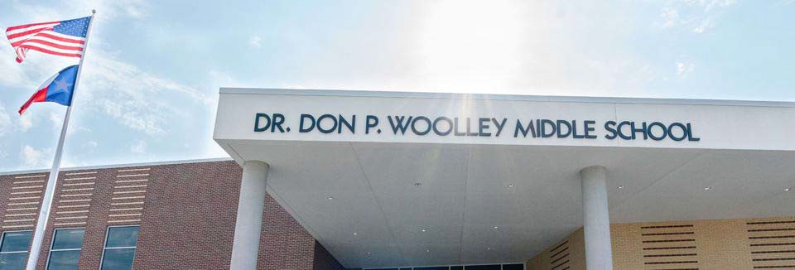Woolley Middle School

Ashly Cochran, Principal

2016‐2017 2017‐2018 2018‐2019 2019‐2020 2020‐2021
Enrollment 907
Student/Teacher Ratio Staﬀ FTE's
Professional Teachers
Professional Support Campus Administration
Support
Educational Aides
Total
Expenditures
 | 2017 AUDITED | 2018 AUDITED | 2019 AUDITED | 2020 UNAUDITED | 2021 BUDGET
Payroll Costs |  |  |  | $ 135,101.12 | $ 4,959,600.00
Contracted Services |  |  |  | $ 2,529.75 | $ 235,150.00
Supplies and Materials |  |  |  | $ 635,623.07 | $ 324,500.00
Other Operating Costs |  |  |  | $ 5,403.40 | $ 116,150.00
Fixed Assets |  |  |  | $ 808,302.86 | $ ‐
Grand Total |  |  |  | $ 1,586,960.20 | $ 5,635,400.00
Expenditures by Intent
 | 2017 AUDITED | 2018 AUDITED | 2019 AUDITED | 2020 UNAUDITED | 2021 BUDGET
Basic |  |  |  | $ 17,279.68 | $ 3,161,100.00
Gifted |  |  |  | $ ‐ | $ 1,000.00
Career & Technology |  |  |  | $ 2,105.29 | $ 146,200.00
Special Education |  |  |  | $ ‐ | $ 533,800.00
Bilingual |  |  |  | $ ‐ | $ 69,750.00
SCE to Support Title 1 |  |  |  | $ 1,813.38 | $ 220,250.00
Athletics |  |  |  | $ 1,435.00 | $ 130,450.00
Other Instructional Areas $ 1,564,326.85 $ 1,372,850.00
Grand Total $ 1,586,960.20 $ 5,635,400.00

Per Student Cost $ 6,213.23

Assessment Results | 2017 STAAR | 2018 STAAR | 2019 STAAR | 2020 STAAR | 2021 STAAR
Reading
Mathematics
Writing
Social Studies
Science

**Information obtained from the TEA PEIMS Standard Report and Munis Accounting

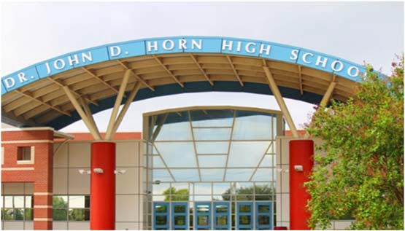Dr. John D. Horn High School

Bruce Perkins, Principal

Our mission is to enable all students at Dr. John D. Horn High to become lifelong learners and to acquire the attitudes, values, and ethics needed to be cooperative and productive citizens of a free society. We will strive to create a school community of empowerment, leadership, and continuous learning that oﬀers
Success for all students.
 | 2016‐2017 | 2017‐2018 | 2018‐2019 | 2019‐2020 | 2020‐2021
Enrollment | 2358 | 2386 | 2620 | 2898 | 3099
Student/Teacher Ratio  Staﬀ FTE's  Professional | 16  171 | 15  184 | 16.4  189.5 | 16.9  201.2
Teachers | 147.4 | 160 | 159.7 | 171.1
Professional Support | 17 | 17 | 21.3 | 21.4
Campus Administration  Support  Educational Aides | 7  12 | 7  12 | 8.5  14.8 | 8.7  14.7
Total | 183 | 196 | 204.3 | 215.9
Expenditures By Character | 2017 AUDITED | 2018 AUDITED | 2019 AUDITED | 2020 UNAUDITED | 2021 BUDGET
Payroll Costs | $ 12,641,304.24 | $ 13,199,747.54 | $ 13,946,850.54 | $ 15,053,516.21 | $ 17,135,100.00
Contracted Services | $ 612,724.44 | $ 627,057.18 | $ 778,674.45 | $ 607,873.62 | $ 636,450.00
Supplies and Materials | $ 765,981.22 | $ 704,990.52 | $ 886,311.56 | $ 708,246.04 | $ 758,350.00
Other Operating Costs | $ 598,481.24 | $ 635,487.68 | $ 717,954.74 | $ 616,643.72 | $ 547,150.00
Fixed Assets $ 788,474.60 |  | $ 725,512.08 | $ 715,455.39 | $ 481,919.00 | $ ‐
Grand Total $ 15,406,965.74 |  | $ 15,892,795.00 | $ 17,045,246.68 | $ 17,468,198.59 | $ 19,077,050.00
Expenditures by Program Intent
 | 2017 AUDITED | 2018 AUDITED | 2019 AUDITED | 2020 UNAUDITED | 2021 BUDGET
General | $ 0.00 | $ 0.00 |  |  | $ | ‐
Basic | $ 6,616,960.83 | $ 7,053,691.88 | $ 7,293,625.66 | $ 8,816,729.18 | $ 10,476,950.00
Gifted | $ 194,399.80 | $ 158,156.11 | $ 191,399.18 | $ 217,850.37 | $ 228,250.00
Career & Technology | $ 2,116,458.20 | $ 2,115,907.75 | $ 2,071,039.85 | $ 2,468,204.89 | $ 2,166,800.00
Special Education | $ 1,325,761.76 | $ 1,344,540.77 | $ 1,482,862.91 | $ 1,599,339.72 | $ 1,629,900.00
Compensatory | $ 418,046.74 | $ 402,780.62 | $ (26.49) $ ‐
Bilingual | $ 68,063.41 | $ 69,308.97 | $ ‐ | $ ‐ | $ 750.00
SCE to Support Title I |  | $ ‐ | $ 421,707.48 | $ 327,737.32 | $ 459,300.00
High School Allotment | $ 539,912.82 | $ 524,073.18 | $ 1,120,391.19 | $ ‐ | $ ‐
College Career & Mil Readiness |  |  |  | $ 66,762.17 | $ 68,050.00
Athletics | $ 1,058,663.43 | $ 1,128,231.53 | $ 1,237,791.97 | $ 974,631.87 | $ 938,600.00
Other Instructional | $ 3,068,698.75 | $ 3,096,104.19 | $ 3,226,454.93 | $ 2,996,943.07 | $ 3,108,450.00
Grand Total | $ 15,406,965.74 | $ 15,892,795.00 | $ 17,045,246.68 | $ 17,468,198.59 | $ 19,077,050.00
Per Student Cost | $ 6,533.91 | $ 6,660.85 | $ 6,505.82 | $ 6,027.67 | $ 6,155.87
Assessment Results | 2017 STAAR | 2018 STAAR | 2019 STAAR | 2020 STAAR | 2021 STAAR
Reading | 63% | 65% | 65% | NA
Mathematics | 79% | 82% | 88% | NA
Social Studies | 87% | 89% | 90% | NA
Science | 93% | 93% | 93% | NA

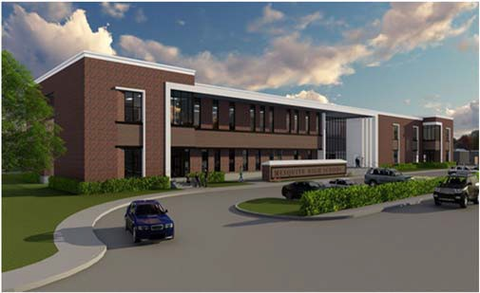Mesquite High School

Gerald Sarpy, Principal

The Skeeter community invests in the growth of our students, empowering them to reach their full potential and impact the future.

 | 2016‐2017 | 2017‐2018 | 2018‐2019 | 2019‐2020 | 2020‐2021
Enrollment | 2855 | 2904 | 2650 | 2625 | 2561
Student/Teacher Ratio | 15.8 | 16.3 | 14.9 | 13.9
Staﬀ FTE's
Professional | 205.8 | 202.7 | 208.1 | 223.7
Teachers | 181 | 177.9 | 178.1 | 188.9
Professional Support | 16.8 | 16.8 | 21.5 | 25.3
Campus Administration Support  Educational Aides | 8  19 | 8  19 | 8.5  21.7 | 9.5  19.4
Total 224.8 |  | 221.7 | 229.8 | 243.1
2017 AUDITED |  | 2018 AUDITED | 2019 AUDITED | 2020 UNAUDITED | 2021 BUDGET
Payroll Costs | $ 15,042,248.79 | $ 15,369,936.12 | $ 15,198,753.72 | $ 15,574,172.56 | $ 16,457,900.00
Contracted Services | $ 881,638.52 | $ 818,270.58 | $ 767,893.08 | $ 820,664.59 | $ 825,350.00
Supplies and Materials | $ 910,478.96 | $ 922,845.13 | $ 980,984.50 | $ 888,580.46 | $ 720,400.00
Other Operating Costs | $ 646,077.02 | $ 660,539.48 | $ 750,595.08 | $ 569,639.54 | $ 566,900.00
Fixed Assets $ 1,068,216.25 $ 976,720.72 $ 1,050,266.10 $ 463,845.95 $ 100,000.00
Grand Total $ 18,548,659.54 $ 18,748,312.03 $ 18,748,492.48 $ 18,316,903.10 $ 18,670,550.00

2017 AUDITED 2018 AUDITED 2019 AUDITED 2020 UNAUDITED 2021 BUDGET
Basic | $ 7,709,786.34 | $ 7,948,281.10 | $ 6,958,841.52 | $ 7,958,386.10 | $ 8,656,450.00
Gifted | $ 225,374.47 | $ 160,266.58 | $ 135,458.57 | $ 36,806.99 | $ 57,450.00
Career & Technology | $ 2,925,754.38 | $ 2,931,899.55 | $ 3,049,395.06 | $ 3,250,230.23 | $ 2,808,750.00
Special Education | $ 1,599,720.46 | $ 1,624,919.27 | $ 1,782,705.93 | $ 1,809,210.90 | $ 1,859,700.00
Compensatory | $ 719,570.92 | $ 656,952.50 | $ ‐ | $ ‐ | $ ‐
Bilingual | $ 60,490.75 | $ 81,042.50 | $ 82,047.61 | $ 86,443.70 | $ 89,250.00
SCE to Support Title I |  | $ 0.00 | $ 598,770.77 | $ 623,600.62 | $ 564,550.00
High School Allotment | $ 661,877.10 | $ 796,432.97 | $ 994,475.10 | $ ‐ | $ ‐
College Career & Mil Readiness |  |  |  | $ 53,418.21 | $ 74,550.00
Athletics | $ 1,022,114.34 | $ 1,098,449.76 | $ 1,155,813.77 | $ 982,832.25 | $ 881,850.00
Other Instructional $ 3,623,970.78 $ 3,450,067.80 $ 3,990,984.15 $ 3,515,974.10 $ 3,678,000.00
Grand Total $ 18,548,659.54 $ 18,748,312.03 $ 18,748,492.48 $ 18,316,903.10 $ 18,670,550.00

Per Student Cost $ 6,496.90 $ 6,456.03 $ 7,074.90 $ 6,977.87 $ 7,290.34

Assessment Results | 2017 STAAR | 2018 STAAR | 2019 STAAR | 2020 STAAR | 2021 STAAR
Reading | 59% | 61% | 63% | NA
Mathematics | 74% | 75% | 88% | NA
Social Studies | 87% | 85% | 88% | NA
Science | 90% | 90% | 89% | NA

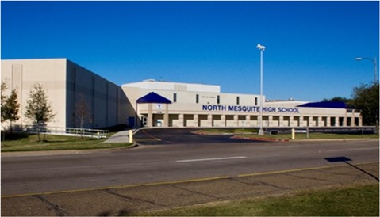North Mesquite High School

Kenneth Washington, Principal

Dream…Believe…Achieve!

 | 2016‐2017 | 2017‐2018 | 2018‐2019 | 2019‐2020 | 2020‐2021
Enrollment | 2812 | 2808 | 2611 | 2522 | 2415
Student/Teacher Ratio | 15.9 | 15.9 | 14.6 | 14.7
Staﬀ FTE's
Professional | 203.1 | 203.1 | 209.7 | 202.5
Teachers | 176.6 | 176.6 | 178.4 | 171.2
Professional Support | 17.4 | 17.4 | 21.8 | 22
Campus Administration | 9.1 | 9.1 | 9.5 | 9.3
Support  Educational Aides | 20.9 | 20.9 | 19.9 | 21
Total 223.9 |  | 224 | 229.6 | 223.5
2017 AUDITED |  | 2018 AUDITED | 2019 AUDITED | 2020 UNAUDITED | 2021 BUDGET
Payroll Costs | $ 14,072,685.17 | $ 14,942,999.87 | $ 14,673,749.55 | $ 14,377,239.57 | $ 15,316,550.00
Contracted Services | $ 701,223.22 | $ 732,825.25 | $ 705,742.08 | $ 682,193.45 | $ 692,250.00
Supplies and Materials | $ 894,105.73 | $ 814,665.71 | $ 851,834.79 | $ 807,834.81 | $ 731,750.00
Other Operating Costs | $ 590,133.58 | $ 680,560.68 | $ 670,909.63 | $ 540,611.65 | $ 580,350.00
Fixed Assets | $ 908,168.48 | $ 2,865,417.44 | $ 2,245,059.21 | $ 1,462,586.89 | $ ‐
Grand Total | $ 17,166,316.18 | $ 20,036,468.95 | $ 19,147,295.26 | $ 17,870,466.37 | $ 17,320,900.00
 | 2017 AUDITED | 2018 AUDITED | 2019 AUDITED | 2020 UNAUDITED | 2021 BUDGET
Basic | $ 8,047,853.89 | $ 8,374,657.41 | $ 7,741,044.99 | $ 8,160,407.47 | $ 8,849,450.00
Gifted | $ 181,578.48 | $ 179,059.19 | $ 172,654.42 | $ 183,153.86 | $ 192,600.00
Career & Technology | $ 2,216,247.46 | $ 2,494,028.53 | $ 2,366,056.48 | $ 2,282,716.19 | $ 1,956,100.00
Special Education | $ 1,170,684.42 | $ 1,185,464.22 | $ 1,231,081.05 | $ 1,219,949.73 | $ 1,247,700.00
Compensatory | $ 499,331.46 | $ 441,645.63 | $ 134.66 |  | $ ‐
Bilingual | $ 64,064.35 | $ 74,350.40 | $ 137,977.86 | $ 115,941.92 | $ 119,900.00
SCE to Support Title I |  | $ ‐ | $ 383,030.44 | $ 437,157.01 | $ 482,350.00
High School Allotment | $ 790,896.32 | $ 875,778.94 | $ 853,676.89 | $ ‐ | $ ‐
College Career & Mil Readiness | $ 830,541.08 | $ 934,552.03 | $ 1,004,890.43 | $ 68,229.60 | $ 78,950.00
Athletics |  |  |  | $ 850,754.93 | $ 851,800.00
Other Instructional $ 4,552,155.66 $ 3,542,050.00
Grand Total | $ 17,166,316.18 | $ 20,036,468.95 | $ 19,147,295.26 | $ 17,870,466.37 | $ 17,320,900.00
Per Student Cost | $ 6,104.66 | $ 7,135.49 | $ 7,333.32 | $ 7,085.83 | $ 7,172.22
Assessment Results | 2017 STAAR | 2018 STAAR | 2019 STAAR | 2020 STAAR | 2021 STAAR
Reading | 60% | 59% | 64% | NA
Mathematics | 78% | 76% | 90% | NA
Social Studies | 86% | 82% | 89% | NA
Science | 89% | 85% | 90% | NA

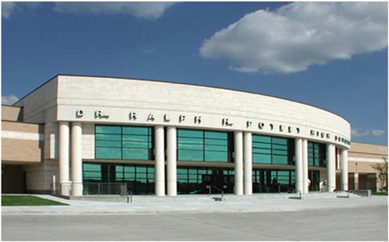Ralph H. Poteet High School
Kelly Long, Principal

Respect the past, Honor the future, and take Pride in today.

 | 2016‐2017 | 2017‐2018 | 2018‐2019 | 2019‐2020 | 2020‐2021
Enrollment | 1752 | 1848 | 1794 | 1822 | 1750
Student/Teacher Ratio  Staﬀ FTE's Professional | 14.8  134.9 | 15.8  134.3 | 15.6  134.5 | 16  133.1
Teachers | 118.6 | 117 | 115.3 | 114
Professional Support | 11.3 | 11.3 | 12.9 | 12.8
Campus Administration  Support | 5 | 6 | 6.3 | 6.3
Educational Aides | 12 | 12 | 12 | 11
Total | 146.8 | 146.3 | 146.5 | 144.1
Expenditures | 2017 AUDITED | 2018 AUDITED | 2019 AUDITED | 2020 UNAUDITED 2021 BUDGET
Payroll Costs | $ 9,765,209.86 | $ 10,271,665.33 | $ 10,270,159.95 | $ 10,381,703.84 | $ 10,752,100.00
Contracted Services | $ 610,311.77 | $ 630,418.29 | $ 586,274.04 | $ 565,069.68 | $ 591,250.00
Supplies and Materials | $ 778,824.49 | $ 775,010.84 | $ 868,850.67 | $ 801,709.19 | $ 712,550.00
Other Operating Costs | $ 597,368.69 | $ 596,125.28 | $ 599,734.90 | $ 530,310.08 | $ 507,800.00
Fixed Assets | $ 612,646.60 | $ 716,570.80 | $ 234,512.36 | $ 456,053.93 | $ ‐
Grand Total | $ 12,364,361.41 | $ 12,989,790.54 | $ 12,559,531.92 | $ 12,734,846.72 | $ 12,563,700.00
Expenditures by Intent | 2017 AUDITED | 2018 AUDITED | 2019 AUDITED | 2020 UNAUDITED | 2021 BUDGET
Basic | $ 5,119,765.63 | $ 5,410,068.78 | $ 5,037,218.81 | $ 6,020,420.36 | $ 5,881,900.00
Gifted | $ 364,191.87 | $ 235,806.78 | $ 254,829.44 | $ 224,288.68 | $ 238,500.00
Career & Technology | $ 1,786,848.23 | $ 2,023,299.58 | $ 1,849,565.36 | $ 1,773,008.06 | $ 1,568,350.00
Special Education | $ 894,639.40 | $ 932,436.65 | $ 943,294.02 | $ 966,154.92 | $ 985,950.00
Compensatory | $ 305,904.40 | $ 262,723.24 | $ 417.69 |  | $ ‐
Bilingual | $ 27,797.70 | $ 28,956.27 | $ 54,656.90 | $ ‐ | $ 750.00
SCE to Support Title I |  | $ ‐ | $ 288,655.23 | $ 289,387.44 | $ 333,550.00
High School Allotment | $ 312,112.20 | $ 556,508.11 | $ 599,666.27 | $ ‐ | $ ‐
College Career & Mil Readiness |  |  |  | $ 62,302.32 | $ 64,700.00
Athletics | $ 919,163.12 | $ 980,118.96 | $ 1,087,737.23 | $ 992,696.79 | $ 882,300.00
Other Instructional $ 2,633,938.86 $ 2,559,872.17 $ 2,443,490.97 $ 2,406,588.15 $ 2,607,700.00
Grand Total $ 12,364,361.41 $ 12,989,790.54 $ 12,559,531.92 $ 12,734,846.72 $ 12,563,700.00

Per Student Cost $ 7,057.28 $ 7,029.11 $ 7,000.85 $ 6 989.49 $ 7,179.26

Assessment Results | 2017 STAAR | 2018 STAAR | 2019 STAAR | 2020 STAAR | 2021 STAAR
 |  |  |  | NA
Reading | 72% | 68% | 69% | NA
Mathematics | 75% | 74% | 88% | NA
Social Studies | 91% | 92% | 86% | NA
Science | 91% | 93% | 90% | NA

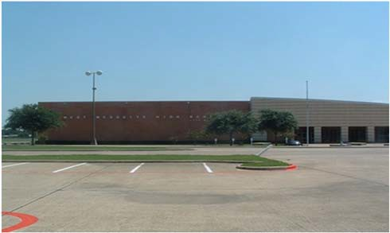West Mesquite High School

Karen Morris, Principal

The Mission of West Mesquite High School is to educate and empower our students by providing them an innovative learning environment which will prepare them to become contributing members of a global society.
 | 2016‐2017 | 2017‐2018 | 2018‐2019 | 2019‐2020 | 2020‐2021
Enrollment | 2061 | 2077 | 2114 | 2162 | 2280
Student/Teacher Ratio Staﬀ FTE's Professional | 14.8  161.1 | 15.4  157.1 | 15.2  160.4 | 15.2  165.8
Teachers | 139.3 | 135.3 | 139.4 | 141.9
Professional Support | 14.5 | 14.5 | 14.9 | 16.8
Campus Administration  Support | 7.3 | 7.3 | 6.1 | 7.1
Educational Aides | 11.8 | 11.8 | 10.5 11
Total | 172.9 | 168.9 | 170.9 176.8
Expenditures By Character | 2017 AUDITED | 2018 AUDITED | 2019 AUDITED 2020 UNAUDITED |  | 2021 BUDGET
Payroll Costs | $ 11,029,851.64 | $ 11,819,221.79 | $ 11,429,987.27 $ 12,630,364.70 |  | $ 13,784,200.00
Contracted Services | $ 577,013.76 | $ 629,519.98 | $ 558,177.98 $ 589,173.94 |  | $ 587,200.00
Supplies and Materials | $ 804,774.89 | $ 855,759.70 | $ 789,765.00 $ 1,021,473.42 |  | $ 638,550.00
Other Operating Costs | $ 478,310.10 | $ 471,936.57 | $ 560,313.22 $ 507,544.23 |  | $ 511,550.00
Fixed Assets | $ 1,636,703.64 | $ 658,172.65 | $ 766,866.31 $ 305,868.43 |  | $ ‐
Grand Total | $ 14,526,654.03 | $ 14,434,610.69 | $ 14,105,109.78 $ 15,054,424.72 |  | $ 15,521,500.00
Expenditures by Intent | 2017 AUDITED | 2018 AUDITED | 2019 AUDITED 2020 UNAUDITED |  | 2021 BUDGET
Basic | $ 6,295,025.93 | $ 6,392,422.23 | $ 5,861,709.83 $ 7,450,560.45 |  | $ 8,347,450.00
Gifted | $ 148,515.76 | $ 141,632.79 | $ 78,230.72 $ 80,458.81 |  | $ 85,050.00
Career & Technology | $ 2,173,482.38 | $ 2,390,790.50 | $ 2,292,286.03 $ 2,551,831.16 |  | $ 1,941,600.00
Special Education | $ 947,253.42 | $ 951,274.77 | $ 935,980.40 $ 1,097,342.28 |  | $ 1,124,900.00
Compensatory  Bilingual | $ 57,634.11 | $ 60,013.62 | $ ‐  $ 65,319.99 $ 42.50 |  | $ ‐  $ 250.00
SCE to Support Title I | $ 363,836.29 | $ 446,080.53 | $ 408,948.94 $ 414,124.98 |  | $ 460,400.00
High School Allotment | $ 422,086.73 | $ 668,891.63 | $ 762,633.12 $ ‐ |  | $ ‐
College Career & Mil Readiness |  |  | $ 77,074.46 |  | $ 88,800.00
Athletics | $ 772,274.12 | $ 823,314.02 | $ 868,397.12 $ 849,616.60 |  | $ 791,500.00
Other Instructional $ 3,346,545.29 $ 2,560,190.60 $ 2,831,603.63 $ 2,533,373.48 $ 2,681,550.00
Grand Total $ 14,526,654.03 $ 14,434,610.69 $ 14,105,109.78 $ 15,054,424.72 $ 15,521,500.00
Per Student Cost $ 6,659.90 $ 6,446.05 $ 6,672.24 $ 6,963.19 $ 6,807.68

Assessment Results | 2017 STAAR | 2018 STAAR | 2019 STAAR | 2020 STAAR | 2021 STAAR
Reading | 58% | 59% | 60% | NA
Mathematics | 74% | 71% | 86% | NA
Social Studies | 81% | 80% | 85% | NA
Science | 87% | 87% | 88% | NA

Serves Grades 9th‐12th
**Information obtained from the TEA PEIMS Standard Report and Munis Accounting

Informational Section 234

Mesquite ISD Official Budget 2020-2021

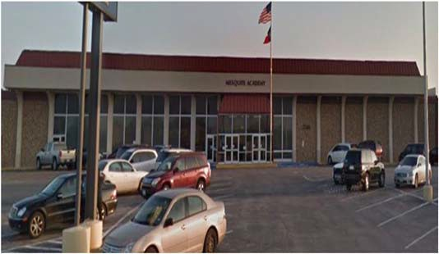Mesquite Academy

Abram Joseph, Principal

DREAM IT! BELIEVE IT!
Excellence Always!
Graduate!

2016‐2017 |  | 2017‐2018 | 2018‐2019 2019‐2020 2020‐2021
Enrollment Student/Teacher Ratio | 167  3.6 | 187  4 | 280  3.8 | Included in Campus Count | Included in Campus Count
Staﬀ FTE's  Professional | 62.4 | 62.4 | 60.4
Teachers | 46.2 | 46.2 | 47.4
Professional Support | 12.2 | 12.2 | 10
Campus Administration  Support  Educational Aides | 4  15 | 4  15 | 3  14
Total | 77.4 | 77.4 | 74.4
Expenditures | 2017 AUDITED | 2018 AUDITED | 2019 AUDITED | 2020 UNAUDITED | 2021 BUDGET
Payroll Costs | $ 1,796,431.87 | $ 2,089,793.91 | $ 2,483,770.37 | $ 2,659,354.55 | $ 2,535,200.00
Contracted Services | $ 31,837.69 | $ 41,727.44 | $ 49,698.20 | $ 62,156.99 | $ 69,800.00
Supplies and Materials | $ 33,662.47 | $ 51,931.36 | $ 51,354.87 | $ 51,776.75 | $ 53,600.00
Other Operating Costs | $ 11,120.97 | $ 18,689.94 | $ 73,814.98 | $ 89,844.23 | $ 85,050.00
Fixed Assets | $ 38,876.04 | $ 56,849.25 | $ 36,480.13 | $ 56,842.00 | $ ‐
Grand Total | $ 1,911,929.04 | $ 2,258,991.90 | $ 2,695,118.55 | $ 2,919,974.52 | $ 2,743,650.00
Expenditures by Intent

Career & Technology | $ 236,363.80 | $ 233,240.01 | $ 234,588.86 | $ ‐ | $ ‐
Special Education | $ 113,948.85 | $ 79,361.23 | $ 86,429.60 | $ 150,793.74 | $ 3,900.00
Bilingual | $ ‐ | $ ‐ | $ ‐ | $ 268.93 | $ 153,750.00
Nondisciplinary AEP Basic | $ 1,404,169.33 | $ 1,776,683.11 | $ 2 ,207,451.31 | $ 2,588,470.75 | $ ‐
Nondisciplinary AEP Supplies | $ ‐ | $ ‐ | $ ‐ | $ ‐ | $ 250.00
Disciplinary AEP Basic |  |  | $ 695.82 | $ ‐ $ 2,395,250.00
Other Instruction Area | $ 157,447.06 | $ 169,707.55 | $ 165,952.96 | $ 180,441.10 $ ‐
$ ‐
2017 AUDITED
2018 AUDITED
2019 AUDITED 2020 UNAUDITED 2021 BUDGET
$ ‐
$ 190,500.00
Grand Total $ 1,911,929.04 $ 2,258,991.90 $ 2,695,118.55 $ 2,919,974.52 $ 2,743,650.00

Per Student Cost $ 11,448.68 $ 12,080.17 $ 9,625.42 ‐ ‐

Assessment Results | 2017 STAAR | 2018 STAAR | 2019 STAAR | 2020 STAAR | 2021 STAAR
Reading | 32% | 20%
Mathematics | 86% | 50%
Writing
Science | 67% | 33%
Social Studies | 79% | 61%

**Information obtained from the TEA PEIMS Standard Report and Munis Accounting

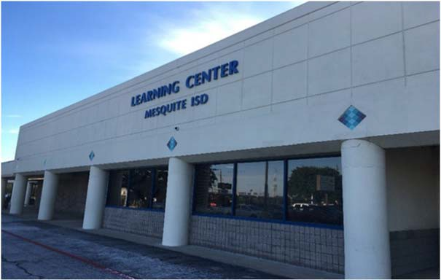The Learning Center

Dr. Valerie Nelson, Principal

Safety‐Relationships‐Engagement
Expenditures  2017 AUDITED | 2018 AUDITED | 2019 AUDITED | 2020 UNAUDITED | 2021 BUDGET
Payroll Costs $ 2,862,735.69 | $ 2,950,447.53 | $ 2,481,968.20 | $ 2,271,223.09 | $ 2,469,000.00
Contracted Services $ 50,308.74 | $ 51,197.25 | $ 44,891.22 | $ 49,282.92 | $ 51,600.00
Supplies and Materials $ 26,367.93 | $ 38,103.04 | $ 25,395.03 | $ 33,322.82 | $ 38,650.00
Other Operating Costs $ 3,581.73 | $ 3,345.97 | $ 54,632.49 | $ 72,242.85 | $ 72,600.00
Fixed Assets $ 11,718.05 | $ 278.65 | $ 5,692.42 | $ 46,885.74 | $ ‐
Grand Total $ 2,954,712.14 | $ 3,043,372.44 | $ 2,612,579.36 | $ 2,472,957.42 | $ 2,631,850.00
Expenditures by Intent  2017 AUDITED | 2018 AUDITED | 2019 AUDITED | 2020 UNAUDITED | 2021 BUDGET
Basic $ ‐ | $ (277.50) | $ 1,827.42 | $ ‐ | $ ‐
Career & Technology $ 1,295.00 | $ 1,203.07 | $ 3,392.00 | $ 636.24 | $ ‐
Special Education $ 222,672.98 | $ 216,350.95 | $ 223,237.44 | $ 316,079.25 | $ 312,500.00
Bilingual $ ‐ | $ ‐ | $ ‐ | $ ‐ | $ ‐
Nondisplinary AEP Basic |  | $ 535.41 | $ ‐ | $ ‐
Disciplinary AEP Basic $ 2,622,750.03 | $ 2,717,945.94 | $ 2,280,831.82 | $ 2,016,276.16 | $ ‐
Other Instruction Area $ 107,994.13 | $ 108,149.98 | $ 102,755.27 | $ 139,965.77 | $ 2,203,450.00
 |  |  |  | $ ‐
$ 115,900.00
Grand Total $ 2,954,712.14 $ 3,043,372.44 $ 2,612,579.36 $ 2,472,957.42 $ 2,631,850.00

**Disciplinary Placements

Athletics

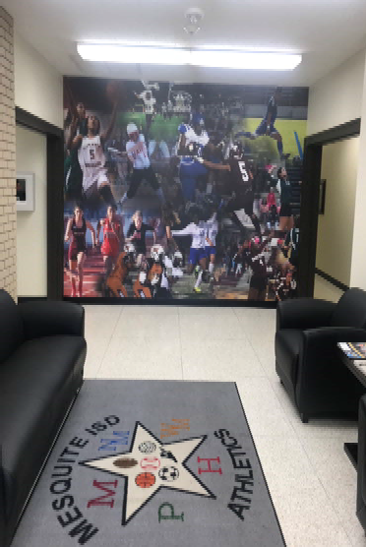Kody Groves, Athletic Director

 | 2017 AUDITED | 2018 AUDITED | 2019 AUDITED | 2020 UNAUDITED | 2021 BUDGET
Payroll Costs | $ 685,234.60 | $ 650,962.00 | $ 619,505.75 | $ 594,063.12 | $ 603,300.00
Contracted Services | $ 9,306.24 | $ 10,641.52 | $ 10,259.51 | $ 10,693.79 | $ 12,200.00
Supplies & Materials | $ 11,623.07 | $ 21,732.35 | $ 13,229.02 | $ 19,886.22 | $ 22,000.00
Other Operating Cost | $ 19,323.99 | $ 15,133.46 | $ 18,907.49 | $ 11,791.70 | $ 22,000.00
Fixed Assets |  | $ 5,021.21 |  |  | $ ‐
Total | $ 725,487.90 | $ 703,490.54 | $ 661,901.77 | $ 636,434.83 | $ 659,500.00

GLOSSARY
This glossary contains definitions of terms used in this guide and such additional terms as seems necessary to common understanding concerning financial accounting procedures for schools. Several terms which are not primarily financial accounting terms have been included because of their significance for school financial accounting.

Account – A descriptive heading under which are recorded financial transactions that are similar in terms of a given frame of reference, such as purpose, object, or source.

Accounting System – The total structure of records and procedures which discover, record, classify, and report information on the financial position and operations of a school district or any of its funds, balanced account groups and organizational components.

Accrual Basis – The basis of accounting, under which revenues are recorded when levies are made, and expenditures are recorded as soon as they result in liabilities, regardless of when the revenue is actually received or the payment is actually made. See also Estimated Revenue and Expenditures.

Accrue – To record revenues when earned or when levies are made, and to record expenditures as soon they result in liabilities, regardless of when the revenue is actually received or the payment is actually made. Sometimes, the term is used in a restricted sense to denote the recording of revenue earned but not yet due, such as accrued interest on investments and the recording of expenditures which result in liabilities that are payable in another accounting period, such as accrued interest on bonds. Also see Estimated Revenues and Expenditures.

ACT – represents American College Testing.

ADA – Average Daily Attendance is based on the number of days of instruction in the school year. The aggregate days attendance is divided by the number of days of instruction to compute average daily attendance. ADA is used in the formula to distribute funding to Texas public school districts.

Administration – Those activities which have as their purpose the general regulation, direction, and control of the aﬀairs of the local education agency that are system‐wide and not confined to one school, subject, or narrow phase of school activity.

Ad Valorem Tax – The primary source of local funding for school districts levied against the local tax base. Ad Valorem means according to the value.

AEIS – represents Academic Excellence Indicator System. A system of indicators established by the Legislature and adopted by the State Board of Education to help determine the quality of learning on a campus and in a school district. The indicators include passing rates on the state assessment tests, attendance, graduation rates, dropout rates, and scores on college entrance exams. The state will assess district and school performance compared with state‐level standards. AEIS is the foundation for a school district’s accountability rating.
Allocation – A part of a lump‐sum appropriation which is designated for expenditure by specific organization units and/or for specific purposes, activities, or objects.

Appropriation – An authorization granted by a legislative body to make expenditures and to incur obligations for specific purposes. An appropriation is usually limited in amount and as to the time when it may be expended.

Assessed Valuation – A valuation set upon real estate or other property by the County Appraisal District to be used as a basis for levying taxes.

Audit – A comprehensive review of the manner in which the government’s resources were actually utilized. A certified public accountant issues an opinion over the presentation of financial statements, tests the controls over the safekeeping of assets and makes recommendations for improvements for where necessary.

Board of Education (School Board of Trustees) – The elected or appointed body which has been created according to State law and vested with responsibilities for school boards, governing boards, boards of directors, school committees, school trustees, etc. This definition relates to the general term and covers State boards, intermediate administrative unit boards, and local basic administrative unit boards.

Bond – A written promise, generally under seal, to pay a specific sum of money called the face value, at a fixed time in the future called the date of maturity, and carrying interest at a fixed rate, usually payable periodically. The diﬀerence between a note and a bond is that the latter usually runs for a longer period of time and requires greater legal formality. See also Surety Bond.

Bonded Debt – The part of the school district debt which is covered by outstanding bonds of the district. Sometimes called “Funded Debt”.

Bonds Authorized and Unissued – Bonds which have been legally authorized but not issued and which can be issued and sold without further authorization. Bonds Issued – Bond sold.

Budget – A plan of financial operation embodying an estimate of proposed expenditures for a given period or purpose and the proposed means of financing them. The budget usually consists of three parts. The first part contains a message from the budget‐making authority together with a summary of the proposed expenditures and the means of financing them. The second part is composed of drafts of the appropriation, revenue, and borrowing measures necessary to put the budget into eﬀect. The third part consists of schedules supporting the summary. These schedules show in detail the proposed expenditures and means of financing them together with information as to past years’ actual revenues and expenditures and other data used in making the estimates.
Budgetary Control – The control management of the business aﬀairs of the school district in accordance with an approved budget with a responsibility to keep expenditures within the authorized amounts.

Capital Budget – A plan of proposed capital outlays and the means of financing them for the current fiscal period. It is usually a part of the current budget. If a Capital Program is in operation, it will be the first year thereof. A Capital Program is sometimes referred to as a Capital Budget.

Capital Outlays – A plan for capital expenditures to be incurred each year over a fixed period of years to meet capital needs arising from the long term work program or otherwise. It sets forth each project or other contemplated expenditure in which the local education agency is to have a part and specifies the full resources estimated to be available to finance the projected expenditures.

Capital Projects Fund – A governmental fund type with budgetary control established to account for projects that are financed by the proceeds from bond issues, or for capital projects otherwise mandated to be so accounted for in this fund.

Classification, Function – As applied to expenditures, this term has reference to an activity or service aimed at accomplishing a certain purpose or end; for example, Instructional, School Leadership, Nursing.

Classification, Object – As applied to e3xpenditures, this term has reference to an article or service received, for example, payroll costs, purchased and contracted service, materials, and supplies.

CPA – represents Certified Public Accountant.

Coding – A system of numbering, or otherwise designating, accounts, entries, invoices, vouchers, etc., in such a manner that the symbol used quickly reveals certain required information.

Debt Limit – The maximum amount of gross or net debt which is legally permitted.

Debt Service Fund – A governmental fund with budgetary control that accounts for expenditures for the retirement of debt and expenditures for interest on debt, except principal and interest of current loans. See also Cur‐rent Loans.

Encumbrance Accounting – A System or procedure which involves giving recognition in the accounting budgetary expenditure control records for the issuance of purchase orders, statements, or other commitments chargeable to an appropriation in advance of any liability or payment.
Encumbrance – Any commitment of funds against an appropriation. It may be in the form of a purchase order or a contract. Encumbrance accounting is formally integrated into the accounting system for expenditure control purposes. An encumbrance diﬀers from an account payable as follows: an ac‐ count payable represents a legal liability to pay and results from the goods and/or services requested in a purchase order or contract having been delivered to the District. Until such time as the goods and/ or services are delivered, the commitment is referred to as an encumbrance.

Equipment – Moveable items used for school operation that are of a non‐expendable and mechanical nature, i.e. perform an operation. Typewriters, projectors, vacuum cleaners, accounting machines, computers, lathes, clocks, machinery, and vehicles, etc., are classified as equipment. (Heating and air conditioning systems, lighting fixtures and similar items permanently fixed to or within a building, are considered as part of the building.)

Estimated Revenue – When the accounts are kept on an accrual basis, this term designates the amount of revenue estimated to accrue during a given period regardless of whether or not it will be collected during the period.

Existing Debt Allotment (EDA) Program – In 1999, the Legislature added Subchapter B to Chapter 46 of the Texas Education Code (TEC) to create the Existing Debt Allotment (EDA) program. The EDA provides tax rate equalization for local debt service taxes, operates without applications, and has no award cycles. Each school district is guaranteed a specified amount per student in state and local funds for each cent of tax eﬀort to pay the principal of and interest on eligible bonds. Only general obligation bonds are eligible for the program. Payments demonstrating eligibility for the EDA must appear on the debt service schedule contained in the final oﬃcial statement or bond order.

Expenditures – This grouping includes total charges incurred, whether paid or unpaid, for current expense, capital outlay, and debt service. (Transfers between funds, encumbrances, exchanges of cash for other current assets such as the purchase stores and investment of cash in U.S. Bonds, payments of cash in settlement of liabilities already accounted as expenditures, and the repayment of the principal of current loans are not considered as expenditures.)

Expense – Charges incurred, whether paid or unpaid, for operation, maintenance, and interest, and other charges which are presumed to benefit the current fiscal period. Legal provisions sometimes make it necessary to treat as expense charges whose benefits extend over future periods.

Fiscal Period – Any period at the end of which a local education agency determines its financial position and the results of its operations. The period may be a month, a quarter, or a year, depending upon the scope of operations and requirements for managerial control and reporting.

Fiscal Year – A twelve‐month period of time to which the annual budget applies and at the end of which a local education agency determines its financial position and the results of its operations. The District’s fiscal year is September 1 through August 31.

Fixed Assets – Assets of a long‐term character which are intended to continue to be held or used, such as land, buildings, machinery, furniture and other equipment.

Foundation School Program (FSP) – A program for the financial support of a basic instructional pro‐ gram for all Texas schoolchildren. Money to support the program comes from the Permanent School Fund, Available School Fund, Foundation School Fund, state general revenue, and local property taxes. The state establishes a foundation level and sets, for each district, a calculated contribution level called the local fund assignment (LFA). The greater a district’s property wealth, the higher the LFA. State aid makes up the diﬀerence between the LFA and the foundation level. (See also “Local Fund Assignment”) Currently, the FSP described in the Texas Education Code consists of three parts or tiers. The first pro‐ vides funding for a basic program. The second tier provides a guaranteed‐yield system so that school districts have substantially equal access to revenue suﬃcient to support an accredited program. The third tier equalizes debt service requirements for existing facilities debt.

FTE – Full‐Time Equivalent measures the extent to which one individual or student occupies a full‐time position or provides instruction, e.g., a person who works four hours a day or a student that attends a half of a day represents a .5 FTE. When FTE counts are included in reports they represent the aggregate of all FTE percentages, e.g., if one teacher provides four hours of instruction and four other provide one hour, together they represent one FTE.

Fund – An independent fiscal and accounting entity with a self‐balancing set of accounts recording cash and/or other resources, together with all related liabilities, obligations, reserves, and equities which are segregated for the purpose of carrying on in accordance with special regulations, restrictions, or limitations.

Fund Balance – The excess of assets of a fund over its liabilities and reserves. During the fiscal year pri‐ or to closing, it represents the excess of the fund’s assets and estimated revenues for the period over its liabilities, reserves and appropriations of the period during the fiscal year prior to closing.

Gift – Money received from a philanthropic foundation, private individual, or private organization for which no repayment or special service to the contributor is expected.

Grant – A contribution by one governmental unit to another. The contribution is usually made to aid in the support of specified function (for example, job training), but it is sometimes also for general purposes.

Guarantee Yield – A school finance plan in which the state specifies a revenue yield that it will guarantee in terms of revenue per student per penny of local tax eﬀort. The districts adopt tax rates and levy taxes. The state makes up the diﬀerence between what each district levies locally per student and the guarantee yield per student. High wealth districts may raise all of their guaranteed‐yield revenue from local tax sources. In Texas, this is commonly known as Tier Two in the Foundation School Program.

Improvements ‐ Buildings, other structures, and other attachments or annexations to land which are intended to remain so attached or annexed, such as sidewalks, trees, drives, tunnels, drains, and sewers.

Independent School District (ISD) – The Texas Constitution permits the state Legislature to create school districts. Each district operates its schools and taxes property within the district to support, in part, the schools. The term independent refers to the fact that the school district is not a part of city or county government and has independent budgeting and taxing authority. ISD’s are governed by locally elected boards of trustees.

Individuals with Disabilities Education Act (IDEA) – The purpose of the Individuals with Disabilities Education Act (IDEA) are to: (1) ensure that all children with disabilities have available to them a free appropriate public education which emphasizes special education and related services designed to meet their unique needs; (2) ensure that the rights of children with disabilities and their parents or guardians are protected; (3) assist States, localities, educational service agencies and Federal agencies to provide for the education of all children with disabilities; and (4) assess and ensure the eﬀectiveness of eﬀorts to educate children with disabilities.

Instruction – The activities dealing directly with the teaching of students or improving the quality of teaching.

Instructional Facilities Allotment (IFA) – Granted by House Bill 4 in 1997, this program provides a guar‐ anteed level ($35) of state and local funds per student per penny of tax eﬀort applicable to debt service on eligible bonds. However, there is a limit on funding for each biennium so the District must apply for funding. The applications are ranked based on relative property wealth and funs are warded up to the dollar limit available.

Inventory – A detailed list of record showing quantities, descriptions, values, units of measure, and unit prices of property on hand.

Levy – To impose taxes or special assessments. (Noun) The total of taxes special assessments imposed by governmental unit.

Liability – An obligation, based on a past transaction, to convey assets or perform services in the future.

M&O Tax Rate – The tax rate calculated to provide the revenues needed to cover Maintenance & Operations (M&O). M&O includes such things as salaries, utilities, and day‐to‐day operations.

Modified Accrual Accounting – A basis of accounting in which expenditures are accrued when incurred and revenues are accounted for when they become measurable and available.

National School Lunch Program (NSLP) – A federally‐assisted meal program operation in more than 101,000 public and non‐profit private schools across the nation. The program was established under the National School Lunch Act, signed by President Harry Truman in 1946.

PEIMS ‐ represents Public Education Information Management System.

Personnel, Administration – Personnel on the school payroll who are primarily engaged in activities which have as their purpose the general regulation, direction, and control of the aﬀairs of the school district that are system‐wide and not confined to one school, subject, or narrow phase of school activity; for example, superintendent of schools, business manager and accountant.
Personnel, Full‐Time – School employees who occupy positions the duties of which require them to be on the job on school days, throughout the school year, at least the number of hours the schools in the system are in session.

Program – A group of related activates performed by one or more organizational units for the purpose of accomplishing a function or project for which the District is responsible.

Program Budget – A budget wherein expenditures are based primarily on program on work and secondarily on character and object. A program budget is a traditional type of budget between the traditional character and object budget on the one hand, the performance budget on the other.

Refined ADA – Refined Average Daily Attendance is based on the number of days of instruction in the school year. The aggregate eligible days attendance is divided by the number of days of instruction to compute the re‐fined average daily attendance. See also ADA.

Refunding Bonds – Bonds issued to pay oﬀ bonds already outstanding.

Revenue – The yield of taxes, tuition, interest earnings, and other monetary resources that the District collects and receives into the treasury for public use. For those revenues which are recorded on the accrual basis, this term designates additions to assets which (a) do not increase any liability; (b) do not represent the recovery of an expenditure; (c) do not represent contributions of fund capital in enterprise and internal service funds. The same definition applies to those cases where revenue is recorded on the modified accrual or cash basis, except that additions would be partially or entirely to cash. See Receipts, Revenues.

Rollback Tax Rate – A tax rate that exceeds the rollback tax rate will automatically trigger an election to limit school taxes on a date not less than 30 days or more than 90 days after the tax rate is adopted. If the election to limit school taxes is successful, the tax rate the district may impose for the current year is limited to the calculated rollback tax rate.

Salary – The total amount regularly paid or stipulated to be paid to an individual, before deductions, for personal services rendered while on the payroll of the school district. Payments for sabbatical leave are also considered as salary.

SAT – represents Standardized Achievement Tests.

School – A division of the school system consisting of a group of pupils composed of one or more teachers to give instruction of a defined type, and housed in a school plant of one or more buildings. More than one school may be housed in one school plant, as is the case when the elementary and secondary programs are housed in the same school plant.

School, Elementary – A school classified as elementary by State and local practice and composed of any span of grades not above grade five. In this District this term includes kindergartens and pre‐ kindergartens if they are under the control of the local board of education.

School, Middle – A separately organized secondary school intermediate between elementary, intermediate, and senior high school. In this District middle schools include grades six through eight.

School Secondary – A secondary school comprises any span of grades beginning with the next grade following the elementary school and ending with grade 12, including middle schools, the diﬀerent types of high schools, and alternative high schools.

Special Revenue Funds – A governmental fund type with budgetary control, used to account for the proceeds of specific revenue sources, other than expendable trusts or for major capital projects, that are legally restricted to expenditures for specified purposes.

Tax Base – The total value of all real, personal and mineral property in the District as of January 1st of each year, as certified by the County Appraisal Board. The tax base represents net value after all ex‐ emptions.

Taxes – Compulsory charges levied by a governmental unit of the purpose of financing service per‐ formed for the common benefit. The term includes licenses and permits. It does not include special assessments.

Tax Rate – Total tax rate is set by the Board of Trustees and is made up of two components: maintenance and operating and debt service rates. It is the amount levied for each $100 of assessed valuation.

Tax Roll – The oﬃcial list showing the amount of taxes levied against each taxpayer of property.

TEA – represents Texas Education Agency. It is the administrative and regulatory unit for the Texas public education system managed by the commissioner of education. TEA is responsible for implementing public education policies as established by the Legislature, State board of Education, and commissioner of education.

Teacher Retirement System (TRS) – TRS delivers retirement and related benefits authorized by law for members and their beneficiaries.

Unassigned Fund Balance – For budget purposes, the unassigned fund balance is that portion of fund equity that is currently available for allocation.

WADA – To treat school districts fairly in funding, a Weighted Average Daily Attendance (WADA) is used to measure the extent students are participating in special programs. The concept of WADA in eﬀect converts all of a school district’s students with their diﬀerent weights to a calculated number of regular students required to raise the same amount of revenue. The greater the number of students eligible for special entitlements, the greater a school district’s WADA will be.

