

Mesquite Education Association

MAILBAG

November 2018

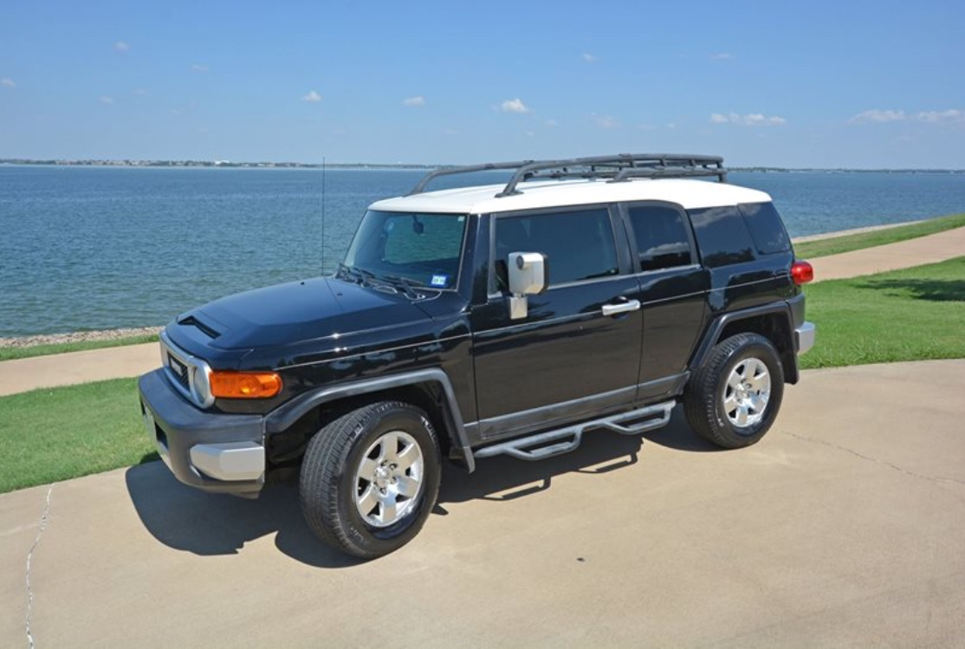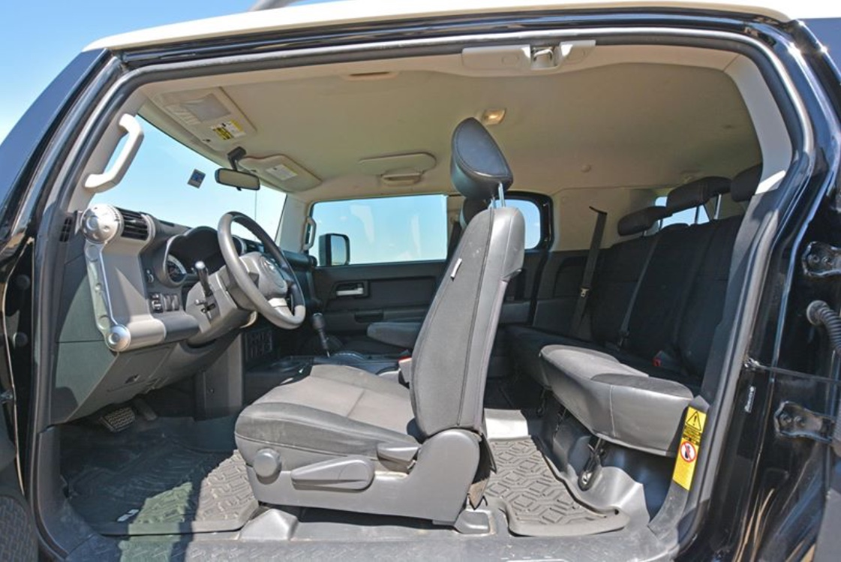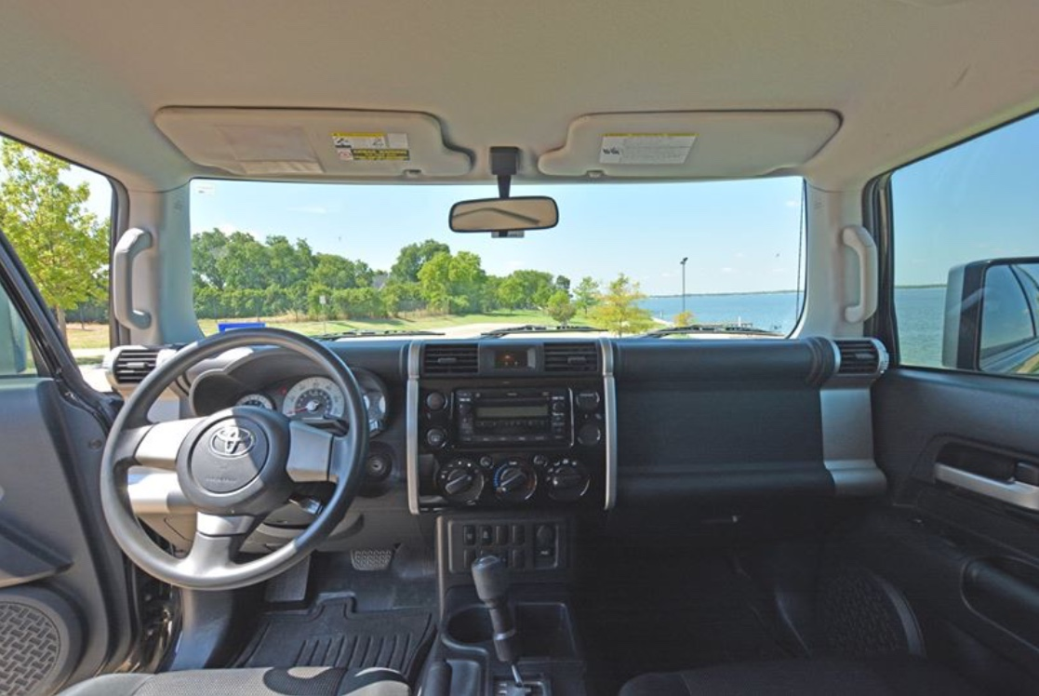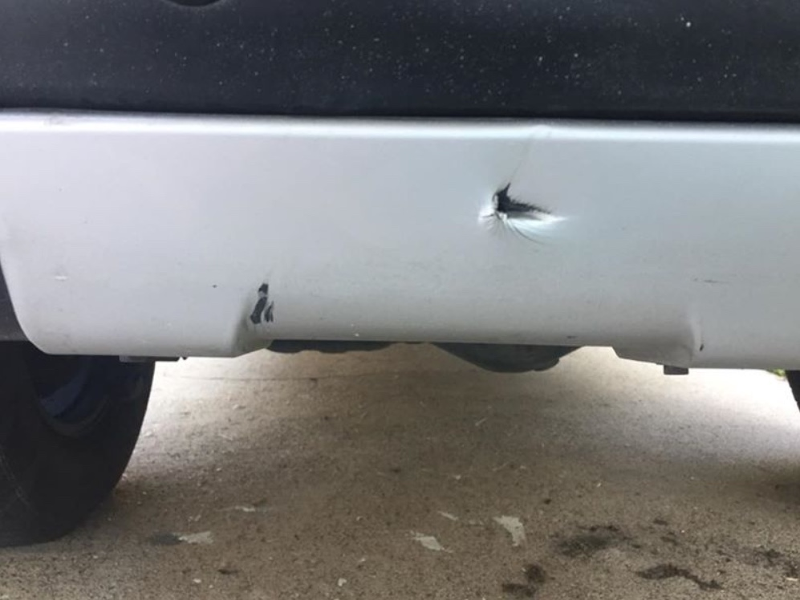

**2008 Toyota FJ Cruiser**

- List Price: $12,000

- Mileage: 151,000

- First and only owner - clean title

- 2WD with rear diff lock feature

- Small puncture on rear bumper (pictured)

**Contact Cathy @ 972.533.3896**

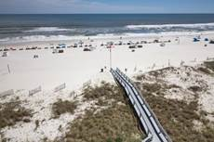



<https://www.vrbo.com/648982>

For Rent: 3 Bedroom & 3 Bath Condo on the Beach

San Carlos 504 in Gulf Shores, AL

Mention MISD for a discount

Call or text 972-979-3346

Tiffani Curtis



Mesquite Education Association

MAILBAG

November 2018

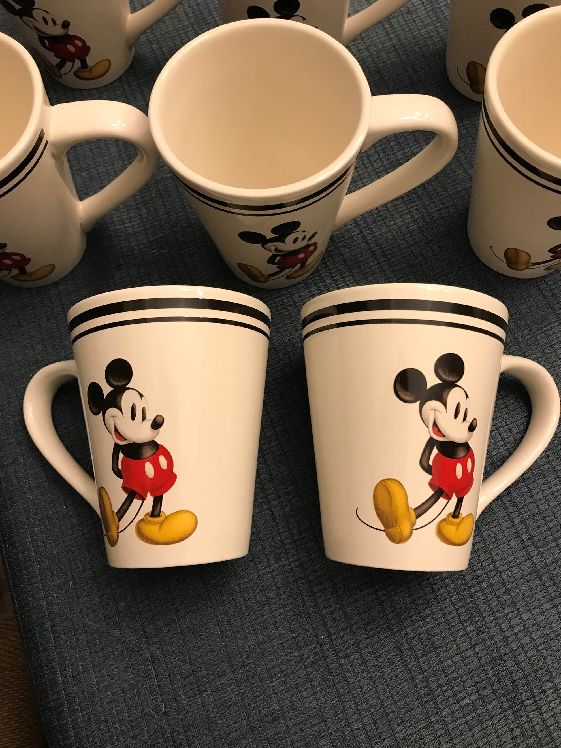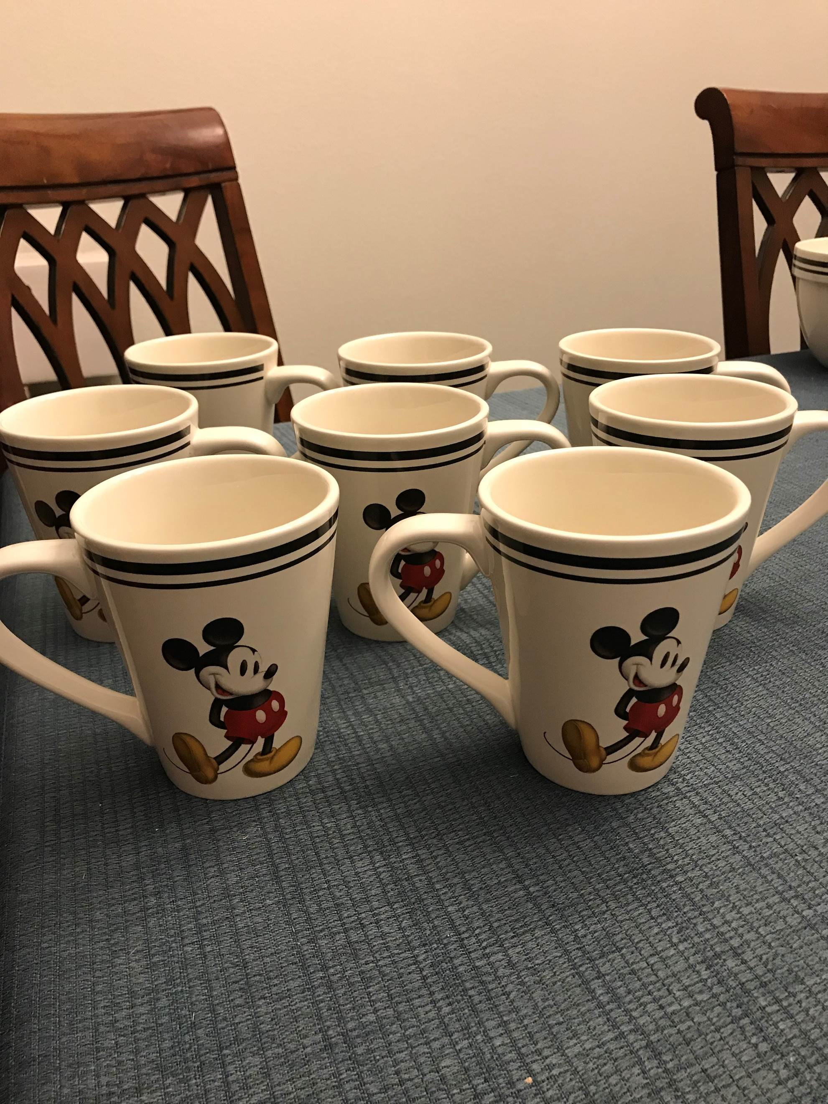

Need a gift for a Mickey Mouse lover?

Eight Mickey Mouse mugs will be perfect! Mickey design printed on both sides. Dishwasher safe!

$35

Jana Christian

972-754-3592

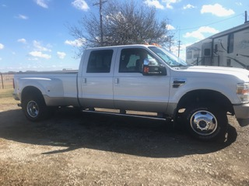

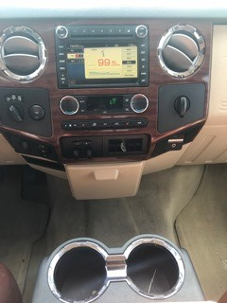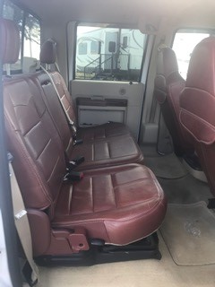

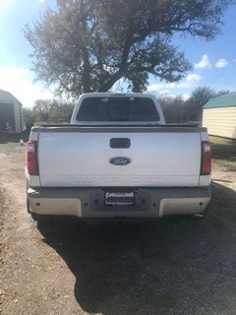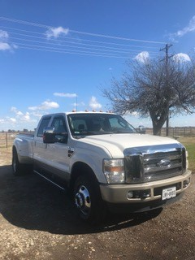

**2010 Ford F350**

6.4 liter V8 power stroke diesel

94,000 miles

$26,500

[alangoodson7@gmail.com](mailto:alangoodson7@gmail.com)

972-427-3910



Mesquite Education Association

MAILBAG

November 2018



Mesquite Education Association

MAILBAG

November 2018

**Gold, Silver & Coin Collections**

I buy gold, silver and coin collections. My brother is an auctioneer and has monthly coin auctions through his business, Fremont Auction Company.

I collect as well as buy and sell bullion, Silver Eagles, Morgan’s and foreign and private mint coins. We will also appraise

and /or auction your collection. Get that old shoe box out of the closet and turn it into cash. From one to one thousand items.

Jim Villwok 214-724-5478

or email at: [dvillwok@gmail.com](mailto:dvillwok@gmail.com)

This space available