

Mesquite Education Association

MAILBAG

March 2019

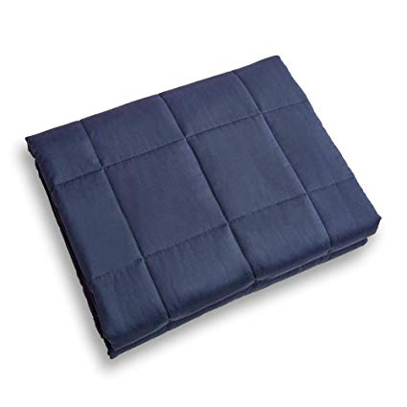

15lb Navy blue weighted blanket

60 X 72 inches

New only used 2-3 times

Org $100 asking $50

Christy Jorgensen WMHS

Text 469-585-6441





<https://www.vrbo.com/648982>

For Rent: 3 Bedroom & 3 Bath Condo on the Beach

San Carlos 504 in Gulf Shores, AL

Mention MISD for a discount

Call or text 972-979-3346

Tiffani Curtis



Mesquite Education Association

MAILBAG

March 2019

**Gold, Silver & Coin Collections**

I buy gold, silver and coin collections. My brother is an auctioneer and has monthly coin auctions through his business, Fremont Auction Company.

I collect as well as buy and sell bullion, Silver Eagles, Morgan’s and foreign and private mint coins. We will also appraise

and /or auction your collection. Get that old shoe box out of the closet and turn it into cash. From one to one thousand items.

Jim Villwok 214-724-5478

or email at: [dvillwok@gmail.com](mailto:dvillwok@gmail.com)

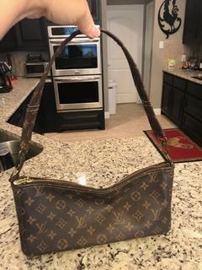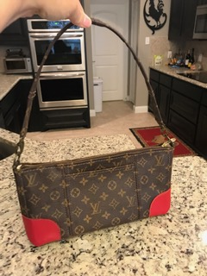

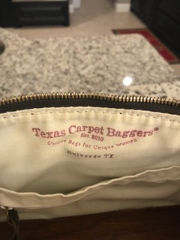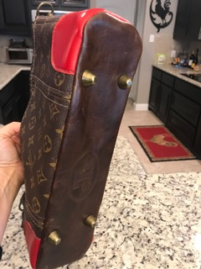

Recycled authentic Louis Vuitton material. Made by Texas Carpet Baggers. Both 13 x 8 inches.

$100 each

If interested call:

Theresa Dinkins

214-803-8704



Mesquite Education Association

MAILBAG

March 2019

Mesquite Education Association

MAILBAG

March 2019



**Gold, Silver & Coin Collections**

I buy gold, silver and coin collections. My brother is an auctioneer and has monthly coin auctions through his business, Fremont Auction Company.

I collect as well as buy and sell bullion, Silver Eagles, Morgan’s and foreign and private mint coins. We will also appraise

and /or auction your collection. Get that old shoe box out of the closet and turn it into cash. From one to one thousand items.

Jim Villwok 214-724-5478

or email at: [dvillwok@gmail.com](mailto:dvillwok@gmail.com)